“DEVELOPMENT AND VALIDATION STABILITY INDICATING RP-HPLC AND UV SPECTROPHOTOMETRIC METHOD FOR DETERMINATION OF LENALIDOMIDE IN BULK AND TABLET”
A Thesis submitted
In Partial fulfillment of the requirements
For the Degree of

MASTER OF PHARMACY
In
PHARMACEUTICAL CHEMISTRY
By

ASHUKA SINGH
Enrollment No. 201020050072230
Under the Supervision of
DR. ROHIT TRIPATHI
(PROFESSOR)
SHAMBHUNATH INSTITUTE OF PHARMACY, JHALWA, PRAYAGRAJ

To the
FACULTY OF PHARMACY
DR. APJ ABDUL KALAM TECHNICAL UNIVERSITY
(Formerly Uttar Pradesh Technical University)
LUCKNOW
OCTOBER, 2026
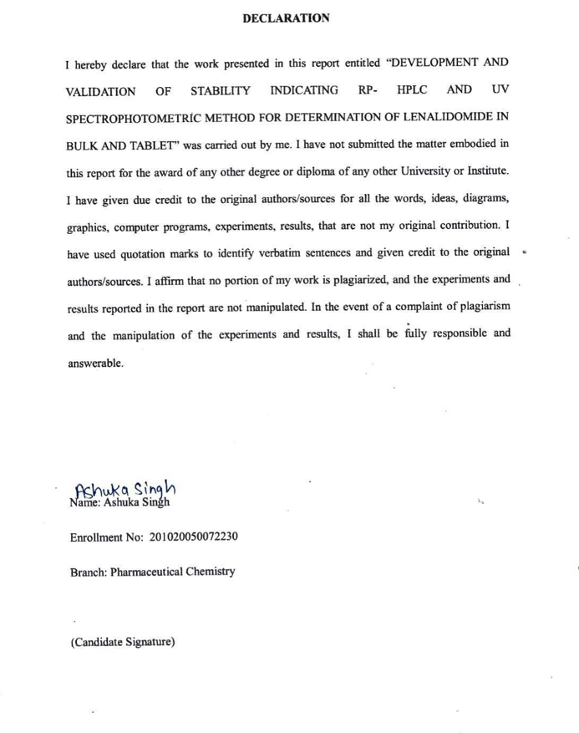

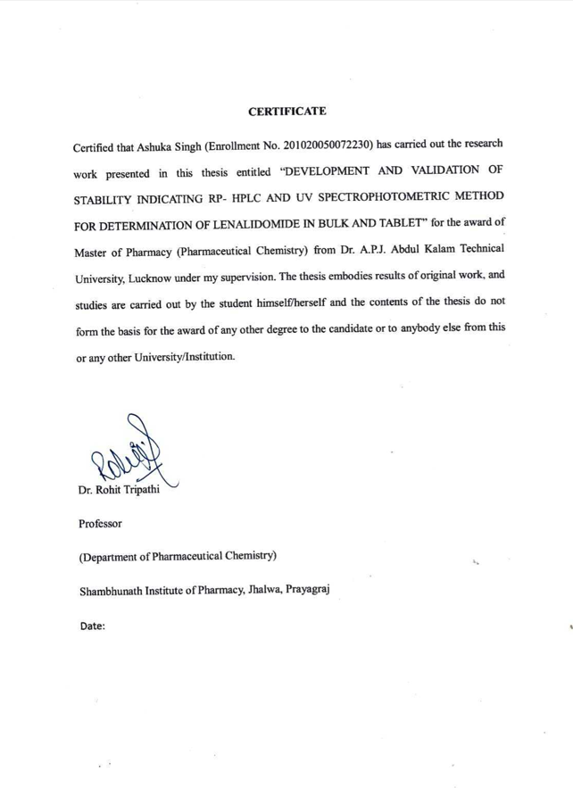
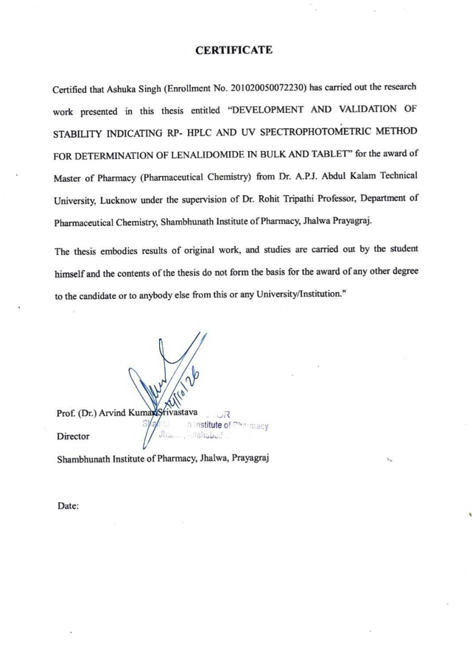
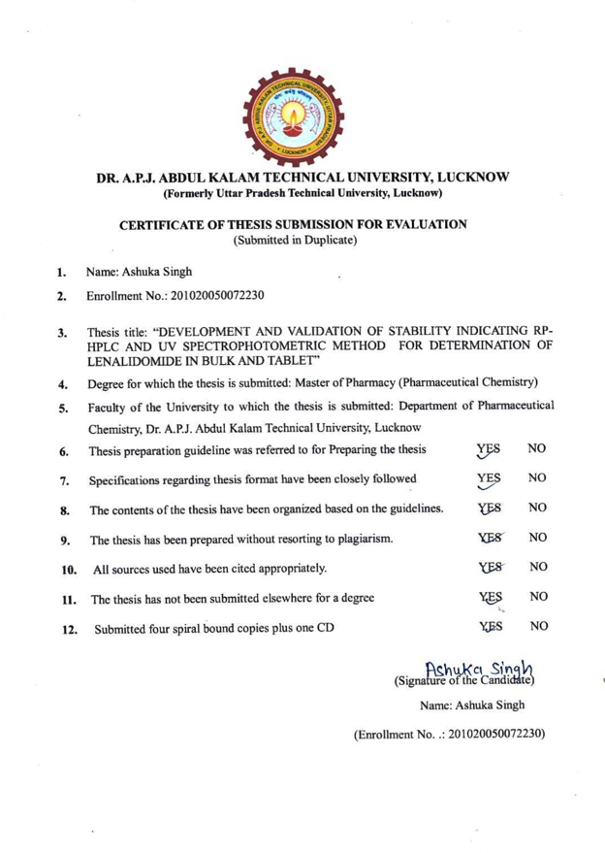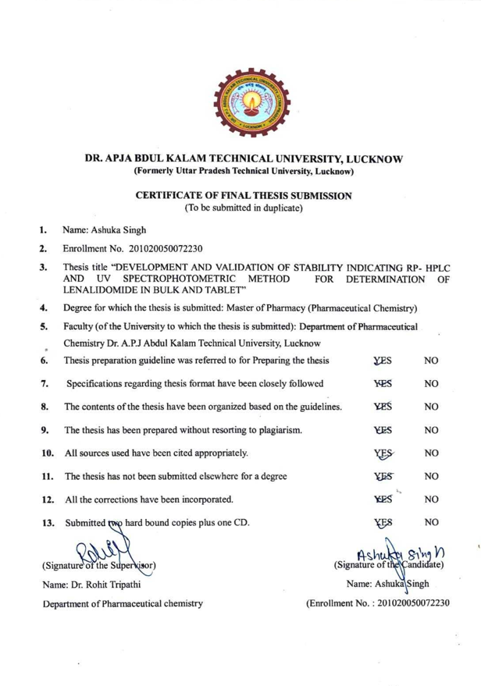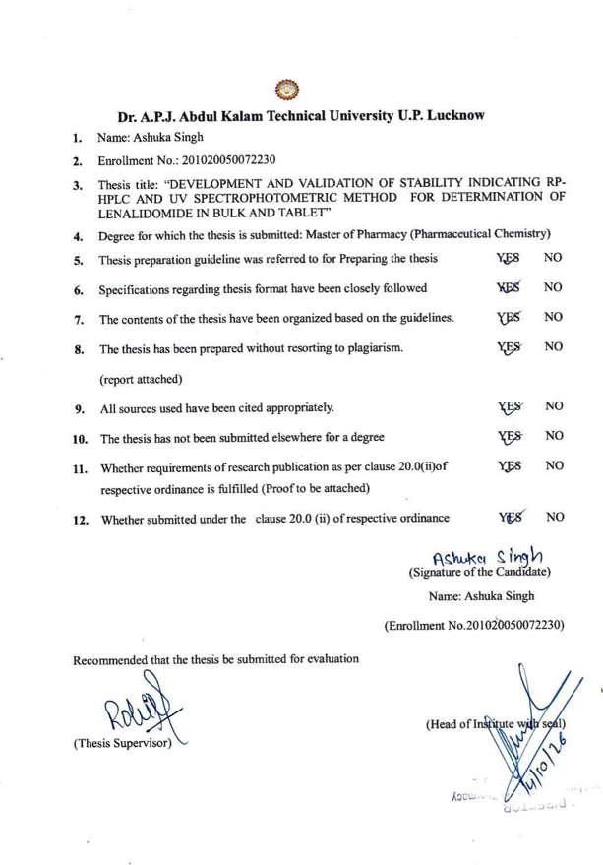

Table of Contents

S. No. | TITLES | PAGE NO.
1. | INTRODUCTION | 1-14
1.1 | Analytical Chemistry | 1
1.2 | Analytical method development | 1
1.3 | CHROMATOGRAPHY | 1
1.4 | HIGH PERFORMANCE LIQUID CHROMATOGRAPHY | 2
1.5 | High- Performance Thin–Layer Chromatography (HPTLC) | 2
1.6 | Spectrophotometric methods | 2
1.7 | Validation of analytical method | 2
1.8 | Analytical Method for Determination of Lenalidomide | 3
2 | Drug Profile | 3
3 | Review of Literature | 3
4 | Aim and Objective | 3
5 | Experimental & Result | 4
5.1 | Method 1: Establishment and validation of an RP-HPLC technique for estimating Lenalidomide in pharmaceutical bulk and capsule preparations. | 4
5.2 | Method 2: Development and Validation of UV-Spectrophotometric Method for Determination of Lenalidomide in Bulk and Tablets | 4
6 | References | 4

List of Tables

Table No. | Titles | Page No.
1 | Characteristics of standard and ideal columns | 25
5.1 | Optimization of Mobile Phase Composition also RP-HPLC Method Development Flow rate | 69
5.2 | Final Optimized Conditions for RP-HPLC method | 71
5.3 | Linearity Studies | 71
5.4 | Bulk determination | 71
5.5 | Analysis of Capsule Formulation | 72
5.6 | Recovery Studies | 72
5.7 | Repeatability Studies | 73
5.8 | Precision Studies | 73
4.9 | Sensitivity Studies | 73
4.10 | System Suitability studies | 73
5.11 | Ruggedness Investigation | 75
5.12 | Robustness Studies | 75
5.13 | Linearity Studies of Lenalidomide | 84
5.14 | Analysis of Bulk API Drug | 84
5.15 | Analysis of Capsule Formulation | 85
5.16 | Recovery Investigation | 85
5.17 | Repeatability Studies | 85
5.18 | Precision Studies | 86
5.19 | Ruggedness Studies | 86

List of Figures
Figure No. | Titles | Page No.
1.5 | HPLC system: A schematic representation | 12
5.A.a | Trial I - Mobile phase composition ACN: H₂O (8:2) | 23
5.A.b | Trial II - Ratio CH₃OH: H₂O (70: 30 v/v) | 40
5.A.c | Trial III - Ratio CH₃OH: H₂O (80: 20 v/v) | 41
5.A.d | Trial IV-Ratio CH₃OH: H₂O (80:20 v/v) (pH 9) | 41
5.A.e | Trial V- Ratio CH₃OH: H₂O (70:30 v/v) (pH 9) | 42
5.A.f | Trial IV-Ratio CH₃OH: H₂O (70:30 % v/v) (pH 9) | 43
5.B | Chromatogram of Lenalidomide CH₃OH: H₂O (70:30 v/v) (pH 9) | 42
5.C | Calibration Graph for Lenalidomide | 43
4.3.A | UV spectrum of Lenalidomide displaying λ max at 395.00 nm in Methanol | 42
4.3.C | Standard Curve of Lenalidomide. | 43

List of Symbols/Abbreviations

Abbreviations/Symbols | Full Form
% | Percentage
%RSD | Percentage relative standard deviation
± | Plus or minus
× | Multiplication; used in dimensions or calculations
°C | Degree Celsius
Å | Ångström; unit of length
µg | Microgram
µg/mL | Micrograms per millilitre
µL | Microlitre
µm | Micrometre
cm | Centimetre
g | Gram
mL | Millilitre
mL/min | Millilitres per minute; mobile-phase flow rate
mg | Milligram
min | Minute
mm | Millimetre
m²/g | Square metres per gram; specific surface area
m/z | Mass-to-charge ratio
nm | Nanometre; analytical wavelength
pH | Measure of acidity or alkalinity
psi | Pounds per square inch; pressure unit
r² | Coefficient of determination
tR | Retention time
v/v | Volume by volume; solvent-mixture ratio
λ | Wavelength
σ | Standard deviation (when used in validation equations)
N | Number of theoretical plates (chromatographic efficiency)
Rs | Chromatographic resolution or response ratio, depending on context
ACN | Acetonitrile
API | Active Pharmaceutical Ingredient
C8 | Octyl-bonded chromatographic stationary phase
C18 | Octadecyl-bonded chromatographic stationary phase
CE–MS | Capillary Electrophoresis–Mass Spectrometry
ct-DNA | Calf Thymus Deoxyribonucleic Acid
DNA | Deoxyribonucleic Acid
EPA | Environmental Protection Agency
ESR | Electron Spin Resonance
FDA | Food and Drug Administration
GC | Gas Chromatography
GC–IR | Gas Chromatography–Infrared Spectroscopy
GC–MS | Gas Chromatography–Mass Spectrometry
HPLC | High-Performance Liquid Chromatography
HPLC–MS | High-Performance Liquid Chromatography–Mass Spectrometry
HPTLC | High-Performance Thin-Layer Chromatography
ICH | International Council for Harmonisation of Technical Requirements for Pharmaceuticals for Human Use
IR | Infrared
IS | Internal Standard
LC | Liquid Chromatography
LC–MS/MS | Liquid Chromatography–Tandem Mass Spectrometry
LC–NMR | Liquid Chromatography–Nuclear Magnetic Resonance
LOD | Limit of Detection
LOQ | Limit of Quantification
MeOH | Methanol
MS | Mass Spectrometry
MS/MS | Tandem Mass Spectrometry
NMR | Nuclear Magnetic Resonance
PDA | Photodiode Array
RF | Response Factor
RP-HPLC | Reversed-Phase High-Performance Liquid Chromatography
RSD | Relative Standard Deviation
SST | System Suitability Testing
THF | Tetrahydrofuran
TLC | Thin-Layer Chromatography
UHPLC | Ultra-High-Performance Liquid Chromatography
UV | Ultraviolet
UV–Vis | Ultraviolet–Visible
USFDA | United States Food and Drug Administration

