PREDICTIVE ANALYTICS
PROJECT REPORT
(Project Semester August–December 2026)
Loan Default Risk Analysis and Prediction Using Supervised Machine Learning
Submitted by
Aniket Raj
Registration No. 12416201
Roll No. 61
Programme and Section: B.Tech CSE, Section ____
Course Code: INT234
Under the Guidance of
(Name of faculty coordinator, U.Id: _____, Designation)
Discipline of CSE/IT
Lovely School of Computer Science and Engineering
Lovely Professional University, Phagwara

DECLARATION
I, Aniket Raj, student of B.Tech (Computer Science and Engineering) under CSE/IT Discipline at Lovely Professional University, Punjab, hereby declare that all the information furnished in this project report is based on my own intensive work and is genuine.
Date: ____________
Signature: ____________________
Registration No. 12416201
Name of the student: Aniket Raj

CERTIFICATE
This is to certify that Aniket Raj bearing Registration no. 12416201 has completed INT234 (Predictive Analytics) project titled, “Loan Default Risk Analysis and Prediction Using Supervised Machine Learning” under my guidance and supervision. To the best of my knowledge, the present work is the result of his original development, effort and study.
Signature and Name of the Supervisor
Designation of the Supervisor
School of Computer Science and Engineering
Lovely Professional University
Phagwara, Punjab.
Date: ____________

ACKNOWLEDGEMENT
I would like to express my sincere gratitude to my faculty guide for the guidance, encouragement and valuable feedback that shaped this project from the first idea to the final report. The discussions in class on supervised learning, model evaluation and data preparation directly helped me to plan and complete this work.
I am thankful to Lovely Professional University and the School of Computer Science and Engineering for providing the learning environment, the computing facilities and the opportunity to work on a practical data science project as part of the Data Science minor.
I also thank the creators and maintainers of the Credit Risk Dataset on Kaggle and the open-source community behind Python, pandas, NumPy, Matplotlib, Seaborn and scikit-learn, whose tools made this analysis possible. Finally, I thank my friends and family for their constant support and motivation.
Aniket Raj
Registration No. 12416201
TABLE OF CONTENTS
1. Introduction 1
1.1 Background 1
1.2 Problem Statement 1
1.3 Objectives of the Project 1
1.4 Scope of the Work 1
1.5 Tools and Technologies Used 2
2. Source of Dataset 3
2.1 Dataset Description 3
2.2 Description of the Columns 3
2.3 Summary Statistics of the Raw Data 3
2.4 The Target Variable 4
3. EDA Process 5
3.1 Understanding the Dataset 5
3.2 Data Cleaning and Preprocessing 5
3.3 Visual Exploratory Analysis 6
3.4 Feature Engineering and Feature Preparation 8
4. Analysis on Dataset 10
4.1 Logistic Regression 10
4.2 K-Nearest Neighbors (KNN) 12
4.3 Gaussian Naive Bayes 14
4.4 Decision Tree 15
4.5 Random Forest 17
4.6 Model Comparison 18
4.7 Why Accuracy Alone Is Not Enough 19
4.8 Best Model Analysis 19
5. Conclusion 21
5.1 Recommendations 21
5.2 Limitations 21
6. Future Scope 23
7. References 24
Appendix: Project Links and Screenshots 25
LIST OF FIGURES
Figure 1: Distribution of loan status 7
Figure 2: Default rate by loan grade 7
Figure 3: Interest rate and loan-to-income ratio by loan status 8
Figure 4: Correlation heatmap of the numerical variables 8
Figure 5: Confusion matrix of Logistic Regression 12
Figure 6: Coefficients of the Logistic Regression model 12
Figure 7: Confusion matrix of KNN 13
Figure 8: Confusion matrix of Gaussian Naive Bayes 15
Figure 9: Confusion matrix of Decision Tree 16
Figure 10: Decision Tree (top 3 levels) 16
Figure 11: Confusion matrix of Random Forest 18
Figure 12: Feature importance of the Random Forest model 18
Figure 13: F1-score comparison of the classification models 19
LIST OF TABLES
Table 1: Tools and technologies used in the project 2
Table 2: Columns of the credit risk dataset 3
Table 3: Summary statistics of the numerical columns (raw data) 4
Table 4: Category counts of the categorical columns (after cleaning) 5
Table 5: Summary of data cleaning steps 6
Table 6: Evaluation metrics used in the project 10
Table 7: Confusion matrix of Logistic Regression 11
Table 8: Confusion matrix of KNN 13
Table 9: Confusion matrix of Gaussian Naive Bayes 14
Table 10: Confusion matrix of Decision Tree 16
Table 11: Confusion matrix of Random Forest 17
Table 12: Comparison of the five classification models on the test set 18
Table 13: Confusion matrix of the selected model (Random Forest) 19

1. Introduction

1.1 Background
Lending is one of the core activities of the financial sector, and every loan carries the risk that the borrower may fail to repay it. When a loan is not repaid it is recorded as a default, and a large number of defaults can cause serious losses to a lender. Lenders therefore study the information they collect about applicants and loans, such as income, age, employment length, loan amount, interest rate and credit history, to understand which kinds of loans are more likely to end in default.
Data science and machine learning give a systematic way to do this. A supervised classification model learns from past loans whose outcome is already known (repaid or defaulted) and then predicts the outcome for new loans. This project applies that idea to a public credit risk dataset and compares five standard classification algorithms.

1.2 Problem Statement
The problem addressed in this project is to predict the recorded default status of a loan (loan_status) from the borrower and loan characteristics available in the dataset. The target is binary: 0 means the loan was not recorded as a default and 1 means it was recorded as a default. The project is an educational prediction exercise. It does not claim that any variable causes default and it is not a complete credit-decision system.

1.3 Objectives of the Project
- To preprocess the loan dataset and perform exploratory data analysis.
- To evaluate Logistic Regression for loan default prediction.
- To evaluate K-Nearest Neighbors (KNN) for loan default prediction.
- To evaluate Gaussian Naive Bayes for loan default prediction.
- To evaluate Decision Tree for loan default prediction.
- To evaluate Random Forest for loan default prediction.
- To compare the five classifiers using Accuracy, Precision, Recall, Confusion Matrix and Classification Report.
- To identify the best-performing classifier and summarize the key findings and limitations.

1.4 Scope of the Work
The work covers the complete workflow of a small data science project: loading and understanding the data, cleaning it, exploring it with statistics and charts, preparing features, training five models, evaluating them on unseen data and drawing conclusions. The analysis uses a single dataset and a single stratified train-test split, so the results describe how the models behave on this data and should not be generalised without further validation.

1.5 Tools and Technologies Used
Table 1: Tools and technologies used in the project
Tool / Library | Purpose
Python 3 | Programming language used for the whole project
Jupyter Notebook | Interactive environment for code, outputs and explanations
pandas, NumPy | Loading, cleaning and transforming tabular data; numerical operations
Matplotlib, Seaborn | Creating charts for exploratory analysis and model evaluation
scikit-learn | Train-test split, scaling, five classifiers and evaluation metrics

2. Source of Dataset

2.1 Dataset Description
The dataset used in this project is the Credit Risk Dataset, which is publicly available on Kaggle (https://www.kaggle.com/datasets/laotse/credit-risk-dataset). The file used is credit_risk_dataset.csv. It contains one row for every loan and describes the borrower, the loan and the borrower’s credit history, together with the recorded loan status.
The raw file contains 32,581 records and 12 columns: 8 numerical columns (including the target loan_status) and 4 categorical columns. Two columns, person_emp_length and loan_int_rate, contain missing values.

2.2 Description of the Columns
Table 2: Columns of the credit risk dataset
Column | Type | Description
person_age | Numerical | Age of the borrower in years
person_income | Numerical | Annual income of the borrower
person_home_ownership | Categorical | Home ownership status: RENT, MORTGAGE, OWN or OTHER
person_emp_length | Numerical | Employment length in years
loan_intent | Categorical | Purpose of the loan (education, medical, venture, personal, debt consolidation, home improvement)
loan_grade | Categorical | Grade assigned to the loan, from A (best) to G (worst)
loan_amnt | Numerical | Loan amount requested
loan_int_rate | Numerical | Interest rate of the loan (%)
loan_status | Numerical (target) | 0 = not recorded as default, 1 = recorded as default
loan_percent_income | Numerical | Loan amount as a share of the borrower’s income
cb_person_default_on_file | Categorical | Whether the borrower has a previous default on file (Y/N)
cb_person_cred_hist_length | Numerical | Length of the borrower’s credit history in years

2.3 Summary Statistics of the Raw Data
Table 3 summarises the main numerical columns of the raw file. The typical borrower is around 26 years old, earns a median income of about 55,000 and asks for a loan of about 8,000. The maximum values of person_age (144), person_emp_length (123) and person_income (6,000,000) already hint at unusual records, which are examined in Chapter 3.
Table 3: Summary statistics of the numerical columns (raw data)
Column | Mean | Std. dev. | Min | Median | Max
person_age | 27.73 | 6.35 | 20 | 26 | 144
person_income | 66,074.85 | 61,983.12 | 4,000 | 55,000 | 6,000,000
person_emp_length | 4.79 | 4.14 | 0 | 4 | 123
loan_amnt | 9,589.37 | 6,322.09 | 500 | 8,000 | 35,000
loan_int_rate | 11.01 | 3.24 | 5.42 | 10.99 | 23.22
loan_percent_income | 0.17 | 0.11 | 0 | 0.15 | 0.83
cb_person_cred_hist_length | 5.8 | 4.06 | 2 | 4 | 30

2.4 The Target Variable
The target variable loan_status is imbalanced. After cleaning, about 78.13% of the loans are non-default (0) and about 21.87% are default (1). Because of this imbalance, a model that predicts “non-default” for every loan would already reach an accuracy of about 78.1% without finding a single default. For this reason accuracy alone is not used to judge the models; precision, recall and F1-score for the default class are used as well.

3. EDA Process
Exploratory Data Analysis (EDA) is the step in which the data is inspected, cleaned and visualised before any model is built. All cleaning in this project was performed on a copy of the data so that the original dataframe remained unchanged.

3.1 Understanding the Dataset
The data was loaded with pandas and inspected using head(), tail(), info() and describe(). These functions show the number of rows and columns, the data types, the non-null counts and the statistical summary of each column. The categorical columns were inspected with value_counts(). The dataset has the following category distributions.
Table 4: Category counts of the categorical columns (after cleaning)
Column | Categories (count)
person_home_ownership | RENT (16,375), MORTGAGE (13,367), OWN (2,563), OTHER (106)
loan_intent | EDUCATION (6,409), MEDICAL (6,042), VENTURE (5,680), PERSONAL (5,497), DEBTCONSOLIDATION (5,189), HOMEIMPROVEMENT (3,594)
loan_grade | A (10,703), B (10,384), C (6,436), D (3,620), E (963), F (241), G (64)
cb_person_default_on_file | N (26,681), Y (5,730)

3.2 Data Cleaning and Preprocessing

3.2.1 Missing values
Only two columns contain missing values: person_emp_length (895 missing, 2.75%) and loan_int_rate (3,116 missing, 9.56%). Instead of filling them immediately, the imputation was postponed until after the train-test split. The median of each column is calculated from the training set only and then applied to both the training and test sets. This prevents information from the test set from leaking into the preprocessing step. The training medians were 4 years for employment length and 10.99% for interest rate.

3.2.2 Duplicate records
The data contains 165 exact duplicate rows. Duplicates add no new information and can appear in both the training and test sets, which would make the test score look better than it really is. They were removed, reducing the dataset from 32,581 to 32,416 rows.

3.2.3 Inconsistent categorical data
The labels of the four categorical columns were listed with sorted(unique()) and checked for spelling or capitalisation variants. The labels were already consistent, so no relabelling was needed.

3.2.4 Invalid numerical values
Five records had an age of 123 or 144 years and two records had an employment length of 123 years for borrowers aged 21 and 22. These values are impossible. No negative values were found. Very high incomes (up to 6,000,000) are unusual but possible, so they were kept. The treatment was:
- Rows with an age above 100 were removed because the whole record is unreliable.
- An employment length above 60 years was replaced with a missing value, to be filled later together with the other missing values.
Table 5: Summary of data cleaning steps
Step | Action | Rows after step
Raw data | — | 32,581
Duplicate rows | 165 exact duplicates removed | 32,416
Impossible age (> 100) | 5 rows removed | 32,411
Impossible employment length (> 60) | 2 values set to missing | 32,411
Missing values | Filled with training-set medians after the split | 32,411

3.3 Visual Exploratory Analysis

3.3.1 Distribution of loan status
Figure 1 shows the number of non-default and default loans. Non-default loans outnumber default loans by roughly 3.6 to 1, confirming the class imbalance discussed earlier.
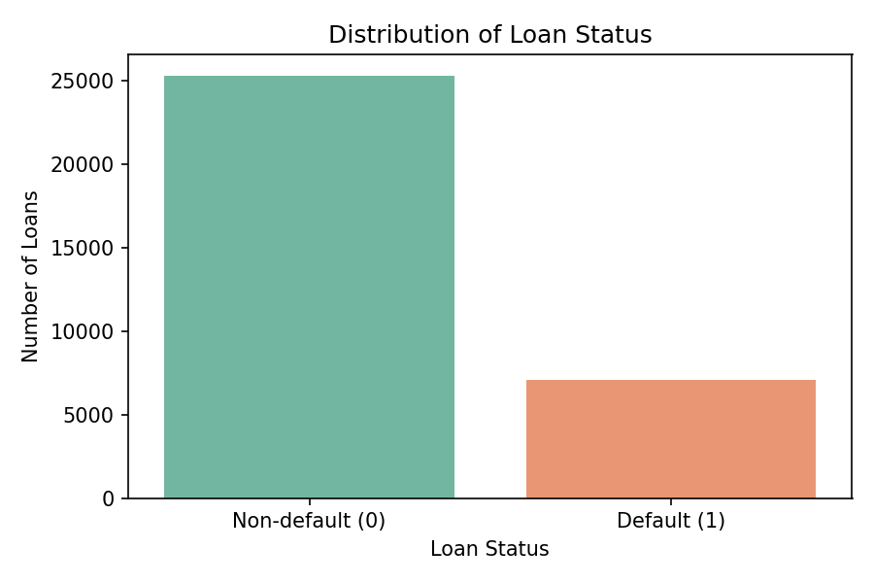
Figure 1: Distribution of loan status

3.3.2 Default rate by loan grade
The mean of loan_status within each grade is the proportion of loans that defaulted, which allows groups of different sizes to be compared fairly. The default rate rises steadily from about 9.96% for grade A to 59.06% for grade D, about 64.49–70.54% for grades E and F, and almost 98.44% for grade G, which is a very small group of only 64 loans. Loan grade is clearly associated with the recorded default status.
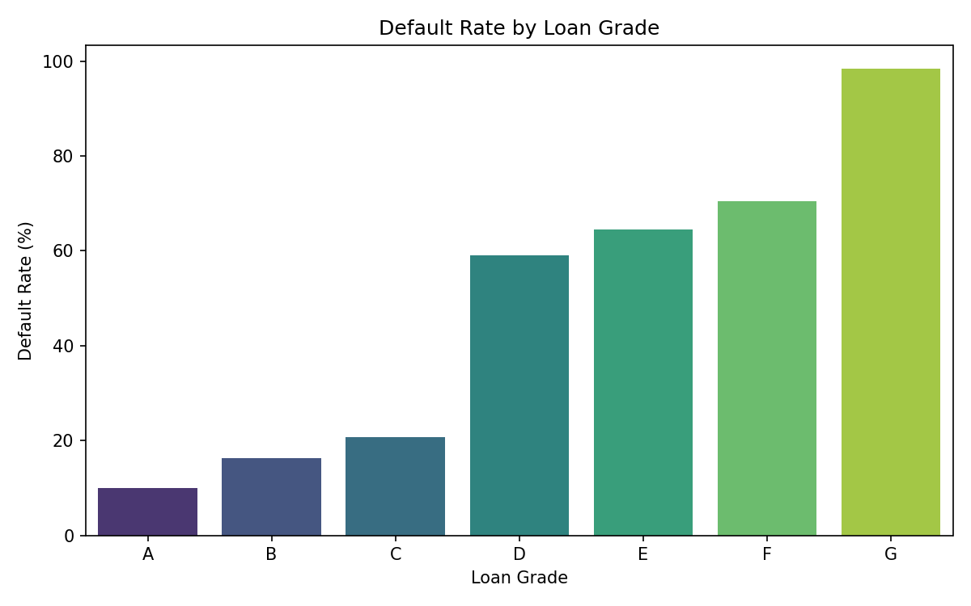
Figure 2: Default rate by loan grade

3.3.3 Interest rate and loan-to-income ratio
Box plots compare the spread of a numerical variable across the two classes. Defaulted loans have a higher median interest rate (13.49% against 10.59%) and take a larger share of the borrower’s income (0.24 against 0.13). This is an association and not proof that these values cause default.
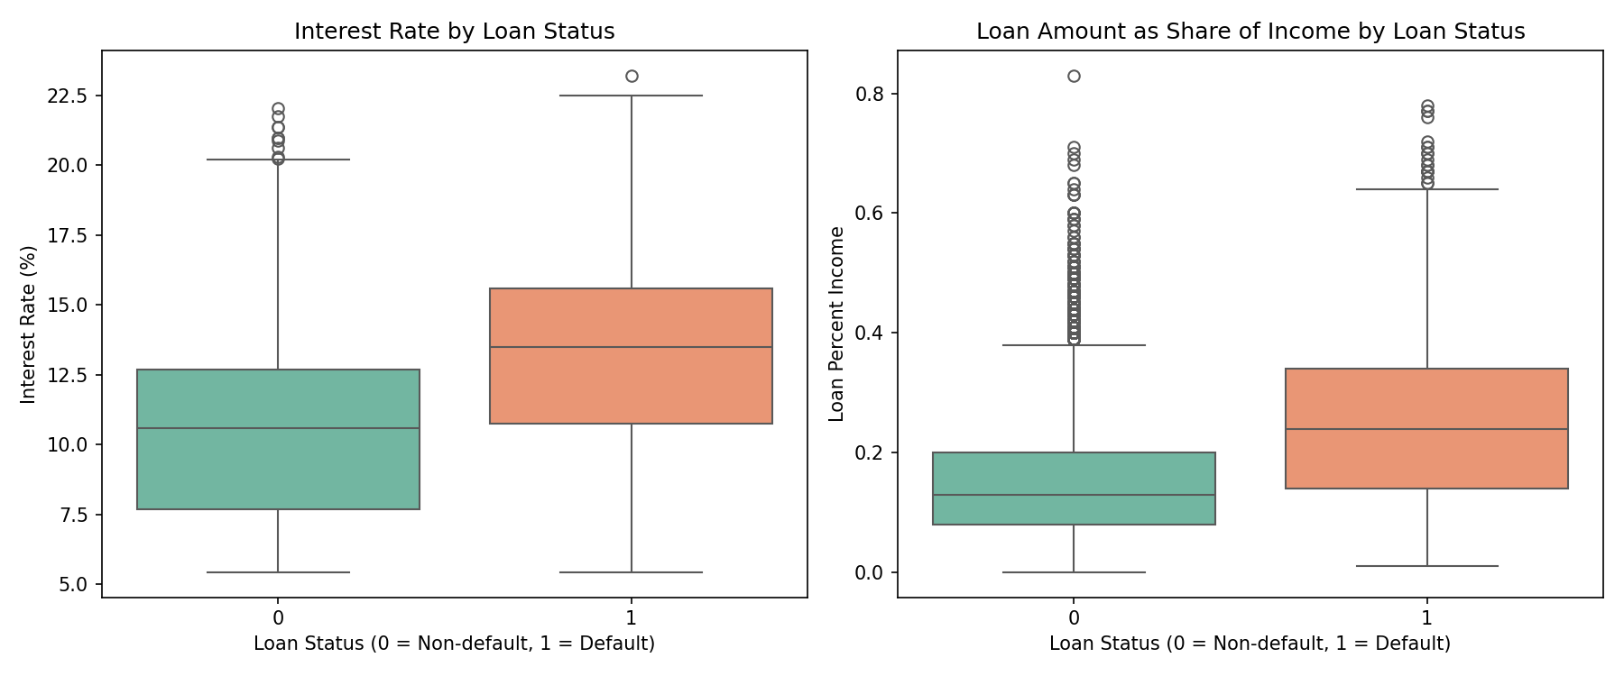
Figure 3: Interest rate and loan-to-income ratio by loan status

3.3.4 Correlation analysis
The correlation heatmap in Figure 4 measures the strength of the linear relationship between pairs of numerical variables (from -1 to +1). loan_percent_income (0.38) and loan_int_rate (0.34) have the strongest positive correlation with loan_status, while person_income (-0.17) is negatively correlated. person_age and cb_person_cred_hist_length are strongly correlated with each other (0.88), so they carry overlapping information. All relationships with the target are only moderate, which suggests that no single variable is enough to predict default and a combination of variables is needed.
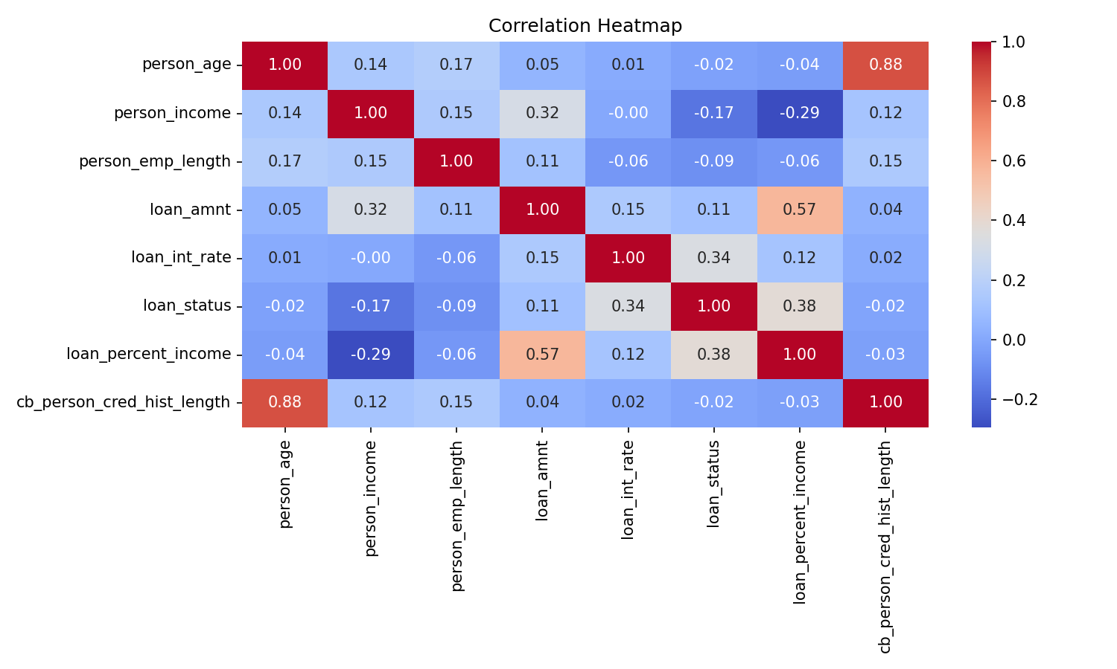
Figure 4: Correlation heatmap of the numerical variables

3.4 Feature Engineering and Feature Preparation

3.4.1 Encoding categorical variables
Machine learning models need numerical input, so the categorical columns were converted as follows. loan_grade has a natural order (A is the best grade), so it received ordinal codes 1 to 7. cb_person_default_on_file is binary and became 1 (Y) or 0 (N). person_home_ownership and loan_intent have no natural order, so they were one-hot encoded into 0/1 columns with drop_first=True to avoid redundant columns. No new derived feature was created because loan_percent_income already captures the loan-to-income ratio. After encoding, the model data has 17 input features.

3.4.2 Train-test split
The data was split into 80% training data (25,928 rows) and 20% test data (6,483 rows) using train_test_split with stratify=y and random_state=42. Stratification keeps the default proportion the same in both sets and the fixed random state makes the experiment reproducible.

3.4.3 Feature scaling
K-Nearest Neighbors measures distances and Logistic Regression is sensitive to feature size, so a large-valued column such as income could dominate small ones. StandardScaler rescales every feature to mean 0 and standard deviation 1 using the formula z = (x − μ) / σ. The scaler was fitted on the training set only and then used to transform the test set. Decision Tree and Random Forest split on thresholds and do not need scaling. Gaussian Naive Bayes was also run on the unscaled data.
from sklearn.model_selection import train_test_split
from sklearn.preprocessing import StandardScaler

X_train, X_test, y_train, y_test = train_test_split(
X, y, test_size=0.2, random_state=42, stratify=y)

medians = X_train[['person_emp_length', 'loan_int_rate']].median()
X_train = X_train.fillna(medians)
X_test = X_test.fillna(medians)

scaler = StandardScaler()
X_train_scaled = scaler.fit_transform(X_train)
X_test_scaled = scaler.transform(X_test)

4. Analysis on Dataset
Five supervised classifiers were trained on the training set and evaluated on the test set. Default (1) is the positive class. The following metrics were calculated for every model, where TP, TN, FP and FN are the entries of the confusion matrix.
Table 6: Evaluation metrics used in the project
Metric | Formula | Meaning
Accuracy | (TP + TN) / (TP + TN + FP + FN) | Share of all predictions that are correct
Precision | TP / (TP + FP) | Of the loans predicted as default, the share that really defaulted
Recall | TP / (TP + FN) | Of the loans that really defaulted, the share the model found
F1-score | 2 × Precision × Recall / (Precision + Recall) | Harmonic mean of precision and recall

from sklearn.metrics import accuracy_score, precision_score, recall_score, f1_score

def evaluate_model(name, y_pred):
predictions[name] = y_pred
results.append({
'Model': name,
'Accuracy': accuracy_score(y_test, y_pred),
'Precision': precision_score(y_test, y_pred, pos_label=1, zero_division=0),
'Recall': recall_score(y_test, y_pred, pos_label=1, zero_division=0),
'F1-score': f1_score(y_test, y_pred, pos_label=1, zero_division=0)})

4.1 Logistic Regression

4.1.1 Introduction
Logistic Regression is the first and simplest model evaluated. It is a linear classification model that estimates the probability that a loan belongs to the default class.

4.1.2 General Description
Logistic Regression combines the scaled input features linearly and passes the result through the sigmoid function to produce a probability between 0 and 1. A loan is classified as default when this probability is at least 0.5. The coefficients are learned by minimising the log-loss on the training data. Because it is a linear model, the learned coefficients are easy to interpret: a positive coefficient pushes the prediction towards default and a negative coefficient pushes it away from default.
The model is sensitive to the scale of the features, so it was trained on the standardised data.

4.1.3 Specific Requirements, Functions and Formulas
The probability of default is given by P(y = 1 | x) = 1 / (1 + e^−(b0 + b1x1 + … + bnxn)). The model was created with LogisticRegression from scikit-learn with max_iter=1000 so that the optimiser converges, and random_state=42 for reproducibility.
from sklearn.linear_model import LogisticRegression

lr_model = LogisticRegression(max_iter=1000, random_state=42)
lr_model.fit(X_train_scaled, y_train)
lr_pred = lr_model.predict(X_test_scaled)
evaluate_model('Logistic Regression', lr_pred)

4.1.4 Analysis Results
On the test set of 6,483 loans, Logistic Regression achieved an accuracy of 85.50%, a precision of 74.29%, a recall of 51.55% and an F1-score of 0.6087 for the default class. It correctly identified 731 defaults and 4,812 non-defaults, wrongly flagged 253 good loans as defaults and missed 687 real defaults. Accuracy looks acceptable, but recall is only about 52%, so nearly half of the real defaults are missed. The accuracy is only a few points above the 78% baseline of always predicting non-default.
Table 7: Confusion matrix of Logistic Regression
 | Predicted Non-default | Predicted Default
Actual Non-default | 4812 | 253
Actual Default | 687 | 731

4.1.5 Visualization
Figure 5 shows the confusion matrix of Logistic Regression and Figure 6 shows the learned coefficients. The largest positive coefficients belong to loan_percent_income (1.401) and loan_grade (1.118), meaning that a higher share of income and a worse grade push the prediction towards default, which agrees with the exploratory analysis.
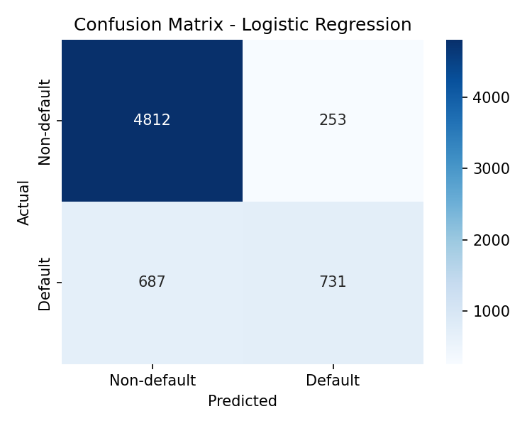
Figure 5: Confusion matrix of Logistic Regression
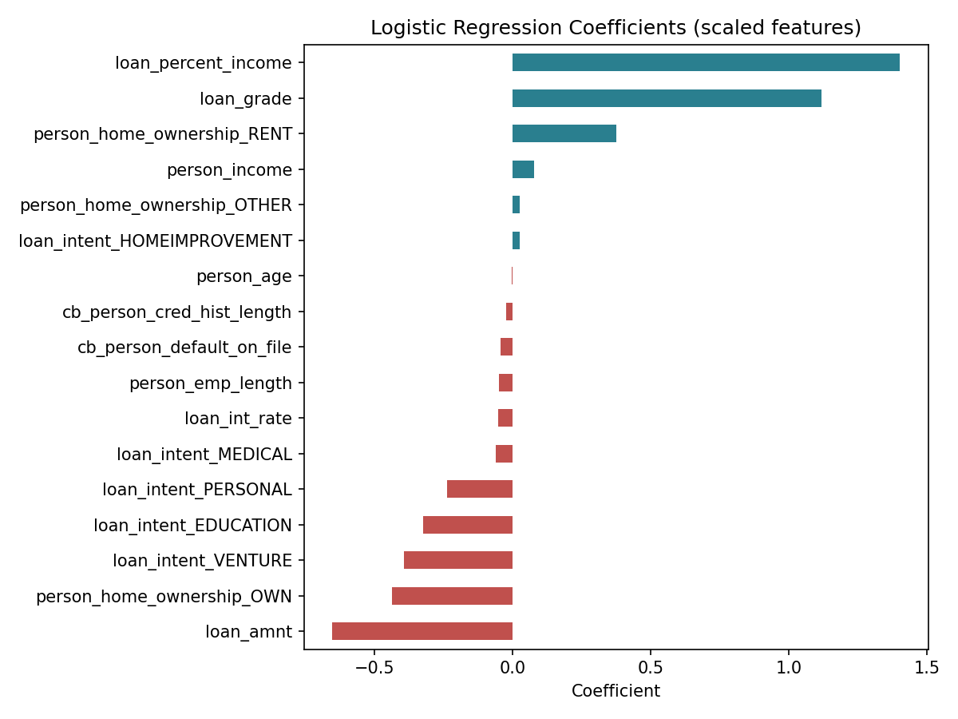
Figure 6: Coefficients of the Logistic Regression model

4.2 K-Nearest Neighbors (KNN)

4.2.1 Introduction
K-Nearest Neighbors is an instance-based classifier. It does not learn an explicit equation; instead it stores the training data and classifies a new loan by looking at similar loans.

4.2.2 General Description
For a new loan, KNN finds the k closest training loans using the Euclidean distance and assigns the class that occurs most often among them. In this project k = 5 was used. The idea is that similar loans tend to have the same outcome. Since distances are used, all features must be on the same scale, so the standardised data was used.
KNN is simple and needs no training phase, but prediction is slower on large data because distances to all training points must be calculated.

4.2.3 Specific Requirements, Functions and Formulas
The Euclidean distance between two loans a and b with n features is d(a, b) = √( Σ (ai − bi)² ). The model was created with KNeighborsClassifier(n_neighbors=5) from scikit-learn.
from sklearn.neighbors import KNeighborsClassifier

knn_model = KNeighborsClassifier(n_neighbors=5)
knn_model.fit(X_train_scaled, y_train)
knn_pred = knn_model.predict(X_test_scaled)
evaluate_model('KNN', knn_pred)

4.2.4 Analysis Results
On the test set of 6,483 loans, KNN achieved an accuracy of 88.77%, a precision of 84.99%, a recall of 59.10% and an F1-score of 0.6972 for the default class. It correctly identified 838 defaults and 4,917 non-defaults, wrongly flagged 148 good loans as defaults and missed 580 real defaults. KNN improves on Logistic Regression in every metric, which suggests that similar loans tend to share the same outcome, but about 41% of the defaults are still missed.
Table 8: Confusion matrix of KNN
 | Predicted Non-default | Predicted Default
Actual Non-default | 4917 | 148
Actual Default | 580 | 838

4.2.5 Visualization
Figure 7 shows the confusion matrix of KNN. The model identifies non-default loans very well; its main weakness is the bottom-left cell, the real defaults predicted as non-default.
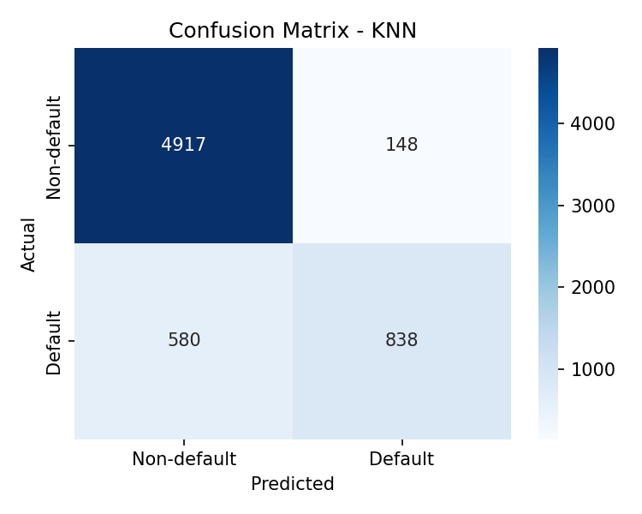
Figure 7: Confusion matrix of KNN

4.3 Gaussian Naive Bayes

4.3.1 Introduction
Gaussian Naive Bayes is a fast probabilistic classifier based on Bayes’ theorem. It is a useful baseline because it makes strong, simple assumptions about the data.

4.3.2 General Description
The model assumes that the features are independent of each other given the class and that each numerical feature follows a normal (Gaussian) distribution within each class. For a new loan it computes the probability of each class and predicts the class with the higher probability. These assumptions are only approximate for this dataset: for example, loan_grade and loan_int_rate are related, and income is strongly skewed.

4.3.3 Specific Requirements, Functions and Formulas
Bayes’ theorem states P(class | x) ∝ P(class) × Π P(xi | class), where each P(xi | class) is taken from a normal distribution with the mean and variance of that feature in that class. The model was created with GaussianNB from scikit-learn and trained on the unscaled data.
from sklearn.naive_bayes import GaussianNB

nb_model = GaussianNB()
nb_model.fit(X_train, y_train)
nb_pred = nb_model.predict(X_test)
evaluate_model('Gaussian Naive Bayes', nb_pred)

4.3.4 Analysis Results
On the test set of 6,483 loans, Gaussian Naive Bayes achieved an accuracy of 82.25%, a precision of 68.02%, a recall of 35.54% and an F1-score of 0.4669 for the default class. It correctly identified 504 defaults and 4,828 non-defaults, wrongly flagged 237 good loans as defaults and missed 914 real defaults. This is the weakest model: recall is only about 36%, so it misses most defaults. Its accuracy is only slightly above the 78% baseline. The independence and normality assumptions do not fit this data well.
Table 9: Confusion matrix of Gaussian Naive Bayes
 | Predicted Non-default | Predicted Default
Actual Non-default | 4828 | 237
Actual Default | 914 | 504

4.3.5 Visualization
Figure 8 shows the confusion matrix of Gaussian Naive Bayes. The large bottom-left cell shows that more than half of the real defaults were predicted as non-default.
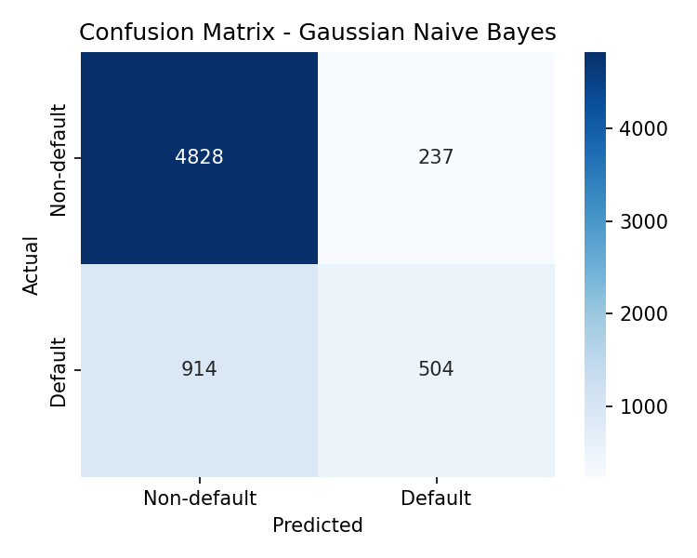
Figure 8: Confusion matrix of Gaussian Naive Bayes

4.4 Decision Tree

4.4.1 Introduction
A Decision Tree is a rule-based model that predicts the class by asking a sequence of yes/no questions about the feature values. Its main advantage is that the rules are easy to read and explain.

4.4.2 General Description
The tree is built from the top. At every node the algorithm chooses the feature and threshold that best separates the two classes, usually by minimising the Gini impurity. Each leaf holds the majority class of the training loans that reach it. A tree that is allowed to grow without limit memorises the training data, so the maximum depth was limited to 5 to keep the tree readable and to limit overfitting. Decision trees need no feature scaling, so the unscaled data was used.

4.4.3 Specific Requirements, Functions and Formulas
The Gini impurity of a node is Gini = 1 − Σ pk², where pk is the proportion of class k in the node. The model was created with DecisionTreeClassifier(max_depth=5, random_state=42) from scikit-learn.
from sklearn.tree import DecisionTreeClassifier

dt_model = DecisionTreeClassifier(max_depth=5, random_state=42)
dt_model.fit(X_train, y_train)
dt_pred = dt_model.predict(X_test)
evaluate_model('Decision Tree', dt_pred)

4.4.4 Analysis Results
On the test set of 6,483 loans, Decision Tree achieved an accuracy of 91.05%, a precision of 95.54%, a recall of 61.99% and an F1-score of 0.7519 for the default class. It correctly identified 879 defaults and 5,024 non-defaults, wrongly flagged 41 good loans as defaults and missed 539 real defaults. The tree reaches very high precision (about 96%), so when it predicts default it is usually right, but its recall is about 62%, so it still misses many real defaults.
Table 10: Confusion matrix of Decision Tree
 | Predicted Non-default | Predicted Default
Actual Non-default | 5024 | 41
Actual Default | 539 | 879

4.4.5 Visualization
Figure 9 shows the confusion matrix and Figure 10 shows the top three levels of the tree. The first split is on loan_percent_income (at about 0.31), followed by splits on loan_grade, person_home_ownership_RENT, person_income and employment length. The most important features of the tree are loan_percent_income, loan_grade and person_home_ownership_RENT, which agrees with the EDA.
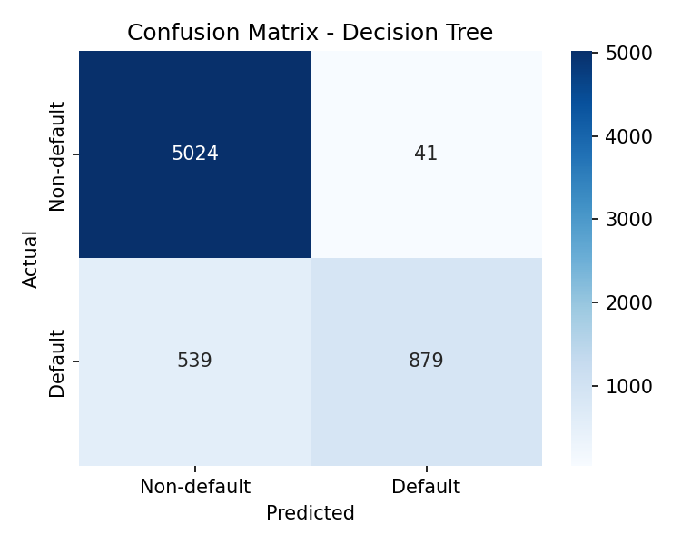
Figure 9: Confusion matrix of Decision Tree
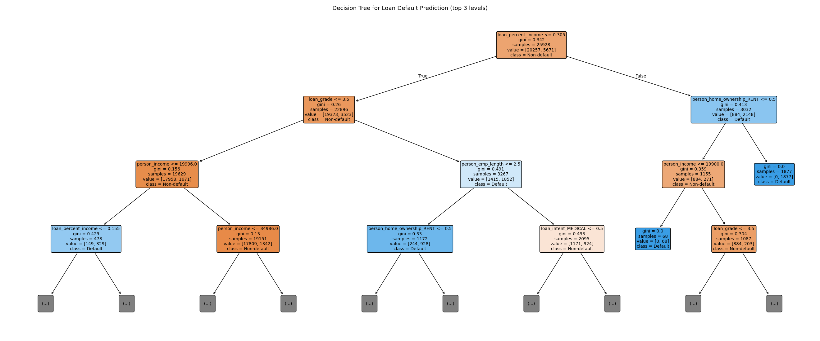
Figure 10: Decision Tree (top 3 levels)

4.5 Random Forest

4.5.1 Introduction
Random Forest is an ensemble model that combines many decision trees. It is usually more accurate and more stable than a single tree.

4.5.2 General Description
A Random Forest trains many decision trees, each on a different random sample of the training data and with a random subset of the features considered at every split. The final prediction is the majority vote of all trees. Averaging many different trees reduces the tendency of a single tree to overfit. In this project 100 trees were used. As the model is built from trees, it works on the unscaled data.

4.5.3 Specific Requirements, Functions and Formulas
The prediction is ŷ = majority_vote(T1(x), T2(x), …, T100(x)), where Ti is the i-th tree. The model was created with RandomForestClassifier(n_estimators=100, random_state=42) from scikit-learn. The feature_importances_ attribute gives the contribution of each feature to the splits.
from sklearn.ensemble import RandomForestClassifier

rf_model = RandomForestClassifier(n_estimators=100, random_state=42)
rf_model.fit(X_train, y_train)
rf_pred = rf_model.predict(X_test)
evaluate_model('Random Forest', rf_pred)

4.5.4 Analysis Results
On the test set of 6,483 loans, Random Forest achieved an accuracy of 93.40%, a precision of 96.79%, a recall of 72.21% and an F1-score of 0.8271 for the default class. It correctly identified 1024 defaults and 5,031 non-defaults, wrongly flagged 34 good loans as defaults and missed 394 real defaults. Random Forest gives the highest accuracy, precision, recall and F1-score of the five models, showing the benefit of combining many trees.
Table 11: Confusion matrix of Random Forest
 | Predicted Non-default | Predicted Default
Actual Non-default | 5031 | 34
Actual Default | 394 | 1024

4.5.5 Visualization
Figure 11 shows the confusion matrix of Random Forest and Figure 12 shows its feature importance. The most important features are loan_percent_income (0.2145), person_income (0.1548), loan_grade (0.1225) and loan_int_rate (0.1006). Feature importance shows how much a feature was used by the model and does not prove that the feature causes default.
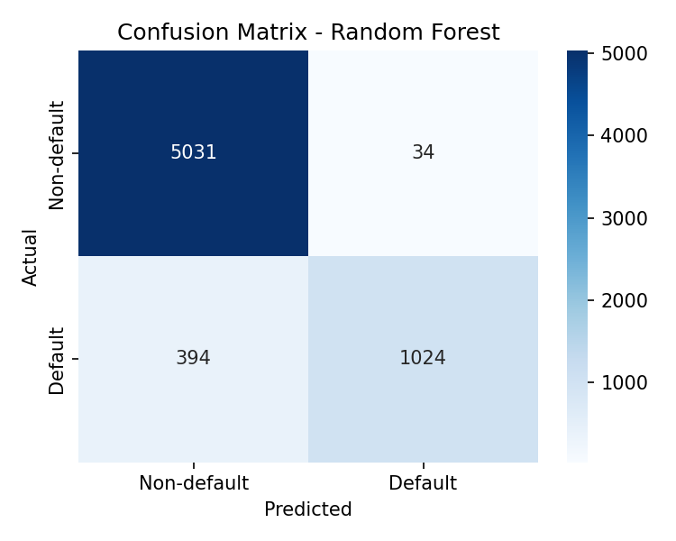
Figure 11: Confusion matrix of Random Forest
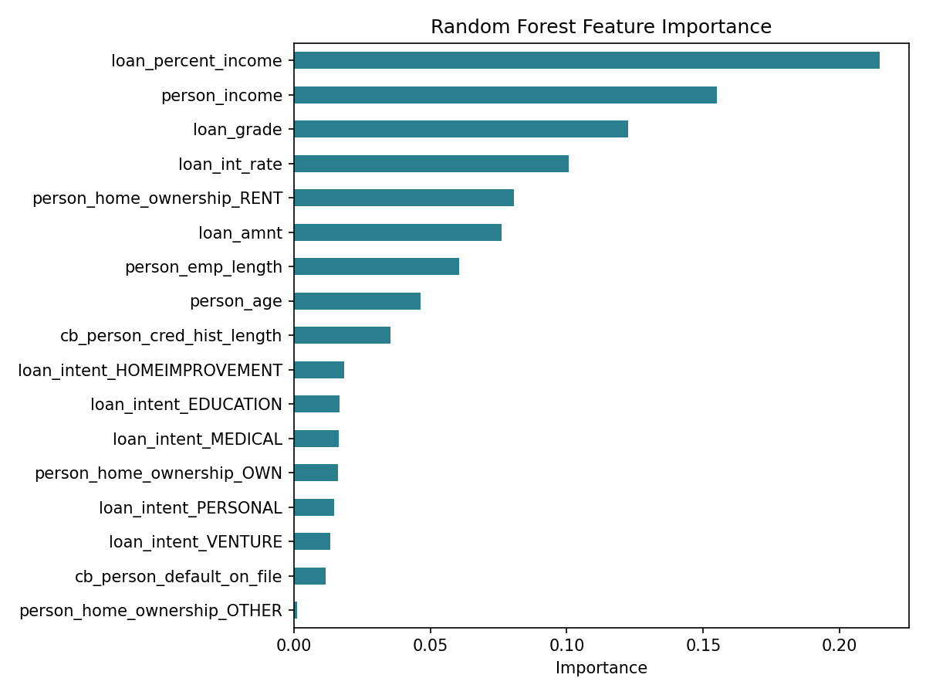
Figure 12: Feature importance of the Random Forest model

4.6 Model Comparison
All five models were judged on the same test set. F1-score was used as the primary selection criterion because it balances precision (avoiding false alarms) and recall (finding real defaults) and is not inflated by the large non-default class the way accuracy can be. Table 12 lists the results in descending order of F1-score.
Table 12: Comparison of the five classification models on the test set
Model | Accuracy | Precision | Recall | F1-score
Random Forest | 0.9340 | 0.9679 | 0.7221 | 0.8271
Decision Tree | 0.9105 | 0.9554 | 0.6199 | 0.7519
KNN | 0.8877 | 0.8499 | 0.5910 | 0.6972
Logistic Regression | 0.8550 | 0.7429 | 0.5155 | 0.6087
Gaussian Naive Bayes | 0.8225 | 0.6802 | 0.3554 | 0.4669

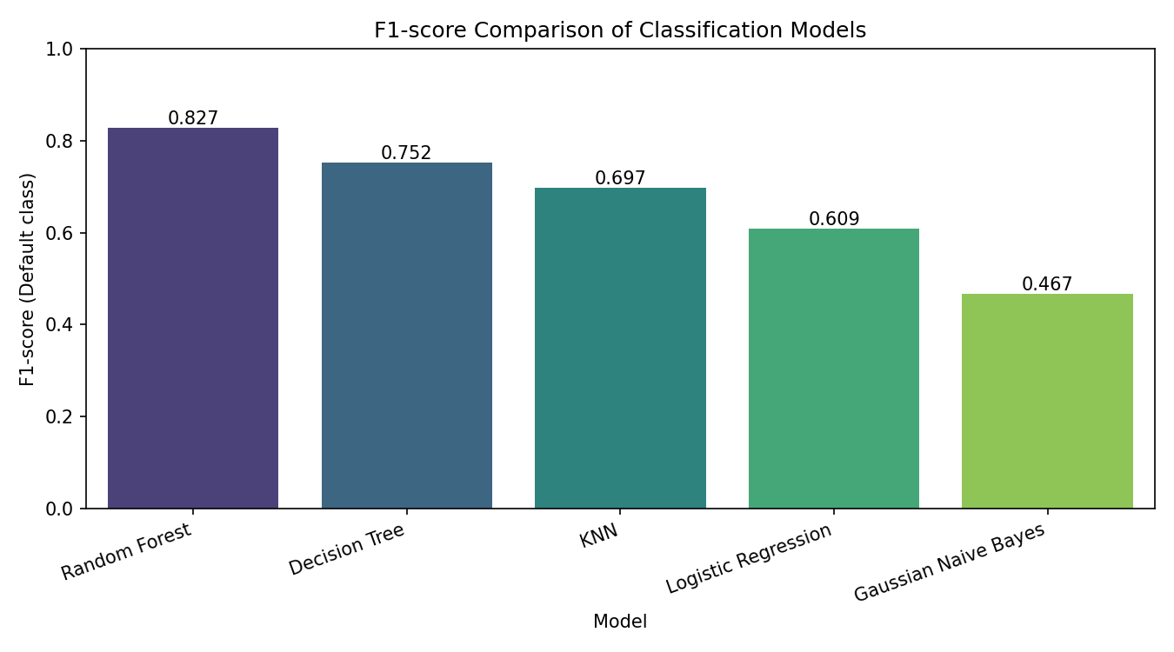
Figure 13: F1-score comparison of the classification models
The ranking by F1-score is Random Forest, Decision Tree, KNN, Logistic Regression, Gaussian Naive Bayes. The two tree-based models clearly outperform the other three on this dataset. A possible reason is that the relationship between the features and default is not linear: for example, the default rate jumps sharply between grades C and D and between low and high loan-to-income ratios, which trees can capture with simple threshold splits while Logistic Regression and Naive Bayes cannot.

4.7 Why Accuracy Alone Is Not Enough
The test set contains about 78% non-default loans, so a model that always predicts “non-default” would score an accuracy of 78.13% while finding no defaults at all. Gaussian Naive Bayes (82.2%) and Logistic Regression (85.5%) are only a few points above this baseline. This is why recall and F1-score for the default class are the most informative figures when comparing the models.

4.8 Best Model Analysis
Random Forest has the highest F1-score (0.8271) and also leads in accuracy, precision and recall, so the choice does not depend on which metric is used. Its confusion matrix on the test set of 6,483 loans is shown below.
Table 13: Confusion matrix of the selected model (Random Forest)
 | Predicted Non-default | Predicted Default
Actual Non-default | 5031 | 34
Actual Default | 394 | 1024

- Precision = 0.9679: when the model predicts default, it is correct about 97% of the time.
- Recall = 0.7221: it finds about 72% of the loans that actually defaulted.
- F1-score = 0.8271: a balance between the two.
Trade-off: the model rarely raises a false alarm (only 34 good loans were wrongly flagged) but it misses about 28% of the defaults (394 loans). A lender who cares more about catching defaults would prefer a higher recall, even at the cost of more false alarms, that is, rejecting some good borrowers. The results come from one dataset and one train-test split and should not be treated as reliable enough for real lending decisions without independent validation.

5. Conclusion
This project analysed a credit risk dataset of 32,581 loan records and evaluated five supervised classifiers for predicting the recorded default status of a loan. The main outcomes are summarised below.
- Data preparation: 165 duplicate rows and 5 records with impossible ages were removed and 2 impossible employment-length values were treated as missing. Missing values were filled with training-set medians after the split. Categorical variables were encoded (ordinal for loan_grade, one-hot for the others), the data was split 80/20 with stratification and StandardScaler was fitted on the training set only.
- EDA observations: About 22% of the loans are recorded as defaults. Default rates rise sharply with worse loan grades and defaulted loans have higher interest rates and a larger share of income. These are associations, not causes.
- Model comparison: Random Forest (F1 0.8271) ranked first, followed by Decision Tree (0.7519), KNN (0.6972), Logistic Regression (0.6087) and Gaussian Naive Bayes (0.4669).
- Selected model: Random Forest with accuracy 93.40%, precision 96.79% and recall 72.21%. It identifies most defaults with very few false alarms but still misses about 28% of them.

5.1 Recommendations
- Stricter checks for high-risk grades: applicants in loan grades D to G and those with a high loan-to-income ratio show the highest default rates and could require additional verification or collateral.
- Support for renters with high interest rates: borrowers who rent their home show a higher default rate (31.6% against 7.5% for owners), so structured repayment plans or lower loan limits could be considered for this group.

5.2 Limitations
- The results depend on this dataset, the particular train-test split, the preprocessing choices and the selected models.
- The data is imbalanced, and loan grade and interest rate are set by the lender, so they may already reflect the lender’s own risk assessment.
- About 10% of the interest rates were missing and were filled with the median, which may hide useful information.
- The patterns found are associations, not causes, and the test set was used once, without repeated validation.
- This is an educational prediction exercise, not a complete credit-decision system.

6. Future Scope
The project can be extended in several directions to make the predictions more reliable and more useful.
- Cross-validation and hyperparameter tuning: apply k-fold cross-validation for more stable results and tune model settings such as tree depth, number of trees and the value of k in KNN to improve recall for the default class.
- Handling class imbalance: use resampling techniques such as SMOTE or class weights to deal with the 78:22 imbalance more directly, and adjust the decision threshold to trade precision for recall.
- More models and metrics: try gradient boosting methods and add the ROC curve and AUC to the evaluation.
- Explainability: use feature importance and tools such as SHAP to explain individual predictions.
- Deployment: save the final model and deploy it as a simple web application for real-time loan screening.

7. References
- Credit Risk Dataset, Kaggle. https://www.kaggle.com/datasets/laotse/credit-risk-dataset
- Pedregosa, F. et al. (2011). Scikit-learn: Machine Learning in Python. Journal of Machine Learning Research, 12, 2825–2830.
- scikit-learn documentation. https://scikit-learn.org/stable/
- pandas documentation. https://pandas.pydata.org/docs/
- NumPy documentation. https://numpy.org/doc/
- Matplotlib documentation. https://matplotlib.org/stable/
- Seaborn documentation. https://seaborn.pydata.org/
- Breiman, L. (2001). Random Forests. Machine Learning, 45(1), 5–32.
- James, G., Witten, D., Hastie, T. and Tibshirani, R. An Introduction to Statistical Learning. Springer.

Appendix: Project Links and Screenshots
[Add here: project / notebook screenshot, GitHub repository link and screenshot, LinkedIn post link and screenshot, as required by the assignment.]

