Unit I: Network Layer Services, Mobile IP, VPNs & IPv6 Architecture
1. Network Layer Services & Core Functions
The Network Layer (Layer 3) provides the functional and procedural means of transferring variable-length data sequences from a source host to a destination host across one or more networks.
[ App / Transport Payload ]
│
▼
[ Encapsulation (L3 Header) ]
│
┌───────┴───────┐
│ │
▼ ▼
[ Logical ] [ Routing & ]
[ Address ] [ Forwarding]
Core Data Processing Pipeline:
- Application / Transport Payload ↓
- Layer 3 Encapsulation (Adding Source/Destination IP) ↓
- Logical Addressing & Path Selection ↓
- Data Plane Packet Forwarding
Core Responsibilities:
- Host-to-Host Delivery: Unlike Layer 2 (which handles hop-to-hop delivery between directly connected nodes) or Layer 4 (process-to-process), Layer 3 delivers packets end-to-end across heterogeneous intermediate networks.

- Encapsulation / Packetization: Wraps transport-layer segments (TCP/UDP) into Layer 3 packets (datagrams) by attaching IP headers containing logical source and destination addresses.

- Logical Addressing: Provides a universal, software-based global identification system (IPv4/IPv6) independent of underlying physical hardware addresses (MAC).

- Routing and Forwarding:

  - Routing: Dynamically determines the best path across the global network topology (Control Plane).

  - Forwarding: Moves packets from an incoming router interface to an outgoing interface based on local table matches (Data Plane).

2. Mobile IP Architecture
Mobile IP (RFC 3344 / RFC 6275) allows a mobile node (e.g., a smartphone or laptop mounted on a moving vehicle) to change its point of attachment to the Internet without dropping its active TCP connections or changing its primary IP address.

A. Key Components & Agents
- 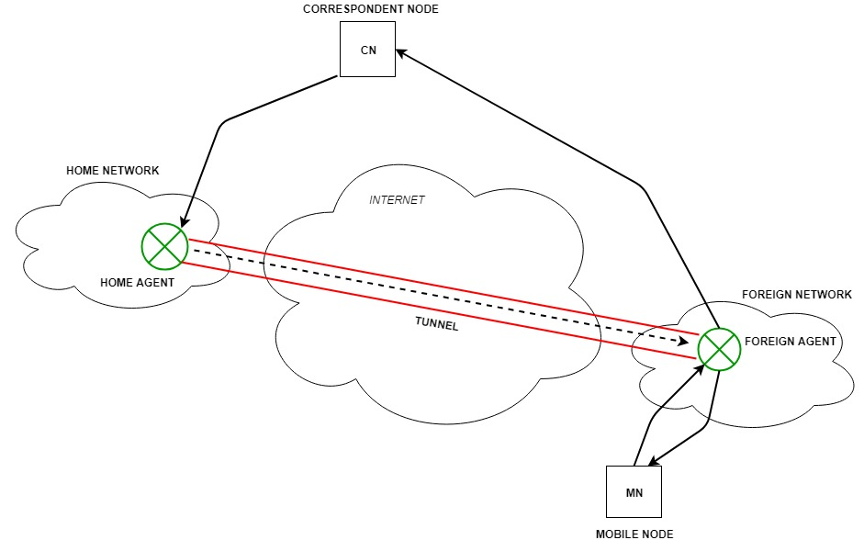Mobile Node (MN): The host device that changes its network access point from one network/subnet to another.

- Home Address (HoA): A permanent IP address assigned to the MN on its home network. It remains unchanged regardless of where the device moves.

- Home Agent (HA): A router on the MN's home network that maintains location tracking info and tunnels packets addressed to the MN when it is away from home.

- Foreign Agent (FA): A router on the visiting (foreign) network that assists the MN in registering its temporary location and decapsulates traffic forwarded by the HA.

- Care-of Address (CoA): A temporary IP address assigned to the MN while connected to a foreign network. It reflects the MN's current physical location:

  - FA-Colocated CoA: An IP address belonging directly to the Foreign Agent router.

  - Co-located CoA: A temporary IP acquired directly by the MN via DHCP/SLAAC on the visiting network.

B. Mobile IP Registration & Packet Forwarding Workflow
- Agent Discovery: The MN receives periodic Agent Advertisements (ICMP-based) from local routers to detect whether it is on its home network or a foreign network.

- Registration: When the MN detects it has moved to a foreign network, it obtains a CoA and sends a Registration Request to the Foreign Agent, which forwards it to the Home Agent. The HA updates its mobility bindings.

- Tunneling & Encapsulation: When a Correspondent Node (CN) sends a packet to the MN's Home Address:

  - The packet routes naturally to the Home Network.

  - The Home Agent intercepts the packet, encapsulates it inside a new IP header targeted at the Care-of Address (CoA) (IP-in-IP Encapsulation), and tunnels it over the Internet.

  - The Foreign Agent decapsulates the packet and delivers the original payload to the MN.

C. Inefficiency in Mobile IP: Triangular Routing
Standard Mobile IP suffers from Triangular Routing, an inefficient path trajectory where packets sent from a Correspondent Node (CN) must travel to the Home Agent first, before being tunneled to the Mobile Node's actual location.

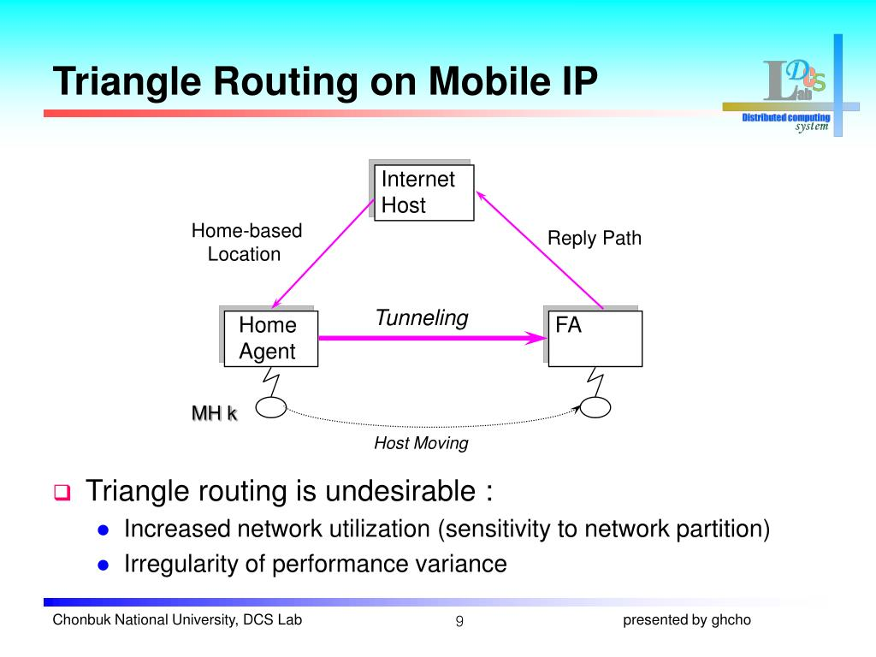The Problem: Even if the CN and MN are physically located in the same room on a foreign network, traffic must travel halfway across the world to the HA and back, introducing severe latency and bandwidth waste.

- Solution (Route Optimization): Allows the CN to learn the MN's Care-of Address directly. Once notified via a binding update, the CN can bypass the Home Agent and tunnel packets directly to the MN's CoA.

3. Virtual Private Network (VPN) Technology
A Virtual Private Network (VPN) extends a private network across a public network (such as the Internet) by creating secure, encrypted point-to-point connections called Tunnels.
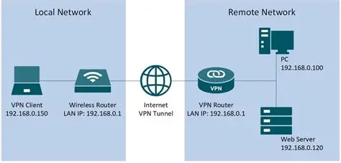
[ HOME NETWORK ]
├── Mobile Node (MN) [HoA]
└── Home Agent (HA)
│
(Internet)
│
▼
[ FOREIGN NETWORK ]
├── Foreign Agent (FA)
└── Mobile Node (MN) [CoA]
A. Core Security Objectives
- Confidentiality: Encryption algorithms (AES, 3DES) protect packet payloads from eavesdropping.
- Integrity: Hashing mechanisms (SHA-256) ensure data is not modified in transit.
- Authentication: Verifies the identity of endpoints using digital certificates, pre-shared keys (PSK), or RSA key pairs.
- Anti-Replay: Uses packet sequence numbers to prevent attackers from re-transmitting captured packets.

B. Key VPN Technologies & Protocols
1. IPsec (Internet Protocol Security)
Operates at Layer 3 (Network Layer), protecting all protocols and applications running above it. IPsec consists of two primary protocol headers and two operational modes:

Protocol Headers:
- Authentication Header (AH): Provides data integrity, authentication, and anti-replay protection. Does not provide encryption/confidentiality.

- Encapsulating Security Payload (ESP): Provides data encryption/confidentiality, integrity, authentication, and anti-replay protection.

Operational Modes:
- Transport Mode: Encrypts only the IP packet payload (e.g., TCP segment). The original IP header remains unencrypted. Used primarily for end-to-end host-to-host communications.

- Tunnel Mode: Encrypts the entire original IP packet (Header + Payload) and prepends a brand new outer IP header. Used for Gateway-to-Gateway (Site-to-Site) VPNs.

Original IPv4 Packet:
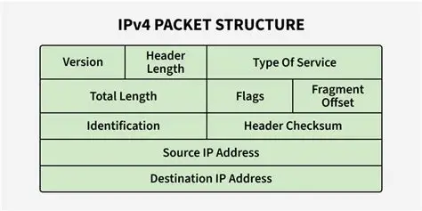
2. SSL/TLS VPN
Operates at Layer 4/7 (Transport/Application Layer). Uses standard Web browser cryptography (TLS/HTTPS). Commonly used for Remote Access VPNs (e.g., OpenVPN, Cisco AnyConnect) because it traverses NAT devices and firewalls easily without requiring client software installation for basic web apps.

3. GRE (Generic Routing Encapsulation)
A Layer-3 tunneling protocol that encapsulates a wide variety of network-layer protocols inside standard IP tunnels. GRE by itself provides zero encryption/security; it is paired with IPsec (GRE over IPsec) to securely transmit multicast routing traffic across a public IP network.

4. IPv6 Addressing Architecture
IPv6 was developed to overcome IPv4 address exhaustion ($2^{32}≈4.3×{10}^{9}$ addresses) by expanding to a 128-bit address space ($2^{128}≈3.4×{10}^{38}$ addresses).

A. Representation & Notation
An IPv6 address is 128 bits long, divided into eight 16-bit blocks (hextets) written in hexadecimal and separated by colons:

$$\text{Full Format: }2001:0db8:0000:0000:0000:0000:1234:5678$$
Compression Rules:
- Omit Leading Zeros: Leading zeros within a hextet can be omitted (0db8 $→$ db8, 0000 $→$ 0).

- Double Colon (::) Substitution: A single contiguous sequence of all-zero hextets can be replaced by a double colon (::). This substitution can only be performed ONCE per address to prevent ambiguity.

$$\text{Compressed Format: }2001:db8::1234:5678$$
B. Technical Comparison: IPv4 vs. IPv6
Feature | IPv4 | IPv6
Address Length | 32 bits ($2^{32}≈4.3×{10}^{9}$) | 128 bits ($2^{128}≈3.4×{10}^{38}$)
Representation | Dotted-decimal (e.g., 192.168.1.1) | Hexadecimal with colons (e.g., 2001:db8::1)
Address Types | Unicast, Multicast, Broadcast | Unicast, Multicast, Anycast (Broadcast eliminated)
Header Size | Variable (20–60 bytes) | Fixed base header (40 bytes) + Extension Headers
Layer-3 Checksum | Included (Recalculated at every hop) | Removed (Delegated to Layer 2 and Layer 4)
Configuration | Static or Stateful DHCP | Static, SLAAC, Stateless DHCPv6, Stateful DHCPv6
IPsec Support | Optional add-on feature | Natively integrated into architecture specifications
C. Unicast Scopes & Allocations
- Global Unicast Address (GUA - 2000::/3): Globally unique and routable on the public Internet (equivalent to IPv4 public addresses).

- Link-Local Address (LLA - fe80::/10 or /64): Mandatory non-routable address automatically generated on every IPv6 interface. Used strictly for single-link local communication, NDP, and default gateway routing.

- Unique Local Address (ULA - fc00::/7): Non-routable on the public Internet (equivalent to IPv4 RFC 1918 private addresses). Used for internal enterprise networks.

- Loopback Address (::1/128): Refers to the local host interface (equivalent to 127.0.0.1).

- Unspecified Address (::/128): All zeros address used as a placeholder source IP before a host obtains its real IP.

D. Administrative Governance & Hierarchical Allocation
IPv6 address distribution follows a strict top-down administrative hierarchy to keep global internet routing tables clean and aggregated:

- /48 Site Prefix: Standard allocation block handed by an ISP to an enterprise site, giving the customer $16\text{ bits}$ of Subnet ID space to create up to $65,536$ subnets.

- /64 Subnet Boundary: Every individual IPv6 LAN subnet is standardized strictly at a /64 prefix length. Subnetting smaller than /64 breaks core autoconfiguration mechanisms like SLAAC.

5. IPv6 Neighbor Discovery Protocol (NDP) & ICMPv6
NDP (RFC 4861) replaces IPv4 ARP, ICMPv4 Router Discovery, and Redirect mechanisms. It is built inside ICMPv6 (IP Protocol 58).

A. ICMPv6 Inclusion & Venn Structure
NDP is a specialized subset of ICMPv6 operating exclusively on local link scopes.

+-----------------------------------------------------------------------------------+
| ICMPv6 |
| (Protocol Type 58 - Layer 3) |
| |
| Broad Control/Error Functions: Ping (128/129), Packet Too Big (2) |
| |
| +------------------------------------------------------+ |
| | NDP (Neighbor Discovery Protocol) |
| | (ICMPv6 Types 133–137) |
| | |
| | • Type 133: Router Solicitation (RS) |
| | • Type 134: Router Advertisement (RA) |
| | • Type 135: Neighbor Solicitation (NS) |
| | • Type 136: Neighbor Advertisement (NA) |
| | • Type 137: Redirect |
| +------------------------------------------------------+ |
+------------------------------------------------------------------------------------+
- Hop Limit Guardrail: All NDP messages must be transmitted with an IPv6 Hop Limit = 255. If a host receives an NDP packet with a Hop Limit less than 255, it discards it immediately to prevent off-link spoofing attacks.

B. Core NDP Message Types
- Type 133 - Router Solicitation (RS): Host sends to ff02::2 (All-Routers Multicast) asking active routers to advertise their presence immediately.

- Type 134 - Router Advertisement (RA): Router sends to ff02::1 (All-Nodes Multicast) or unicast, announcing network prefixes, hop limits, MTU, and flag signals (A, M, O flags).

- Type 135 - Neighbor Solicitation (NS): Host sends to resolve a neighbor's MAC address or perform Duplicate Address Detection (DAD).

- Type 136 - Neighbor Advertisement (NA): Host responds to an NS message, delivering its physical MAC address.

- Type 137 - Redirect: Routers inform a host of a better first-hop router for a specific destination.

6. Host Address Assignment Methods & SLAAC
A. Summary of Assignment Pathways
Feature | Static Assignment | Pure SLAAC | Stateless DHCPv6 | Stateful DHCPv6
Address Generation | Manual Entry | Host Self-generates | Host Self-generates | Server Assigns
RA Flag Signal | N/A | A=1, M=0, O=0 | A=1, M=0, O=1 | A=0, M=1
Server State Kept? | Manual Record | None (Stateless) | None (Stateless) | Yes (Stateful Ledger)
DNS Options Source | Manual Entry | RA Option (RFC 8106) | DHCPv6 Server | DHCPv6 Server
B. SLAAC Execution Sequence
• Host boots & generates tentative Link-Local Address (fe80:: + Interface ID) ↓
• Perform Duplicate Address Detection (DAD) via NS Type 135 ↓
• Send Router Solicitation (RS Type 133) ↓
• Receive Router Advertisement (RA Type 134) containing /64 Prefix ↓
• Combine 64-bit RA Prefix + 64-bit Interface ID to assemble Global IP

- Generate Link-Local Address: Device creates its tentative LLA (fe80:: + Interface ID).

- Duplicate Address Detection (DAD): Device sends ICMPv6 Type 135 (NS) to check if any other node owns that tentative LLA. If no reply (NA) is received, the address is validated.

- Router Solicitation: Device transmits an RS message asking for router information.

- Router Advertisement: Local router returns an RA message containing the /64 network prefix (e.g., 2001:db8:abc:1::/64) and sets flag A=1.

- Form Global Unicast Address: The device combines the 64-bit RA Prefix with its 64-bit Interface ID to assemble a full 128-bit Global Unicast Address.

C. Modified EUI-64 Interface ID Worked Example
Modified EUI-64 transforms a 48-bit physical MAC address into a 64-bit Interface ID.

Input MAC Address:
$$\text{MAC}=\text{7007.1234.5678} \left(\text{Hexadecimal: }70:07:12:34:56:78\right)$$
Step 1: Insert 0xFFFE in the Middle
$$\text{7007:12} FF:FE \text{34:5678}$$
Step 2: Invert the 7th Bit (Universal/Local Bit)
Isolate the first byte (${70}_{16}$) and convert to binary:

$${70}_{16}=0111 {0000}_{2}$$
Invert the 7th bit (2nd least-significant bit of the first byte):

$$0111 0000_{2}⟶0111 0010_{2}={72}_{16}$$
Final Assembled Link-Local Address (LLA):
$$FE80::7207:12FF:FE34:5678/64$$
7. IPv6 Packet Structure & Extension Headers
A. Base Header Format (Fixed 40 Bytes)
IPv6 replaces the variable IPv4 header with a streamlined, fixed 40-byte base header to optimize hardware processing speed at core routers:

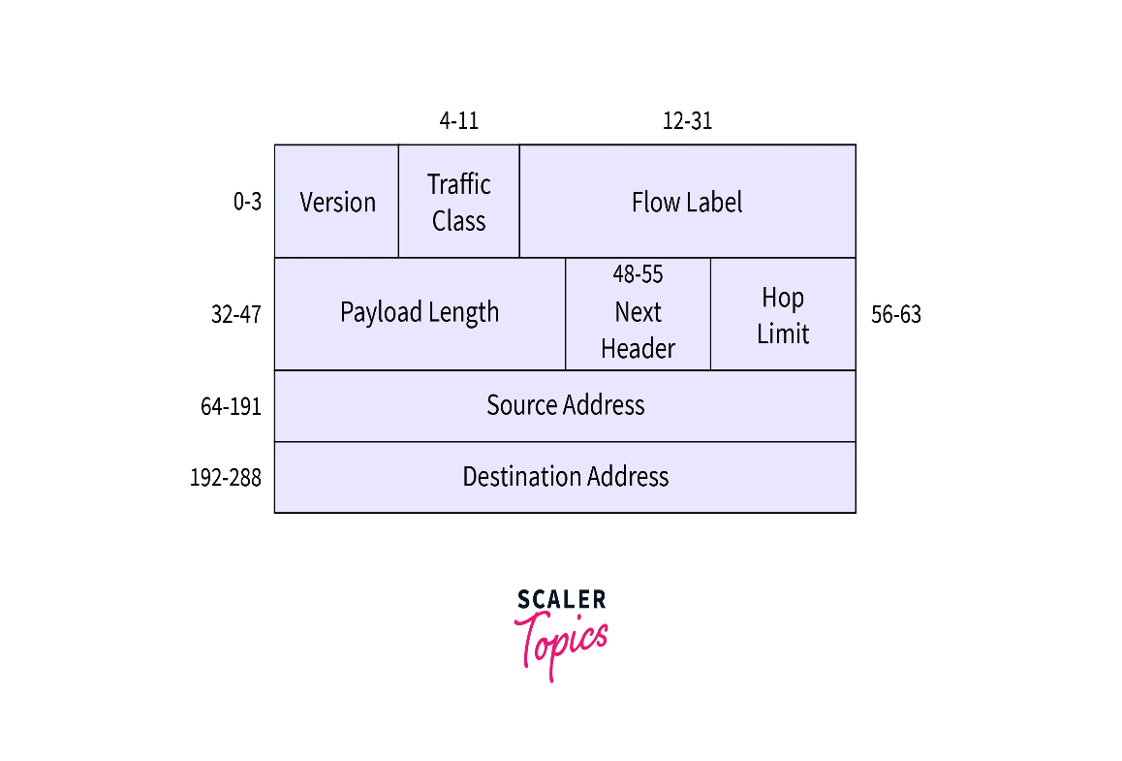

Fields in the IPv6 Datagram
1. Version
This is a 4-bit field that identifies the IP version. For IPv6, this field always has the value 6. It tells the network that the datagram should be processed according to IPv6 rules.
2. Traffic Class
This 8-bit field is similar to the Type of Service (TOS) field in IPv4. It helps prioritize packets. For example, voice or video packets might get higher priority over email packets to ensure smooth real-time communication.
3. Flow Label
This is a 20-bit field used to identify a specific flow of packets. A “flow” means a stream of related packets that require special handling, like a video call or a live audio stream.
Routers can recognize these flows and treat them differently from regular traffic, possibly providing better speed or quality for those packets.
4. Payload Length
This 16-bit field tells how many bytes of data are in the payload (that is, everything after the 40-byte header). It helps routers and devices know the size of the data being carried.
5. Next Header
This field identifies the protocol that handles the next portion of data. For example, it might indicate TCP, UDP, or even an IPv6 extension header. It works just like the “Protocol” field in IPv4.
6. Hop Limit
Every time a packet passes through a router, the hop limit decreases by one. If it reaches zero, the router discards the packet. This prevents data from looping endlessly in the network.
It is similar to the Time-to-Live (TTL) field in IPv4.
7. Source and Destination Addresses
These are the 128-bit IP addresses of the sender and the receiver. The large size allows for a massive number of unique addresses. IPv6 supports unicast, multicast, and anycast addressing:
Unicast: One-to-one communication between devices.
Multicast: One-to-many communication (for example, streaming video to multiple users).
Anycast: One-to-nearest communication — the packet goes to the nearest of several possible destinations.
8. Data (Payload)
This is the actual information being carried — such as a web page, email, or video data. When the datagram arrives at its destination, the payload is handed over to the correct protocol (like TCP or UDP) for further processing.

B. Extension Headers (Daisy Chaining Mechanism)
Optional IPv6 parameters are chained as separate Extension Headers (EH) inserted between the base header and the transport payload:

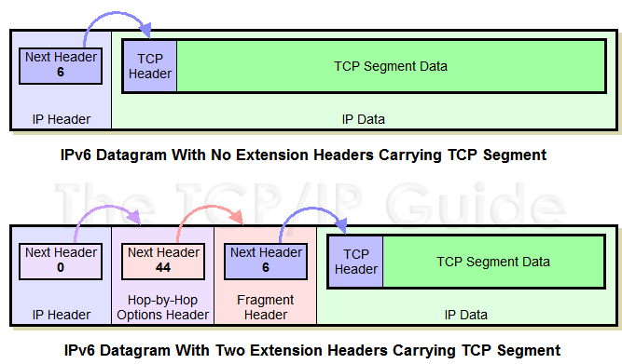
- Daisy Chaining: Each header contains a Next Header field pointing sequentially to the next header in the chain until reaching the final transport protocol payload (TCP = 6, UDP = 17, ICMPv6 = 58).

- Processing Efficiency: Intermediate core routers inspect only the fixed Base Header and ignore extension headers not meant for them (such as Destination Options or ESP), significantly speeding up forwarding throughput.

8. IPv6 Transition Mechanisms
Because the global Internet cannot switch from IPv4 to IPv6 overnight, three migration strategies are deployed:
1. Dual Stack
- Concept: Network interfaces and operating systems run both IPv4 and IPv6 protocol stacks concurrently.

- Operation: Devices use DNS to decide which stack to use: if an AAAA record is returned, the host prefers IPv6; if only an A record is available, it falls back to IPv4.

2. Tunneling (Encapsulation)
- Concept: Encapsulates IPv6 packets inside standard IPv4 headers so they can travel across legacy IPv4-only intermediate networks.

- Key Implementations:

  - Configured Tunnels (6in4): Manual point-to-point tunnels configured between two static edge routers.

  - 6to4 (RFC 3056): Automatic tunneling system using the special prefix 2002::/16 to dynamically derive IPv4 endpoints.

  - ISATAP (Intra-Site Automatic Tunnel Addressing Protocol): Transmits IPv6 traffic across an enterprise internal IPv4 network.

3. Translation (NAT64 / DNS64)
- Concept: Translates packet headers directly between IPv6-only networks and IPv4-only networks.

- Operation:

  - NAT64: Converts IPv6 header fields into IPv4 headers (and vice versa) at the network border router.

  - DNS64: Synthesizes fake IPv6 AAAA records from standard IPv4 A records so IPv6-only devices can initiate connections to IPv4-only servers.

