Unit 2

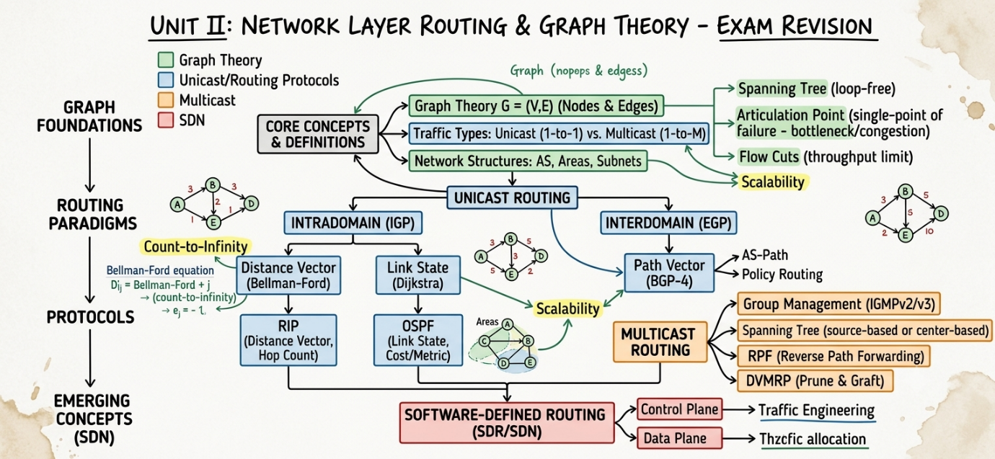

1. Routing Fundamentals & Terminology
- Unicast Communication: One-to-one communication between a single sender node and a single receiver node.
- Cost / Metric: A numerical value assigned to pass through a network link, calculated using parameters like hop count, delay, bandwidth, or link cost.
- Static vs. Dynamic Routing Tables:
  - Static: Routing table entries configured manually by network administrators.
  - Dynamic: Routing entries updated automatically via protocol updates whenever network changes occur.
- Autonomous System (AS): A collection of connected IP networks and routers managed under a single administrative authority with a defined routing policy.
- Intradomain vs. Interdomain Routing:
  - Intradomain (Interior Gateway Protocols - IGP): Routing within a single Autonomous System (e.g., RIP, OSPF). Priorities are minimal path cost and fast convergence.
  - Interdomain (Exterior Gateway Protocols - EGP): Routing between different Autonomous Systems across the internet (e.g., BGP). Priorities are administrative policy enforcement, loop prevention, and high scalability.

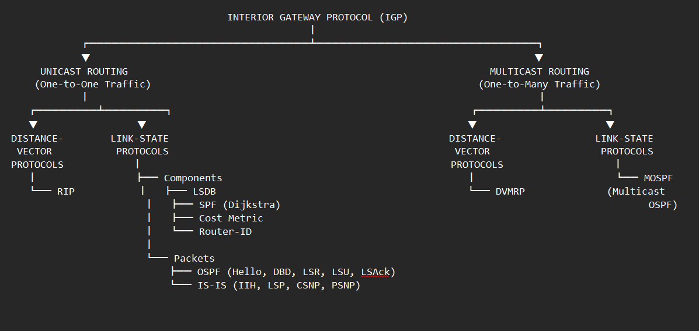

Link-State Routing:
[Link-State Routing] ──► The Algorithmic Concept / Paradigm
│
▼
[OSPF] ──► Unicast Implementation (One-to-One)
│
▼
[MOSPF] ──► Multicast Extension (One-to-Many)
1. Link-State Routing (The Theoretical Foundation)
Link-State Routing is a routing paradigm (or class of algorithms) where every router in a network acquires a complete, global view of the entire network topology before calculating paths.
- Topology Mapping: Every router collects state information about its directly attached links (status, cost, bandwidth) and packages it into a Link-State Packet (LSP).
- Flooding: Routers flood these LSPs throughout the entire network so every router receives identical topological data.
- Database & Path Computation: Routers aggregate these LSPs into a global topology database and independently execute Dijkstra’s Shortest Path Algorithm to construct a shortest-path tree rooted at themselves.
2. OSPF — Open Shortest Path First (The Unicast Implementation)
OSPF is a specific unicast routing protocol built directly on top of the Link-State Routing paradigm for interior gateway routing (within an Autonomous System).
- LSDB (Link-State Database): Implements the global topology map concept by flooding Link-State Advertisements (LSAs) to maintain a synchronized LSDB across all routers.
- Unicast Routing: Calculates the optimal, loop-free shortest path from a single source router to every possible individual destination network address.
- Hierarchical Areas: Extends basic Link-State theory to large enterprise networks by dividing the network into Areas (with Area 0 as the backbone) to restrict LSA flooding scope and optimize router CPU/memory usage.
Core Components of an IGP
Every Interior Gateway Protocol (IGP) consists of four core operational components running inside the router:
- Data Structures (Databases):
  - Neighbor/Adjacency Table: Tracks the status, IP addresses, and operational states of directly connected adjacent routers running the same protocol.
  - Topology Database: Stores raw network information (such as the Link-State Database / LSDB in OSPF/IS-IS) or full distance lists prior to path filtering.
  - Routing Table (Forwarding Table): Contains only the best, optimal paths chosen by the algorithm for active packet forwarding.
- Protocol Messages & Packet Engine:
  - Handles the creation, transmission, and parsing of control packets used for neighbor discovery, topology synchronization, route updates, and delivery acknowledgments.
- Algorithmic Engine:
  - Executes pathfinding calculations over the topology database to compute loop-free shortest paths (e.g., Dijkstra's algorithm in Link-State protocols, Bellman-Ford in Distance-Vector protocols).
- Timers & State Machines:
  - Enforces state transitions (e.g., OSPF Neighbor States: $\text{Down}→\text{Init}→\text{2-Way}→\text{ExStart}→\text{Exchange}→\text{Loading}→\text{Full}$) and governs periodic actions via Hello, Dead, Expiration, and Garbage Collection timers.
A Router ID (RID) is a unique 32-bit number—formatted like an IPv4 address (e.g., 1.1.1.1)—used to uniquely identify a router within an Interior Gateway Protocol (IGP) domain.
Core Purposes of a Router ID
- Graph Node Identifier: In link-state protocols (OSPF, IS-IS), the Router ID acts as the unique vertex name in the mathematical graph $G=\left(V,E\right)$ when running Dijkstra's algorithm.
- LSDB Ownership: Links every Link-State Advertisement (LSA) to the specific router that generated it inside the Link-State Database (LSDB).
- DR/BDR Tie-Breaker: In multi-access broadcast networks (like Ethernet), if all routers have equal priority, the router with the highest Router ID is elected as the Designated Router (DR).
- Adjacency Formation: Used in Hello packets to establish, verify, and maintain peer relationships with adjacent routers
Types of IGP Packets
Control packets allow IGPs to discover peers, synchronize databases, and update route changes across an Autonomous System.
1. OSPF Packet Types (Link-State)
- Type 1: Hello Packet
  - Purpose: Discovers neighbours, establishes adjacencies, elects Designated Routers (DR) and Backup Designated Routers (BDR) on multi-access networks, and serves as a periodic keepalive.
- Type 2: Database Description (DBD / DDP)
  - Purpose: Exchanged during initial database sync; contains summary headers of the router's LSDB so neighbours can check for missing or outdated LSAs.
- Type 3: Link-State Request (LSR)
  - Purpose: Sent by a router to request detailed, updated LSA records after discovering missing entries in a received DBD.
- Type 4: Link-State Update (LSU)
  - Purpose: Carries full, detailed LSAs to update neighbouring databases. Used during database initialization and for immediate, triggered flooding when topology changes occur.
- Type 5: Link-State Acknowledgment (LSAck)
  - Purpose: Explicitly acknowledges the receipt of LSU packets to guarantee reliable transfer over the network.
2. RIP Packet Types (Distance-Vector)
- Request Message (Command 1): Broadcasted/multicast by a newly booted or reset router to solicit routing updates from adjacent neighbours.
- Response Message (Command 2): Carries destination-metric vectors. Sent either periodically (every 30 seconds) or immediately as a triggered update/solicited reply.
3. IS-IS Packet Types (Layer 2 PDUs)
- IS-IS Hello PDU (IIH): Used to establish and maintain link-layer adjacencies with neighbouring routers.
- Link State PDU (LSP): Contains state, interface, and metric information; equivalent to an OSPF LSA/LSU combined.
- Complete Sequence Number PDU (CSNP): Contains a list of all LSPs in the sender's database to maintain synchronization across the area (equivalent to an OSPF DBD).
- Partial Sequence Number PDU (PSNP): Used to request missing LSPs or acknowledge received LSPs (combines the roles of OSPF LSR and LSAck).

3. MOSPF — Multicast OSPF (The Multicast Extension)
MOSPF is an extension of OSPF designed to handle multicast traffic (delivering data from one sender to multiple interested receivers simultaneously).
- Group-Membership LSAs: Enhances standard OSPF by introducing specialized LSAs (Type 6 LSAs) that carry multicast group membership information learned via IGMP from local hosts.
- Source-Based Multicast Trees: Because multicast target receivers change dynamically, MOSPF routers use the existing OSPF LSDB combined with group membership LSAs to calculate a dynamic source-rooted shortest-path tree on demand whenever a multicast packet arrives.
- Traffic Forwarding: Ensures multicast data travels only along active branches that lead directly to group members, eliminating redundant traffic replication across the network.

Components and packets:
1. Core IGP Components (Link-State Foundations)
- Link-State Database (LSDB): A organized table stored on every link-state router containing topological information of the entire network area. All routers in the same area maintain identical LSDBs.
- SPF (Shortest Path First): Dijkstra's algorithm executed on the LSDB to compute the shortest, loop-free path tree to every destination network, placing the local router at the root.
- Cost Metric: The routing metric used by OSPF to evaluate paths. Calculated as $\text{Cost}=\frac{\text{Reference Bandwidth}}{\text{Interface Bandwidth}}$ (Default Reference Bandwidth = 100 Mbps). Lower cost indicates a preferred route.
- Router-ID (RID): A 32-bit unique IP address (e.g., 1.1.1.1) assigned to identify each router uniquely within an OSPF/IGP domain. Selected via explicit configuration, highest loopback IP, or highest active interface IP.
2. Packet Classification & Functional Breakdown
OSPF Packets
- OSPF Packet Header: Common 24-byte header attached to all OSPF packets containing Version, Packet Type, Packet Length, Router ID, Area ID, Checksum, Authentication Type, and Authentication Data.
- Hello (Type 1): Discovers, establishes, and maintains neighbor adjacencies. Used for electing Designated Routers (DR) and Backup Designated Routers (BDR) on multi-access networks.
- DBD / DDP (Database Description - Type 2): Contains summary headers of the LSDB to check database synchronization between neighbors during initial adjacency setup.
- LSR (Link-State Request - Type 3): Sent by a router to request detailed information about specific Link-State Advertisements (LSAs) missing from its LSDB.
- LSU (Link-State Update - Type 4): Carries the actual detailed LSAs to update adjacent routers' databases.
- LSAck (Link-State Acknowledgment - Type 5): Explicitly acknowledges receipt of LSU packets to ensure reliable transmission.
IS-IS Packets (Intermediate System to Intermediate System)
- IIH (IS-IS Hello): Used to establish and maintain adjacencies between neighboring IS-IS systems.
- LSP (Link State PDU): Equivalent to OSPF's LSU; carries actual link-state topology information across the domain.
- CSNP (Complete Sequence Number PDU): Equivalent to OSPF's DBD; contains a complete summary list of all LSPs in the LSDB for periodic synchronization.
- PSNP (Partial Sequence Number PDU): Equivalent to OSPF's LSR and LSAck; requests missing LSPs or acknowledges received LSPs.

✨ Path Vector Routing (Concept)
Think of it as “GPS with the full route listed” instead of just distance.
- Definition: A routing algorithm where routers exchange entire paths (sequence of Autonomous Systems, ASes) to reach a destination, not just distances or costs.
- How it works:
  - Each router advertises the complete path it knows to a destination.
  - Other routers use this path info to avoid loops and apply policies.
  - Paths are updated when network changes occur.
- Key Features:
  - Prevents routing loops (since the full path is visible).
  - Allows policy-based routing (choose routes based on business/administrative rules, not just shortest path).
  - Used for inter-domain routing (between different organizations/ISPs).
- Easy Memory Trick: Distance Vector = “How far” Link State = “Map of the network” Path Vector = “Full travel itinerary (list of stops)”

🌍 Border Gateway Protocol (BGP-4)
This is the real-world implementation of Path Vector Routing.
- Definition: BGP-4 (Border Gateway Protocol version 4) is the standard inter-domain routing protocol of the Internet, based on Path Vector.
- Role: Connects different Autonomous Systems (ASes) — basically, it’s the protocol that makes the Internet of ISPs work.
- How it works:
  - Routers exchange AS-paths (the list of AS numbers to reach a destination).
  - Each router applies routing policies (e.g., prefer customer routes over peer routes).
  - Ensures loop-free routing by checking if its own AS number appears in the path.
- Key Features:
  - Supports CIDR (Classless Inter-Domain Routing) → efficient IP aggregation.
  - Handles policy-based routing → ISPs can control traffic flow.
  - Scales to the entire Internet (hundreds of thousands of routes).
- Easy Memory Trick: BGP = “Internet’s Post Office” → It decides which ISP hands the packet to which next ISP, using the path vector list.

Components of Path Vector Routing
Think of it as a system with three main parts:
- Autonomous Systems (ASes):
  - Large networks (like ISPs or organizations).
  - Each AS has a unique number (ASN).
- Routers (BGP speakers):
  - Exchange routing information between ASes.
  - Maintain a routing table with paths (AS sequences).
- Path Vector Mechanism:
  - Instead of just distance, routers store the entire path (list of ASNs) to reach a destination.
  - Helps detect loops and enforce policies.
👉 Easy memory hook: AS → Routers → Path list (like “Stops on a train route”).

🔹 Packets in Path Vector Routing
The protocol that uses Path Vector (BGP-4) sends special routing update packets:
- OPEN Packet
  - Establishes a connection between two BGP routers.
  - Contains ASN, BGP version, and identifiers.
- UPDATE Packet
  - The most important one.
  - Carries path information (AS-PATH) and network prefixes.
  - Used to advertise new routes or withdraw old ones.
- KEEPALIVE Packet
  - Sent periodically to confirm the connection is still alive.
  - Prevents timeouts.
- NOTIFICATION Packet
  - Sent when there’s an error (e.g., invalid update, connection issue).
  - Terminates the session.
