YuvaIntern — Junior Software Developer Intern
WEEK 3 FEATURE DEVELOPMENT
AND CODE PROTOTYPE DOCUMENTATION
Student Task & Study Management System (STSMS)

Document Item | Details
Internship Role | Junior Software Developer Intern
Internship Program | YuvaIntern / NSDC
Task | Week 3 — Feature Development and Code Prototype Documentation
Selected Feature | Task Creation and Management (CRUD + Status Workflow)
Project Type | Hypothetical Web-Based Student Productivity Application
Prepared By | Aniket
Date | 20 August 2026
Document Version | 1.0 — Submission Version
Status | Prototype Design / Pre-Implementation

This document describes the intended implementation logic and prototype workflow. It is a technical design artifact, not a claim that the complete production system has been implemented.

Executive Summary
The Student Task & Study Management System (STSMS) is a proposed web application for organizing academic tasks, assignments, subjects, deadlines, priorities and progress. The Week 1 planning document identified task creation, editing, deletion, deadline tracking and status management as core requirements. The Week 2 design document translated these requirements into a three-tier architecture using HTML/CSS/JavaScript for the front end, Node.js and Express.js for the REST API, and MongoDB for persistent storage.
For Week 3, the selected prototype feature is Task Creation and Management. This feature is central to the system because the dashboard, filtering, deadline tracking and progress views depend on correctly stored task records. The prototype covers create, read, update, delete and status-change workflows; validation; authentication and ownership checks; error handling; data structures; API contracts; performance considerations; and testing scenarios.
The implementation is intentionally modular. The browser is responsible for user interaction and basic validation, the API layer performs authentication and business validation, and MongoDB handles persistent task records. This separation reduces coupling and provides a path for future features such as reminders and analytics.

1. Feature Selection and Traceability
The selected feature directly continues the approved requirements and architecture from Weeks 1 and 2.
Previous Requirement / Design | Week 3 Prototype Response
Create and manage tasks | Task CRUD service and REST endpoints
Deadlines | dueDate validation and deadline-aware task model
Priorities | Low / Medium / High priority field and validation
Task status/progress | Pending / In Progress / Completed / Overdue logic
Subject organization | subjectId reference and ownership validation
Filtering | Server-side filter parameters and indexed fields
Security | Authentication plus userId ownership checks
Dashboard | Task mutations trigger refreshed summary data

Week 1 defined task management and deadline visibility as core acceptance criteria, while Week 2 specified a Task Management Module with CRUD APIs and a tasks collection. fileciteturn0file0L114-L124 The Week 2 design further specifies the task API endpoints, task fields, validation, authentication, indexes and testing strategy used by this prototype. fileciteturn1file0L159-L217 fileciteturn1file0L225-L268

2. Feature Objective
Primary objective:
Allow an authenticated student to create, view, edit, delete and update the status of academic tasks while ensuring valid data, correct ownership and predictable error handling.
Functional scope:
- Create a task with title, subject, due date and priority.
- Assign a default status of Pending when a task is created.
- Retrieve only tasks belonging to the authenticated student.
- Edit task fields without allowing ownership to be changed by the client.
- Update task status through controlled values.
- Delete a task only when the authenticated student owns it.
- Automatically classify unfinished past-due tasks as Overdue at read/calculation time.
- Return clear success and error responses to the front end.

3. Prototype Assumptions and Constraints
Item | Prototype Decision
Authentication | Assume authenticated request context containing userId.
Backend | Node.js + Express.js as selected in Week 2.
Database | MongoDB; task documents stored in tasks collection.
Identifiers | MongoDB-style unique _id values.
Status values | Pending, In Progress, Completed, Overdue.
Priority values | Low, Medium, High.
Date format | ISO date string / database date value; server validates parseability.
External reminders | Out of the core prototype; optional event can be emitted later.
Security | Server-side validation and ownership checks are mandatory.
Scale target | Planning baseline: 500 users and 10,000+ task records.

4. Feature-Level Architecture
The feature follows the three-tier architecture established in Week 2. The front end collects user input and renders results. Express routes receive HTTP requests and pass them through authentication, validation and the task service. The task service applies business rules and communicates with MongoDB through a repository/data-access layer. This keeps database details out of the UI.
Layer | Prototype Components | Responsibility
Presentation | Task form, task list, edit controls, status controls | Collect input, show validation, render API results
API | Express routes /api/tasks | HTTP interface, request parsing, authentication middleware
Business | Task service | Validation, status rules, ownership checks, orchestration
Data Access | Task repository / model | Find, insert, update and delete task documents
Database | MongoDB tasks collection | Persistent task storage

Feature request path:
Browser UI
↓
fetch() / HTTPS + JSON
↓
Express Route
↓
Authentication Middleware
↓
Task Service
↓
Validation + Ownership Rules
↓
Task Repository / MongoDB
↓
JSON Response
↓
UI State Update

5. Data Structures and Data Model
The principal data structure is a task document. MongoDB's document model is suitable because a task is a self-contained record with a small number of related identifiers and attributes.
Field | Type | Required | Rule / Purpose
_id | ObjectId | Yes | Unique task identifier.
userId | ObjectId | Yes | Owner of the task; never trusted from client input.
subjectId | ObjectId | Yes | Links task to an academic subject.
title | String | Yes | Task title; trimmed and length-limited.
description | String | No | Optional task details.
dueDate | Date | Yes | Deadline used for ordering and overdue logic.
priority | String | Yes | Low, Medium or High.
status | String | Yes | Pending, In Progress or Completed; Overdue derived where appropriate.
createdAt | Date | Yes | Creation timestamp.
updatedAt | Date | Yes | Last modification timestamp.

Conceptual task object:
{
_id: ObjectId("..."),
userId: ObjectId("..."),
subjectId: ObjectId("..."),
title: "Complete DBMS assignment",
description: "Finish questions 1–10",
dueDate: Date("2026-09-05"),
priority: "High",
status: "Pending",
createdAt: Date("2026-08-20T12:00:00Z"),
updatedAt: Date("2026-08-20T12:00:00Z")
}

5.1 Data Structures Used in Application Logic
Structure | Use | Expected Benefit
Object / document | Represent one task | Direct mapping to database record and JSON.
Array | Hold task lists returned to UI | Simple iteration, rendering and filtering.
Set / enum-like constants | Allowed status and priority values | Prevents unsupported values.
Map / dictionary | Dashboard counts by status or priority | Efficient aggregation in application code when needed.

6. Algorithms and Business Rules

6.1 Task Creation Algorithm
- Receive task input from the client.
- Confirm an authenticated user exists.
- Trim text fields and normalize input.
- Check required fields.
- Validate title length, subject identifier, date and enumerated priority.
- Set userId from the authenticated session/token rather than request body.
- Set status to Pending by default.
- Create timestamps.
- Persist the task in MongoDB.
- Return the new task identifier and normalized task data.

6.2 Task Retrieval Algorithm
- Read the authenticated userId.
- Build a query containing userId as a mandatory condition.
- Apply optional filters such as subjectId, status, priority or due-date range.
- Sort by dueDate and optionally priority.
- Apply pagination using page/limit or cursor-based strategy.
- Transform unfinished tasks whose dueDate is in the past into the display state Overdue.
- Return the task list and pagination metadata.

6.3 Task Update Algorithm
- Authenticate the request.
- Validate the task ID format.
- Locate the task using both task ID and authenticated userId.
- Reject the operation if the record is absent or unauthorized.
- Validate only the fields allowed to change.
- Prevent updates to userId, _id, createdAt and other protected fields.
- Persist the modified fields and update updatedAt.
- Return the updated task.

6.4 Task Deletion Algorithm
- Authenticate the request.
- Locate the task using task ID + authenticated userId.
- If no matching record exists, return a safe not-found response.
- Delete the record.
- Return a success response.
- Refresh the task list and dashboard counts in the client.

7. Pseudocode

7.1 Create Task
FUNCTION createTask(request):
userId ← request.authenticatedUserId
IF userId is missing:
RETURN 401 Unauthorized
input ← normalize(request.body)
IF input.title is empty:
RETURN 400 "Title is required"
IF input.subjectId is invalid:
RETURN 400 "Invalid subject"
IF input.dueDate is invalid:
RETURN 400 "Invalid due date"
IF input.priority NOT IN {Low, Medium, High}:
RETURN 400 "Invalid priority"
task ← {
userId: userId,
subjectId: input.subjectId,
title: input.title,
description: input.description,
dueDate: input.dueDate,
priority: input.priority,
status: Pending,
createdAt: NOW,
updatedAt: NOW
}
savedTask ← database.insert(task)
IF savedTask fails:
log internal error
RETURN 500 "Task could not be created"
RETURN 201 savedTask

7.2 Update Task Status
FUNCTION updateTaskStatus(taskId, newStatus, userId):
allowed ← {Pending, In Progress, Completed}
IF newStatus NOT IN allowed:
RETURN 400 "Invalid status"
task ← database.findOne({
_id: taskId,
userId: userId
})
IF task does not exist:
RETURN 404 "Task not found"
updated ← database.updateOne(
{_id: taskId, userId: userId},
{$set: {status: newStatus, updatedAt: NOW}}
)
IF updated.modifiedCount != 1:
RETURN 500 "Update failed"
RETURN 200 updated task

7.3 Display Overdue Status
FUNCTION displayStatus(task, currentDate):
IF task.status == "Completed":
RETURN "Completed"
IF task.dueDate < currentDate:
RETURN "Overdue"
RETURN task.status

8. Code Prototype Snippets
The following snippets illustrate the intended JavaScript/Express implementation style. They are intentionally prototype-level examples rather than a complete production application.

8.1 Validation Constants
const ALLOWED_PRIORITIES = ["Low", "Medium", "High"];
const ALLOWED_STATUSES = ["Pending", "In Progress", "Completed"];
function validateTaskInput(data) {
if (!data.title || data.title.trim().length === 0) {
return "Title is required";
}
if (data.title.trim().length > 120) {
return "Title must be 120 characters or fewer";
}
if (!ALLOWED_PRIORITIES.includes(data.priority)) {
return "Invalid priority";
}
if (Number.isNaN(Date.parse(data.dueDate))) {
return "Invalid due date";
}
return null;
}

8.2 Express Route Prototype
router.post("/api/tasks", requireAuth, async (req, res) => {
try {
const error = validateTaskInput(req.body);
if (error) {
return res.status(400).json({
success: false,
message: error
});
}
const task = {
userId: req.user.id,
subjectId: req.body.subjectId,
title: req.body.title.trim(),
description: req.body.description?.trim() || "",
dueDate: new Date(req.body.dueDate),
priority: req.body.priority,
status: "Pending",
createdAt: new Date(),
updatedAt: new Date()
};
const savedTask = await taskRepository.create(task);
return res.status(201).json({
success: true,
task: savedTask
});
} catch (error) {
console.error("Task creation failed:", error);
return res.status(500).json({
success: false,
message: "Unable to create task"
});
}
});

8.3 Ownership-Safe Update Prototype
router.put("/api/tasks/:id", requireAuth, async (req, res) => {
try {
const allowedUpdates = {
title: req.body.title,
description: req.body.description,
subjectId: req.body.subjectId,
dueDate: req.body.dueDate,
priority: req.body.priority,
status: req.body.status
};
const updated = await taskRepository.updateOwnedTask(
req.params.id,
req.user.id,
allowedUpdates
);
if (!updated) {
return res.status(404).json({
success: false,
message: "Task not found"
});
}
return res.json({
success: true,
task: updated
});
} catch (error) {
console.error("Task update failed:", error);
return res.status(500).json({
success: false,
message: "Unable to update task"
});
}
});

9. Workflow and Flowcharts
The following diagrams represent the internal workflow planned for the prototype. They show the separation between client validation, API validation, authentication, business rules and persistence.
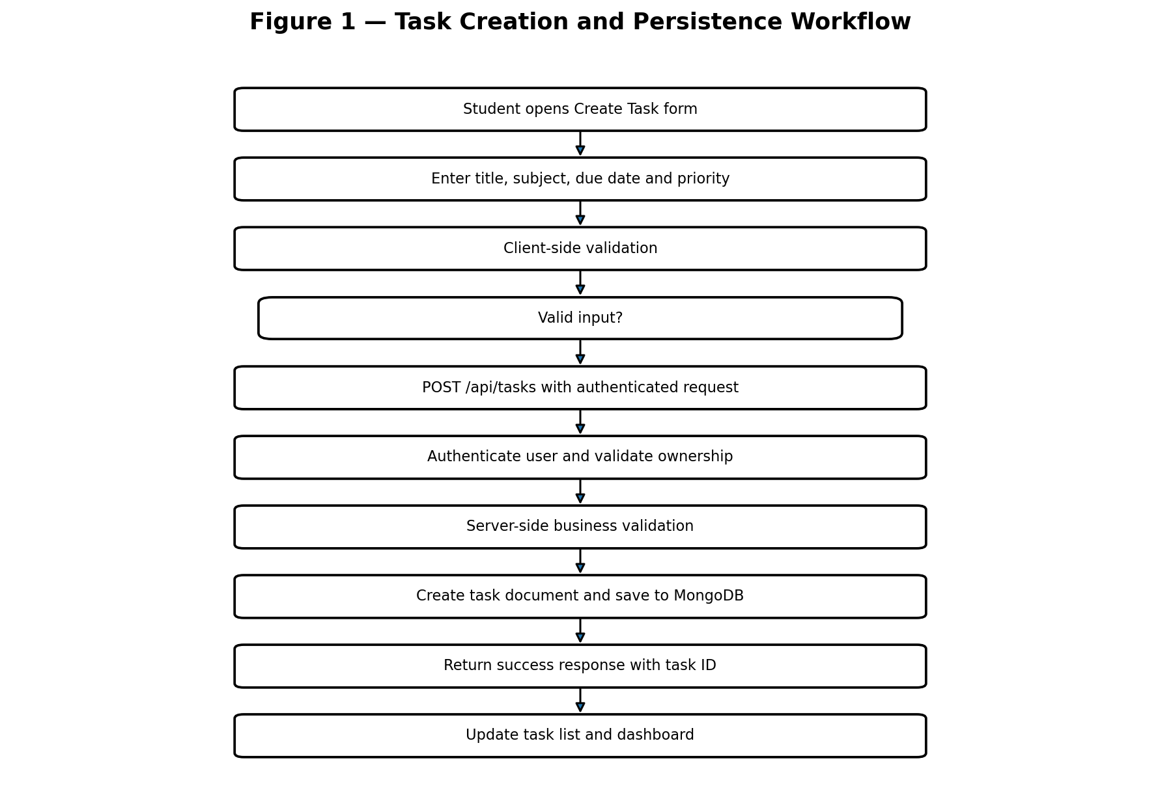
The create workflow prevents invalid data from reaching the database and derives userId from the authenticated context.
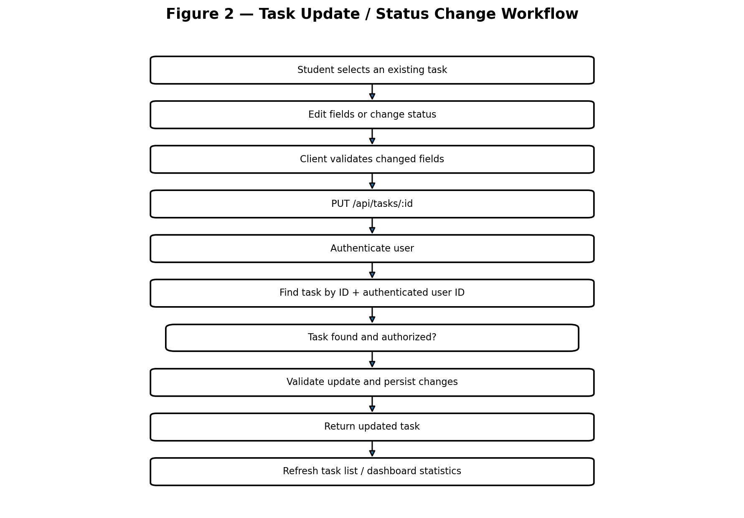
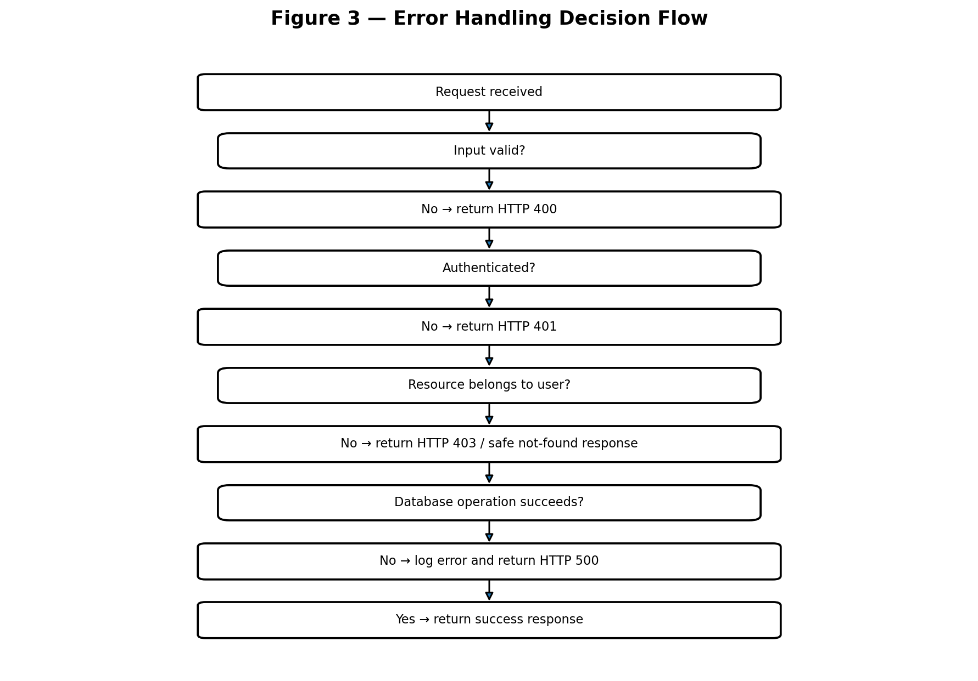

10. API Contract
Method | Endpoint | Purpose | Success | Common Errors
GET | /api/tasks | List user's tasks | 200 | 401, 500
POST | /api/tasks | Create task | 201 | 400, 401, 500
GET | /api/tasks/:id | Read one owned task | 200 | 401, 404
PUT | /api/tasks/:id | Update owned task | 200 | 400, 401, 404, 500
DELETE | /api/tasks/:id | Delete owned task | 200 | 401, 404, 500

10.1 Example Request
POST /api/tasks
{
"title": "Complete DBMS assignment",
"subjectId": "SUB123",
"dueDate": "2026-09-05",
"priority": "High",
"description": "Finish questions 1 to 10"
}

10.2 Example Response
HTTP 201 Created
{
"success": true,
"task": {
"taskId": "TASK456",
"title": "Complete DBMS assignment",
"priority": "High",
"status": "Pending"
}
}

11. Error Handling Strategy
Error handling is designed as a layered responsibility. The client provides immediate feedback for obvious input errors, while the server remains the authoritative validator. Internal errors are logged for debugging but sensitive implementation details are not exposed to the user.
HTTP | Situation | Prototype Response
400 | Missing/invalid fields | Return field-level or concise validation message; do not write.
401 | No/invalid authentication | Ask user to sign in; do not reveal protected data.
403 | Authenticated but unauthorized | Reject access; avoid exposing another user's record.
404 | Task does not exist for user | Return safe not-found response.
409 | Conflict such as duplicate constrained data | Explain conflict and request correction.
500 | Unexpected application/database failure | Log technical details; return generic message.

11.1 Error Handling Principles
- Never trust client-side validation alone.
- Do not return stack traces, database credentials or internal query details to the browser.
- Use consistent JSON response structures for API errors.
- Log unexpected errors with enough context for debugging without storing unnecessary sensitive information.
- Keep optional notification failures separate from core task CRUD so a reminder problem does not prevent task creation.

12. Efficiency and Performance Improvements
Technique | Application to Feature | Reason
Database indexes | Index userId, dueDate and status; consider compound indexes for frequent filters. | Reduce query time as records grow.
Pagination | Return a limited task page rather than every record. | Controls response size and memory use.
Projection | Return only fields required by a list view. | Reduces database and network payload.
Server-side filtering | Filter by subject/status/priority in the API. | Avoids downloading unnecessary records.
Input normalization | Trim strings and normalize values before storage. | Improves consistency.
Atomic update | Use one ownership-safe update operation. | Reduces race conditions and prevents extra reads.
Debounced UI filters | Delay repeated filter requests while typing. | Reduces unnecessary API calls.
Caching | Consider later for dashboard summaries. | Can reduce repeated reads when scale increases.

The Week 2 architecture already identifies indexes on userId, dueDate and status plus pagination as the initial strategy for handling the planned 10,000+ task records. fileciteturn1file0L369-L394

13. Security Considerations
- Derive userId from authenticated server-side context; never accept userId from the task form as authoritative.
- Scope every task query by both task ID and authenticated userId.
- Validate ObjectId/task identifiers before database operations.
- Store passwords as secure hashes and never return password hashes to the client.
- Use HTTPS in deployment.
- Store database credentials and API keys in environment variables.
- Apply rate limiting to authentication and other abuse-prone public endpoints.
- Escape or safely render user-generated text in the browser to reduce XSS risk.
- Use least-privilege database credentials.

14. Testing Plan for the Prototype
Test ID | Scenario | Expected Result | Level
TC-01 | Create task with valid data | Task stored and HTTP 201 returned | API / Integration
TC-02 | Create task with blank title | HTTP 400; no database write | Unit / API
TC-03 | Create task with invalid priority | HTTP 400 | Unit / API
TC-04 | Create task without authentication | HTTP 401 | Security
TC-05 | Read another user's task | Task is not exposed | Security
TC-06 | Update owned task | Allowed fields change | API / Integration
TC-07 | Attempt to change userId | Ownership remains unchanged | Security
TC-08 | Delete owned task | Task removed and success returned | API / Integration
TC-09 | Delete nonexistent task | HTTP 404 | API
TC-10 | Past-due incomplete task | Displayed as Overdue | Unit
TC-11 | Completed past-due task | Displayed as Completed | Unit
TC-12 | Large task list | Pagination limits response size | Performance
TC-13 | Database unavailable | HTTP 500; generic message; error logged | Recovery

14.1 Test Data Examples
Valid:
title = "Complete DBMS assignment"
priority = "High"
status = "Pending"
dueDate = "2026-09-05"
Invalid:
title = ""
priority = "Urgent"
dueDate = "not-a-date"
status = "Unknown"

15. Proposed Implementation Sequence
- Create the feature branch and define task model/schema rules.
- Implement reusable validation constants and helper functions.
- Implement authentication middleware integration.
- Implement task repository/data-access methods.
- Implement POST /api/tasks and unit/API tests.
- Implement GET endpoints with ownership filters and pagination.
- Implement PUT/status update logic.
- Implement DELETE endpoint.
- Connect the front-end task form and task list using fetch().
- Add dashboard refresh after successful task mutations.
- Run security, integration, responsive and performance tests.
- Merge only after review and regression testing.

15.1 Suggested Project Structure
stsms/
├── frontend/
│ ├── index.html
│ ├── dashboard.html
│ ├── css/
│ └── js/
│ ├── api.js
│ ├── tasks.js
│ └── dashboard.js
│
├── backend/
│ ├── routes/
│ │ └── taskRoutes.js
│ ├── controllers/
│ │ └── taskController.js
│ ├── services/
│ │ └── taskService.js
│ ├── repositories/
│ │ └── taskRepository.js
│ ├── middleware/
│ │ └── auth.js
│ └── server.js
│
├── tests/
└── README.md

16. Innovative / Quality-Oriented Design Decisions
- Derived Overdue display state: instead of permanently rewriting a task status every midnight, the system can derive Overdue from dueDate for unfinished tasks. This reduces scheduled database writes.
- Ownership-safe queries: authorization is embedded directly in task lookups, reducing the chance that a developer accidentally retrieves a record first and checks ownership later.
- Layered validation: the same business rules can be reused across routes and services rather than duplicating checks in every endpoint.
- Optional notification isolation: reminders are treated as an extension point rather than a dependency of task creation.
- Pagination-first task retrieval: the design avoids an architecture that works only for small demo datasets.
- Traceable API responses: success and error objects use predictable structures so the front end can handle them consistently.

17. Feature-Specific Risks and Mitigation
Risk | Impact | Mitigation
Invalid task data | Medium | Client + server validation and controlled enumerations.
Unauthorized task access | High | Authentication and userId ownership filters on every task operation.
Slow task queries | Medium | Indexes, pagination, filtering and projection.
Database failure | High | Structured exception handling, logging and generic client response.
Inconsistent status rules | Medium | Central constants and service-level validation.
UI/API mismatch | Medium | Documented API contract and integration tests.
Feature scope creep | Medium | Keep reminders/analytics outside core CRUD prototype.

18. Prototype Acceptance Criteria
- A signed-in student can submit a valid task and receive a successful creation response.
- A new task receives the authenticated user's ID and cannot be assigned to another user through request input.
- Invalid title, date, priority or status values are rejected before persistence.
- A student can retrieve only their own tasks.
- A student can update permitted task fields and status.
- A student cannot modify ownership metadata.
- A student can delete only their own task.
- Past-due incomplete tasks can be displayed as Overdue while completed tasks remain Completed.
- API failures return controlled JSON errors and do not expose internal implementation details.
- Task list operations support filters and pagination suitable for the planned initial dataset.

19. Requirements-to-Prototype Traceability Matrix
Requirement | Prototype Element | Verification
Create tasks | POST /api/tasks + createTask() | TC-01, TC-02
Edit tasks | PUT /api/tasks/:id | TC-06, TC-07
Delete tasks | DELETE /api/tasks/:id | TC-08, TC-09
Deadlines | dueDate validation + overdue calculation | TC-10, TC-11
Priorities | ALLOWED_PRIORITIES | TC-03
Progress/status | ALLOWED_STATUSES + updateTaskStatus() | Unit tests
Private user data | userId ownership query | TC-04, TC-05, TC-07
Error handling | HTTP status mapping + try/catch | TC-02, TC-03, TC-13
Efficiency | Indexes + pagination + filtering | TC-12

20. Conclusion
The Task Creation and Management feature provides a suitable Week 3 prototype because it is one of the most important functional modules of STSMS and directly connects the requirements from Week 1 with the architecture defined in Week 2. The prototype demonstrates how a user action moves through the browser, REST API, authentication middleware, business logic, validation and MongoDB persistence.
The proposed algorithms emphasize correctness and security before optimization: required fields are validated, ownership is enforced on the server, protected fields cannot be overwritten, and errors are returned in a controlled format. Performance improvements such as indexes, filtering, pagination and limited projections provide a practical path for handling the planned early dataset. The design also keeps reminders and analytics optional so that the core task-management workflow remains understandable and testable.
This document therefore serves as a convincing code-prototype specification for the development phase. It does not claim that the full application is already implemented; instead, it provides the algorithms, data structures, API contracts, pseudocode, code examples, flowcharts, security rules and testing plan needed to implement the feature in a structured manner.

21. References and Source Documents
Internal project documents used for continuity:
- Week 1 — Student Task & Study Management System: Project Planning and Requirements Analysis, Version 1.1, August 2026.
- Week 2 — STSMS: Design Documentation and System Architecture Plan, Version 1.0, August 2026.
The feature design in this document is original project work based on the requirements and architecture established in the previous internship assignments. General software engineering practices are applied conceptually.

22. Document Control
Version | Date | Prepared By | Change Description
1.0 | 20 August 2026 | Aniket | Initial Week 3 feature development and code prototype documentation prepared for submission.

