WEEK 2 DESIGN DOCUMENTATION
AND SYSTEM ARCHITECTURE PLAN
Student Task & Study Management System (STSMS)
YuvaIntern Internship Assignment
Document Version: 1.0
Date: August 2026
Status: Design Proposal / Pre-Implementation

Document Control
Item | Details
Project | Student Task & Study Management System (STSMS)
Document | Design Documentation and System Architecture Plan
Version | 1.0
Status | Proposed / Pre-Implementation
Primary Users | Students
Architecture | Three-tier web architecture with REST API
Front End | HTML, CSS, JavaScript
Back End | Node.js + Express.js
Database | MongoDB

Executive Summary
The Student Task & Study Management System (STSMS) is a proposed web application that helps students organize academic tasks, assignments, study activities, deadlines, priorities and progress in one centralized platform. This Week 2 document converts the Week 1 requirements into a practical technical architecture.
Initial planning assumptions are approximately 500 registered users during the first six months, at least 10,000 stored task records, a normal API response target below two seconds, and 99% target availability. These are planning benchmarks, not production measurements.

1. Project Overview
Students can register, log in, create subjects, add tasks, set deadlines and priorities, update task status, filter tasks and view dashboard statistics. The design is modular so optional reminders and analytics can be added later.

1.1 Objectives
- Provide a simple academic task-management interface.
- Store user and task information persistently.
- Separate presentation, business logic and data storage.
- Protect user-specific academic information.
- Provide a foundation for reminders, analytics and future scaling.

1.2 Planning Assumptions
Metric | Initial Target
Registered users | 500 in first 6 months
Task records | 10,000+
Normal API response | < 2 seconds
Availability target | 99%
Password minimum | 8 characters
Early performance test | 50 concurrent users

2. High-Level System Architecture
The architecture uses presentation, application and data tiers. The browser interacts with the front end, the front end communicates with the REST API, and the server performs business logic and database operations.
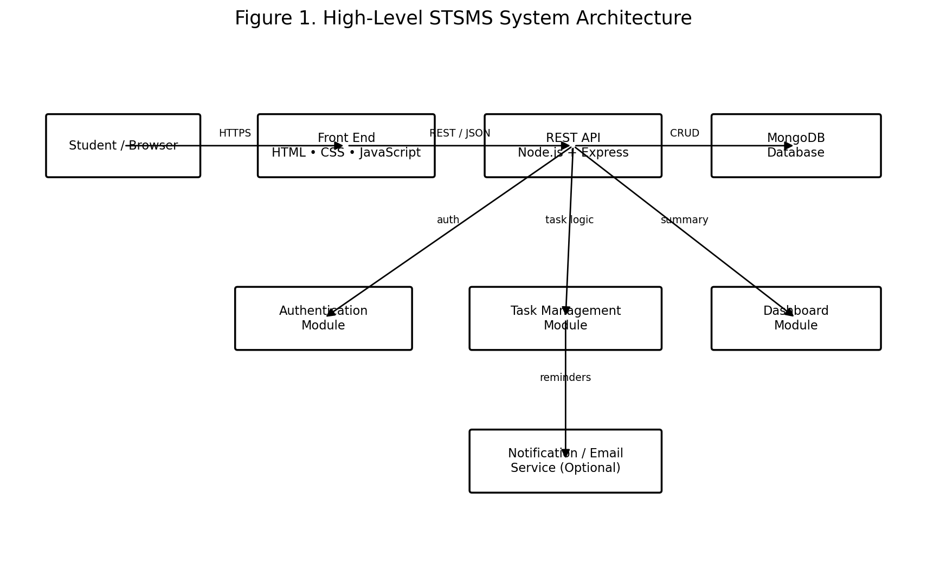
Figure 1. High-Level STSMS System Architecture.

2.1 Component Responsibilities
Component | Responsibility | Interactions
Student / Browser | Provides user interaction. | Sends requests and receives responses.
Front End | Forms, dashboard, lists and UI state. | Communicates with REST API.
REST API | HTTP endpoints and request handling. | Calls application modules.
Authentication | Registration, login and authorization. | Reads user data; protects endpoints.
Task Management | CRUD operations for tasks. | Uses validation and database services.
Dashboard | Calculates task summaries. | Reads task data.
Notification Service | Optional deadline reminders. | Receives reminder events.
MongoDB | Persistent storage. | Stores users, subjects, tasks and reminders.

3. Detailed Components

3.1 Presentation Layer
HTML provides semantic structure, CSS provides responsive presentation, and JavaScript handles interaction and API communication. Planned screens include registration, login, dashboard, task creation/editing, task list, subject management and profile.

3.2 Application / API Layer
Node.js and Express.js provide the server-side application. The API is the controlled boundary between the browser and MongoDB.
Area | Example Endpoint | Purpose
Authentication | POST /api/auth/register | Create account
Authentication | POST /api/auth/login | Authenticate user
Tasks | GET /api/tasks | Retrieve tasks
Tasks | POST /api/tasks | Create task
Tasks | PUT /api/tasks/:id | Update task
Tasks | DELETE /api/tasks/:id | Delete task
Dashboard | GET /api/dashboard | Return statistics

3.3 Database Layer
Collection | Important Fields | Purpose
users | _id, name, email, passwordHash, createdAt | Account information
subjects | _id, userId, name, createdAt | Academic subjects
tasks | _id, userId, subjectId, title, dueDate, priority, status | Assignments and study tasks
reminders | _id, taskId, reminderTime, sent | Reminder scheduling

3.4 External Services
An email or notification API may be integrated later. It remains optional so core task management does not depend on an external notification provider.

4. Data Flow Design
The browser never communicates directly with MongoDB. Requests pass through the API, authentication, validation and business logic before database operations occur.
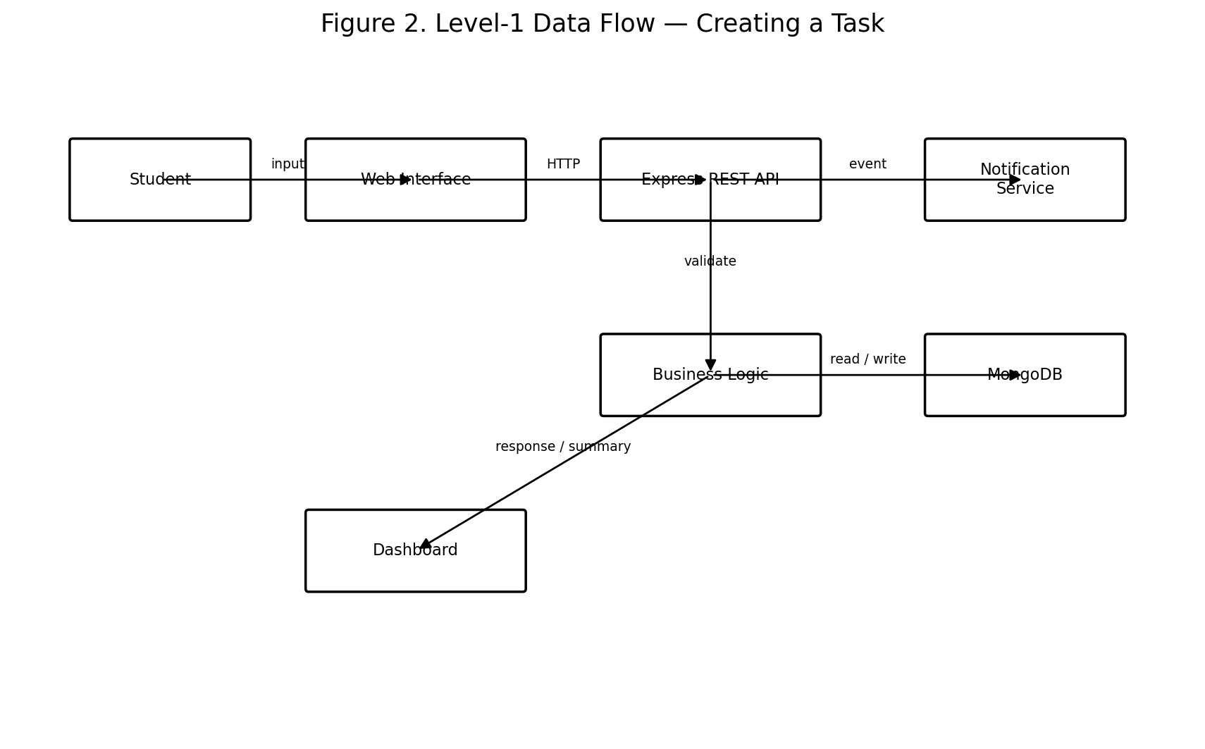
Figure 2. Level-1 Data Flow — Creating a Task.

4.1 Task Creation Scenario
Step | Stage | Description
1 | Input | Student enters title, subject, deadline and priority.
2 | Client validation | JavaScript checks required fields and formats.
3 | API request | Browser sends POST /api/tasks.
4 | Authentication | Server verifies authenticated user.
5 | Business validation | Server checks fields, dates and ownership.
6 | Database write | Task is stored in MongoDB.
7 | Optional reminder | Reminder event may be registered.
8 | Response | API returns created task / success response.
9 | UI update | Front end displays the new task.

4.2 Login Scenario
- Student submits email and password.
- Browser sends credentials over HTTPS.
- Server finds the account and compares the password against its secure hash.
- Valid credentials produce an authenticated session/token response.
- Invalid credentials return a generic authentication error.
- The dashboard is loaded only after successful authentication.

4.3 Dashboard Scenario
- Browser requests dashboard data.
- API verifies authentication.
- Dashboard module retrieves the user's relevant tasks.
- Application calculates total, pending, completed and overdue counts.
- JSON summary is returned and rendered by the front end.

5. Interfaces and Communication
Interface | Protocol / Format | Purpose | Security
Browser → Front End | HTTPS, HTML/CSS/JS | User interaction | HTTPS in deployment
Front End → API | HTTPS + JSON | Application operations | Authentication + validation
API → Database | Database driver | Persistent storage | Server-side credentials
API → Notification | HTTPS API | Optional reminders | Server-side API key

6. Technology Stack Selection
Technology | Role | Advantages | Limitations
HTML5 | Page structure | Semantic, standard, widely supported | Needs CSS/JS for rich interaction
CSS3 | Styling | Responsive and flexible | Needs organization at scale
JavaScript | Client interaction | Browser-native; reusable language | Requires careful async/error handling
Node.js | Server runtime | Efficient for I/O-heavy apps; JavaScript ecosystem | Not ideal for CPU-heavy workloads
Express.js | REST framework | Lightweight, simple routing, middleware | Structure must be defined by project team
MongoDB | Database | Flexible document model; JSON-like data | Requires good indexes/query design
Git/GitHub | Version control | History and collaboration | Requires disciplined workflow

6.1 Technology Rationale
The selected stack is appropriate for a small-to-medium CRUD web application. JavaScript can be used across client and server, Express provides a straightforward API layer, and MongoDB fits document-oriented records such as users and tasks. The design supports future additions without requiring a complete architectural rewrite.

7. Security Architecture
- Passwords must be stored as secure hashes, never plain text.
- HTTPS should protect deployed client-server communication.
- Protected endpoints must verify authentication.
- Every task query must be scoped to the authenticated user's ID.
- Server-side validation is required even when client-side validation exists.
- Database credentials and API keys must be stored in environment variables.
- Production errors must not expose stack traces or sensitive implementation details.
- Rate limiting should be considered for login and public endpoints.

8. Performance and Scalability
The initial system targets 500 users and 10,000+ tasks. Database indexes should support frequent queries on userId, dueDate and status. Pagination should prevent large task collections from being returned in one response.
Area | Initial Strategy | Future Option
API | Single Node.js service | Multiple instances behind load balancer
Database | Indexes and efficient queries | Replica/scaled deployment
Task lists | Pagination + filters | Caching
Notifications | Optional external service | Queue-based processing
Static assets | Web hosting | CDN

9. Error Handling
Status | Example | Expected Handling
400 | Invalid input | Return validation message; no write
401 | Missing/invalid authentication | Require login
403 | Unauthorized resource | Reject request
404 | Task not found | Return not-found response
409 | Duplicate email | Inform user
500 | Unexpected server/database failure | Log details; return generic message

10. API Example
Example: creating a task.
Request: POST /api/tasks
Body: { "title": "Complete DBMS assignment", "subjectId": "SUB123", "dueDate": "2026-09-05", "priority": "High" }
Response: { "success": true, "taskId": "TASK456", "status": "Pending" }

11. Deployment Architecture
The front end can be deployed as static web assets, the Node.js/Express API can run on an application hosting platform, and MongoDB can be hosted as a managed database. Production secrets remain server-side.
Layer | Development | Production Concept
Front End | Local browser/server | Static hosting / CDN
Back End | Local Node.js server | Managed application server
Database | Local/development MongoDB | Managed MongoDB deployment
Version Control | Git | GitHub repository with protected main branch

12. Testing Strategy
Test Level | Example
Unit | Validate task date/status rules
API | Verify valid and invalid /api/tasks requests
Integration | Verify API + MongoDB task creation
Security | Verify one user cannot access another user's task
UI | Verify forms, filters and dashboard
Performance | Test around 50 concurrent users during early testing

13. Week 1 → Week 2 Traceability
Week 1 Requirement | Week 2 Design Response
Registration/login | Authentication module + users collection
Create/manage tasks | Task Management Module + CRUD API
Deadlines | dueDate field + dashboard queries
Priorities | priority field
Task status/progress | status field + Dashboard Module
Filtering | API filters + indexes
Dashboard | Dashboard Module
Reminders | Optional Notification Service
Security | Authentication, authorization, validation and HTTPS

14. Risks and Mitigation
Risk | Impact | Mitigation
Poor database performance | Medium | Indexes, pagination, query optimization
Unauthorized data access | High | Authentication and ownership checks
API failure | High | Structured error handling and logging
Notification failure | Low/Medium | Separate notification workflow from core CRUD
Scope expansion | Medium | Prioritize core features first
Learning curve | Medium | Implement and test modules incrementally

15. Implementation Sequence
- Create Git repository and project structure.
- Build static front-end pages.
- Design MongoDB collections and validation rules.
- Configure Node.js and Express.
- Implement registration and login.
- Implement task CRUD APIs.
- Connect front end to API.
- Implement dashboard statistics and filtering.
- Add optional reminders.
- Perform security, integration, UI and performance testing.
- Deploy and document final configuration.

16. Conclusion
The proposed STSMS architecture provides a clear and technically feasible foundation for the requirements defined in Week 1. The three-tier structure separates the interface, application logic and persistent data, making the system easier to maintain, test and extend.
The measurable planning assumptions—500 users, 10,000+ task records, less than two seconds for normal API operations, and 99% target availability—provide concrete criteria that can be evaluated during later implementation and testing. The modular design allows reminders and analytics to be added without redesigning the core workflow.

Appendix A — Diagram Interpretation
Figure 1 shows the overall relationship among the browser, front end, REST API, application modules, database and optional notification service. Figure 2 shows the flow of a task-creation request from student input through validation and persistence to the dashboard.

