SAAGAR TRADERS Titan World (WLMHW) | Helios (HEMW) | Latur

Saagar Audit App: My Reply to the Evolution Brief and Review of the Current Build
To | Development Team, Saagar Audit App
From | Sagar Bora, Saagar Traders, Latur
Date | 24 October 2026
Build reviewed | Saagar Audit 0.1.0 (build 1), file "app-release. v1apk.apk", SHA-256 f9b18e4c…5fda29bfb

Hello,
Thank you for the Audit System Evolution brief. I have gone through it section by section and my decisions are in Part A below. In Part B, I have shared what I found when I went through the current build over the last two days. For every issue I have written what I did, what went wrong, why it matters to us in the store, and what I expect from the fix, with screenshots.
Please read both parts together before planning the next build. A few of my decisions in Part A, especially the multi-user login and the "never delete" rule, are directly linked to problems I found in Part B.

Part A: Your questions and my decisions
Decision item | My choice
1. Management scope | Level B: edit checkpoints and SOPs, with SOP versioning
2. Interface | Option 3: Hybrid (in-app editor + Excel export/import), with archive instead of delete
3. Date-range handling | Keep daily, weekly and monthly as they are, and add ad-hoc audits with an admin-defined date range
Additional | Multi-user login with role-based access (raised earlier, not yet built)

1. Do you want to edit checkpoints only, or SOPs too?
My decision: Level B. We need to edit SOPs as well, not only checkpoints.
Over time we learn which systems are working in the store and which are not. Sometimes it is not one checkpoint that is wrong; the whole SOP stops fitting, or its frequency has to change (for example, a daily check that should really be weekly). So editing checkpoints alone will not be enough.
My main concern is data integrity. Editing an SOP must never break existing data, reports or links. This is how I want it handled:
- Version every SOP. When an SOP is edited, the old one is not overwritten. For example, "Grooming SOP v1.0" becomes "Grooming SOP v1.1" (or v2.0 for a major change), and the old version is kept.
- Old audits stay linked to the version that was in force on that day. A March audit should always show the March checklist, even after we change the SOP in June.
- Reports and trends should say which version they cover, so a score change caused by a changed checklist is not mistaken for a change in store performance.
- The same applies to checkpoints: changing text, weight or frequency creates a new version, not an overwrite.
- No broken links, missing records or "not found" errors anywhere in the app after an SOP or checkpoint is edited.
Before you build this, please share a short note on how you plan to store versions in the database and in Firebase, so we agree on it first.

2. How should updates be made: mobile app or Excel import?
My decision: Option 3, the Hybrid model.
I agree with the plan: a Manage Checkpoints screen under Settings for quick on/off and text edits on the phone, and Export Template / Import Excel buttons for bulk changes from the laptop.
One important correction on "Past Audits Protection". The brief says the system will do a soft delete (is_active = 0). Our rule for this software is simple: the system does not delete anything. It archives or disables. Records in this app are connected to each other (a checkpoint is linked to audit results, findings, photos, CAPs and escalations). Deleting one thing can break the things that depend on it. So:
- Removing or disabling an SOP, checkpoint, user, staff member (CRO) or CAP should only archive it or mark it inactive. The record stays in the database with its full history.
- Archived items disappear from future audits and pick-lists, but all past audits, reports and compliance percentages stay exactly as they were.
- An archived item can be restored by the Super Admin.
- The Excel import must check every row before applying anything, show me a preview of what will change, and reject the whole file (with the row numbers of the errors) rather than applying half of it.
- Every import and every edit should be logged: who changed what and when.

3. Arbitrary date-range audits
My decision: Keep daily, weekly and monthly execution exactly as it is, and add a separate ad-hoc audit type with a date range set by the admin.
I agree with your reasoning for store-floor checks. Grooming, cash and opening photos must be checked on the day, and a date range should not become a way for anyone to backfill a week of daily audits on Sunday night.
However, some audits are not daily, weekly or monthly. They happen once in a while, or once a year, and their timing depends on circumstances. A good example from my CA practice is the tax audit under Section 44AB of the Income Tax Act, 1961. It is done once a year. Depending on the accountant's availability we may do it in March or in April; the government deadline is 30 September, but we do not want to wait till then. Every year the Finance Act brings amendments, so the checklist itself changes each year. That means a new SOP version with new checkpoints every year.
So the app should support ad-hoc / periodic audits with:
- their own SOP and checklist (versioned, as in point 1);
- a start date and end date chosen by the admin, plus an assignee and a due date;
- results reported separately, so they do not distort the daily, weekly and monthly compliance scores;
- the same CAP, escalation and report features as regular audits.

4. Additional point: multi-user login and role-based access
This was not covered in the brief, so I am raising it again. We discussed it in our last two meetings, and it is one of the main reasons we chose Firebase. So far no work has been done on it. Please take it up now; otherwise something else will be built first and we will have to redo it, which will cost a lot of time.
- Super Admin (me): the app on my phone with full rights. I see all audit results from all users and stores so that I can take corrective action. Only I have access to sensitive modules such as the personnel module.
- General Manager (for example, Mr Shardul): responsible for conducting audits. Whatever he submits should be visible to me as soon as it is done.
- Store Manager and other users: access only to the audit modules assigned to them.
- Every device must log in to our store account before it can see or send any cloud data.
This is not only a feature request. In Part B you will see that a fresh install of the app could pull our existing cloud records without any store login (item 4), and that a GM could complete and verify the same corrective action himself (item 6). Proper role-based login fixes both.

Part B: My findings on the current build
I have gone through the app in detail and these are my findings. I went through first-time setup and login; all 68 daily checkpoints, including drafts, Marathi, failures and photos; cash-variance escalation; history and backup export; adding SM and GM users, PIN reset and deactivation; GM verification; the weekly and monthly audits with their reports and PDFs; the full CAP cycle; PIN lockout; larger text and smaller screens; and cloud sync, offline use and reinstall on Android 11 and Android 15. All testing used test accounts and test entries only. I did not change or delete any of the existing records in our cloud project.
The basic daily audit works well. Scoring is correct (my test daily audit scored 87/90 = 96.7%, weekly 63.4/122 = 52.0%, monthly 3/5 = 60.0%, and I checked each figure by hand), drafts survive closing the app, N/A is excluded properly, and the weekly and monthly PDFs do get generated. The problems are mostly in backup and restore, in what the app claims has happened (sent, backed up, escalated), in control of CAPs, and in a few layout and language areas.

Summary
# | Issue | Priority
1 | Cloud says "All Data Mirrored", but a reinstalled phone gets back no audits or photos | Critical
2 | Exported backup file has no photos, and there is no import option | High
3 | Backup screen says "All local changes backed up" when nothing has been backed up | High
4 | A fresh install pulls our cloud data without any store login | Critical
5 | No way to recover a forgotten Owner PIN | High
6 | GM can mark a CAP done and verify it himself | High
7 | Store Manager can export everyone's PIN data | High
8 | PIN lockout is only 60 seconds and locks out every user | Medium
9 | "WhatsApp Sent" shown when nothing was sent | High
10 | Submitting an audit jumps to WhatsApp before confirming the save | Medium
11 | Low-score escalation is announced but never created | High
12 | Weekly report escalation section is a placeholder | Medium
13 | Cash variance of Rs 600 saved as Pass; three different cash limits | High
14 | Safe-cash checkpoint counted under Sales Buddy | Medium
15 | Daily audit detail buttons are "Phase 2" placeholders | Medium
16 | Marathi text is broken in all PDFs; other PDF issues | High
17 | CAP form shows the wrong checkpoints; monthly/weekly failures cannot get a CAP | Medium
18 | CAP can be marked done with no note or photo | Medium
19 | "Request Extension" can move the deadline earlier | Low
20 | Daily checkpoints are not translated into Marathi | High
21 | Camera permission denial leaves the user stuck | Medium
22 | App never asks for notification permission on Android 13 and above | Medium
23 | Question disappears on small screens; report breaks with larger text | Medium
24 | Phone Back button exits the audit; app back arrow goes to previous checkpoint | Medium
25 | Times shown in two different time zones without a label | Medium
26 | "Photo is mandatory" shown where a Pass needs no photo | Low
27 | General ease-of-use points | Low–Medium

A. Backup, cloud sync and data safety

1. Cloud says "All Data Mirrored", but a reinstalled phone gets back no audits or photos
Priority: Critical | Our ref: F26
What I did: On Android 15 I set up the app, did a monthly audit with a failure and a photo, and pressed Force Cloud Sync. The photo uploaded to Firebase Storage. I then cleared the app's data (same effect as reinstalling or changing the phone), set the app up again, and synced.
What happened: The sync screen said "All Data Mirrored (Cloud up to date)". Staff (CRO) records came back, including one I had added while offline. But the audit, its results, the photo and the report did not come back at all: audits 0, results 0, photos 0. The app log shows the reason and two other errors in the same sync:
- _pullTableData(caps): FOREIGN KEY constraint failed
- _pullTableData(escalations): FOREIGN KEY constraint failed
- countPendingChanges: no such column: created_at (SELECT COUNT(*) FROM audits WHERE created_at > ?)
Why it matters: If a store phone is lost, damaged or reset, we lose all audit history, findings and photos, while the app tells us everything is safe in the cloud. Together with item 2, there is currently no working way to recover our audit records.
- Pull audits, audit results, photos and reports, and pull them before the tables that depend on them (CAPs, escalations), or handle the dependency order properly.
- Fix the pending-changes query (the audits table has no created_at column).
- If any table fails to pull or push, show it on screen. Never show "All Data Mirrored" unless every table actually completed.
How I will check it: I will reset a phone, sync, and compare the number of audits, findings, photos, CAPs and escalations with the original phone. They must match.
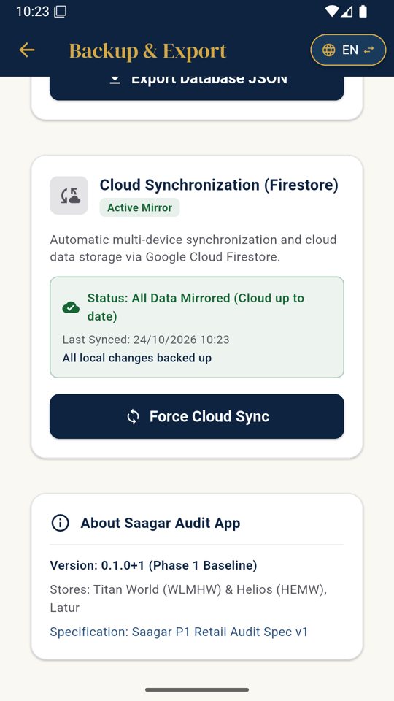  Sync shows "All Data Mirrored" | 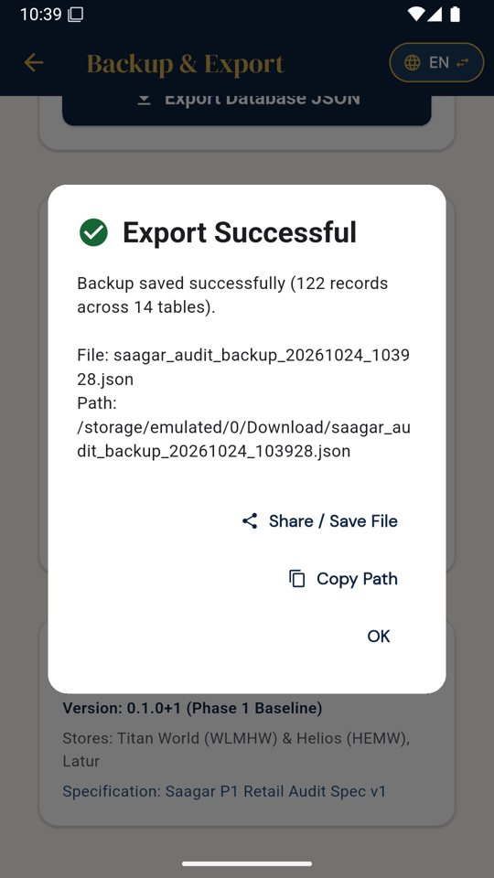  Export after restore: only 122 records, no audits | 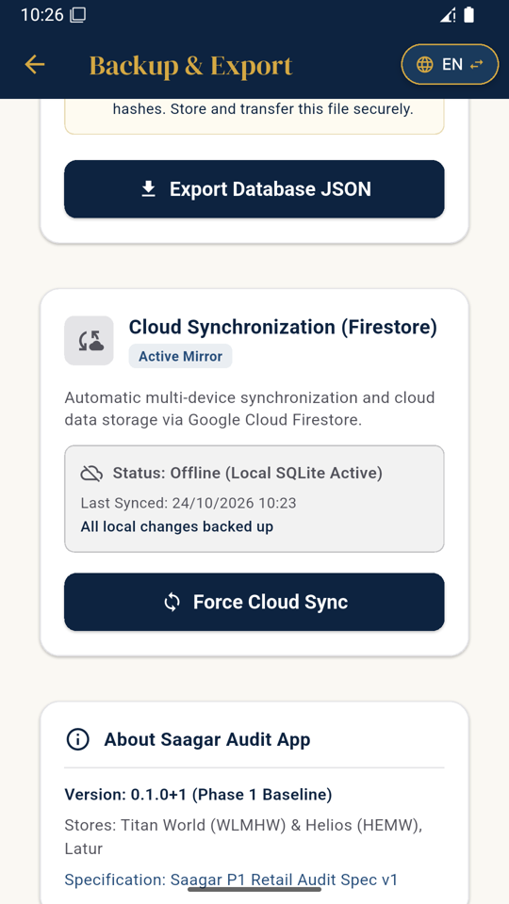  Offline, yet "All local changes backed up"

2. Exported backup file has no photos, and there is no import option
Priority: High | Our ref: F10
What I did: Attached a photo to a cash failure, submitted, then used Settings > Backup & Export > Export Database JSON.
What happened: The file contains the photo record only as a path inside the phone's private app storage, with cloud_url empty and upload status pending. The photo itself is not in the file. I also could not find any option anywhere in the app to import or restore this file.
Why it matters: This export cannot rebuild our data on another phone, and photos, which are our evidence, are lost.
What needs to be done: Either provide a complete backup (records plus photos in one package) with a tested Restore option, or clearly label this export as "data export only, not a backup". The real recovery path should be the cloud restore in item 1.
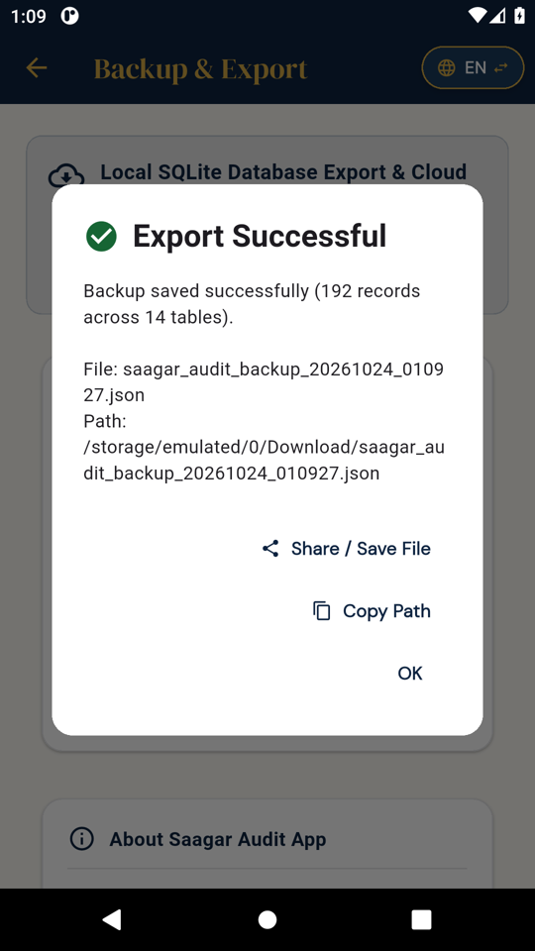
Export done as Store Manager

3. Backup screen says "All local changes backed up" when nothing has been backed up
Priority: High | Our ref: F02
What I did: Opened Backup & Export straight after setup, then again while offline with an unsynced change.
What happened: It showed "Last Synced: Never" and "All local changes backed up" together. While offline it showed "Offline (Local SQLite Active)" and still "All local changes backed up". After submitting a monthly audit while online it said "Will sync when online".
Why it matters: Staff and I cannot tell what is only on the phone and what is safely in the cloud.
What needs to be done: Show three separate, honest lines: "Saved on this phone", "Waiting to upload: N items" and "Last successful cloud backup: date and time". Replace terms like SQLite and Firestore with plain words.
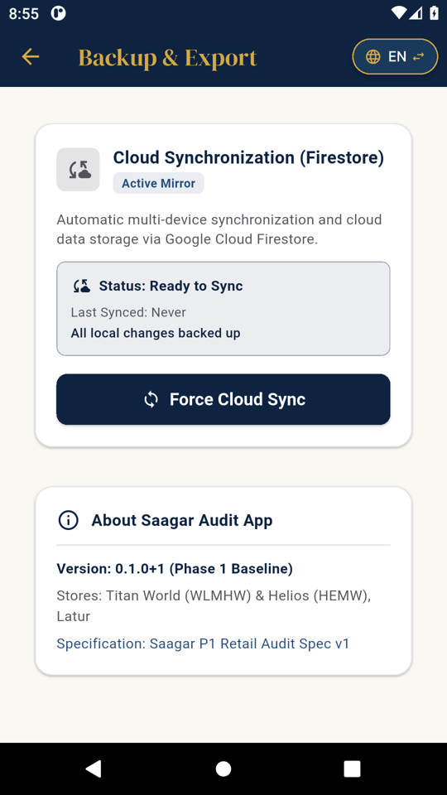  Never synced, yet "backed up" | Offline, yet "backed up"

4. A fresh install pulls our cloud data without any store login
Priority: Critical | Our ref: F27
What I did: Installed the app on a new phone and created a brand-new Owner with a test name. There was no store account, email or cloud login anywhere. Then I pressed Force Cloud Sync.
What happened: The phone downloaded three staff (CRO) records that already existed in our cloud project. It also tried to download CAPs and escalations from September 2026 that were created on another phone. I did not edit or delete any of these records.
Why it matters: Anyone who gets the APK may be able to read, and possibly change, our store data in Firebase. Staff names and audit findings are confidential business data.
- Every device and user must sign in to our store account before any cloud read or write (this is the multi-user login from Part A, point 4).
- Firestore and Storage security rules must restrict data to the logged-in store and role. Please send me the current rules so I can see what is open today.
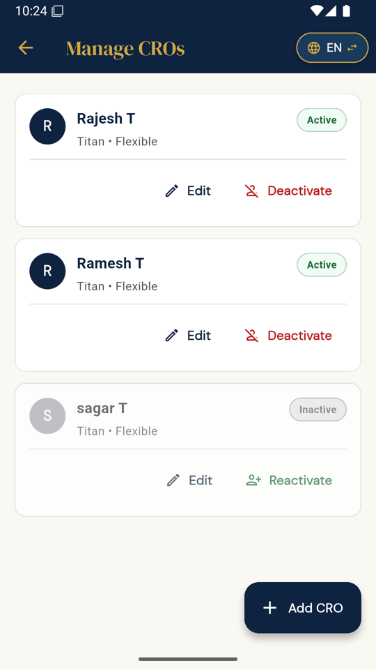
Fresh install showing existing cloud staff records

5. No way to recover a forgotten Owner PIN
Priority: High | Our ref: F16
What I did: Checked the login screen and every role's Settings.
What happened: There is no "Forgot PIN" option. Only the Owner can reset PINs (GM and SM do not have Manage Users). If the Owner forgets the PIN, the only option is to reinstall, which because of items 1 and 2 means losing data.
What needs to be done: Provide a secure Owner recovery route, for example a recovery code at setup, a second Super Admin, or reset through the store's cloud login.
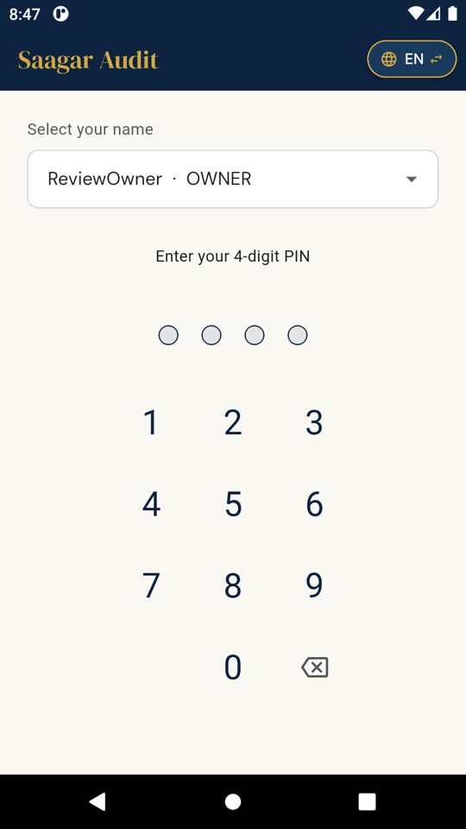  Login screen: no recovery option | 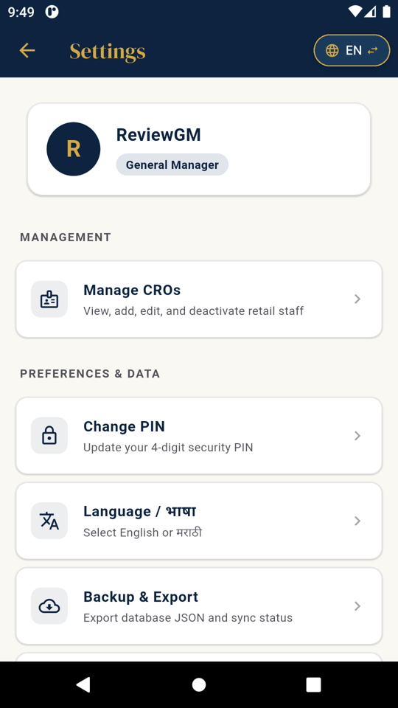  GM Settings: no Manage Users

B. Roles, controls and security

6. GM can mark a CAP done and verify it himself
Priority: High | Our ref: F21
What I did: Created a CAP assigned to the Store Manager. The SM completed the steps and marked it done. As GM I marked it "Verification Failed" and reopened it. Then, still logged in as GM, I opened the CAP again.
What happened: The screen says "Only the assigned responsible user can check off action steps", but the GM was able to press Mark CAP Done and confirm it. Two minutes later the same GM passed and verified it. The timeline records both actions under the GM. Also, "Reopen at Plan" left all action steps ticked, so the CAP could be marked done again immediately without redoing anything. The "Verification Failed" step does not ask for the reason.
Why it matters: The person who checks the work can complete and approve his own work. This defeats the purpose of verification.
- Only the responsible user can mark a CAP done.
- The verifier must be a different person from the one who marked it done.
- Reopening must reset the action steps, and a failed verification must record the reason.
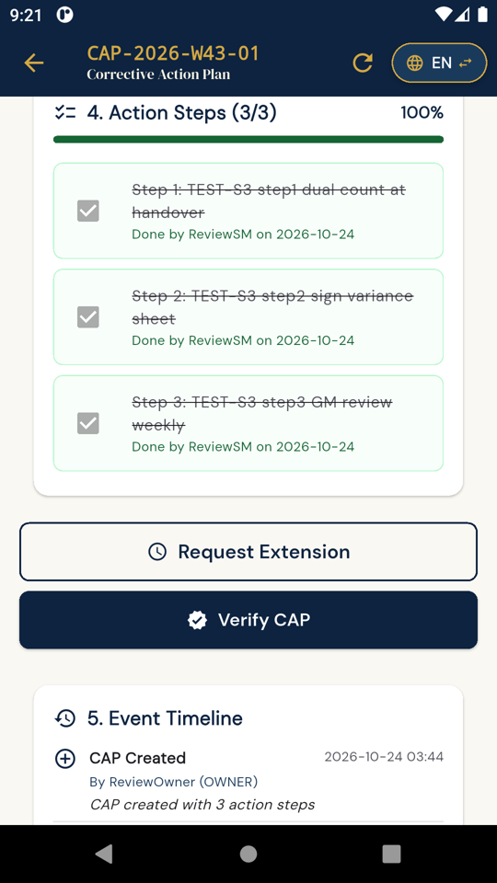  GM marks the SM's CAP done | 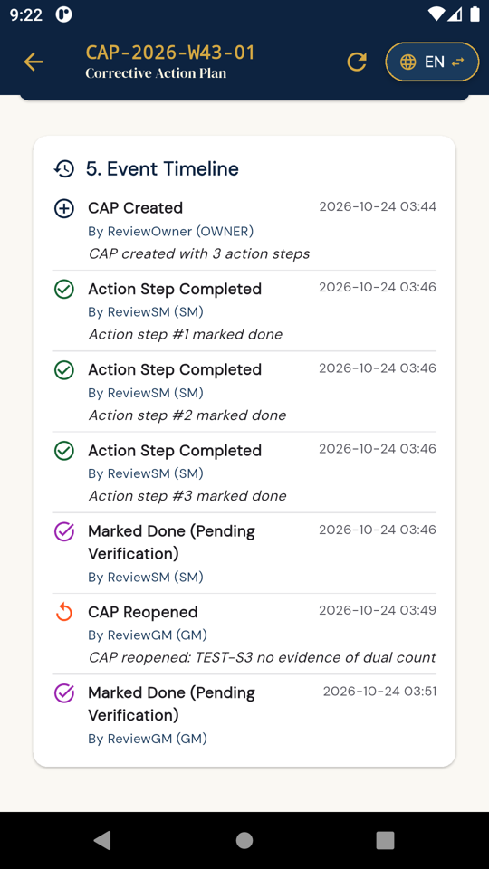  Timeline: marked done by GM | 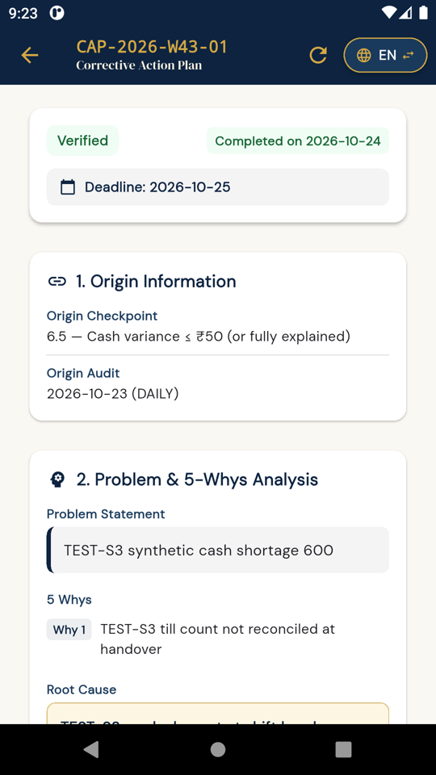  Same GM verifies it

7. Store Manager can export everyone's PIN data
Priority: High | Our ref: F11
What I did: Logged in as Store Manager and used Backup & Export.
What happened: Manage Users is correctly hidden from the SM, but the export file includes the full users table with the PIN hashes of the Owner, GM and SM, plus all audit records.
Why it matters: A staff member can take away security data for all accounts and all audit data on a single file.
What needs to be done: Allow full exports only to the Super Admin, never include PIN hashes in any export, and define what each role can export.
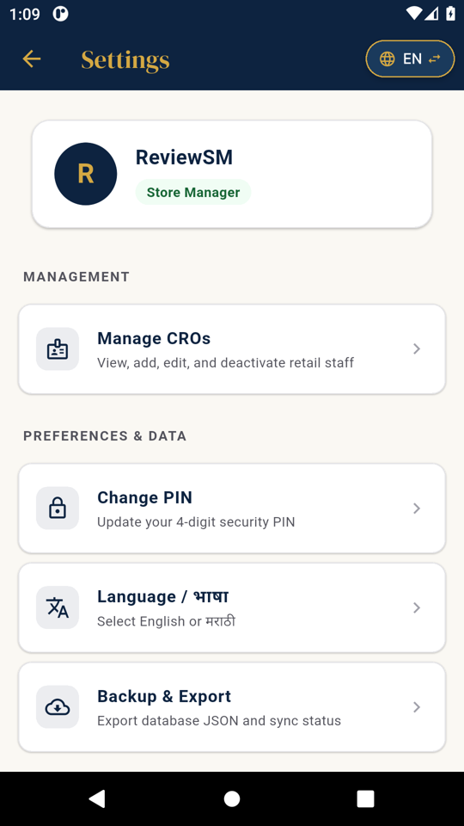  SM Settings with Backup & Export | SM export of all tables

8. PIN lockout is only 60 seconds and locks out every user
Priority: Medium | Our ref: F23
What I did: Entered a wrong PIN five times for the Store Manager, then repeated it.
What happened: The app locked for 60 seconds, and the lock stayed even after closing and reopening the app, which is good. But the lock applies to the whole login screen, so the Owner was locked out because of the SM's attempts. After 60 seconds it reset fully, and the next five wrong attempts again gave only 60 seconds. Nothing is notified or logged. After a wrong PIN, sometimes the four wrong digits stay in the box and the keypad stops responding until you press backspace four times. The message also reads "1 attempts left".
Why it matters: Someone with the phone can keep trying PINs, and one person can block everyone else from logging in.
What needs to be done: Count attempts per user, increase the lock time after each lockout, alert the Super Admin after repeated lockouts, log it, and clear the PIN box after every wrong attempt.
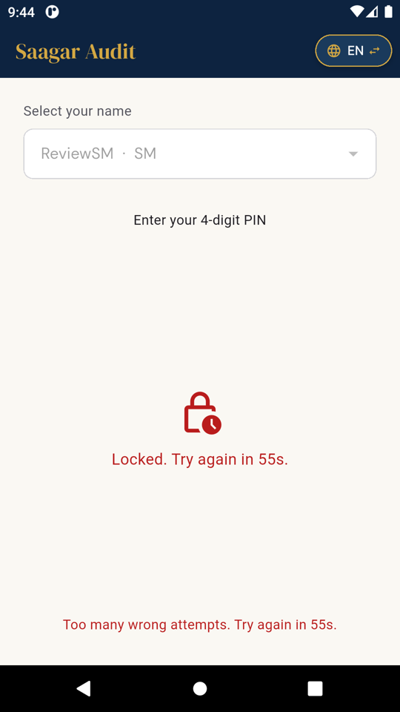  Lock after 5 wrong PINs | 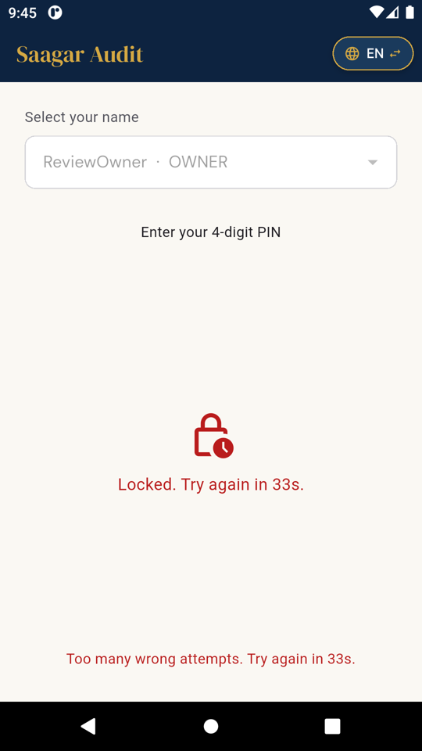  Owner locked by SM's attempts

C. Alerts, escalations, cash logic and reports

9. "WhatsApp Sent" shown when nothing was sent
Priority: High | Our ref: F01
What I did: Submitted a daily audit with a closing cash shortage of Rs 600.
What happened: The app opened a WhatsApp web link. No WhatsApp app was used, no contact was picked and no message was sent, yet the escalation card shows a green "WhatsApp Sent" badge. The database also stores whatsapp_sent = 1.
Why it matters: Staff will believe the GM or I have been informed about a cash shortage when nobody has been told.
What needs to be done: Show "Share opened" or "Not confirmed" instead. Only show "Sent" if delivery can actually be confirmed.
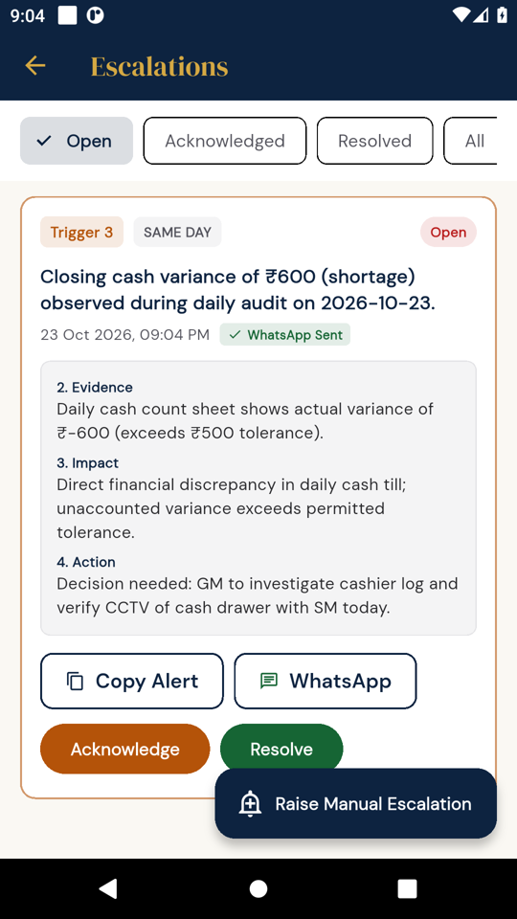
Escalation shows "WhatsApp Sent"

10. Submitting an audit jumps to WhatsApp before confirming the save
Priority: Medium | Our ref: F09
What I did: Submitted the same daily audit.
What happened: The app went straight to the WhatsApp link. Only after pressing Back did I see that the audit had been saved.
Why it matters: Staff may think the submission failed and repeat it, or leave the audit unsure.
What needs to be done: First show "Audit saved, escalation created", then give a separate "Share alert" button.
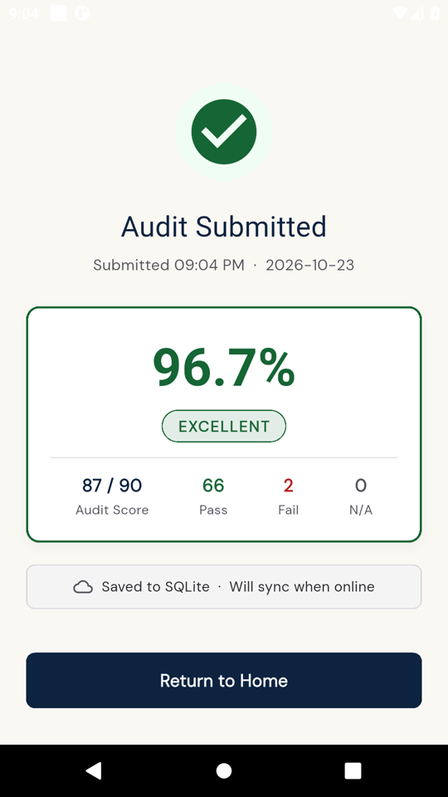
Save confirmation seen only after coming back

11. Low-score escalation is announced but never created
Priority: High | Our ref: F18
What I did: Submitted a monthly audit scoring 60% (and earlier a weekly at 52%).
What happened: The confirmation says "Score < 85.0% (Poor/Critical): Mandatory Escalation Trigger 1 activated." But Escalations > All shows only the old cash alert, and the database has no new escalation. It was the same on both Android versions.
Why it matters: A critical score is reported to the user as escalated, but nobody receives it and nothing can be followed up.
What needs to be done: Create the Trigger 1 escalation record, assign it to the right person and show it in Escalations and in the reports. If that is not ready yet, remove the message.
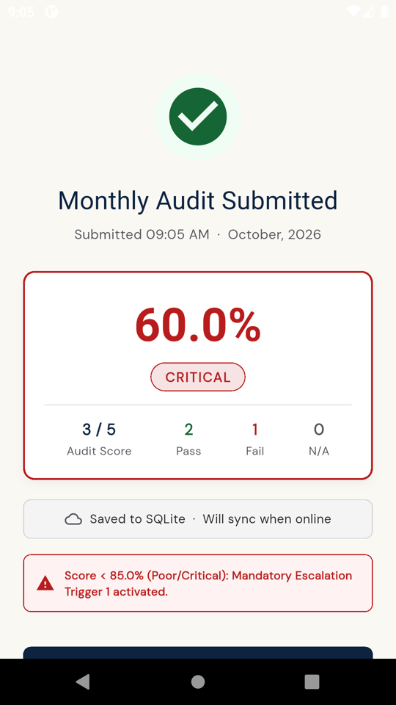  "Trigger 1 activated" | 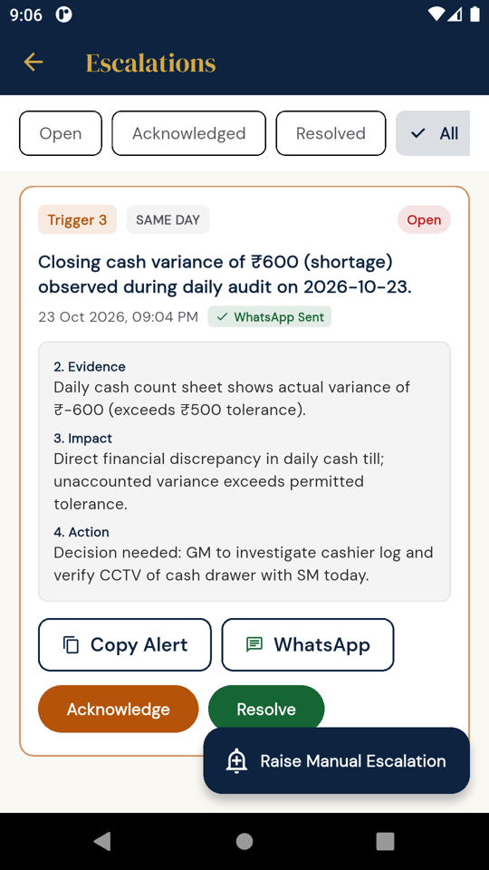  No Trigger 1 escalation exists

12. Weekly report escalation section is a placeholder
Priority: Medium | Our ref: F13
What I did: Opened the week-43 weekly report and its PDF, then the October monthly report.
What happened: The weekly report says "No escalations triggered (Escalation engine active in Phase 3)" and the PDF says "Escalations: 0", even though the Rs 600 cash alert for that week exists and is open. The monthly report correctly lists the same alert. So the data is there; the weekly section just does not read it. The weekly PDF also shows "Phase 2-5" placeholders in the CAP boxes.
Why it matters: A weekly report that says "no escalations" when there is an open cash alert gives the reader false comfort.
What needs to be done: Fill the weekly escalation and CAP sections from the real records, and remove phase placeholders from anything that goes in a report.
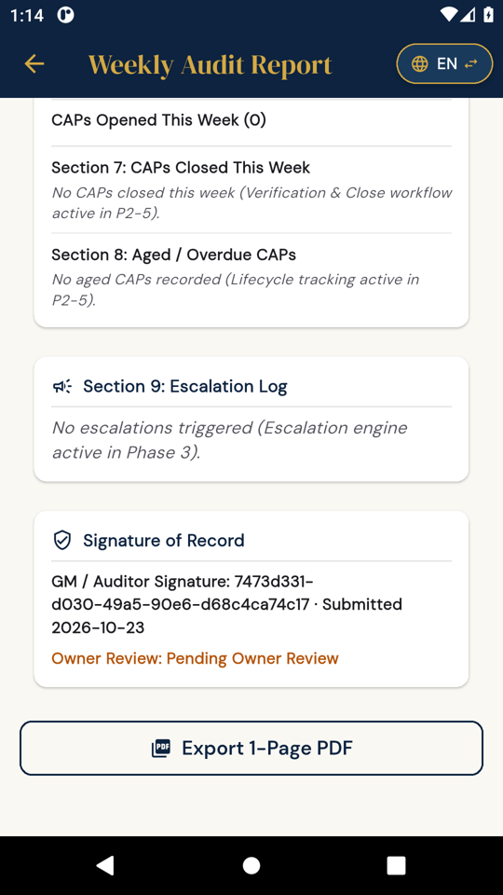  Weekly report: placeholder | 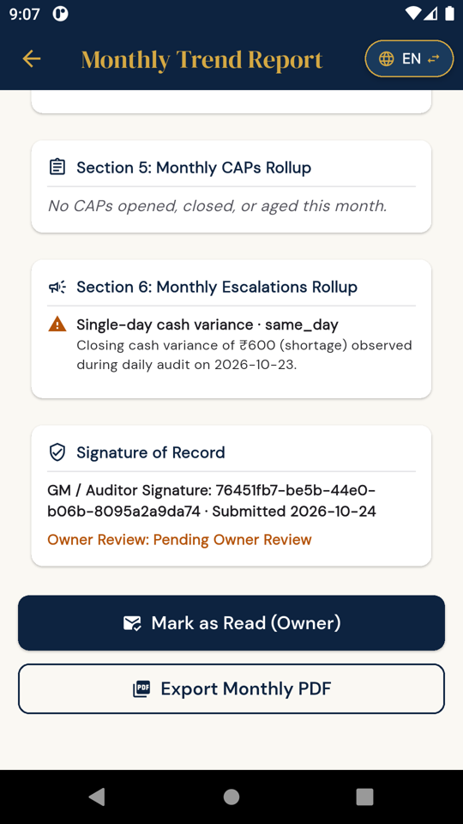  Monthly report lists the alert

13. Cash variance of Rs 600 saved as Pass, and three different cash limits
Priority: High | Our ref: F12 and F15
What I did: Daily audit with closing cash variance of -Rs 600, followed by the weekly audit.
What happened: Daily checkpoint 6.5 "Cash variance ≤ Rs 50" was saved as Pass in the same audit that records a variance of -600. In the weekly audit, CW.7 "Cumulative weekly variance within ±Rs 200" was accepted as Pass while the review screen itself showed -600. The weekly report and PDF then show Cash Management 16/16, 100%. On top of that, the app uses three different limits: Rs 50 (daily checkpoint), Rs 500 (the escalation message says "exceeds Rs 500 tolerance") and Rs 200 (weekly).
Why it matters: Our cash compliance can show 100% in a week with an unexplained shortage. Cash is the most sensitive area for us.
- Calculate cash checkpoints automatically from the variance entered, or require a written explanation and approval to pass them when the variance is above the limit.
- Keep one set of cash limits in settings and use them everywhere. I will confirm the limits we want.
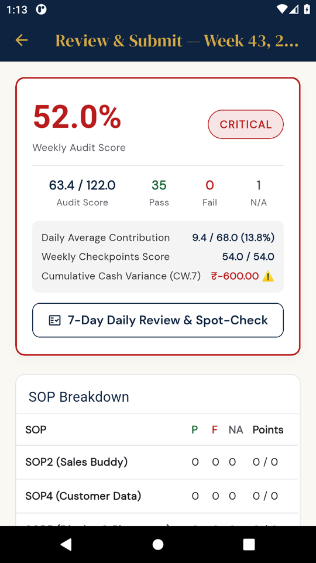  Weekly review shows -600 but allows Pass | 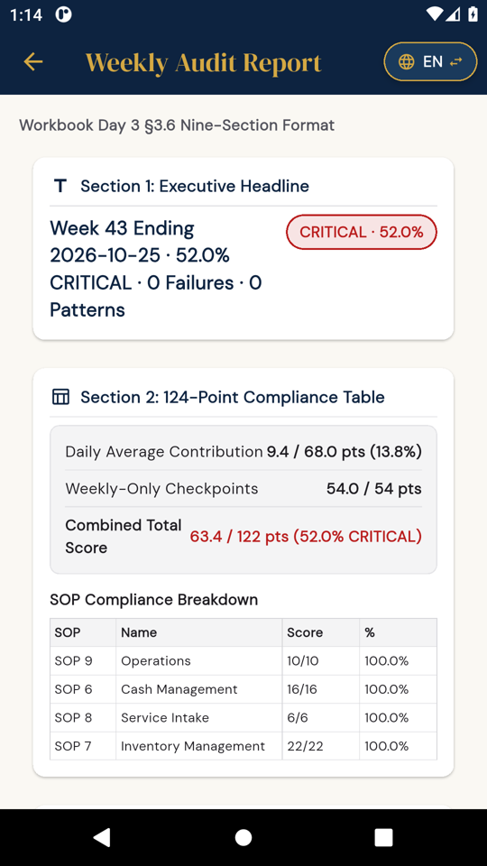  Weekly report: Cash 16/16, 100%

14. Safe-cash checkpoint counted under Sales Buddy
Priority: Medium | Our ref: F08
What I did: Completed the monthly audit.
What happened: Monthly checkpoint MC.1 "Recount safe cash" is under Sales Buddy (SOP 2). In the score breakdown, the monthly report and the PDF its points appear under Sales Buddy 2/2, while Cash Management shows 0/0.
What needs to be done: Move MC.1 to Cash Management (SOP 6) and correct existing records carefully. This is a good first use of the versioning in Part A, point 1.
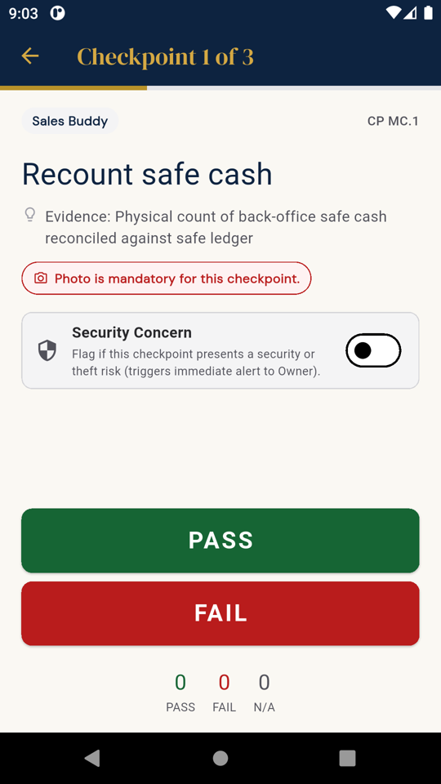  MC.1 labelled Sales Buddy | 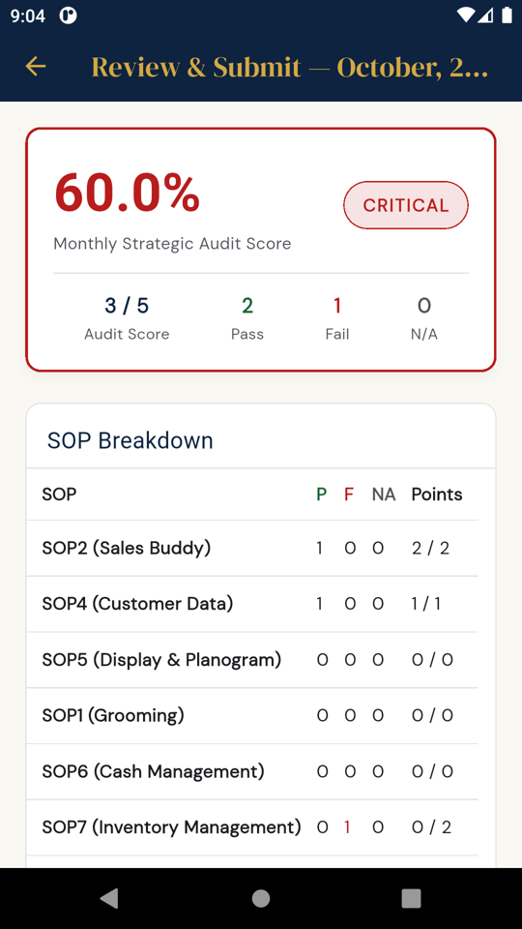  Breakdown: Sales Buddy 2/2, Cash 0/0

15. Daily audit detail buttons are "Phase 2" placeholders
Priority: Medium | Our ref: F03
What I did: Opened a submitted daily audit from history and tapped Export PDF, Verify and Share.
What happened: Each shows a "scheduled for Phase 2" message. GM verification actually works through 7-Day Review, so the button on this screen just goes nowhere.
What needs to be done: Connect these buttons to the working features (verification through 7-Day Review), or hide them until they are built.
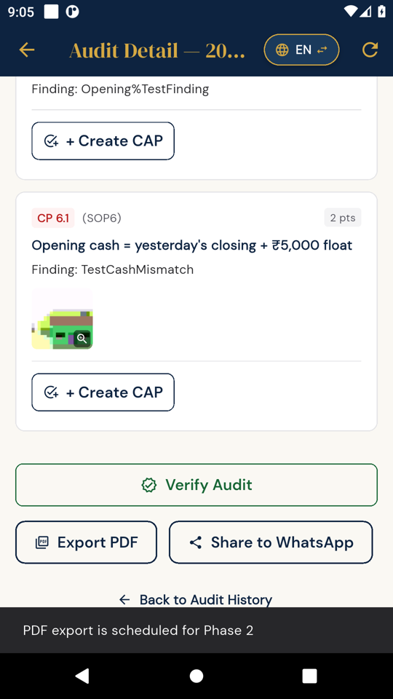
Export PDF: "Phase 2"

16. Marathi text is broken in all PDFs, and other PDF issues
Priority: High | Our ref: F14
What I did: Exported the weekly and monthly reports to PDF and opened them.
What happened: The PDFs are produced, fit on one page and the numbers match the app. But every Marathi word with a vowel sign is drawn wrongly: विभाग appears as "वभिाग", साप्ताहिक as "साप्ताहकि", मासिक as "मासकि". The underlying text is correct (copy-paste gives the right Marathi); only the printed shape is wrong.
- Export goes straight to the Android share sheet. The app does not save its own copy and does not confirm the export, and the file name is a long code (weekly_report_<id>.pdf).
- Paper size is US Letter; please use A4.
- The signature line prints the user ID code and a raw UTC time (2026-10-23T19:43:45.860586Z) instead of the person's name and local time. The monthly report also labels the Owner as "GM / Auditor".
- The weekly headline says "0 Failures" although the daily audit that week had 2 failures, and the heading says "124-point" while the total is out of 122.
Why it matters: These PDFs go to management and Titan. Broken Marathi on every heading looks unprofessional.
What needs to be done: Use a PDF method that supports Devanagari shaping, then check both PDFs again. Fix the other points listed above.
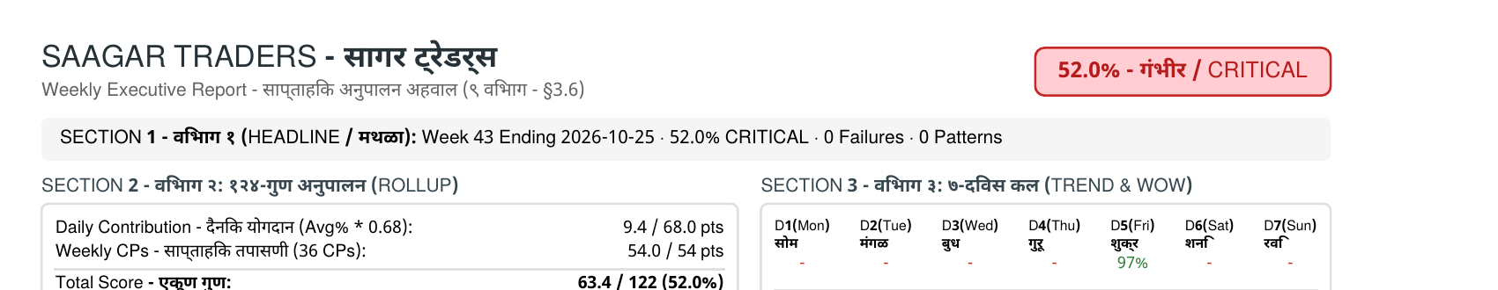  Weekly PDF: broken Marathi | 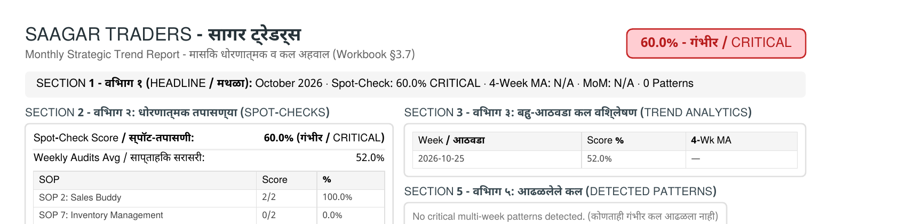  Monthly PDF: broken Marathi

D. Corrective Action Plans (CAPs)

17. CAP form shows the wrong checkpoints, and monthly/weekly failures cannot get a CAP
Priority: Medium | Our ref: F19
What I did: Opened New CAP and selected the origin audit.
What happened: The "Failed Checkpoint" list shows all daily checkpoints (2.1 to 8.8) regardless of which audit is selected, and pre-selects 2.1. Monthly (MC) and weekly checkpoints are not in the list at all, so the monthly failure MC.2, which shows "CAP Deferred", cannot get a CAP. I was able to create a CAP against checkpoint 6.5, which had passed in that audit.
What needs to be done: Show only the failed items of the selected audit, including weekly and monthly ones, and do not allow a CAP on an item that passed unless it is a pattern CAP.
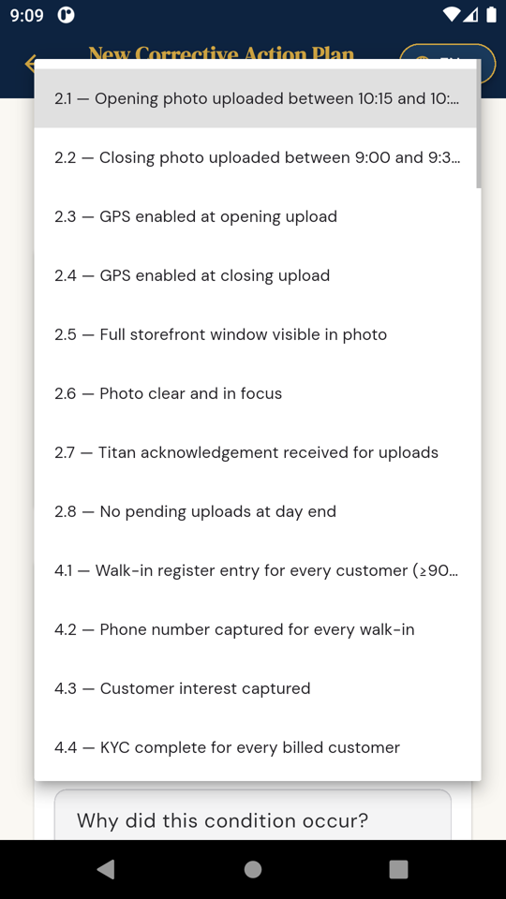  All daily checkpoints listed | 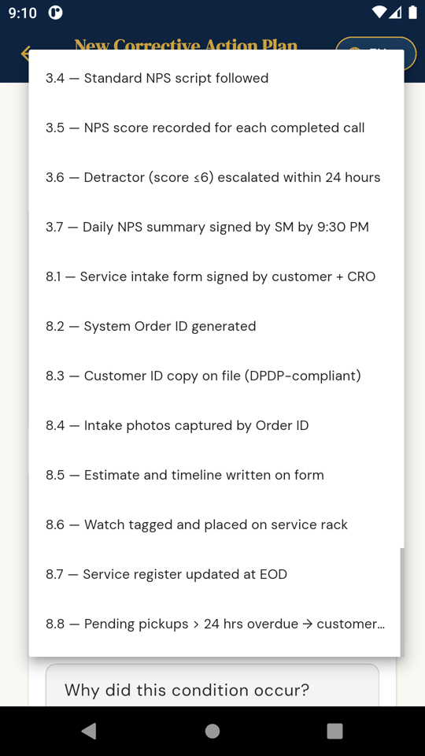  List ends at 8.8: no monthly items

18. CAP can be marked done with no note or photo
Priority: Medium | Our ref: F20
What I did: As Store Manager, ticked the three steps of the Rs 600 cash CAP and pressed Confirm & Mark Done with the notes empty and no photo.
What happened: It was accepted and moved to "Done (Pending Verify)".
What needs to be done: Make completion notes compulsory, and require a photo where the original checkpoint needs evidence.
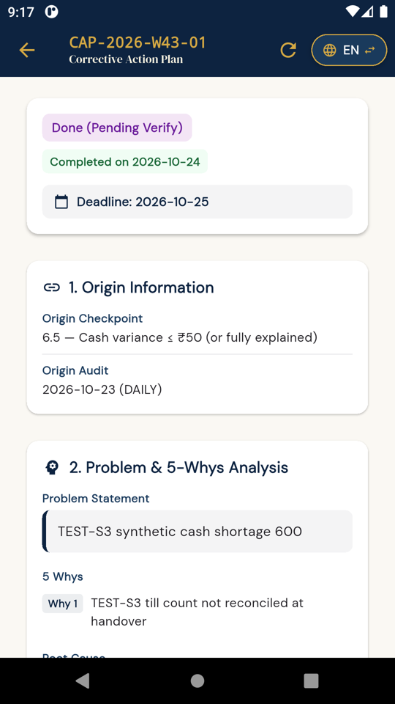
Marked done with nothing entered

19. "Request Extension" can move the deadline earlier
Priority: Low | Our ref: F22
What I did: Used Request Extension on a CAP due on 31 October and picked 25 October.
What happened: It was accepted and recorded as "Deadline extended to 2026-10-25", and counted as one extension.
What needs to be done: An extension date must be later than the current deadline.
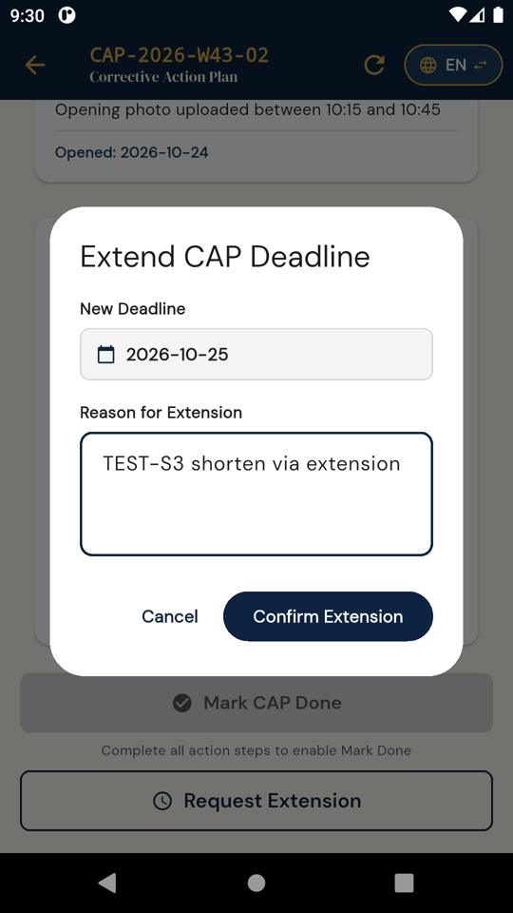  Earlier date allowed | 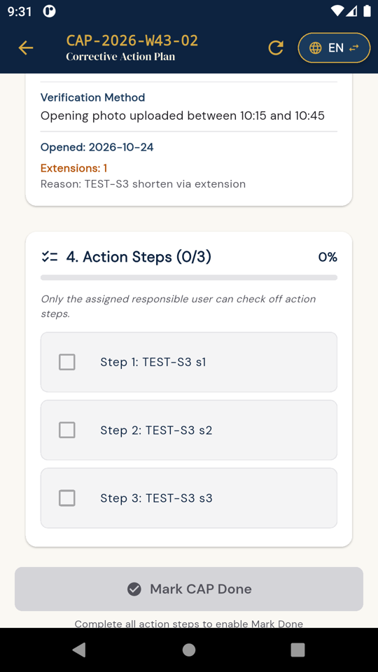  Logged as "extended"
What worked well in CAPs: required-field checks, past dates blocked for the deadline, steps restricted on screen to the responsible user, the reopen reason being compulsory, the verification photo being compulsory, Owner closure and a clear timeline. I could not yet test what happens when a CAP goes overdue; I will check that once you share the next build.

E. Language, permissions and screen layout

20. Daily checkpoints are not translated into Marathi
Priority: High | Our ref: F04
What I did: Switched the app to Marathi during the daily audit.
What happened: Buttons and menus change to Marathi, but the daily question, the evidence instruction and the category stay in English. In the app data, all 68 daily checkpoints have the English text copied into the Marathi field. The weekly and monthly ones are translated.
Why it matters: The daily audit is the one our store staff use every day.
What needs to be done: Translate all 68 daily questions and evidence lines. I will have them checked by our team before release.
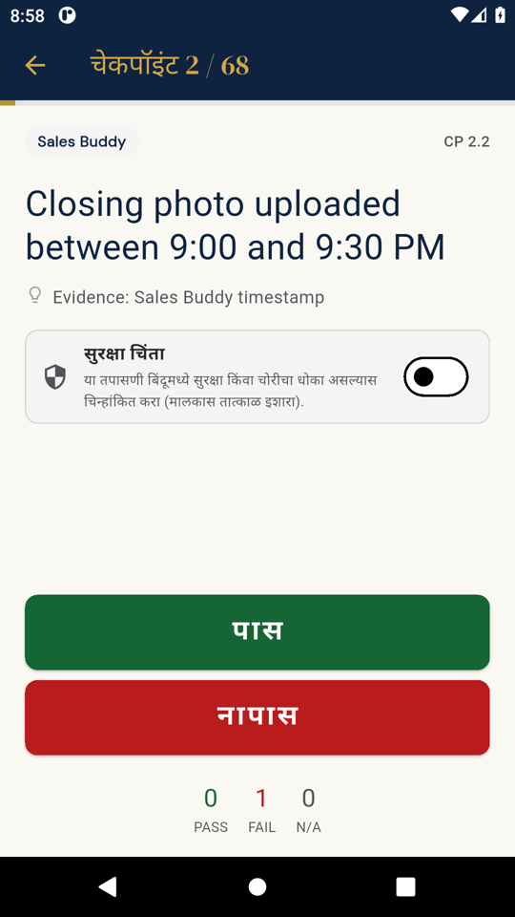
Marathi mode, English question

21. Camera permission denial leaves the user stuck
Priority: Medium | Our ref: F06
What I did: On a failed checkpoint that needs a photo, tapped Add photo and pressed "Don't allow" (and on Android 15, "Don't allow" twice).
What happened: Nothing explains what happened. After the second refusal, Add photo does nothing at all. The app log shows an unhandled error: PlatformException(camera_access_denied) in PhotoService.captureAndStore (photo_service.dart:28). The user cannot attach the required photo and cannot save the failure.
What needs to be done: Catch the error, explain why the camera is needed, offer Retry, and after a permanent refusal give a button that opens the app's settings.
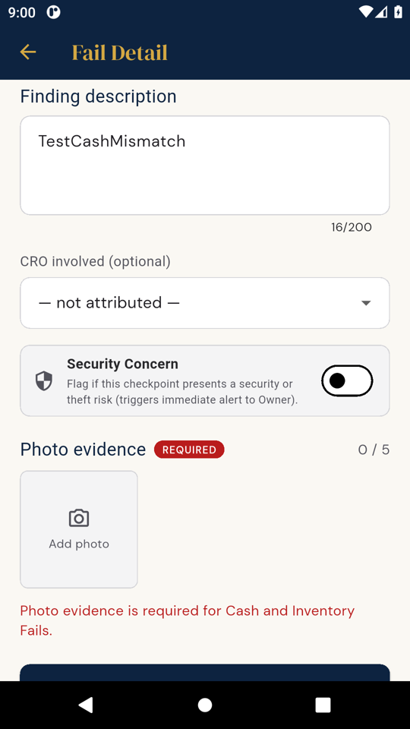  After denial | 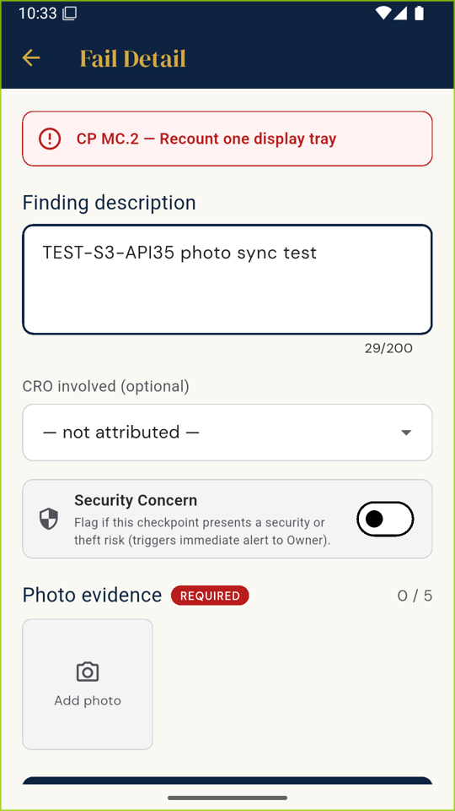  After permanent denial: no response

22. App never asks for notification permission on Android 13 and above
Priority: Medium | Our ref: F25
What I did: Fresh install on Android 15, setup and login as Owner.
What happened: No notification permission request appeared, and the permission stays off. The app includes reminders and notification code, so these will not show on newer phones. The app also requests contacts, microphone and storage permissions that are not used in any screen I went through.
What needs to be done: Ask for notification permission at the right moment (for example after login, with a one-line explanation), and remove permissions the app does not need.
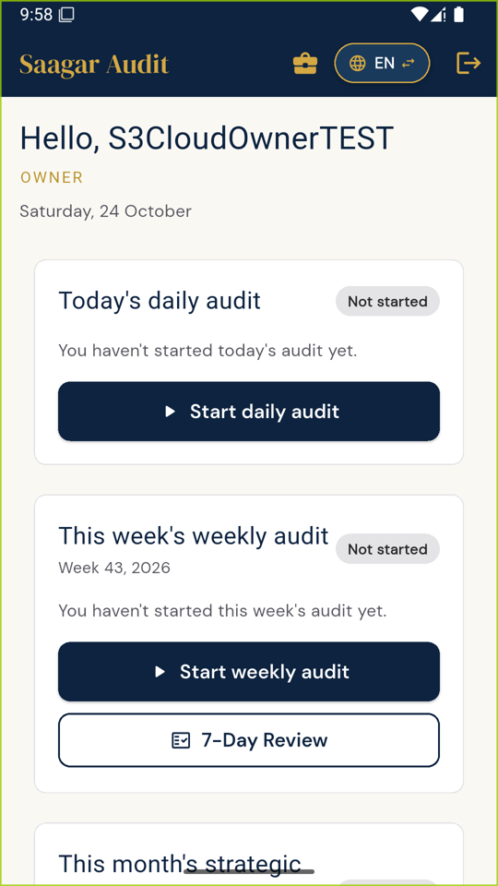
Home after first login: no permission request

23. Question disappears on small screens, and the report breaks with larger text
Priority: Medium | Our ref: F24 and U07
What I did: Increased the phone's font size to 130% and display size to the largest, and also checked a smaller 720×1280 screen in portrait and landscape.
What happened: On the smaller screen in landscape, the checkpoint question, the evidence text and the Security Concern switch do not appear at all; only PASS and FAIL are visible, so a person could mark an item without seeing what it is. In portrait, the PASS button covers part of the Security Concern card. With larger text, "Combined Total Score" on the weekly report breaks into one letter per line and overlaps the score.
Why it matters: Some of our staff use larger text, and not every store phone has a big screen.
What needs to be done: Let the PASS/FAIL area scroll or shrink so the question is always visible, and let report labels wrap properly.
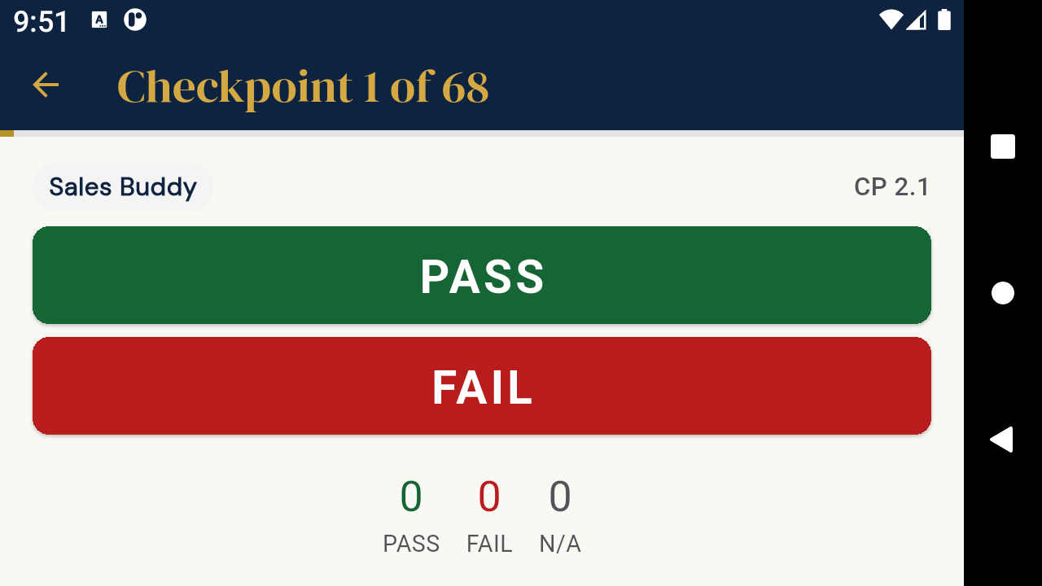  Landscape: no question shown | 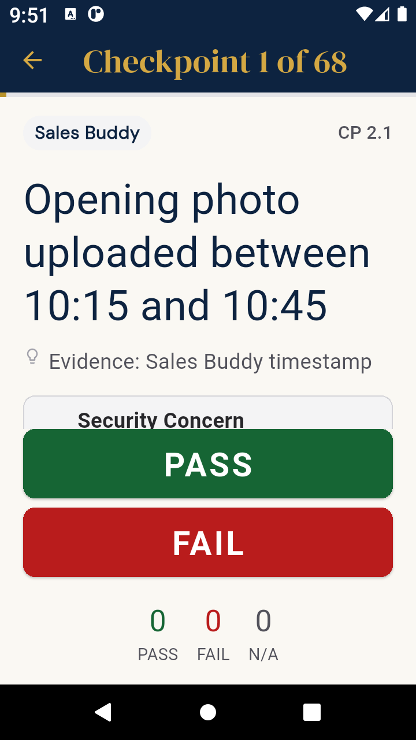  PASS covers Security Concern | 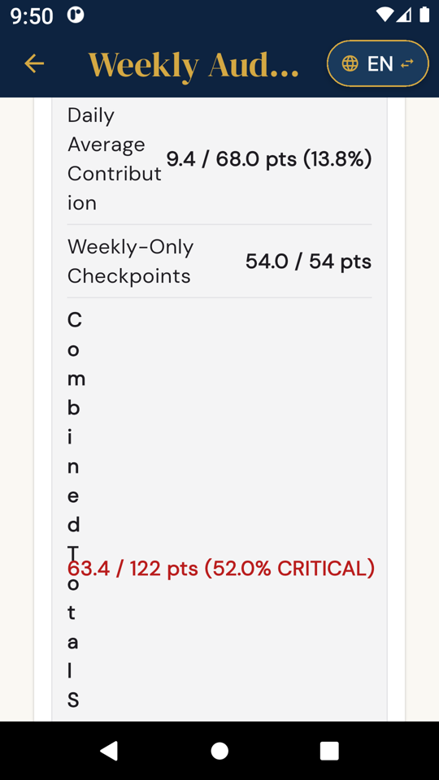  Larger text: report label breaks

24. Phone Back button exits the audit; the app back arrow goes to the previous checkpoint
Priority: Medium | Our ref: F05
What I did: Pressed the phone's Back button at checkpoint 2, then tried the arrow at the top of the screen.
What happened: Phone Back closed the app, and I had to log in again (the draft was saved, which is good). The app's arrow went back one checkpoint instead.
What needs to be done: Both should behave the same way. Add clear "Previous" and "Save & exit" buttons.
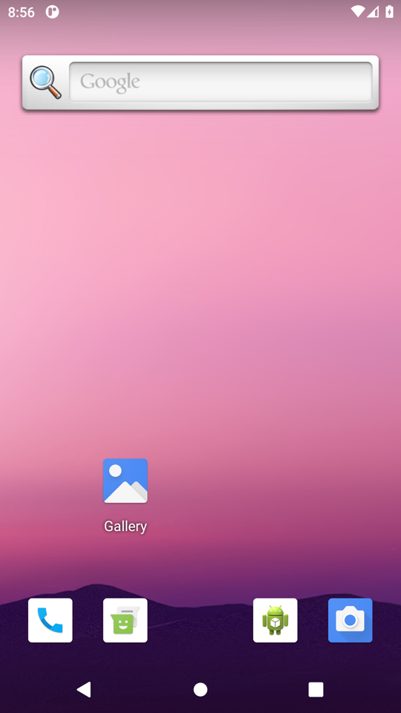  Phone Back exits the app | 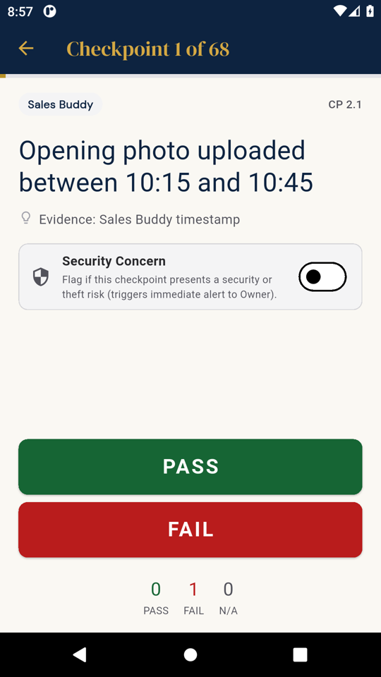  App arrow: previous checkpoint

25. Times shown in two different time zones without a label
Priority: Medium | Our ref: F07
What I did: Compared times across the app.
What happened: Submission said 09:04 PM while Audit Detail showed 15:34 for the same audit, which is UTC. CAP timelines also show UTC (03:44 for an action done at 09:14 IST). After midnight, a verification appeared under the previous day's date.
What needs to be done: Store in UTC if needed, but always display in IST.
Confirmation: 09:04 PM | 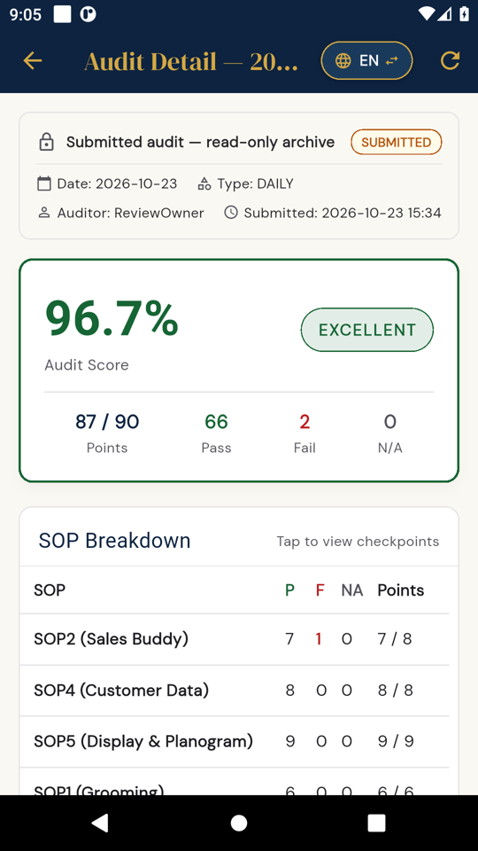  Detail: 15:34 (UTC)

26. "Photo is mandatory" shown where a Pass needs no photo
Priority: Low | Our ref: F17
What I did: Monthly checkpoint MC.1 shows "Photo is mandatory for this checkpoint". I pressed Pass without a photo.
What happened: Pass was accepted. A photo is actually needed only when marked Fail, which is fine, but the message says otherwise.
What needs to be done: Change it to "Photo required if marked Fail".
Message before answering | 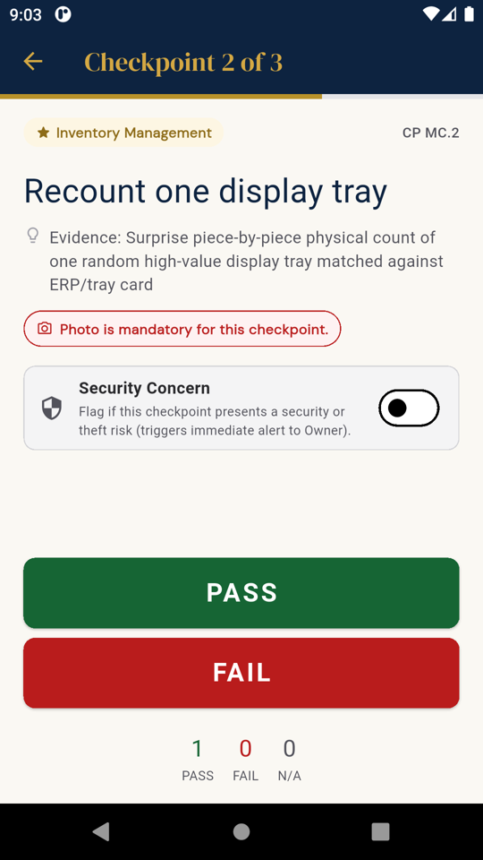  Pass accepted without photo

F. General ease-of-use points
These are not errors, but they will make daily use much easier for the store team:
- Too much scrolling. The large audit cards push History, CAPs, Escalations, Reports and Settings below the screen. A bottom menu (Home, Audits, Actions, Reports) would help. The 68-checkpoint audit needs a jump list showing answered, unanswered and failed items.
- Review screen cuts off text. Failed checkpoint names are shortened next to the "CAP Deferred" badge, and tapping a finding does not open it for correction.
- Error messages stay after the problem is fixed. For example, "photo required" stays after the photo is attached, and the CAP form keeps showing "required" after the fields are filled.
- Setup asks for the PIN three times (twice at setup, then again at login), and the owner-name error only appears after both PIN entries. Screens also show technical words such as SQLite, Firestore, 14 tables and Phase 1 Baseline.
- Progress shows "1% complete" before anything is answered, because it counts position rather than answers.
- Report signatures show a code instead of the person's name (see item 16).
- Reports are frozen at submission, so a CAP created after the weekly report never appears in it. That is acceptable if it is intended, but please confirm and add a note or addendum option.
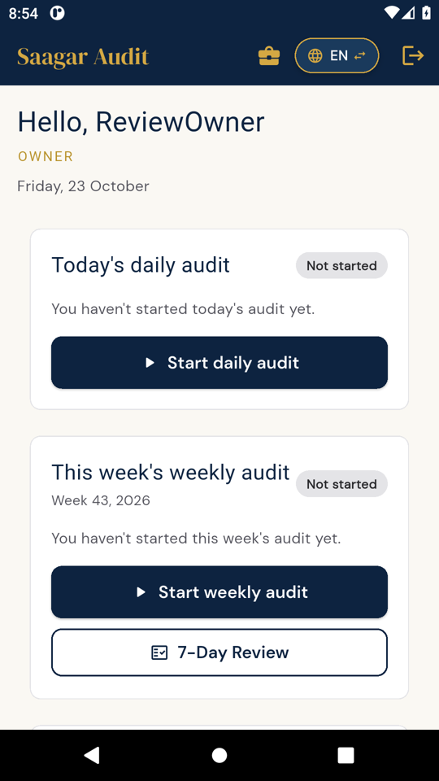  Home: main menus below the fold | 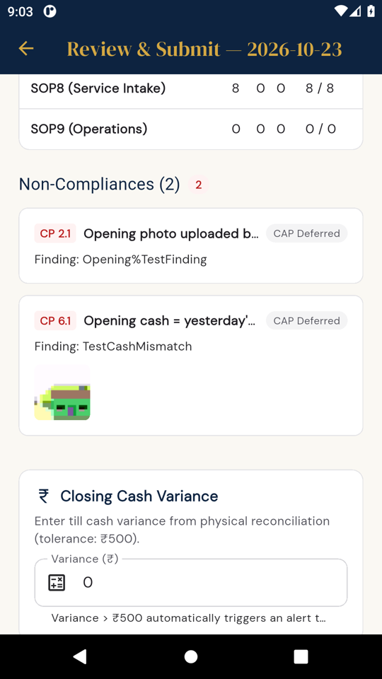  Review: titles cut off | 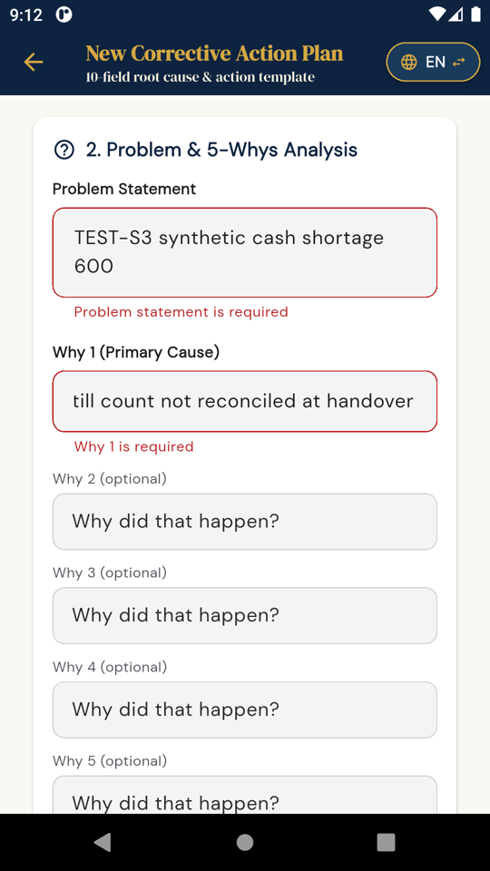  CAP form: errors stay after filling

Next steps
My suggested order of work:
- Multi-user login with roles and cloud security rules (Part A point 4; items 4, 6 and 7).
- Real restore and honest backup status (items 1, 2, 3 and 5).
- Escalations, cash logic and reports that we can trust (items 9 to 16).
- CAP controls (items 17 to 19).
- Marathi, permissions, layout and the ease-of-use points (items 20 to 27).
- SOP/checkpoint versioning, the hybrid editor with archive-only, and ad-hoc audits (Part A points 1 to 3).
With the next build, please send a short change list against these item numbers and increase the version number, so I can retest each one. I will then also check overdue CAP ageing, behaviour on our store phones, and whether existing data survives the app update.
I have a full evidence pack with all screenshots and the detailed steps if your team needs more information on any item.
Regards,
Sagar Bora
Saagar Traders, Latur

