**A Project Report**

**on**

**Academic system**

*Submitted in partial fulfillment of the requirement*

*for the award of the degree*

**Bachelor of Technology**

**in**

**Computer Science and Engineering**

By

Saurabh Soni(18CS002113)

&

Aniket Vyas(18CS002096)

*Submitted to*

**

***Computer Science and Engineering Department,***

***Sir Padampat Singhania University***

***Udaipur 313601, Rajasthan, India***

***Under the supervision of***

Dr. Ashutosh Gupta

Associate Professor

Computer Science and Engineering Department

Sir Padampat Singhania University

Udaipur 313601 Rajasthan India

**DECLARATION**

We, Saurabh Soni and Aniket Vyas, student of B.Tech (Computer Science & Engineering) hereby declare that the project entitled ***“Academic system”***, which is submitted by me/us to the department of **Computer Science & Engineering , School of Engineering, Sir Padampat Singhania University, Udaipur,** in partial fulfillment of requirement for the award of the degree of Bachelor of Technology in Computer Science & Engineering , has not been previously formed the basis for the award of any degree, diploma or other similar title or recognition.

Udaipur

Date: 19/11/20

**

**C E R T I F I C A T E**

This is to certify that the project entitled **‘Academic system’** is being submitted by Saurabh Soni and Aniket Vyas, in partial fulfillment of the requirement for the award of degree of *Bachelor of Technology,* has been carried out under my supervision and guidance.

The matter embodied in this report has not been submitted, in part or in full, to any other university or institute for the award of any degree, diploma or certificate.

Dr. Ashutosh Gupta

Associate Professor

Department of Computer Science and Engineering

Sir Padampat Singhania University

Udaipur 313601 Rajasthan India

**ACKNOWLEDGEMENT**

First, I express our heartiest thanks and gratefulness to almighty God for His divine blessing makes it possible to complete the final year project/internship successfully.

I would like to express my sincere gratitude to my project guide Ashutosh Gupta for awarding me with proper guidance and opportunity to work on this topic. I would also like to thank all my colleagues for helping me throughout the internship. It would not have been possible for me to carry this project to this level without their innovative ideas, valuable suggestions, relentless support and encouragement.

           I also take this opportunity to express a deep sense of gratitude to the **COMPUTER SCIENCE** department which helped me in completing this report through various stages.

Finally, I must acknowledge with due respect the constant support and patients of my parents.

**ABSTRACT**

There is no communication medium which is beneficent to all the people in the college through which they can share their ideas, information and have a personal account where they can save some stuff which is helpful in future. So our aim is to provide an application which provides a good interaction between all members of the college and is available for them anywhere.

The project is meant for web app based which allow the users to access it from anywhere as most of them carry smart phones with them. The proposed project is to help learn subject efficiently with connected to the university network : Faculty, Students, Management and other department.

**CONTENTS**

**DECLARATION i**

**CERTIFICATE ii**

**ACKNOWLEDGEMENT iii**

**ABSTRACT iv**

**TABLE OF CONTENTS v**

**LIST OF TABLES vi**

**LIST OF FIGURES vii**

**LIST OF ABBREVATIONS viii**

**CHAPTER 1. INTRODUCTION AND OVERVIEW**

1.1 Introduction of our project 9

1.2 Objectives 9

**CHAPTER 2. WORKING OF OUR PROJECT 14**

2.1 Application Development Process 14

2.1.1 Strategy 14

2.1.2 Analysis and Planning 14

2.1.3 UI / UX Design 15

2.1.3.1 Wireframes 15

2.1.3.2 Style Guide 15

2.1.3.3 Mockups 16

2.1.3.4 Prototype 16

2.1.4 App Development 16

2.1.4.1 Back-End/ Server Technology 16

2.1.4.2 API 16

2.1.4.3 Web app app Frontend 17

2.1.5 Testing 17

2.1.6 Deployment and support 18

2.1.7 Maintenance & Update 19

2.2 Methodology of our project 19

2.3 Project Outcomes 20

**CHAPTER 3. CONCLUSIONS AND FUTURE SCOPE OF WORK 35**

**REFERENCES**

**APPENDIX**

**LIST OF FIGURES**

TOPIC PAGE NO

Figure 1 Working of our Project 19

Figure 2 Login screen 22

Figure 3 Student layout 23

Figure 4.1 Student lecture dashboard 23

Figure 4.2 Enrolled lectures 23

Figure 4.3 lecture tracking 24

Figure 4.4. Attendance View 25

Figure 4 Faculty layout 26

Figure 5.3 Faculty dashboard 27

Figure 5.4 Lecture View 27

Figure 5.5 Set Goal 28

Figure 5.6 Lecture tracking 29

Figure 5.7 Attendance view 31

Figure 5.8 Attendance upload 31

Figure 5.9 Request a lecture 32

Figure 5 HOD Layout

Figure 5.3 HOD dashboard 33

Figure 5.4 Lecture View 34

Figure 5.6 Lecture tracking 36

Figure 5.7 Attendance view 37

Figure 5.9 validate a lecture 39

**Chapter 1: Introduction & Overview**

* 1. **Introduction of our Project**

“Academic Portal “ is a web app system that provides the functions and features to authenticate and identify the users and provide them with an easy, intuitive, personalized and user-customizable web app-interface for facilitating access to information and services that are of primary relevance and interests to the users. Academic Portal is nothing but a portal which thinks students as the main target users & provides so many useful services to students at a single place & through a single interface but in customized form.

* 1. **Objective**

Main objective of our project is to provide single place for all kinds of jobs like creating department, subjects students are enrolled to and which faculty assigned to which student, attendance management, etc. and proposed system is not only to be useful to students of the college but also staff members & administrative persons of the college. System objective is of being useful in significant way by providing most basic & most essential functionalities & features to its users in efficient & effective manner.

**CHAPTER 2. WORKING OF OUR PROJECT**

**2.1 Application Development Process**

**Various Steps consider in Application Development Process:**

● Strategy

● Analysis and Planning

● UI / UX Design

● App Development

● Testing

● Deployment & support

● Maintenance & Update

**2.1.1 Strategy:**

The first phase of the web app development process is defining the strategy for evolving your idea into a successful app. You may include a more significant part of this in your overall[enterprise mobility strategy](https://www.invonto.com/insights/enterprise-mobility-strategy/). As one app’s objectives may differ from another, there is still an app-specific impact to the mobility strategy to address during the development process.

In this phase, you will:

* Identify the app users
* competition Research the
* Establish the app’s goals and objectives
* Select a mobile platform for your app

**2.1.2 Analysis and Planning:**

At this stage, your app idea starts taking shape and turns into an actual project. Analysis and planning begin with defining use cases and capturing detailed functional requirements.

After you have identified the requirements for your app, prepare a product roadmap.  This includes prioritizing the web app app requirements and grouping them into delivery milestones. If time, resources or costs are a concern, then define your[minimum-viable-product (MVP)](https://en.wikipedia.org/wiki/Minimum_viable_product) and prioritize this for the initial launch.

Part of the planning phase includes identifying the skills needed for your app development initiative.

Have you selected the name of your app yet? Web app names are like domain names Research each app store ensuring your app’s name isn’t already in use!

**2.1.3 UI / UX Design:**

The purpose of an app’s design is to deliver seamless and effortless user experiences with a polished look.

The success of a web app app is determined based on how well users are adopting and benefiting from all its features. The goal for web app app [UI / UX design](https://www.invonto.com/services/mobile-app-development/) is creating excellent user experiences making your app interactive, intuitive, and user-friendly. While polished UI designs will help with early adoption, your app must have intuitive user experiences to keep app users engaged.

### **2.1.3.1 Wireframes**

Web app app designers often start app design with sketches on paper. Wireframes are the digital form of sketches. Wireframes are conceptual layouts, also referred to as low-fidelity mock-ups—they give visual structure to your app’s functional requirements.

With wireframes, the focus is more on aesthetics and user experience, not on color schemes and styles. Creating wireframes is a quick and cost-effective approach for designing app layouts and iterating through them in the design review process. While creating wireframes you should consider device specific design. So, whether your app is used on iPhone, iPad, or Android phone and tablets; it provides intuitive and device specific user experiences.

### **2.1.3.2 Style Guide**

Style guides are “living documents” where an app’s design standards from your company’s branding rules down to the navigation icons, are documented.

Style guides include:

* What font family will your app’s text use?
* What will the color scheme be?
* How will your company brand be reflected in the app design?

Style guides contribute to an app’s design strategy. Establishing a style guide early on as part of your web app development process improves the productivity of your web app developers. At the same time, following a style guide will help keep your app’s look and feel consistent.

### **2.1.3.3 Mockups**

Mockups, or high-fidelity designs, are the final renderings of your app’s visual design. Mockups are created by applying your style guide on to the app wireframes. As your app’s design begins to finalize, expect further modifications to its information architecture, workflow, and aesthetics. Adobe Photoshop is the most popular tool for creating high-fidelity mockups.

### **2.1.3.4 Prototype**

While mockups display your web app app’s functionality using static designs, these can turn into click-thru prototypes with tools like[Invision](https://www.invisionapp.com/) and Figma. Prototypes are highly useful for simulating the user experience and the app’s workflows expected from the finished product. While prototype development can be time-consuming, the efforts are well worth it, as they offer early-stage testing of your app’s design and functionality. Often, prototypes help identify modifications to the app’s proposed functionality.

Some companies prefer even doing prototypes at a wireframing stage, especially when an app’s functional requirements are not well thought out. Or, there is a need to review the app’s proposed functionality with a focus group.

**2.1.4 App Development:**

Planning remains an integral part of this phase in the web app development process. Before actual development/programming efforts start, you will have to:

* define the technical architecture,
* pick a technology stack, and
* Define the development milestones.

A typical web app project is made up of three integral parts: back-end/server technology, API(s) and the web app front-end.

### **2.1.4.1 Back-End/Server Technology**

This part includes database and server-side objects necessary for supporting functions of your web app. If you are using an existing back-end platform, then modifications may be needed for supporting the desired web functionality.

### **2.1.4.2 API**

An Application Programming Interface (API) is a method of communication between the app and a back-end server/database.

### **2.1.4.3 Web app app Front-End**

The front-end is the native web app app an end-user will use. In most cases, web app apps consist of interactive user experiences that use an API and a back-end for managing data. In some cases, when an app needs to allow users to work without internet access, the app may utilize local browser storage.

You can utilize almost any web app programming language and databases for the back-end. For native web app apps..

There is more than one programming language and technology stack for building web app apps —the key is picking a technology stack that is best suited for your web app app.

Web technologies advance much faster with new versions of web platforms. Furthermore, With platforms and devices rapidly changing, agility is essential for building web app apps within timelines and budgets. If time-to-market is a priority, use an agile development approach. This approach supports frequent software releases with completed functionality. Defining development milestones as part of the agile development plan supports developing your web app application in iteration.

As each development milestone completes, it is passed on to the app testing team for validation.

**2.1.5 Testing:**

Performing thorough quality assurance (QA) testing during the web app app development process makes applications stable, usable, and secure. To ensure comprehensive QA testing of your app, you first need to prepare test cases that address all aspects of app testing.

Similar to how use cases drive the process of web app app development, test cases drive web app app testing. Test cases are for performing test steps, recording testing results for software quality evaluation, and tracking fixes for retesting. A best practice approach is involving your QA team in the Analysis and Design stages. The familiarity with your app’s functional requirements and objectives will help produce accurate test cases.

Your app should undergo the following testing methods, to deliver a quality mobility solution.

### 1 User Experience Testing

### 2 Functional Testing

### 3 Performance Testing

### 4 Security Testing

### 5 Device and Platform Testing

### **2.1.6 Deployment & Support**

Releasing a native web app requires Hosting it to a shared/vps/cloud based hosting service.

An app’s release in the app store requires preparing Information including:

* App’s Information
* Description
* DB Creds
* Environment Setup
* Security checkup/firewall
* Configuring bash console

**2.1.7 Maintenance & Update:**

For better operation of the world’s cyber site, monitor the application time to time. We make update periodically needed as per the requisites. Even maintenance of app is required, when any visitors keep updated. Whatever changes in the information comes from contact, any additional articles added and other links added in the app added. We offer maintenance support on the app according to time.

**2.2 Methodology of our project**

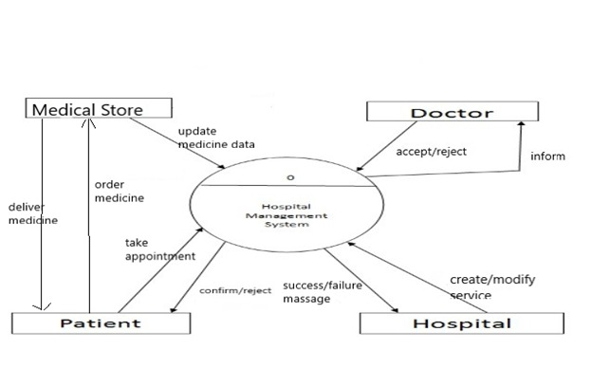

**Figure 1. Working of our Project**

The above flowchart shows working of our academic portal

In this project, we are using information of different university users and develop this by using web application.

1.student: The students would be able to view thier lectures onto which they are enrolled, also can track their lecture status and access lecture notes in chronological order, they can also view their attendance for their respective lectures.

2. Faculty: A faculty can use this app to set his daily goals for the lecture he has been assigned to , and can update his goals,upload teaching stuff for references, and also can give attendance to students.

3. HOD: A HOD can use this app to manage the department that he is assigned to , he can create a lecture , assign a faculty to it, and also enroll students onto the lecture.,and also he can put a lecture on hold and also disable it temporarily.

.

All the accounts are managed by admin here. Every student, faculty, hod has their own id for using this Application.

5. System Requirement:

(A)For application development: -

1. Python based Django Environment

2. PostgreSQL Database.

System Requirements: - Microsoft® Windows® 7/8/10 (64-bit),4 GB RAM minimum, 8 GB RAM recommended,2 GB of available disk space minimum, 4 GB Recommended (500 MB for IDE + 1.5 GB

(B)For application deployment: -

1. Python based Django Environment support with latest updates

System Requirements: - 1.2 GHz Processor Minimum, 512 MB memory (RAM) Minimum, and 960×540 display resolution.

**2.3 Project Outcome**

First is our splash screen it is the first screen visible to the user when the applications launched.

Second are main dashboard in this dashboard application ask you to login and once the authentication is completed, you will be redirected to your respective dashboard and with respective the access and permission level you can use those functionality provided to you in the first place. Every user application has its own working and is completely secured through anonymous attacks that nowdays noob hackers does. Last but not the least, it also has completed access to the admin guy who can do whatever he needs to do.

**CHAPTER 3. CONCLUSIONS AND FUTURE SCOPE OF WORK**

**3.1 Conclusions**

The research is based on the implementation of a web app portal in web app development platform. It can be easily implemented in any institution without much modification. Some of the user requirements are user friendliness, data security and data maintainability. All these requirements are included in this project. The maintenance is done only by authorized person which called as admin user. Thus the application is more flexible and changes can be made without any difficulty.

**3.2 Future Scope**

In future, the system can be extended to conduct various interacting sections for each and every person comes under the college or institution. Also more discussion forums can be introduced in order to know each moment in college.

**Login Screen For everyone using this application**

**Student dashboard**

**Lecture Information on student dashboard**

**Lecture Tracking**

**Attendance view from student dashboard**

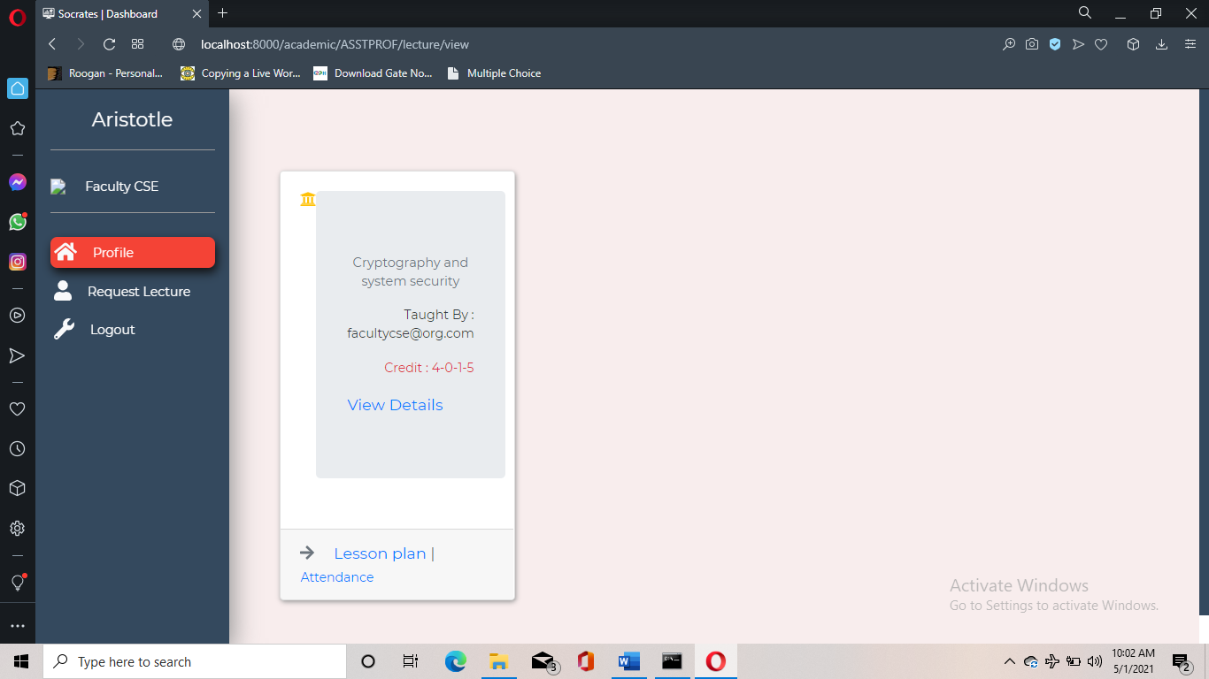

**Faculty Lecture View**

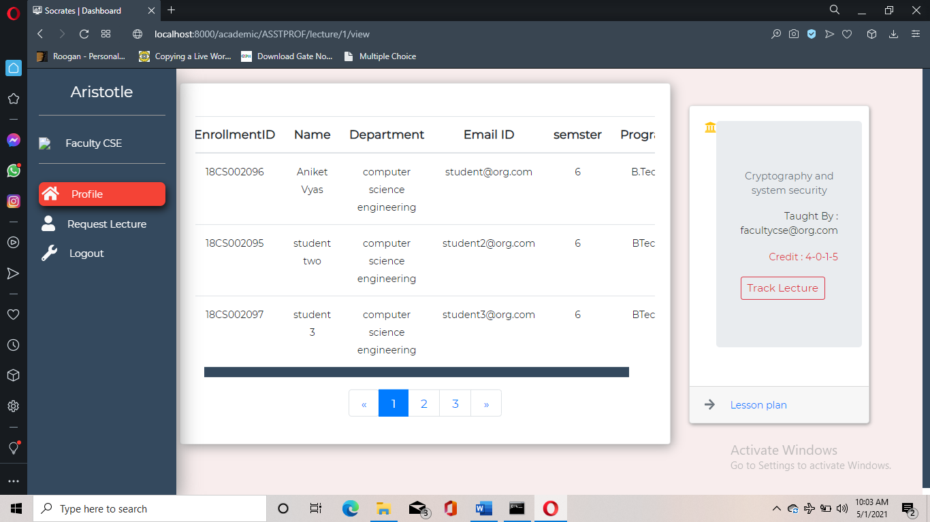

**Lecture Details (Faculty View)**

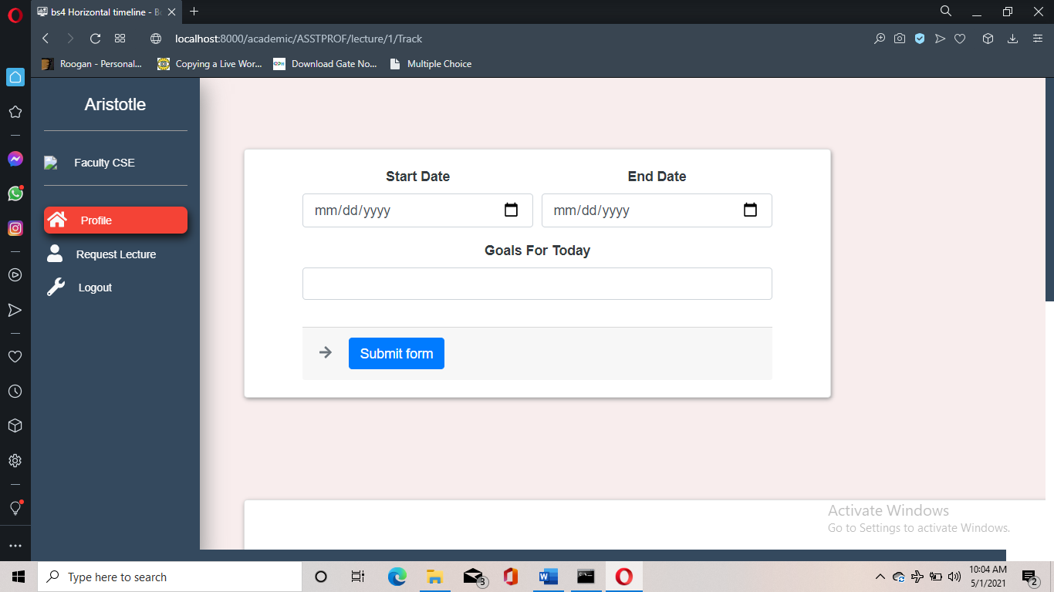

**Goal Settings(Faculty View)**

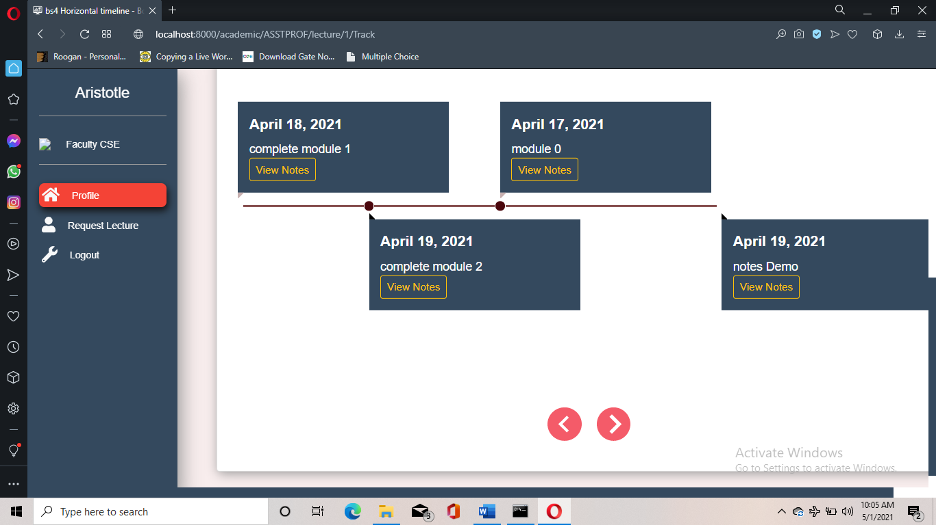

**Lecture Track(Faculty View)**

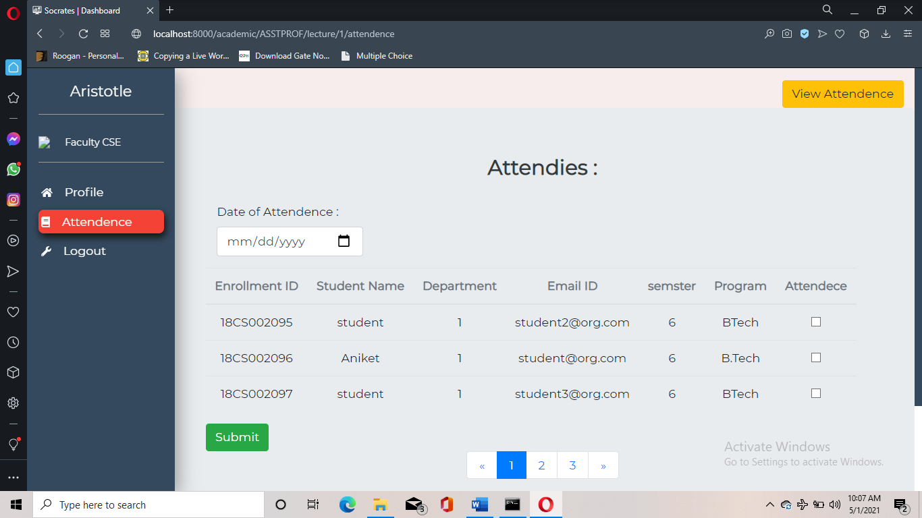

**Upload Attendance (Faculty View)**

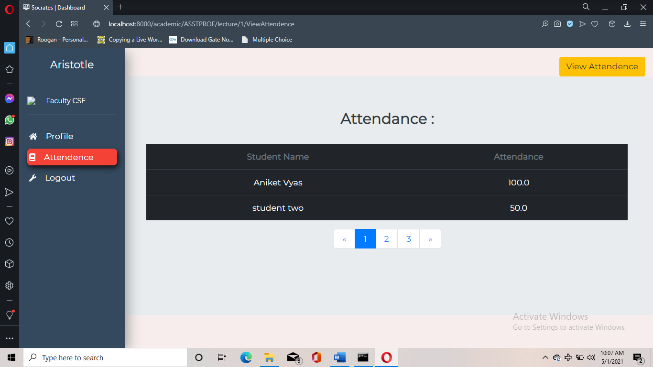

**Attendance View(Faculty view)**

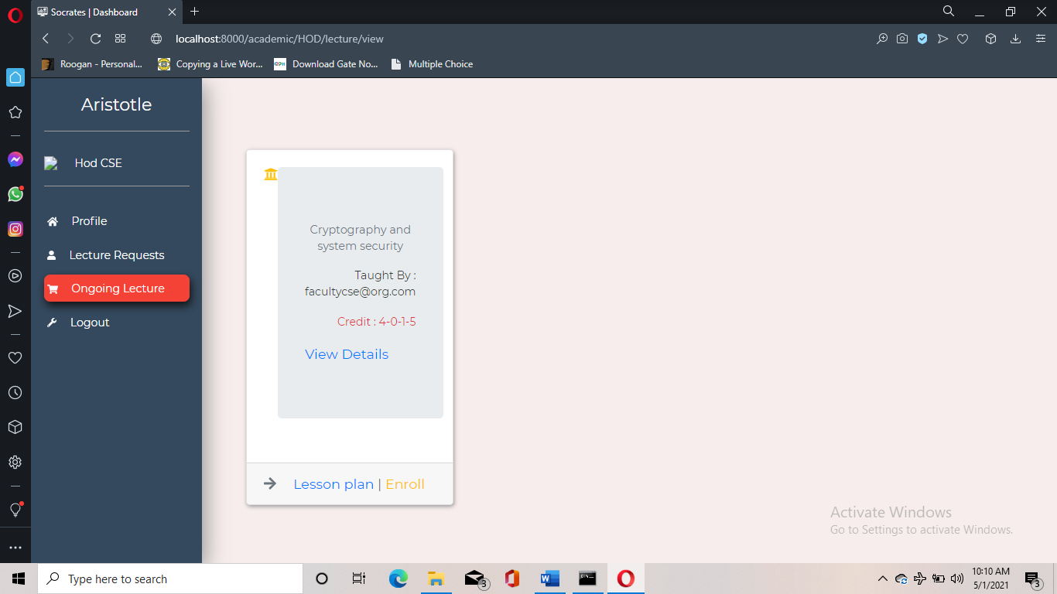

**Hod Lecture View**

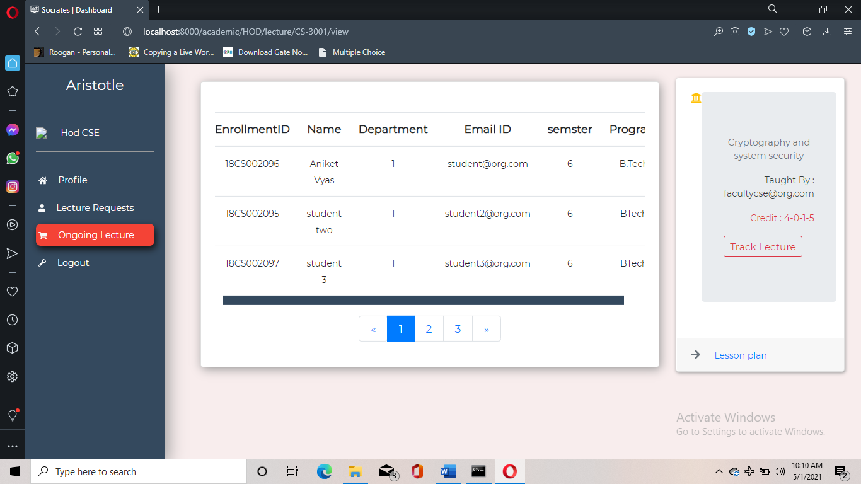

**Hod Lecture Detail View**

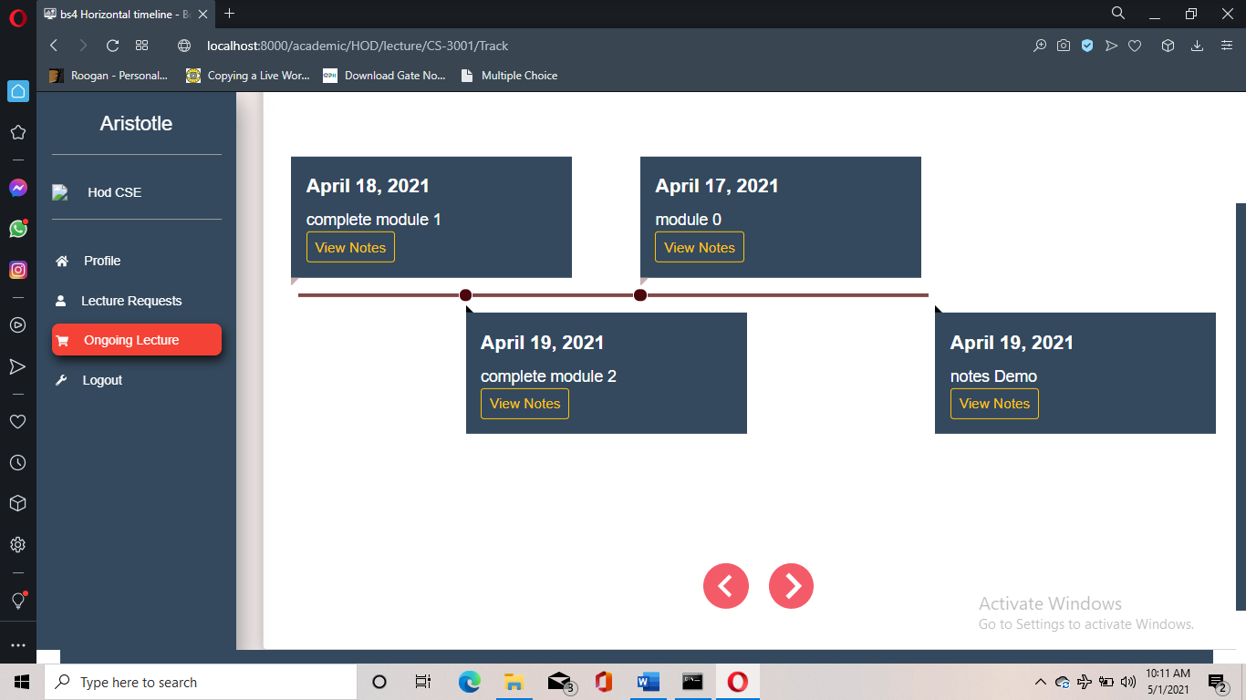

**Hod Lecture Track View**

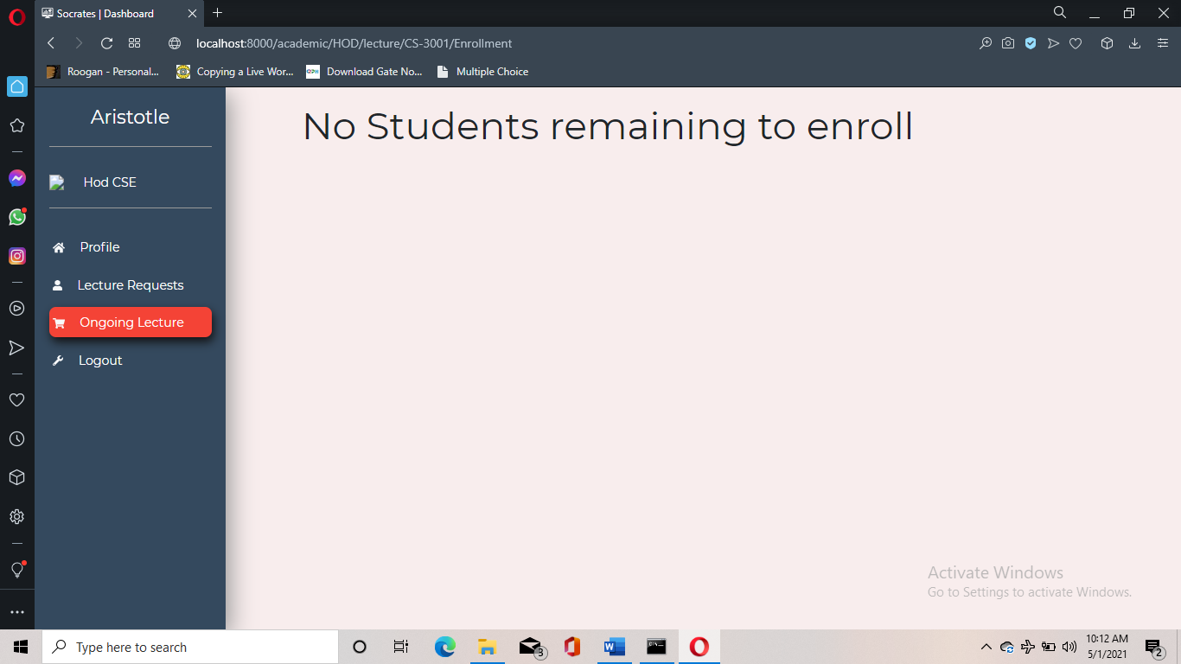

**Enroll students to Lecture(Hod View)**

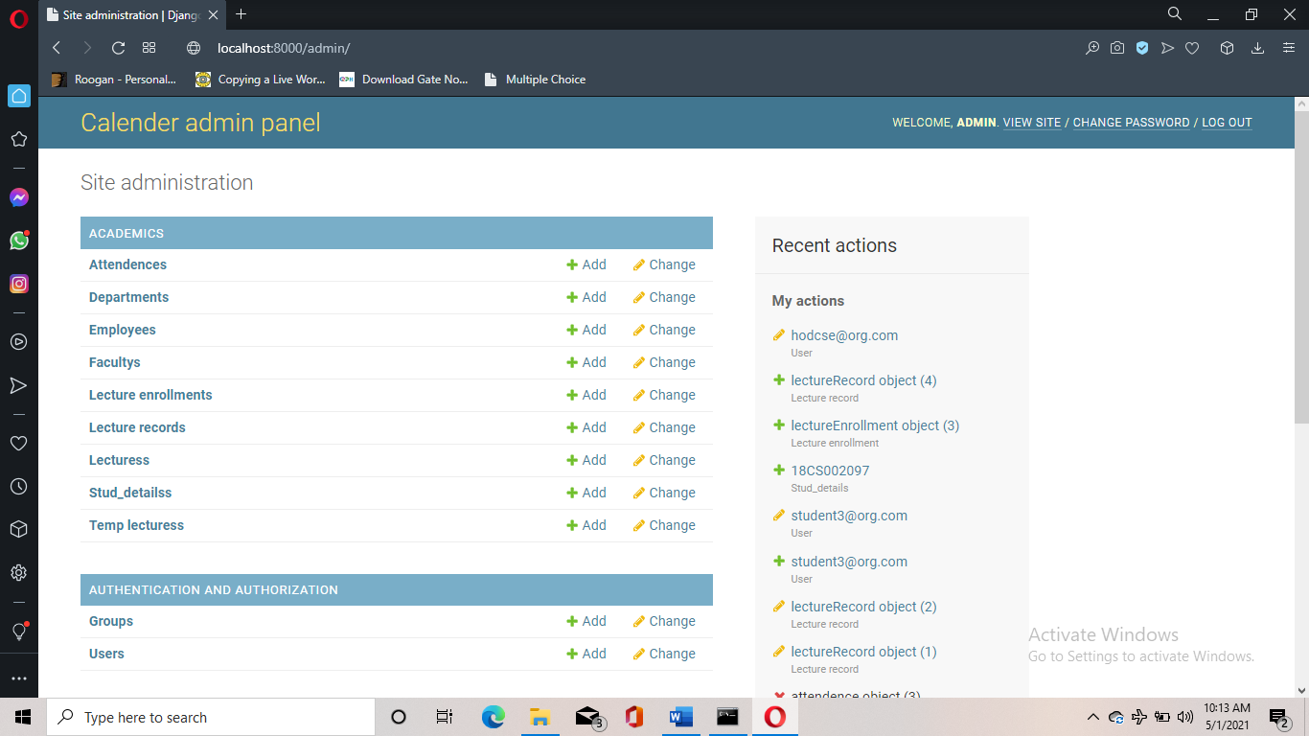

**Admin Panel**

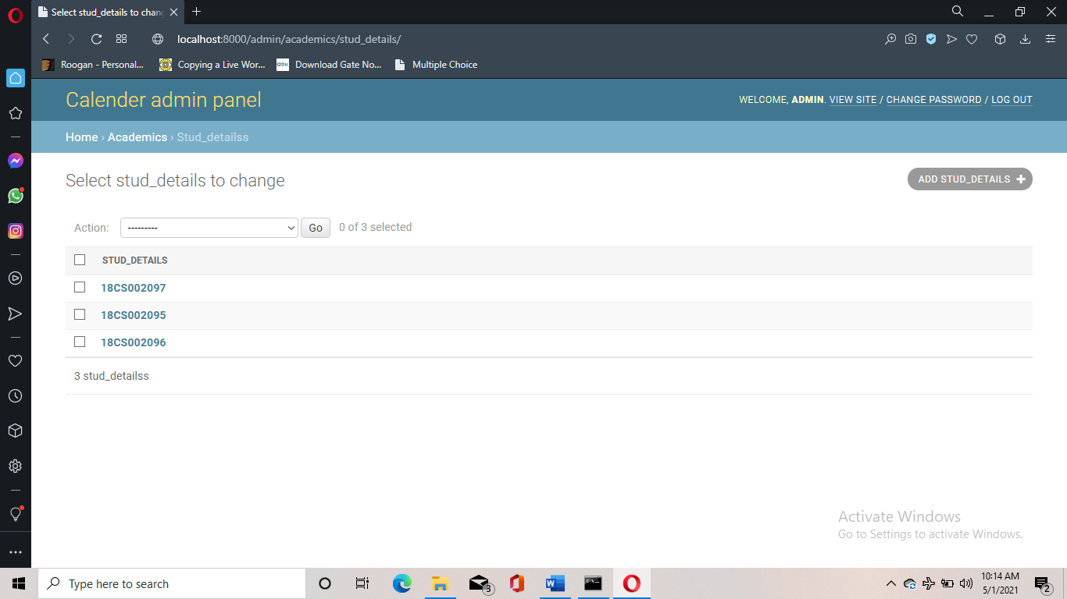

**Student View from admin panel**

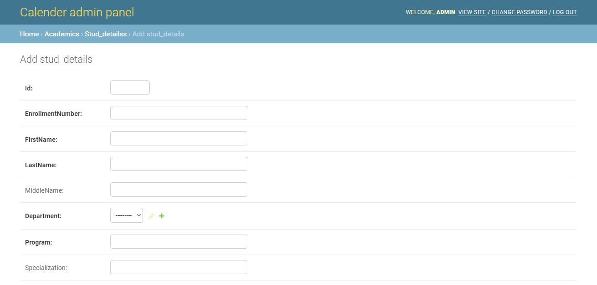

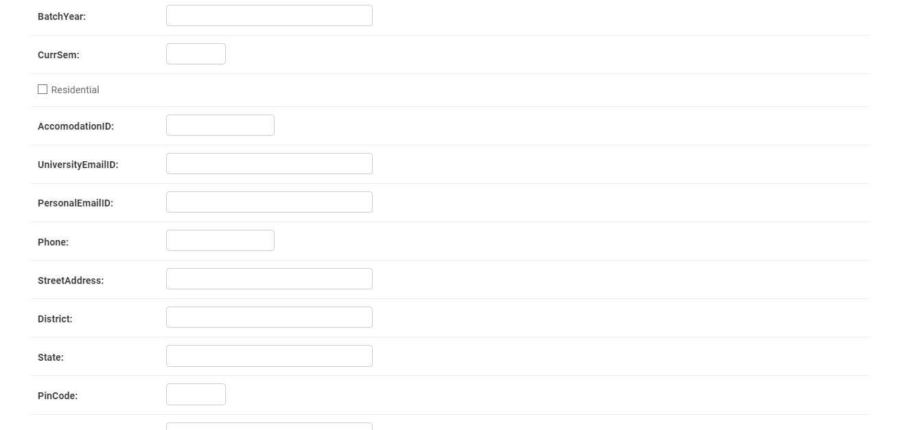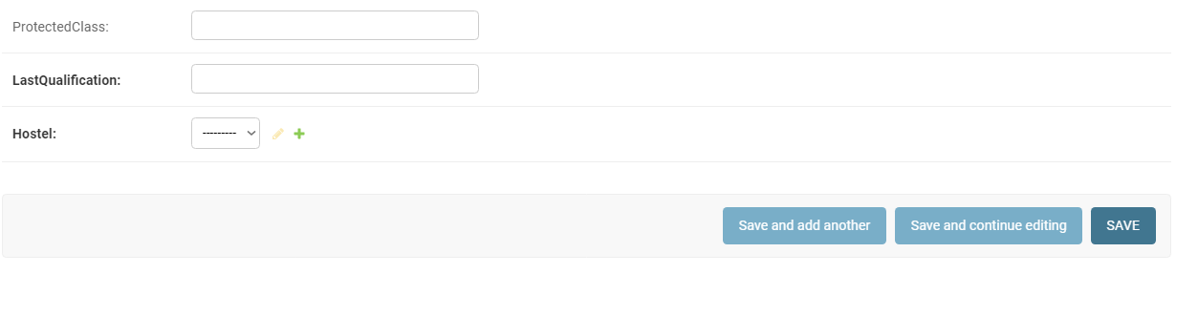

**Add Student View from admin**

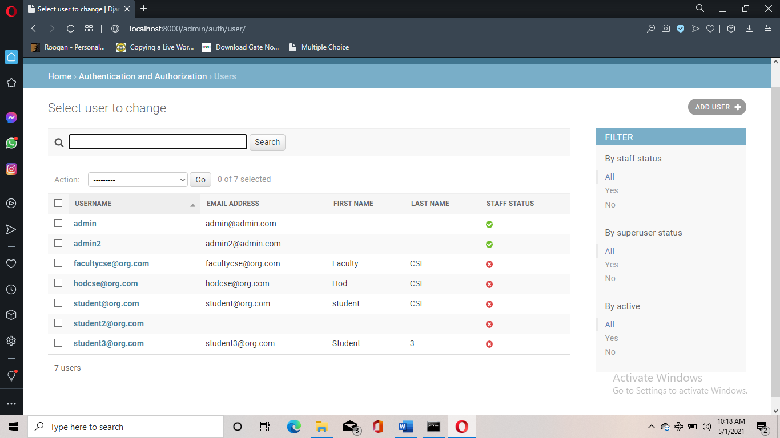

**User View from admin**