Project 1 : CLIO’S

DESCRIPTION :

This project is based on web application, which is about digitalizing all the process carried at a Hospital on a single platform.

The features are included below :  
 1.Appointment booking portal for patients where they can book their appointments and re-view their previous appointments and prescription.

2. A portal for doctors for viewing booked appointment and assigning prescription digitally and request for lab reports too.

3. Medical certificate are issued automatically based on the appointment taken previously.

TOOLS AND TECHNOLOGIES USED:

HTML , CSS , BOOTSTRAP , JAVASCRIPT , PYTHON DJANGO , POSTGRESQL

ROLES AND RESPONSIBILITY :

Project leader , back-end developer and database administrator.

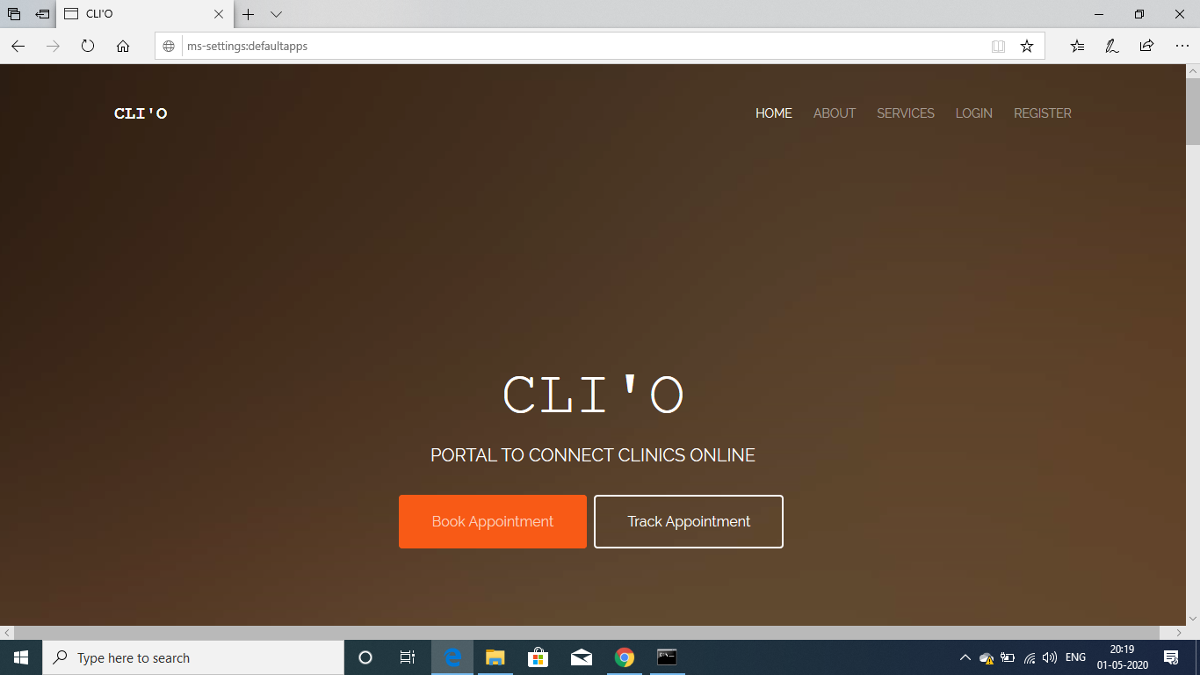

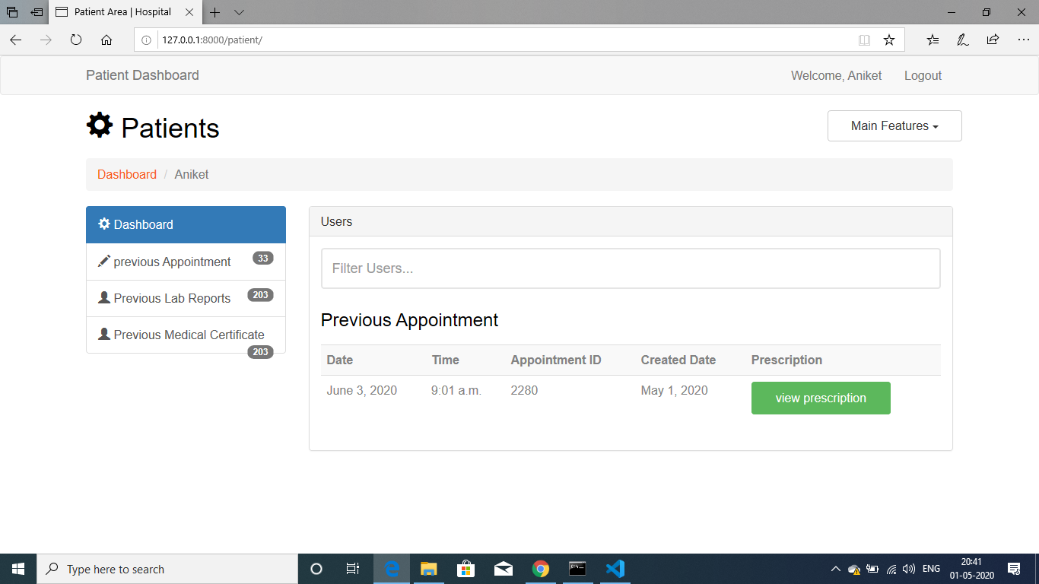

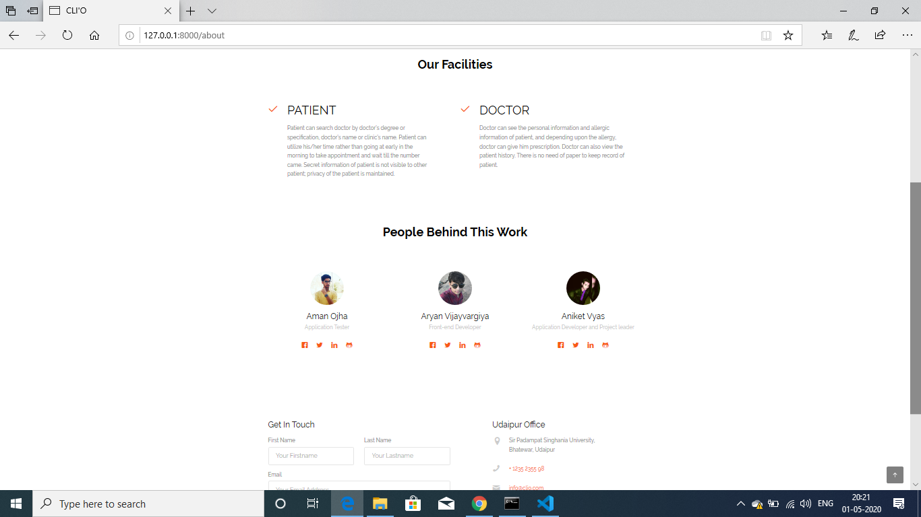

Project 2 : Student Unified Portal

DESCRIPTION:

This project is about the IT system of the university , which is all about digitalizing the manual and paper work done within the university .

The functionalities includes :

1. This application works for all most every kind of user , starting from a student to the president of the university.
2. It includes all kind of academic as well as non-academic work like creating departments , lectures , attendance , exam marks etc and non academics work like out pass system , hostel management system.
3. All the job roles can work with their known user permissions.

TOOLS AND TECHNOLGIES :

HTML ,CSS , BOOTSTRAP , JAVASCRIPT , PYTHON DJANGO , GOOGLE API’S , POSTGRESQL

ROLE AND RESPONSIBILITEIS :

(this project is done by me whole handedly)

Project leader , full-stack developer, database administrator.

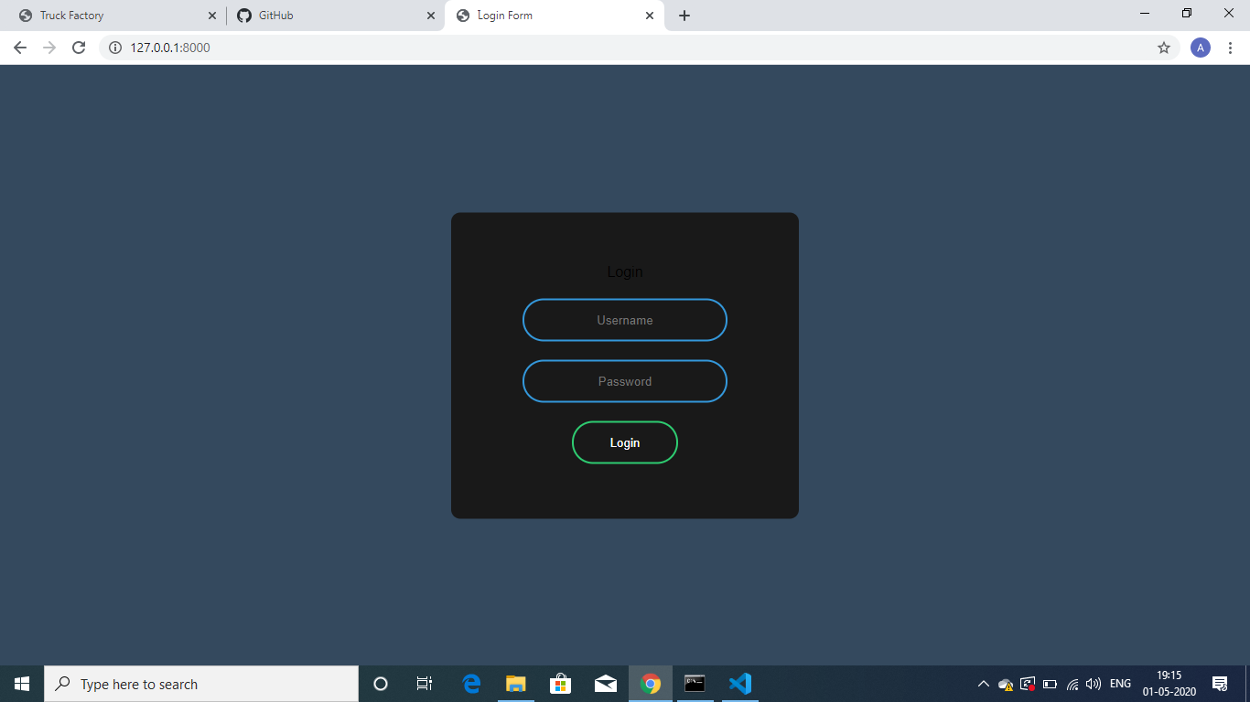

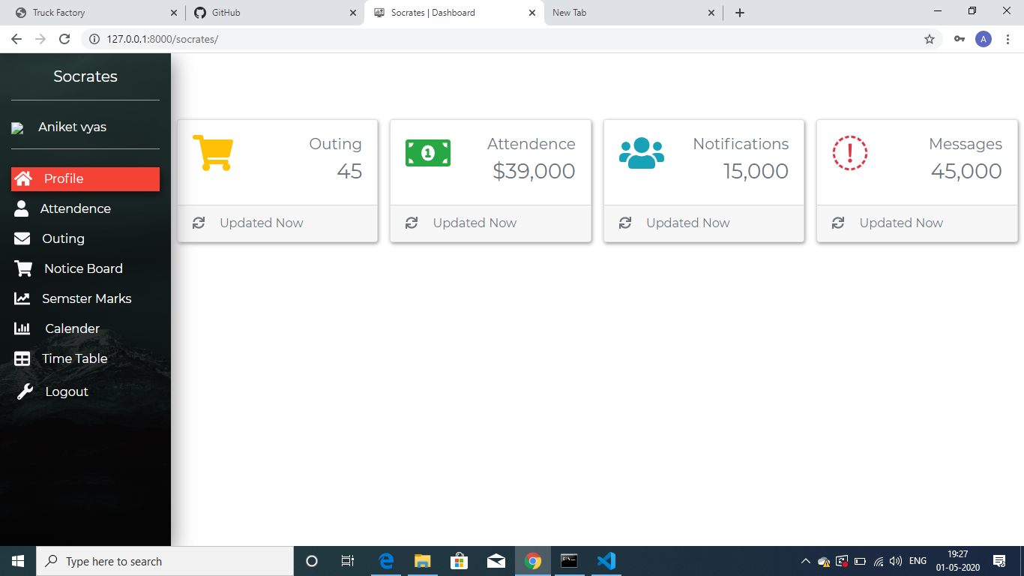

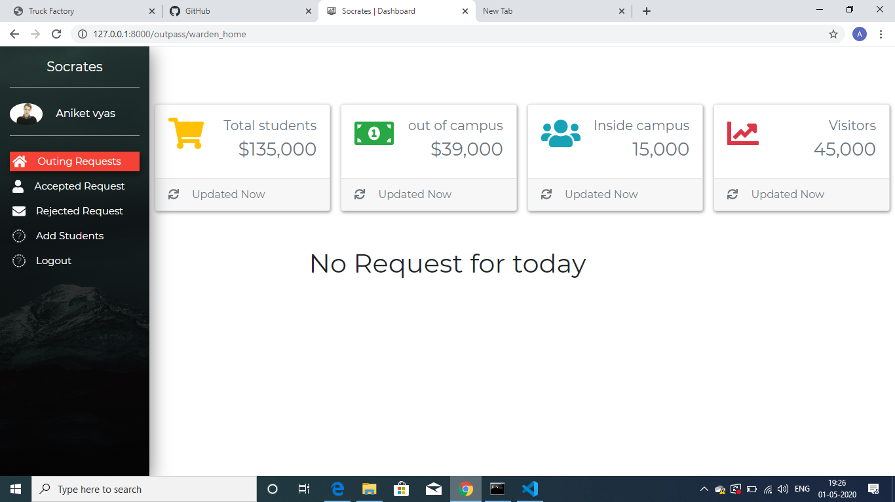

Project 3: Truck Factory

DESCRIPTION :

It is a theme template which is created to showcase a company’s profile and scale-up their business globally , this website includes a good amount of design and effects , some of which includes “Neumorphism” , “caraousal” etc .

TOOLS AND TECHNOLOGIES :

HTML , CSS , JAVASCRIPT , BOOTSTRAP , JQUERY

ROLE AND RESPONSIBILITIES :

This project is created by me whole handedly.

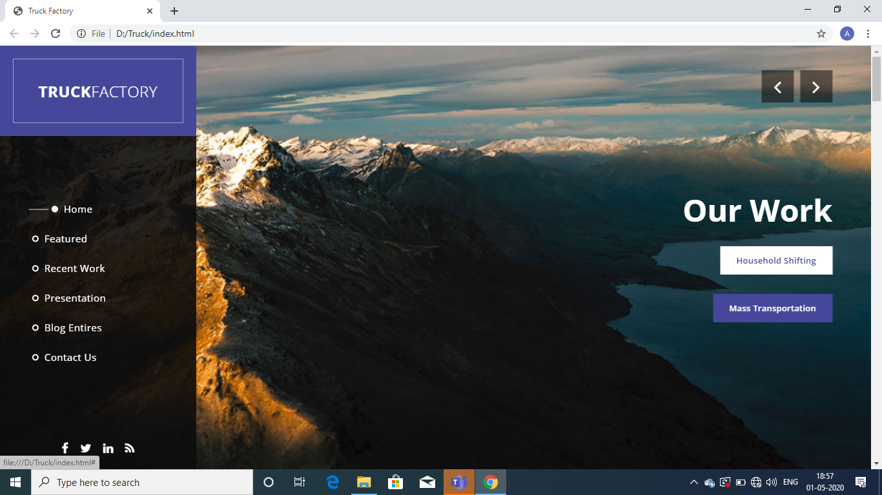

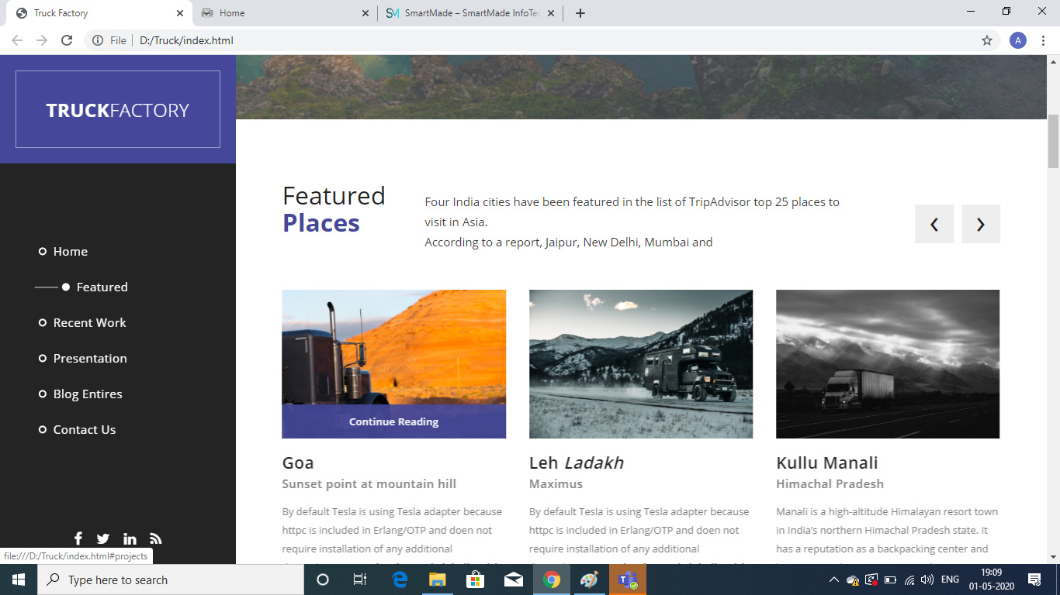

Project 4 : Tournament manager

DESCRIPTION :

This software is basically designed to manage a branch of the bank digitally , which includes various features which can help to remove the manual work and helps in less paperwork

The functionalities includes:

1. Account creation with appropriate account details

2. Amount deposition/Withdrawal feature has also been implemented

3. User data updation and deletion

TOOLS AND TECHNOLOGIES :

PYTHON

ROLE :

Whole handedly created this project

