Warden View

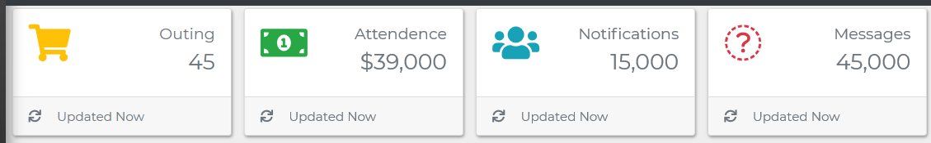

1. Outing : Outstanding Outing Requests
2. Attendance: Tagged Students
3. Notification: Stud. Out Campus
4. Messages: Special Students

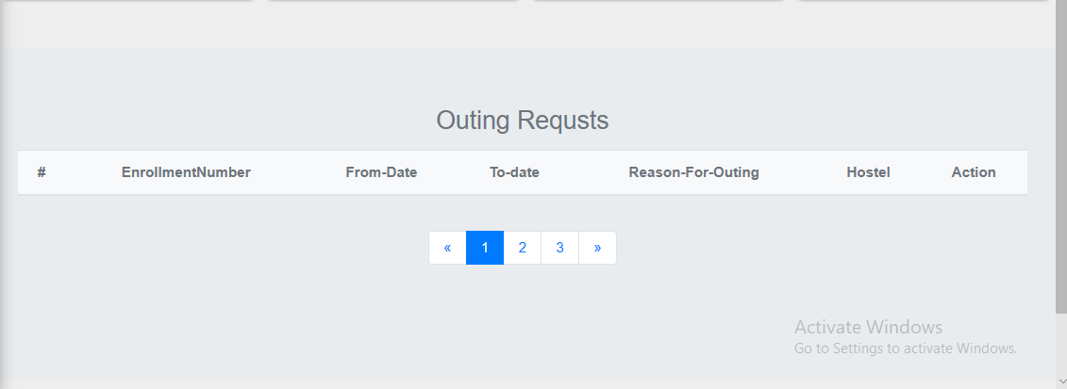

Before Frame spacing removal to 1/2.

Attribute Sequence: #, Name, Enrollment#, FromDate, ToDate, Reason, Action, Comment (Remove Hostel)

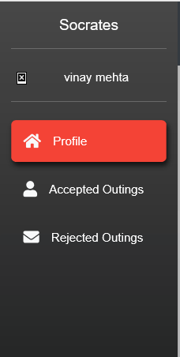

Vinay.Mehta:

1. Password Change
2. Notification Frequency (Immediate, Hourly, 4 hourly, Night Shift(10pm to 7 AM))
3. Addition of Other phone number
4. Student Detail Changes (These Request will however be only limited to Hostel and so a simultaneous request for Admin will be raised to flourish the changes to the student main records at college level.)

Profile -> Dashboard

1. Reporting (Approved Request, Rejected Request, Outing report for tagged students, Late Attendance)

Student:

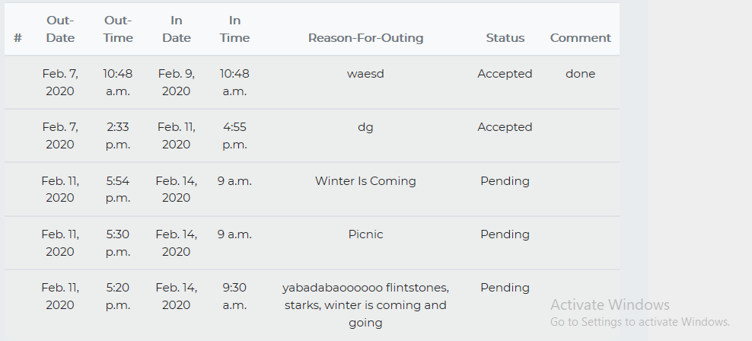

**Sequence Number:** Find some way

**Reason for outing and Comment:** Text data limitation for web view. Don’t restrict db limits.

**Sorting the out requests** latest to oldest so that recently requested comes first.

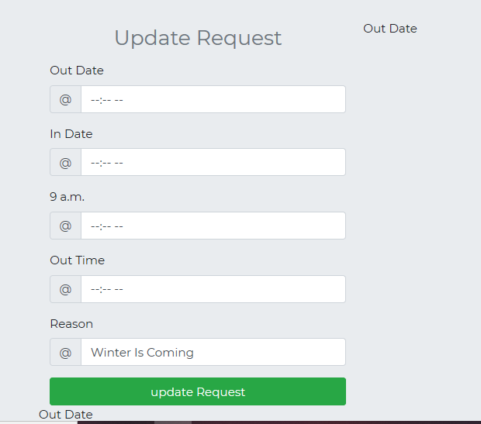

Merge functionality of updating request into the “Recent Outing”.

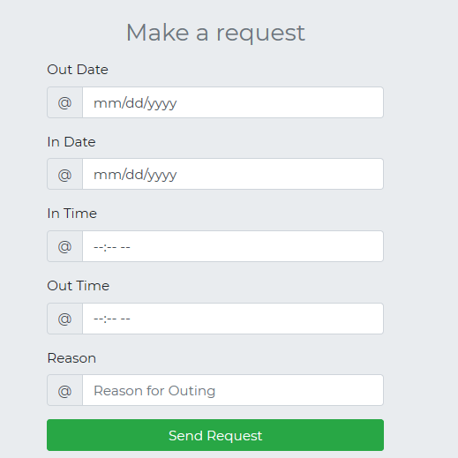

Change the calendar and time appearances to some version that will suit both mobile and desktop versions.

