Getting Started : Run Locally

This guide aims to provide the easiest and most reliable method for getting a copy of the application running locally.

Quick start with pre-requisite installation:

The following pre-requisites should by installed in your system and if not please install them and follow the below written steps

1. Python
2. PostgreSQL

after installing above two tools, you need to further setup environment in your system in order to run the Hospital web-based application so first of all, create a virtual-environment. make sure you have pip installed , open your command prompt as administrator and then hit the following command

“pip install virtualenv”

“pip install virtualenvwrapper-win // for windows operating system

After installing above packages into your system , further you need to create one virtual environment so hit the below command :

“mkvirtualenv <Environment: name>”

“ workon <Environment: name>”

And once the virtual environment is created we need to install some of the package in order to full-fill the requirements written in the requirements.txt file so in order to do ,move towards the project directory in command-prompt , so just hit the following command:

“pip install -r requirements.txt”

And once all those packages are installed then we need to setup the database

Here we are using postgresSQL , so open PgAdmin and create a database named Hospital (or if you give it any other name then you need to specify it later) ,

After creating the database we need to configure Django settings to interact with “Hospital” database, in order to do that , open settings.py file stored in main project-directory(hospital)

Stu > settings.py

after opening settings.py find the DATABASES array which would be like this:  
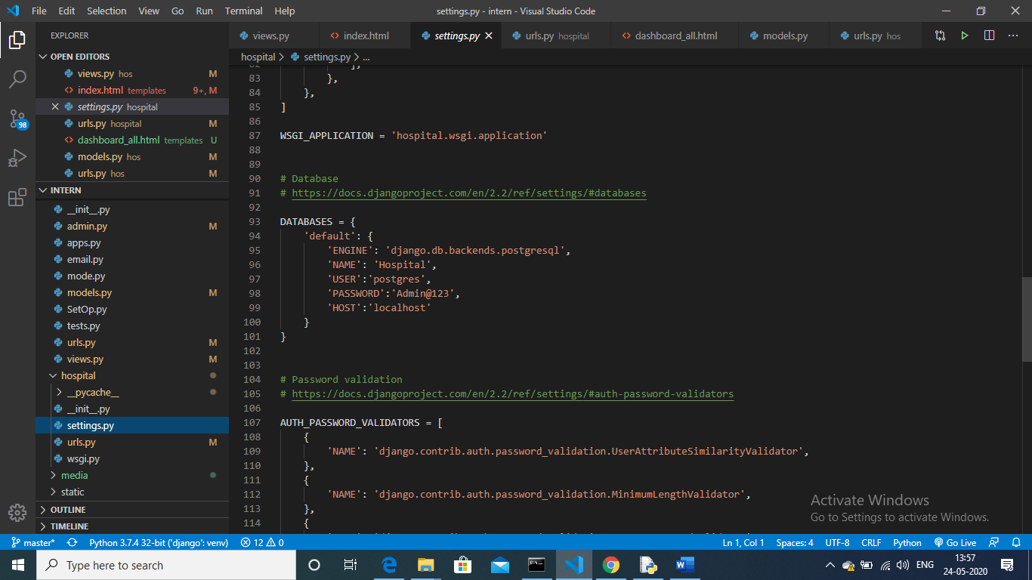

Put all the relevant information there in order to configure your database

After configuring the database credentials we need to migrate our existing migration files onto the database so in order to do that, hit the following command:

“python manage.py migrate”

And now your database is properly connected to the Hospital application , and now we are ready to run our project locally so just start the development server by hitting the following command :

“python manage.py runserver”

Now the application is now accessible on the web address : 127.0.0.1:8000/

To use the feature of receptionist and HR you need to first upload their data to the database so , in order to do that you need to create a superuser by simply hitting the following command ,

“python manage.py createsuperuser”

, And fill all relevant details , once created , visit admin portal and fill information of receptionist and hr into receptionist and hr table respectively and register them using the user table.