**AI4SEE INTERN ASSIGNMENT**

**NAME: ANIRUDH.S**

For TEST_DATA THE FOLLOWING HAS BEEN FOUND:

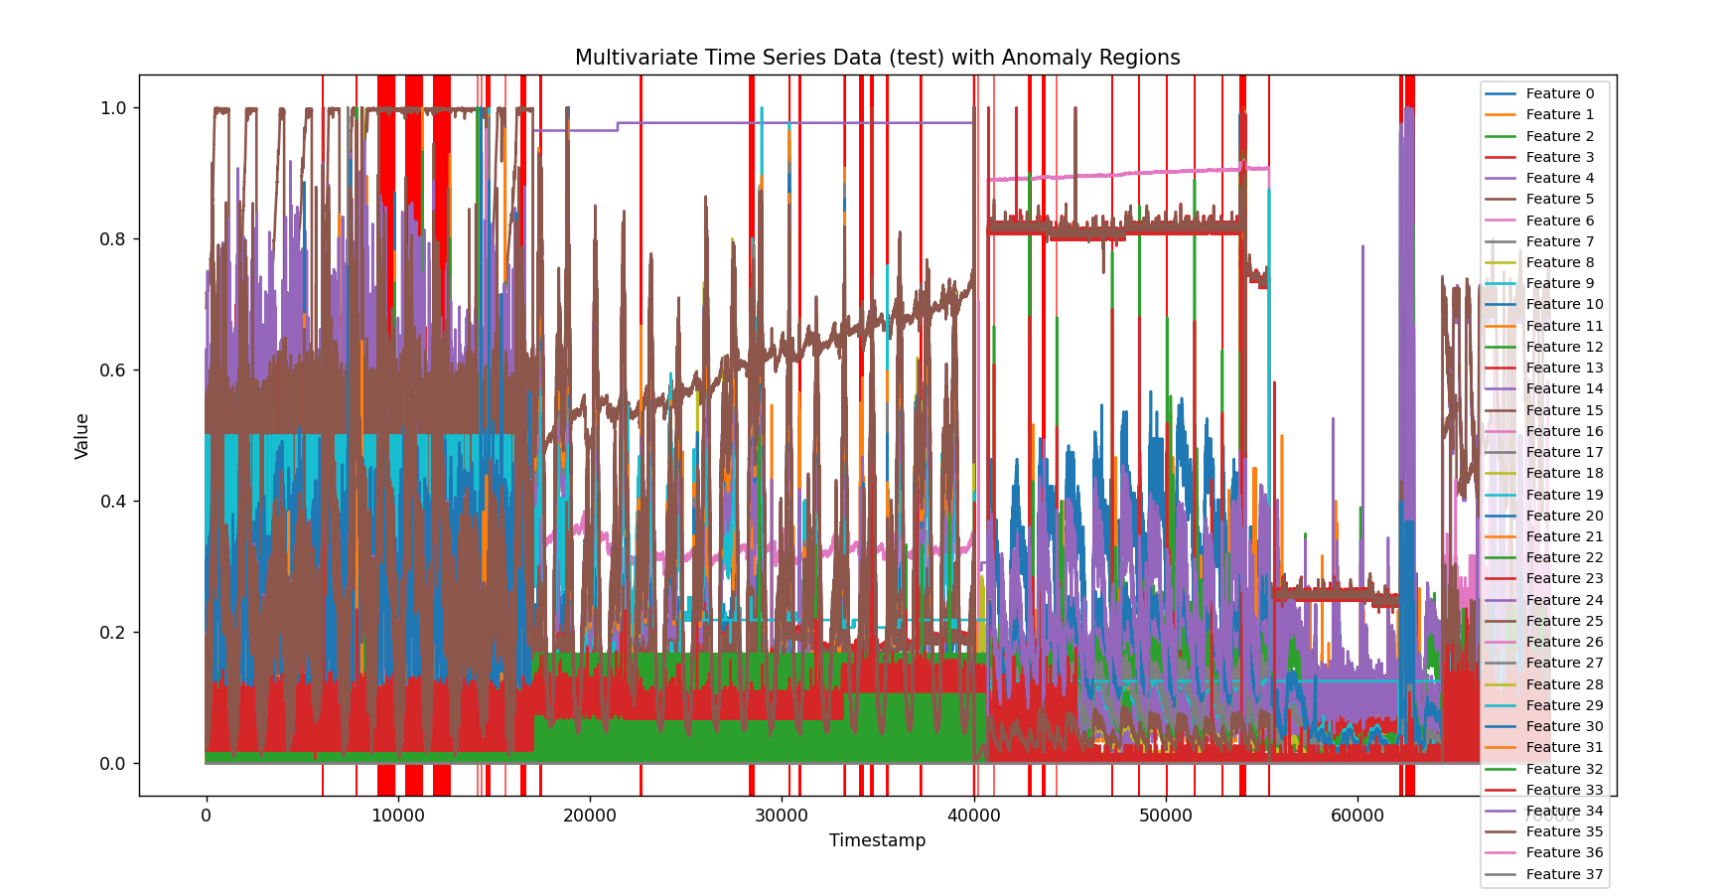

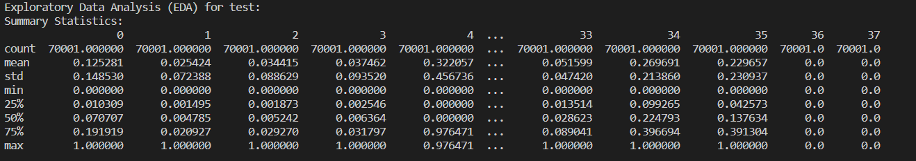

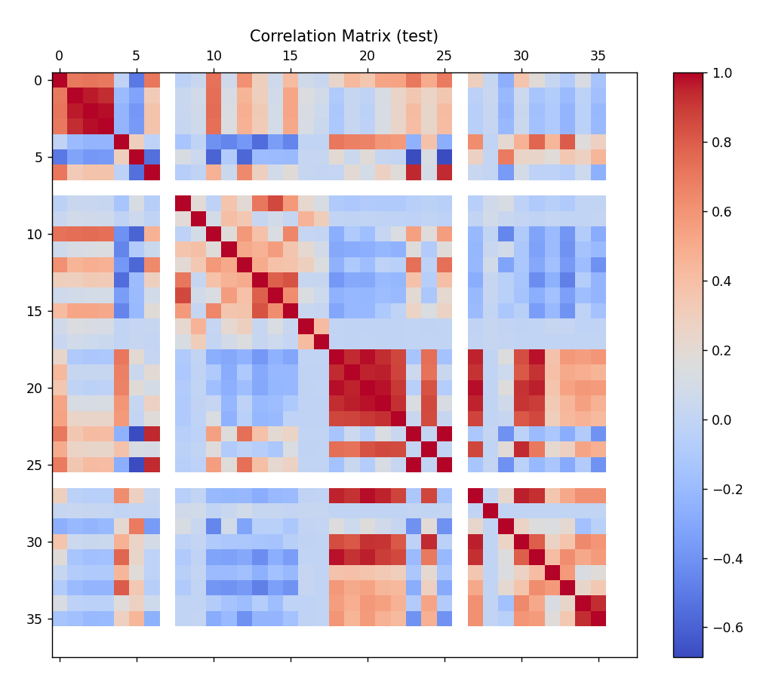

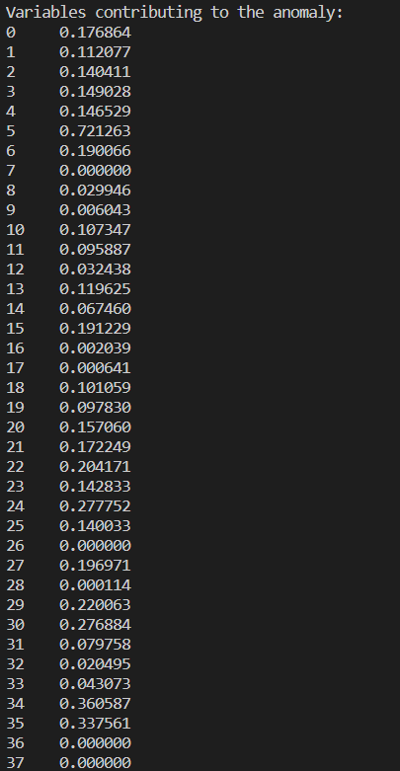

FROM THE ABOVE WE FOUND OUT THAT VARIABLE 5 CONTRIBUTES MOST TO THE ANAMOLY

For PSM_TEST THE FOLLOWING HAS BEEN FOUND:

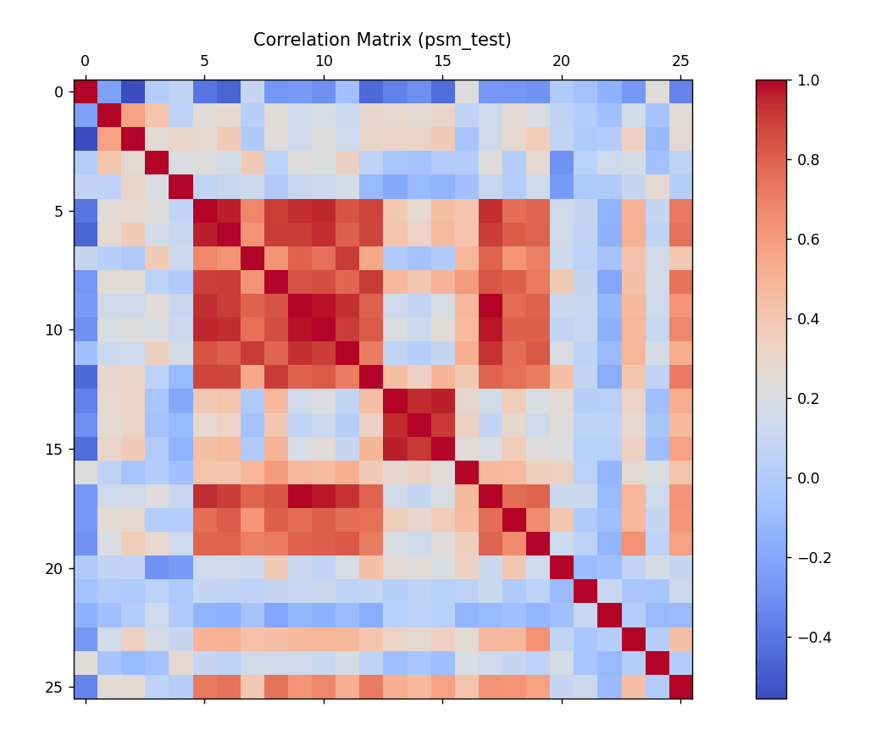

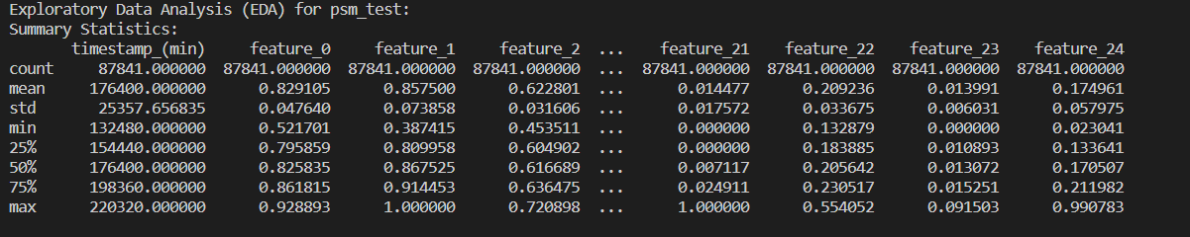

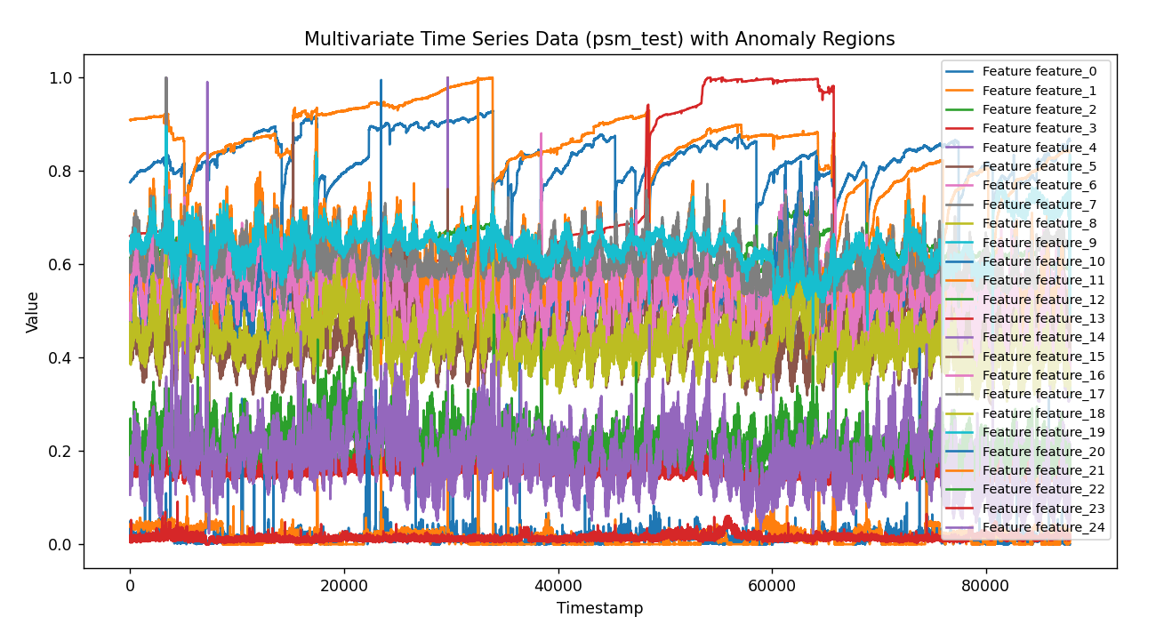

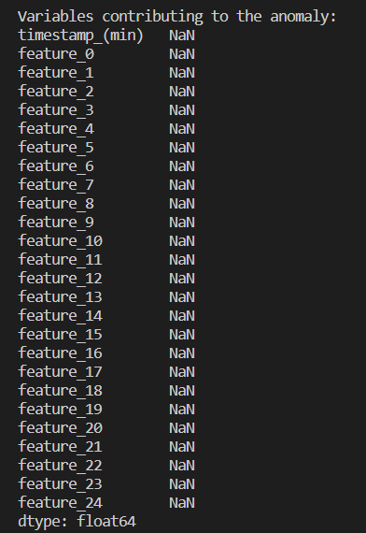

For SMAP_TEST THE FOLLOWING HAS BEEN FOUND:

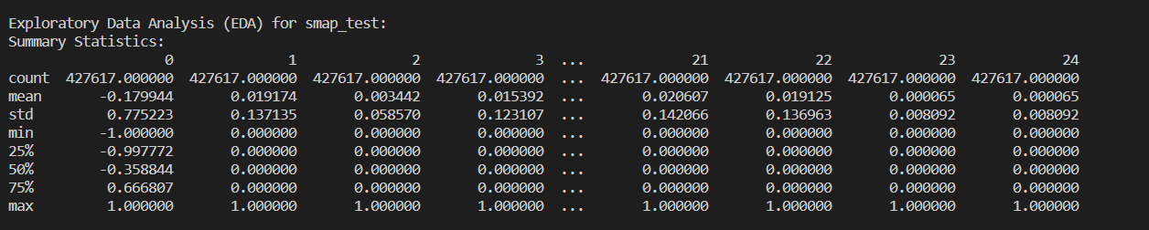

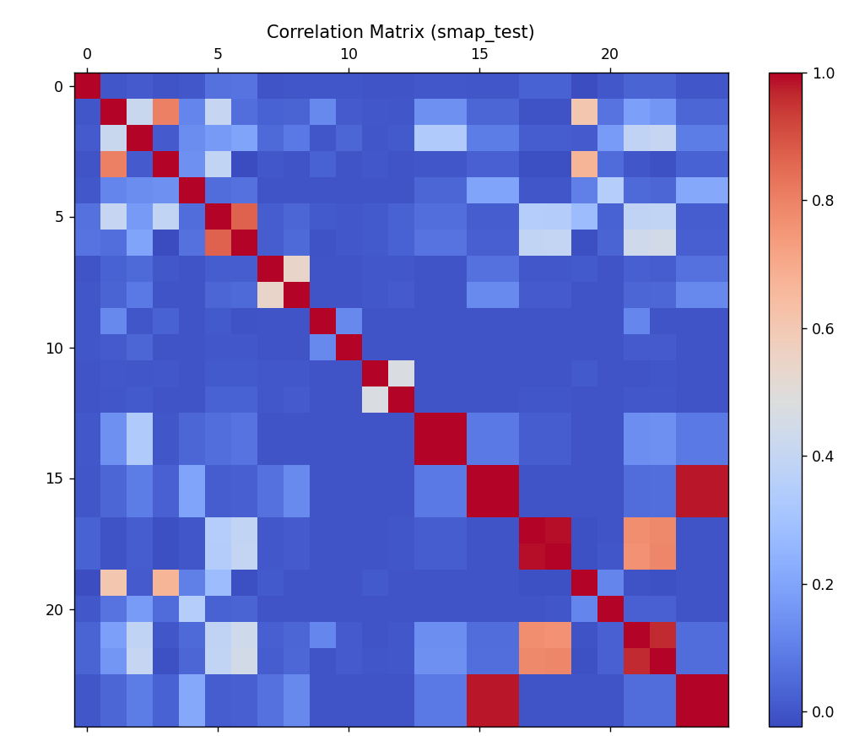

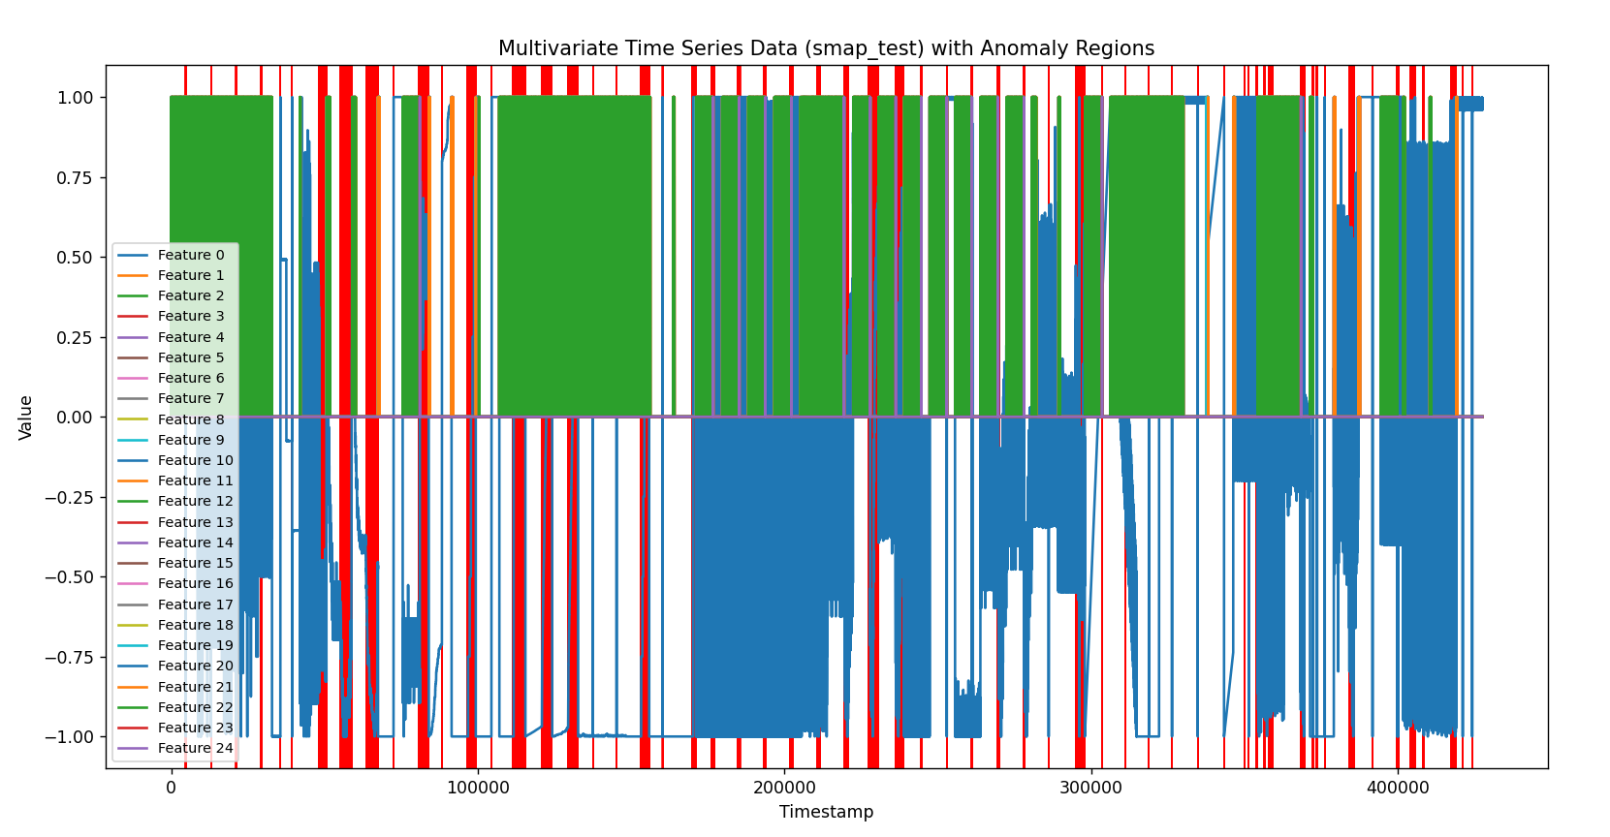

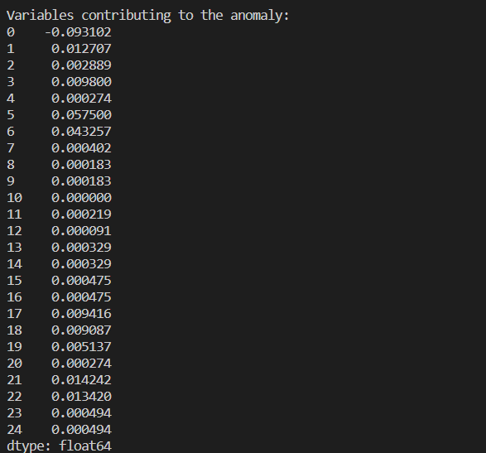

FROM THE ABOVE WE FOUND OUT THAT VARIABLE 5 CONTRIBUTES MOST TO THE ANAMOLY

For MSL_TEST THE FOLLOWING HAS BEEN FOUND:

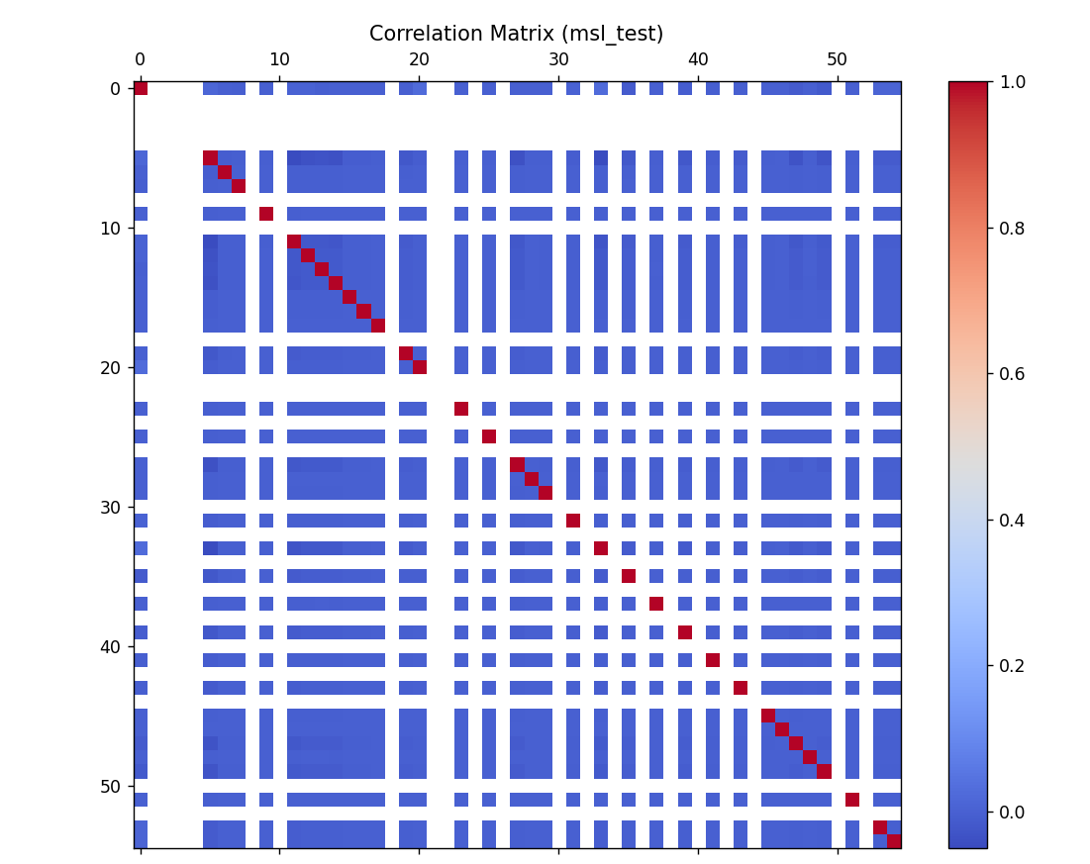

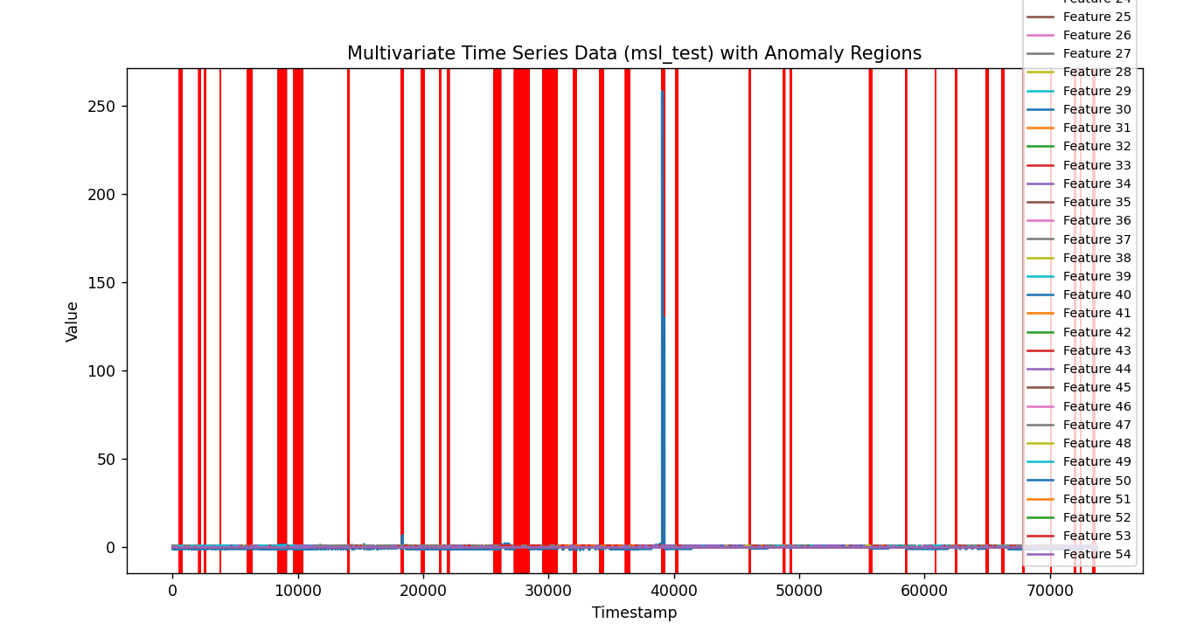

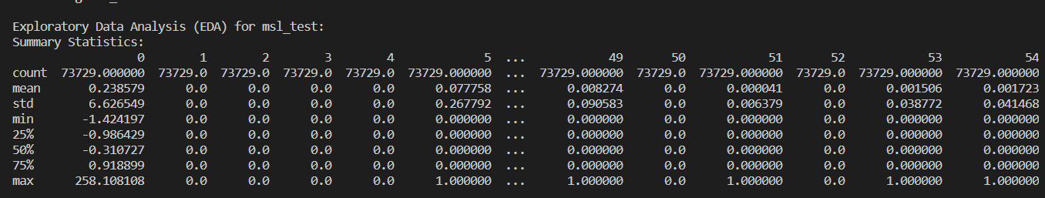

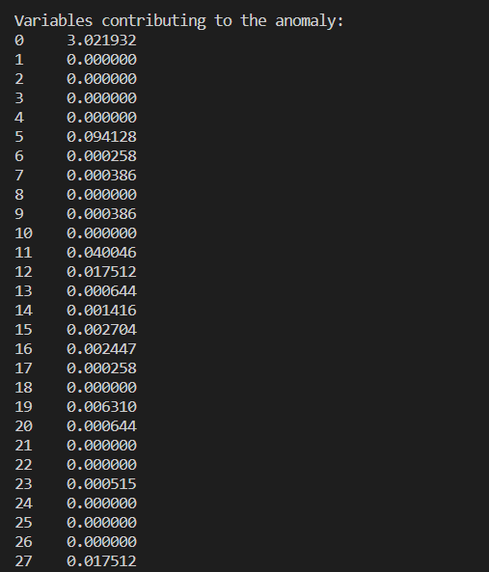

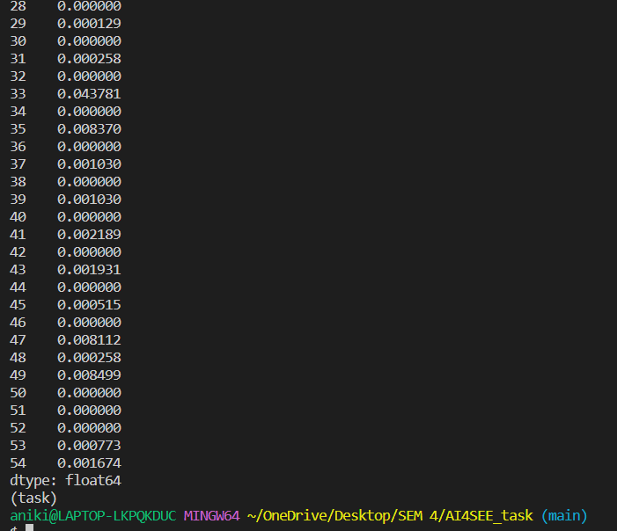

FROM THE ABOVE WE FOUND OUT THAT VARIABLE 5 CONTRIBUTES MOST TO THE ANAMOLY BUT VARIABLE 0 WHICH IS NEGATIVE INTEGER MAKES THE DIFFRENCE.