DevOps day-6
1.Create simple directories with files
mkdir command to create a directory and copy files from another directory to this directory
2.Compress files using tar and gzip
tar -cvf tar is command -cvf is options and anildir.tar is file /home/anil is directory
tar is used to compress the file and gzip is command to zip the file and decrease the directory size

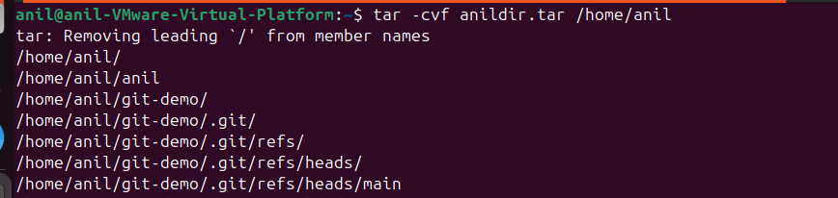

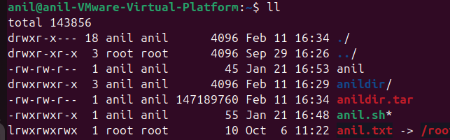

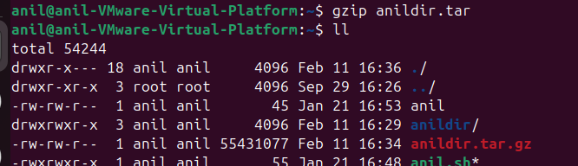
3.Extract compressed files
Tar -xvf x is extract the files from the compressed directory
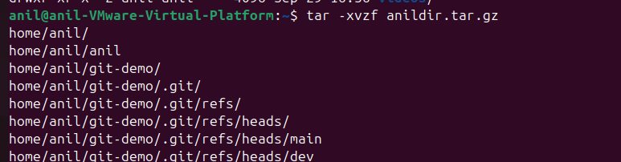
4.Automate backup using script
Here I am using bash scripting to compress the file and taking backup
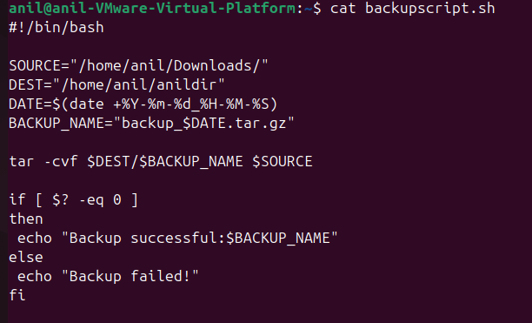
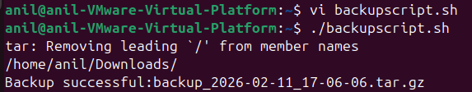
5.Schedule backup with cron
Crontab -e is using to edit the crontab and mention time in daily or weekly to schedule the file run
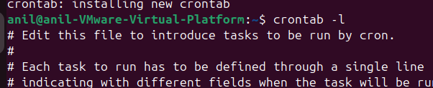

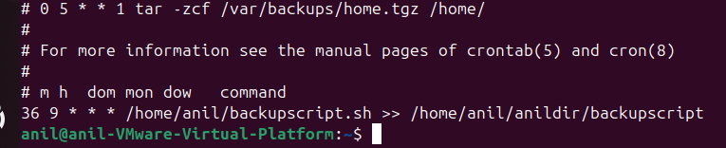
6.verify backups
After schedule the crontab the file execute and take backup the file
