Devops Day-5
1.List running processes using ps, top
Top can show the cpu, memory and swap memory and process
Ps is used to diplay which process is running in system and user prority

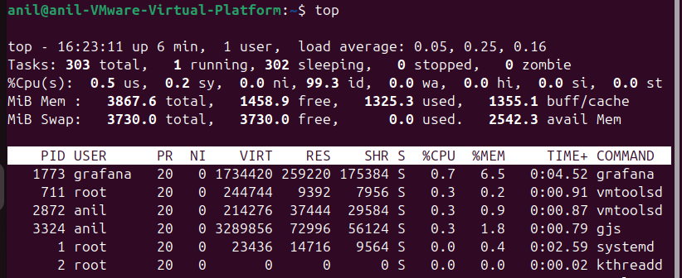

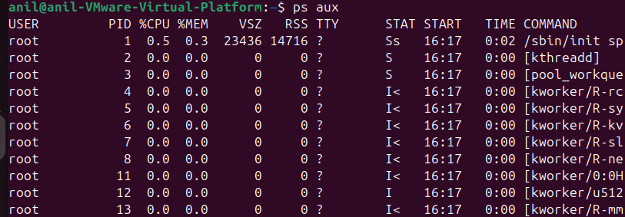
2.Kill processes using kill and kill-9
Kill is used to terminated the process and kill-9 is used to killed the process and some other kill are their
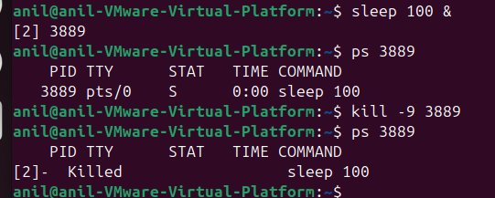

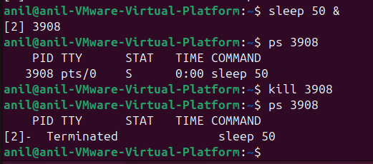

3.Understand process states
R-running state, S-sleeping state, T- stopped, Z-Zombie state,
4.Start and stop service using systemctl
If we want start the any service using the command systemctl start servicename
If service is active then we have to connect any application or server
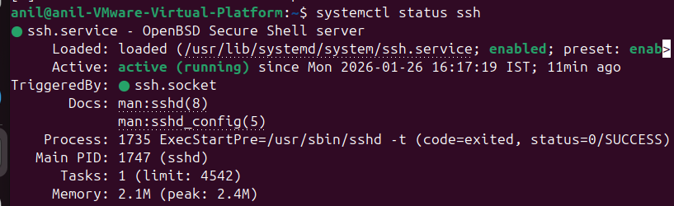

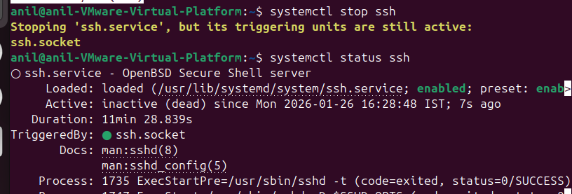

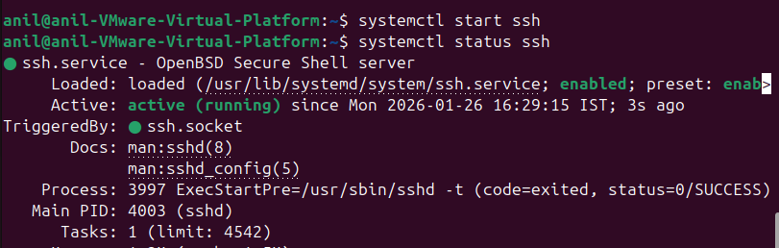

5.Enable services at boot
If we have enable the service then after reboot the system the service start at boot level
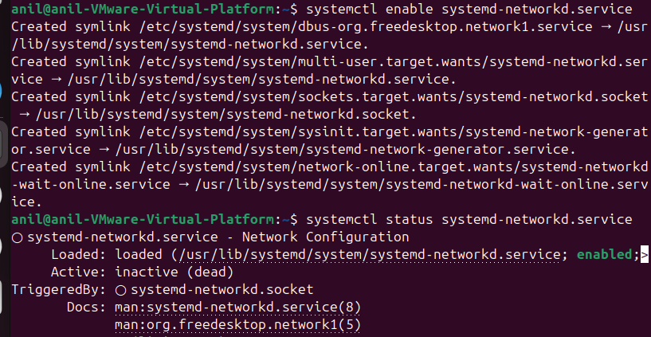
6.Monitor resource usage
We can use the uptime to check the load average and df-h to check the usage of the dik
