A project report

On

Expense Tracker

Submitted in partial fulfillment of the requirement of Project-VI

BIT379CO

Of

Bachelor of Information Technology

**Submitted to**



Purbanchal University

Biratnagar, Nepal

**Submitted By**

Anil Limbu ()

Ashok Dahit Tharu (363531)

Reena Shrestha ()

**KANTIPUR CITY COLLEGE**

Putalisadak, Kathmandu

August 5, 2021

A project reports

On

Expense Tracker

Submitted in partial fulfillment of the requirement of Project –VI BIT379CO

Of

Bachelor of Information Technology

**Submitted to**

Purbanchal University

Biratnagar, Nepal



**Submitted By**

Anil Limbu ()

Ashok Dahit Tharu (363531)

Reena Shrestha ()

**Project Supervisor**

Mr. Anand Singh

**KANTIPUR CITY COLLEGE**

Putalisadak, Kathmandu

August 5, 2021

**TOPIC APPROVAL SHEET**

It is hereby informed that the topic selected by Anil Limbu (363529), Ashok Dahit Tharu (363531) and Reena Shrestha () of BIT VI semester for their semester project has been found suitable and as per the credit assigned by Purbanchal University (PU), Biratnagar, Nepal.

The project Committee has approved the following topic for the above-mentioned students.

Topic Approved: Expense Tracker

|  |  |  |
| --- | --- | --- |
| ________________ | ________________ | __________________ |
| Mr.Ashim KC | Mr. Anand Singh | Mr.Bikash Neupane |
| Coordinator BCA, BIT | Project Coordinator | Project Coordinator |

**CERTIFICATE FROM THE SUPERVISOR**

This is to certify that the project entitled “Expense Tracker” submitted by Anil Limbu (), Ashok Dahit Tharu (363531) and Reena Shrestha () to the department of Information Technology, School of Science and Technology at Kantipur City College, Kathmandu, Nepal towards the requirement for BIT279CO of is an original work carried out by them under my supervision and guidance.

Signature:

________________________

Mr. Anand Singh

Project Supervisor

Place: Kantipur City College, Putalisadak Kathmandu

Date: August 5, 2021

# ACKNOWLEDGEMENT

We would like to express our deepest appreciation to all those who provided us the possibility to complete this report. We would like to acknowledge with much appreciation the crucial role of the staff of Kantipur City College, who gave us the permission to use all required equipment and the necessary materials to complete the task.

Furthermore, special thanks to our project supervisor, Mr. Anand Singh, whose contribution in stimulating suggestions and encouragement, helped us to coordinate our project especially in writing this report also suggesting us about the task and guiding us during the completion of this project. Finally, many thanks to lab in-charge for providing the facilities of lab during our project. We must appreciate the guidance given by other supervisor as well as the panels especially in our project presentation that has improved our presentation skills, thanks to their comment and advice.

# ABSTRACT

In today’s busy and expensive life we are in great rush to make money. But at the end of the month we broke off. As we are unknowingly spending money on little and unwanted things. So we have come over with the idea to track our earnings. Expense Tracker aims to help everyone who are planning to know their expenses and save from it. This is an android app which users can execute in their mobile phones and update their daily expenses. User will be able to see pie chart of income and expense.

# TABLE OF CONTENTS

ACKNOWLEDGEMENT i

ABSTRACT ii

TABLE OF CONTENTS iii

LIST OF FIGURES v

LIST OF TABLES v

Chapter 1: INTRODUCTION 1

1.1 Project Introduction 1

1.2 Problem Statement 1

1.3 Objective of the project 1

1.4 Significance of the project 1

1.5 Features of the project 1

1.6 Assignment of Roles 2

1.7 Documentation Organization 3

Chapter 2: Existing System Overview 4

2.1 Existing System Overview 4

2.2 Limitation of existing system 4

CHAPTER 3: SYSTEM ANALYSIS 5

3.1 System Development Model 5

3.2 Requirement specification 5

3.2.1 Functional requirement 5

3.2.2 Non-Functional requirement 6

3.3 Feasibility Study 6

3.3.1 Technical feasibility 6

3.3.2 Economical feasibility: 6

3.3.3 Operational feasibility: 6

3.3.4 Schedule feasibility 6

3.4 Gantt Chart 7

CHAPTER 4: SYSTEM DESIGN 8

4.1 Context Diagram 8

4.2 level 1 DFD 9

4.3 ER Diagram 11

4.4 Use case diagram 12

CHAPTER 5: SYSTEM DEVELOPMENT AND IMPLEMENTATION 13

5.1 Programming Platform 13

5.2 Tools and Technologies 13

5.3 Testing and Debugging 13

CHAPTER 6: CONCLUSION and FUTURE ENHANCEMENT 14

6.1 Conclusion 14

6.2 Limitations 14

6.3 Future Enhancement 14

APPENDIX 15

REFERENCES 15

# LIST OF FIGURES

|  |  |  |
| --- | --- | --- |
| S. N | Figure name | Reference |
| 1. | Water flow model | 3.1 |
| 2. | Gantt Chart | 3.2 |
| 3. | Context level D.F. D | 4.1 |
| 4. | Level 1 D.F. D | 4.2 |
| 5. | ER Diagram | 4.3 |
| 5. | Use Case diagram | 4.4 |

# LIST OF TABLES

|  |  |  |
| --- | --- | --- |
| S. N | Table name | Reference |
| 1. | Assignment of roles | 1.2 |
| 2. | Document organization | 1.2 |
| 3. | Black box testing | 5.1 |

# Chapter 1: INTRODUCTION

## Project Introduction

Expense tracker is an important tool for recording our income and expense of daily life. Keeping a daily records of our income and expense helps to makes us a better money manager. Recording your expenses daily can ensure that you are financially aware all year long. Knowing where your money is going and how much you’re spending can improve your spending habits plus, you’ll have better idea of where you can allocate money to positively impact your bottom line.

## Problem Statement

Every earning people are mostly obsessed at the end of the month as they cannot remember where all their money have gone when they have spent and ultimately have to sustain in little money minimizing their essential needs. There is no as such complete solution present easily or we should say free of cost which enables a person to keep a track of its daily expenditure easily and notify them if they are going to have money shortage. To do so a person has to keep a log in a diary or in a computer, also the calculations needs to be done by the user which may sometimes results in error leading to losses. Due to lack of a complete tracking system, there is a constant overload to rely on the daily entry of the expenditure and income.

## Objective of the project

* To know where the money is going.
* To spent only on priorities

## Significance of the project

* Helps to keep track of money being spent.
* Keep you from overspending.

## Features of the project

* Keeps track of budget income source.
* Keeps track of daily expenses.

## Assignment of Roles

|  |  |  |
| --- | --- | --- |
| **Team Members** | **Symbol number** | **Task done.** |
| Anil Limbu | 363529 | Documentation, DFD, ER, |
| Ashok Dahit Tharu | 363531 | Documentation |
| Reena Shrestha |  | Documentation |

## Documentation Organization

|  |  |  |
| --- | --- | --- |
| **Chapter** | **Heading** | **Contents (Topic)** |
| Chapter-1 | Introduction | * 1. Background   2. Significance   3. Objectives   4. Features   5. Organization of Documents |
| Chapter-2 | Literature Review | 2.1 Overview of existing system  2.2 Limitation of existing system |
| Chapter-3 | System Analysis | 3.1 System development model  3.2 Requirement Specification  3.2.1 Functional requirement  3.2.2NonFunctional requirement  3.3 Feasibility Study  3.3.1 Technical  3.3.2 Economy  3.3.3 operational feasibility  3.3.4 Schedule |
| Chapter-4 | System Design | 4.1 Context Diagram  4.2 Level 1 DFD  4.3 |

Table 1.2 Documentation organization

# Chapter 2: Existing System Overview

## 2.1 Existing System Overview

There are different applications available to record the daily expenses and income. This becomes easier as the user can record all his daily expense and income. It helps to manage the users data and can keep all the data safe .There are various system where users can login from only device and cannot access from other devices.

CASE 1: EasyBudget

The first system we reviewed for literature review is EasyBudget. It is available in play store with an average rating of 4.6. In this app, the budget planning is made very simple and easy to use app to manage budget on a daily basis. The app lets the user specify the date of expense and income.

CASE 2: Budget My Life

The second system we reviewed for literature review is Budget my Life. It is also available in play store with an average rating of 4.2. In this app user can simply add the data to the app to trace the expense and income. The UI of this app is very clear and simple to use.

## 2.2 Limitation of existing system

1. It cannot manage multiple accounts.
2. It doesn’t show any charts and statistics
3. User cannot access their data from another device
4. The data store by user is saved only in local app.

# CHAPTER 3: SYSTEM ANALYSIS

System analysis is the process of studying a procedure in order to identify its goals and purposes and create system and procedures that will achieve them in an efficient way. It is phase of software development where a system requirement, initial investigation, requirement analysis and feasibility study are performed.

## 3.1 System Development Model

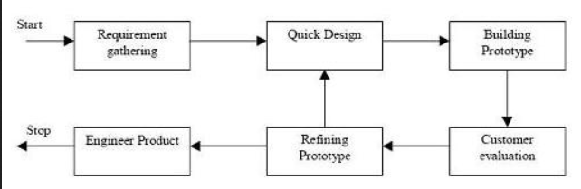

Fig 3.1 Prototype Model

This model is simple and easy to understand and use. It allows the user to experiment with the system and refine the system. Furthermore, as the prototype is developed, it may reveal errors and in the requirements. The specification maybe modified to reflect changes. In the system design, a prototype can help to carry out design experiments to check the feasibility of a proposed design.

## 3.2 Requirement specification

After the selection of the development process of the system. The first thing we did was to specify the requirement, which has been divided into two parts according to the requirement of the system.

### 3.2.1 Functional requirement

* **Register**:

Register function is used to create new account.

* **Login**:

User can login in the system.

* **Add Income**

User can add their income .

* **Add Expense**

User can add their expense

* **Add Notes**

The system shall allow users to add notes to their income and expense.

### 3.2.2 Non-Functional requirement

* User can update income and expense data.
* Each data record is stored on a well built database so, there is no risk of data loss

## 3.3 Feasibility Study

We found 4 types of feasibility during the study. They are:

### 3.3.1 Technical feasibility

During study of these process, we studied the requirement of the technical equipment for the development of the system and found out all the equipment is full filled except the development platform of the system, which was initially downloaded.

### 3.3.2 Economical feasibility:

The only cost for building this project is for printing and binding the report files. Additionally, effort and time of every team member is the cost involved for this project. Also. The user does not need to pay a single rupees to use this app. Hence , this app is economically feasible for any one with the android mobile.

### 3.3.3 Operational feasibility:

This assessment has a simple UI. Anyone with the basic knowledge of android mobile phones can use this app.

### 3.3.4 Schedule feasibility

During this study we studied about the time required to complete the development of the system. And to check whether the system can be completely developed in the given time.

## 3.4 Gantt Chart

3.2 Gantt Chart

# CHAPTER 4: SYSTEM DESIGN

## 4.1 Context Diagram

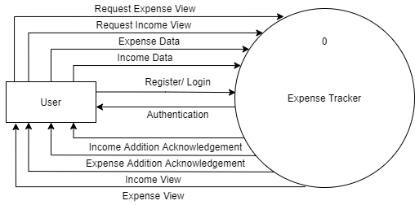

Fig.4.1 Context level D.F.D

## 4.2 level 1 DFD

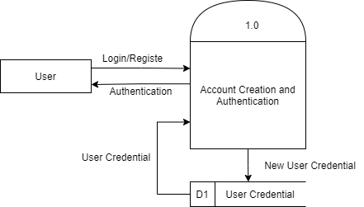

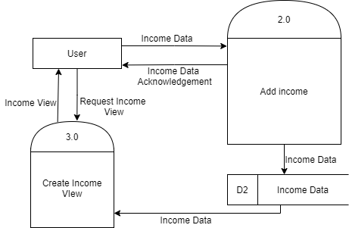

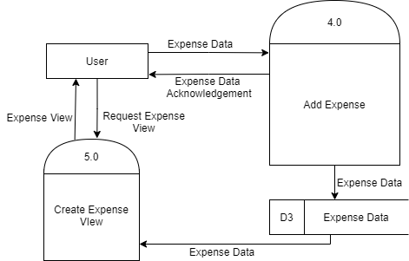

Fig.4.2 level 1 DFD

4.3 ER Diagram

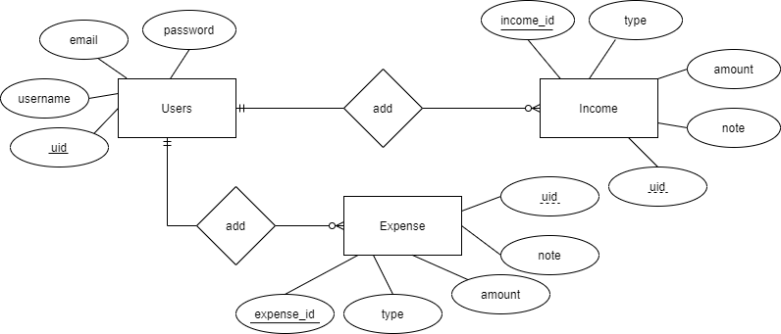

Fig. 4.3 ER diagram

## 4.4 Use case diagram

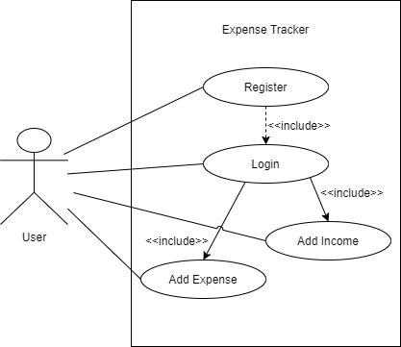

Fig. 4.4 Use Case diagram

# CHAPTER 5: SYSTEM DEVELOPMENT AND IMPLEMENTATION

System development and implementation is the process of implementing the developed software which meets the user’s goal and demand.

## 5.1 Programming Platform

* **Front end:** Android Studio, JAVA, Material UI
* **Back end:** Firebase

## 5.2 Tools and Technologies

The minimum requirement for the system to run are:

**Software details**

Android API level 23(Marshmallow) or higher

## 5.3 Testing and Debugging

Testing begins at the module level and works outward towards the integration of the entire computer-based system. Different testing techniques are appropriate at different level of time. Testing & debugging are different activities, but debugging must be accommodated in any testing strategy. There is different model of testing. Based on testing methods, there are two types of testing. But we did only black box testing.

**Black-box testing**:

# CHAPTER 6: CONCLUSION and FUTURE ENHANCEMENT

## 6.1 Conclusion

After making this application we assure that this application will help its users to manage the cost of their daily expenditure. It will guide them and aware them about their daily expenses. It will prove to be helpful to those people who are frustrated with their daily expense management. In short, we can say that this application will help its users to overcome the wastage of money.

## 6.2 Limitations

Android version below Marshmallow (6.0) cannot run this application.

Needs Internet connection.

## 6.3 Future Enhancement

# APPENDIX

# REFERENCES

The following references were used for the completion of the project.