

**BY:ANIL R**

**Problem Statement**  
  
You are working as a business analyst at Amazon, a company currently performing well. The stakeholders wish to maintain this level of performance and seek improvement. For this purpose, they want to devise new strategies. You are part of a team exploring new ways to benefit customers, such as offering more discounts and Prime membership perks. Could you suggest additional methods to identify and reward customers and enhance their shopping experience?

**Objective Questions**

1. What is the total number of attributes in the customer table?

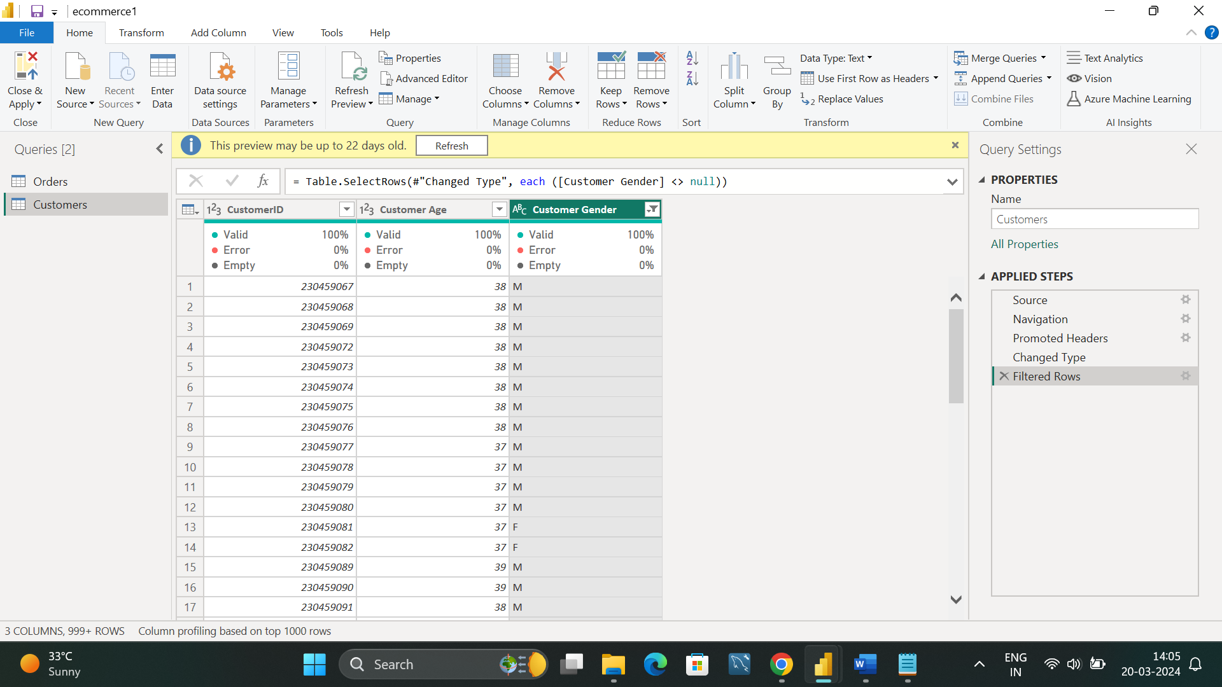

The total number of attributes in the customer table is 3

They are as follows:

1)customerID

2)customer age

3)Customer gender

1. How will you get the “Customer’s” ages in the “Order” tables according to customer ids?

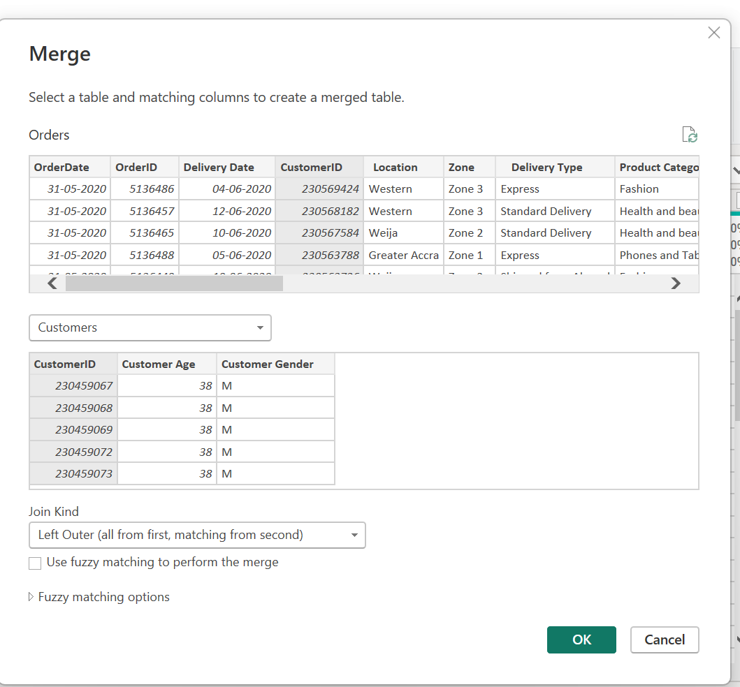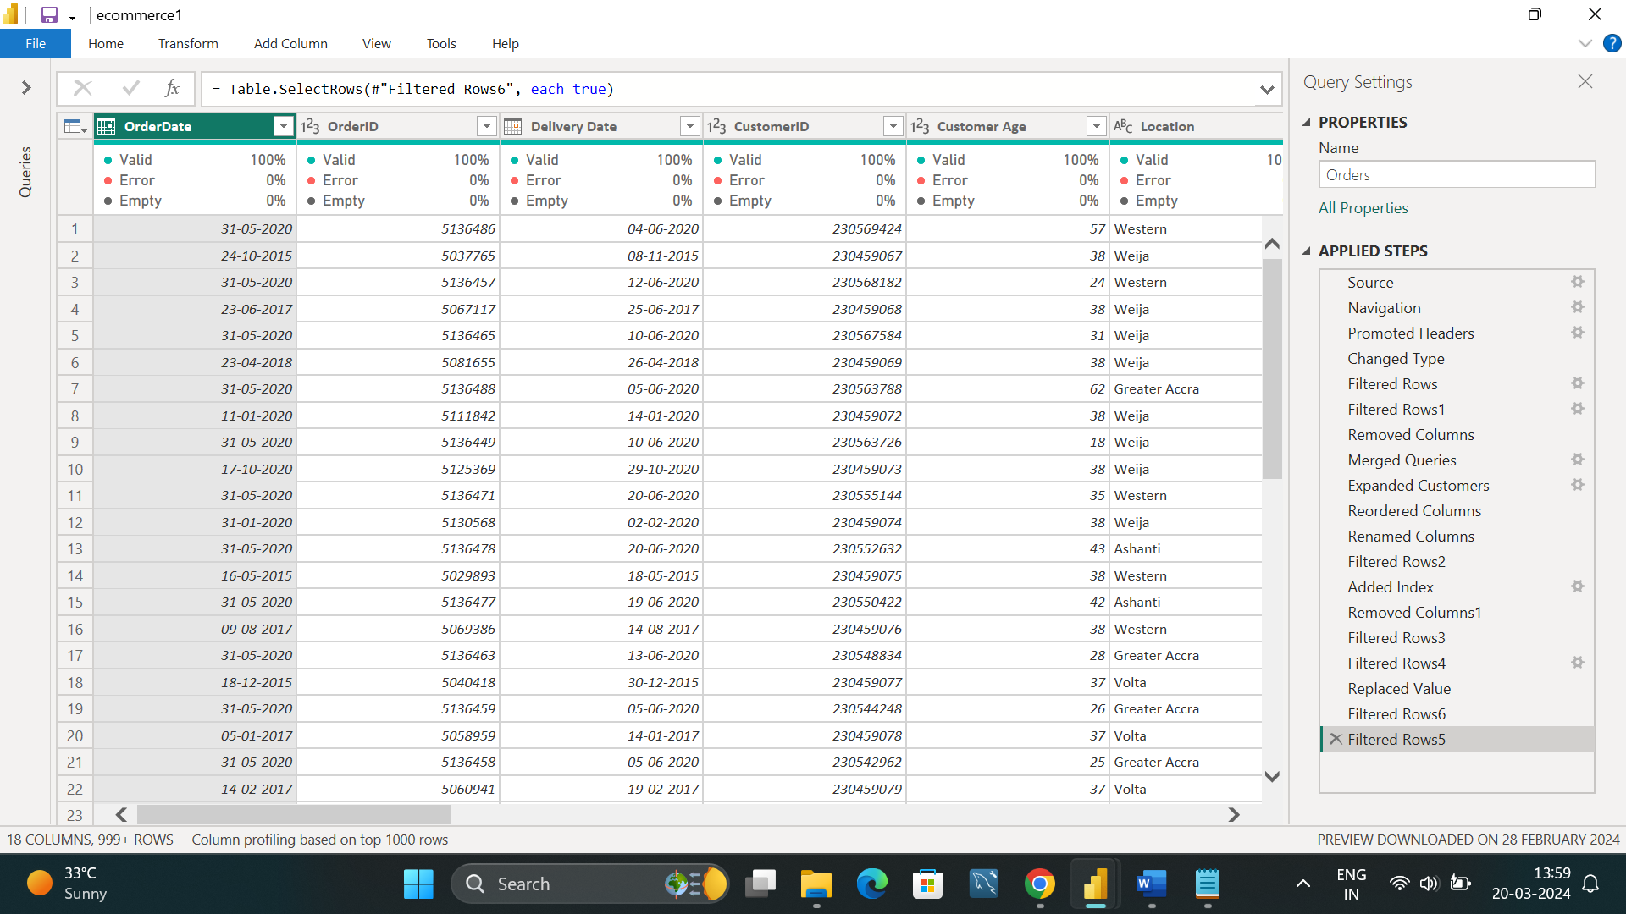

To achieve this, I performed the following steps:

* Used merge queries to join the order table with the customer table based on the 'CustomerID' column.
* Applied a left outer join to retain all records from the order table.
* Expanded the resulting table to include the 'Customer Age' attribute from the customer table. This adds the customer ages to the order table based on their respective IDs."

This addition explicitly mentions that the 'Customer Age' attribute will be added to the order table through the merge operation.

1. In analyzing the dataset with Power BI, ensure data cleaning to address inconsistencies and missing values before further analysis.

1. Initially, I removed empty columns 18 to 22 from the dataset as they contained no useful information.

2. Next, I observed null values in the "Product Category" column and eliminated them to ensure data integrity.

3. Additionally, I removed null values from the "Unit Price" column to maintain meaningful sales data, considering that missing prices would impact the accuracy of sales calculations.

4. When products are returned, sometimes the reasons in “reason” column for the return is mentioned, but often it's not. To handle this, I used a formula in Power Query (M Query) to fill the blank rows. If the product's status indicates a return and the reason column is empty, I replaced those empty spaces with 'not-mentioned'. Otherwise, I kept the existing reason as it is.

Formula: = Table.ReplaceValue(#"Filtered Rows4",each[Reason],each if[Status]="Returned" and[Reason]="" then "not-mentioned" else[Reason],Replacer.ReplaceValue,{"Reason"})

5. For products whose status is marked as 'delivered', I replaced blank values with ‘–‘ in the 'reasons' column as they indicate non-returns. Additionally, I addressed null values in reason column specifically for returned items.

1. How can we calculate the total revenue generated by all the sales?

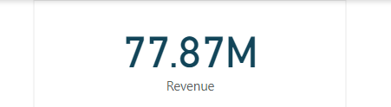

I've created a measure using the DAX function to calculate the total revenue from delivered products. This measure is displayed on a card visualization, indicating that $77.87 million in revenue has been generated.

formula: Revenue = CALCULATE(SUM(Orders[Sale Price]),Orders[Status]="delivered")

1. What is the total number of unique customers who made purchases in each year? Is there any increase in the number over the years?

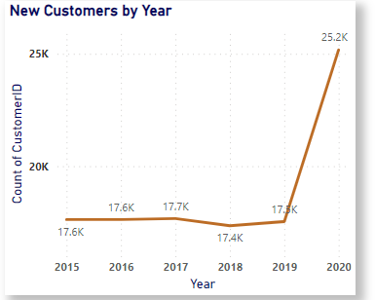

I employed a DAX formula to calculate unique customer counts, then visualized the data in a line chart based on year.

Formula: distinct_count_of_customer = DISTINCTCOUNT(Orders[CustomerID])

In our dataset, we have a total of 113,000 unique customers. When we break down the new customers by year, we observe the following trends:

* + In 2015, approximately 17,600 customers placed orders.
  + Similarly, in 2016, we saw around 17,600 unique customers making purchases.
  + The trend continued with approximately 17,700 unique customers in 2017.
  + In 2018, there were about 17,400 unique customers who made purchases.
  + For 2019, the number of unique customers remained consistent at around 17,500.
  + Interestingly, in 2020, we noticed a significant increase in customer activity, with approximately 25,200 unique customers engaging with our products and services.

From this analysis, it's evident that there has been a general trend of growth in the number of unique customers over the years, with fluctuations in some years. However, the most notable increase occurred in 2020, indicating a substantial expansion of the customer base compared to previous years. This analysis provides valuable insights into the dynamics of customer acquisition and can inform strategic decisions aimed at sustaining and furthering this growth trend.

­

1. How can we determine the total number of unique products available in the company?

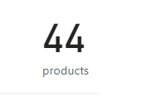

* I've created a measure called "Product Count" using the DISTINCTCOUNT function on the "Product" column from the Orders table. This measure calculates the total number of unique products available and there are 44 products are available in dataset

Formula: product count = DISTINCTCOUNT(Orders[Product]

* This measure is visualized using a card visualization, providing a clear and concise representation of the total count of unique products in the dataset.

1. What is the average number of days it takes for products to be delivered, get the metric for only the delivered orders?

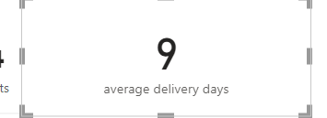

9 is the average number of days it takes for products to be delivered.

I've created a column named days taken for delivery that calculates the number of delivery days taken for each product, regardless of its status, using the DATEDIFF function with the order date and delivery date. Subsequently, to determine the average delivery time specifically for delivered products, I've devised a measure using the CALCULATE function. This measure computes the average of the days taken for delivery and filters the order status to include only delivered orders. This provides insight into the average delivery time for completed orders, facilitating performance evaluation and potential process improvements.

Formula: **calculate(AVERAGE(Orders[days taken for delivery]),Orders[Status]="Delivered")**

It calculates the average of days taken for delivery and filters the order status to delivers to get only for delivered orders.

1. Which products, categories, and subcategories are the most popular

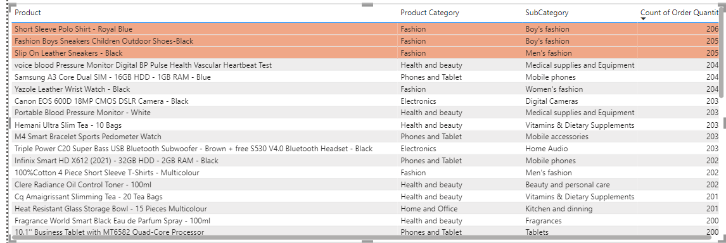

|  |  |  |
| --- | --- | --- |
| **products** | **categories** | **subcategories** |
| **Short sleeve polo shirt-royal blue** | **fashion** | **Boys fashion** |
| **Fashion boys sneakers children outdoor shoes-black** | **fashion** | **Boys fashion** |
| **Slip on leather sneakers-black** | **Fashion** | **Men’s fashion** |

The products, categories, and subcategories listed are popular due to their frequent orders. Through analyzing order quantities, I've identified the most sought-after products to prioritize. This approach ensures our attention is directed towards the most in-demand items for comprehensive analysis.

1. Which products have seen an increase or decrease in sales over the year? 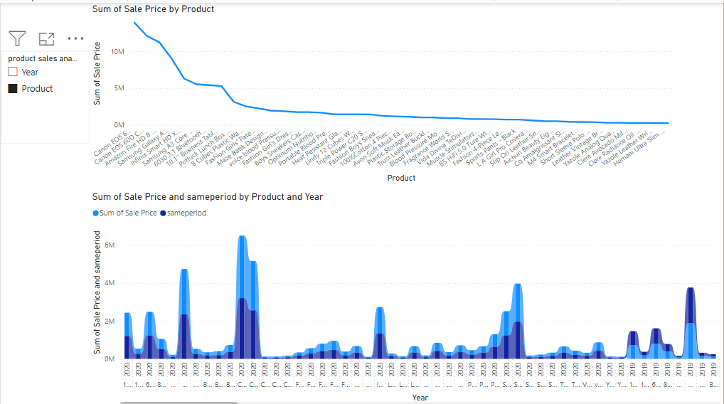

Products which have seen increase sales over the year are

**Note**: In the dataset, orders are recorded from 2015 to 2020. However, there is no order data available for the year 2021. It's important to note that orders placed at the end of 2020 may have generated sales revenue in 2021. Therefore, while analyzing sales trends, it's essential to understand that the absence of order data for 2021 does not necessarily indicate a decline in sales. Instead, it may reflect the timing of revenue recognition. As a result, the sales trends observed should be interpreted within the context of this data limitation, focusing on the period from 2015 to 2020 for comprehensive insights into sales performance over time.

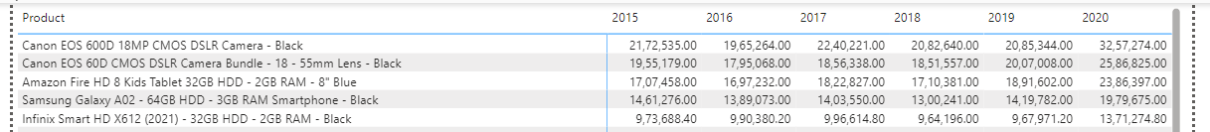

* Canon EOS 60D CMOS DSLR Camera Bundle - 18 - 55mm Lens – Black
* Canon EOS 600D 18MP CMOS DSLR Camera – Black
* Amazon Fire HD 8 Kids Tablet 32GB HDD - 2GB RAM - 8" Blue
* Samsung Galaxy A02 - 64GB HDD - 3GB RAM Smartphone – Black
* Infinix Smart HD X612 (2021) - 32GB HDD - 2GB RAM – Black

These above mentioned are top 5 products experienced year-over-year sales ///growth from 2015 to 2020, significantly contributing to overall revenue …..generation.

Products which have seen decrease sales over the year are

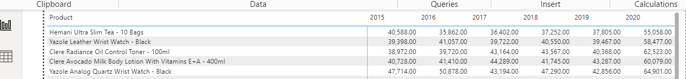

* Hemani Ultra Slim Tea - 10 Bags
* Yazole Leather Wrist Watch – Black
* Clere Radiance Oil Control Toner - 100ml
* Clere Avocado Milk Body Lotion With Vitamins E+A - 400ml
* Yazole Analog Quartz Wrist Watch – Black

The sales performance of the aforementioned products is unimpressive, exhibiting alternating decreases in sales over the years. Consequently, these products do not demonstrate favorable trends and have not significantly contributed to revenue generation.

1. While modeling the data relationships, what will be the type of relationship between the customer id of Orders and customers tables?

* The relationship between the customer ID in the orders table and the customer's table is a many-to-one relationship. This is because multiple orders can be associated with the same customer ID, indicating that one customer can place multiple orders.

1. How have you handled the null values in the data?

* Upon loading the data into Power Query Editor, columns 18 to 22 were observed to lack headings and contained entirely null values.
* As these columns were deemed non-essential, they were removed from the dataset to enhance clarity and streamline analysis.
* Within the product category column, null values were identified and subsequently filtered out to ensure data integrity and consistency.
* Similarly, null values within the unit price column were identified as not meaningful and removed using the "Remove Empty" option within Power Query Editor.
* These data cleaning steps aimed to improve the quality and usability of the dataset for subsequent analysis and visualization.
* When products are returned, sometimes the reason for the return is mentioned, but often it's not. To handle this, I used a formula in Power Query (M Query) to fill the blanks rows. If the product's status indicates a return and the reason column is empty, I replaced those empty spaces with 'not-mentioned'. Otherwise, I kept the existing reason as it is.

Formula: = Table.ReplaceValue(#"Filtered Rows4",each[Reason],each if[Status]="Returned" and[Reason]="" then "not-mentioned" else[Reason],Replacer.ReplaceValue,{"Reason"})

* For products whose status is marked as 'delivered', I replaced blank values with ‘-‘ in the 'reasons' column as they indicate non-returns. Additionally, I addressed null values in the reason column specifically for returned items.

1. Were there any data format issues in the data, and if there …….were/are how you handled them?

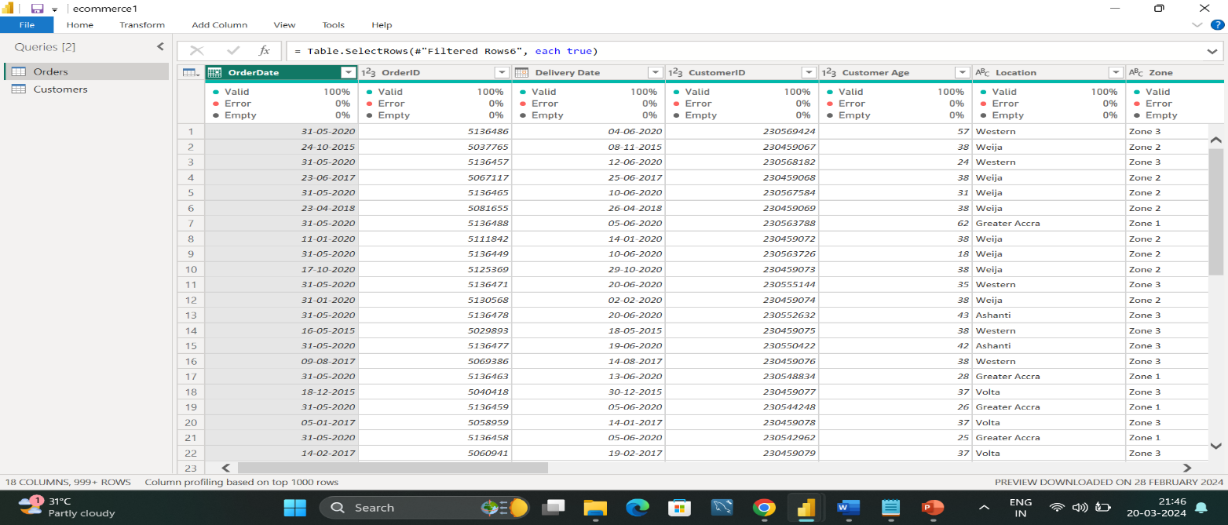

* In the dataset, all columns were appropriately defined with the correct data types, ensuring no format inconsistencies. However, several columns contained numerous null values, which required attention. These null values were effectively managed and addressed during the data processing stage. By handling these null values, data integrity and completeness were maintained, ensuring accurate analysis and insights.

13. When we add a column in Power Query what’s the code that comes .. in M language in formula bar? What do you know about M-query?

* When we add a column in Power Query, the code that appears in the formula bar is written in the M language. It defines the steps needed to create the new column based on the operations we specify. For example, if we're adding a custom column using a formula to sum two existing columns, the M language code might look like this:
* = Table.AddColumn(#"PreviousStep", "NewColumn", each [Column1] + [Column2])

In this code, "NewColumn" is the name of the new column being created, and each [Column1] + [Column2] is the formula used to calculate the values for each row in the new column.

* M-query, also known as the Power Query Formula Language, is a scripting language used within Power Query for data transformation and manipulation tasks. It allows users to perform various operations on data sources, such as filtering, sorting, merging, and transforming data before loading it into their analysis tools like Excel or Power BI. M-query is based on a functional programming paradigm, providing flexibility and power for handling complex data manipulation tasks effectively.

**Subjective Questions**

1. Explain the revenue breakdown by year and by product? Evaluate how different products contribute to annual revenue and come up with the suggestions to increase the sales of the low selling items.

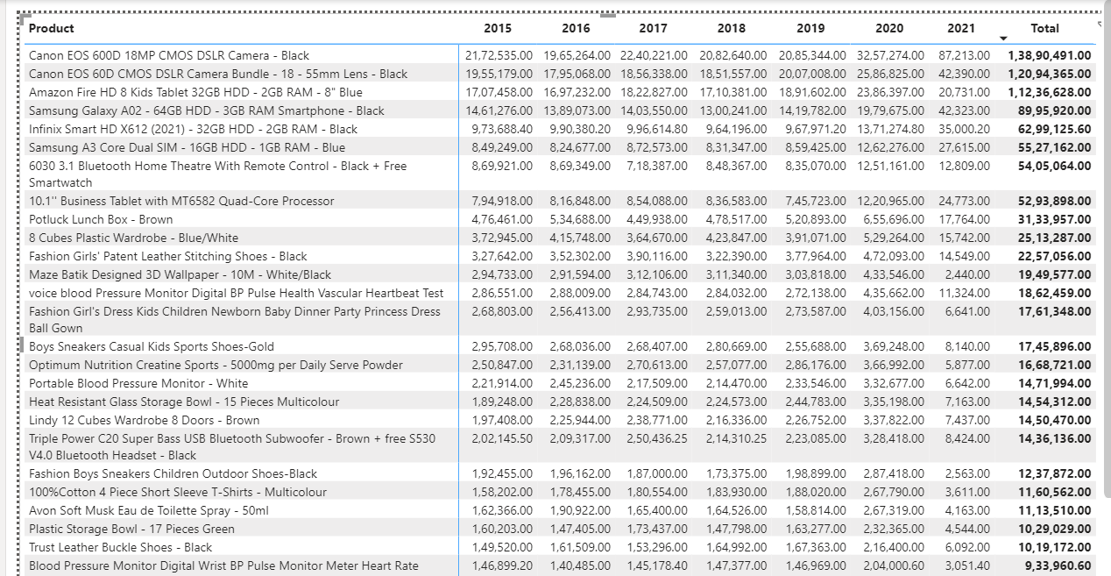

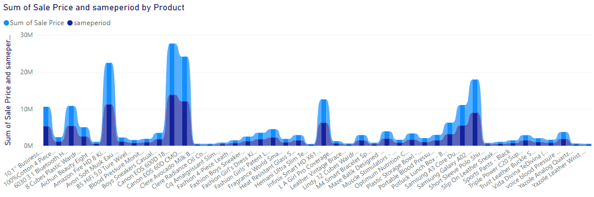

* Revenue generation commenced positively across all products in 2015, marking the beginning of the sales trend analysis.
* Subsequent years from 2016 to 2019 witnessed a gradual increase in sales, contributing to a steady rise in revenue.
* The pinnacle of revenue generation occurred in 2020, characterized by a significant surge in sales, resembling a "golden year" in terms of financial performance.
* Notably, the absence of order data for 2021 in our dataset does not imply a decline in revenue. Orders placed towards the end of 2021 likely contributed to sales revenue recorded within the same year. Therefore, it's essential not to interpret this as a drop in revenue for 2021.

Products that consistently generated high sales and contributed significantly to revenue generation each year are

* Canon EOS 60D CMOS DSLR Camera Bundle - 18 - 55mm Lens – Black
* Canon EOS 600D 18MP CMOS DSLR Camera – Black
* Amazon Fire HD 8 Kids Tablet 32GB HDD - 2GB RAM - 8" Blue
* Samsung Galaxy A02 - 64GB HDD - 3GB RAM Smartphone – Black
* Infinix Smart HD X612 (2021) - 32GB HDD - 2GB RAM – Black

The aforementioned product contributed 12.95%, 11.28%, 10.48%, 8.39% and 5.87% respectively to revenue generation.

These are the top 5 products chosen based on the total revenue generated by each products

Products with Low Revenue Contribution and Minimal Yearly Trends

* Hemani Ultra Slim Tea - 10 Bags
* Yazole Leather Wrist Watch – Black
* Clere Radiance Oil Control Toner - 100ml
* Clere Avocado Milk Body Lotion With Vitamins E+A - 400ml
* Yazole Analog Quartz Wrist Watch – Black

The aforementioned product contributed 0.23%,0.24%,0.25%,0.25% and 0.28% respectively to revenue generation.

These are the least 5 products chosen based on the total revenue generated by each products

**Suggestions to increase least selling products**

* Develop targeted marketing campaigns to promote low selling items.
* Explore opportunities to cross-sell low selling items with popular products or create bundles that include them. This can help increase their visibility and sales.
* Gather feedback from customers and consider making improvements or modifications to low selling items based on their preferences and suggestions.

1. How many products were returned? Use a DAX function in order get this metric. Examine the possible reasons for returns and consider how this metric could indicate improvements in product descriptions or quality control.

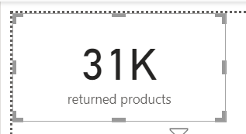

Thirtyone Thousand thousand products were returned

Formula: **returned products = CALCULATE(COUNT(Orders[Product]),Orders[Status]="Returned")**

Returning Reasons:

1. Defective items: Products returned due to defects or quality issues.

2. Missing item/part during delivery: Items returned because they were incomplete upon delivery.

3. Product not fitting expectation: Returns resulting from discrepancies between customer expectations and the actual product received.

4. Delivery of wrong items: Products returned because they were not the items ordered by the customer.

Examine:

* The returned products often receive low ratings due to above mentioned reasons, indicating dissatisfaction among customers.
* Utilizing these reasons as inputs, we can enhance product quality by addressing defects and improving overall product descriptions.
* Implementing rigorous quality checks during product dispatch can help ensure accurate deliveries, reducing the likelihood of wrong items being sent.
* By resolving these issues, we anticipate a decrease in the rate of product returns, leading to increased revenue generation and improved customer satisfaction.

1. Whenever a customer goes to Amazon, they’ll filter the most rated products in order to buy the better category. Can you verify this using any visualization or table that the ratings of products impact their sales value.

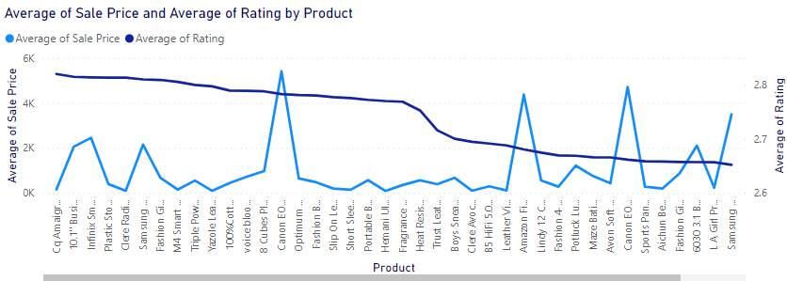

* There is no correlation between the rating of products and their sales value.
* High ratings do not necessarily result in high sales values, and conversely, low ratings do not always lead to low sales values.
* Despite the perception that higher-rated products would have higher sales and vice versa, this is not observed in the data.
* The relationship between product ratings and sales values does not follow a consistent pattern.
* Contrary to expectations, products with high ratings may not always perform better in terms of sales, and products with low ratings may still achieve significant sales volumes.

1. Investigate how revenue distribution varies across different locations. Explore which geographical areas contribute most to sales and consider the strategic implications for regional marketing and distribution efforts. How might location-based trends inform the company's approach to market segmentation and resource allocation?

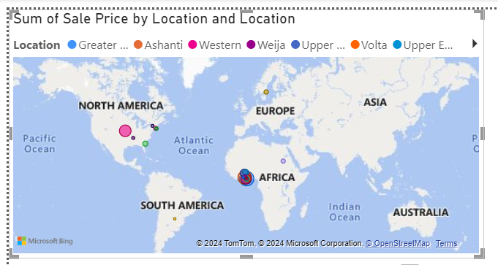

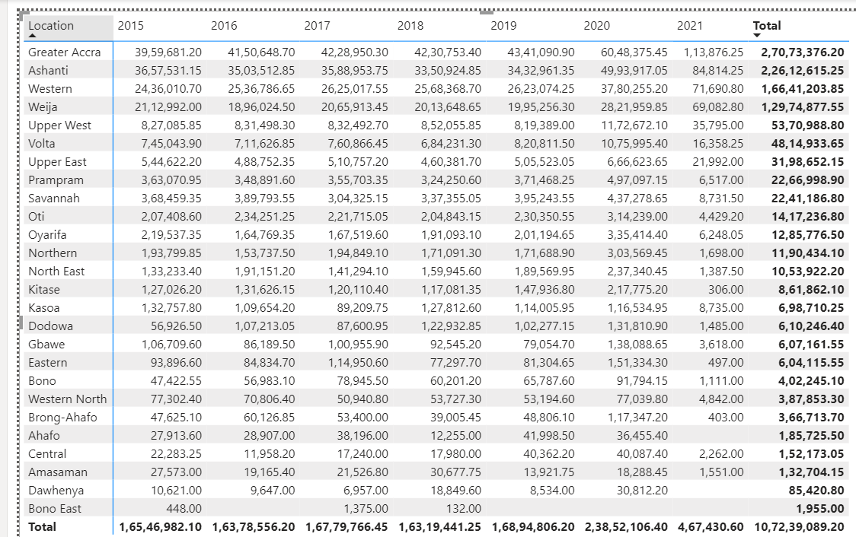

I used a map chart to visualize sales by location. While most locations showed positive trends with increasing year-over-year (YOY) sales, there were a few locations where the trend was notably poor, and improvements were not impressive..

Locations contributed more sales

Greater Accra,ashanthi,western,wejja,Upper West are the top locations that have highest sales.

Location contributed the least sales

Central,Amasaman,dawhenya, Bono East are the locations which contributed the least sales

Strategical implication for regional marketing

High-Performing Locations:

1. Targeted Marketing: Invest in targeted marketing efforts tailored to high-performing regions to maximize brand visibility and customer engagement. Utilize data-driven insights to develop personalized advertising campaigns and promotions that resonate with local preferences.

2. Localized Product Assortment: Customize product offerings to meet the specific needs and preferences of customers in high-performing areas. This may involve introducing region-specific products or variations to better align with local demand and drive sales.

3. Enhanced Distribution Networks: Optimize distribution networks by strategically locating warehouses and fulfillment centers closer to high-performing regions. This reduces delivery times, improves customer satisfaction, and lowers shipping costs, leading to increased sales and loyalty.

Strategies for Low-Performing Locations:

1. Market Research: Conduct thorough market research to understand the underlying reasons for low sales in specific regions. Identify factors such as competition, consumer preferences, and economic conditions to inform targeted strategies for improvement.

2. Targeted Marketing Campaigns: Develop focused marketing campaigns aimed at raising awareness and stimulating demand in low-performing areas. Utilize messaging that addresses local needs and concerns, and offer incentives such as special promotions or discounts to attract customers.

3. Local Partnerships: Forge strategic partnerships with local businesses, influencers, or community organizations to increase brand visibility and credibility in low-performing areas. Collaborate on joint marketing initiatives to reach new audiences and drive sales growth.

Market segmentation and resource allocation

1. Regional Preferences Drive Targeted Marketing: Understanding regional differences in consumer preferences helps company to tailor marketing campaigns to specific areas. For instance, urban and rural areas may have different product preferences, and adjusting marketing strategies accordingly can improve sales.

2. Efficient Resource Allocation: By identifying regions with high market potential, company can focus resources like advertising budgets and sales teams where they're most likely to succeed. This maximizes sales opportunities and ensures resources aren't wasted on areas with low demand.

3. Customized Offerings Enhance Customer Satisfaction: Analyzing regional preferences allows companies to customize products or services to better suit local tastes. This demonstrates understanding and appreciation of local needs, fostering stronger customer loyalty and satisfaction.

1. Determine which month could benefit from enhanced promotional offers to boost sales. Can you suggest some targeted marketing strategies here?

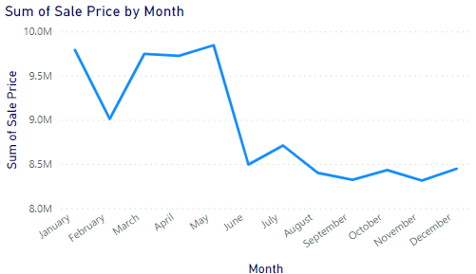

Sales are dropping drastically from August to December. Conversely, sales show an increasing trend from January to May, with sales being decent in the months of June and July. Implementing promotional offers between August and December could significantly increase sales during these months.

Targeted marketing strategies:

* Offer special quick discounts on certain products with Lightning Deals and Daily Deals. They make people feel like they have to buy now, which boosts sales when things are slow.
* Put together deals where customers get a discount if they buy more than one item or if they buy products that go together. This encourages people to buy more, which increases sales.
* Spend some money on ads on social media. You can target ads to reach exactly the kind of people who might want to buy your stuff. This helps you make the most out of the money you spend on ads.
* Leverage Amazon Prime Day to boost sales. Provide special deals and discounts exclusively for Prime members to encourage sign-ups and increase sales.
* Encourage happy customers to refer their friends and family by giving them rewards or discounts when their referrals make a purchase. This helps bring in new customers through word-of-mouth, boosting sales.

1. Identify which products may require increased marketing efforts. Which items have high price yet underperform in sales?

Products that may require increased marketing efforts are

* Hemani Ultra Slim Tea - 10 Bags
* Yazole Leather Wrist Watch – Black
* Clere Radiance Oil Control Toner - 100ml
* Clere Avocado Milk Body Lotion With Vitamins E+A - 400ml
* Yazole Analog Quartz Wrist Watch – Black

The aforementioned product contributed 0.23%,0.24%,0.25%,0.25% and 0.28% respectively to revenue generation.

These are the least 5 products chosen based on the total revenue generated by each products

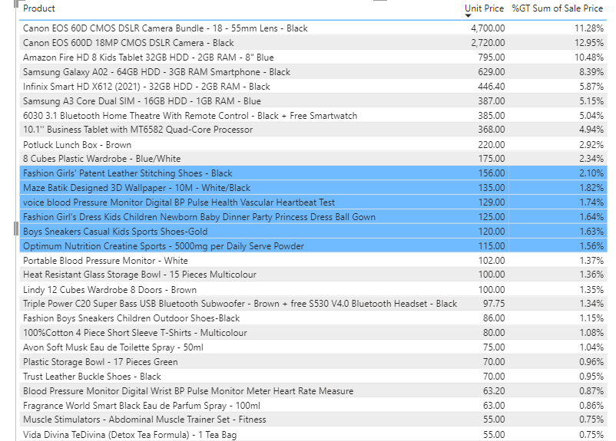

Based on the criteria, here is a list of selected products with a unit price of 115 and above, but with an average sales below 2.25%. These products are considered to have a high unit price but underperformance, and they may benefit from additional marketing efforts to meet at least the average sales price:

1. fashion girl's patent leather stitching shoe black

2. Maze Batik Designed 3D Wallpaper - 10M - White/Black

3. Voice blood Pressure Monitor Digital BP Pulse Health Vascular Heartbeat Test

4. Fashion Girl's Dress Kids Children Newborn Baby Dinner Party Princess Dress ….Ball Gown

5. Boys Sneakers Casual Kids Sports Shoes-Gold

6. Optimum Nutrition Creatine Sports - 5000mg per Daily Serve Powder

These products could potentially benefit from targeted marketing campaigns, promotions, or pricing strategies to increase their average sales price and improve overall performance.

1. Assess which products should have discounts. How can targeted incentives drive sales and customer loyalty for specific products?

* Discounts can be given primarily on products that are showing low sales trends to stimulate demand and improve their performance. Additionally, discounts can also be offered on products with high unit prices and high sales volumes to maintain competitiveness and encourage continued purchases.
* Products having low trends are



* Produts having high trends are

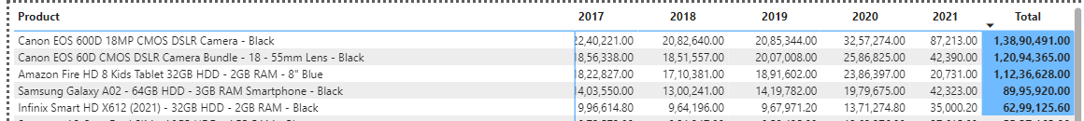

**How these targeted incentives drive sales and customer loyalty for specific products**

* Boost sales and move inventory by offering discounts on products with poor sales trends.
* Attract customers to purchase products already selling due to competitive pricing by providing slightly higher discounts compared to the market.
* Enhance customer satisfaction and maintain competitive pricing by applying discounts to products with high sales and unit prices.
* Encourage customers to explore new offerings by introducing discounts on newly launched products alongside high-sales, high-unit-price items.
* Increase customer satisfaction and word-of-mouth referrals by offering trending products at competitive prices.
* Drive customer engagement and purchases by aligning deals with customer interests and preferences.
* Optimize sales, enhance customer loyalty, and strengthen market position by strategically utilizing targeted incentives.

1. Come up with a loyalty program to benefit company’s customers. From the available lot of customers come up with the strategies to bucket them and provide benefits under different loyalty programs.

Some loyalty program to benefits company’s customers

Amazon Bronze

* + Segment: Occasional shoppers who make sporadic purchases on Amazon.

**Benefits:**

* + Basic customer support.
  + Access to standard shipping options.
  + Occasional discounts on select items.
  + Earn 1% cashback on eligible purchases.

**Amazon Silver**

* + Segment: Regular shoppers who frequently purchase from Amazon but may not have high spending.

**Benefits:**

* + All benefits of Bronze tier.
  + Faster shipping options (standard,express,shipping from abroad).
  + Priority customer support.
  + Exclusive access to Silver tier deals and discounts.
  + Earn 2% cashback on eligible purchases.

**Amazon Gold**

* + Segment:High-value customers who consistently make significant purchases on Amazon.

**Benefits:**

* + All benefits of Silver tier.
  + Free expedited shipping on eligible items.
  + Extended return window.
  + Access to Gold tier deals and discounts.
  + Personalized product recommendations.
  + Earn 3% cashback on eligible purchases.

**Loyalty Program Strategies**:

* Offer tiered benefits that increase in value as customers move up the loyalty ladder, incentivizing them to increase their spending and engagement with Amazon.
* Provide exclusive deals and discounts to each tier, ensuring that higher-tier customers feel valued and receive perks commensurate with their loyalty.
* Offer priority customer support to higher-tier customers, resolving their issues more quickly and effectively to enhance their shopping experience.
* Surprise and delight customers with occasional rewards such as bonus discounts, freebies, or early access to sales events, fostering a sense of appreciation and loyalty.
* Establish a feedback mechanism to gather insights from customers about their preferences and experiences with the loyalty program, allowing for continuous improvement and optimization of benefits.

1. Using the DAX functions Calculate and a row iteration DAX function calculate the total sales for the Product Category “Fashion” and delivery type “Shipped from Abroad”. What are the other types of DAX functions you have used in the project?

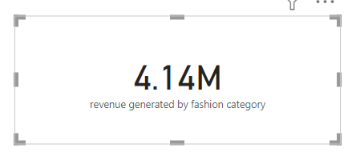

* Revenue of 4.14 million is generated from the fashion product category, where the delivery type is shipping from abroad.
* Formula used :

revenue generated by fashion category = CALCULATE(SUMX(Customers,[Revenue]),Orders[Product Category]="fashion",Orders[Delivery Type]="Shipped from Abroad")

* The formula uses CALCULATE to filter revenue data. SUMX iterates over each customer, summing revenue where product category is fashion and delivery type is Shipped from Abroad. It calculates total revenue from fashion items shipped internationally.

Other dax function used in project are

* Revenue = sum(Orders[Sale Price])

it calculates the overall revenue.

* Net sales = CALCULATE(sum(Orders[Sale Price]),Orders[Status]="Delivered")

This DAX formula calculates net revenue by summing up the revenue generated only by-products marked as 'Delivered' in the Orders table, excluding returned products.

* Products = DISTINCTCOUNT(Orders[Product])

This DAX expression counts how many different products have been ordered, essentially providing the number of unique products in the Orders table.

* avg delivery days = calculate(AVERAGE(Orders[days taken for delivery]),Orders[Status]="Delivered")

This DAX formula calculates the average delivery days for orders marked as "Delivered" by filtering the "days taken for delivery" column in the "Orders" table and then computing their average.

* returned products = CALCULATE(COUNT(Orders[Product]),Orders[Status]="Returned")

This formula counts the number of returned products by filtering the Orders table where the status is marked as "Returned," providing the total count of products that have been returned.

* days taken for delivery = DATEDIFF(Orders[OrderDate],Orders[Delivery Date],DAY)

This DAX expression calculates the number of days taken for delivery by finding the difference in days between the OrderDate and Delivery Date columns in the Orders table.

1. **Wait Times Correlated with Demographics and Care: Explore how .. average wait times vary across different product categories to …...optimize scheduling and staffing.**

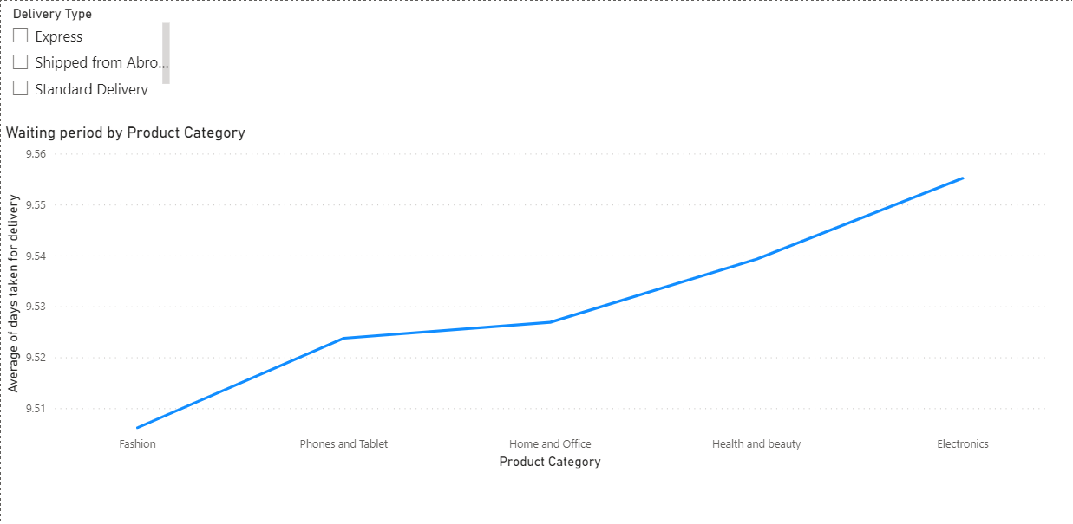

**The average Waiting period varies for different product categories**

The electronics category has the highest waiting period and the fashion category has less waiting period

**Optimizing Staff:**

* Allocate Resources for Peak Hours: Allocate more staff during peak hours and days to handle increased demand efficiently. This ensures that customer needs are met promptly, reducing wait times and enhancing satisfaction.
* Adjust Staffing Based on Demand Fluctuations: Adjust staffing levels based on demand fluctuations. For instance, increase staff availability during peak times for product categories with consistently longer wait times, such as electronics. This proactive approach helps in optimizing resources and minimizing customer wait times.
* Cross-Train Staff for Flexibility: Cross-train staff members to handle multiple tasks or product categories. This flexibility enables better resource allocation, ensuring that staff can be deployed where they are most needed at any given time. It improves operational efficiency and reduces wait times by optimizing staff deployment.
* Match Staffing Schedules to Demand Patterns: Adjust staffing schedules to match demand patterns across different product categories. Ensure sufficient staff availability during peak hours for categories with high wait times. By aligning staffing schedules with demand fluctuations, businesses can efficiently manage customer flow and minimize wait times.

**Reducing Waiting Period:**

* Streamline Processes to Reduce Bottlenecks: Identify and streamline processes for product categories with high waiting times to reduce bottlenecks and improve efficiency. Automation or process optimization can help minimize wait times and enhance overall service quality. By streamlining processes, businesses can expedite order processing and reduce customer wait times significantly.
* Implement Priority Handling: Implement priority handling for product categories with longer wait times. This ensures timely service for customers and reduces wait times for critical orders or high-demand products, improving overall customer satisfaction.
* Optimize Inventory Management: Optimize inventory management for product categories with long waiting times to ensure adequate stock availability. Avoid stockouts or delays in product availability that could contribute to extended wait times. By maintaining optimal inventory levels, businesses can fulfill orders promptly and minimize customer wait times.
* Continuous Monitoring and Evaluation: Continuously monitor wait times across different product categories and evaluate the effectiveness of staffing and scheduling adjustments. Use data-driven insights to identify areas for improvement and implement targeted strategies to further optimize operations and reduce customer wait times.

1. Explore if there is any relationship between the Delivery type and …...waiting time between ordering and receiving an item.

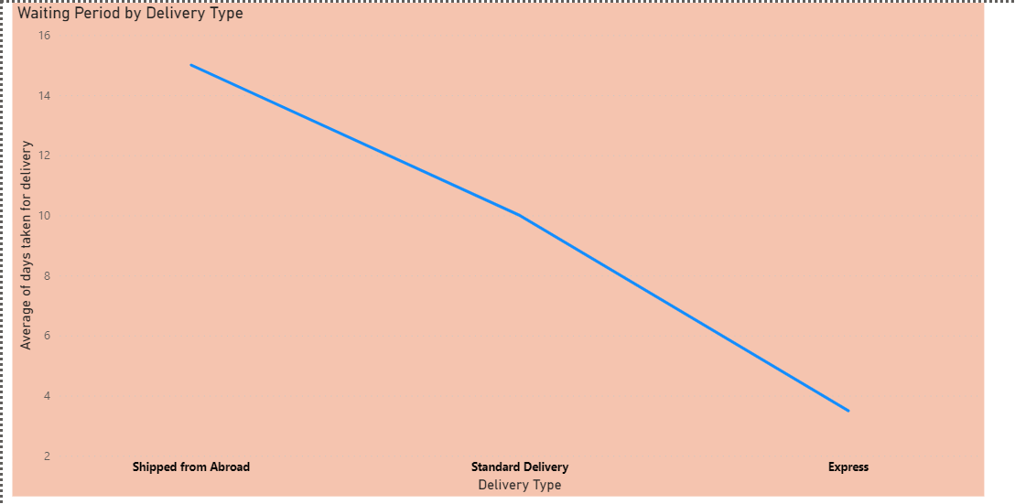

Yes, we can observe a correlation between the delivery type and the waiting period. The available delivery types include express, standard delivery, and shipping from abroad.

* For express delivery, the average waiting period is 3 days.
* For standard delivery, the average waiting period is 10 days.
* For delivery shipped from abroad, the average waiting period is 15 days.
* The average waiting period increases in the order: express < standard < shipped from abroad, indicating a correlation between delivery type hierarchy and waiting time.

1. Is there any relationship between shipping charges and product ……type?

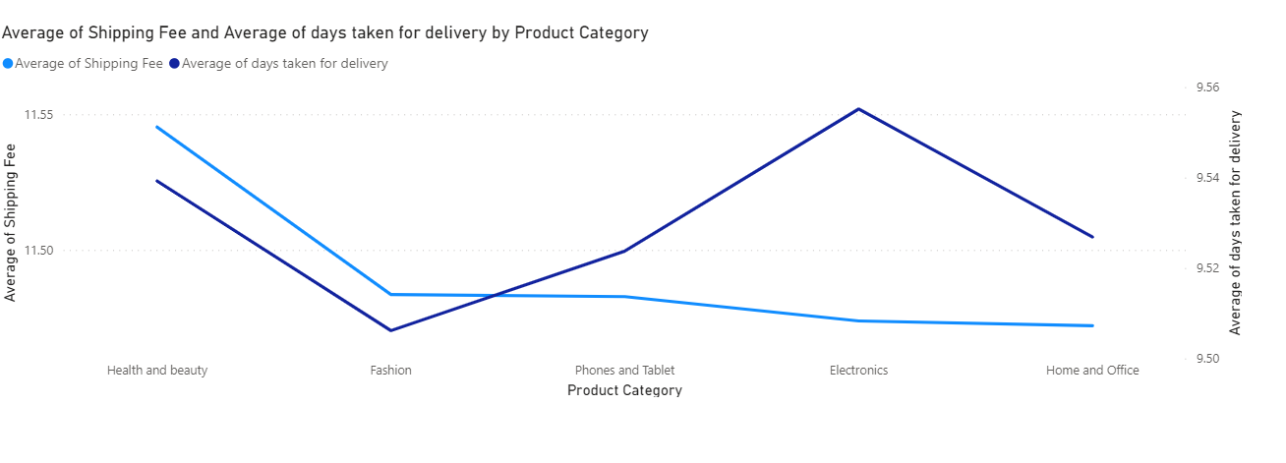

We can observe the relationship between product type/category and the shipping charges

* The shipping value is high for health and beauty > fashion > phones and tablets > electronics > home and office.
* Products with higher average shipping fees typically experience shorter waiting periods, while products with lower shipping fees tend to have longer waiting periods. This trend is particularly noticeable when considering product types with distinct shipping characteristics.

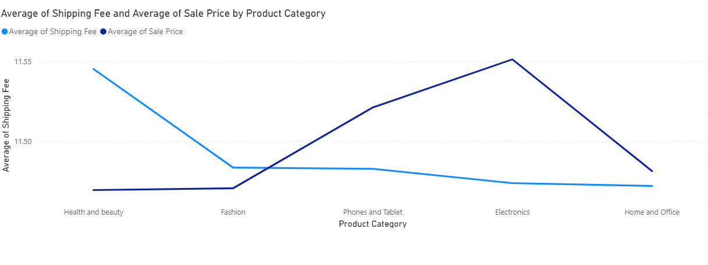

* Concentrating on products with higher shipping values reveals a trend of lower average sales, suggesting that customers may be deterred by the additional shipping costs associated with these items.

* Conversely, products with lower shipping values exhibit a high trend of average sales, indicating that customers may be more inclined to purchase these items due to lower shipping costs, resulting in increased sales volume.

1. Come up with the strategies to decrease the low rating orders after …..analyzing different factors like waiting time, shipping type, unit …...price, etc.

* Improve Product Quality: Address quality issues identified with returned products to gradually increase product ratings.
* Enhance Product Descriptions: Provide detailed and accurate product descriptions, including specifications, features, and benefits, to manage customer expectations and minimize dissatisfaction.
* Reduce Waiting Periods: Focus on reducing waiting times, especially for products shipped from abroad, to improve customer satisfaction and increase ratings.
* Adjust Pricing Strategies: Offer discounts on products with high unit prices but underperforming sales to set competitive prices and boost ratings.
* Provide Efficient Customer Support: Ensure prompt and effective customer support to address any issues or concerns, leading to improved satisfaction and ratings.
* Invest in Product Packaging: Improve product packaging to enhance the presentation and protection of items during shipping, minimizing the risk of damage and improving customer satisfaction.
* Gather Customer Feedback: Collect feedback from customers to tailor services and meet their needs, ultimately decreasing low rating orders.

1. Using the time intelligence DAX function, create a table to compare …..the each month’s sales with the previous year’s same months’ total …..sales. So there will be four columns in the output year, month, total …..sales, previous_years_sales.

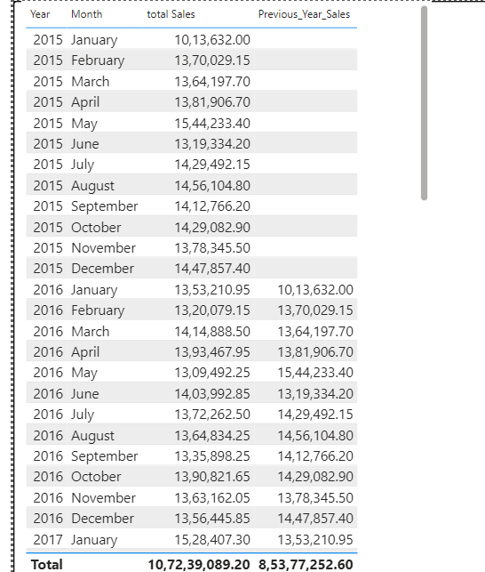

From this visualization we can compare the each month sales with previous year same month

Dax formula used to calculate previous_year_sales is

Previous_year_sale = CALCULATE(sum(Orders[Sale Price]),SAMEPERIODLASTYEAR(Orders[Delivery Date]),ALLEXCEPT(Orders,Orders[Delivery Date]))

This formula sums up the sales prices from the previous year for the same period. It employs the SAMEPERIODLASTYEAR function to filter data for the corresponding period in the prior year. The ALLEXCEPT function maintains the filter on the delivery date column, ensuring accurate year-over-year comparison. Overall, it offers a simple method to analyze sales performance across different years.

1. What do you understand by PowerBI gateway? What are its use ……cases?

I understand PowerBI Gateway as a tool used to securely connect Power BI to on-premises data sources. It acts as a bridge between Power BI in the cloud and data stored locally, allowing users to access and refresh data from sources such as databases, files, and on-premises applications.

**The use cases of Power BI Gateway include:**

* Data Refresh: Power BI Gateway enables scheduled data refreshes for on-premises data sources, ensuring that reports and dashboards in Power BI stay up-to-date with the latest information.
* Direct Query: It allows for real-time access to on-premises data sources through Direct Query mode, enabling users to interact with data in real-time without importing it into Power BI.
* Live Connection: Power BI Gateway supports live connections to on-premises data sources, allowing users to build reports and dashboards directly on top of on-premises data without needing to import it into Power BI.
* Data Protection: It ensures data security by encrypting data transfers between on-premises data sources and Power BI, maintaining compliance with organizational security policies.
* Hybrid Deployment: Power BI Gateway facilitates hybrid deployment scenarios where organizations can leverage both cloud and on-premises data sources, enabling seamless integration and collaboration.
* Overall, Power BI Gateway plays a crucial role in enabling organizations to leverage their on-premises data sources while harnessing the power and flexibility of Power BI for data analysis and visualization.

1. How would you approach this problem, if the objective and ……subjective questions weren't given?

* Customer Segmentation Analysis: Conduct an in-depth analysis of customer demographics, behaviors, and preferences to identify distinct customer segments. This segmentation can help tailor marketing strategies and rewards programs to specific customer groups.
* Purchase Behavior Analysis: Analyze customers' past purchase behavior, including frequency. Identify high-value customers who contribute significantly to revenue and loyalty and design personalized rewards and incentives for them.
* Enhanced Loyalty Programs: Revamp existing loyalty programs or introduce new ones to provide added benefits and perks to loyal customers. Offer tiered membership levels, exclusive discounts, early access to sales, and personalized rewards to incentivize repeat purchases and customer retention.
* Visualize Customer Age Groups Contributing to Sales:
  + Use visualization tools to analyze sales data by customer age groups.
  + Identify which age groups contribute the most to overall sales revenue.
  + Use insights to tailor marketing strategies and product offerings to target these age demographics effectively.
* Analyze Product Sales by Customer Gender Ratios:
* Utilize visualization techniques to examine product sales based on customer gender ratios.
* Determine which products are popular among different gender demographics.
* Adjust marketing campaigns and product promotions to better cater to the preferences of each gender group.
* Identify Customer Groups with Declining Orders:
* Visualize trends in customer orders over time to identify groups with declining purchasing behavior.
* Explore possible reasons for the decline, such as changing preferences or market saturation.
* Develop targeted strategies to re-engage these customer segments and stimulate repeat purchases.
* Analyze Customer Distribution Across Locations:
* Utilize geographic visualization tools to map customer distribution across provided locations.
* Identify regions with high concentrations of customers and sales.
* Use insights to optimize marketing efforts and expand customer reach in underrepresented areas.
* Referral Programs: Launch referral programs that reward customers for referring friends or family members to the platform, providing incentives such as discounts or store credits for successful referrals, driving customer acquisition and retention.