**1. L1 - Demonstrate the AWS EC2 Ubuntu Instance Creation steps and connect to EC2 Instance using Mobaxterm/putty agent**

**Ans:- Steps to create EC2 instance are**

First of all login the aws console.

**Step1:- Type EC2- in search box of console of accunt and then click on launch ec2**

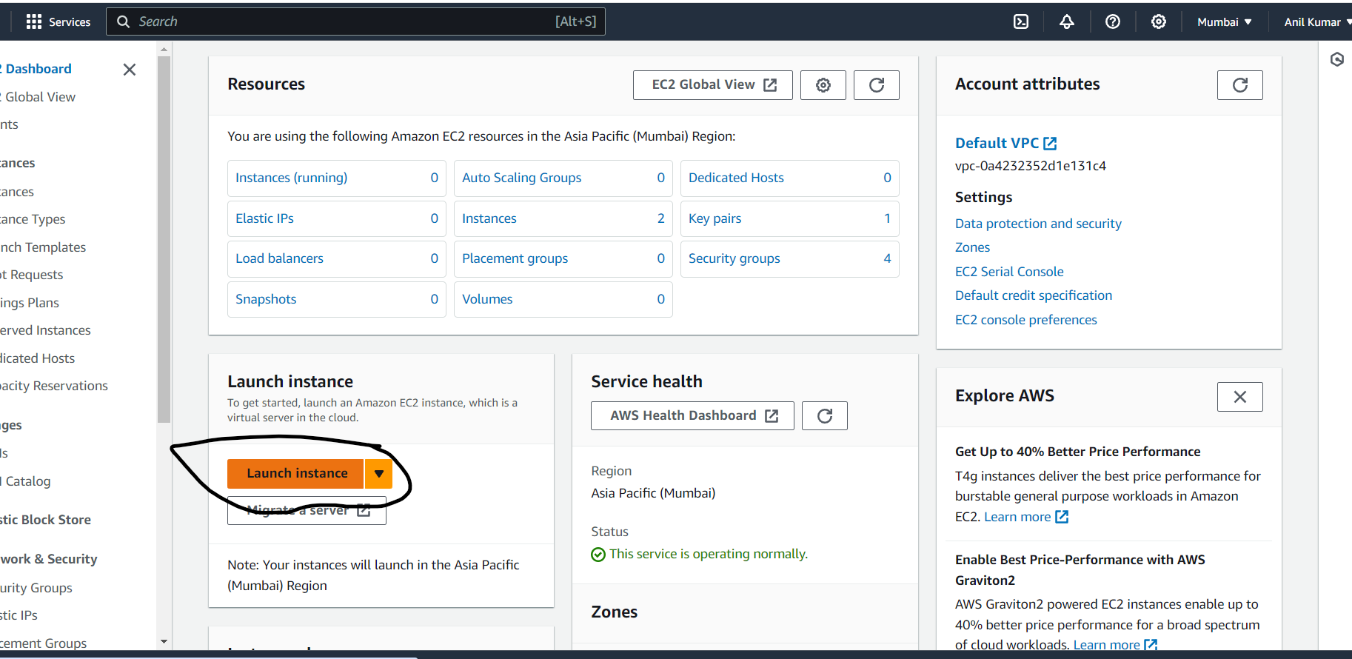

**Configure the server specification**

## Server Name =Server1 🡪 Application and OS Images (Amazon Machine Image)= Ubuntu server 2023 free tier  🡪 instance type = T2 micro

## Key pair (login)

reate new key pair🡪 Key pair name=server-1 🡪 Key pair type=RSA 🡪 .pem 🡪 Create new keypair

## 

## Network settings🡺

##### Edit 🡪 Auto-assign public IP=Enable🡪 Firewall (security groups)= Create Security group🡪 Inbound Security Group Rules=SSH enable

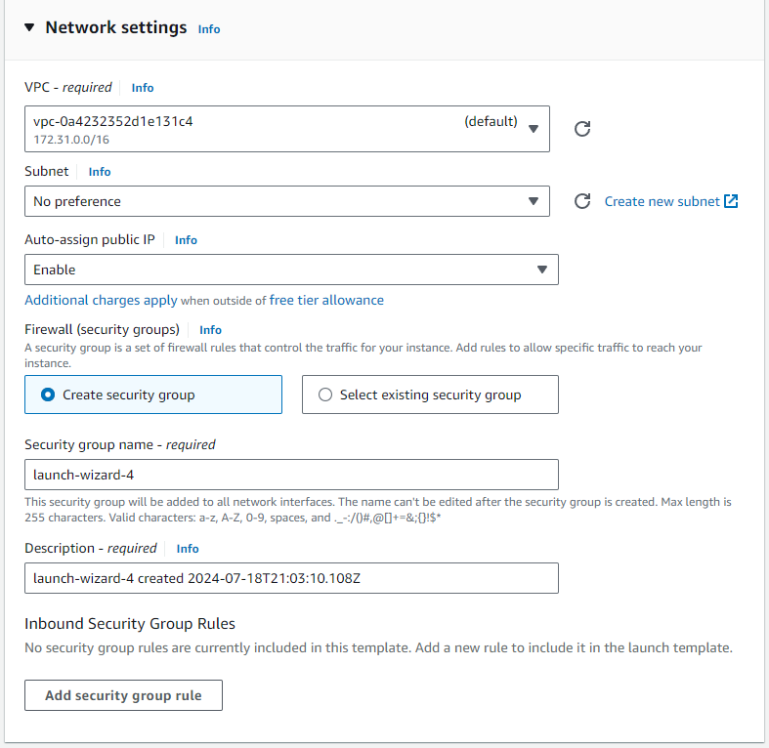

**Configure Storage**

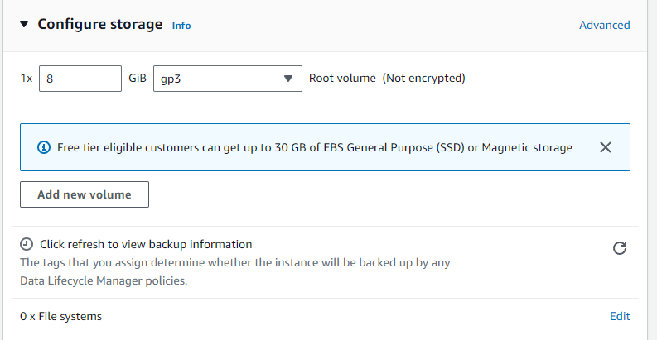

**Then Launch Instance**

**Step2 : Connect to mobaxterm**

Copy the public ip of instance and open the mobaxterm and click the the SSH

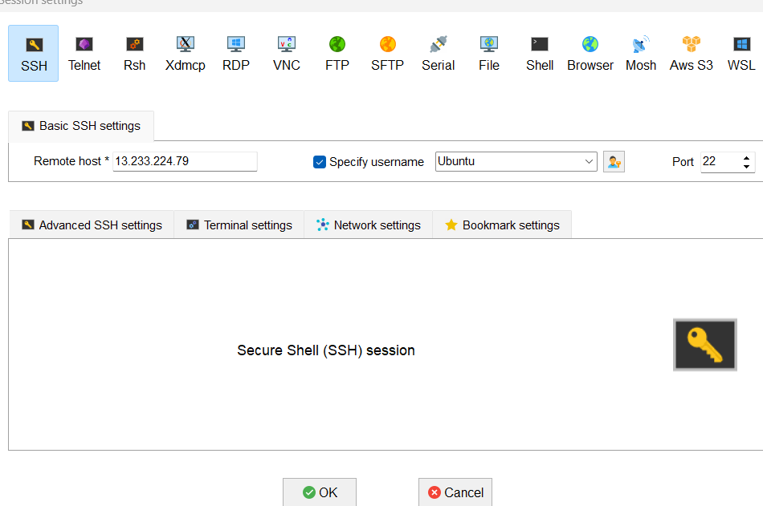

Then check on specify username click on box and type = “Ubuntu” 🡪

Advance SSH Setting 🡪 check on use private key 🡪 select the public key 🡪 ok 🡪 accept

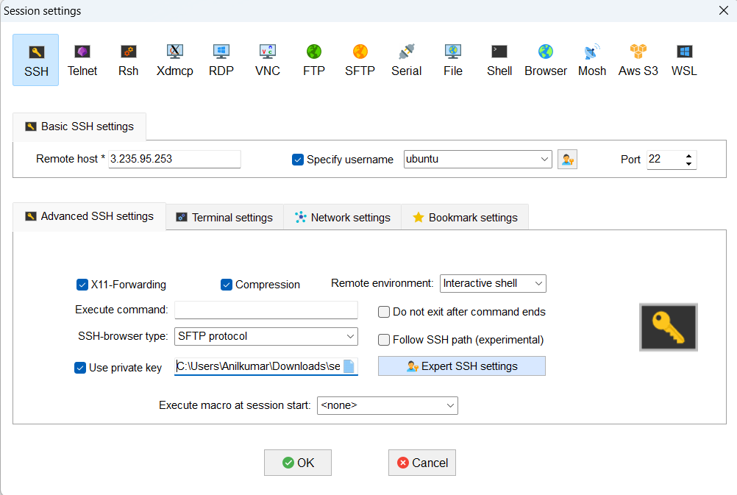

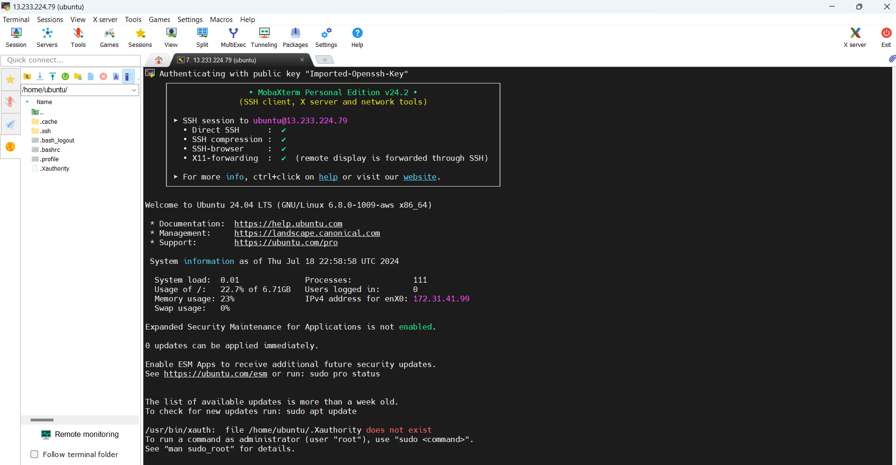

**2. L2 - Login to AWS Console and Create IAM User, Role, and Group**

**Ans-**first of all open chrome browser and search AWS console and click on it.

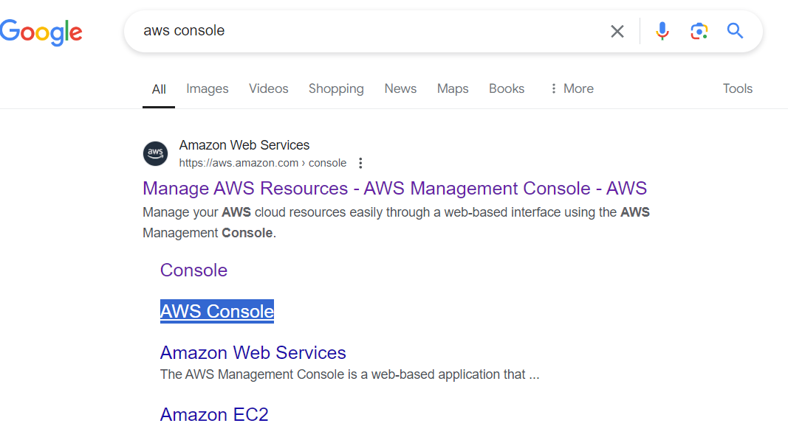

**Step 1:-** Login your credential of AWS account

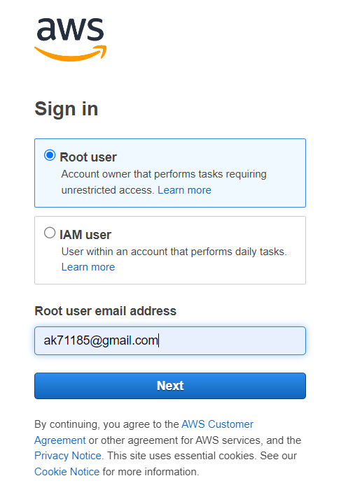

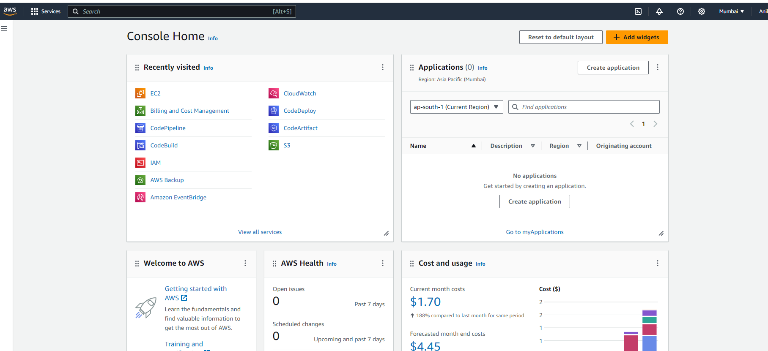

**Step 2:- IAM User creation**

Type IAM in Search box 🡪 click on IAM 🡪 Access management 🡪 click on user 🡪 Create User 🡪 User name = Aman 🡪 click on check box **Provide user access to the AWS Management Console - *optional*** 🡪 click on **I want to create an IAM user 🡪** Console password 🡪 Custom password = xxxxxx 🡪 next

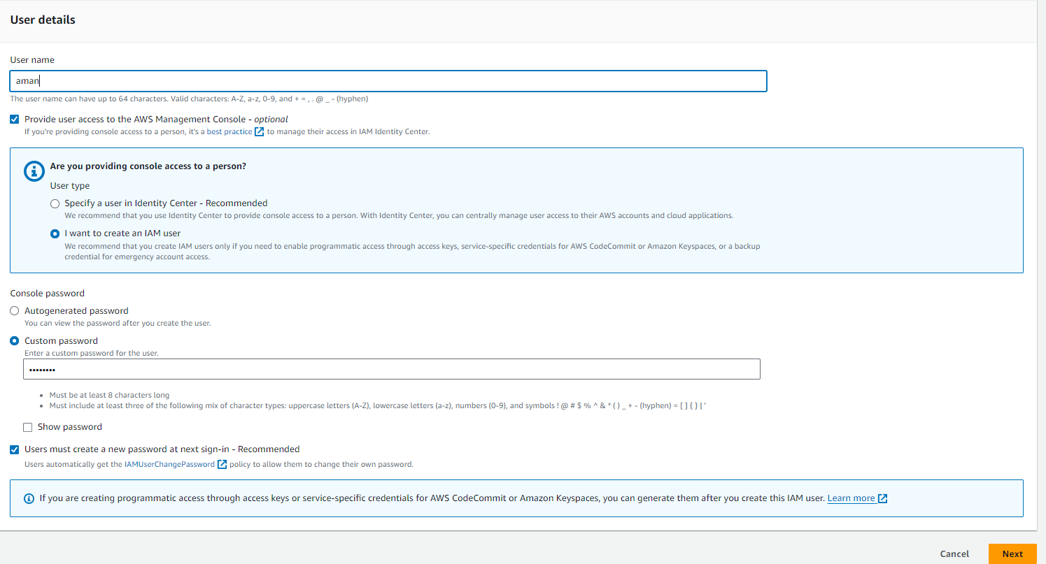Set permissions 🡪 Add user to group🡪 Next 🡪 click on create user

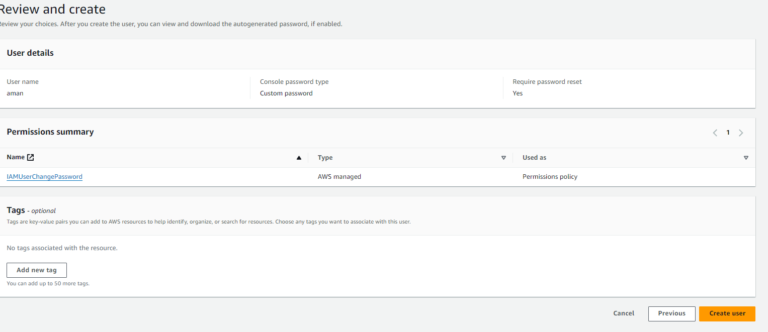

**Step 3:- Role creation**Type IAM in Search box 🡪 click on IAM 🡪 Access management 🡪 click on Roles

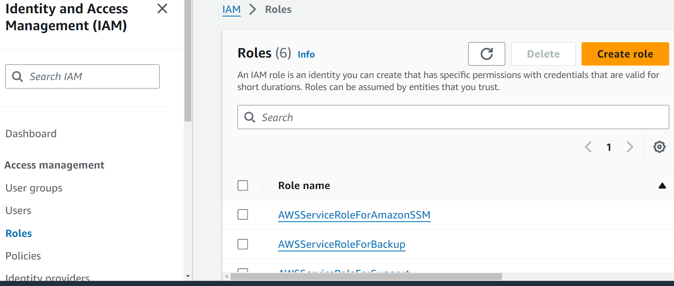

# Trusted entity type = AWS Services 🡪 Service or use case = EC2🡪 Next 🡪 Add permissions= Adminstrator access 🡪 Next

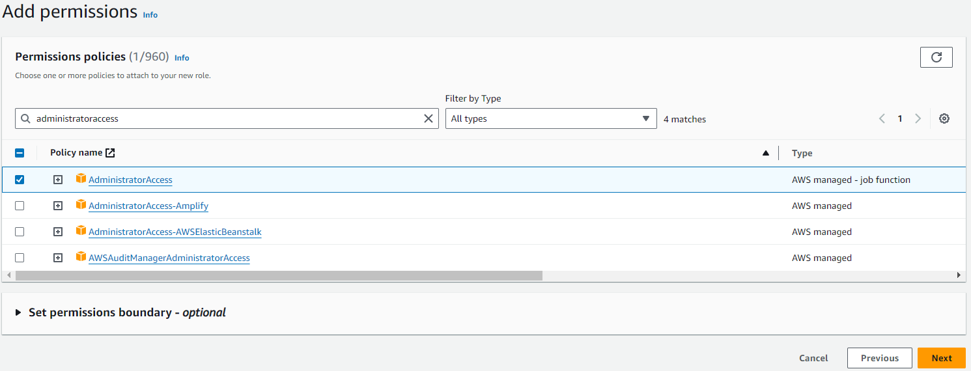

Role name= Role-for-ec2 🡪 Create Role

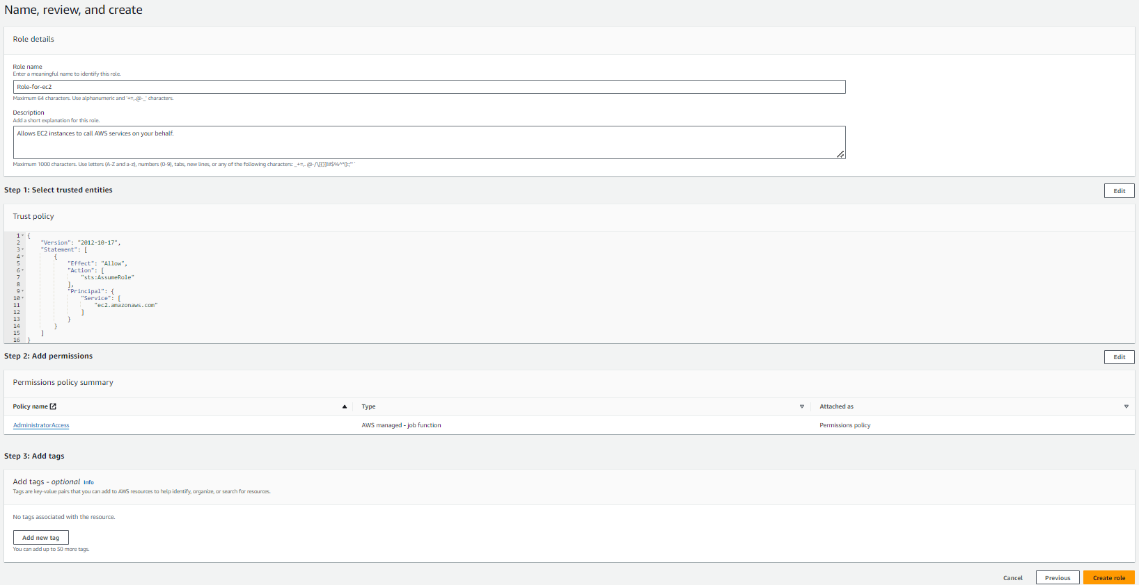

**Step 4:- Group creation**

Type IAM in Search box 🡪 click on IAM 🡪 Access management 🡪 click on User Groups 🡪Click on Create Group 🡪

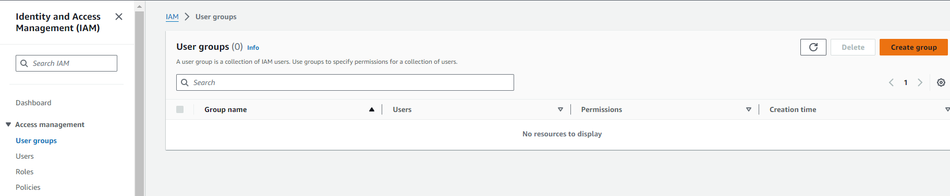

Name the group = Finance-Group 🡪 Add users to the group 🡪 check on finance group user to add on finance group 🡪Attach permissions policies 🡪 administrator access 🡪 click on create user and group

