3. L3 - Launch AWS EC2 Ubuntu Instance and configure the Security Group - Inbound Rule: 8080. Justify the usage of Inbound Rules

First of all login the aws console.

**Ans:-**

**Step1 : Creating of Security Group**

EC2🡪

Networking🡪 click on security group

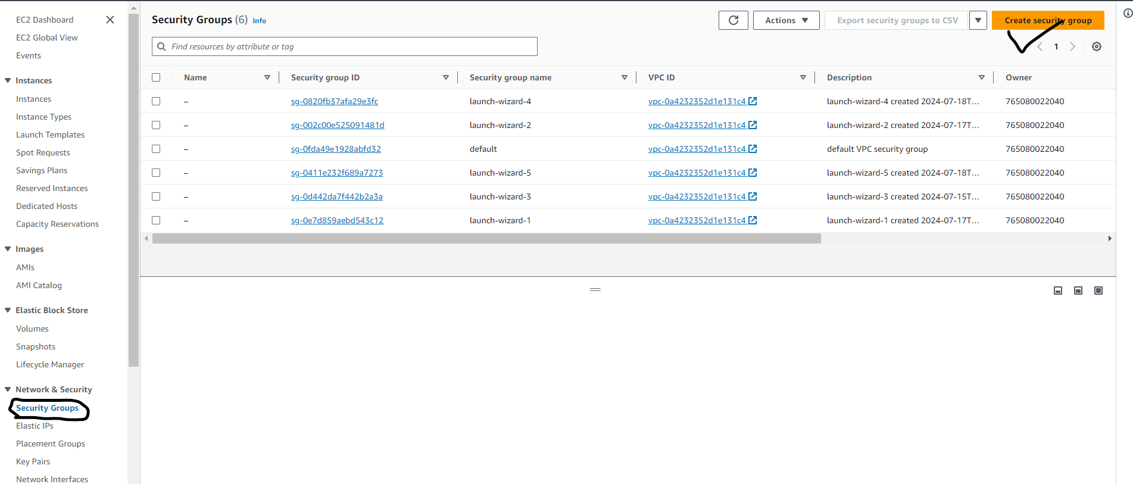

## Basic Details 🡪 Security group name – SecuritygroupforUbuntu 🡪 inbound rules 🡪 add rule Create Security group

## 

Inbound rules are created to protect your network from unauthorized access by incoming requests based on criteria such as IP addresses, port numbers, and protocols

Through costom TCP We can add the port no. according to our choice.

**Step 2:- Creation of Ubuntu Instance :**

Type EC2- in search box of console of account and then click on launch Ubuntu

AMI=Ubuntu🡪 instance Type = T2 Micro 🡪 Keypair = Server1.pem 🡪

Networking 🡪 Edit🡪select existing security group = SecuritygroupforUbuntu 🡪 launch instance

