4. L4Connect to the AWS EC2 Ubuntu Instance and Update default packages, install JDK, Maven, Git, and validate the versions

Step 1 :- install the AWS EC2 Ubuntu instance

## 

**Step2 : Connect to mobaxterm**

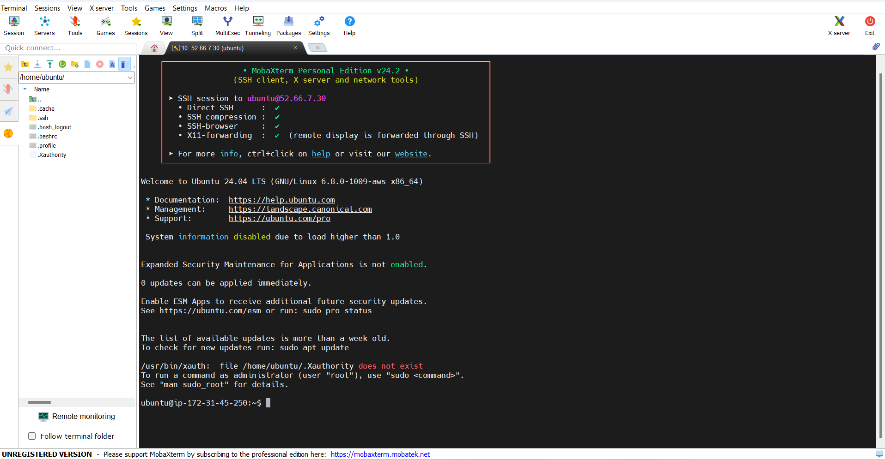

**Step 3:**

**Perform the following command and Clear the screen**

**Clear**

**sudo apt update -y**

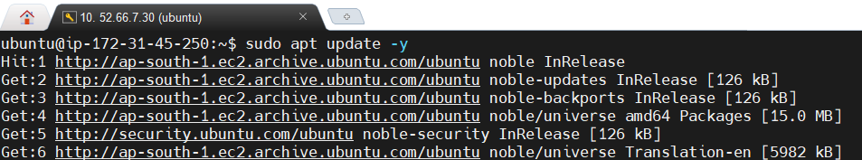

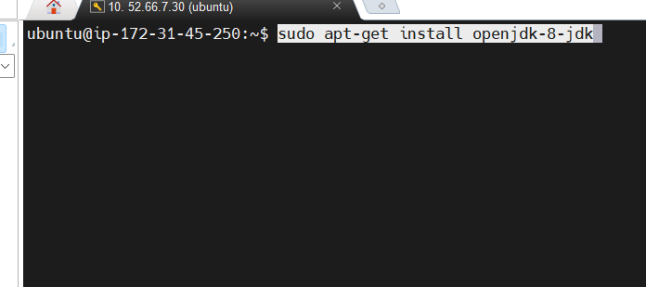

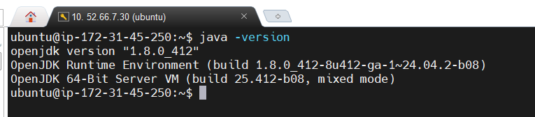

**Step 4 : Installing maven**

Execute command below to install maven

Sudo apt install maven -y

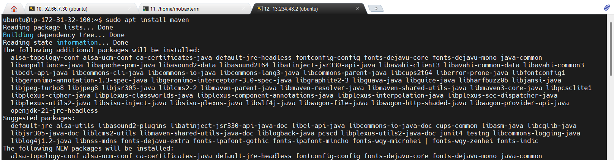

mvn –version to check the version of maven

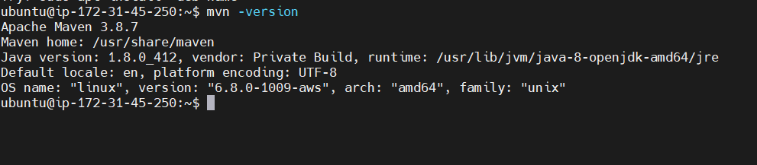

**Step 4 : Installing git**

Execute command below to install maven

sudo apt install git -y

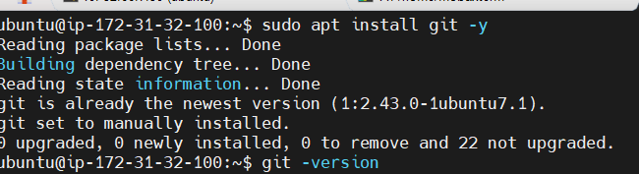

To check the git version execute the command

git --version

