L6 - Create S3 Bucket and add folders and files.

Ans :-

First of all login your credential and aws console.

Steps1:- go to search box of aws console and type ‘S3’ and click on it then click on create bucket

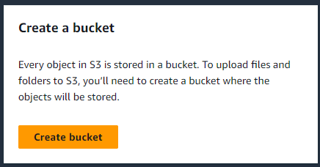

**General configuration 🡪 Bucket Name= “anil-aws-sa-bucket”**

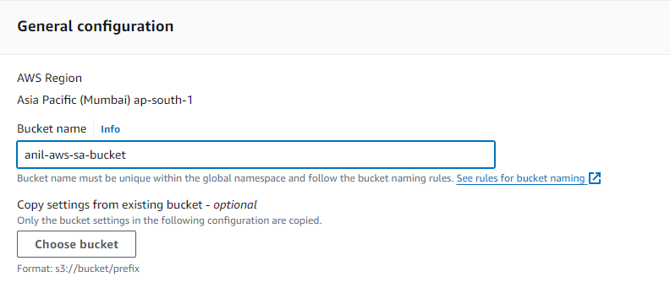

Object Ownership 🡪 ACLs disabled (recommended)

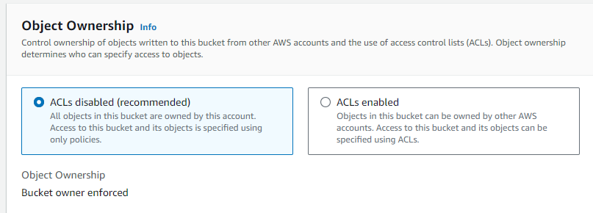

* **Block Public Access settings for this bucket**

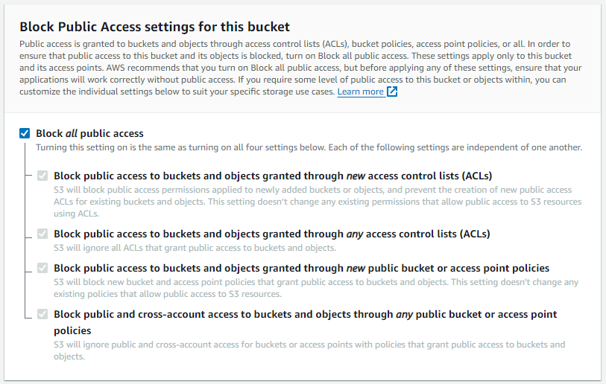

Bucket Versioning = enable

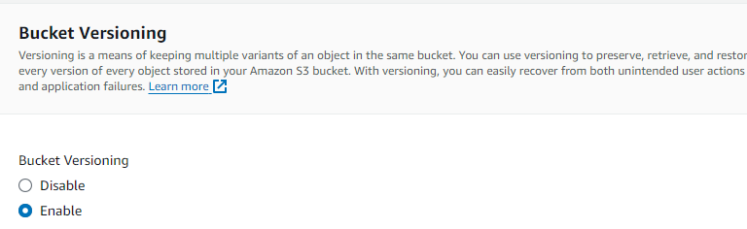

* Create Bucket

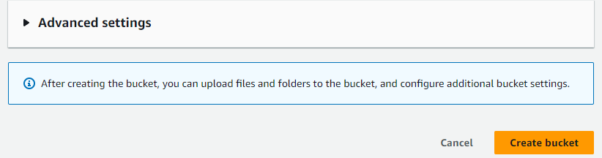

Now bucket has been created

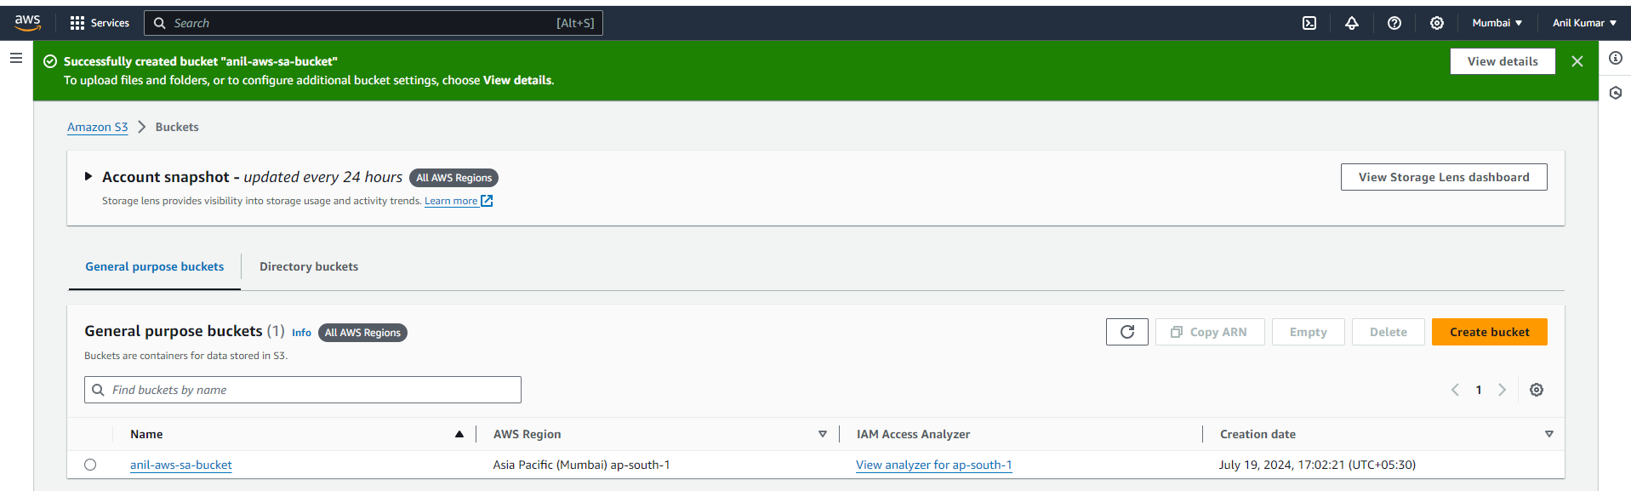

**Step 2:- Adding folder in bucket**

Now click on the bucket ‘**anil-aws-sa-bucket**’

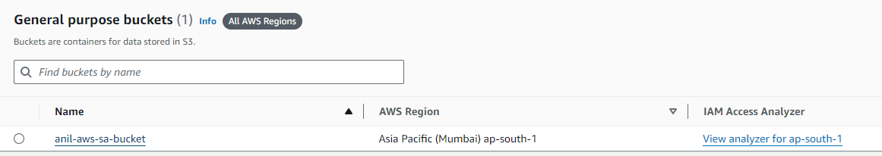

* Click on upload

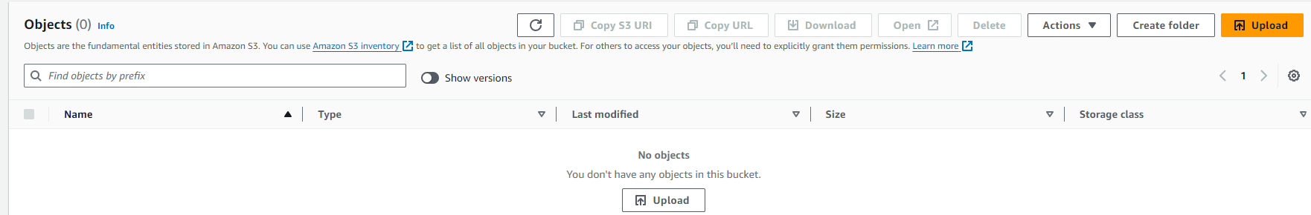

* Click on add folder

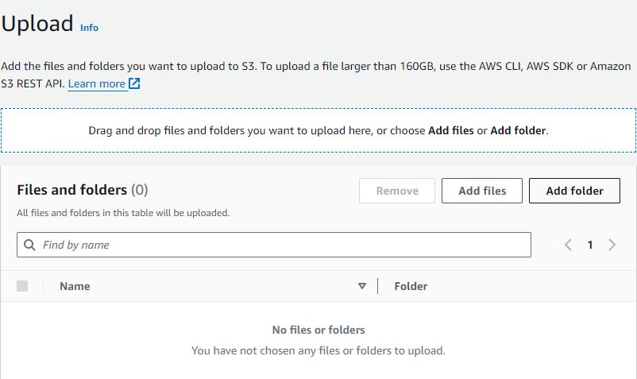

* Select the folder you want to add in bucket and click on upload

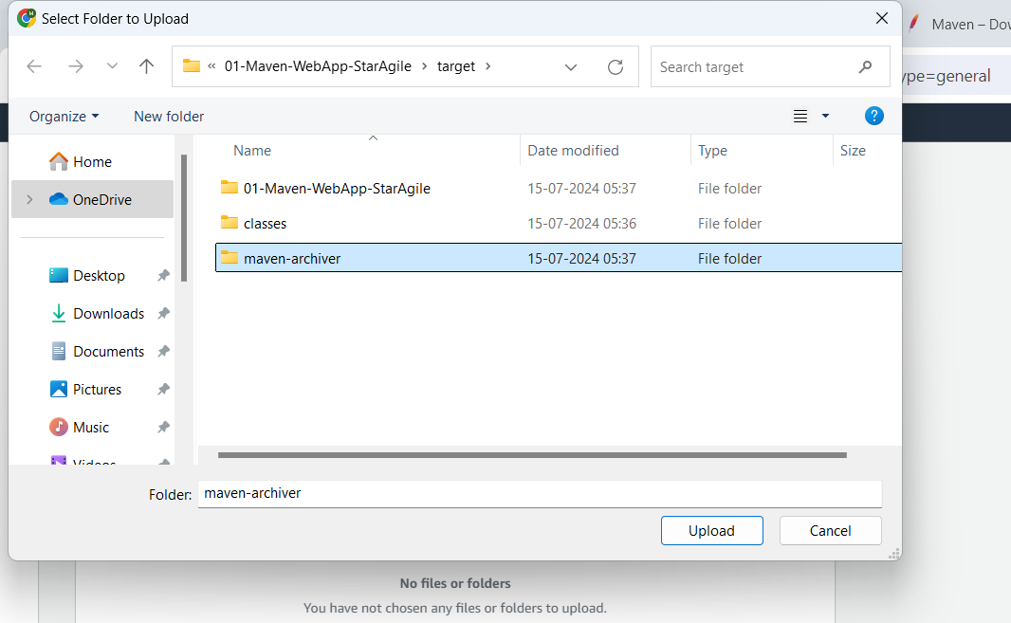

As a result folder is uploaded in bucket

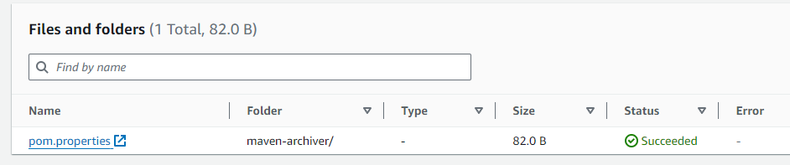

**Step 3:- Adding folder in file in bucket**

* Click on upload again

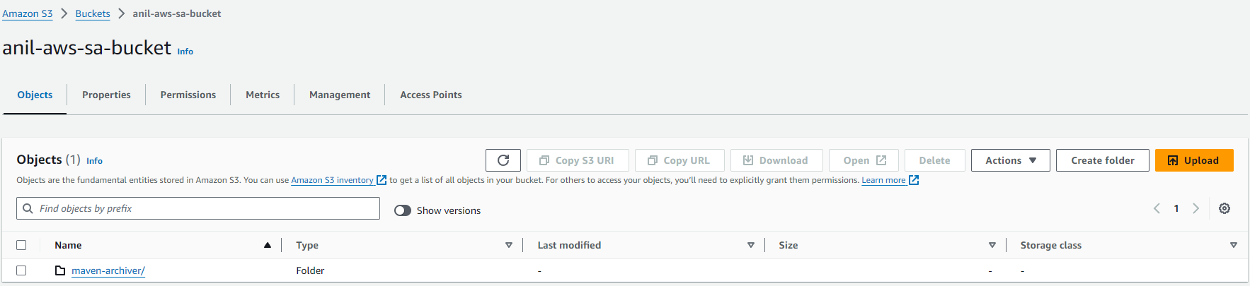

* Click on add file

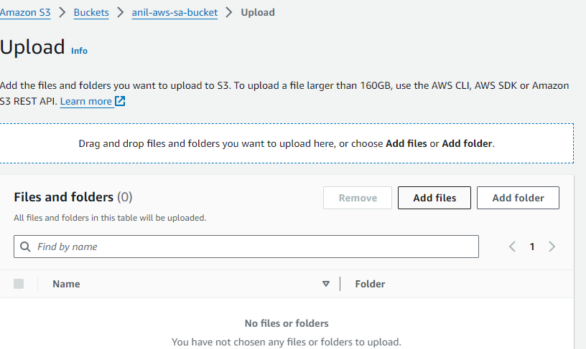

* Select the file you want to add in bucket and click on “Open” and upload

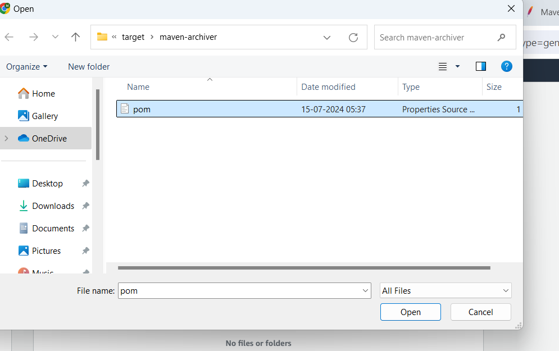

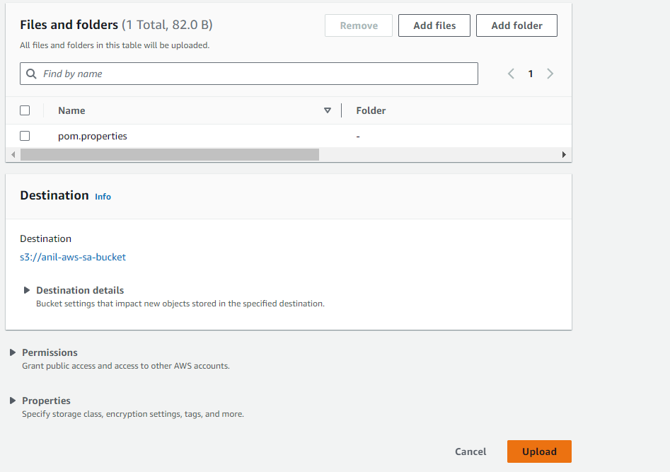

As a result file is uploaded in bucket

