

**Everest College**

**Thapathali, Kathmandu**

**(Affiliated to Tribhuvan University)**

**LAB REPORT OF**

**Network Programming**

**Submitted By**

Anil Pandey

BCA 6th Semester

# Submitted To

Sunny Kumar

Lecturer

Department of BCA

**Output :-**

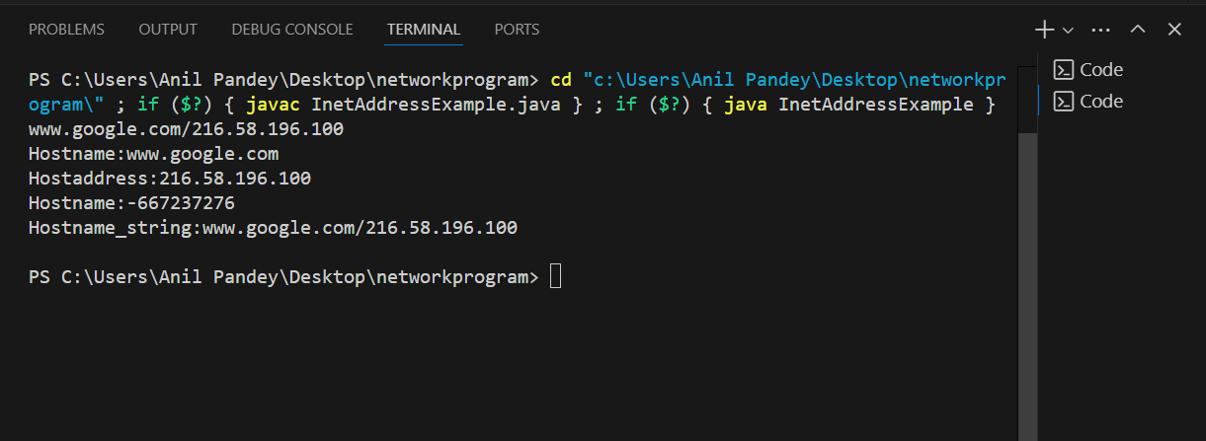

**Output :-**

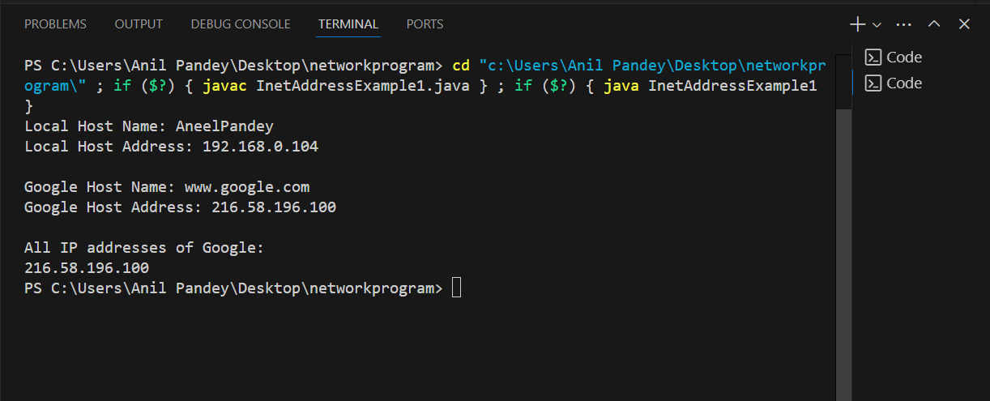

**Output :-**

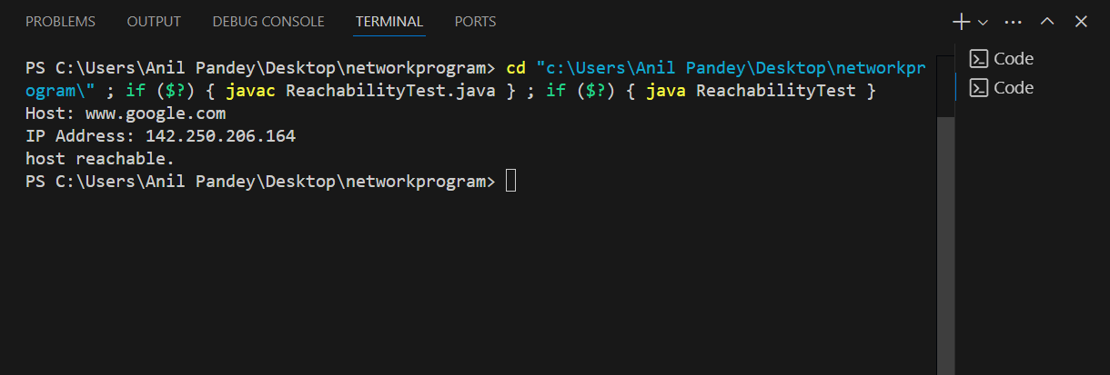

**Output:-**

