1. Build a web application with registration, login, catalog and cart pages using CSS3 features, flex and grid.

**1. Project Setup:**

* Create three HTML files: index.html for the landing page,
* register.html for registration, and
* login.html for login.
* Create a separate CSS file styles.css to style all pages.

index.html

<!DOCTYPE html>

<html lang="en">

<head>

    <meta charset="UTF-8">

    <meta name="viewport" content="width=device-width, initial-scale=1.0">

    <title>My Web App</title>

    <link rel="stylesheet" href="styles.css">

</head>

<body>

    <header>

        <h1>Welcome to My Web App</h1>

        <nav>

            <a href="register.html">Register</a>

            <a href="login.html">Login</a>

        </nav>

    </header>

    <main>

        <section class="hero">

            <h2>Explore our amazing products!</h2>

            <button>Shop Now</button>

        </section>

    </main>

    <footer>

        <p><center>&copy; 2024 My Web App </center></p>

    </footer>

</body>

</html>

register.html

<!DOCTYPE html>

<html lang="en">

<head>

    <meta charset="UTF-8">

    <meta name="viewport" content="width=device-width, initial-scale=1.0">

    <title>Register</title>

    <link rel="stylesheet" href="styles.css">

</head>

<body>

    <header>

        <h1>Register</h1>

        <nav>

            <a href="index.html">Home</a>

        </nav>

    </header>

    <main>

        <form>

            <label for="username">Username:</label>

            <input type="text" id="username" name="username" required>

            <label for="password">Password:</label>

            <input type="password" id="password" name="password" required>

            <button type="submit">Register</button>

        </form>

    </main>

</body>

</html>

login.html

<!DOCTYPE html>

<html lang="en">

<head>

    <meta charset="UTF-8">

    <meta name="viewport" content="width=device-width, initial-scale=1.0">

    <title>Login</title>

    <link rel="stylesheet" href="styles.css">

</head>

<body>

    <header>

        <h1>Login</h1>

        <nav>

            <a href="index.html">Home</a>

        </nav>

    </header>

    <main>

        <form>

            <label for="username">Username:</label>

            <input type="text" id="username" name="username" required>

            <label for="password">Password:</label>

            <input type="password" id="password" name="password" required>

            <button type="submit">Login</button>

        </form>

    </main>

</body>

</html>

styles.css

body {

    font-family: Arial, sans-serif;

    margin: 0;

    padding: 0;

}

header, main, footer {

    padding: 20px;

}

header {

    display: flex;

    justify-content: space-between;

    align-items: center;

    background-color: #f0f0f0;

}

nav {

    display: flex;

    gap: 10px;

}

main {

    display: flex;

    justify-content: center;

    align-items: center;

    min-height: calc(100vh - 160px); /* Account for header and footer heights */

}

.hero {

    text-align: center;

}

Output:

Index.html

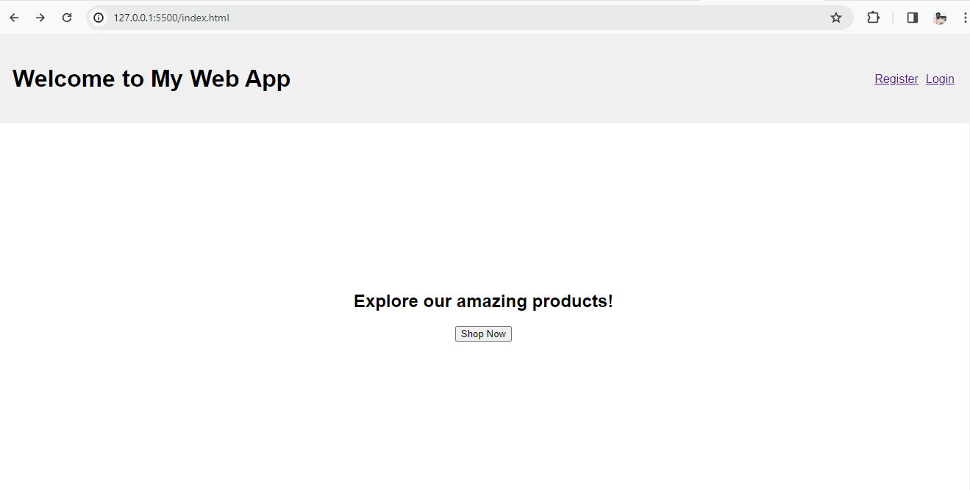

register.html

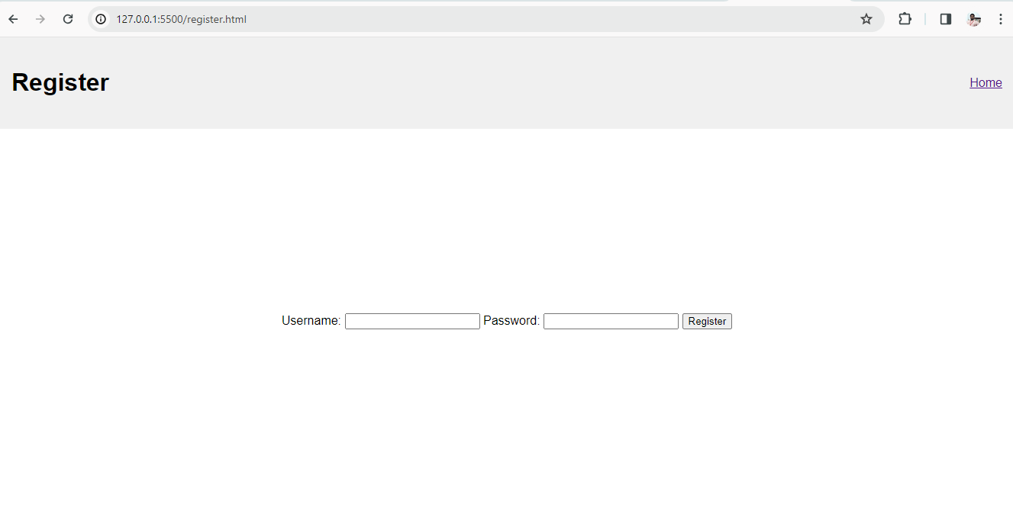

login.html

