ASSIGNMENT -11

1) Write a query that uses a subquery to obtain all orders for the customer named Cisneros.Assume u dont know his customer number.

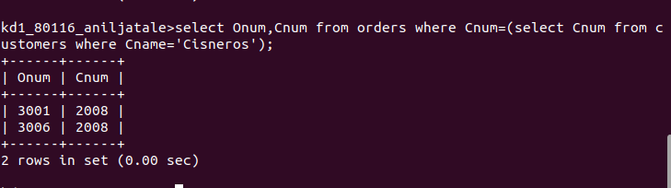

2) Write a query that produces the names and rating of all customers who have above-average orders.
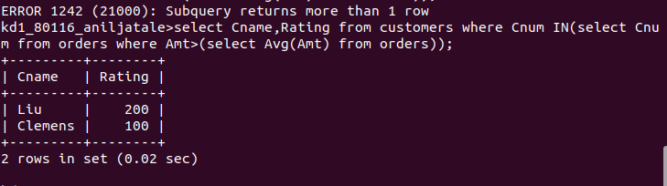

3) Write a query that select the total amount in orders for each salesperson for whom this total is greater than the amount of the largest order in the table.

