Assignment-15

USING SUBQUERIES WITH DML COMMAND-

1) Assume there is a table called multicust with all of same column defination as salesperson .write a commnd that insert allsalesperson with more than one customers into this tables.
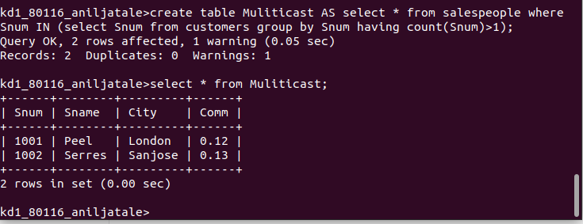

2) write a coond that delete all customers with no curent orders.

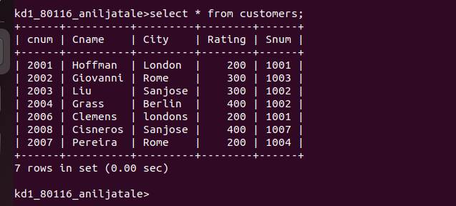

3) write coond that incrses by twenty percent the commission of all salesperson with total orders above 3.000;

