ASSIGNMENT-14

1) Write a command that put the following values ,in their city in given order into salespeople table:city sanjose ,name-balanco,comm-null,cnum-1100
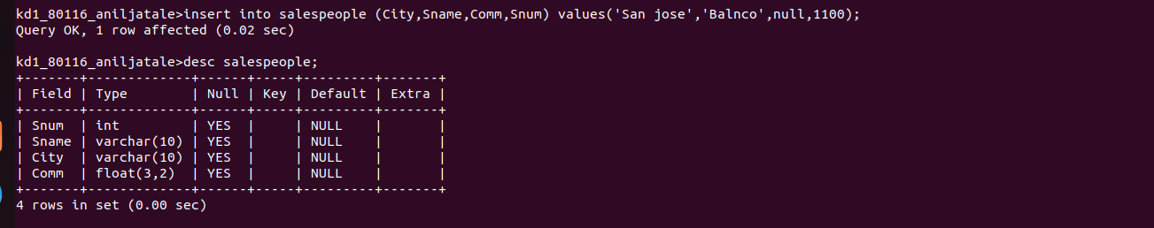

2) write a commnd that remove all orders from customers from order tables.

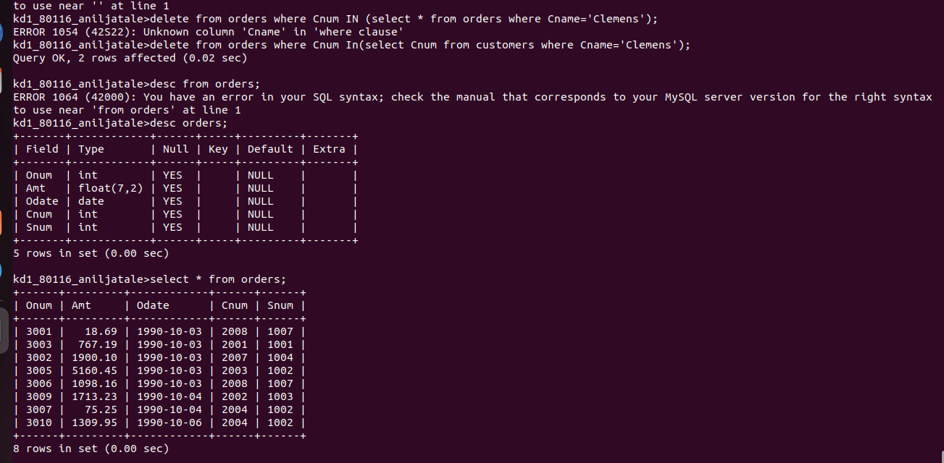

3) write a coomnd that incresed the rating of all customers in rome by 100.

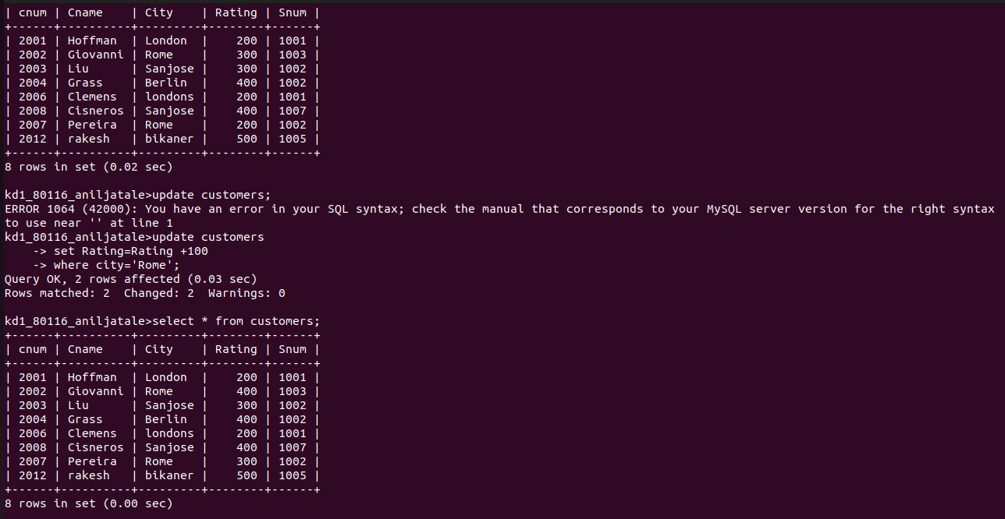

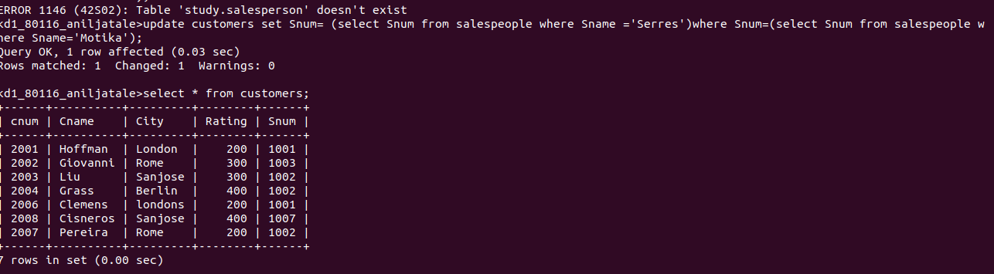
4) salesperson serres has left the company .assign her customers to motika.

