ASSIGNMENT-9

QUE-1 Write a query that lists each other number followed by the name of custoomers who made order.
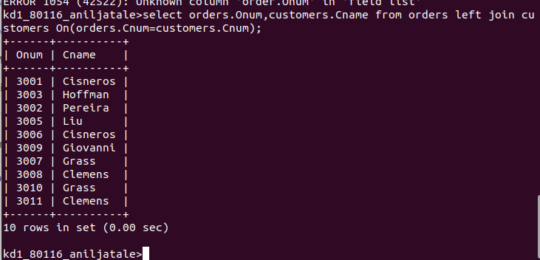
QUE 2- Write a query that give names of both the salesperson and customer for each order along with order number
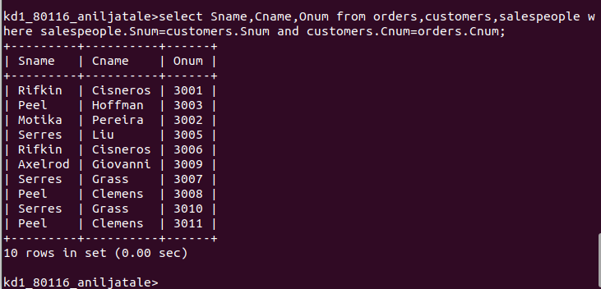
QUE 3- Write a query that produces all customers serviced by salesperson with commssion above 12%.output the customer name ,the salepersons name,and salesperson’rate of commission.
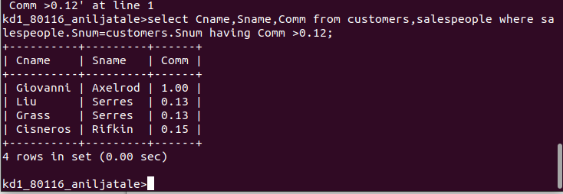

QUE 4- Write a query that calculate the amount of salesperson commssion on each order by a customers with rating above 100

