ASSIGMENT NO-5

QUE-1 Write a query that will give u all order for more than RS.1000.
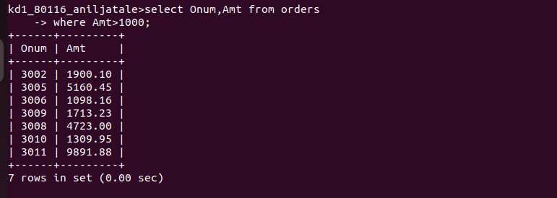
QUE -2 Write a query that will give u the names and cities of all salespeople in london with commision above 0.10.

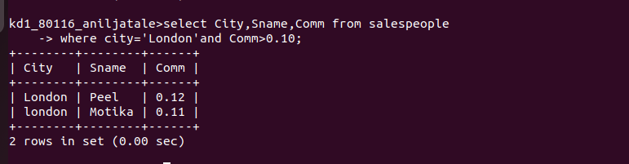
QUE 3- Write a query on the Customers table whose output will exclude all customers with rating <=100 ,unless they are located in Rome.

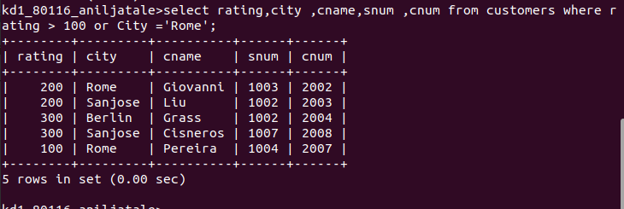
QUE 4- What will be output from the following query.

What will the output from following query
select * from orders where (amt <1000) or not(odate =’1990-10-03’ and cnum >2003));
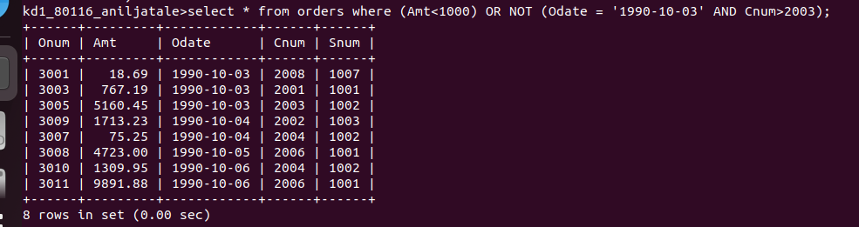
QUE -5 what will be the output of following query ?

Select * from orders where not (( odate = ‘1990-10-03’ or snum >1006 ) and amt >1500);

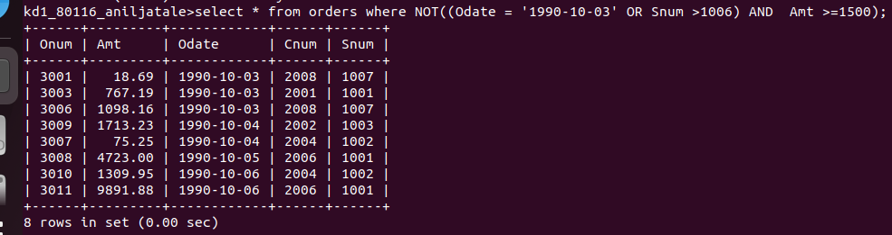
QUE 6- what is the simplest way to write this query ?
Select snum,sname,city,comm from salepeople where (comm >0.12 or comm <0.14);


