SQL ASSIGMENT -1

QUE- Create the following tables with the given structures and insert sample data as specified:

(A) SALESPEOPLE-

QUERY- create table salepeople(snum int ,sname varchar(10),city varchar(10),comm varchar (10));

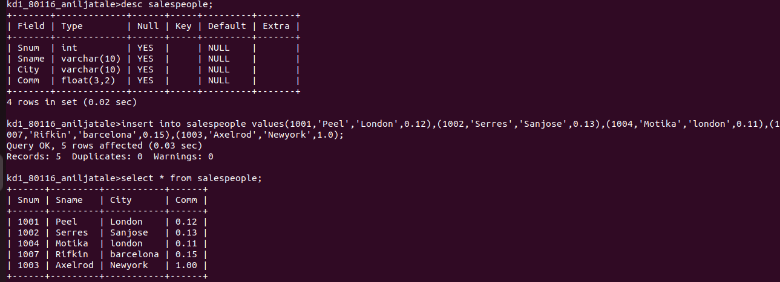

(B) CUSTOMERS-
QUERY- create table customers(cnum int, cname varchar(10),city varchar()10),rating int(4),snum int(4) );
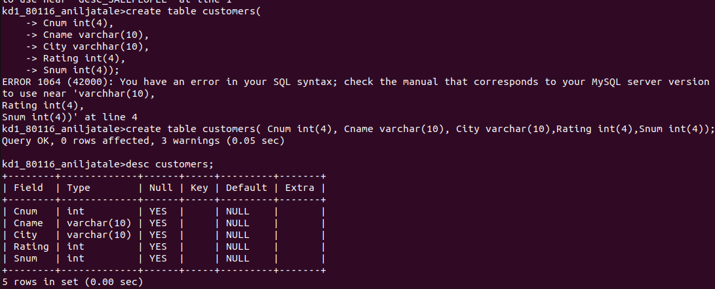

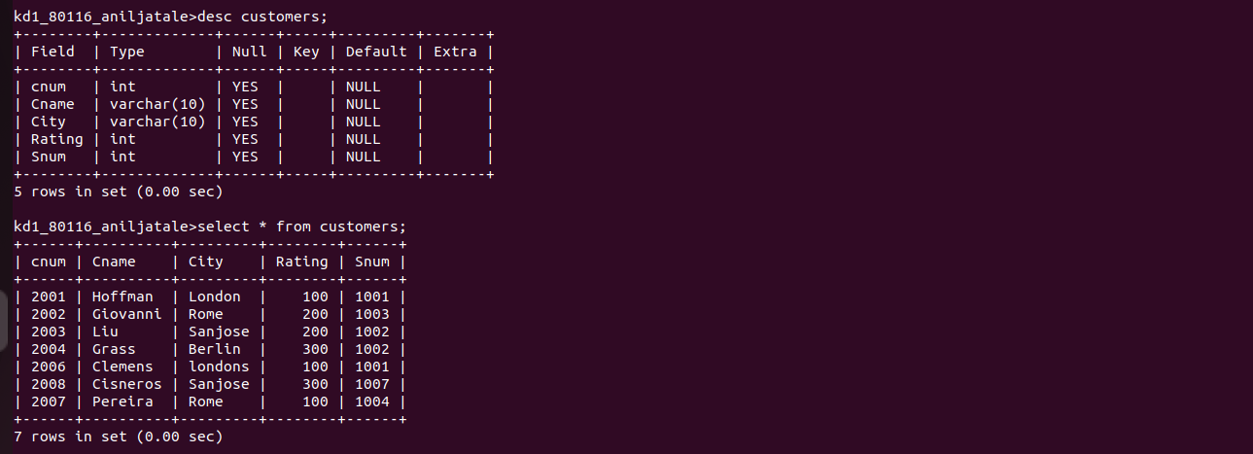

ORDERS -
QUERY- create table orders(onum int(4), amt float(7,2),odate date,cnum int (4),snum(4));

