ASSIGNMENT-13

USING UNION CLAUSE -

1) create a union of two querries that show the names ,cities,and rating of all customerss.those with rating of 200 or greater will also have the word “high rating” while the other will have the word”low rating”.

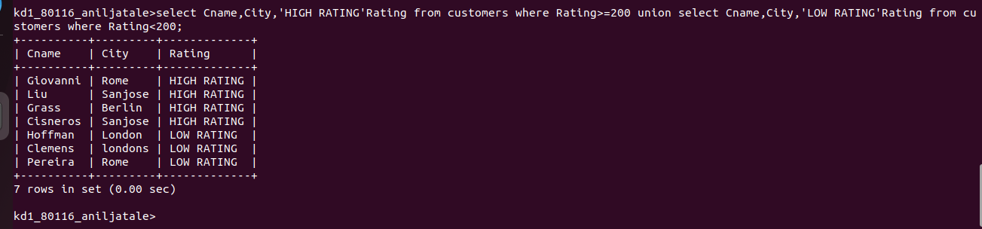
2) write a command that produces the name and number of each salesperson and each customer
with more than one current order.put result in alphbetical orders
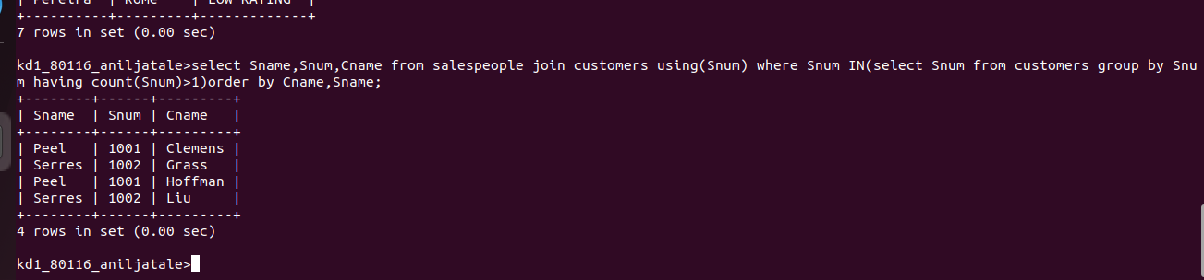

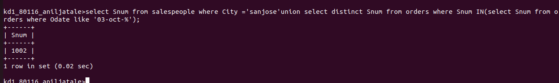
3) Form a union of three queries .have the first select the snum of all salesperson in san jose,the second ,the cnum of all customer in sanjose and the third onum of all orders on octo-3 .retain duplicate betwen the last two queeries bt eliminate any redundancies betwen either of them and first.

