ASSIGNMENT -12

USING SPECIAL OPERATOR IN,ANY,ALL

1) Write a query that select all customers whose rating are equal to or greater than any of “Serres”

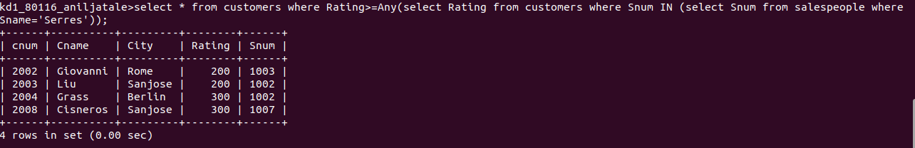

2)write a query using any or all that will find all salespeople who have no customer located in their city.


3) write a query that select all orders for amount greater than any for customers in london.
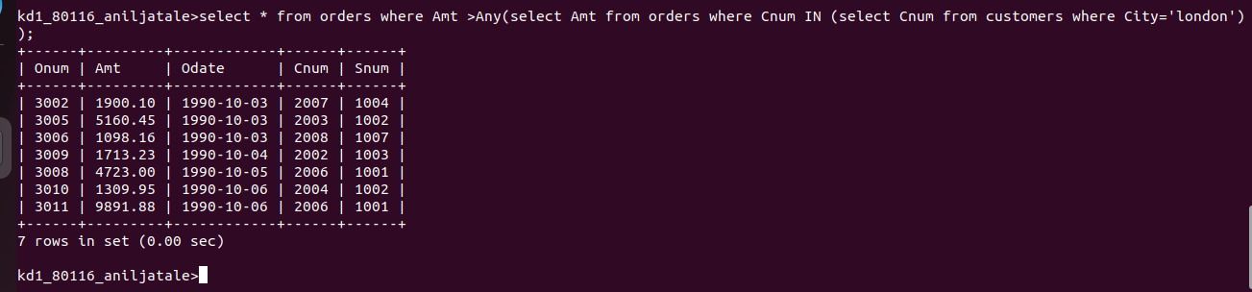

QUE-4 WRITE THE ABOVE QUERY USING MIN OR MAX.

