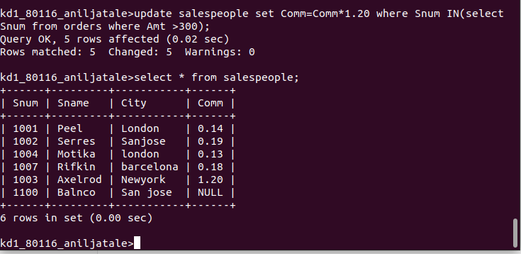
SQL ASSIGNMENT -10

JOINING A TABLE TO ITSELF

1) Write a query that produces all pairs of salespeople who are living in the same city.exclude combination of salesperson with themselves as well as duplicate row with order reserved.

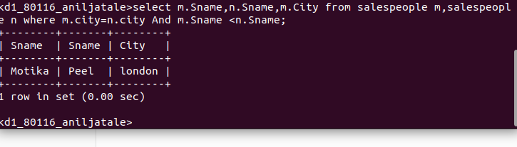

2) Write a query that produces the names and cities of all customers with the same rating as hoffman

