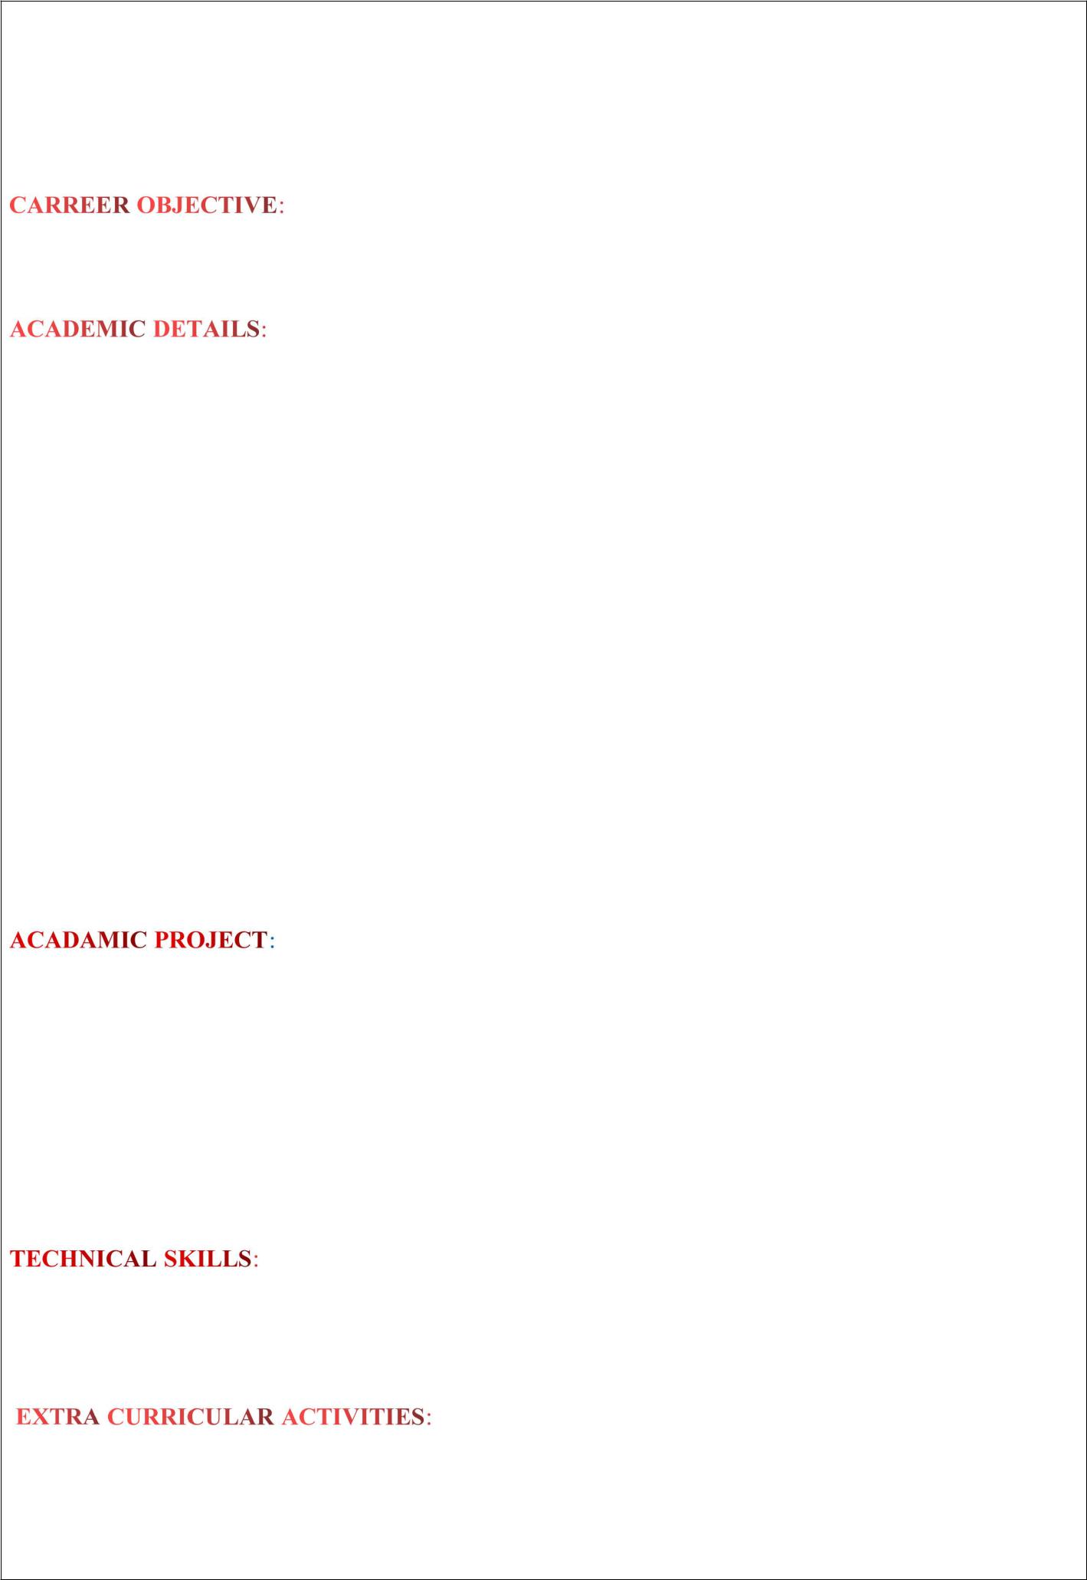
ANIL KUMAR. DERANGULA

e-mail : anilkumarvjc@gmail.com

Phone : +91 8688060587

Seeking a challenging position in a reputed organization where I can learn new skills,expand my knowledge and leverage my learning.

QUALIFICATION | INSTITUTE | BOARD/ | YEAR OF | PERCENTAGE
 |  | UNIVERSITY | PASSING | SCORED
 |  | Jawaharlal Nehru
 |  | technological
B.TECH(ECE) | Khit | university, | 2019-2023 | 70%
 |  | Kakinada
 |  | Board of
INTERMEDIATE | Vidhyardhi | intermediate, | 2017-2019 | 98.8%
 | junior college | Andhra Pradesh
 |  | Board of
 |  | secondary |  | 92%
SSC | Vidhyardhi School | education, | 2016-2017
 |  | Andhra Pradesh

Title : Lung cancer detection using IMAGE PROCESSING

Platform:Python & Django

MINOR PROJECT:

Automatic water pump switcher

Basics of SQL,HTML,CSS Basics of Java and Python.

Participated in IT Workshop

Participated in future prime skills

Participated in fundamentals digital marketing

To do new things

Reading books

Playing games

Listening to music

Self control and integrity Quick learner

Positive Thinking

:

If I am working I can’t see the time

Date of birth

Sex

Languages known

Address

: 15-05-2001

: MALE

: Telugu,English

: 3-140/1-BC Colony,Konaki(v),Piduguralla(mandal),Guntur(dt).

I hereby declare that the above mentioned information is true up to my knowledge and I bear the responsibility for the correctness of the above mentioned particulars.

Place: Konaki ( Anil Kumar.Derangula)

