**CHAPTER 1:**

**INTRODUCTION**

**Chapter no:1**

**Chapter name: Introduction**

**1.1 About the Mini project**

**Breif description:**

The mini-project entitled “CYBER CAFE MANAGEMENT SYSTEM “ is developed as a part of the fifth semester DBMS laboratory, for the partial fulfillment of the requirement for the BE( Information Science) course.

#### **Project Description**

In this project an attempt is made to design a computer system for the CYBER CAFÉ that makes the management of recording user details, internet usage and billing much easier. The objective of this software is to maintain the details of users, computer systems and login history.

The Software powered by PHP assures clear and efficient services to the agency. This easy-tooperate system helps to access and modify user details, provides efficient billing facility. The software is designed to provide Reliable and error free information. The database is driven by My SQL thus providing portability.

#### **Objectives**

The objective and scope of my Project Cyber Cafe Management System is to record the details various activities of user. It will simplifies the task and reduce the paper work. during implementation every user will be given appropriate training to suit their specific needs. Specific support will also be provided at key points within the academic calendar. Training will be provided on a timely basis! and you will be trained as the new is Cyber Cafe Management System rolled out to your area of responsibility.

At the moment we are in the very early stages! so it is difficult to put a specific time on the training! but we will keep people informed as plans are developed. The system is very user friendly and it is anticipated that functions of the system will be easily accessed by administrators(admin).

**1.2 About SQL**

Structured Query Language (SQL) is comprehensive database language. Hence it has both DDL and DML.

* Data Definition Language (DDL): We can use CREATE, INSERT, DELETE and MODIFY statements. We cannot manipulate the data in the table.
* Data Manipulation Language (DML): We can manipulate the data in the record using UPDATE and ALTER statements.
* SQL has several different techniques for writing programs in various Programming languages that include SQL statements to access one or more database.
* SQL has transaction control commands. These are used to specify units of database processing for concurrency control and recovery purpose.

MySQL is a relational database management system (RDBMS).

The MySQL development project has made its source code available under the terms of the GNU General Public License, as well as under a variety of proprietary agreements. MySQL was owned and sponsored by a single for-profit firm, the Swedish company MySQL AB, now owned by Oracle Corporation. For proprietary use, several paid editions are available, and offer additional functionality.

MySQL was initially created for personal usage from MSQL based on the low-level language ISAM, which the creators considered too slow and inflexible. They created a new SQL interface, while keeping the same API as MySQL.

MySQL is written in C and C++. Its SQL parser is written in yacc, but it uses a home-brewed lexical analyser.

MySQL dump is a logical backup tool included with both community and enterprise editions of MySQL. It supports backing up from all storage engines. MySQL Enterprise Backup is a hot backup utility included as part of the MySQL Enterprise subscription from Oracle, offering native InnoDB hot backup, as well as backup for other storage engines. Xtra Backup is an open-source MySQL hot backup software program. Features include hot, non-locking backups for InnoDB storage, incremental backups, streaming, parallel-compressed backups, throttling based on the number of I/O operations per second, etc.

MySQL Fabric is an integrated system for managing a collection of MySQL servers, and a framework on top of which high availability and database sharing is built. MySQL Fabric is open-source, and supports procedure execution in the presence of failure, providing an execution model usually called resilient execution.

**1.3 Scope and application of mini project**

The system we propose has great scope in the current real time situation. The cyber crime monitoring system can be enhanced to an extent by implementing this system. Most of the firms and establishments are being computerized in order to ease the tasks to be performed. The internet cafes unfortunately are rarely computerized. We aim through this venture, a better reliable solution. In the primary stage of feasibility study itself we received an exquisite response and so we plan to go ahead with our project**.**

**CHAPTER 2:**

**LITERATURE SURVEY**

**CHAPTER 2:**

**LITERATURE SURVEY**

**2.1 Related work:**

The mini-project entitled “CYBER CAFÉ MANAGEMENT SYSTEM “ is developed as a part of the fifth semester DBMS laboratory, for the partial fulfillment of the requirement for the BE( Information Science) course.

#### **Project Description**

In this project an attempt is made to design a computer system for the CYBER CAFÉ that makes the management of recording user details, internet usage and billing much easier. The objective of this software is to maintain the details of users, computer systems and login history.

The Software powered by PHP assures clear and efficient services to the agency. This easy-tooperate system helps to access and modify user details, provides efficient billing facility. The software is designed to provide Reliable and error free information. The database is driven by My SQL thus providing portability.

#### **2.2 Problem Statement**

The objective and scope of my Project Cyber Cafe Management System is to record the details various activities of user. It will simplifies the task and reduce the paper work. during implementation every user will be given appropriate training to suit their specific needs. Specific support will also be provided at key points within the academic calendar. Training will be provided on a timely basis! and you will be trained as the new is Cyber Cafe Management System rolled out to your area of responsibility.

At the moment we are in the very early stages! so it is difficult to put a specific time on the training! but we will keep people informed as plans are developed. The system is very user friendly and it is anticipated that functions of the system will be easily accessed by administrators(admin).

**2.3 Proposed Statement**

The system we propose has great scope in the current real time situation. The cyber crime monitoring system can be enhanced to an extent by implementing this system. Most of the firms and establishments are being computerized in order to ease the tasks to be performed. The internet cafes unfortunately are rarely computerized. We aim through this venture, a better reliable solution. In the primary stage of feasibility study itself we received an exquisite response and so we plan to go ahead with our project**.**

**2.4 Advantages :**

Using a DBMS to manage data has many advantages:

**1.** Data Independence: application program should not, ideally, be expected to details of data representation and storage, the DBMS provides an abstract view of the data that hides such details. 1.2.2 Efficient Data Access: A DBMS utilizes a variety of sophisticated technique to store and retrieve data efficiently. This feature is especially important if the data is to be stored on external device.

**2.** Data Integrity and Security: if data is always accessed through DBMS, the DBMS can enforce integrity constraints. For example, before inserting salary information for an employee, the DBMS can check that the department budget is not exceeded. Also, it can enforce access controls that govern what data is visible to different classes of users.

**3.** Data Administration: when several users share data, centralizing the administration of data can offer significant improvements. Experienced professionals who understand the nature of the data being managed, and how different groups of users use it, can be responsible for organizing the data representation to minimize redundancy and for fine-tuning the storage of the data to make retrieval efficient.

**4.** Concurrent Access and Crash Recovery: A DBMS schedules concurrent accesses to the data in such a manner that users can think of the data as being accessed by only one user at a time. Further, the DBMS protects users from the effects of system failures.

**5.** Reduced Application Development Time: clearly, the DBMS supports important functions that are

common to many applications accessing data in the DBMS. This, in conjunction with the high-level

interface to data, facilities quick application development. DBMS applications are also likely to be

more robust than similar stand-alone application because many important tasks are handled by the

DBMS.

**CHAPTER 3:**

**SYSTEM REQURIMENTS AND SPECIFICATIONS**

**CHAPTER 3:**

# SYSTEM REQUIREMENTS AND SPECIFICATIONS

#### **3.1.1 FUNCTIONAL OR SPECIFIC REQUIREMENTS**

To access the contents of the application the user must first login through employee admin-login.

Cyber Cafe Management System has one module i.e. admin.

1. **Dashboard**: In this section admin can briefly view total number of computers and total number of user come in cyber cafe.

1. **Computer**: In this section, admin can manage the computers (add/update).

1. **Users**: In this section, admin can add new users, update outime, price and remarks, and view details of old users.

1. **Search**: In this section admin can search users on the basis of entry id.

1. **Report**: In this section admin can view number of users comes in cyber café in particular periods.

1. **Profile**: In this section admin can update his/her profile.

1. **Change Password**: In this section admin can change his/her passwords

1. **Logout**: Through this button admin can logout.

**Admin can also recover his/her password.**

**3.2 HARDWARE REQUIREMENTS**

* Processor : Intel P-IV based system
* Processor Speed : 2.0. GHz• RAM : 1GB
* Hard Disk : 40GB to 80GB

**3.3 SOFTWARE REQUIREMENTS**

* Database : MySQL
* Server : Apache
* Frontend : HTML
* Scripting language : Java Script
* IDE : Sublime
* Technology:PHP

**CHAPTER 4:**

**DESIGN AND METHODOLOGY**

**CHAPTER 4:**

# DESIGN

### 4.1 ENTITY RELATIONSHIP DIAGRAM

ER Relationship model allows us to describe the data involved in a real-world enterprise in terms of objects and their relationship widely used to develop an initial database design. It is primarily important in its role in database design.

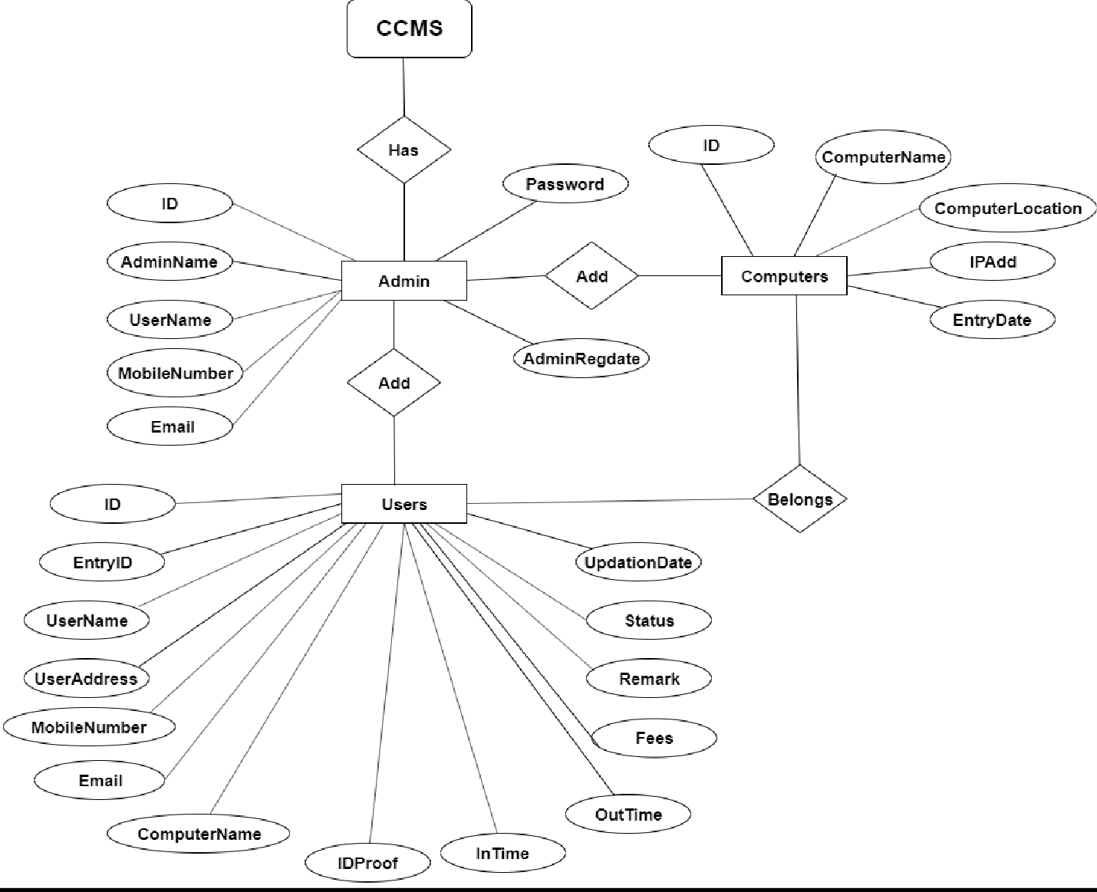

Fig 3.1: ER diagram

In this ER Diagram shown in Fig 3.1 Entities ADMIN, COMPUTERS , USERS , are represented by rectangles, attributes of the tables are represented by ovals and relationships are represented using diamonds.

### 4.2 ARCHITECTURE OF THE PROPOSED SYSTEM

1.ADMIN

|  |  |  |  |  |  |  |
| --- | --- | --- | --- | --- | --- | --- |
| ID | AdminName | UserName | MobileNumber | Email | Password | AdminRegdate |

* Assuming the above relation to be in 1NF since there are no multivalued attributes and composite attributes
* Since Admin_id is determining all the other attributes it does not suffer from partial dependency therefore it is in 2NF
* Since there are no transitive functional dependencies we can say it is in 3NF
* The determinate is Admin_id which is the primary key , therefore it is in BCNF(Boyce Codd normal form)

1. COMPUTERS

|  |  |  |  |  |
| --- | --- | --- | --- | --- |
| ID | C_NAME | C_LOCATION | IPADD | EntryDate |

* + Assuming the above relation to be in 1NF since there are no multivalued attributes and composite attributes
  + Since Computers id is determining all the other attributes it does not suffer from partial dependency therefore it is in 2NF
  + Since there are no transitive functional dependencies we can say it is in 3NF
  + The determinate is Computers id which is the primary key, therefore it is in BCNF(Boyce Codd normal form)

1. TABLE USERS

|  |  |  |  |  |  |  |  |  |  |  |  |  |  |
| --- | --- | --- | --- | --- | --- | --- | --- | --- | --- | --- | --- | --- | --- |
| ID | Entry ID | User Name | User  Address | Mobile Number | Email | Computer Name | Id proof | In  Time | Out Time | Fees | Remark | Status | Updation Date |

* + Assuming the above relation to be in 1NF since there are no multivalued attributes and

composite attributes

•

Since

USER

id is determining all the other

attributes it does not suffer from partial

dependency therefore it is in 2NF

•

Since there are no transitive functional dependencies we can say it is in 3NF

•

The determinate is

USER

id which is the primary key,

therefore it is in BCNF(Boyce Codd

normal form)

**4.3 SCHEMA DIAGRAM**

•

A database schema can be represented in a visual diagram, which shows the database object

and their relationship which represents the logical view of the database and how the

relationships among them are represented.

Fig 3.2: Schema Diagram

This Schema Diagram in Fig 3.2 represents different tables used and underlined attributes are

primary keys and arrows are used to represent foreign keys..

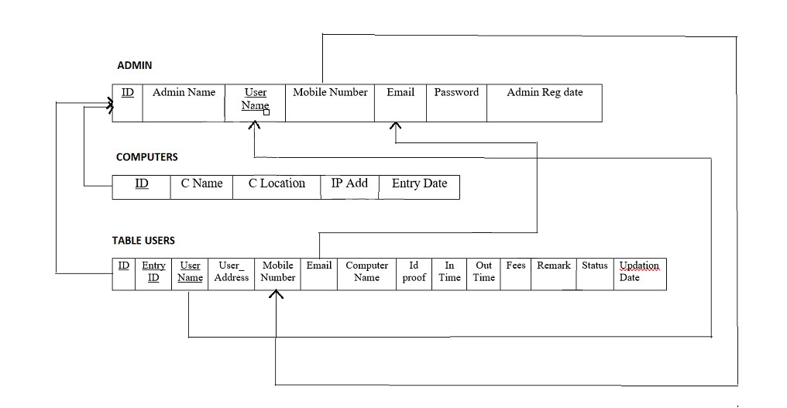

**CHAPTER 5:**

**TESTING**

**5.1 Testing Objectives**

The main objective of testing is to uncover a host of errors, systematically and with minimum effort and time. Stating formally, we can say,

• Testing is a process of executing a program with the intent of finding an error.

• A successful test is one that uncovers an as yet undiscovered error.

• A good test case is one that has a high probability of finding error, if it exists.

• The tests are inadequate to detect possibly present errors.

• The software more or less confirms to the quality and reliable standards.

**5.2 Levels of Testing**

In order to uncover the errors, present in different phases we have the concept of levels of testing. The basic levels of testing are as shown below.

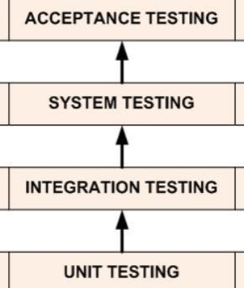

**5.3 Types of Testing**

**5.3.1 Code Testing**

This strategy examines the logic of the program. To follow this method, we developed some test data that resulted in executing every instruction in the program and modulei.e. Every path is tested. Systems are not designed as entire nor are they tested as single systems. To ensure that the coding is perfect two types of testing is performed or for that matter is performed or that matter is performed or for that matter is performed on all systems.

**5.3.2 Unit Testing**

Unit testing focuses verification effort on the smallest unit of software i.e., the module. Using the detailed design and the process specifications testing is done to uncover errors within the boundary of the module. All modules must be successful in the unit test before the start of the integration testing begins. In this project each service can be thought of a module. There are so many modules like Login, HW Admin, Master Admin, Normal User, and Manager. Giving different sets of inputs has tested each module. When developing the module as well as finishing the development so that each module works without any error. The inputs are validated when accepting from the user. In this application developer tests the programs up as system. Software units in a system are the modules and routines that are assembled and integrated to form a specific function. Unit testing is first done on modules, independent of one another to locate errors. This enables to detect errors. Through this error resulting from interaction between modules initially avoided.

**5.3.3 Link Testing**

After the unit testing, we have to perform integration testing. The goal here is to see if module scan beintegrated properly, the emphasis being on testing interfaces between modules. This testing activity can be considered as testing the design and hence the emphasis on testing module interactions. In this project integrating all the modules forms the main system. When integrating all the modules I have checked whether the integration effects working of any of the services by giving different combinations of inputs with which the two services run perfectly before Integration.

**5.3.5 System Testing**

Here the entire software system is tested. The reference document for this process is the requirements document, and the goal us to see if software meets its requirements.

**5.3.6 Acceptance Testing**

Acceptance Test is performed with realistic data of the client to demonstrate that the software is working satisfactorily. Testing here is focused on external behavior of the system; the internal logic of program is not emphasized. In this project „Network Management of Database System‟ I have collected some data and tested whether project is working correctly or not. Test cases should be selected so that the largest number of attributes of an equivalence class is exercised at once. The testing phase is an important part of software development. It is the process of finding errors and missing operations and also a complete verification to determine whether the objectives are met and the user requirements are satisfied.

**5.3.7 White Box Testing**

This is a unit testing method where a unit will be taken at a time and tested thoroughly at a statement level to find the maximum possible errors. I tested step wise every piece of code, taking care that every statement in the code is executed at least once. The white box testing is also called Glass Box Testing. I have generated a list of test cases, sample data which is used to check all possible combinations of execution paths through the code at every module level.

**5.3.8 Black Box Testing**

This testing method considers a module as a single unit and checks the unit at interface and communication with other modules rather getting into details at statement level. Here the module will be treated as a block box that will take some input and generate output. Output for a given set of input combinations are forwarded to other modules.

**5.8 Criteria Satisfied by Test Cases**

Test cases that reduced by a count that is greater than one, the number of additional test cases that much be designed to achieve reasonable testing. Test cases that tell us something about the presence or absence of classes of errors, rather than an error associated only with the specific test at hand.

**CHAPTER 6:**

**RESULTS AND DICUSSIONS**

**APPENDIX ‘A’ : CODE SNIPPETS**

**A.1 DATABASE CONNECTION**

The connect() / mysqli_connect() function opens a new connection to the MySQL server with the

following syntax: mysqli_connect(host, username, password, dbname, port, socket)

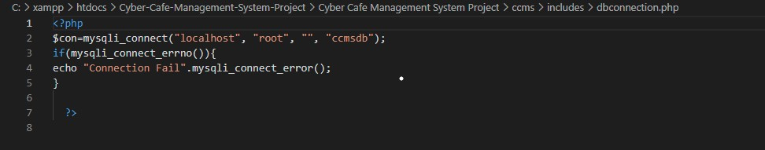

**A.2 ADD COMPUTER**

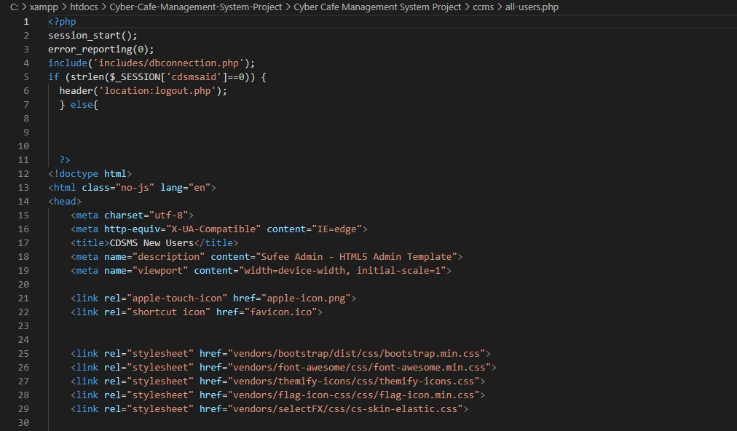

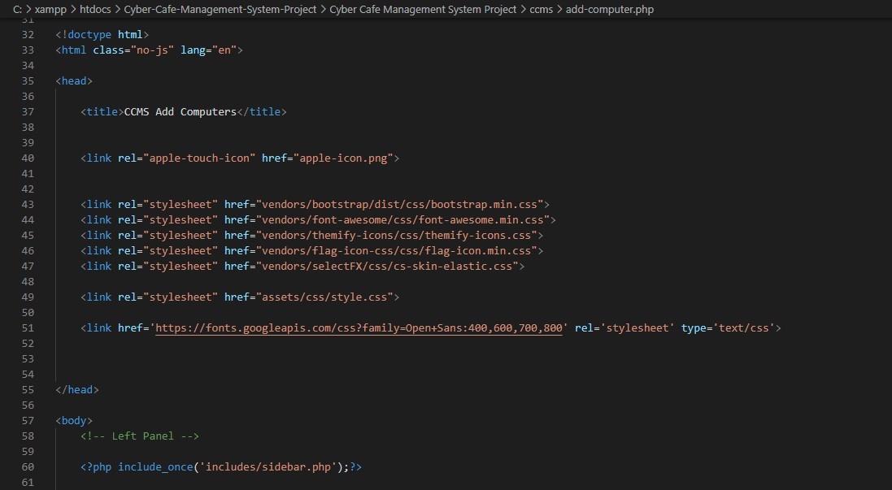

#### **FIG A.2 Add Computer**

### A.3 ADD USERS

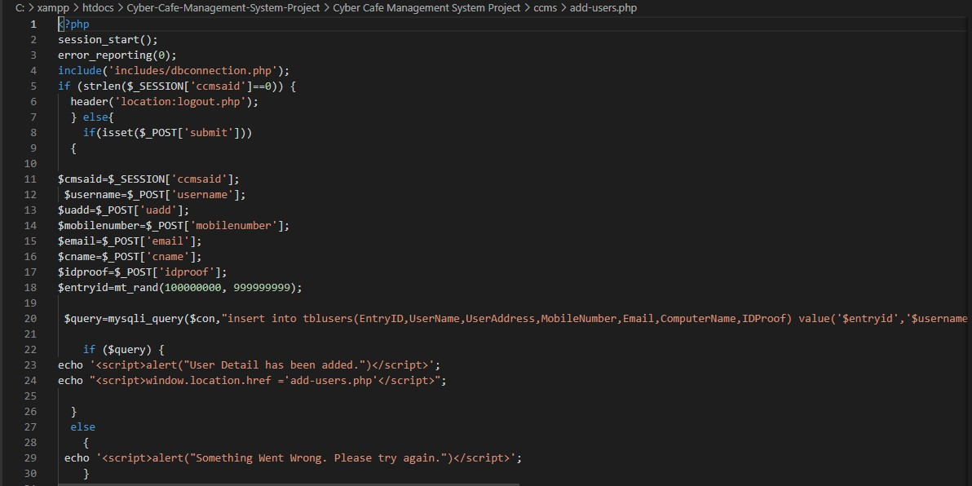

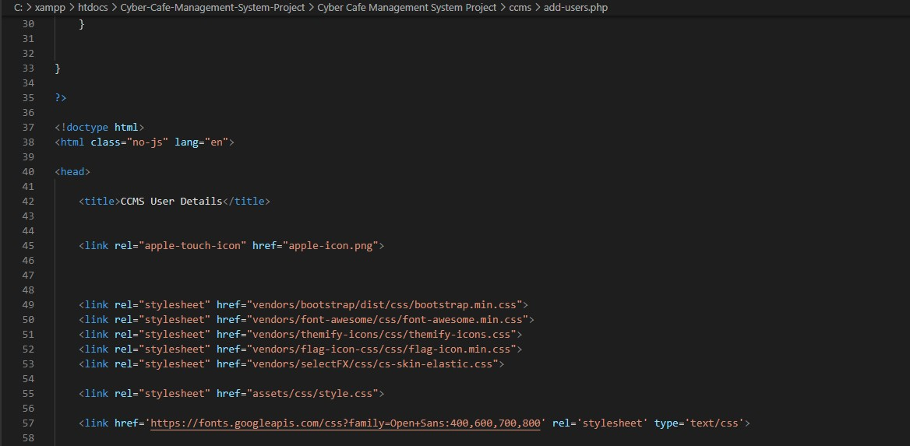

#### FIG A.3 Add user

### A.4 Admin profile

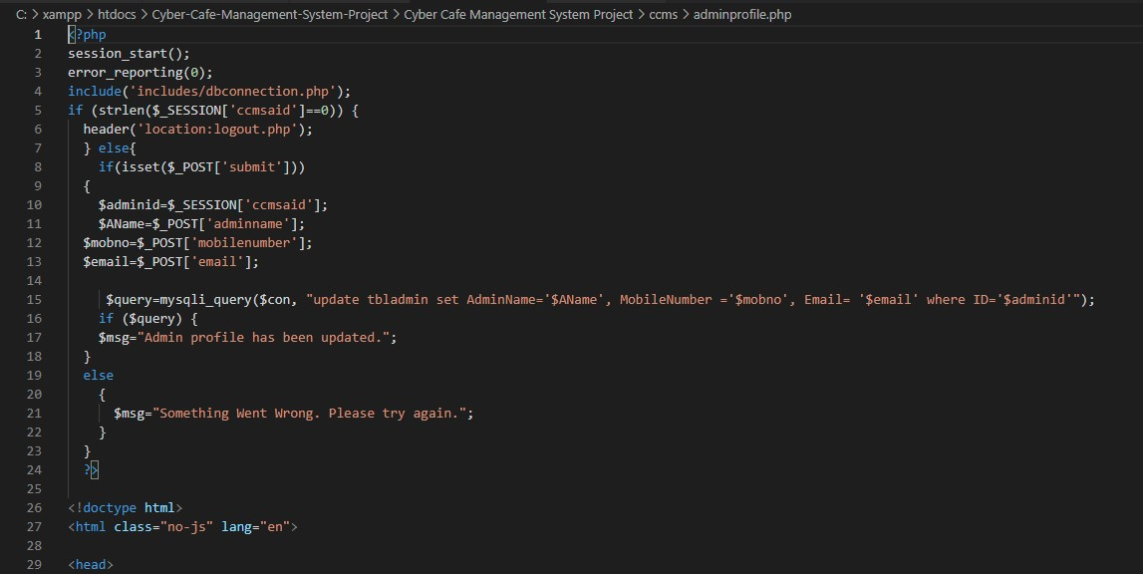

FIG A.4 Admin profile

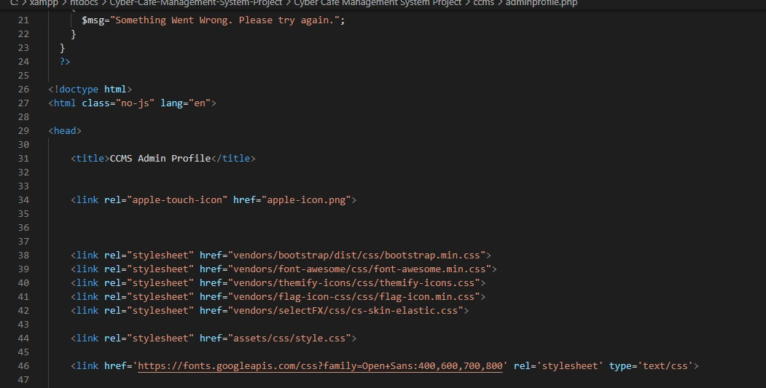

### A.5 All users

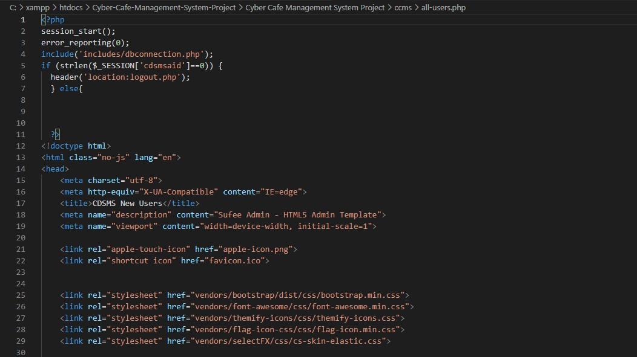

### 

### 

FIG A.4 All users

## **APPENDIX ‘B’ – SCREENSHOTS**

### B.1 Admin Login

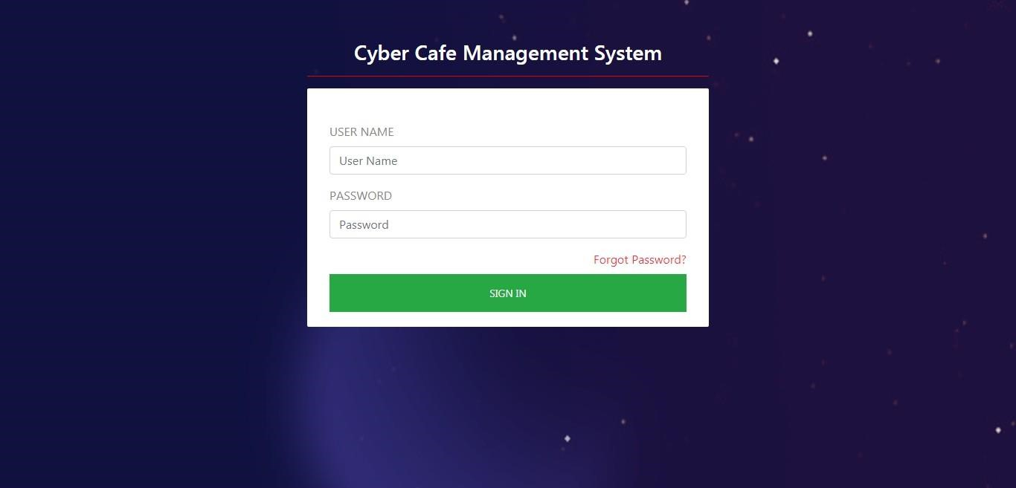

#### **B.2 Dashboard**

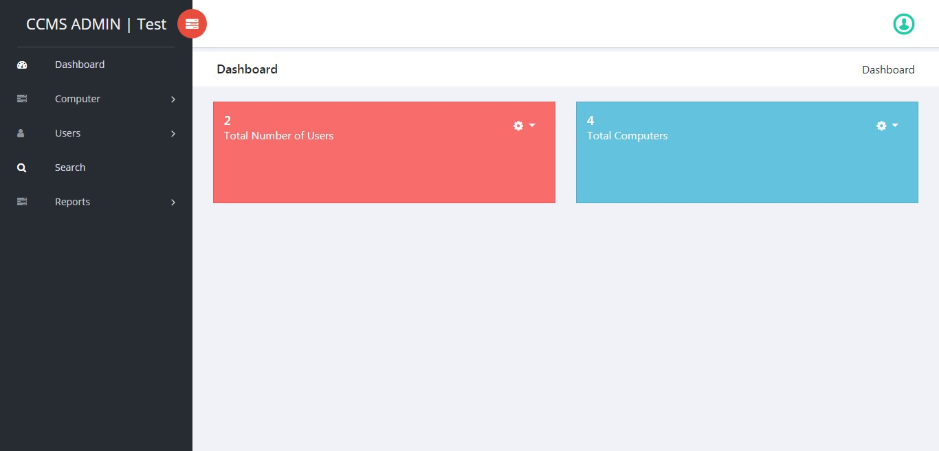

### B.3 Profile

### 

**B.4 Change Password**

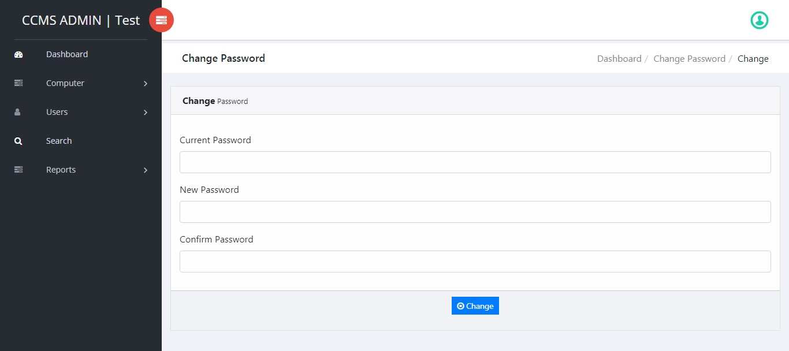

### B.5 Add Computer

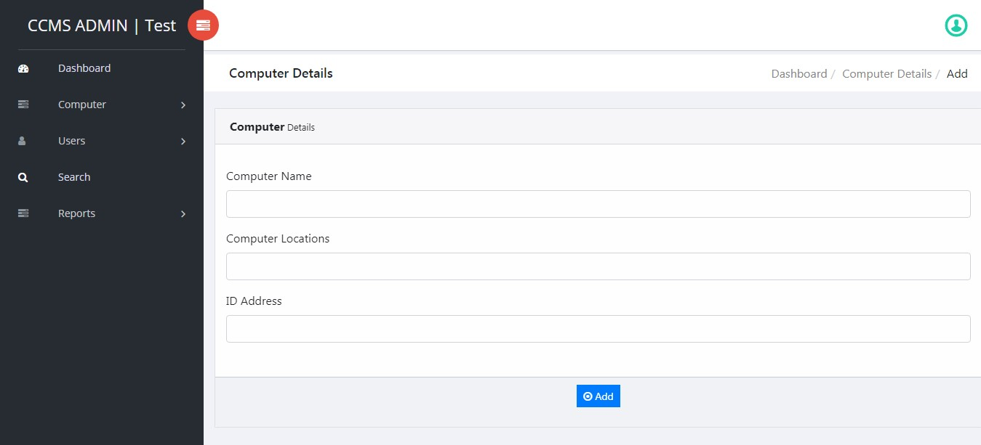

**B.6 Manage Computer**

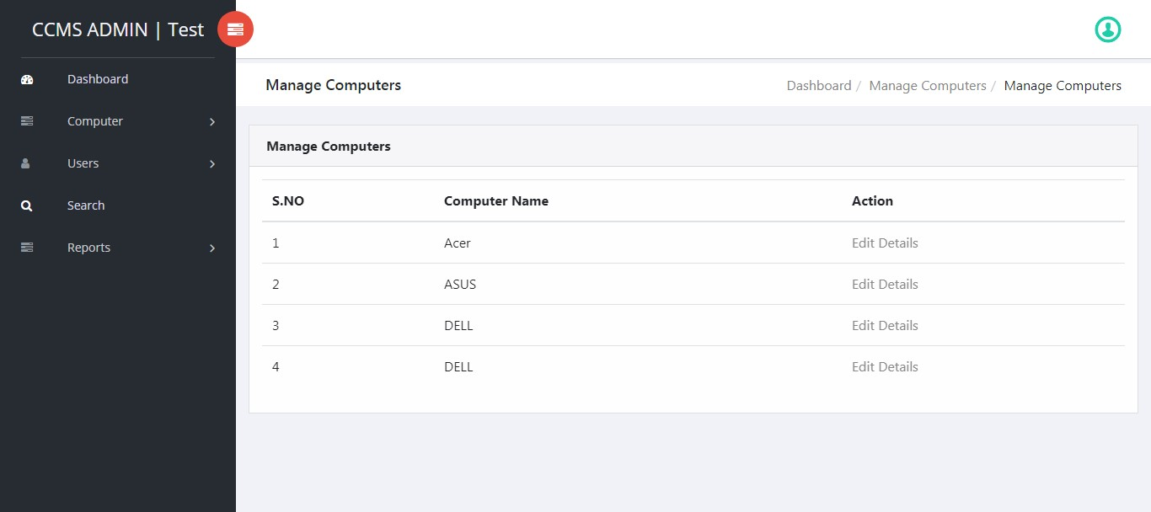

**B.7 Update Computer**

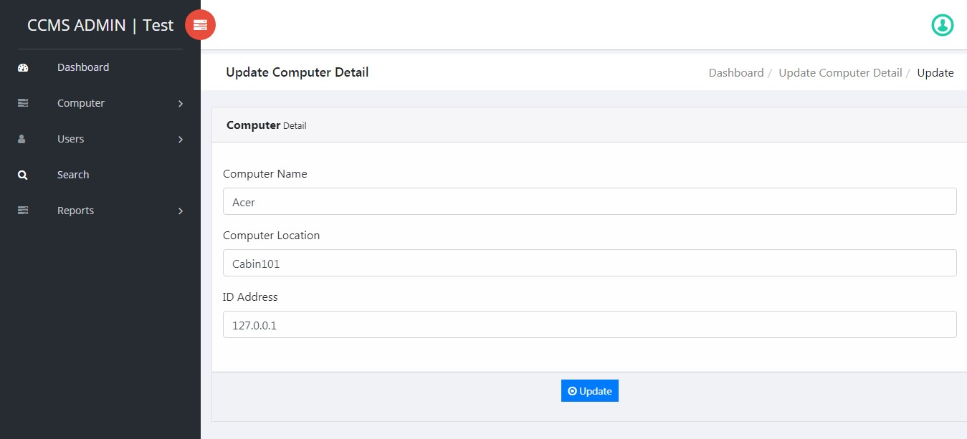

**B.8 Add Users**

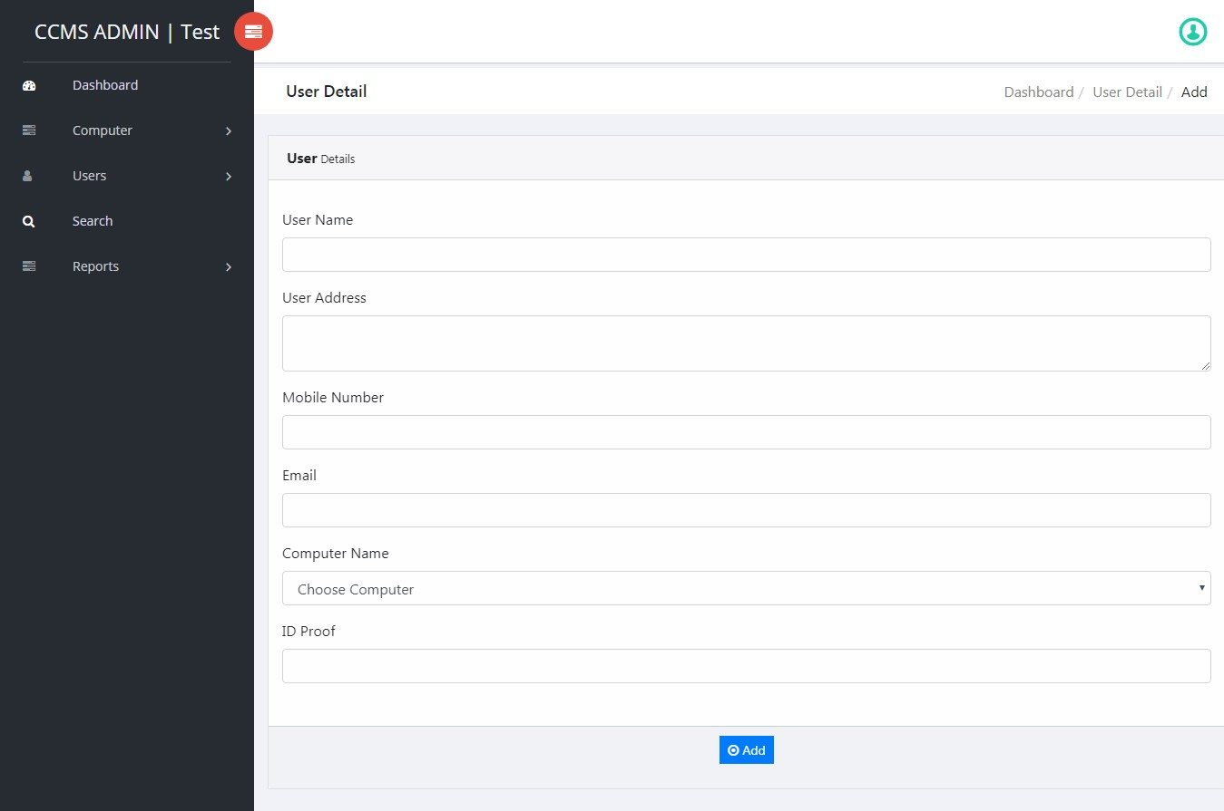

**B.9 Update User**

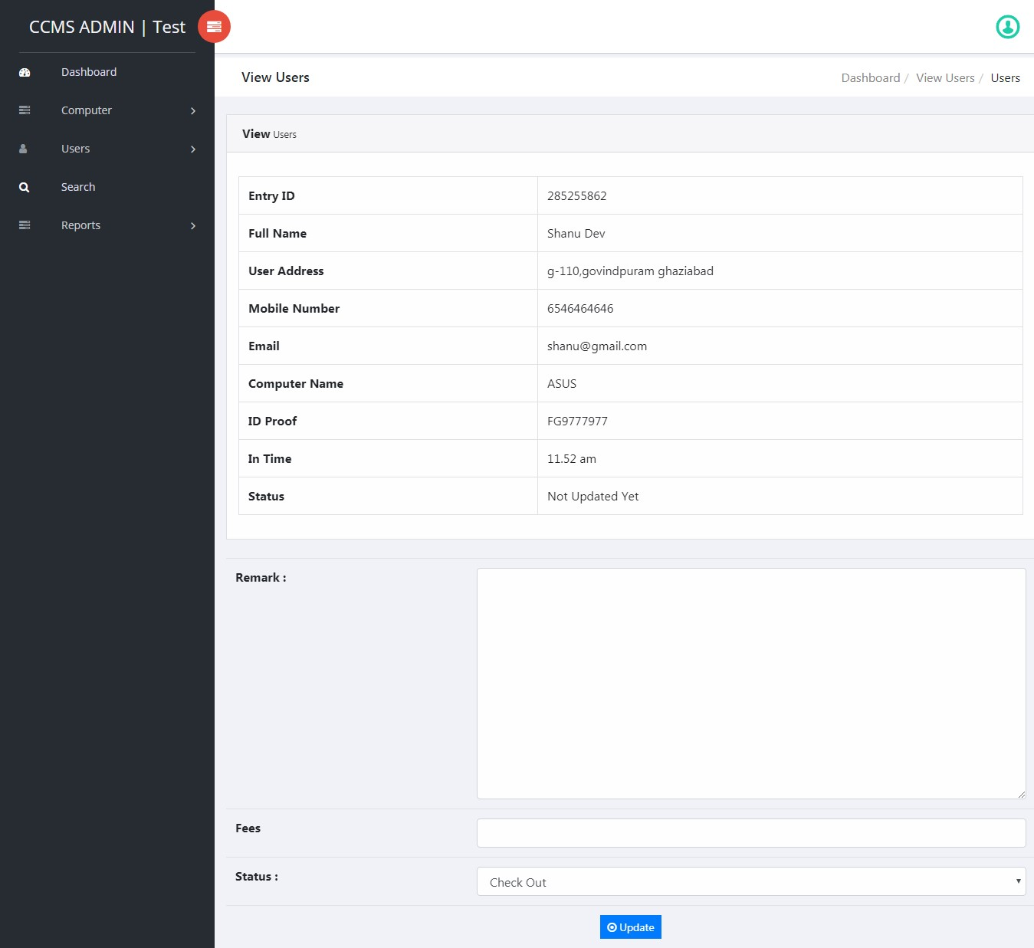

**B.10 User Details**

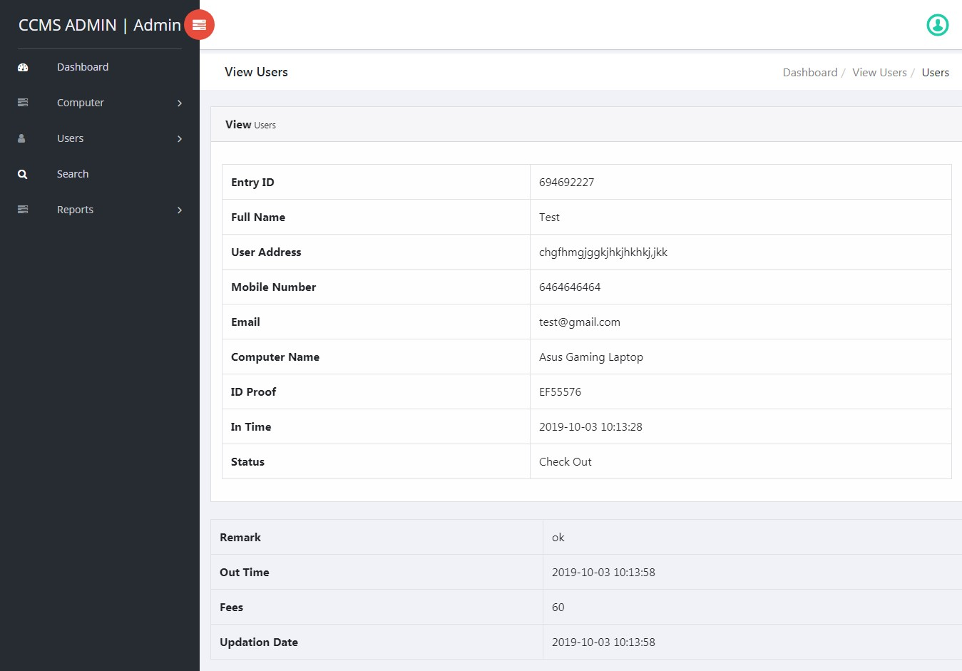

**B.11 Search Data**

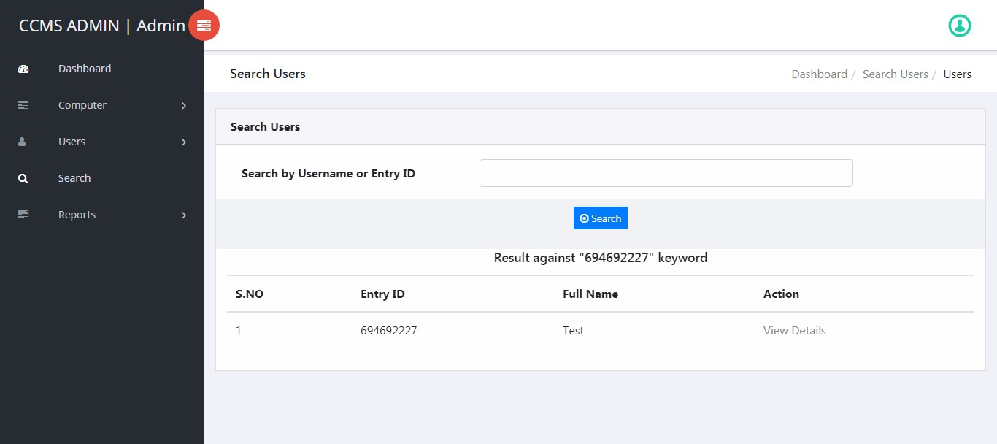

### B.12 Between Reports

### 

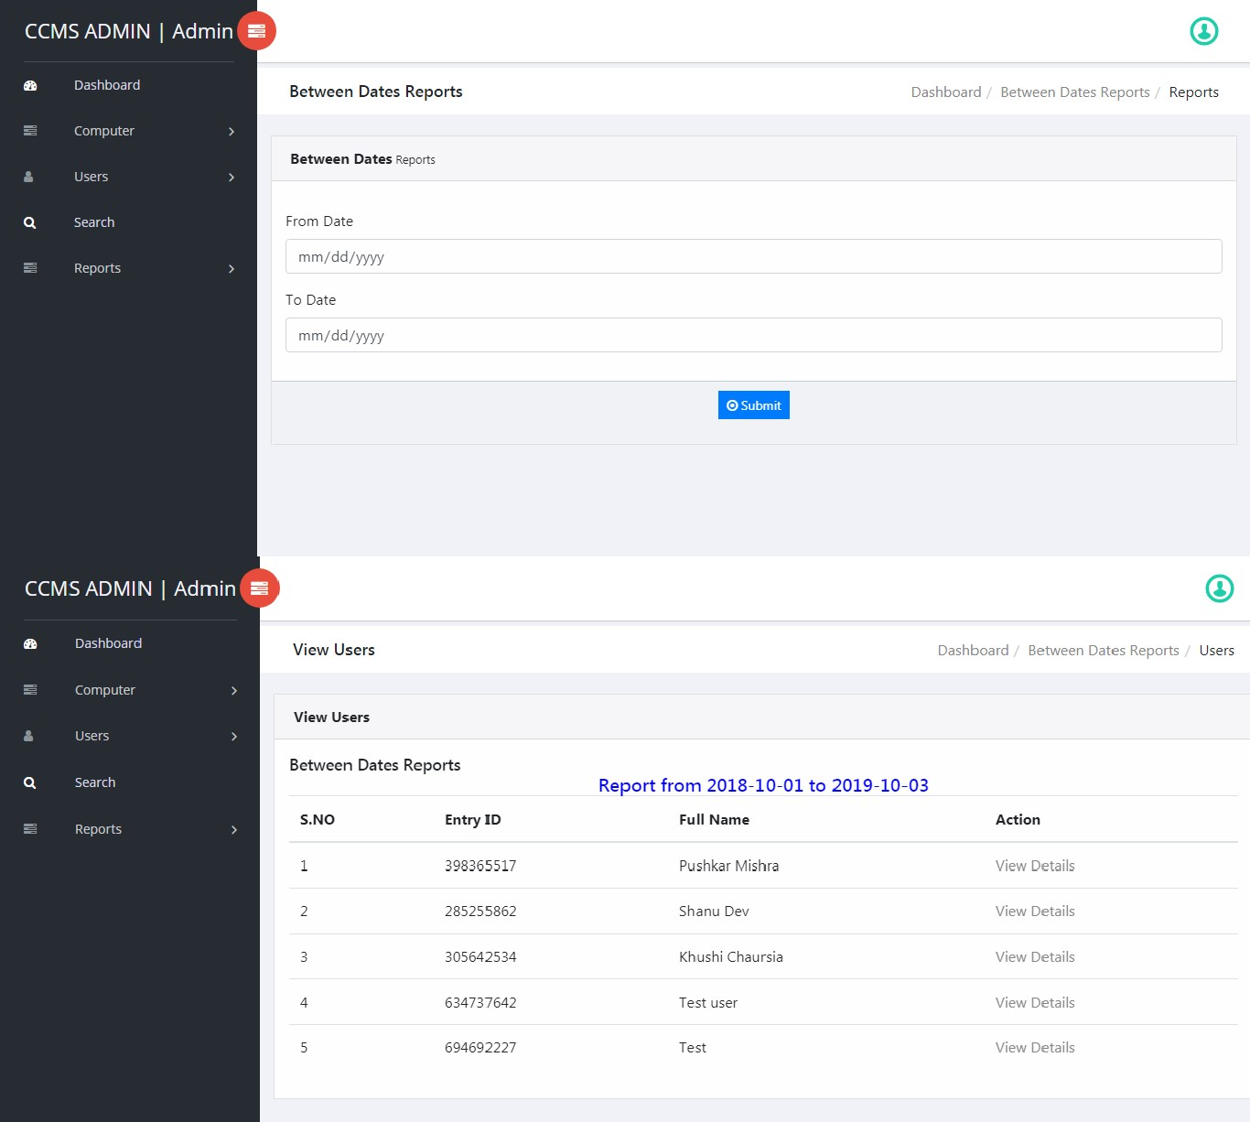

**B.13 Forgot Password**

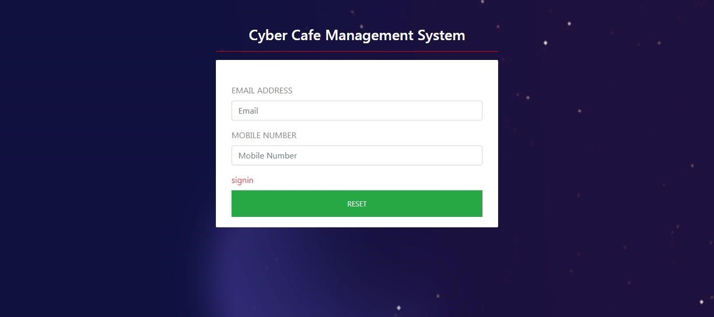

### B.14 Reset Password

### 

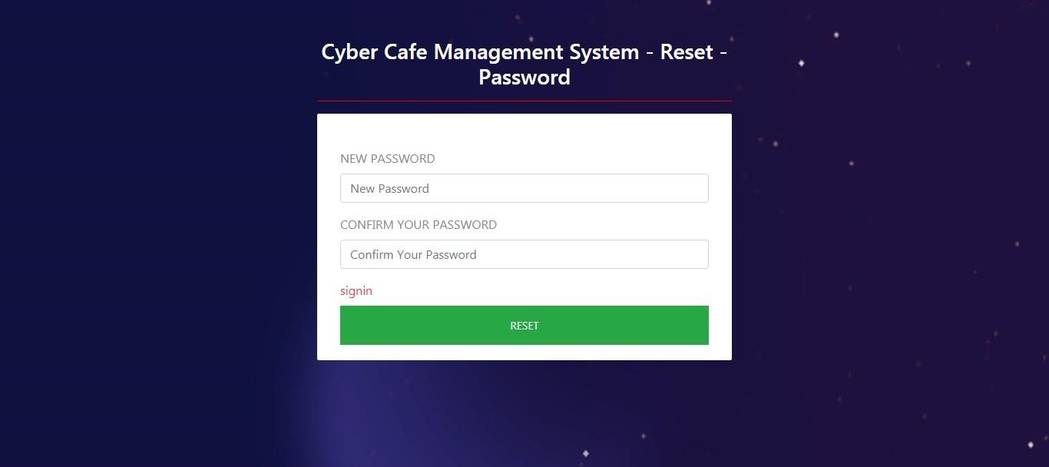

**CHAPTER 7:**

**CONCLUSION**

**CHAPTER 7:**

**CONCLUSION AND FUTURE ENCHANCEMENTS**

CCMS has many powerful features and is certainly more than a "simple" diagramming tool. With its support of MDA (Model Driven Architecture), it is more aimed at people using UML in an intensive way and with some code generations objectives than for simply drawing diagrams to document requirements. However, using CCMS just as a diagramming tool work fine, especially on Windows as the tool is built with Delphi and might execute faster than the Java-based tools.

Modern world is computer world where the things have to be done promptly that requires optimal resources and optimal methods. Due to this inevitable requirement, computerisation of each and every sector in the main stream is must, so that it can be held itself in the race. Few eye catching features of our project are its simplicity, accuracy, and its user friendly interface. Our software incorporates all the features and facilities provided by the Visual Studio software.

This project has been developed to manage the entire working of the Cyber Café. Our software simplifies and replaces all the manual effort and the paper works done by the owner of the cyber to a completely electronically environment, be it bill generation or customer creation and fulfilment of their needs and customer satisfaction. Hence both the customer and the owner are at their ease. The customer is serviced at his footsteps wherein he just types in the request and he is

Just a click away

We would like to convey our sincere gratitude and thanks to all, who stood as our backbone, in desiging formatting and helping us in executing in this project successfully.

**REFERENCES**

For PHP

* <https://www.w3schools.com/php/default.asp>
* <https://www.sitepoint.com/php/>
* <https://www.php.net/>

For MySQL

* <https://www.mysql.com/>
* [http://www.mysqltutorial.org](http://www.mysqltutorial.org/)

For XAMPP

<https://www.apachefriends.org/download.html>