Day3:

Dockerfile to create docker image for application

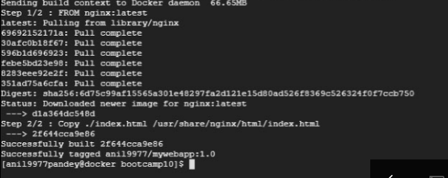

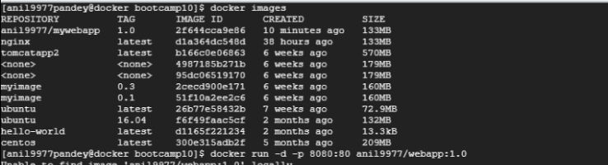



Running Application

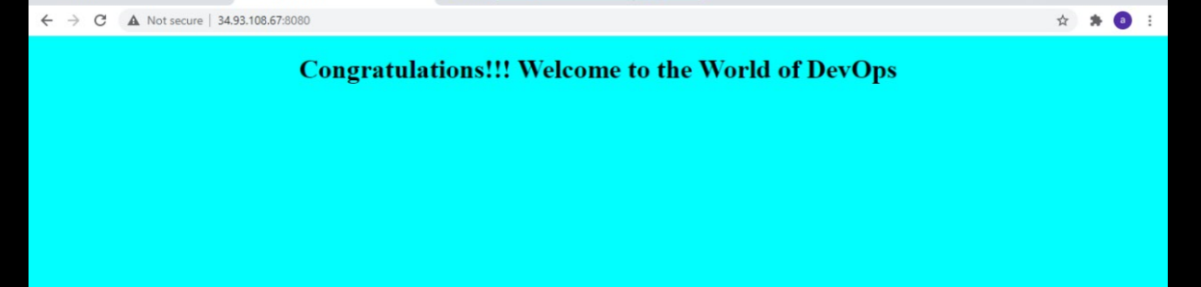

Pushing image to docker hub

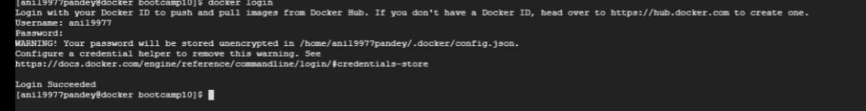

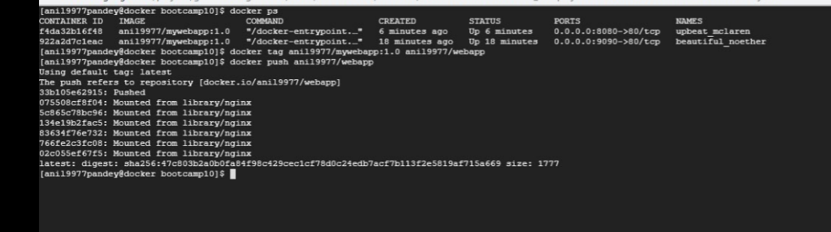

Pulling image from docker hub and running on different VM:

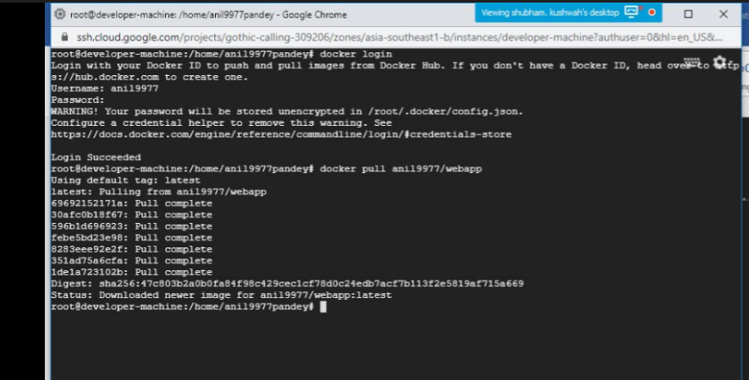

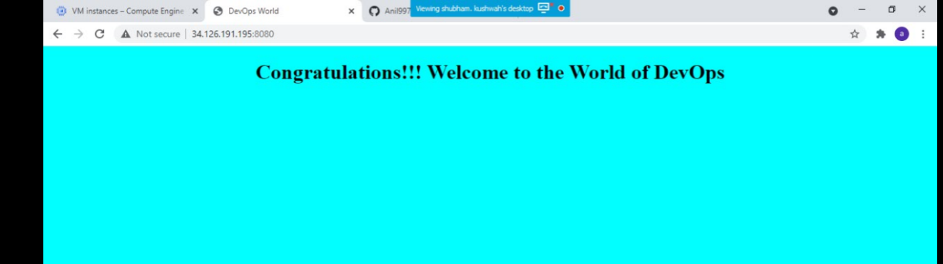

Docker-Compose:

Docker-compose file for running application and creating table in sql

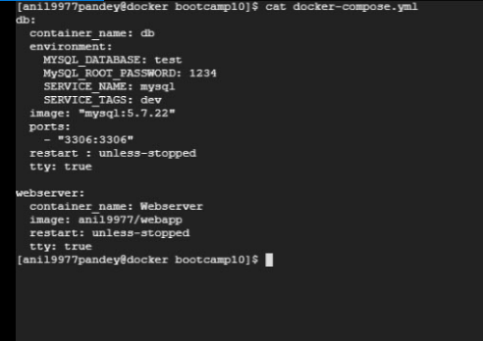

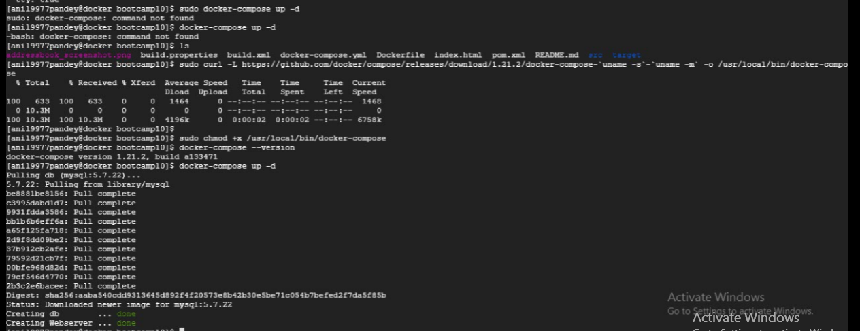

Connecting to sql and creating table:

