**Owner & Admin Login :-**

* There will be two access to login button as Owner and Admin on the Home-page.
* Admin will have access to the things approved by owner.
* Owner can create, update and delete admin details as ID and passwords.
* Owner and Admin both will have access to add/update/delete Ads as per need.
* Owner can see activity of Admin.
* Owner will get notifications of every updates by Admin.
* Owner will get details of Ad owner updated by Admin and Admin can only add details but update and deletion will be done by Owner only.
* Both can set validity of Ad.

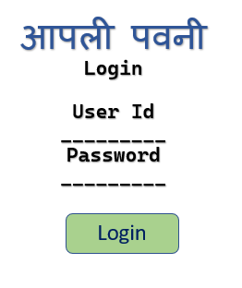

# SYSTEM OVERVIEW

## Introduction

* The purpose of this document is to define the features of the **“Build a responsive website using React.Js”**
* The System will allow Admin to handle their website for daily updates on website and ads as well. The admin can post the daily updates for the locals and Professionals and book them as per the service needed.
* There will be an intuitive section known as admin dashboard over the System, using which System owner will be able to control and manage users and all the activities over the System.

## Different Types of Registered Users on the System:

* Administrator

- The modules and functionalities have been briefly defined in this document.

## Language:

* On this web application, there will one language.
* The language will be: **English**

## Currency:

* There is only one Currency.
* The Currency will be: **Indian Rupees**

## Goals & Objectives:

* There will be only web application at this phase of the project.
* The main purpose of the project is to provide a user friendly and appealing interface for its users providing them a great user experience while visiting the System.
* The system will be optimized in terms of speed and performance.
* The newly designed web application will be

### Visually:

* + - Warm and Welcoming
    - Designs based on the current market trends
    - Easy to navigate
    - Driven by an Overall ‘less is so much more” philosophy

### Technically:

* + - Mobile friendly
    - Compatible with the screen resolutions of all the standard devices
    - Cross browser friendly - compatible with the screen resolutions of all the standard devices.

## Technology Used:

* React / Bootstrap

***The attached screenshot is just for the better understanding of the project. The screenshot is not related with the design of this project. We will create the new design as per your requirement from the scratch.***



Update Post



Admin Dashboard

Create ost

**ADMIN ACCESS**

Update Post

Delete Post

Delete

Post

## Login Process for Admin

* The Admin can do the login process, able to post the Ads, News and get the quotes from the professionals
* For doing the login process, the admin will have to enter the details. The details will be:
  + Email ID as User ID
  + Password
* After entering the following details, the Admin can click on the login button.
* The system will validate the entered email id and the password
* If the entered email ID is invalid, then the system will show the popup message i.e. the entered email id wrong or invalid.
* If the entered password is wrong then the system will show the pop up message i.e. the entered password is wrong/invalid, please enter the valid password.
* If the customer forgets the password, then there will be forget password tab on the page. The customer can click on the same and can proceed with the forget password process.

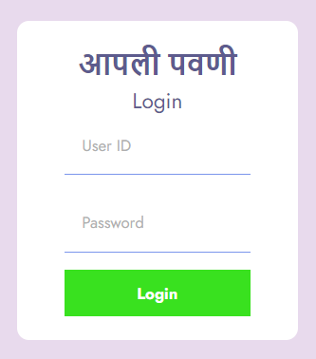

## Forget Password Page

* As soon as the Admin click on the forget password tab, the system will redirect on the forget password page.
* Through this page, the admin will be able to reset the password.
* For doing the same, the admin will have to enter the REGISTERED EMAIL ID and click on the reset password button.
* The system will check whether the entered email id is registered or not on the website.
  + If not registered, then the popup message will get displayed on the screen i.e. entered the valid email id or the entered email Id is not registered on the website.
* The system will send the reset password link on the Registered Email ID of the Admin.
* The admin will get the notification email for the same on the registered email id.
* Once the admin click on the link, the reset password page will get open wherein the admin will have to enter the following details:
* The details will be:
  + New password
  + Re-Enter New Password.
* After entering the following details, the admin can click on create new password button.
* After the above step done successfully, the admin will get logout from the system.
* Now the admin will have to do the login process again.

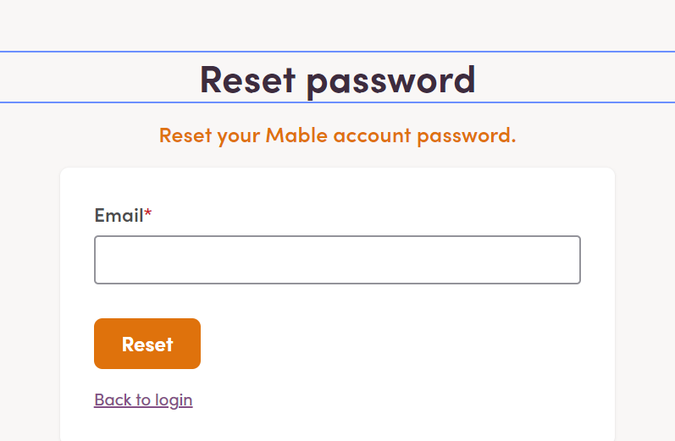

**USER ACCESS LEVEL – ADMIN**

**Admin Dashboard**

* There will be a login section for the admin.
* After logging in to the system, Admin will enter to its dashboard.
* Through the dashboard the admin can do the following things:
  + Total posts
  + Validity of posts Until Date
  + Create posts
  + Update posts and
  + Delete posts
  + Add/Update/Delete posts.

**USER ACCESS LEVEL – OWNER**

**Create Admins (Managers and sub-Admin’s)**

* This module will allow Admin to create various users for its website management purpose like:
  + Manager
  + Sub Admin etc.
* For creating the new user on the system, the admin will have to do the following steps like:
  + Enter the Name of the user
  + Choose Manager or Sub-Admin
  + Assign the Responsibilities of the web app i.e. access level
  + Create User.

