ELK Stack Setup Guide
Docker Compose Method — Installation, Configuration & Verification
Anil Babu | DevOps Notes | 31 July 2026

1. Overview — Ways to Set Up ELK
The ELK stack (Elasticsearch, Logstash, Kibana) can be set up using any of the following methods. This guide walks through Method 1 in full — Docker Compose — with configuration files, commands, and screenshots at each stage.
- Docker Compose (learn installation and configuration)
- Ubuntu Server (manual installation and service management)
- AWS EC2 (cloud deployment)
- MERN + ELK (application log monitoring)
- Jenkins + ELK (CI/CD log monitoring)
- Kubernetes + ELK (production-grade deployment)

2. Method 1 — Docker Compose Setup

2.1 Prerequisites
- Docker installed
- Docker Compose installed (docker compose version)
- At least 4 GB RAM available (8 GB recommended)
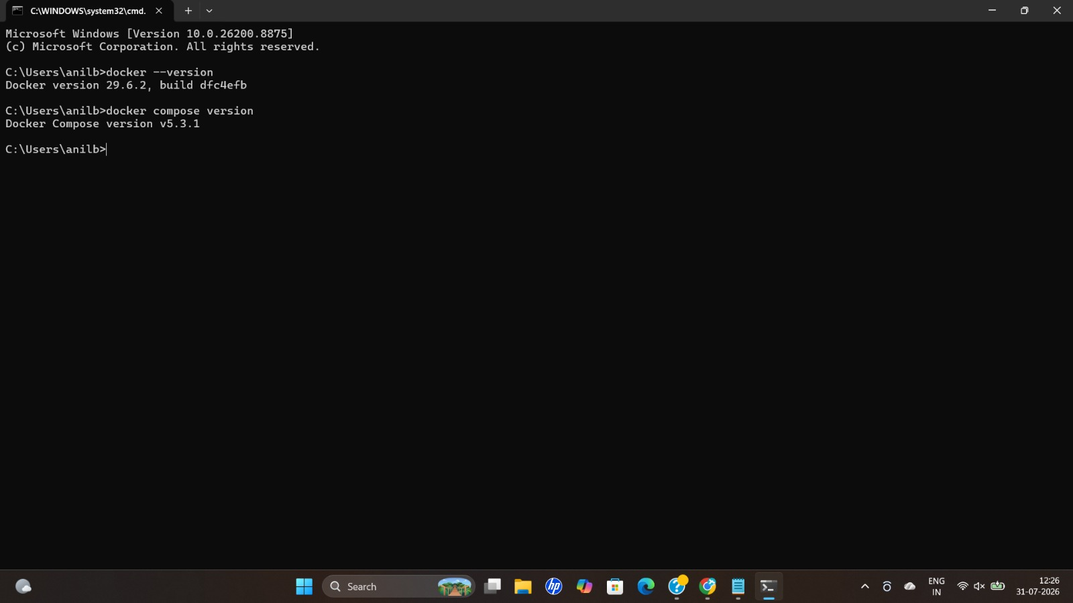
Verifying Docker and Docker Compose versions in the terminal.

2.2 Folder Structure
Create the following folder structure before writing any configuration files:
elk-docker/
│
├── docker-compose.yml
├── logstash/
│ └── logstash.conf
└── sample.log

2.3 docker-compose.yml
This file defines the three ELK services — Elasticsearch, Kibana, and Logstash — as Docker containers.
version: "3.8"

services:

elasticsearch:
image: docker.elastic.co/elasticsearch/elasticsearch:9.1.2
container_name: elasticsearch
environment:
- discovery.type=single-node
- xpack.security.enabled=false
- ES_JAVA_OPTS=-Xms512m -Xmx512m
ports:
- "9200:9200"
- "9300:9300"

kibana:
image: docker.elastic.co/kibana/kibana:9.1.2
container_name: kibana
ports:
- "5601:5601"
environment:
ELASTICSEARCH_HOSTS: http://elasticsearch:9200
depends_on:
- elasticsearch

logstash:
image: docker.elastic.co/logstash/logstash:9.1.2
container_name: logstash
ports:
- "5044:5044"
volumes:
- ./logstash/logstash.conf:/usr/share/logstash/pipeline/logstash.conf
- ./sample.log:/usr/share/logstash/sample.log
depends_on:
- elasticsearch
discovery.type: Normally Elasticsearch expects multiple nodes — single-node tells it to run standalone.
xpack.security.enabled: By default Elasticsearch enforces username, password, TLS, certificates and authentication; disabling this simplifies local development.
ES_JAVA_OPTS: Elasticsearch runs on the JVM, which uses heap memory. Setting -Xms/-Xmx prevents Java from continuously resizing memory (for development this becomes complicated otherwise).

2.4 logstash/logstash.conf
input {
file {
path => "/usr/share/logstash/sample.log"
start_position => "beginning"
sincedb_path => "/dev/null"
}
}

filter {
grok {
match => {
"message" => "%{TIMESTAMP_ISO8601:timestamp} %{LOGLEVEL:level} %{GREEDYDATA:msg}"
}
}
}

output {
elasticsearch {
hosts => ["http://elasticsearch:9200"]
index => "sample-logs"
}

stdout {
codec => rubydebug
}
}

2.5 sample.log
2026-07-31 INFO Application Started
2026-07-31 ERROR Database Connection Failed
2026-07-31 WARN Low Memory
2026-07-31 INFO User Login Success

2.6 Run Docker Compose
Start all three services in detached mode:
docker compose up -d
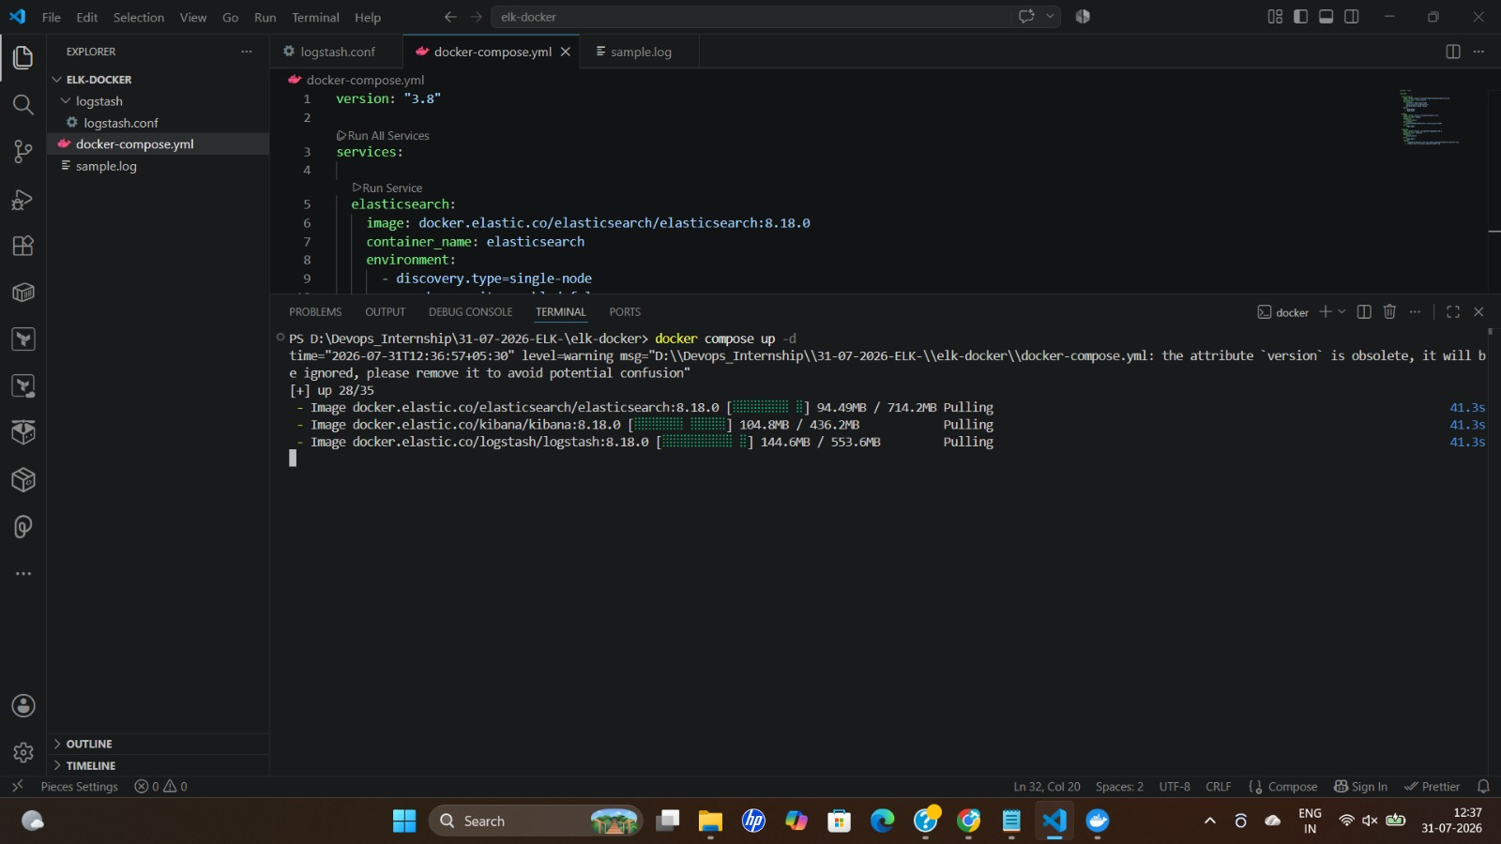
Docker Compose pulling the Elasticsearch, Kibana, and Logstash images.
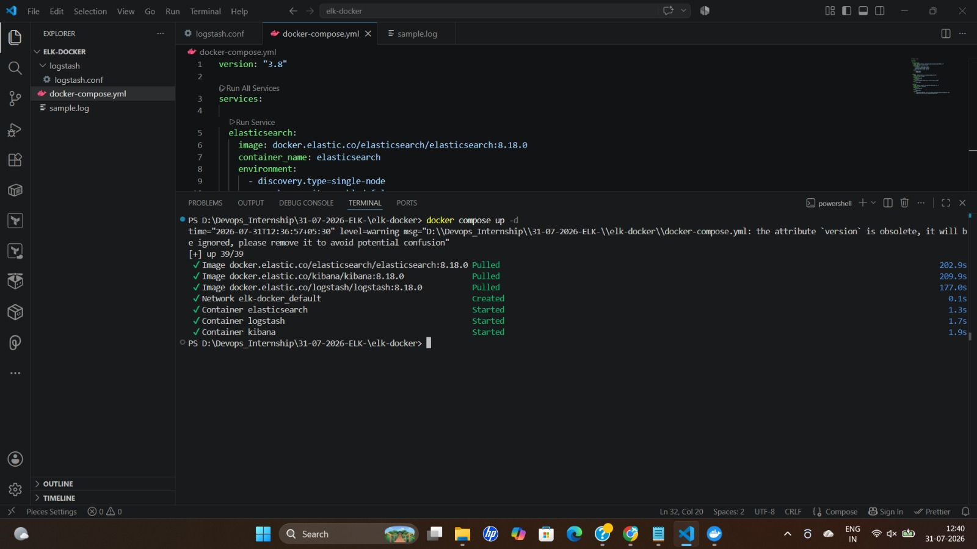
All three containers (elasticsearch, logstash, kibana) created and started successfully.

2.7 Verify Images in Docker Desktop
The pulled images can also be confirmed visually in Docker Desktop under the Images tab.
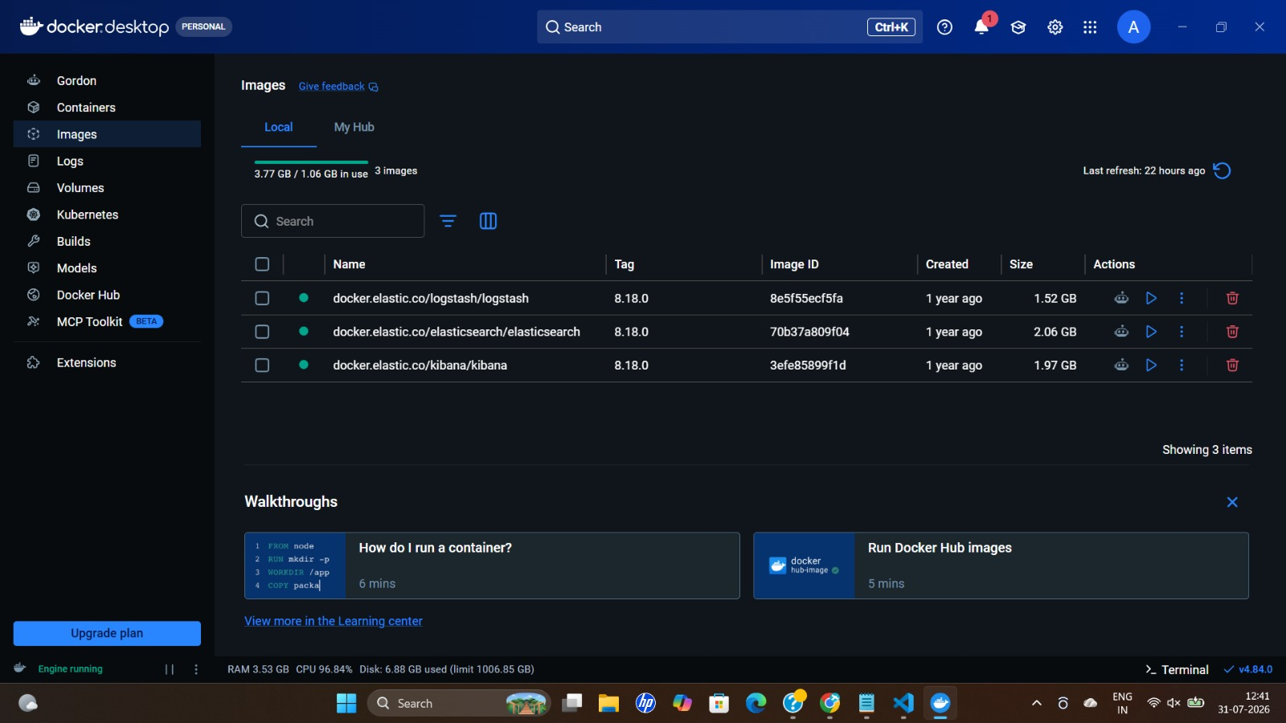
Docker Desktop showing the three pulled ELK images (logstash, elasticsearch, kibana — v8.18.0).

2.8 Verify Elasticsearch
Open the Elasticsearch endpoint in a browser to confirm the node is up and responding:
http://localhost:9200/
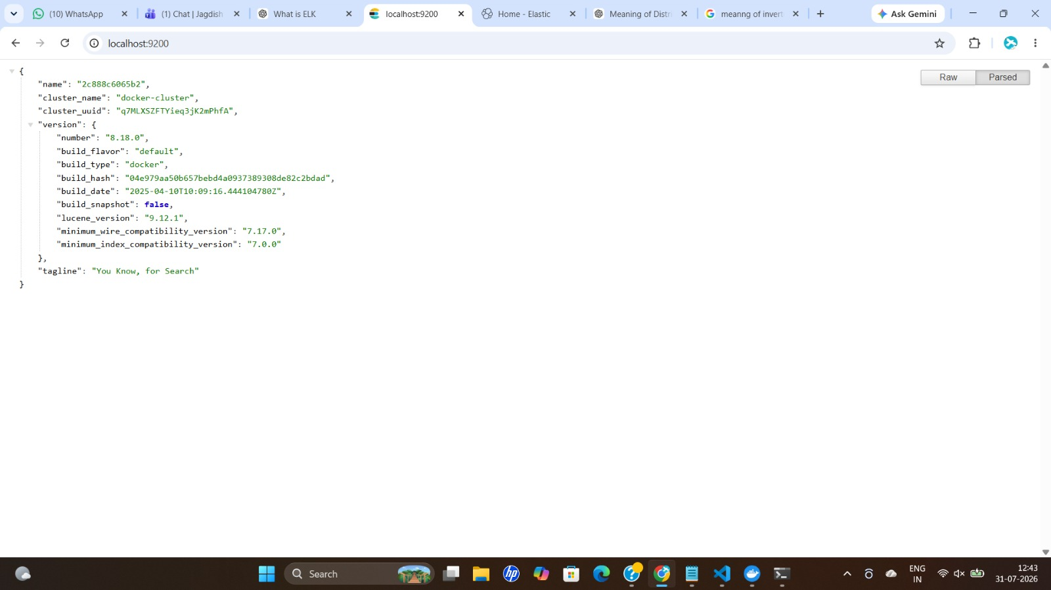
Elasticsearch responding on localhost:9200 with cluster name, version 8.18.0, and tagline "You Know, for Search".

2.9 Verify Kibana
Open the Kibana endpoint to confirm the UI is reachable and connected to Elasticsearch:
http://localhost:5601/

Kibana UI loaded at localhost:5601, ready to create a data view or query with ES|QL.

3. Method 2 — Setup on Windows (native)
- Download Elasticsearch, extract the archive, and run the .bat file
- Download Kibana, extract the archive, and run the .bat file

4. Kibana Dev Tools
The Dev Tools console in Kibana can be used to query Elasticsearch directly, e.g.:
GET _cat/nodes
Syntax: GET is the HTTP method, _cat is the API, and nodes is the command.

5. Running Two Elasticsearch Nodes on One System
A two-node cluster can be simulated on a single machine by running two Elasticsearch containers that discover each other over the Docker network.
version: "3.8"

services:

elasticsearch1:
image: docker.elastic.co/elasticsearch/elasticsearch:8.18.0
container_name: elasticsearch1
hostname: elasticsearch1
environment:
- node.name=node-1
- cluster.name=my-cluster
- discovery.seed_hosts=elasticsearch2
- cluster.initial_master_nodes=node-1,node-2
- xpack.security.enabled=false
- ES_JAVA_OPTS=-Xms512m -Xmx512m
ports:
- "9200:9200"
- "9300:9300"
volumes:
- esdata1:/usr/share/elasticsearch/data

elasticsearch2:
image: docker.elastic.co/elasticsearch/elasticsearch:8.18.0
container_name: elasticsearch2
hostname: elasticsearch2
environment:
- node.name=node-2
- cluster.name=my-cluster
- discovery.seed_hosts=elasticsearch1
- cluster.initial_master_nodes=node-1,node-2
- xpack.security.enabled=false
- ES_JAVA_OPTS=-Xms512m -Xmx512m
ports:
- "9201:9200"
- "9301:9300"
volumes:
- esdata2:/usr/share/elasticsearch/data

kibana:
image: docker.elastic.co/kibana/kibana:8.18.0
container_name: kibana
depends_on:
- elasticsearch1
environment:
- ELASTICSEARCH_HOSTS=http://elasticsearch1:9200
ports:
- "5601:5601"

logstash:
image: docker.elastic.co/logstash/logstash:8.18.0
container_name: logstash
depends_on:
- elasticsearch1
ports:
- "5044:5044"
volumes:
- ./logstash/logstash.conf:/usr/share/logstash/pipeline/logstash.conf
- ./sample.log:/usr/share/logstash/sample.log

volumes:
esdata1:
esdata2:
discovery.seed_hosts=elasticsearch2: Tells Node 1 where to find other nodes.
cluster.initial_master_nodes=node-1,node-2: Used only when the cluster is created for the first time; tells Elasticsearch which nodes are eligible to elect the first master node.
xpack.security.enabled=false: Turns off authentication and security, making learning easier since no usernames, passwords, or certificates are needed.
esdata1 / esdata2 volumes: Stores each Elasticsearch node's data persistently.

