DEPLOYMENT GUIDE
Deploying a Static Website on AWS EC2
Using SSH, SCP, and Nginx

Prepared by Anil Babu
July 28, 2026

Overview
This guide walks through deploying a static website to an AWS EC2 instance using SSH for remote access, SCP for file transfer, and Nginx as the web server. Each step below includes the exact commands used and a screenshot of the result.
1 | Login to AWS Root Account
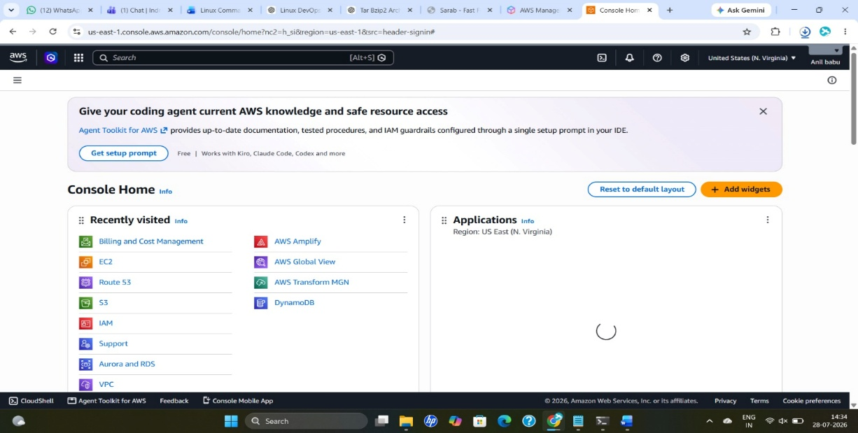
2 | Launch an AWS EC2 Instance
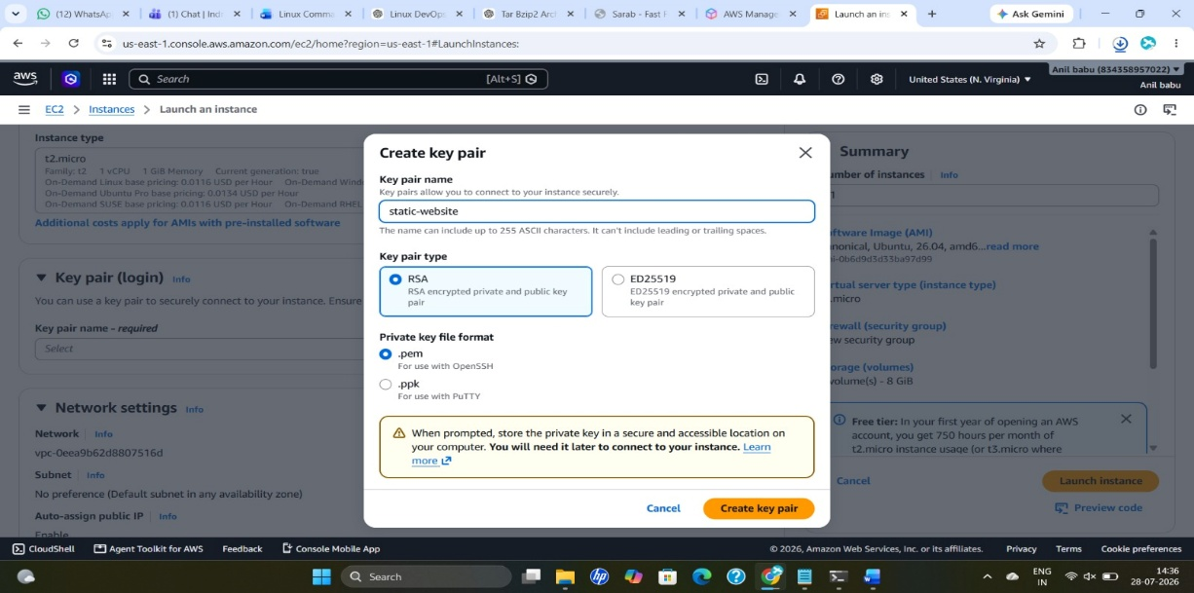
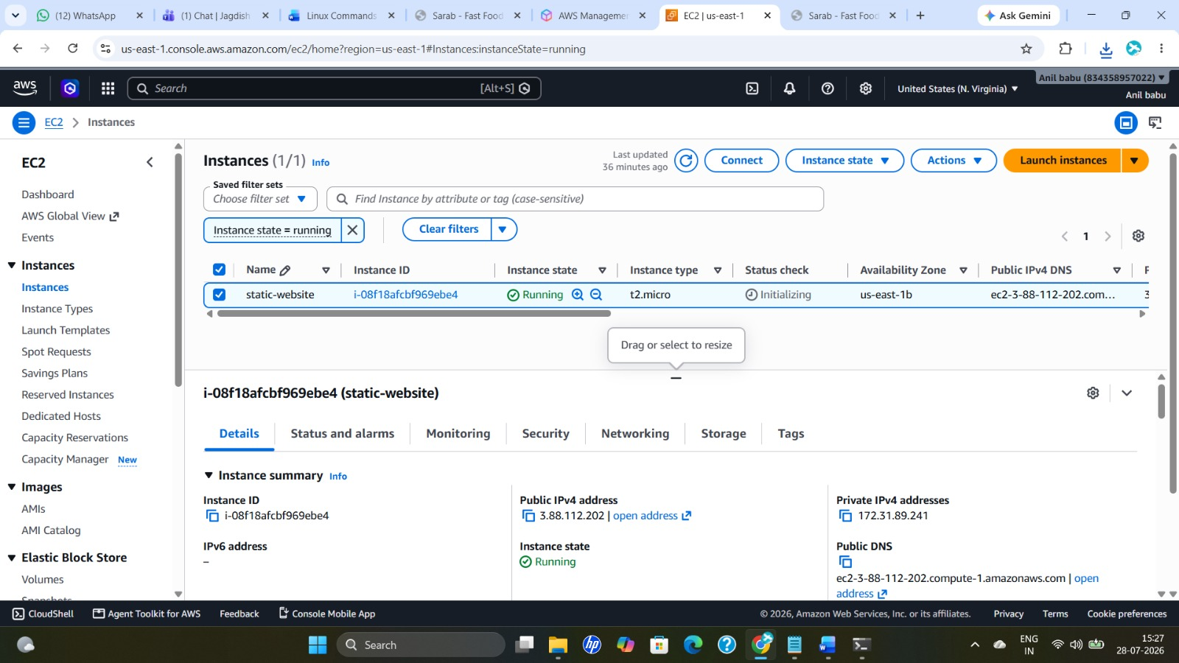
3 | Connect to EC2 from a Windows Terminal via SSH
ssh -i "static-website.pem" ec2-user@ec2-3-88-112-202.compute-1.amazonaws.com
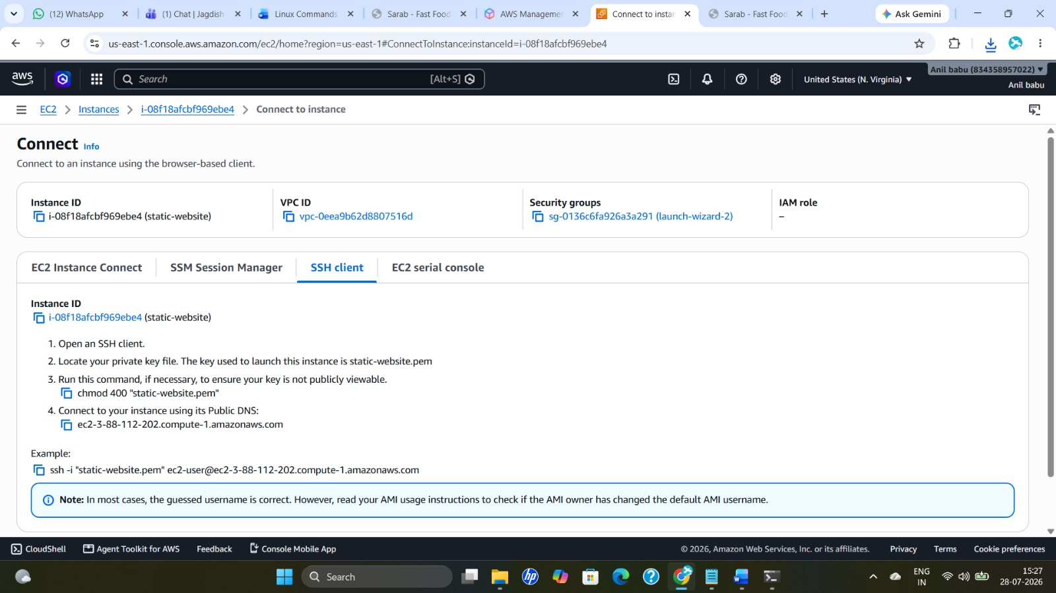
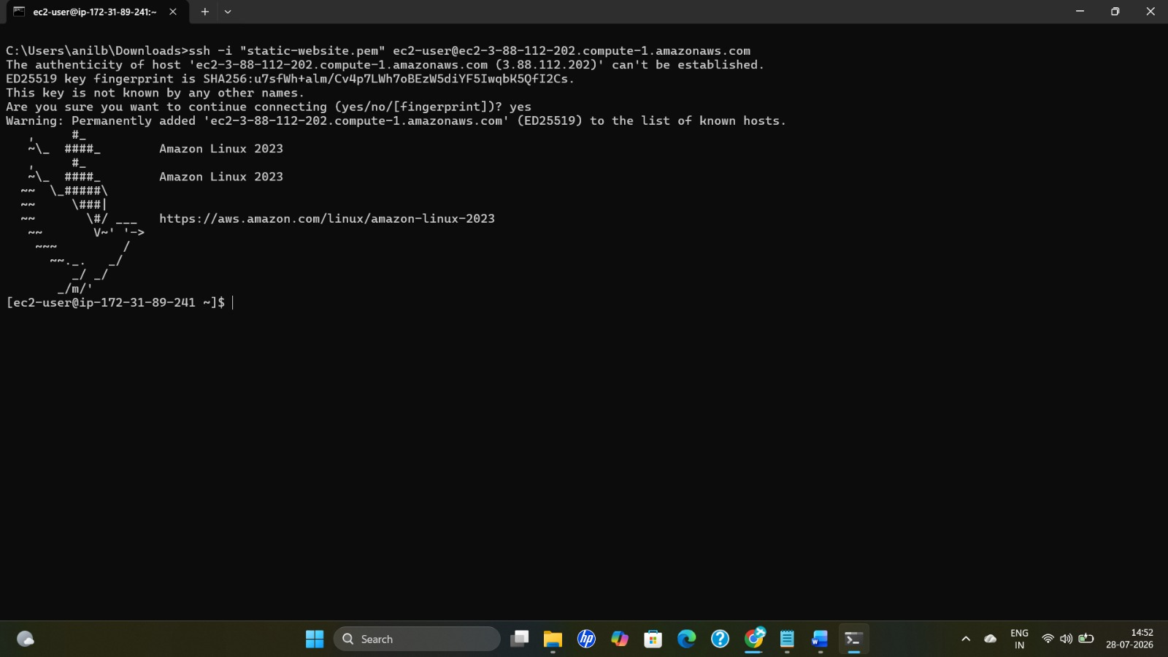
4 | Install, Start, and Verify Nginx
sudo dnf update -y
sudo dnf install nginx -y
sudo systemctl start nginx
sudo systemctl status nginx
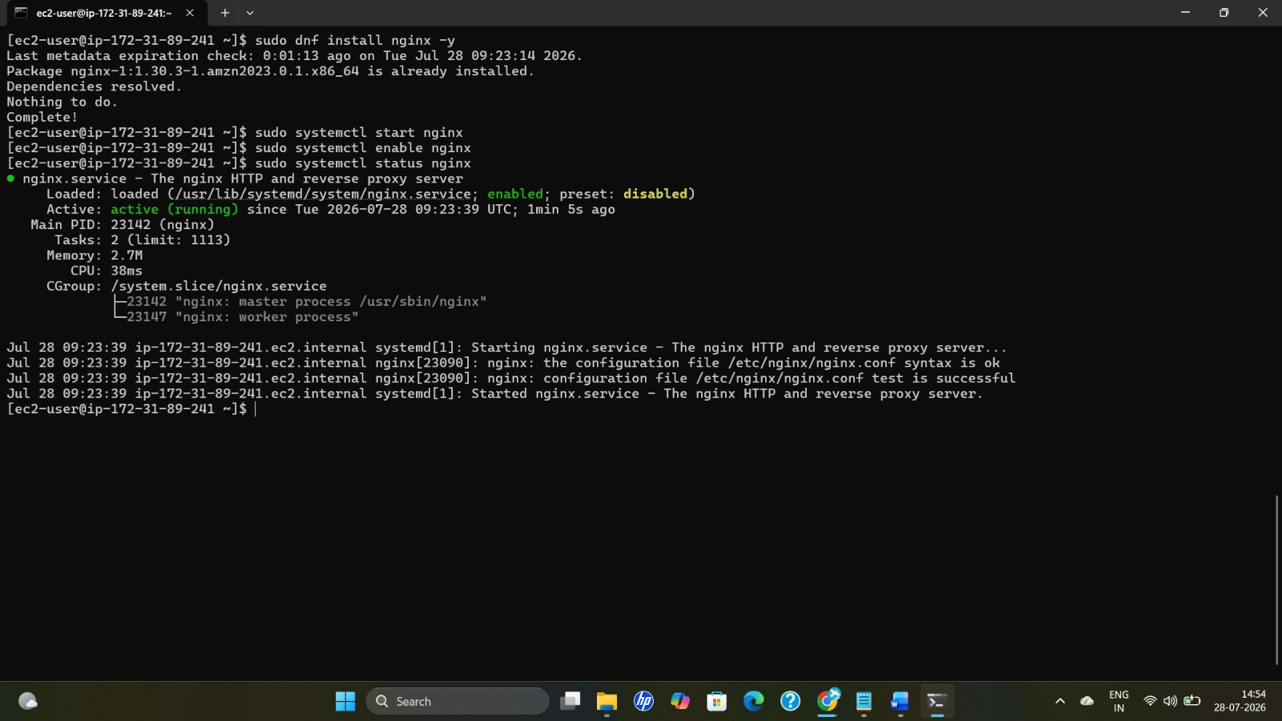
5 | Copy the Project from Local System to the Remote EC2 Server
scp -i "static-website.pem" sarab-1.0.0.zip ec2-user@172.31.89.241:/home/ec2-user/
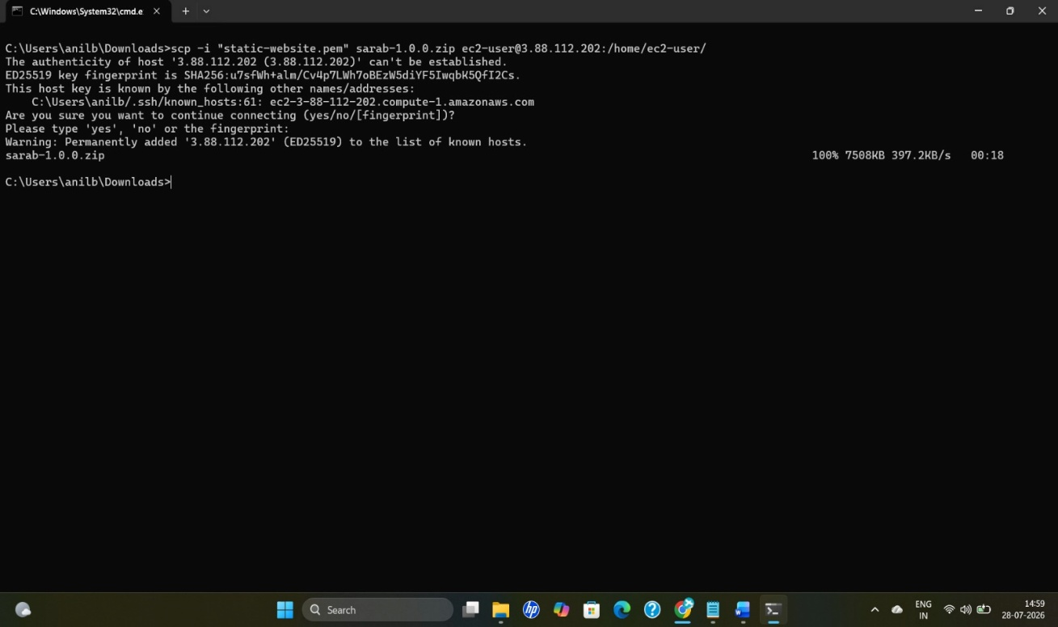
6 | Unzip the Project Folder
unzip sarab-1.0.0.zip
unzip sarab-1.0.0.zip -d sarab
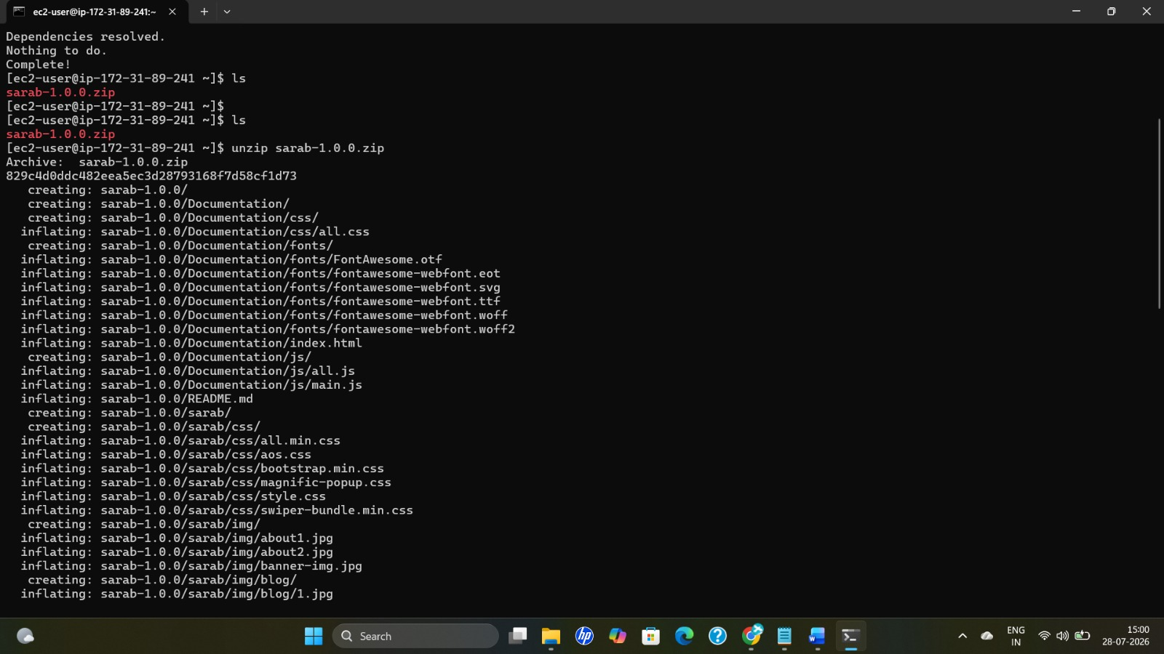

Configure Nginx
1 | Move into the Project Directory
cd sarab
2 | Remove the Default Website Content
sudo rm -rf /usr/share/nginx/html/*
3 | Copy Project Files into the Nginx Web Root
Standard project (plain HTML/CSS/JS):
sudo cp -r * /usr/share/nginx/html/
Next.js / TypeScript project (built output in dist/):
sudo cp -r dist/* /usr/share/nginx/html/
React.js / JavaScript project (built output in build/):
sudo cp -r build/* /usr/share/nginx/html/
4 | Set Ownership for the Nginx Web Root
Recursively assigns the nginx user and group as owner of all files and subdirectories:
sudo chown -R nginx:nginx /usr/share/nginx/html
5 | Set Permissions for the Nginx Web Root
Recursively sets owner: read/write/execute, group: read/execute, other: read/execute:
sudo chmod -R 755 /usr/share/nginx/html
6 | Test the Nginx Configuration
sudo nginx -t
7 | Restart the Nginx Service
sudo systemctl restart nginx
8 | Verify the Live Website
The static website is now live and accessible at:
http://ec2-3-88-112-202.compute-1.amazonaws.com/

The deployed static website running live on EC2 via Nginx

