Kubernetes Setup on Windows
Using Chocolatey, kubectl, Minikube and Docker Desktop
07-08-2026

1. Install Chocolatey
Open Windows PowerShell as Administrator and run the official Chocolatey install command:
Set-ExecutionPolicy Bypass -Scope Process -Force;
[System.Net.ServicePointManager]::SecurityProtocol = [System.Net.ServicePointManager]::SecurityProtocol -bor 3072;
iex ((New-Object System.Net.WebClient).DownloadString('https://community.chocolatey.org/install.ps1'))

2. Install kubectl (Kubernetes CLI)
Open Command Prompt as Administrator and install the Kubernetes CLI using Chocolatey:
choco install kubernetes-cli
kubectl --version --client
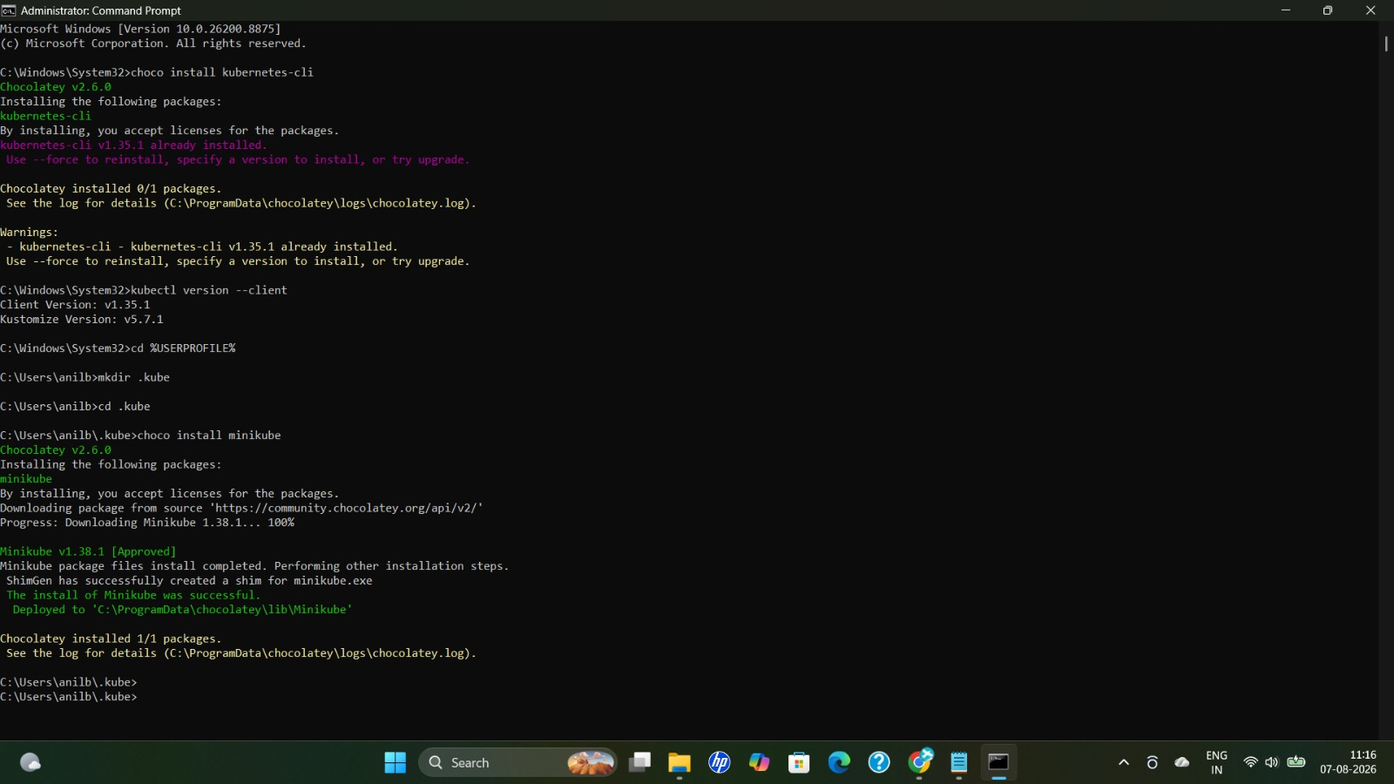
Figure 1: Installing kubernetes-cli and minikube via Chocolatey, and verifying kubectl client version.

3. Configure the .kube Directory
Navigate to your home directory and create the .kube configuration folder:
cd %USERPROFILE% (cmd.exe)
cd ~ (PowerShell)
mkdir .kube
cd .kube
New-Item config -type file

4. Install Minikube
- Select install type: choco
- Install Minikube using the following command:
choco install minikube
The screenshot in Figure 1 above shows Minikube v1.38.1 being downloaded and installed successfully via Chocolatey.

5. Start Minikube
Minikube can run with the Docker driver, or with Hyper-V. Reset and configure the driver, then start the cluster:
minikube delete
minikube config set driver docker
minikube start --driver=docker
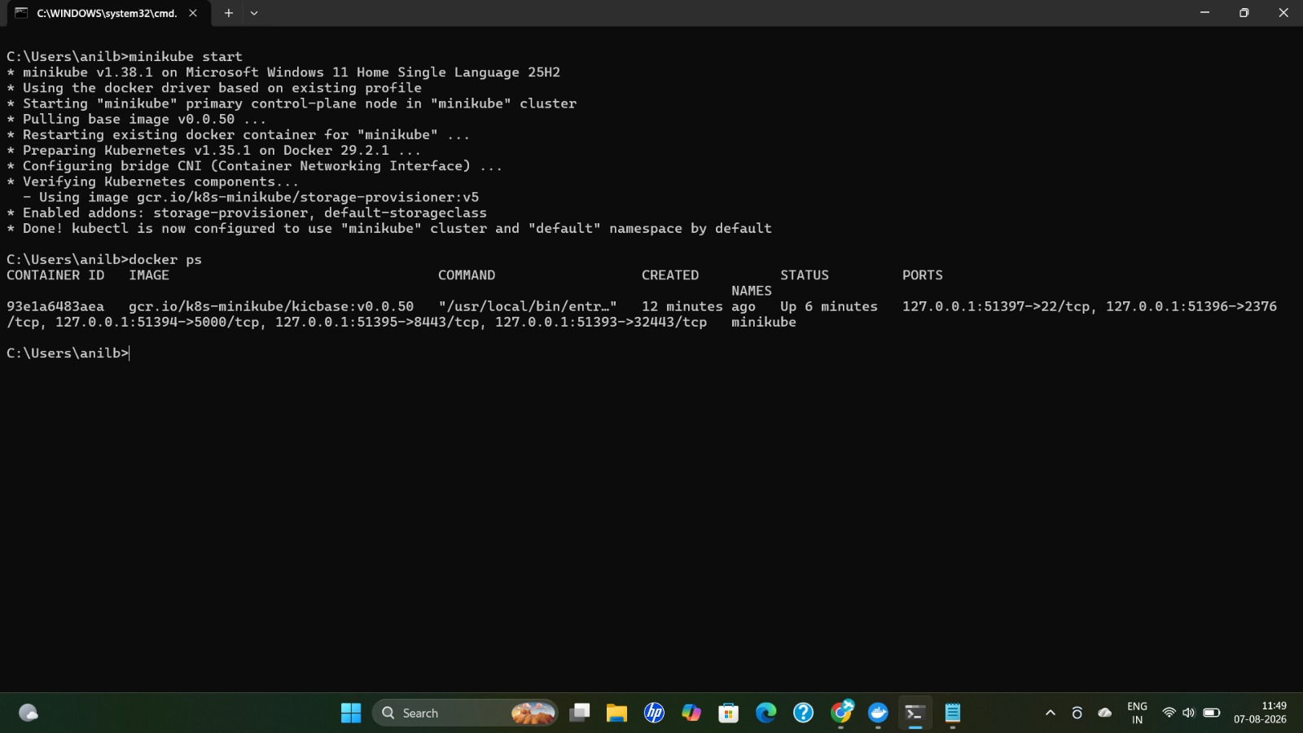
Figure 2: minikube start using the Docker driver, followed by docker ps showing the running minikube container.

6. Minikube Dashboard
The Minikube dashboard shows all details of your cluster, including workloads, services, and config.
minikube dashboard
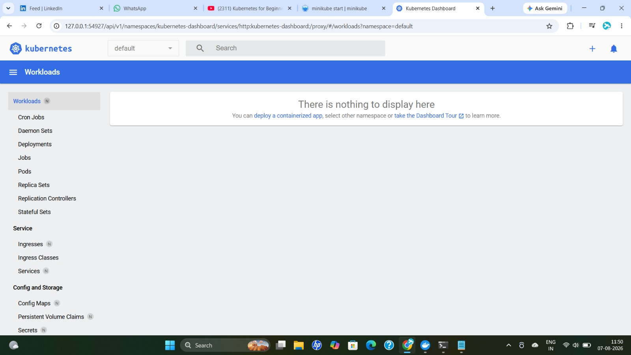
Figure 3: Kubernetes Dashboard opened via minikube dashboard — Workloads view is empty before any deployment is created.

7. Check Minikube Status
minikube status
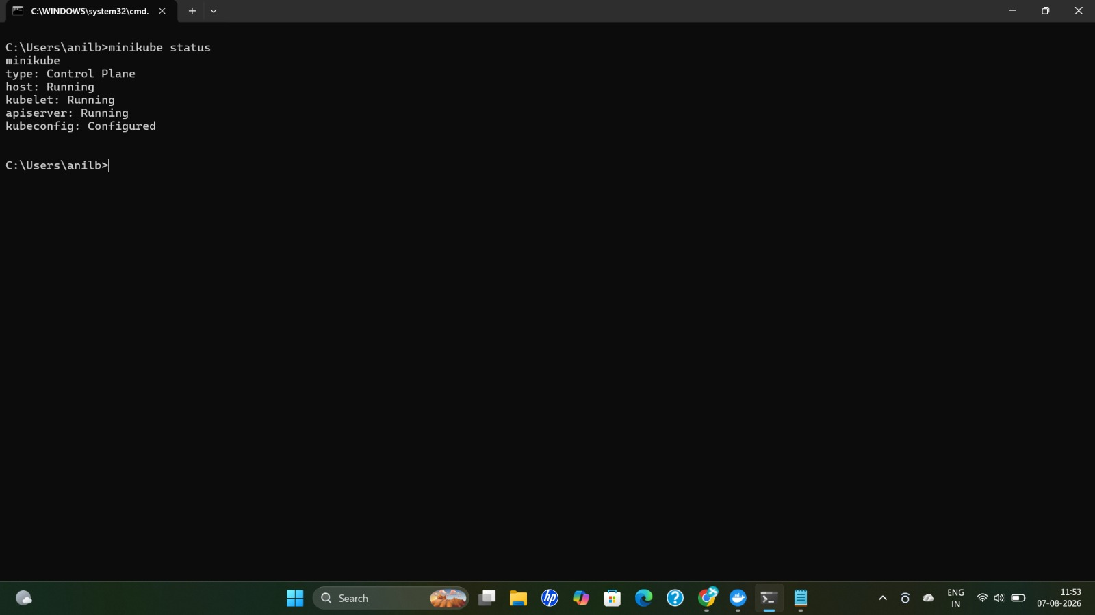
Figure 4: minikube status showing host, kubelet, apiserver running and kubeconfig configured.

8. Setup on macOS and Linux
The same choco-based workflow above is specific to Windows. Equivalent setups exist for macOS and Linux:
- macOS: install via Homebrew (brew install kubectl, brew install minikube).
- Linux: install kubectl and minikube via the official binaries or package manager.
Note: On Linux, the current user must be added to the docker group, otherwise Docker/Minikube commands will show a permission error.

9. Run Nginx in a Pod
Pull the nginx image and create a deployment using kubectl:
docker pull nginx
kubectl create deployment server-nginx --image=nginx
kubectl get deployment
kubectl get pods
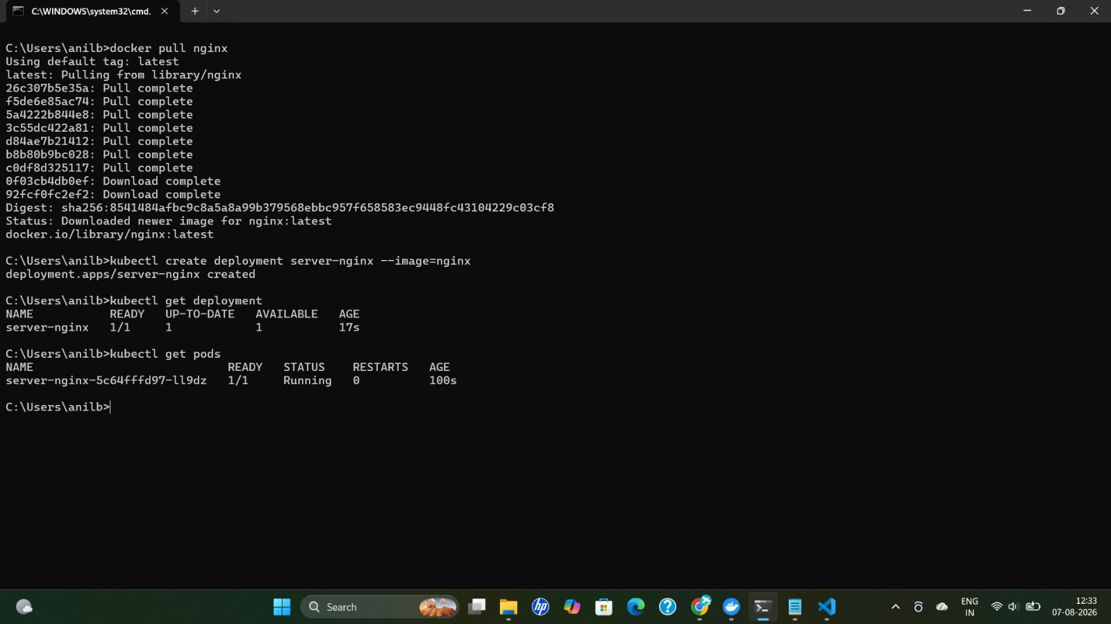
Figure 5: Pulling the nginx image and creating the server-nginx deployment; the pod reaches Running status.
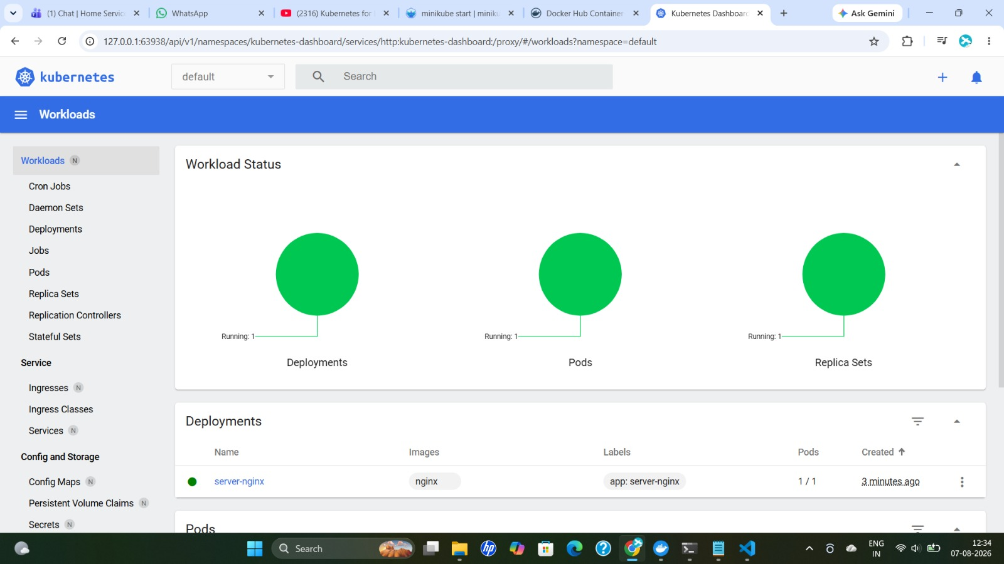
Figure 6: Kubernetes Dashboard confirming the server-nginx deployment, pod and replica set are all running.

10. Expose the Deployment (Service)
Expose the container so it can be accessed from outside the pod:
kubectl expose deployment server-nginx --port=8080 --type=LoadBalancer
kubectl get services
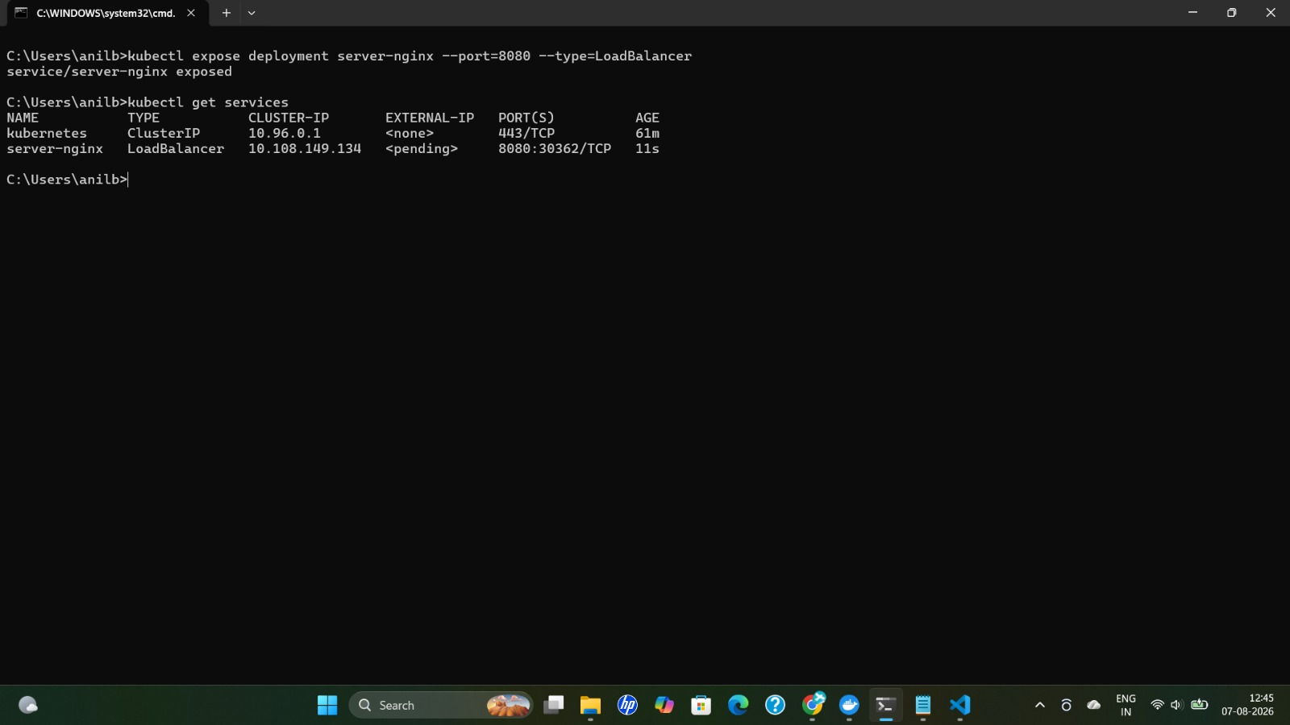
Figure 7: server-nginx service exposed on port 8080 as type LoadBalancer.
Tell Minikube about the service so it can create a tunnel and open it in the browser:
kubectl delete services server-nginx
kubectl expose deployment server-nginx --port=80 --type=LoadBalancer
kubectl get services
minikube service server-nginx
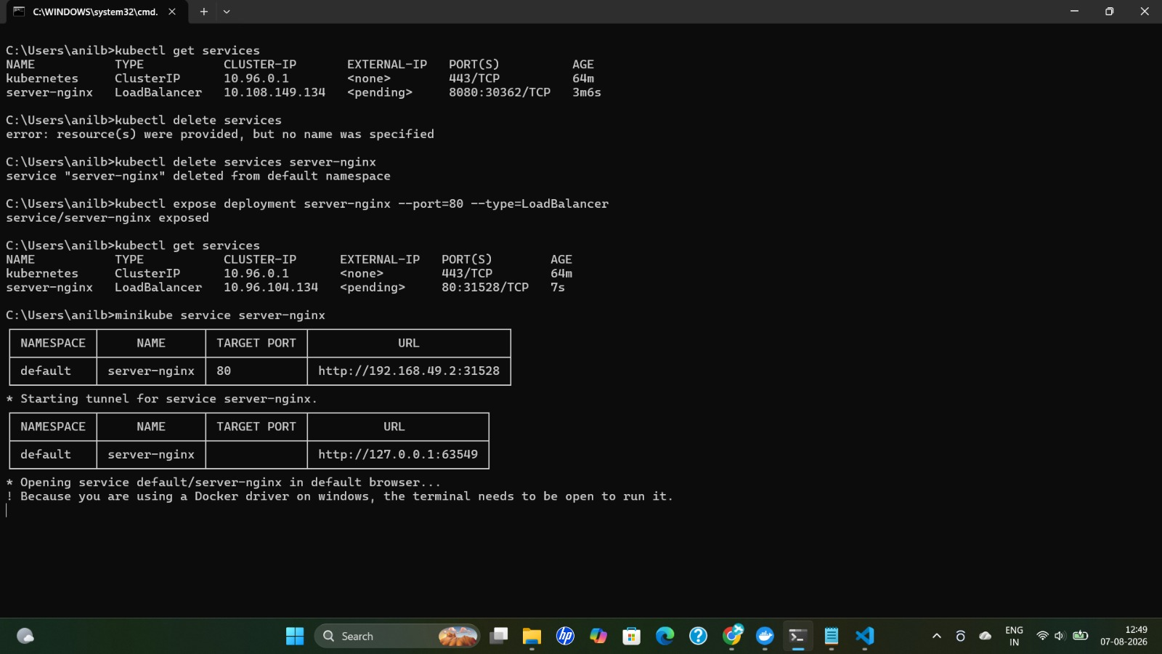
Figure 8: Re-exposing the service on port 80 and using minikube service to start a tunnel. On Windows with the Docker driver, the terminal must stay open for the tunnel to keep running.

11. Build a Custom Docker Image
To deploy your own website, first build and tag a Docker image from your application's Dockerfile:
docker build -t abdocker409/cricket-frontend:01 -f .\docker\frontend.Dockerfile .
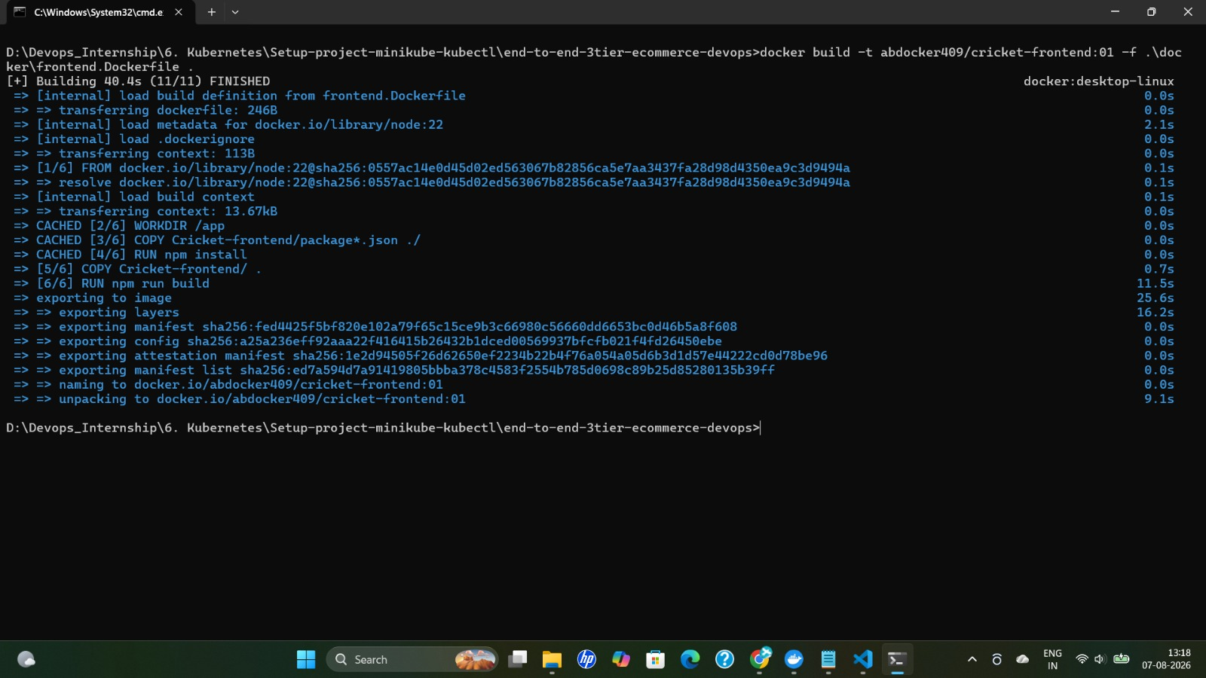
Figure 9: Building the cricket-frontend image from frontend.Dockerfile — image built and named abdocker409/cricket-frontend:01.

12. Deploy Your Own Website
kubectl create deployment user-website --image=abdocker409/cricket-frontend:01
kubectl get deployment
kubectl get pods
kubectl logs <podname>
Expose the app to a web browser:
kubectl expose deployment user-website --port=5173 --type=LoadBalancer
kubectl get services
minikube service user-website
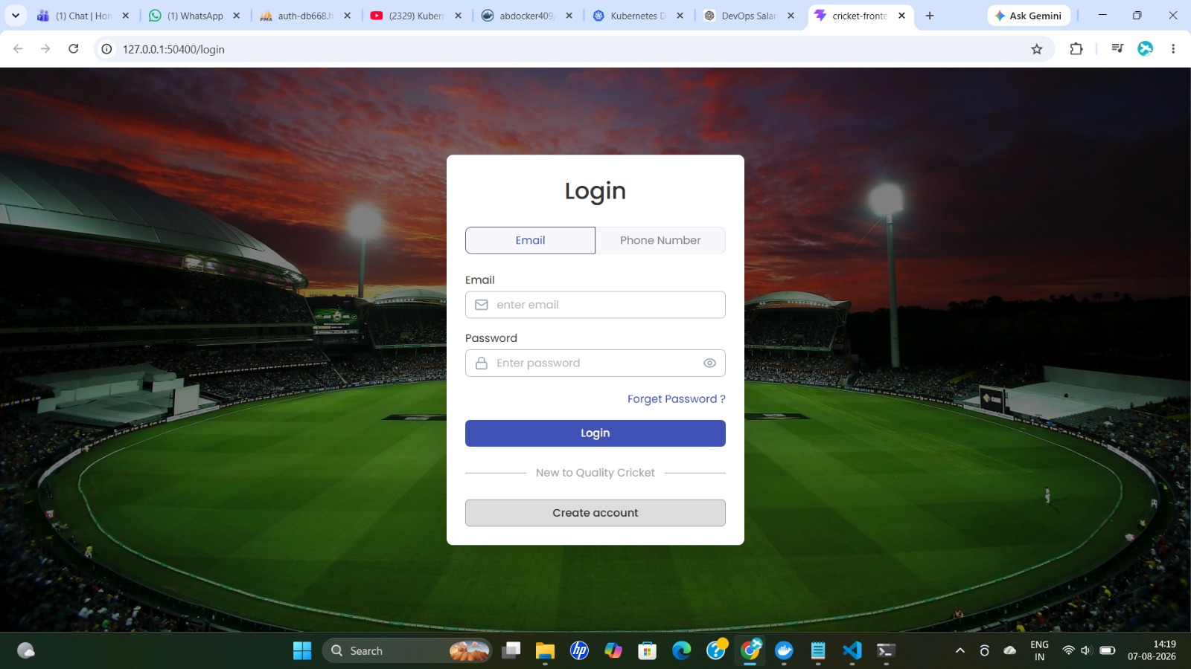
Figure 10: The custom cricket-frontend application login page running locally, served through the minikube service tunnel.
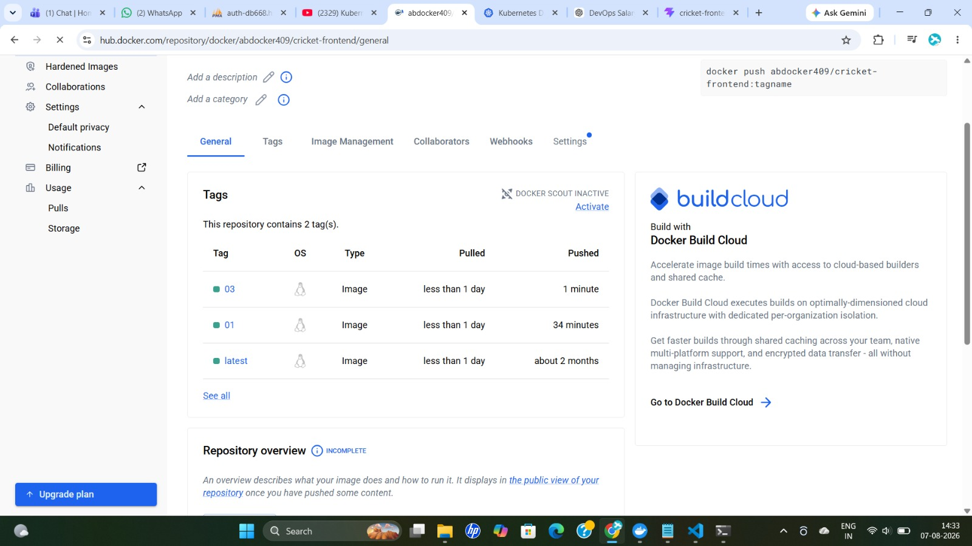
Figure 11: Docker Hub repository abdocker409/cricket-frontend showing pushed image tags (01, 03, latest).

13. Updating the App and Zero-Downtime Scaling

13.1 Push an Updated Image
After making code changes, rebuild the Docker image and push the new version to Docker Hub.
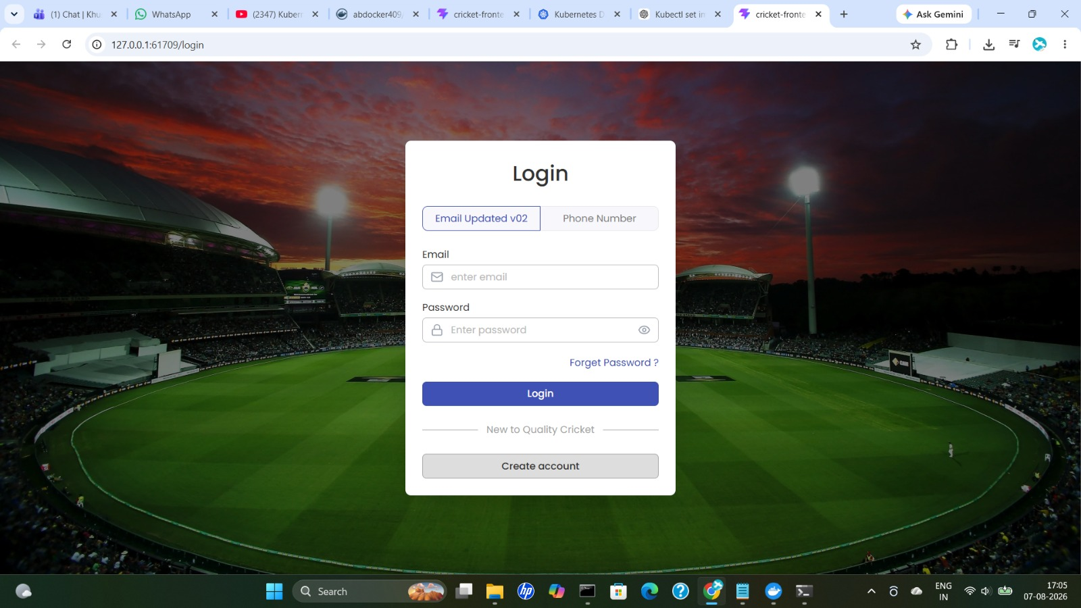
Figure 12: Updated login page ("Email Updated v02") confirming the new application version is live after redeployment.

13.2 Roll Out the New Image to the Pod
Check the current pod, then update the deployment's image in place:
kubectl get pods
kubectl describe pod user-website-87b458668-mcw9f
kubectl set image deployment user-website cricket-frontend=abdocker409/cricket-frontend:03

13.3 Case 1 — Invalid Image Tag (ImagePullBackOff)
If an invalid/non-existent version tag is used, the new pod will fail with ErrImagePull, then ImagePullBackOff:
kubectl set image deployment user-website cricket-frontend=abdocker409/cricket-frontend:08
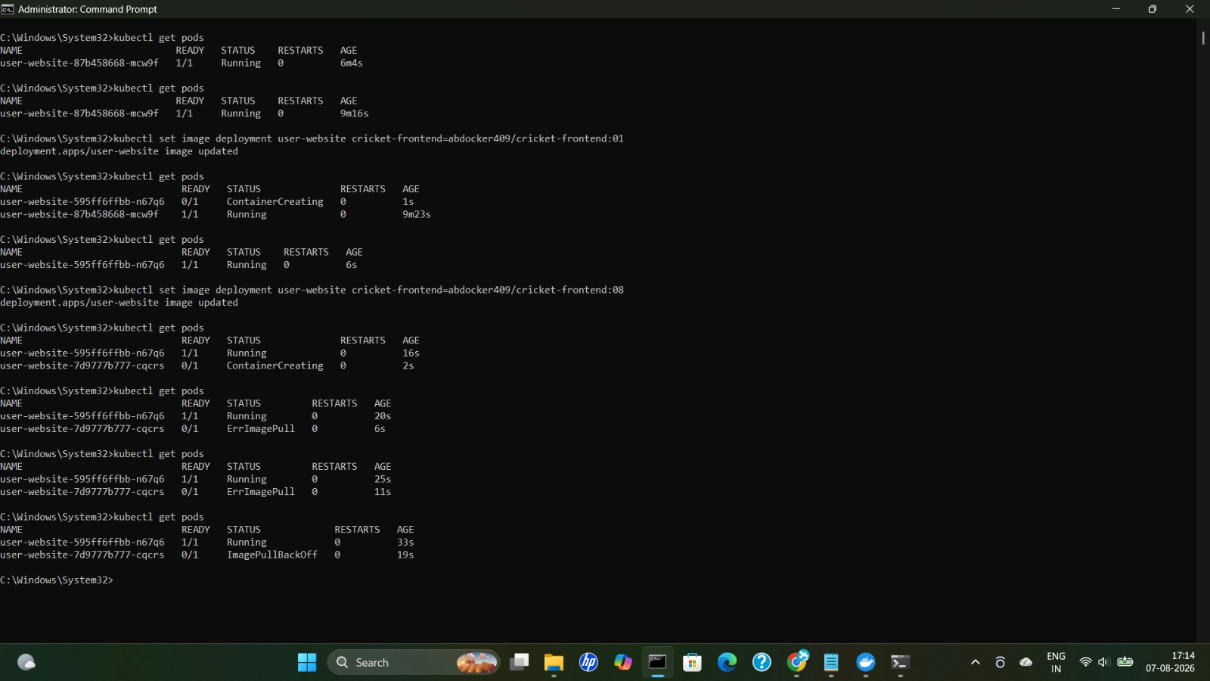
Figure 13: Rolling image updates via kubectl set image. The final update to tag :08 fails, with the new pod showing ErrImagePull and then ImagePullBackOff, while the previous pod keeps running.
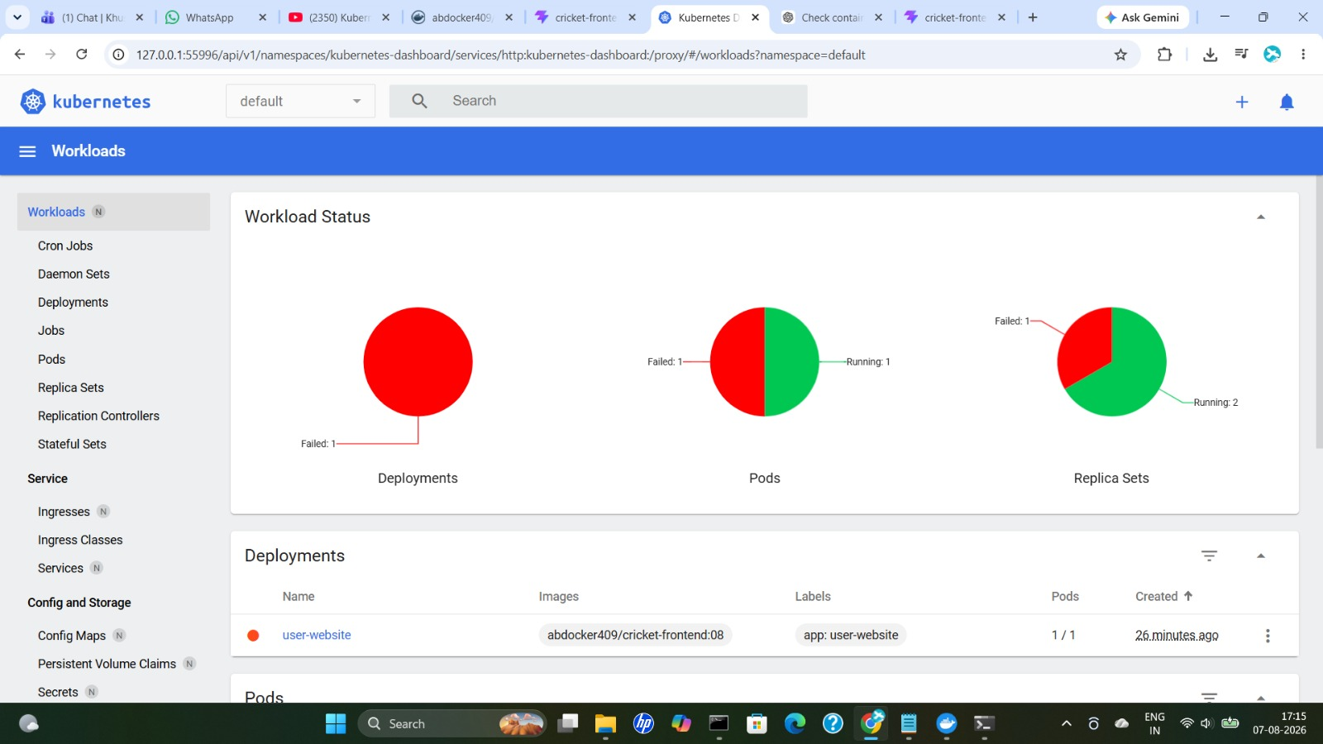
Figure 14: Kubernetes Dashboard reflecting the failed rollout — the user-website deployment and replica set show Failed status while one pod is still Running.
If the update gets stuck, roll back (undo) to the previous working revision:
kubectl rollout status deployment user-website
kubectl rollout undo deployment user-website

13.4 Case 2 — App Crashes Due to a Code Issue
If the website is running in the pod but the application itself stops (for example, due to a code issue), Kubernetes detects the failure and creates a new pod automatically. This can be demonstrated with a small Node app that stops itself when a specific route is hit:
docker push abdocker409/learnbreackapp:01
http://localhost:3000/ -> Your React app is running!
http://localhost:3000/exit -> Server stopped
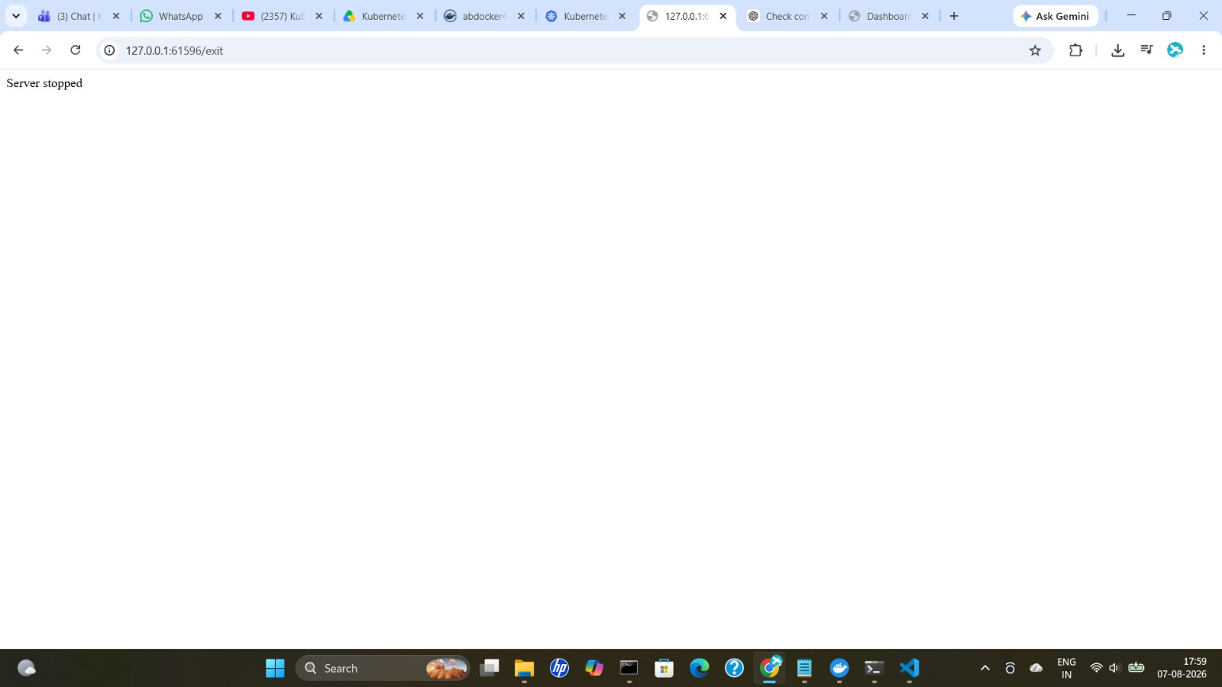
Figure 15: Hitting the /exit route stops the application server ("Server stopped"), simulating a crash.

13.5 Scaling the App Up and Down
Scale the deployment's replica count to distribute load and improve availability:
kubectl scale deployment demo-express --replicas=4
kubectl get pods
NAME READY STATUS RESTARTS AGE
demo-express-6ffb567947-77fjv 1/1 Running 2 (2m8s ago) 3m35s
demo-express-6ffb567947-tlbz9 1/1 Running 1 (2m9s ago) 3m35s
demo-express-6ffb567947-vx7pr 1/1 Running 3 (2m1s ago) 16m
demo-express-6ffb567947-wf7c4 1/1 Running 0 3m35s
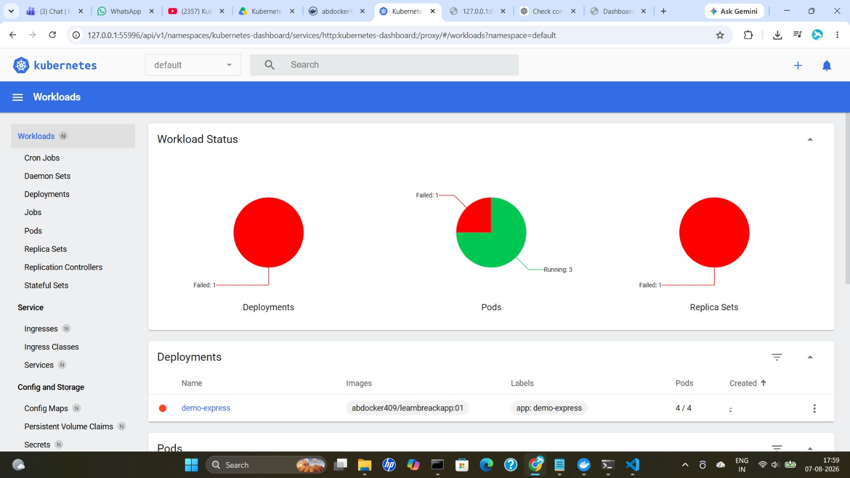
Figure 16: demo-express scaled to 4 replicas. Kubernetes automatically restarts crashed pods to keep the desired replica count — the dashboard shows one failed replica set while 3 pods stay running.
Note: All the above resources were also created via YAML manifests (deployments and services), as an alternative to the imperative kubectl commands shown here.

