Docker Desktop Setup & Usage Walkthrough
A step-by-step summary of installing Docker Desktop, verifying it via CLI, running containers, and building/pushing a custom image.

1. Docker Desktop Website
Docker Desktop homepage showing the download and pricing options.
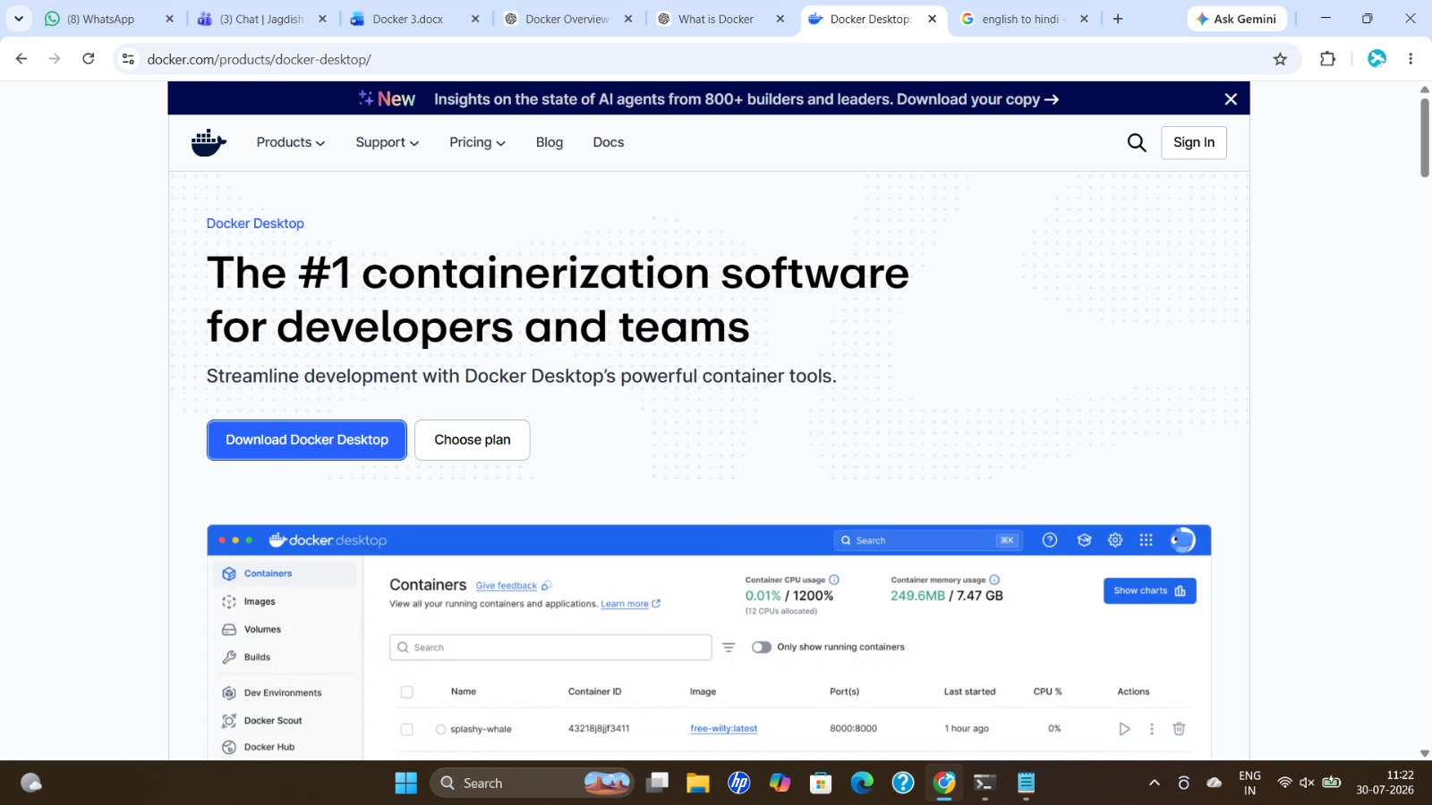

2. Choosing Download Option
Download menu showing OS-specific installers; Windows AMD64 selected.
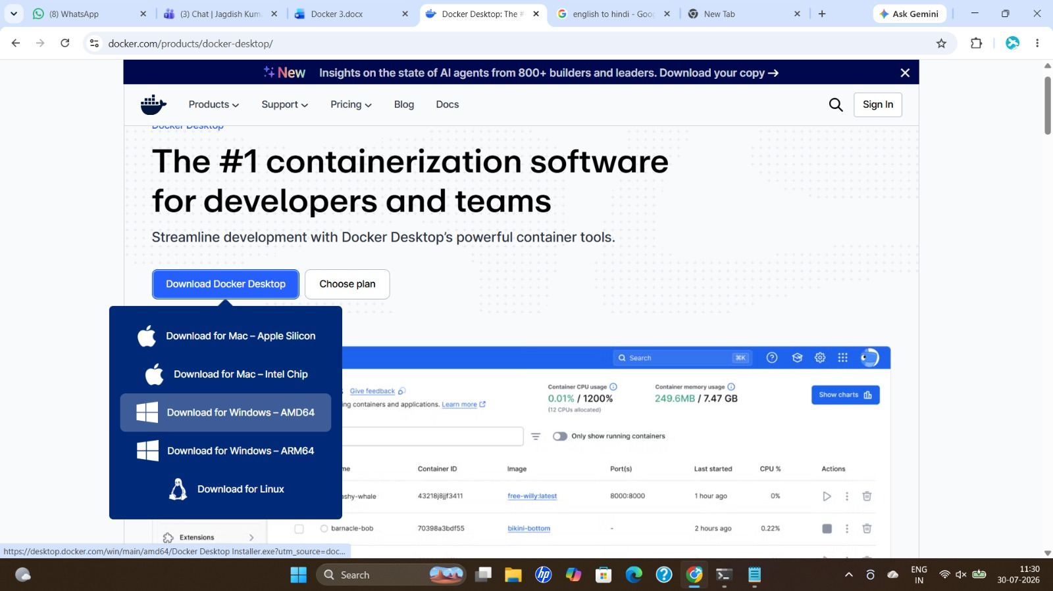

3. Checking WSL Status
Terminal used to verify WSL installation and default distribution (Ubuntu) before installing Docker.
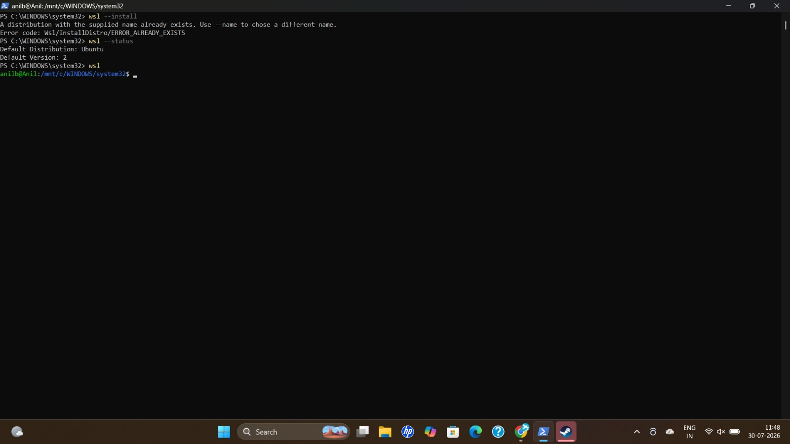

4. Docker Desktop Installer - Configuration
Installer configuration screen; per-user installation selected with desktop shortcut option.
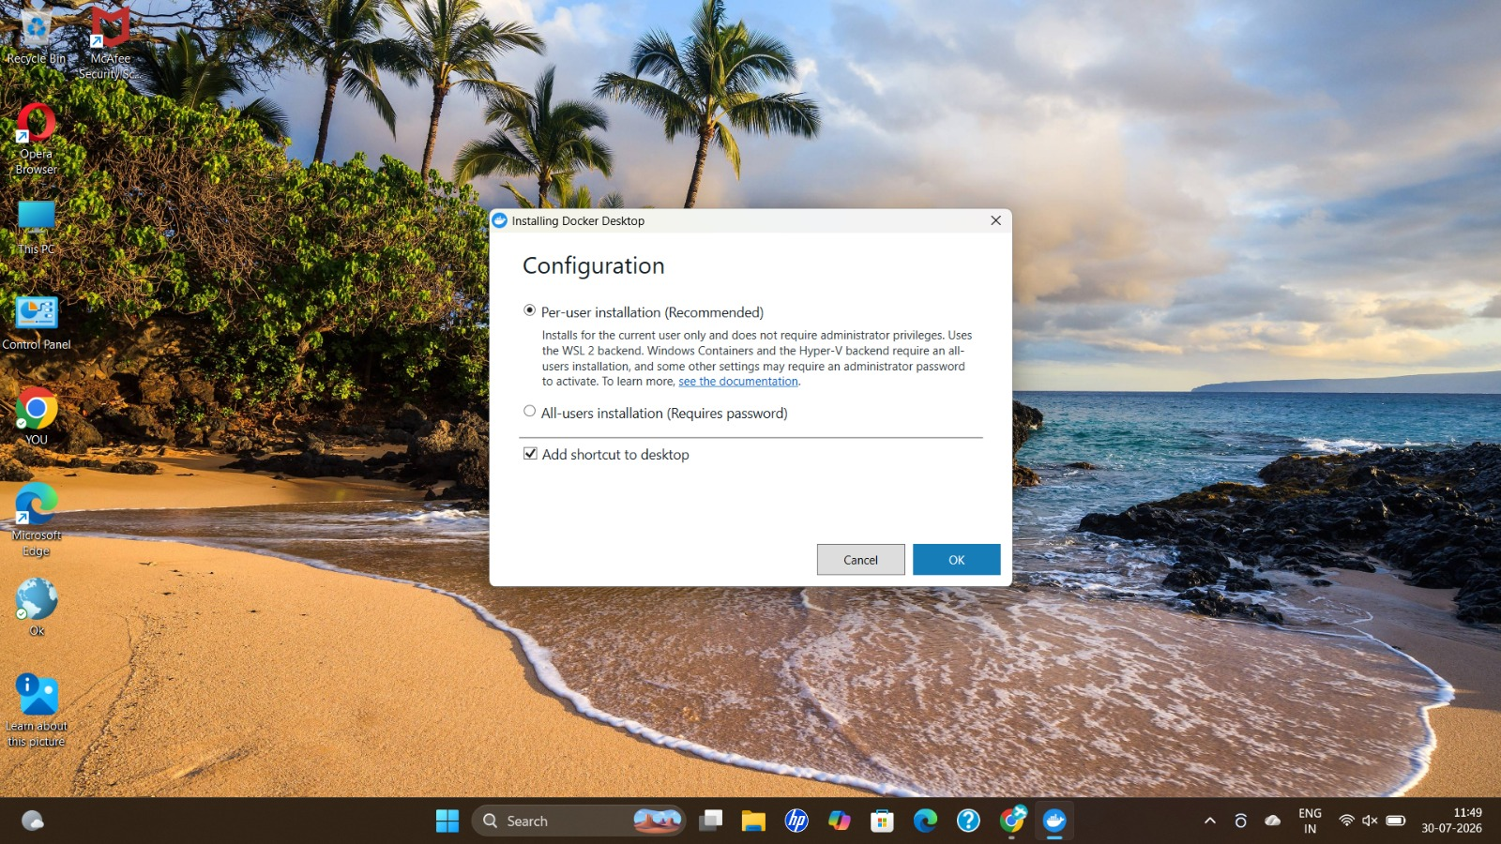

5. Installing Docker Desktop
Installer unpacking files during Docker Desktop 4.84.0 installation.
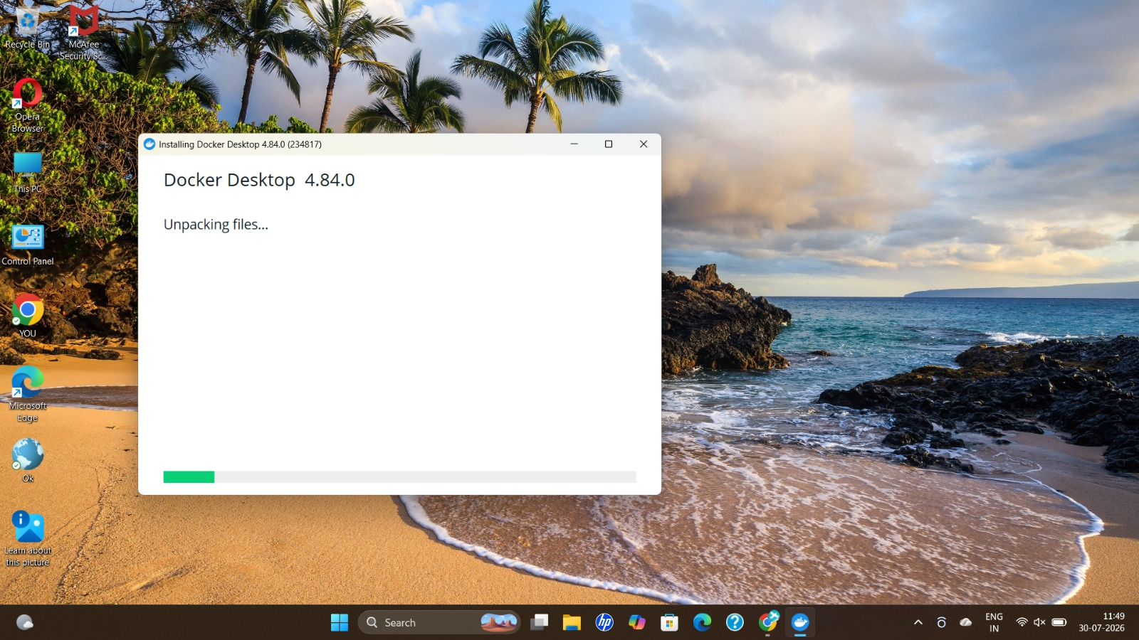

6. Subscription Service Agreement
Docker Subscription Service Agreement prompt shown after installation, accepted to proceed.
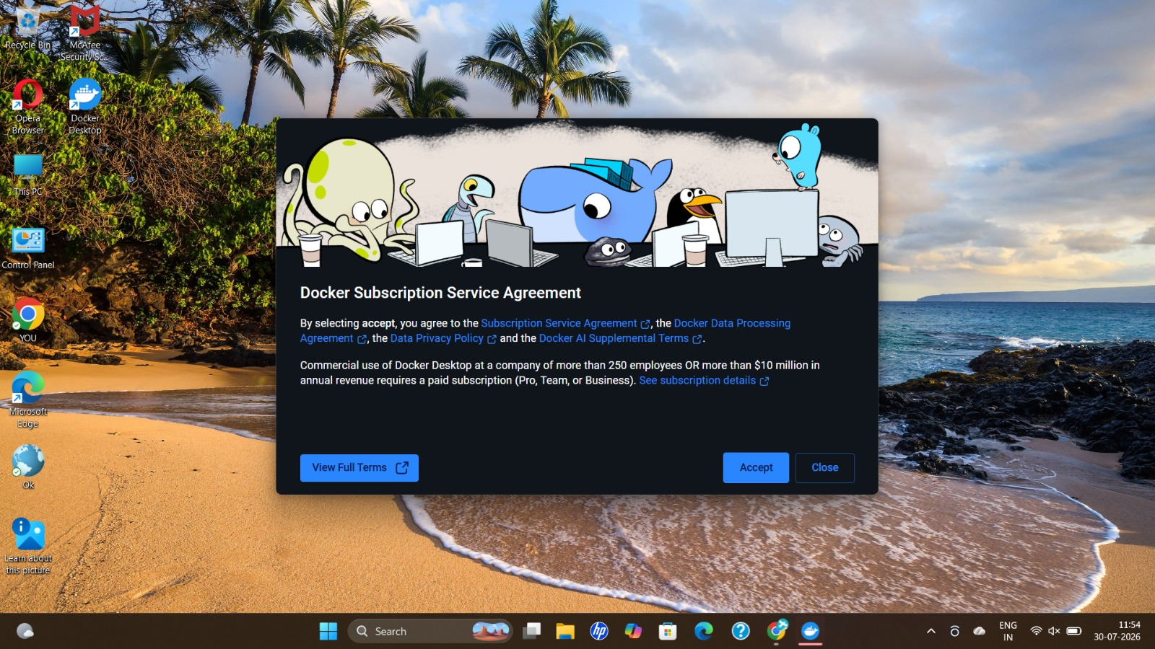

7. Docker Desktop Dashboard
Docker Desktop Containers view after first launch, with no containers running yet.
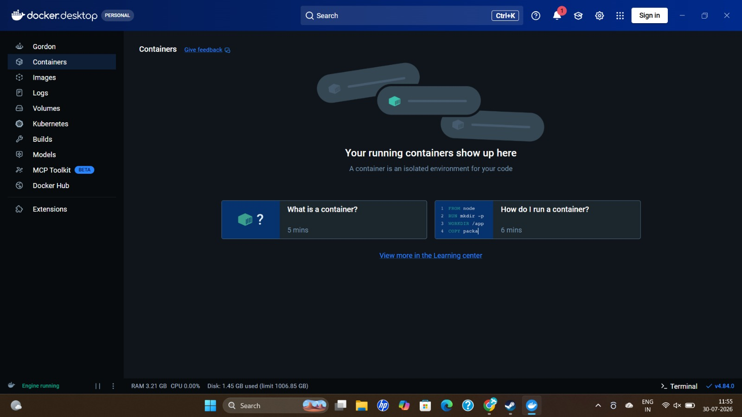

8. Verifying Docker via CLI
Command Prompt used to run docker ps, docker images, and docker info to confirm Docker CLI and engine details.
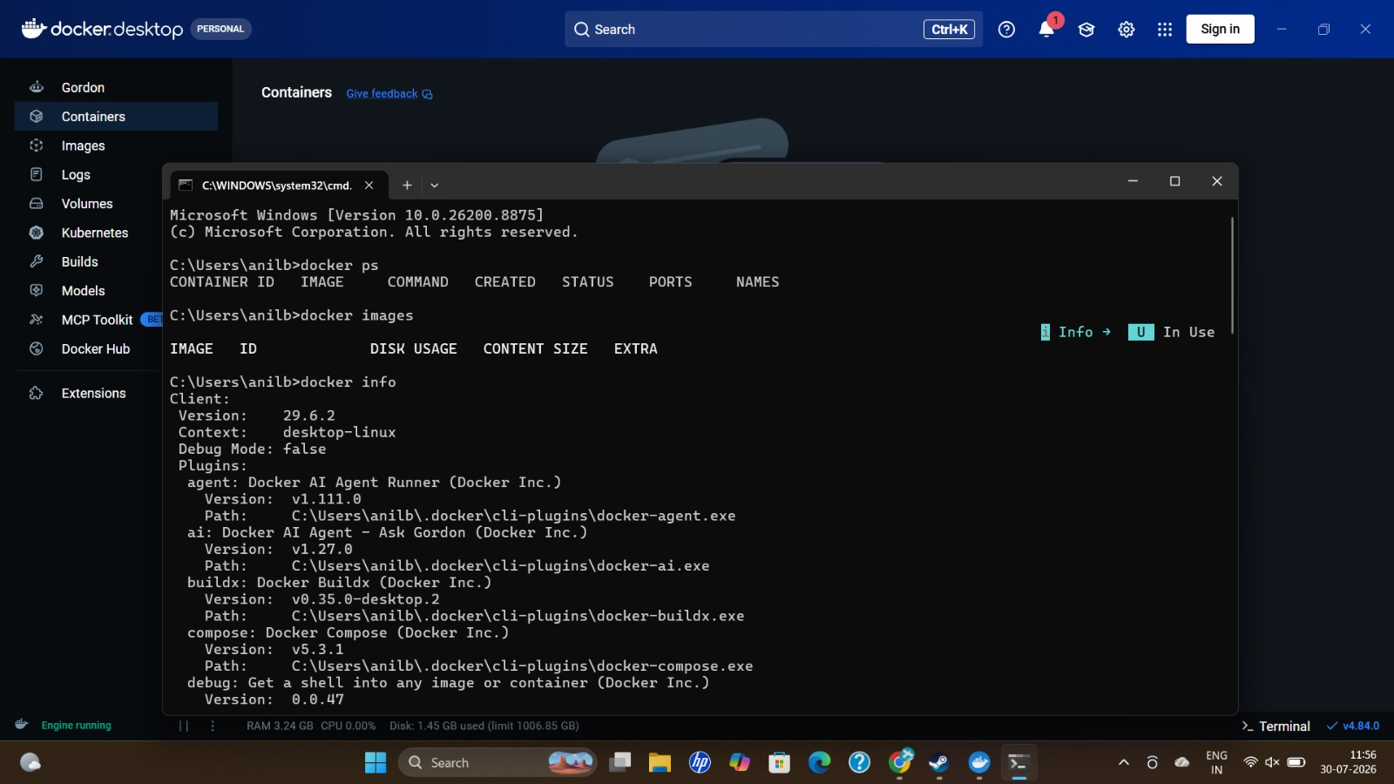

9. Docker Engine Starting
Docker Desktop loading screen while the Docker Engine starts.
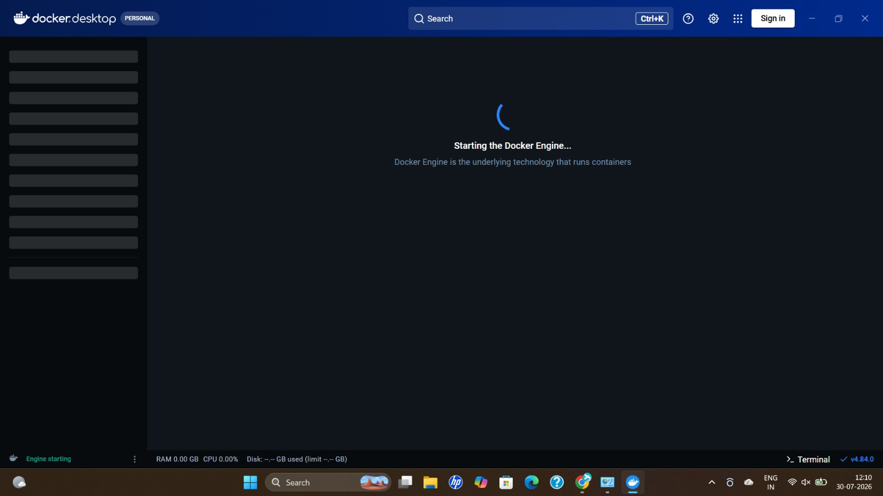

10. Selecting Browser for Sign-in Link
Prompt to choose a browser to open the Docker sign-in link, Google Chrome selected.
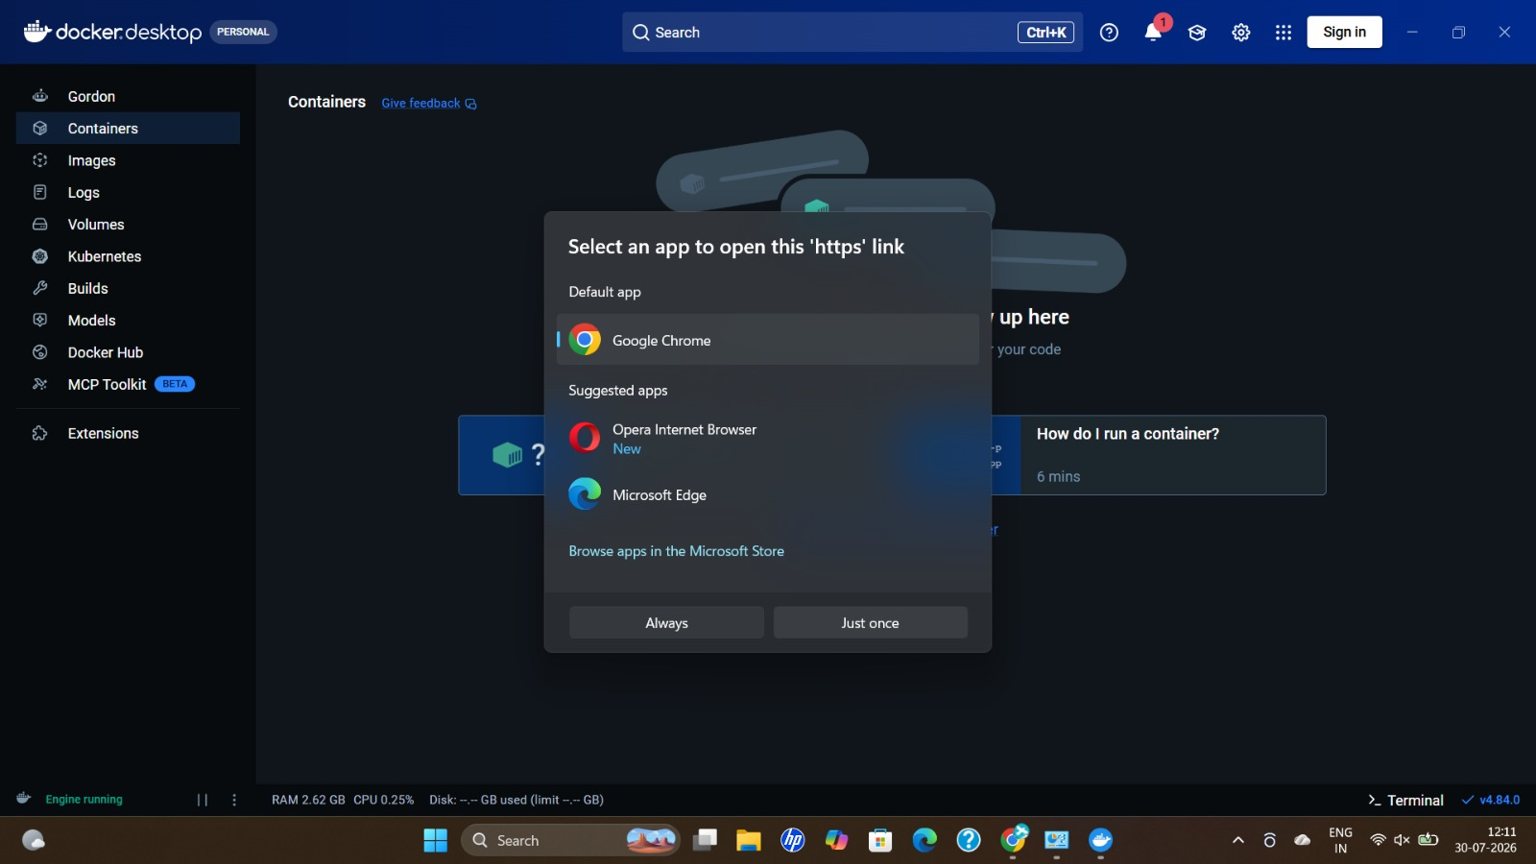

11. Docker Sign-in Redirect
Browser confirming successful sign-in and redirecting back to the Docker Desktop app.
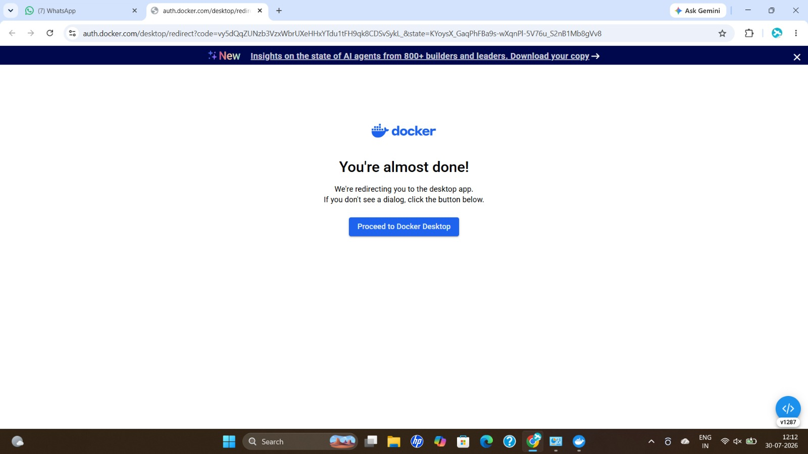

12. Docker Hub Repositories
Docker Desktop 'My Hub' tab listing the user's pushed repositories (cricket-api, cricket-admin, cricket-frontend, nodeapp, etc.).
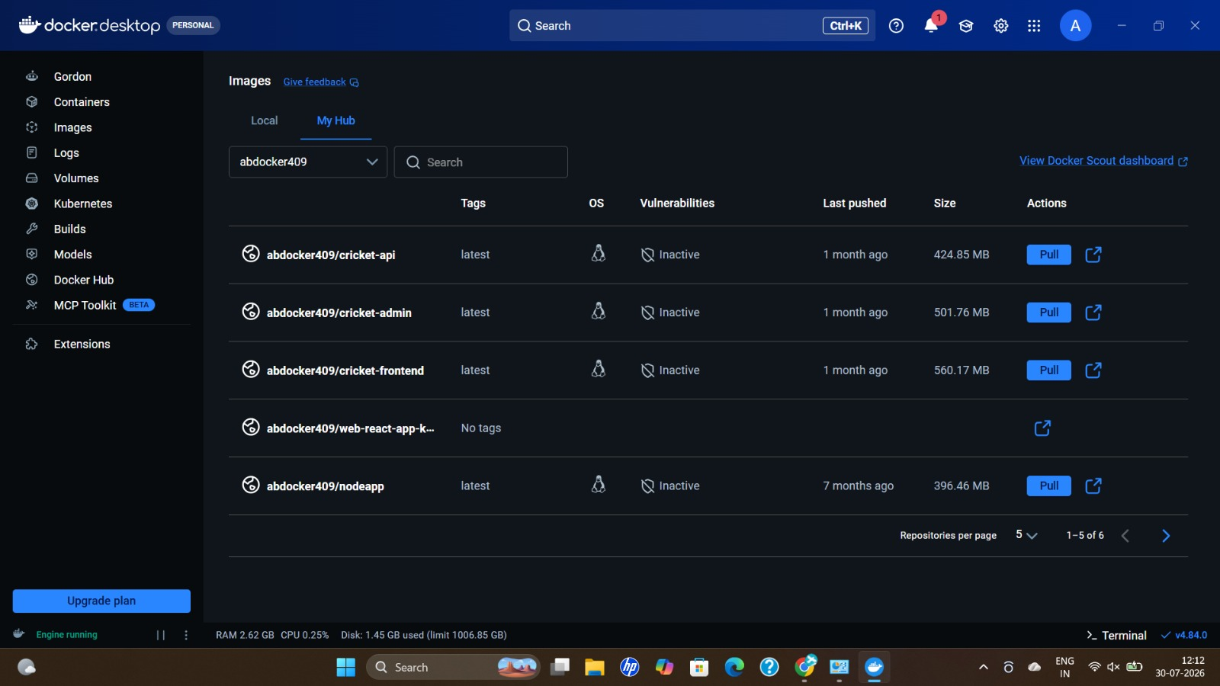

13. Windows Firewall Prompt
Windows Security prompt asking to allow Docker Desktop Backend network access after running a container.
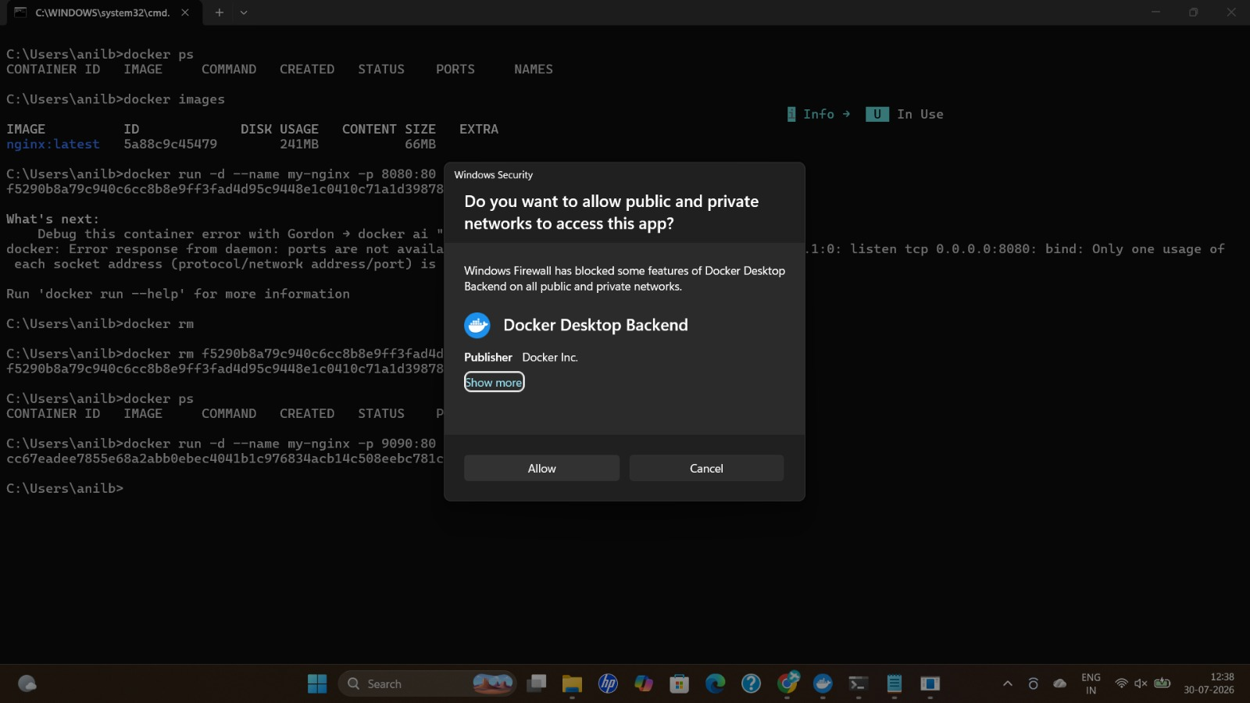

14. Running an Nginx Container
CLI session showing docker run commands for an nginx container, including a port-conflict retry on port 9090.
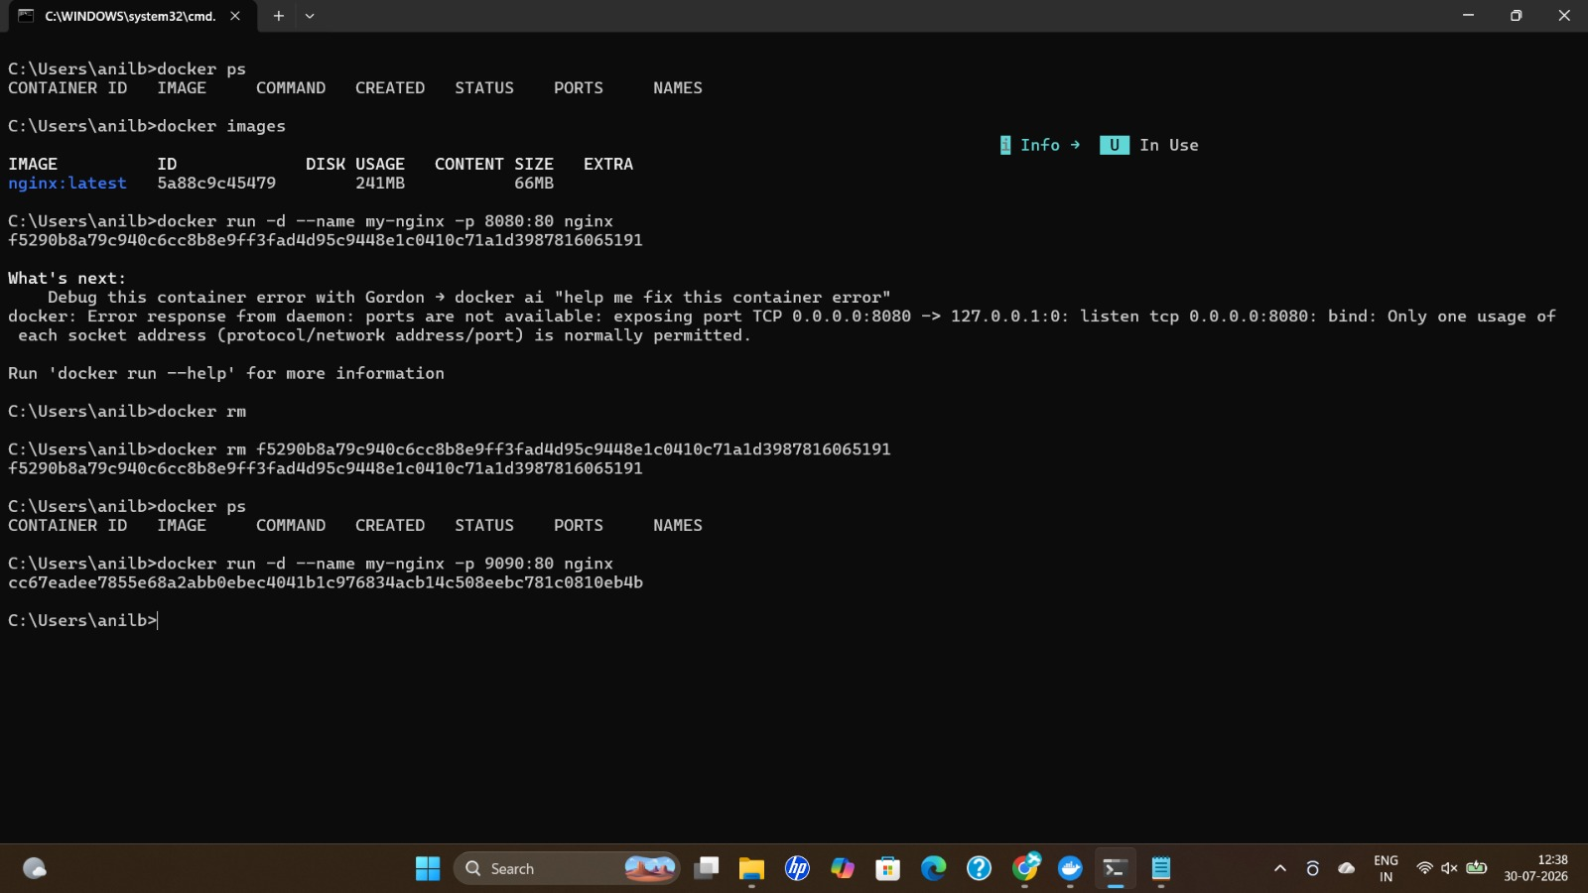

15. Default Nginx Page
Browser confirming the nginx container is running by loading the default welcome page at localhost:9090.
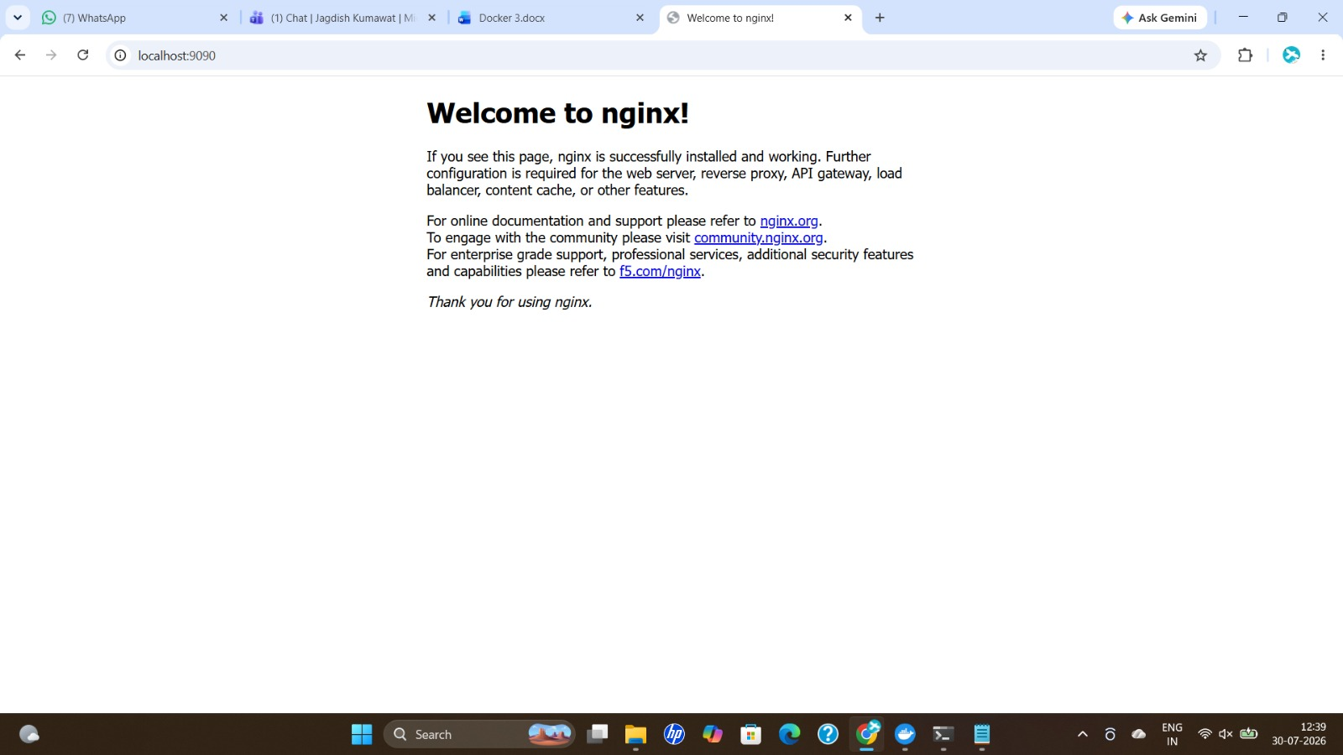

16. Copying Website Files into Container
docker cp command used to copy a custom website's files into the running nginx container's HTML directory.
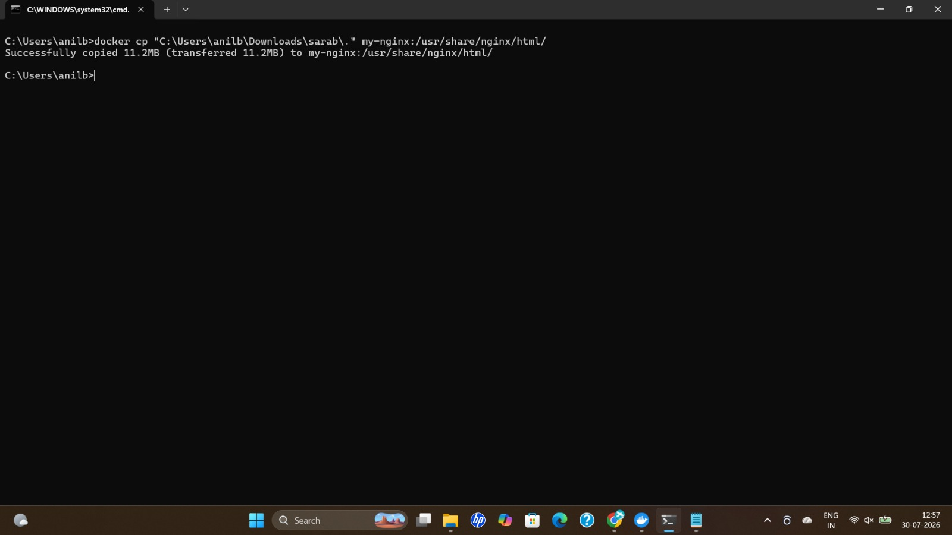

17. Custom Website Served via Nginx
Custom 'Sarab Fast Food & Restaurant' website loading successfully from the nginx container at localhost:9090.
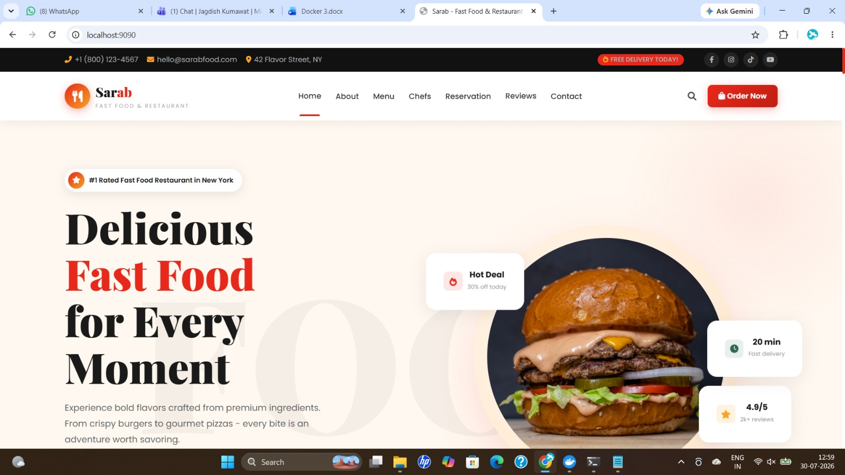

18. Building and Pushing a Custom Image
VS Code terminal showing the Dockerfile, and docker build, tag, and push commands publishing the image to Docker Hub.
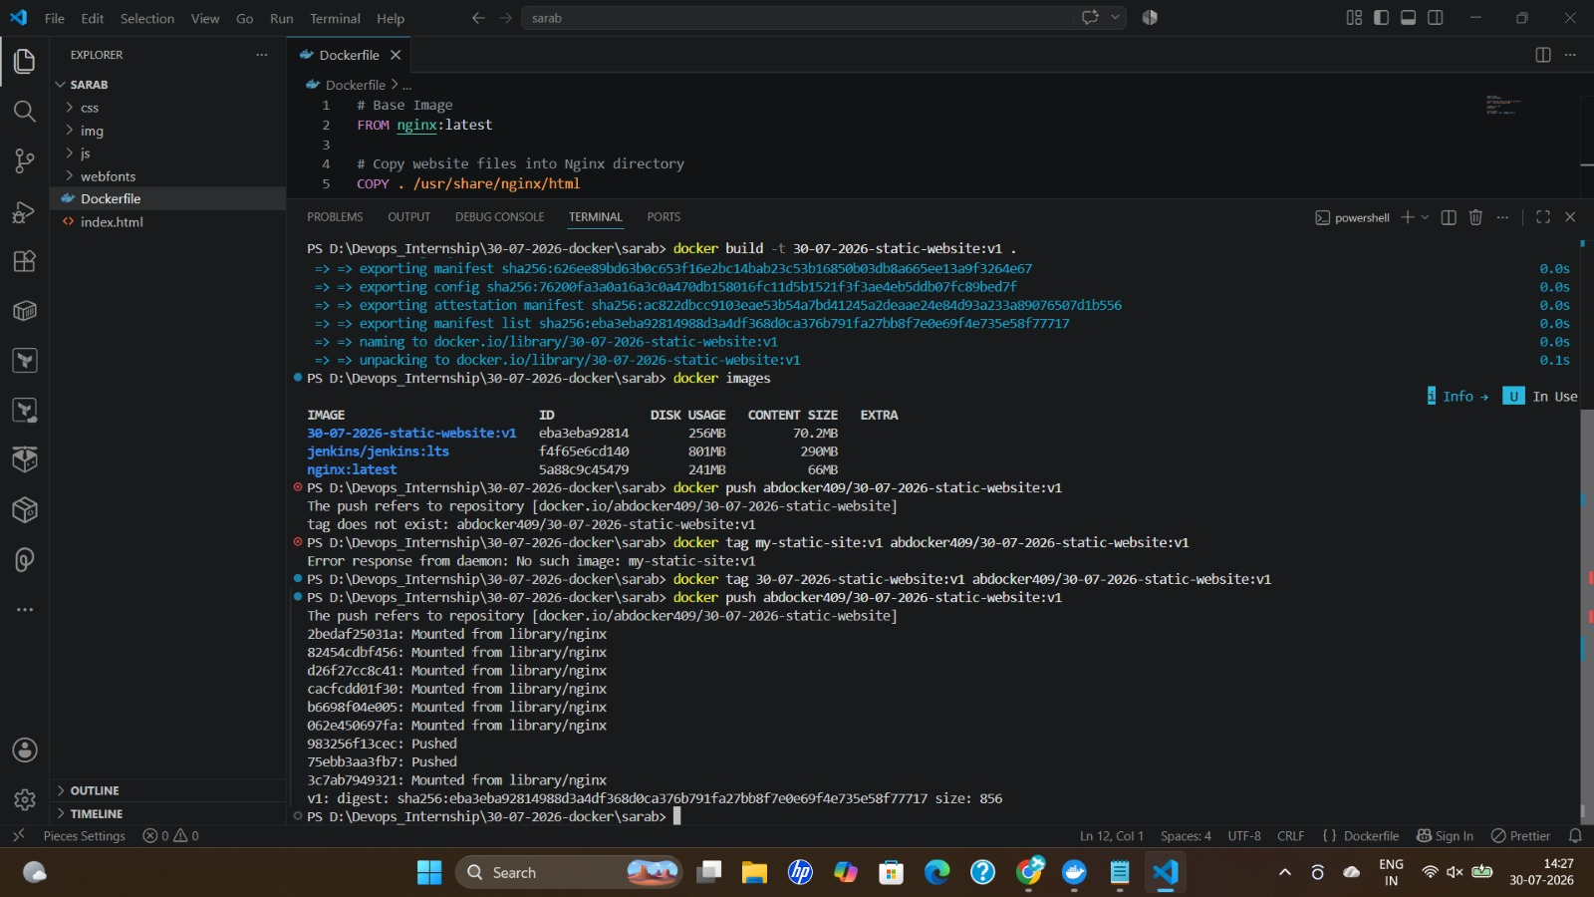

19. Pulling the Pushed Image
docker pull command confirming the custom image can be successfully pulled back from Docker Hub.
