Create the view in react

* + Navigation bar with drop down for Revenue Type on right and a greeting for user on the left.
  + Create required line chart, with ACV on y axis, Posting period on X axis and filter for Revenue Type.
    - Drop down menu Options is to load either one of the Revenue type or load all.
    - Bonus: Let user select any number of Revenue Type (not just 1 or All)
  + Create a table below the chart which shows row level data and filter using the drop-down menu.
  + Table data is at row level and will be plugged directly.
  + Meta data, if required, can be generated by taking unique of any of the columns.
  + Any open source chart available and feasible like D3, High can be used

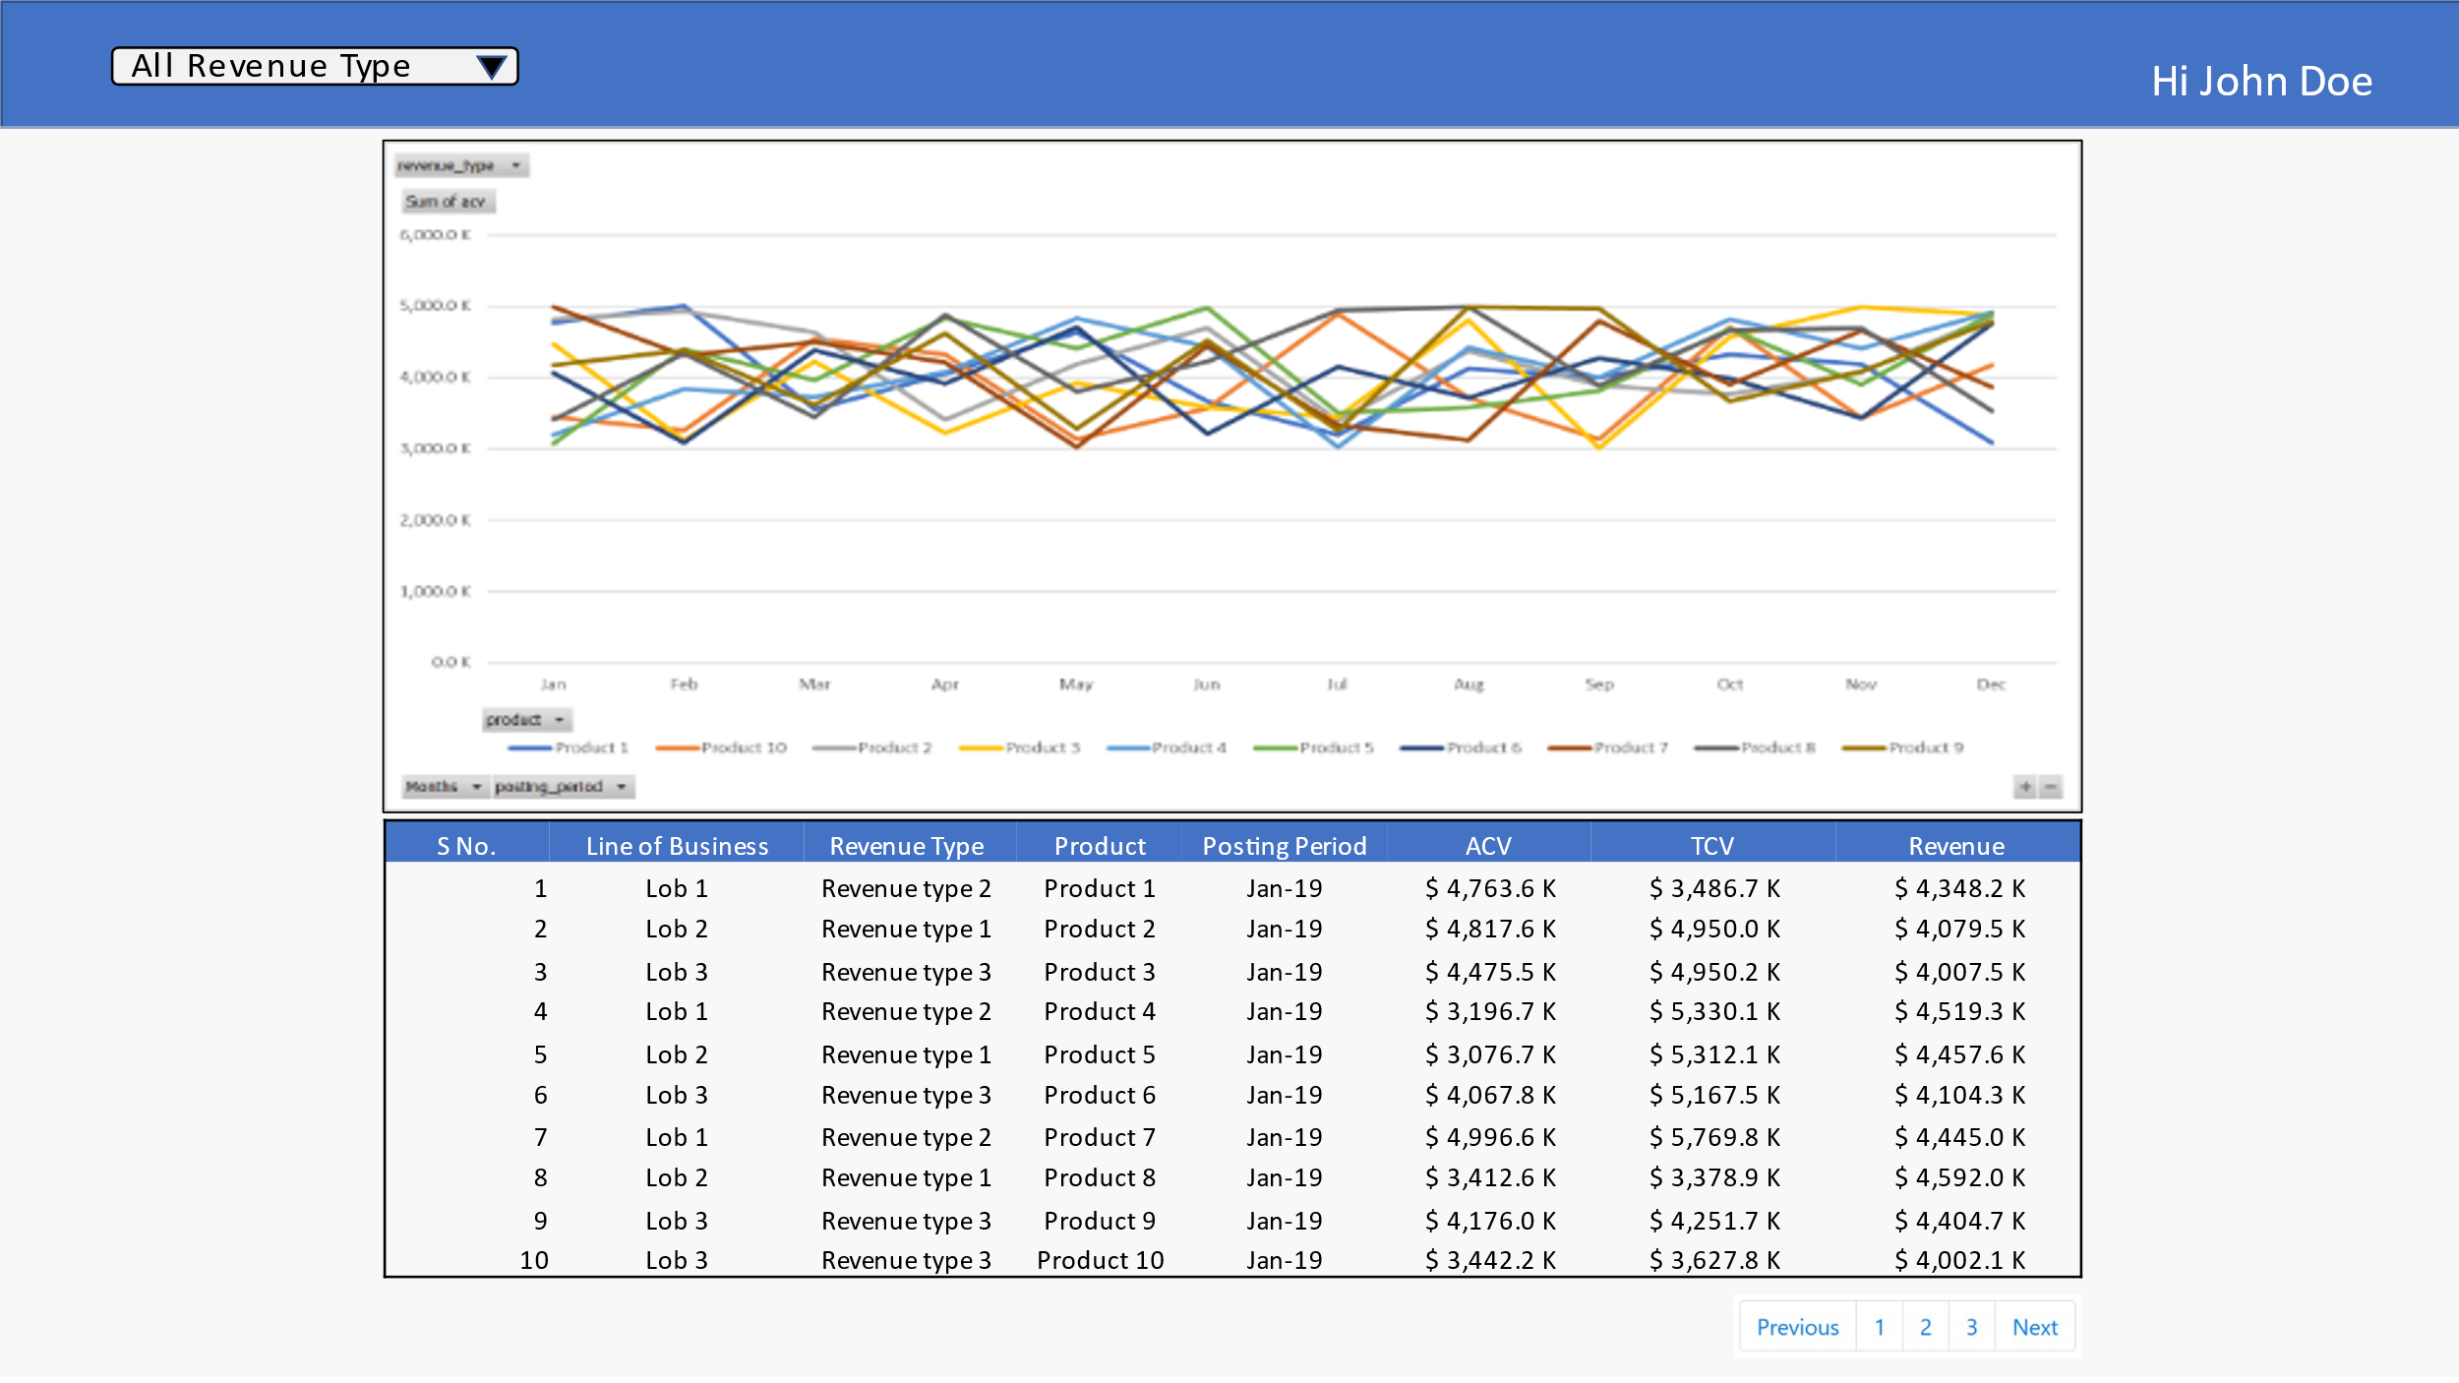

Data Dictionary, Entire data set, the calculations done on excel are in attached Excel File.

API for data: <http://fetest.pangeatech.net/data> . Data retrieval from API is preferred. If that’s not successful , data set from excel can be used.