Problem Definition:

The issue definition for Bitcoin data warehousing, processing, and analysis entails constructing a centralized repository of Bitcoin data, cleaning and transforming the data, and doing data analysis to acquire insights into the Bitcoin market. The project's goal is to enhance decision making, optimize trading techniques, and anticipate future Bitcoin market patterns.

The first step is to get Bitcoin data from the source using an API or scraping tools and store it in a cloud-based data warehouse. After that, the data is cleaned and transformed by eliminating duplicate or incomplete data and normalizing it.

To detect trends and patterns in the Bitcoin market, data is analyzed using tools like as SQL queries, data visualization, and machine learning algorithms. The results and suggestions based on the data analysis are disseminated to stakeholders.

The project's expected outcomes include a centralized repository of Bitcoin data stored in a cloud-based data warehouse, processed and cleaned data ready for analysis, meaningful insights and findings about the Bitcoin market, and recommendations and strategies for investors, traders, and financial analysts to make informed decisions and capitalize on Bitcoin market opportunities. The initiative intends to enhance decision making, optimize trading tactics, and increase business performance for bitcoin enterprises.

Overall, Bitcoin data warehousing, processing, and analysis may give significant insights into the Bitcoin market and assist players in making informed decisions and improving their performance. The initiative is an important step toward utilizing data analytics in the cryptocurrency business, and it has the potential to contribute to the growth and success of the Bitcoin market.

Data source:

The CoinCap API, notably the endpoint that gives information on assets such as Bitcoin, is the data source utilized in this project.

API Endpoint: https://api.coincap.io/v2/assets

The API provides the following JSON response:

[{"id":"bitcoin","rank":"1","symbol":"BTC","name":"Bitcoin","supply":"19365068.0000000000000000","maxSupply":"21000000.0000000000000000","marketCapUsd":"576658318806.8884455124859020","volumeUsd24Hr":"5757755734.3141308428789773","priceUsd":"29778.2749230154237265","changePercent24Hr":"1.6933981721868917","vwap24Hr":"29306.6951015163024700","explorer":"https://blockchain.info/"}]

This answer includes information on the asset "Bitcoin," such as its ID, rank, symbol, name, supply, maximum supply, market capitalization, 24-hour trading volume, price in US dollars, 24-hour change %, volume weighted average price, and a blockchain explorer URL.

This information may be utilized to acquire insights into the Bitcoin market, such as recognizing trade patterns and following price changes. By accumulating this information over time, it is feasible to assess previous trends and forecast future market behavior.

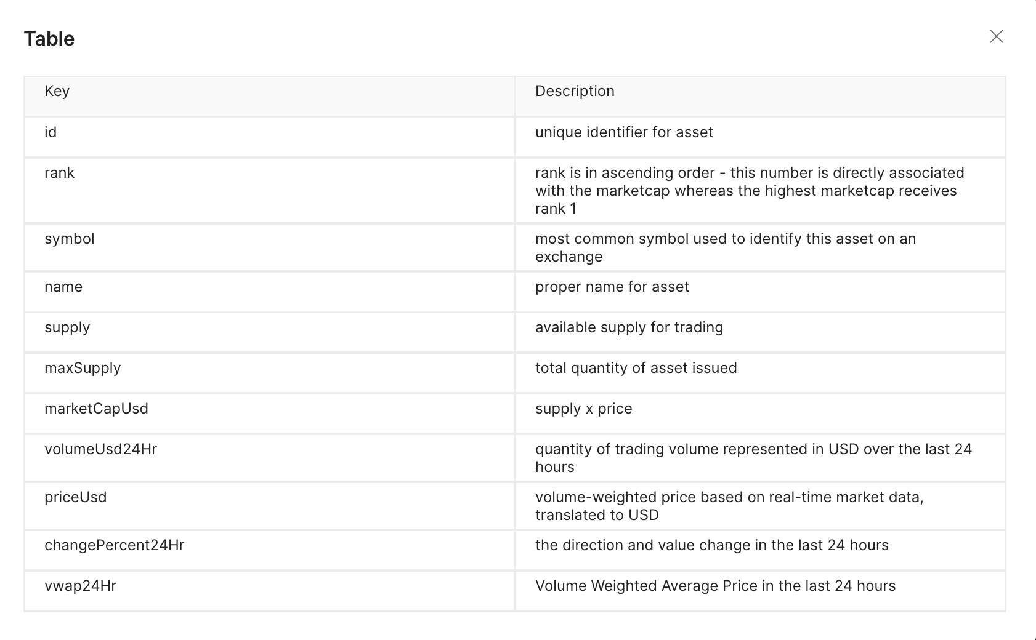

Projects Steps:

- Create a VM.

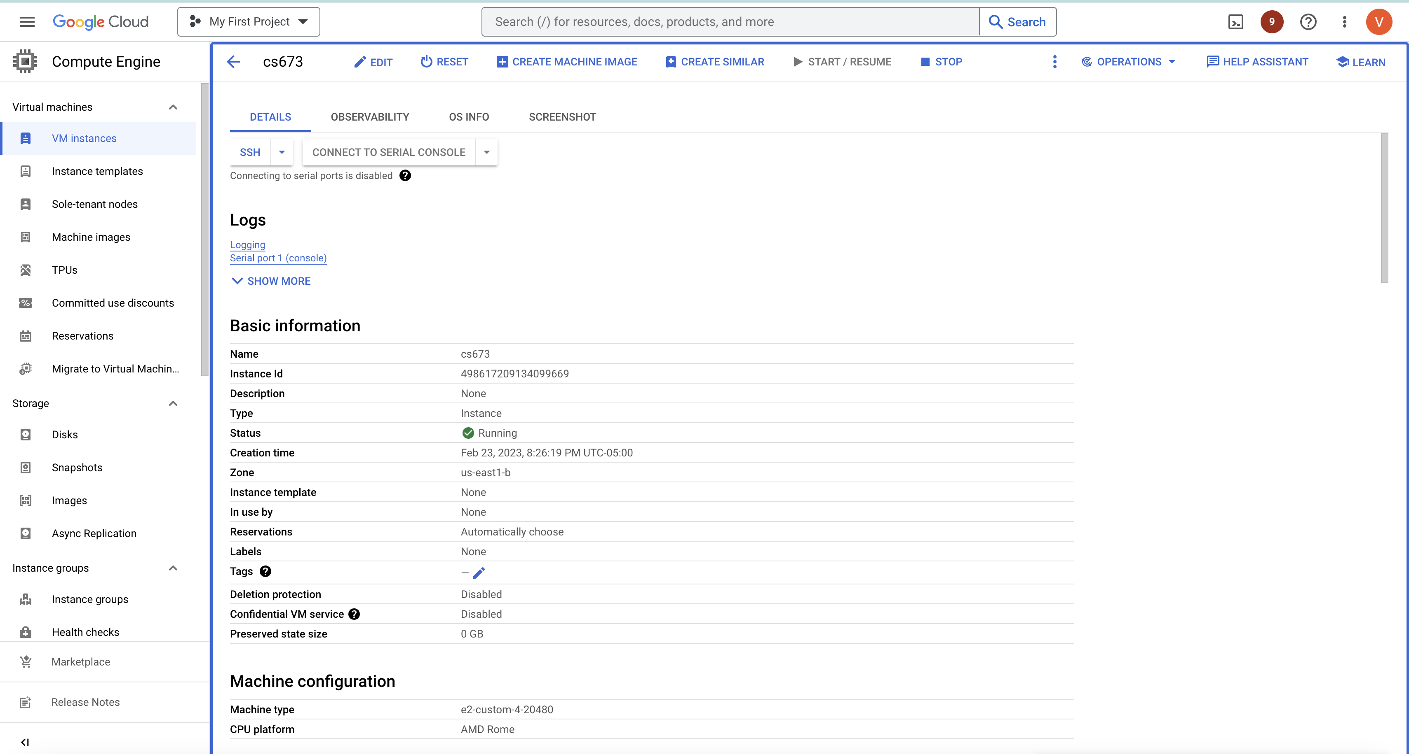
We will use VM to host docker, mongoDB, MINIO.

- Create a google cloud function:

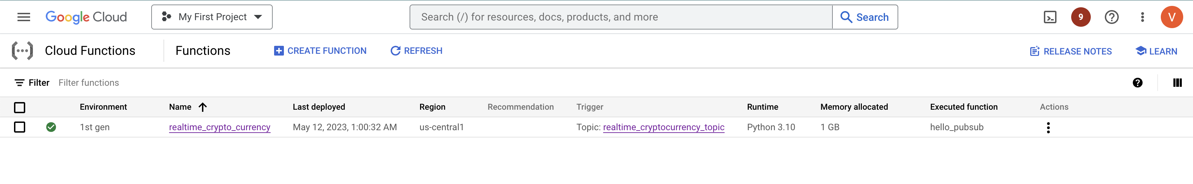
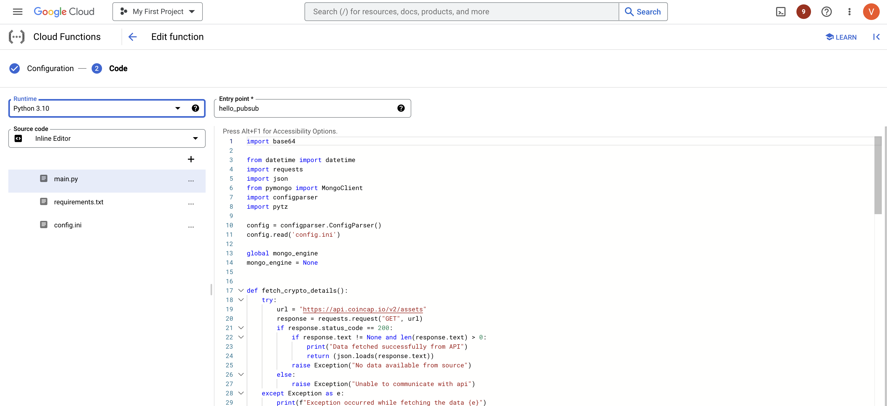

Cloud function used to host a virtual environment to run python script to fetch data from API and dump into MongoDB.

- Cloud Scheduler.

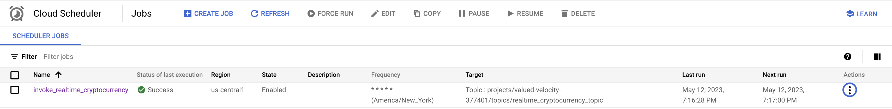

We are using cloud scheduler to trigger cloud function for every second
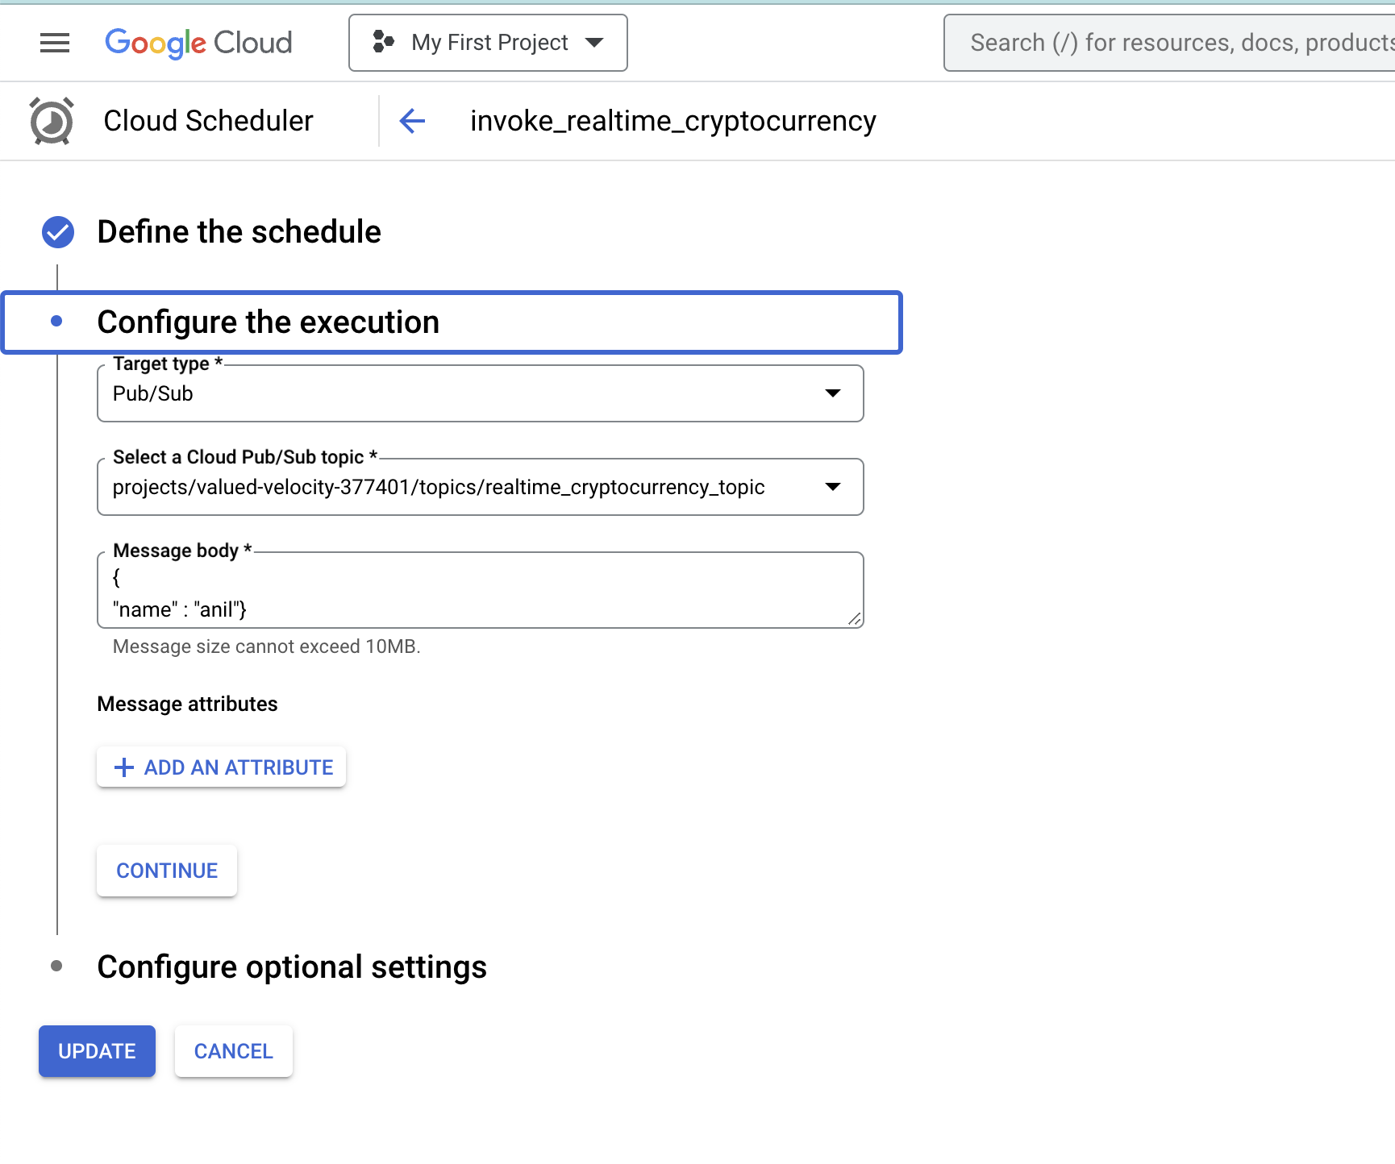
- Start docker and invoke mongo instance:

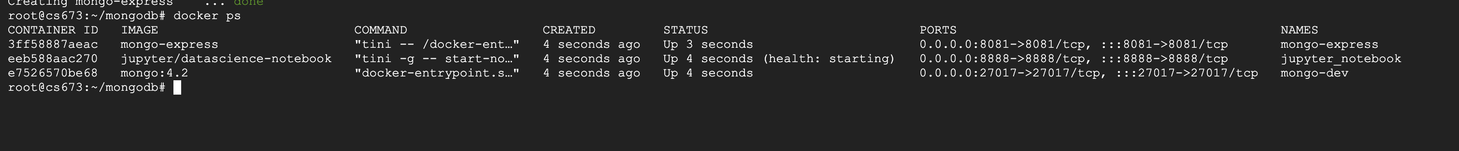

- Invoke SQL instance:

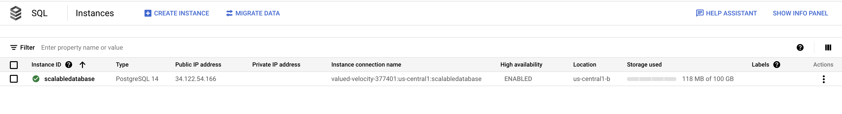

- Schedule python jobs:

We have three python jobs scheduled for various purposes.

- To take the raw data from mongodb and dump into Postgres SQL

- To send reports and upload data into Cloud

- EDA and ML scripts

Data base:

Table to store current rates.

CREATE TABLE public.crypto_currency_rates (
id text NULL,
"rank" text NULL,
market_cap_usd text NULL,
volume_usd text NULL,
price_usd text NULL,
change_percent text NULL,
last_updated timestamptz NULL
);
Table to store dump data.
CREATE TABLE public.crypto_currency_rates_dump (
event_id text NULL,
id text NULL,
"rank" text NULL,
supply text NULL,
maximum_supply text NULL,
market_cap_usd text NULL,
volume_usd text NULL,
price_usd text NULL,
change_percent text NULL,
event_occurred_at timestamp NULL,
inserted_at timestamptz NULL
);
Table to store master data:
CREATE TABLE public.cryptocurreny_master (
id text NULL,
symbol text NULL,
"name" text NULL,
explorer text NULL);
Table to store Daily stats table:

CREATE TABLE public.crypto_currency_daily_stats (
id text NULL,
min_rank int8 NULL,
max_rank int8 NULL,
current_rank int8 NULL,
starting_rank int8 NULL,
current_price float8 NULL,
starting_price float8 NULL,
min_price float8 NULL,
max_price float8 NULL,
report_date date NULL,
difference float8 NULL,
status text NULL
);

By using above architecture we can fetch the data

Architecture Diagrams:

- Flow -1 to fetch the data from API and dump into Mongo

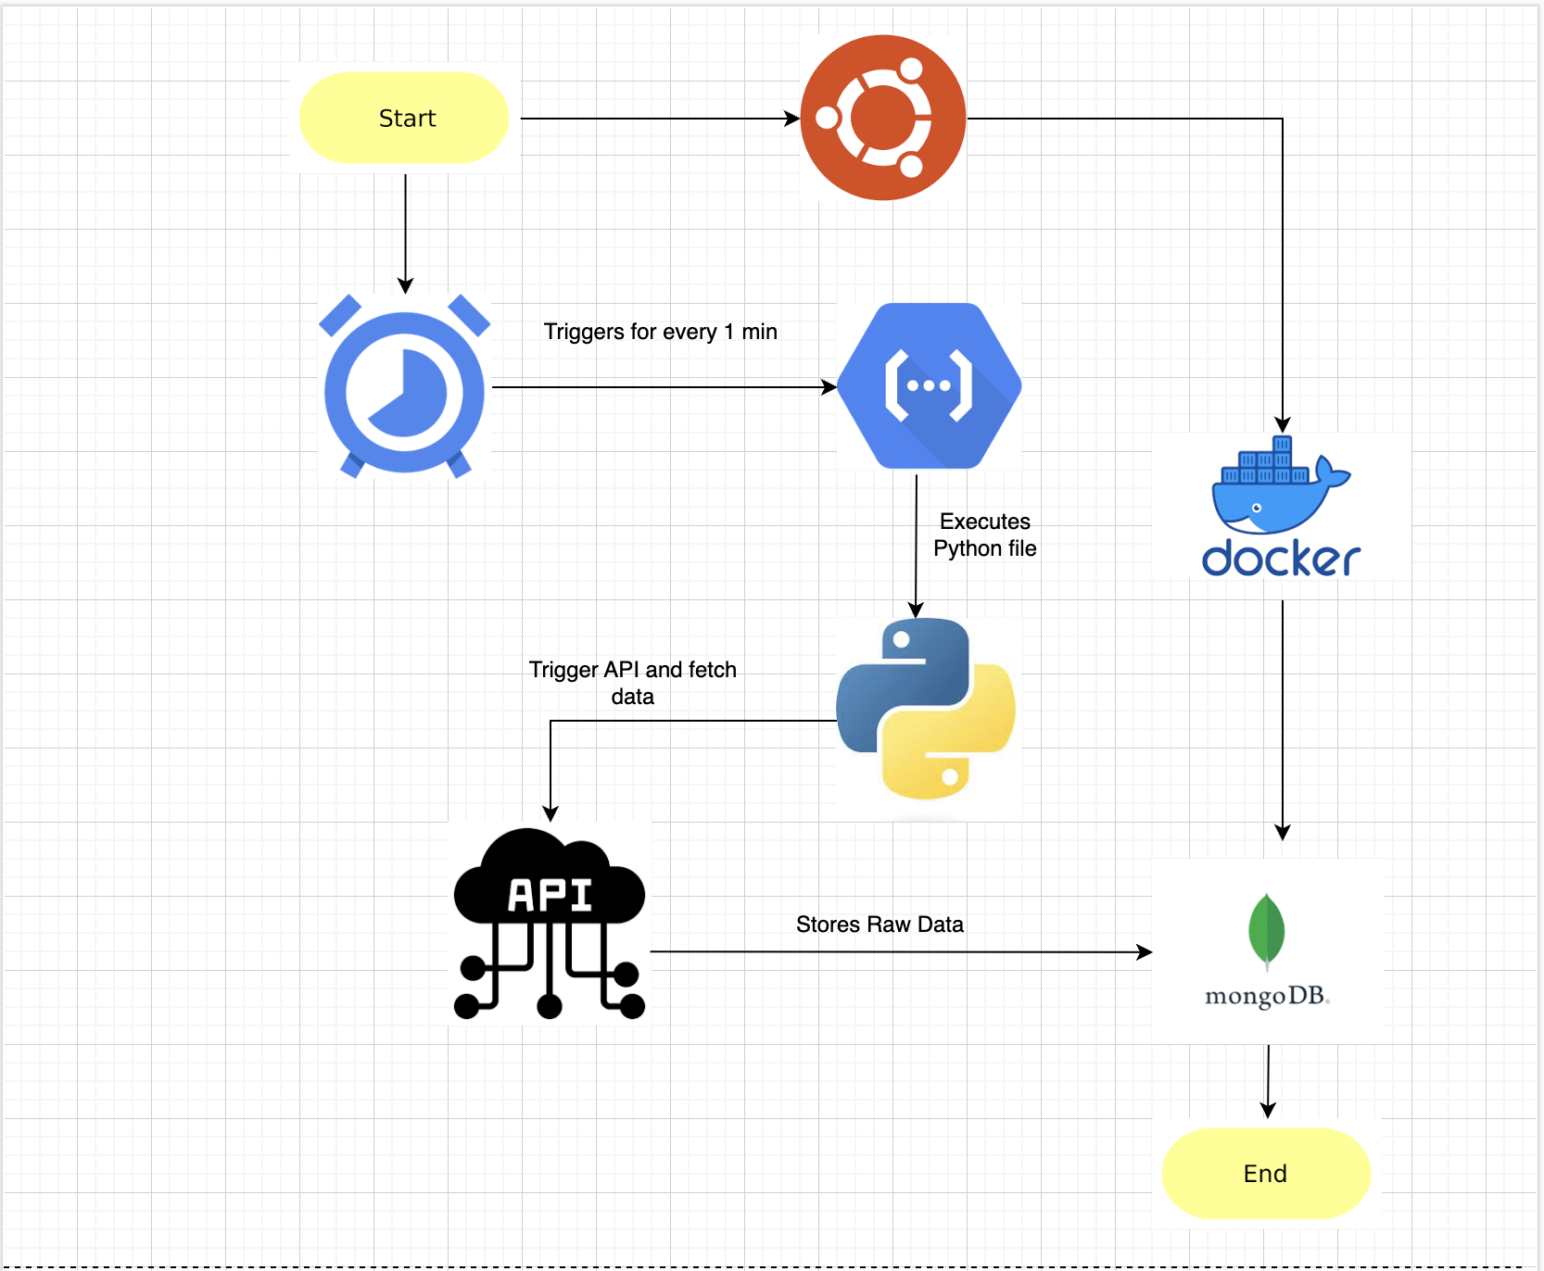

- Flow -1 to fetch the data from Mongo and dump into SQL
- Flow to fetch data from SQL and send reports

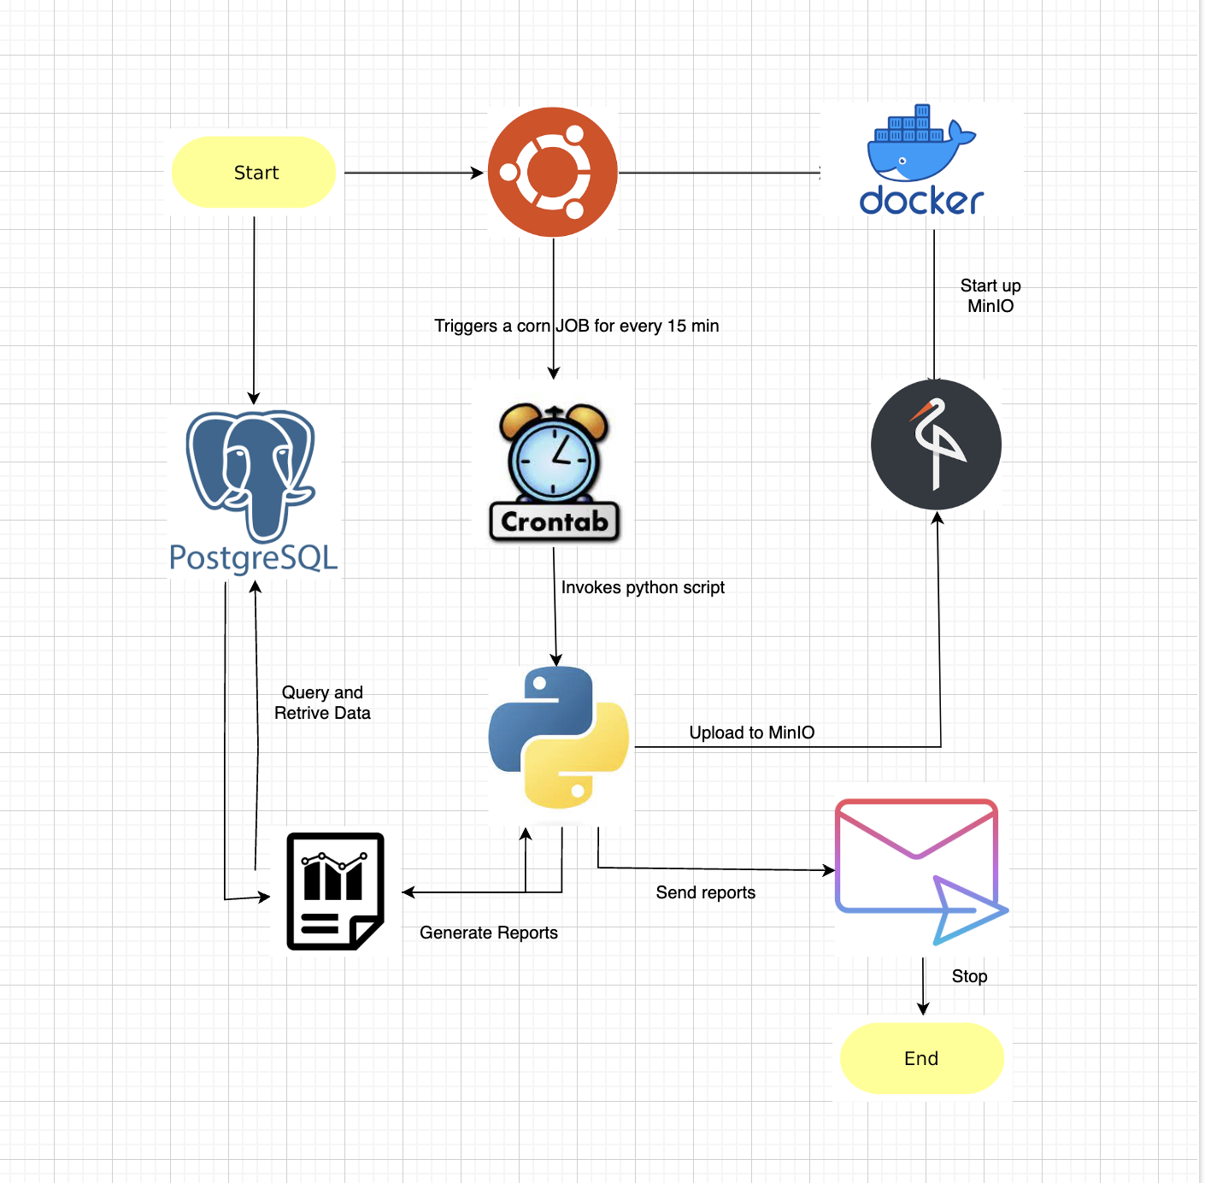

Visualizations:
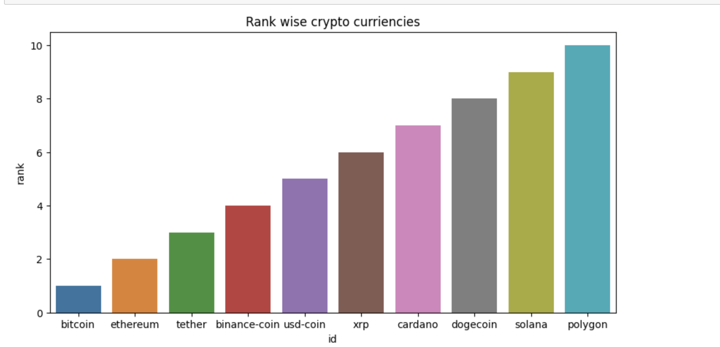

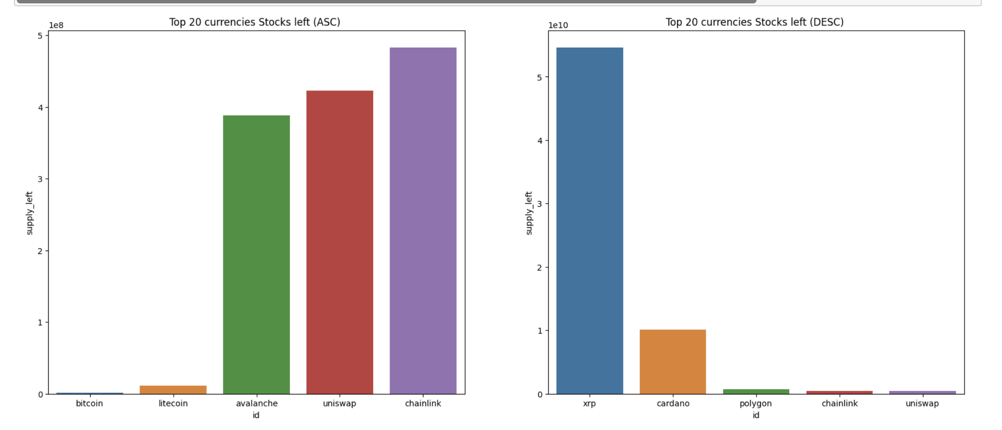

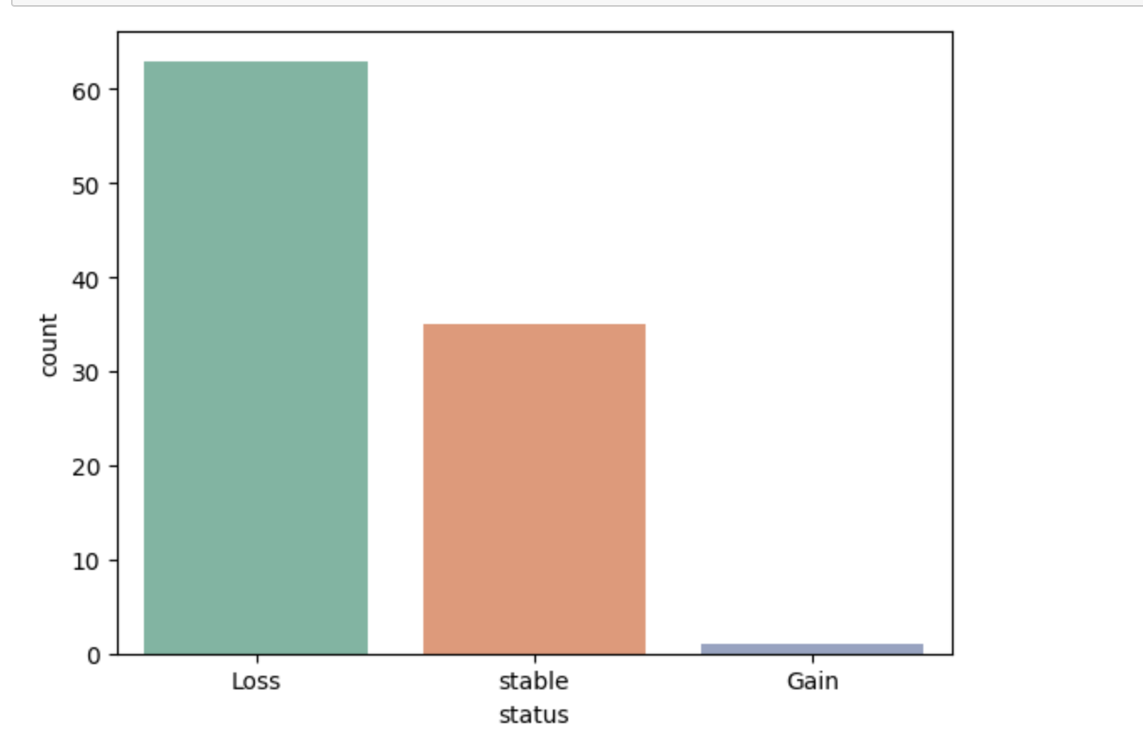

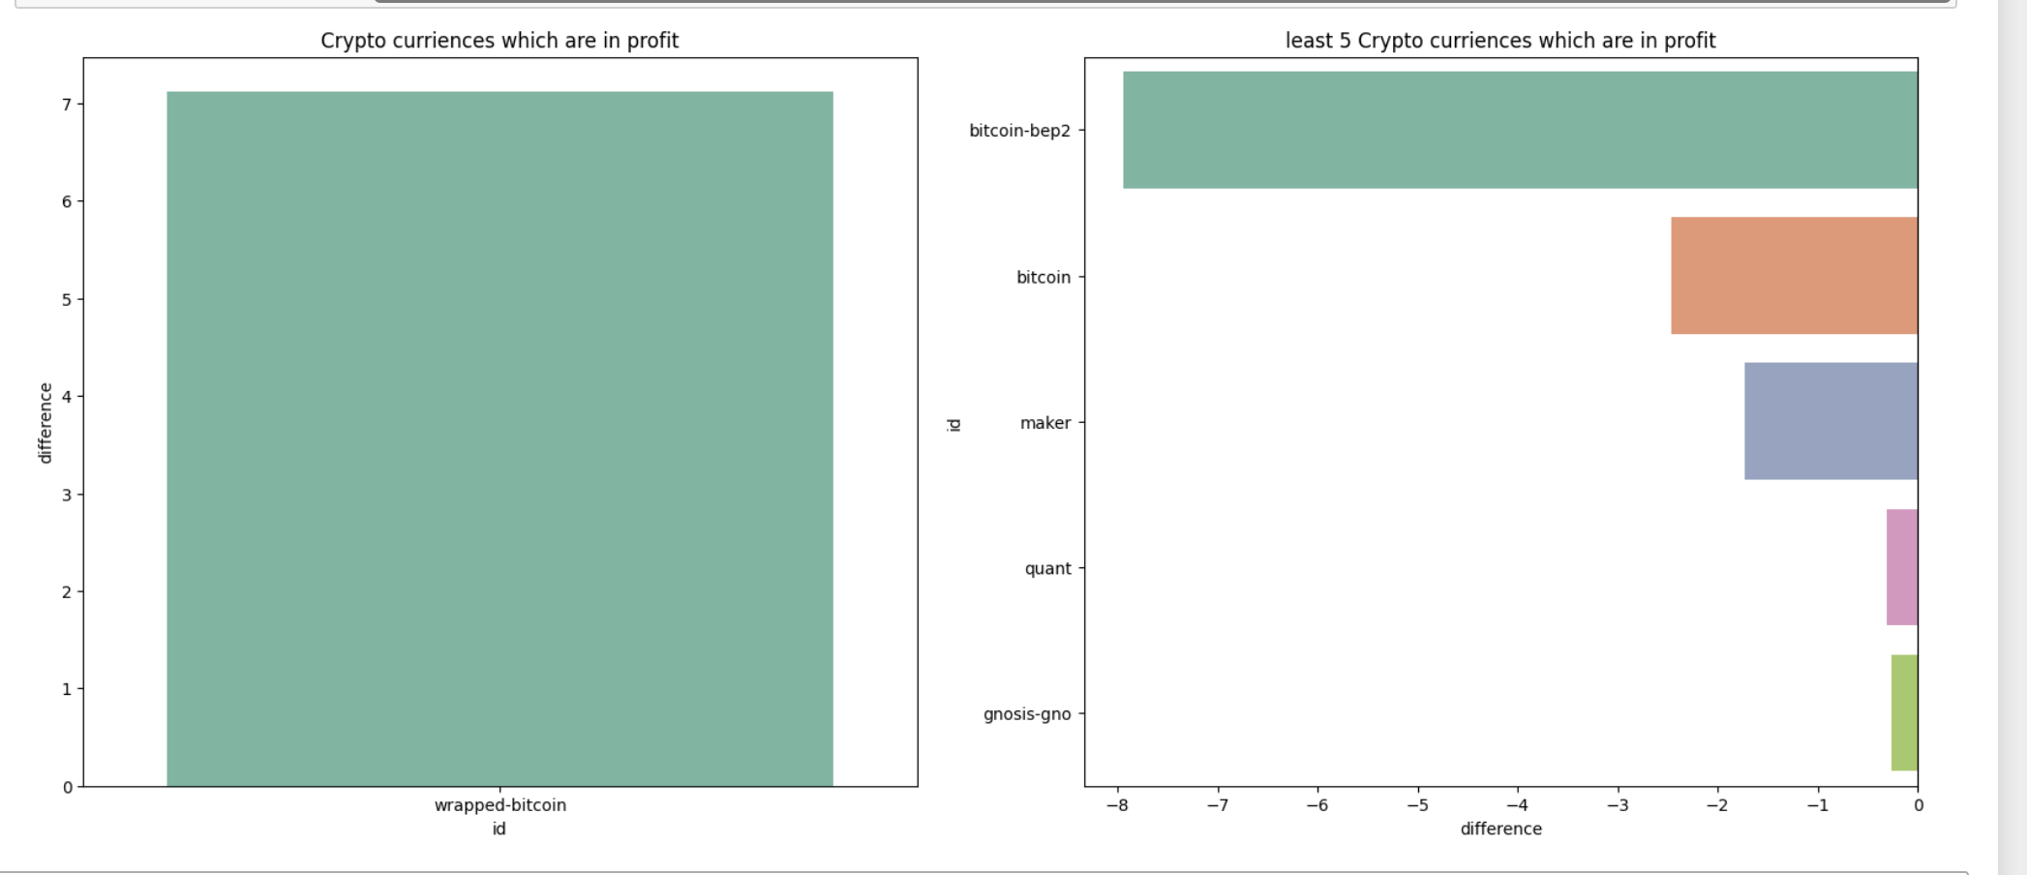

Excel Report:

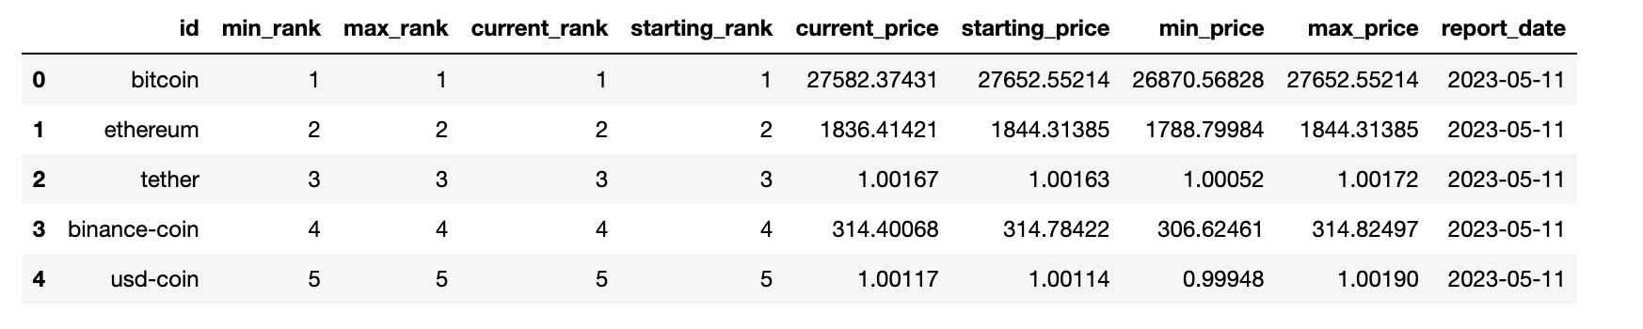

Model development – Use Cases
Predicting the price of the cryptocurrencies by passing necessary parameters.
The main motive of this model is to predict the price of the cryptocurrency by passing necessary parameters. We have built 3 different models to perform this operation and have picked one out of them having better performance.
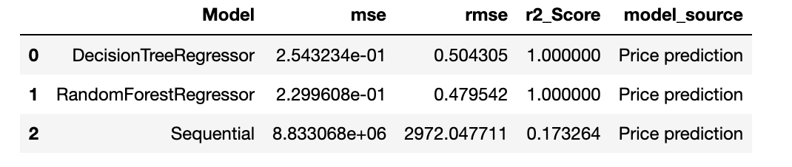
After looking at the performance of all three models we have gone with the Random Forest regressor.

Model conclusion:
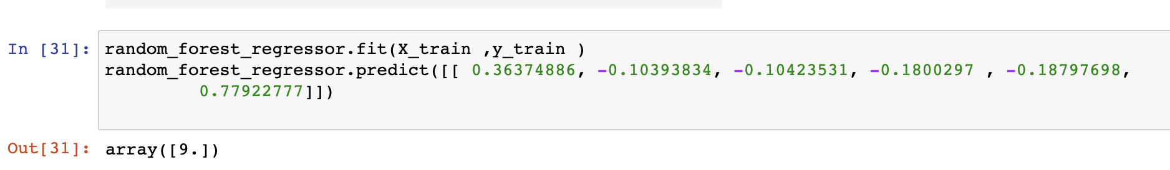

Predicting the rank of the cryptocurrencies by passing necessary parameters.
The main motive of this model is to predict the rank of the cryptocurrency by passing necessary parameters. We have built 3 different models to perform this operation and have picked one out of them having better performance.
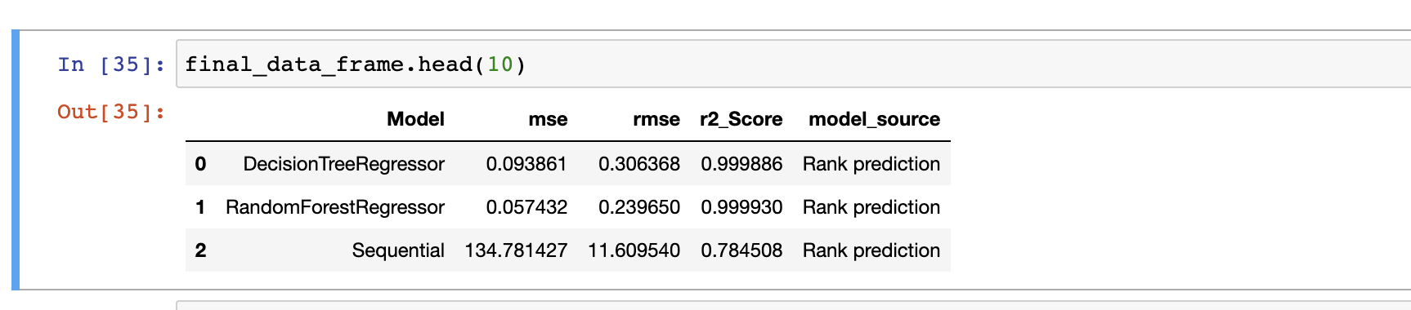
After looking at the performance of all three models we have gone with the Random Forest regressor.

Model conclusion:

Risk assessment:
The main motive this model is to build a classification model which will classify currency into 3 categories. We have built 3 model using 3 algorithms and have chosen the best one.
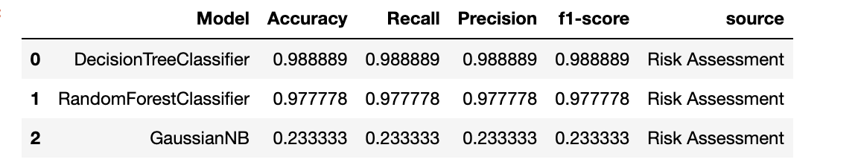

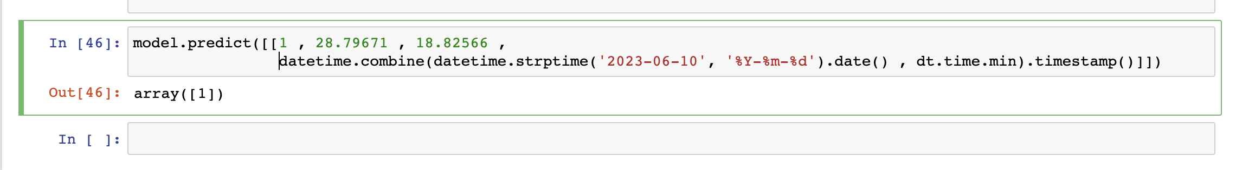

Conclusion:
By implementing this project, we have a centralized repository of Bitcoin data stored in a cloud-based data warehouse, processed and cleaned data ready for analysis, meaningful insights and findings about the Bitcoin market, and recommendations and strategies for investors, traders, and financial analysts to make informed decisions and capitalize on Bitcoin market opportunities. The initiative intends to enhance decision making, optimize trading tactics, and increase business performance for bitcoin enterprises.

References:
Scalable Databases (CS673)
Introduction to Data science (CS675)

