Page index

This is project is designed based On School Education System.
Login Page for User(Admin, Teacher, Student, Warden are users)

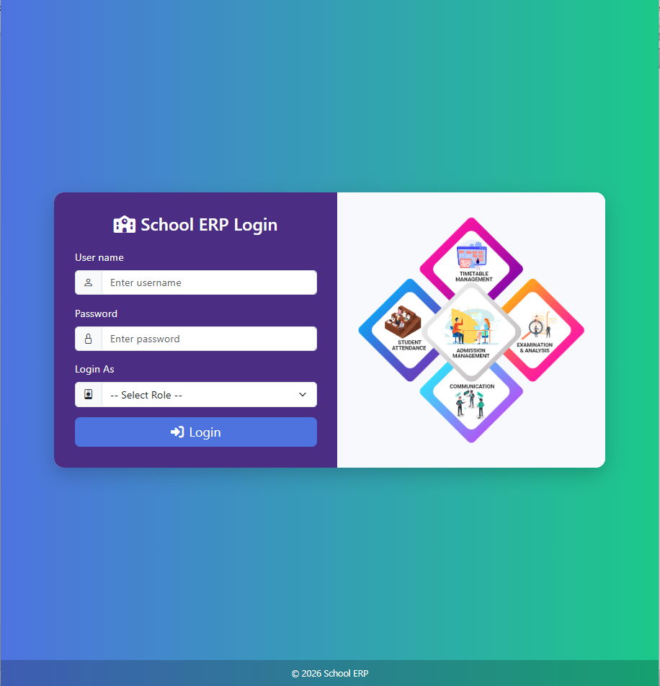

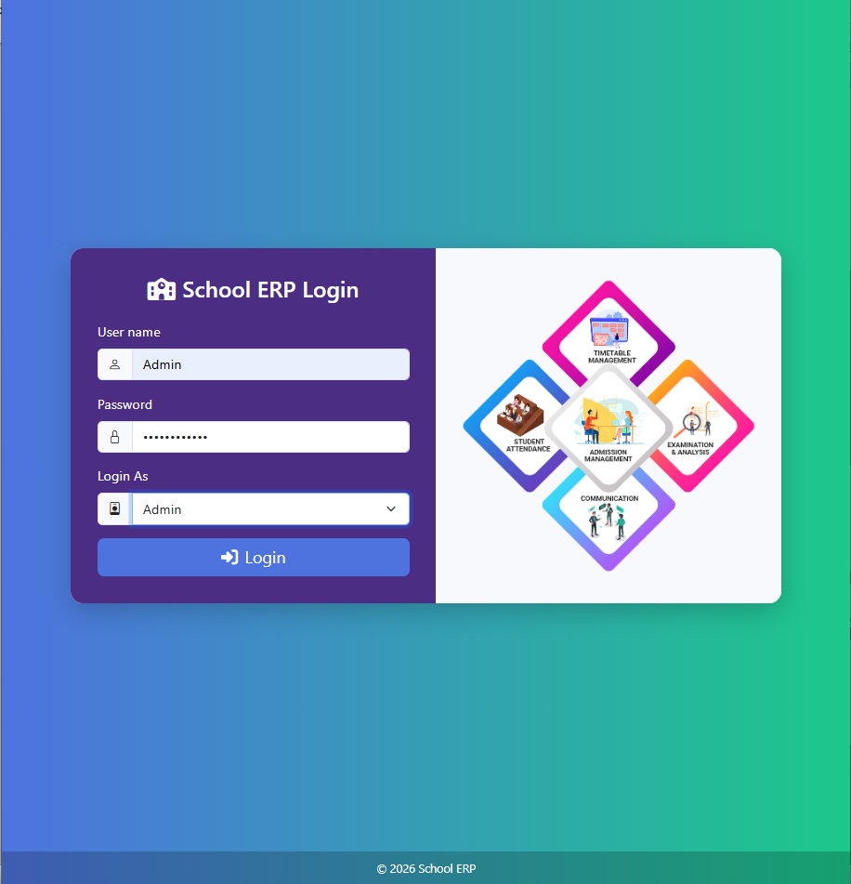

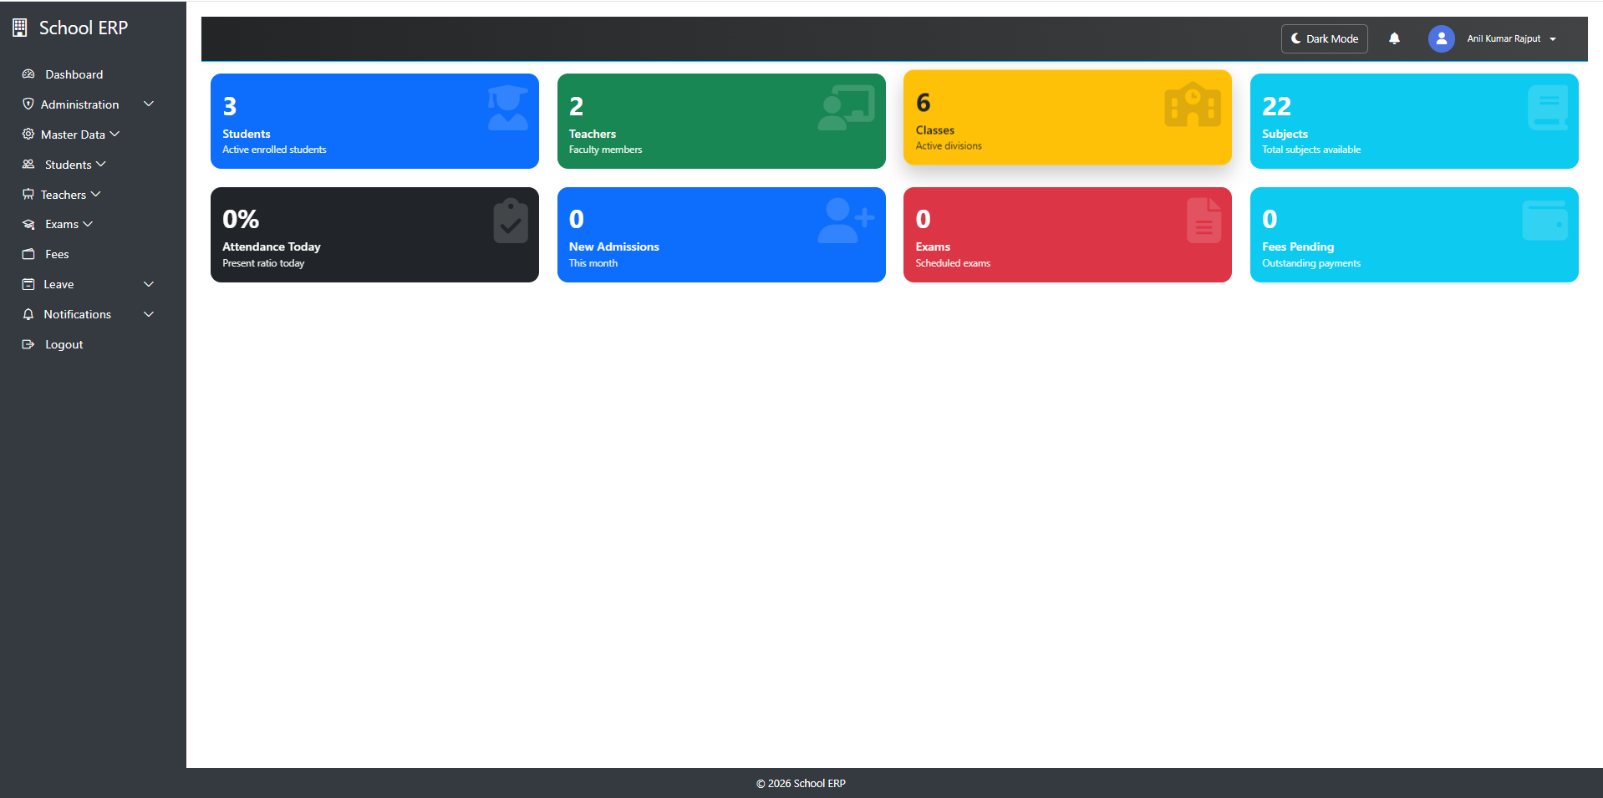

Admin Login

1. Role Management –(ERP System)
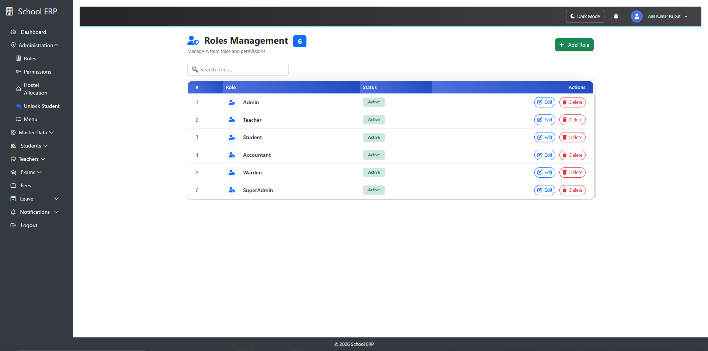

Purpose
Role Management is used to define user roles and control access permissions across the ERP system. It ensures users can only access features relevant to their responsibilities.

Key Functionality
- Create and manage roles (e.g., Admin, Teacher, Accountant, Student)
- Assign permissions to each role
- Control access to modules like Attendance, Fees, Exams, Hostel, etc.
- Restrict unauthorized access to sensitive data

⚙ How it Works
- Each user is assigned a role during account creation
- Permissions are linked to roles, not individual users
- System checks role permissions before allowing access to pages/actions

ERP Modules Controlled by Roles
- Student Management
- Teacher Management
- Attendance
- Fees & Finance
- Exam & Results
- Hostel Management
- Reports & Analytics

2. Permission Management – Notes (ERP System)

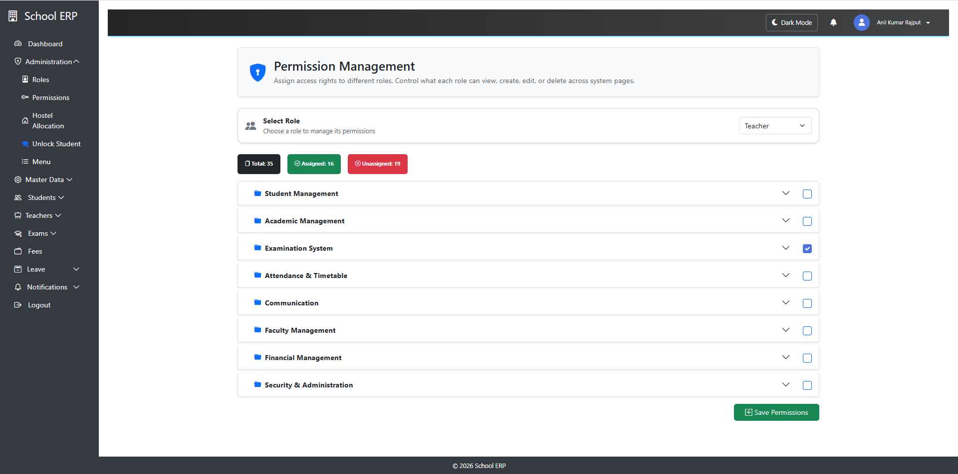

Purpose
Permission Management is used to control what pages a user can see within the ERP system. It ensures fine-grained security beyond roles.

Key Functionality
- Assign permissions to roles
- Control access at module and feature level
- Restrict sensitive operations based on authorization

⚙ How it Works
- Permissions are grouped under roles
- Each role is assigned specific access rights
- System validates permissions before executing any action
- If permission is missing, access is denied

3. Lock User (Student/Teacher)
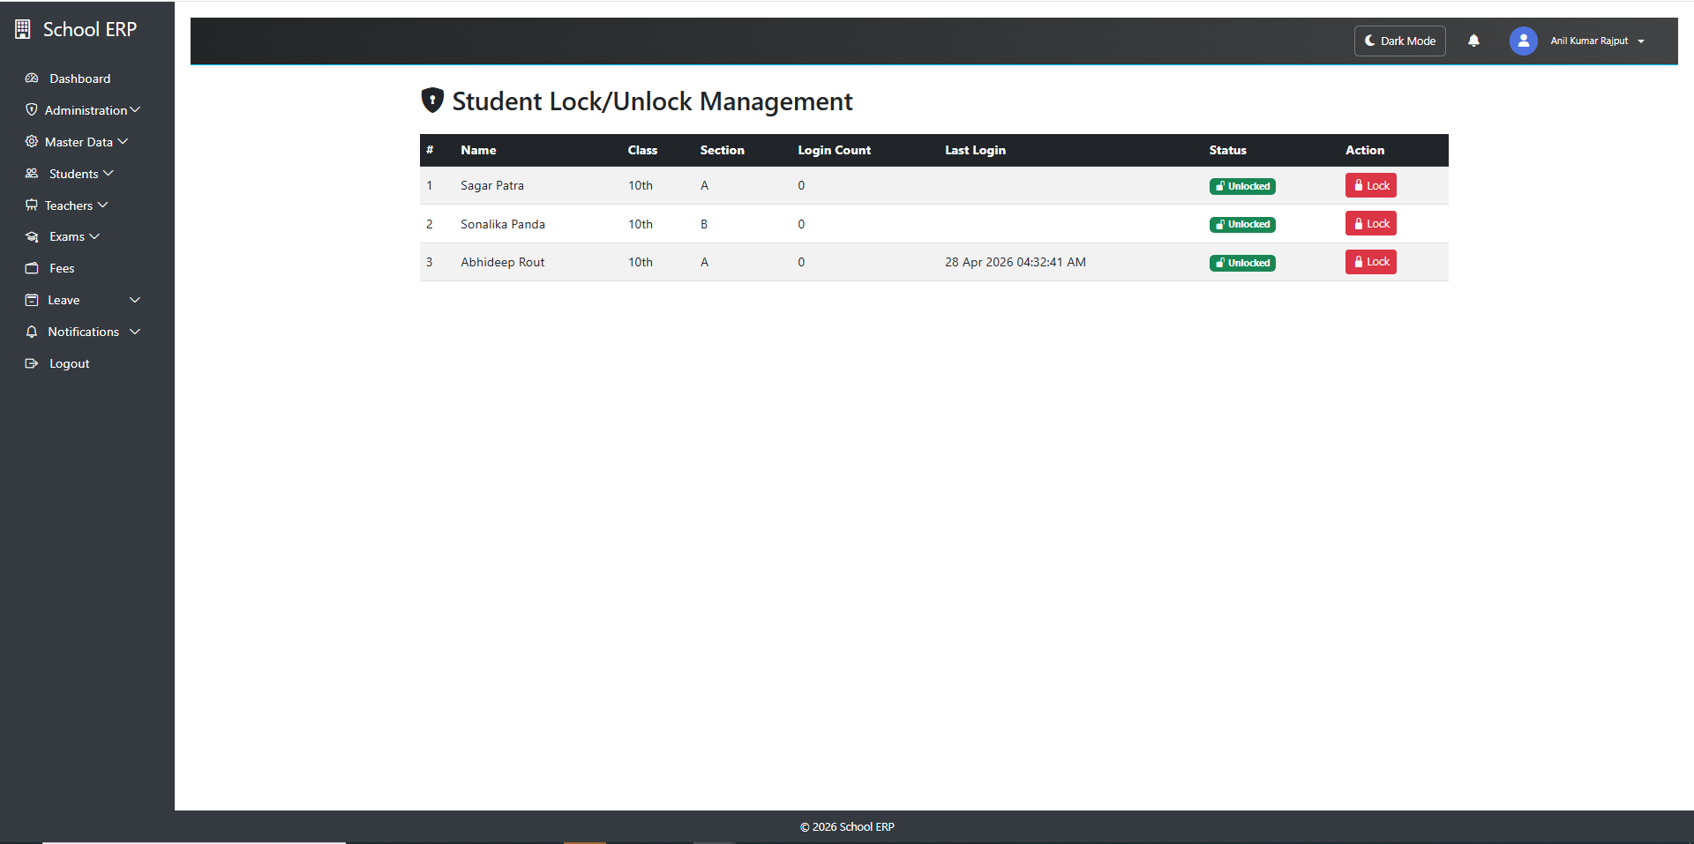

Purpose
The Lock/Unlock feature is used to control user access temporarily without deleting their account. It helps administrators manage active and inactive users in the system.

Lock User (Student/Teacher)

Meaning
Locking a user will restrict their access to the system while keeping their data intact.

⚙ Effects
- User cannot log in to the system
- All modules become inaccessible
- Data remains safe and unchanged
- User record stays active in database

Unlock User (Student/Teacher)

Meaning
Unlocking restores full system access to the user.

⚙ Effects
- User can log in normally
- All assigned permissions are restored
- System access is re-enabled immediately

4. Menu Management – Notes (ERP System)

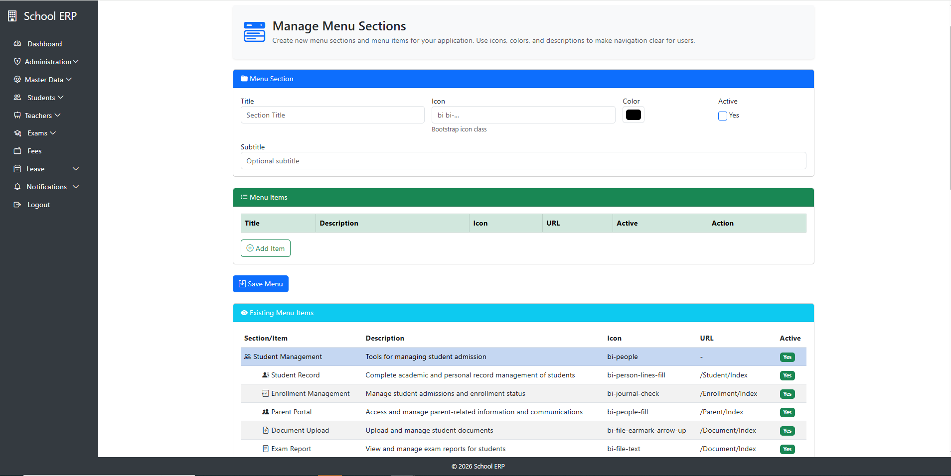

Purpose
Menu Management is used to create, organize, and control navigation menus in the ERP system. It helps define how different modules are accessed by users based on roles and permissions.

⚙ Key Functionality
- Create new menu items for modules (e.g., Students, Fees, Attendance)
- Define menu hierarchy (Parent → Child menus)
- Assign menus to specific roles
- Control visibility based on permissions
- Manage menu order and structure

Menu Structure
- Parent Menu → Main category (e.g., Academic, Finance, Admin)
- Child Menu → Sub-items under parent (e.g., Student List, Fee Setup)
- Supports multi-level navigation (if required)

Access Control
- Menu visibility is controlled by roles and permissions
- Users only see menus assigned to their role
- Unauthorized menus are hidden from UI

⚙ ERP Menu Examples
- Dashboard
- Student Management
- Teacher Management
- Attendance System
- Fee Management
- Exam & Results
- Hostel Management
- Reports & Analytics

5. Academic Year – Notes (ERP System)

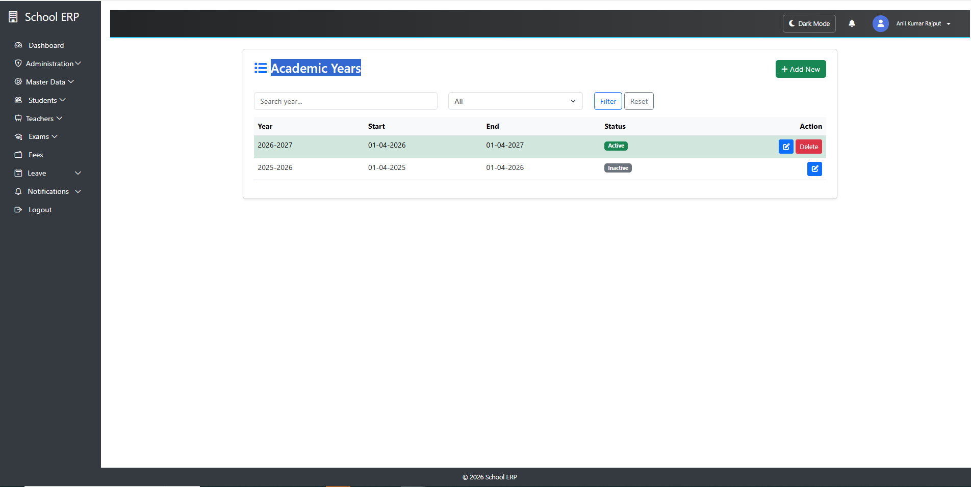

Purpose
Academic Year defines the time period for academic operations in the ERP system, such as admissions, attendance, exams, fees, and reports.

⚙ Key Functionality
- Create and manage academic years (e.g., 2025–2026)
- Set one active academic year at a time
- Control data segregation by year
- Link all academic activities to a specific year
System Impact
Academic Year affects:
- Student admissions
- Attendance records
- Exam results
- Fee collection
- Reports and analytics

6. School Class – Notes (ERP System)

Purpose
School Class defines the academic grade structure of the institution (e.g., LKG, UKG, Class 1 to Class 12). It is used to organize students and manage academic operations effectively.
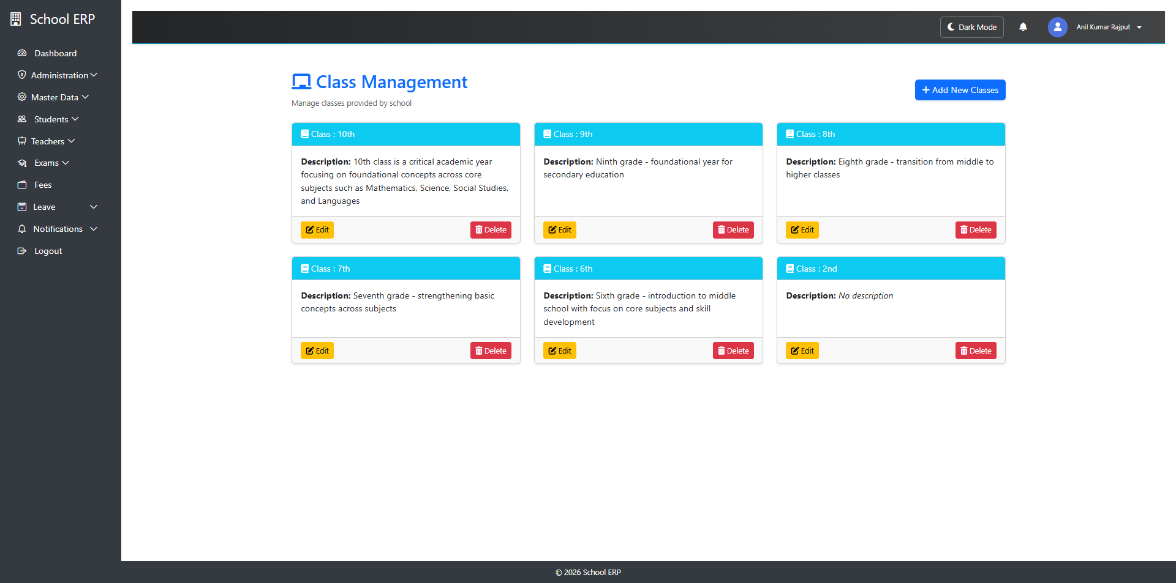

⚙ Key Functionality
- Create and manage school classes (e.g., Class 1, Class 2, etc.)
- Assign sections to each class (A, B, C, etc.)
- Link subjects and teachers to classes
- Organize students based on class enrollment
- Support promotion to next class during academic year transition

System Usage
School Class is used in:
- Student Admission
- Attendance Management
- Exam & Result System
- Fee Management
- Timetable & Scheduling
- Reports & Analytics

7. Subjects – Notes (ERP System)

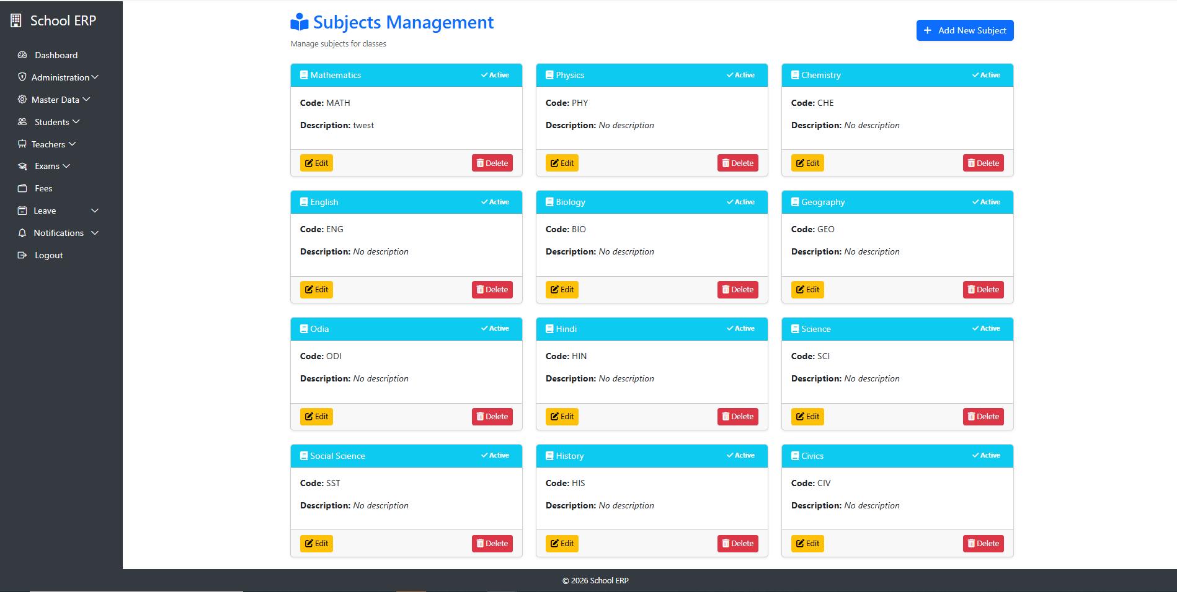

Purpose
Subjects define the academic topics taught to students in each class. They form the core of the curriculum and are used for teaching, exams, attendance, and performance tracking.

⚙ Key Functionality
- Create and manage subjects (e.g., Mathematics, Science, English)
- Assign subjects to classes and sections
- Map subjects to teachers
- Define subject-wise syllabus structure
- Track performance through exams and assessments

System Usage
Subjects are used in:
- Timetable Scheduling
- Attendance Management
- Exam & Result Processing
- Teacher Assignment
- Academic Reports

8. Class–Section & Subject Mapping – Notes (ERP System)

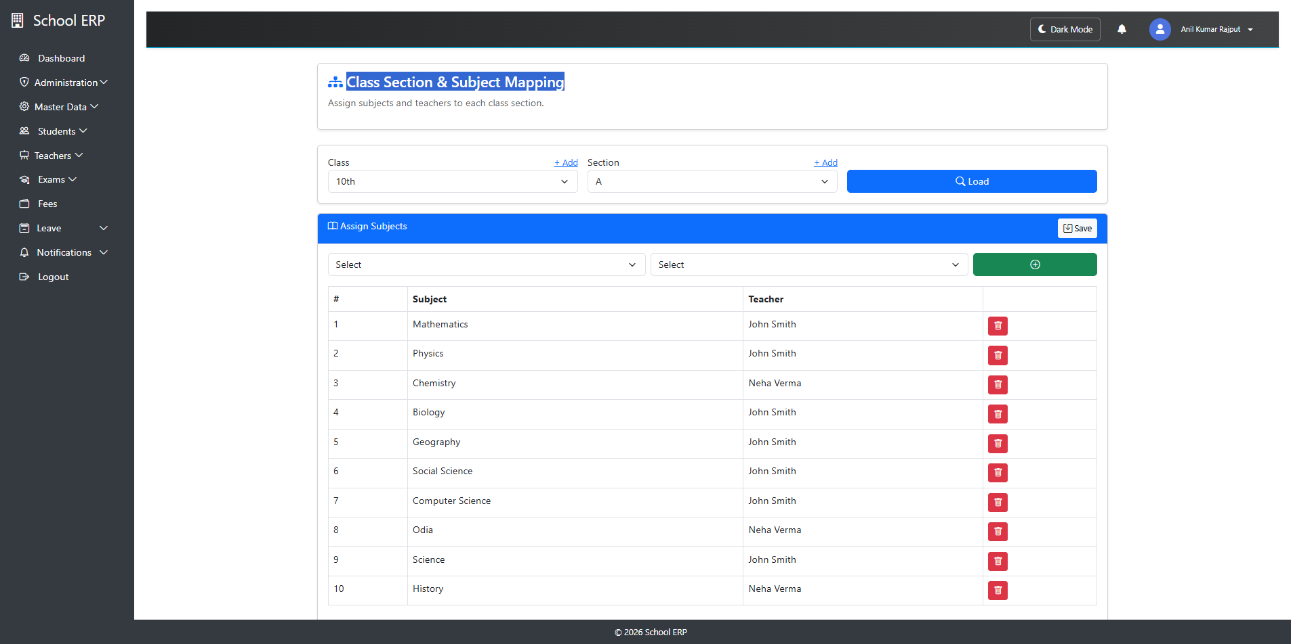

Purpose
Class–Section–Subject Mapping is used to define the relationship between classes, their sections, and assigned subjects. It ensures that each class-section has a properly structured academic curriculum.

⚙ Key Functionality
- Map subjects to specific class and section combinations
- Assign multiple subjects to a single class-section
- Control subject availability per class
- Support structured academic planning
- Link teachers to mapped subjects (if applicable)

System Usage
This mapping is used in:
- Timetable generation
- Attendance marking
- Exam and result management
- Teacher assignment
- Academic reporting

Mapping Structure
- Class → Academic level (e.g., Class 10)
- Section → Division within class (e.g., A, B, C)
- Subject → Academic subject (e.g., Math, Science)
Example:
- Class 10 – Section A → Mathematics, Science, English
- Class 10 – Section B → Mathematics, English, Computer Science

9. Academic Calendar Exceptions – Notes (ERP System)

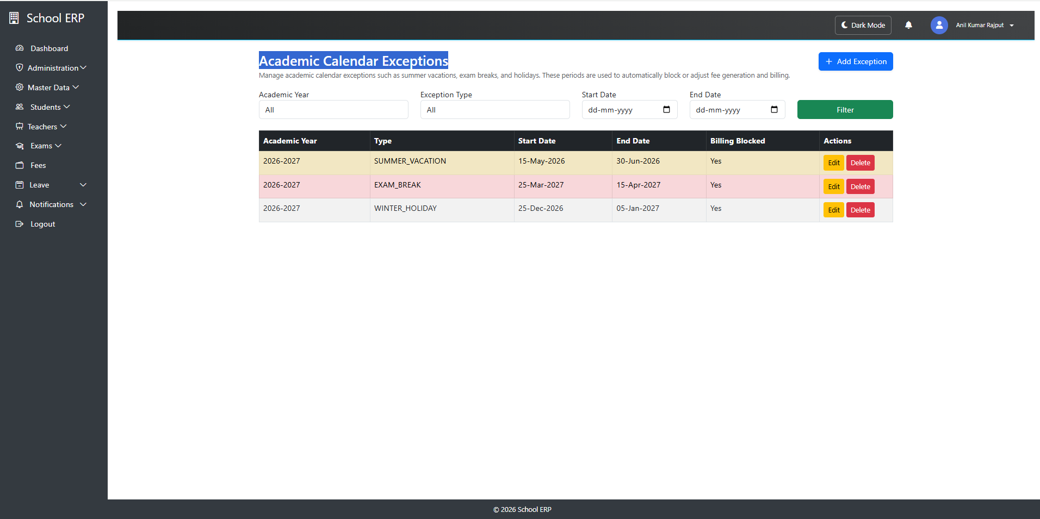

Purpose
Academic Calendar Exceptions are used to define special dates that override the regular academic calendar, such as holidays, events, exam changes, or unexpected closures.

⚙ Key Functionality
- Add exception dates to the academic calendar
- Mark days as holidays, working days, or special events
- Override regular timetable schedules for specific dates
- Manage institution-wide or class-specific exceptions
- Support rescheduling of academic activities

Types of Exceptions
- Holiday → No academic activities
- Working Day Override → Regular activity on a holiday
- Exam Day → Special exam schedule
- Event Day → School functions or programs
- Emergency Closure → Unexpected shutdown

10. Hostel Management – Notes (ERP System)

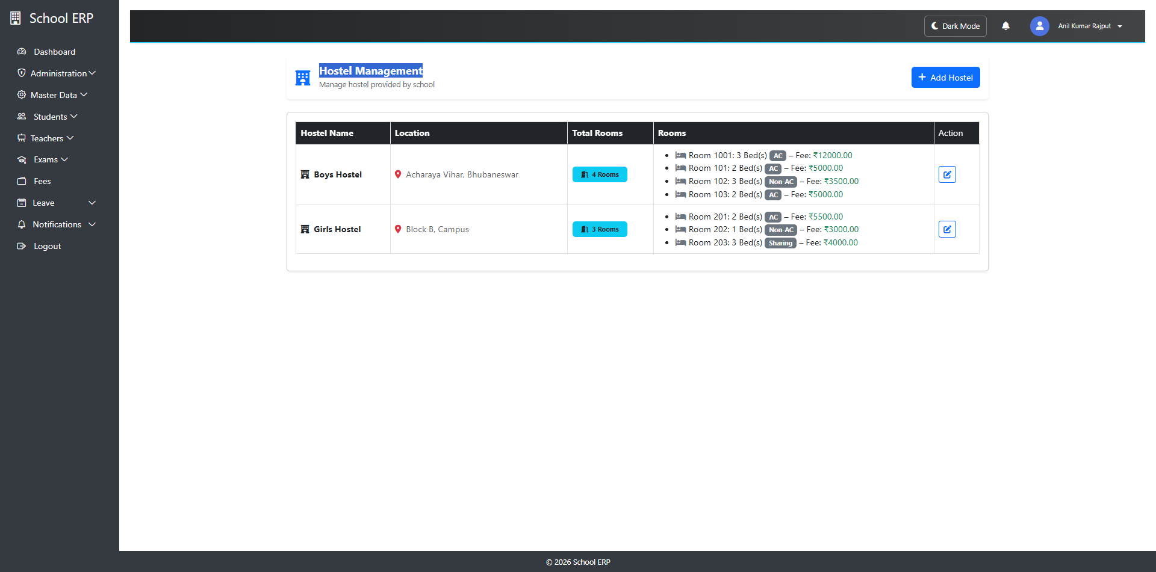

Purpose
Hostel Management is used to manage student accommodation facilities including room allocation, hostel details, and occupancy tracking within the institution.

⚙ Key Functionality
- Create and manage hostel blocks/buildings
- Define rooms with capacity and facilities
- Allocate students to rooms
- Track room occupancy status
- Manage hostel fees (if applicable)
- Monitor vacant and occupied rooms

Hostel Structure
- Hostel → Main building or block
- Floor → Level within hostel
- Room → Individual accommodation unit
- Bed → Allocation unit for students

Room Allocation Flow
- Select hostel and room
- Check available capacity
- Assign student to available bed
- Update occupancy status automatically

11. Grade Rule – Notes (ERP System)
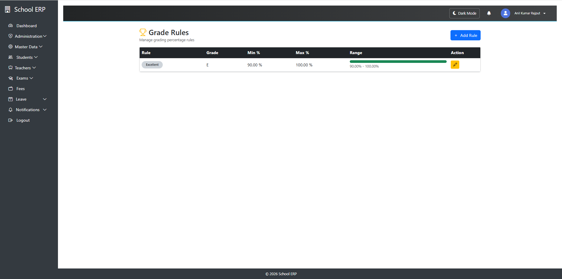
Grade rule refers to the system used to convert marks obtained by a student into grades such as A, B, C, etc., or grade points.
2. Purpose:
- To evaluate student performance in a simplified way
- To reduce stress of exact marks comparison
- To classify performance levels
3. Grading System:
Marks are divided into ranges, and each range is assigned a grade.
Example:
- 90–100 → A (Excellent)
- 80–89 → B (Very Good)
- 70–79 → C (Good)
- 60–69 → D (Average)
- Below 60 → F (Fail)

12. Exam Schedule (ERP System)
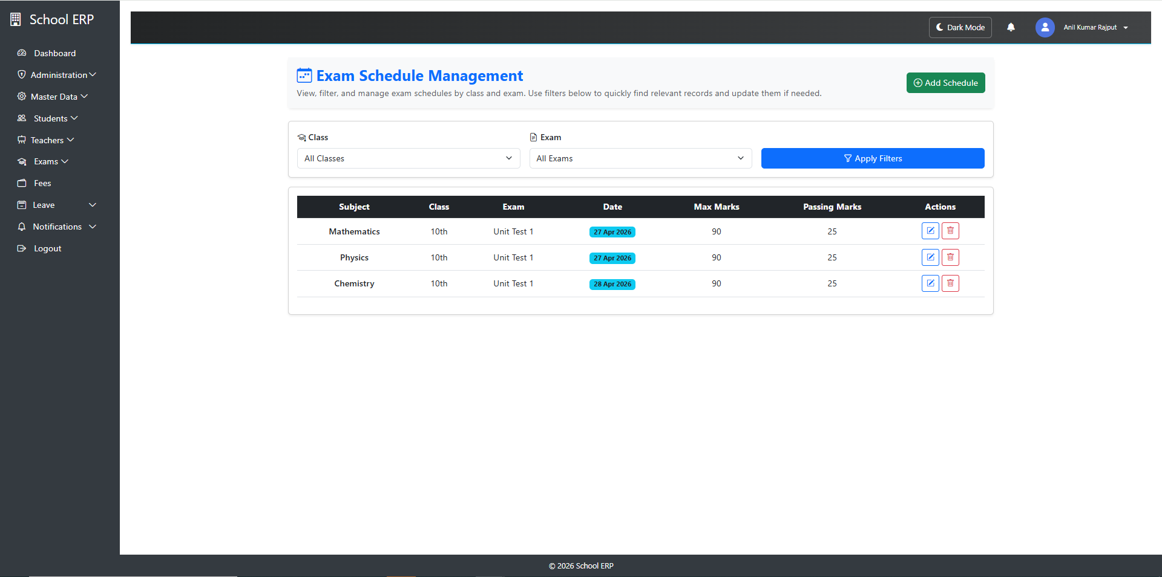
Exam Schedule Management in an ERP (Enterprise Resource Planning) system is a module used by educational institutions to plan, organize, and manage examination timetables efficiently.

Purpose
- To create a structured exam timetable
- To avoid clashes between subjects, classes, or faculty
- To automate scheduling and reduce manual work
- To ensure smooth conduct of examinations

13. Mark Entry in ERP Application – Notes
Mark Entry is a module in an ERP system used by educational institutions to enter, update, and manage students’ examination marks in a structured digital format.

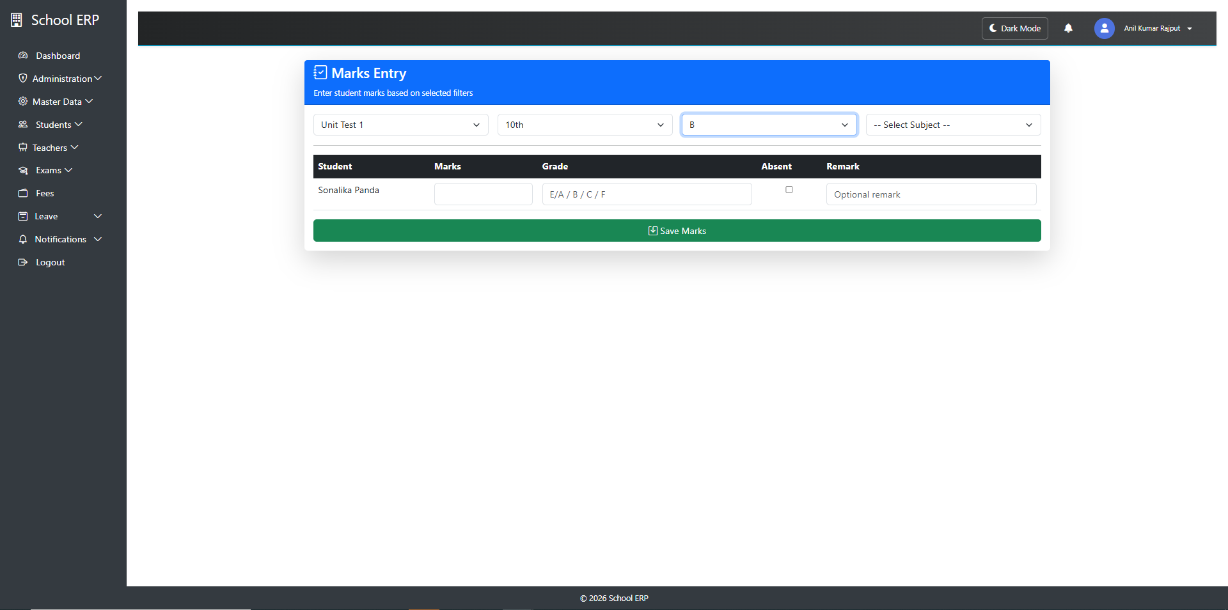

Purpose
- To record students’ exam performance efficiently
- To reduce manual calculation errors
- To automate result processing
- To maintain a centralized marks database

Key Features
- Subject-wise mark entry (theory, practical, internal)
- Class/section-wise student list display
- Bulk or individual mark entry option
- Automatic total and percentage calculation
- Grade conversion based on grading rules
- Edit and correction facility (with permissions)

14. Notification Management in ERP Systems
Notification Management in an ERP (Enterprise Resource Planning) system refers to the process of generating, managing, and delivering alerts, messages, and reminders to users based on system events, workflows, or business rules.
It ensures that users stay informed about important activities such as approvals, deadlines, system updates, and exceptions.

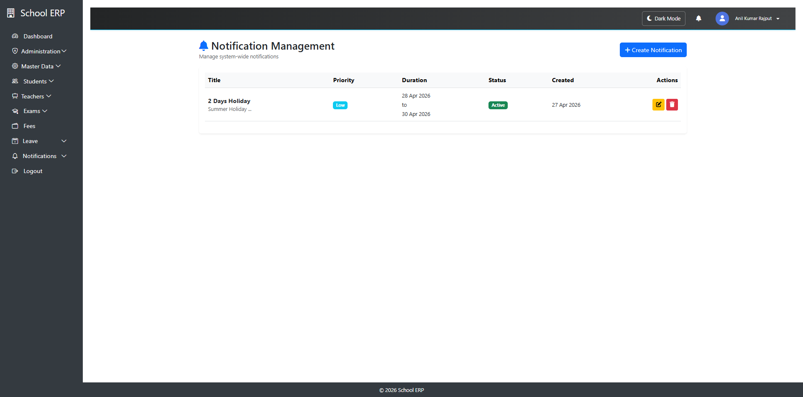
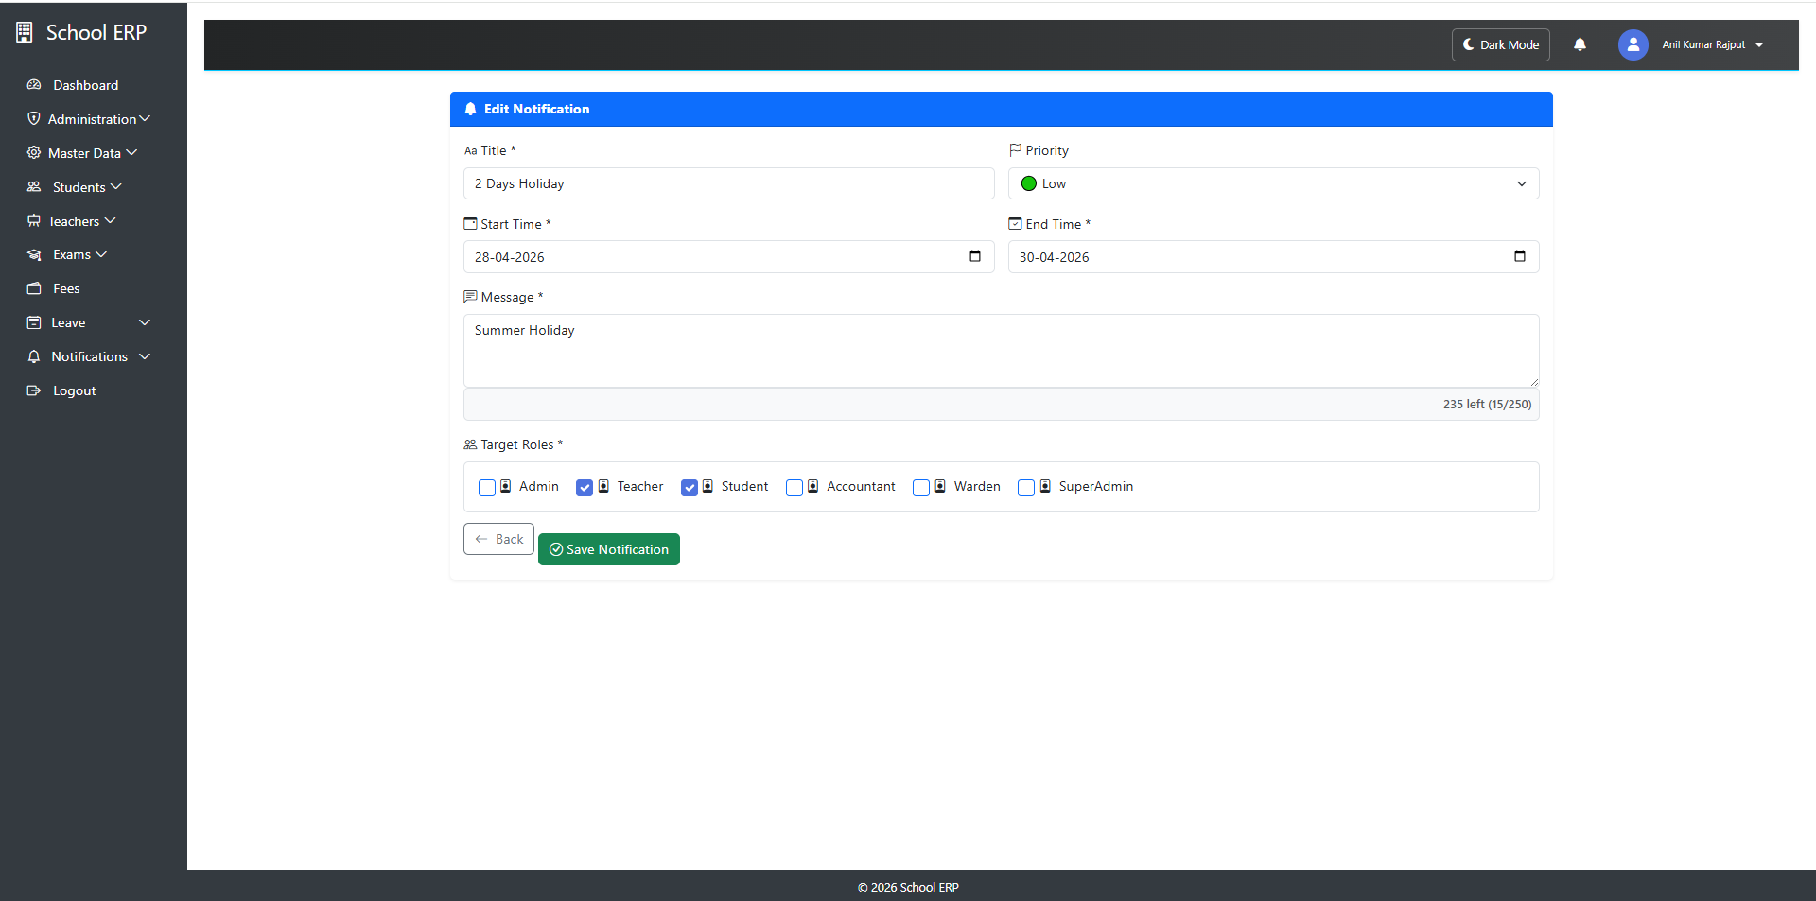

Objectives
- Provide real-time updates to users
- Improve decision-making and responsiveness
- Ensure task accountability and tracking
- Reduce manual follow-ups
- Enhance user engagement and productivity

Teacher Login

15. Leave Management System in ERP (Teacher & Admin)

Introduction
Leave Management in an ERP system is a module that automates the process of applying, approving, tracking, and managing employee leaves. In an educational ERP, it is specifically designed to handle leave requests from teachers and administrative staff efficiently.
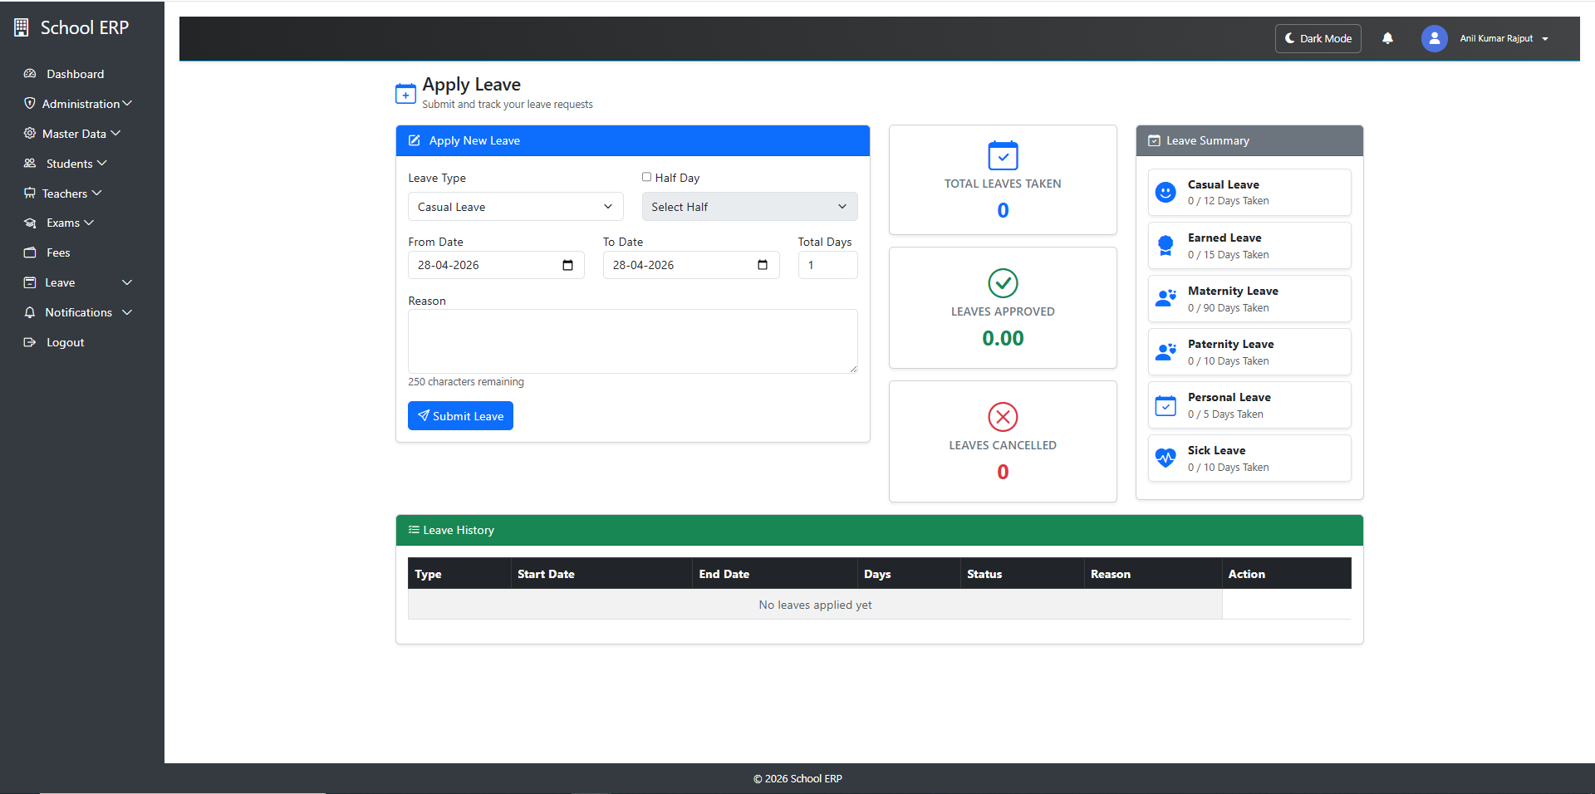
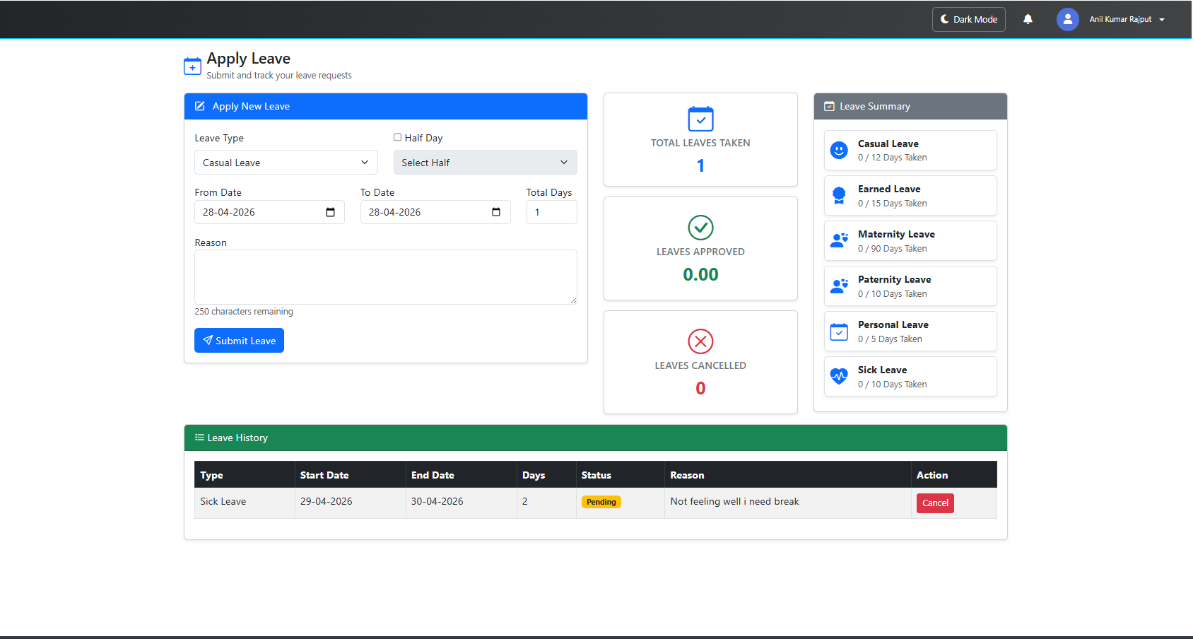

Objectives
- Simplify leave application and approval process
- Maintain accurate leave records
- Ensure transparency between teachers and administration
- Reduce paperwork and manual errors
- Enable better workforce planning

Users of the System

a) Teachers
- Apply for leave
- Check leave balance
- Track leave status

b) Admin (HR / Principal / Management)
- Approve or reject leave requests
- Monitor staff availability
- Maintain leave policies and records

Types of Leaves
- Casual Leave (CL) – Short-term personal leave
- Sick Leave (SL) – For health-related issues
- Earned Leave (EL) – Accumulated leave over time
- Maternity/Paternity Leave
- Leave Without Pay (LWP)

Key Features

a) Leave Application (Teacher)
- Online leave request form
- Selection of leave type and duration
- Option to attach supporting documents

b) Leave Approval Workflow (Admin)
- Multi-level approval (e.g., HOD → Principal)
- Accept / Reject / Request modification
- Automated notifications

c) Leave Balance Management
- Tracks available, used, and remaining leaves
- Auto-calculation based on policy

Workflow Process
- Teacher logs into ERP
- Submits leave request
- Request goes to Admin/HOD
- Admin reviews request
- Approval/Rejection decision made
- Teacher receives notification
- Leave records updated automatically

Teacher Functions
- Apply/cancel leave
- View leave history
- Check leave balance

Admin Functions
- Define leave policies
- Approve/reject requests
- Generate reports
- Monitor staff availability

16. Teacher Management – ERP Application Notes
Teacher Management is a core module in the ERP system used to maintain complete information about teachers, including personal details, job roles, subject assignments, attendance, leave records, and performance tracking.
It helps administrators efficiently manage academic staff and streamline school operations.

Key Features

Teacher Profile Management
- Add new teacher records
- Update teacher details
- View complete teacher profile

Employment Details
- Employee ID / Staff Code
- Department (Science, Math, etc.)
- Designation (Lecturer, Assistant Teacher, etc.)
- Joining Date
- Employment Type (Permanent / Contract)

Subject Allocation
- Assign subjects to teachers
- Assign classes/sections
- Manage academic workload distribution

Document Management (This feature is implied as per client)
- Upload certificates
- Identity proof
- Experience letters
- Qualification documents

Workflow
- Admin adds teacher profile
- Subjects and classes are assigned
- Teacher logs into ERP
- Teacher manages:
  - Attendance
  - Leave requests
  - Academic activities

