-Check Word notes at “Computer Notes” file in “C:\Documents\z- Other\- Computer, Phone”

**---Things to do after setup:**

-Start page – My NetBeans tab - install plugins - available plugins – Darcula (or you could go for “visual studio dark”, “monster”) - Restart.

-Tools -> Options – General -> Web Browser: Chrome

-Tools -> Options -> Import

C:\Computer Engineering\8- Java\3- Java Notes\IDE, Path\formatting.zip

-Tools -> Options -> font &color -> Profile -> Select Darcula, Select Consolas font size 13.

-Tools -> Options -> Appearance -> Look and Feel -> Select Darcula.

-UTF 8: Go to etc folder in Netbeans home --> open netbeans.conf file, add "-J-Dfile.encoding=UTF-8" to “netbeans_default_options” line. Restart Netbeans. Go to Help->About->System to check.

-Help -> Start Page -> Show on Startup

-Window: Keep navigation window open and use “sort by source” by default. Move your cursor to navigator window, right click, select “Sort by Source”.

**---Debugging:** First set a breaking point to where you want the execution to start(it will run the program until it reaches first breaking point). Start debugging mode. Press step over.

<https://www.tutorialspoint.com/jdb/index.htm>

-F8(step over) a pastığında output ekranı gitmemesi için output ekranı tüm horizontal alanı kaplayıp soldaki navigator yada ne varsa onun üstüne gelmemeli. sol alttaki butona basarak "restore window group" diyerek output ekranını sağa, kodların altına küçültebilirsin.

**-If debugger doesn’t work:** If you click debug but the buttons are greyed out, go to debug tab and click step into or just click F7. If buttons are greyed out that probably means you are supposed to enter values to console or some other action is keeping IDE in waiting state.

**-Step over (F8)**

statementA; // step over: to callB

callB(); // step over: to statementB: it will treat the call as a

// black-box.

statementB;

-**Step over expression(Shift + F8):** Basically the same thing as step over. Shows which methods are called in statement but doesnt step into them.

**-Step into(F7)**

statementA = callA() + 4; // step into: will step into the expression

// and start to debug the "callA()" method.

callB(); // step into: will step into the "callB()" method.

statementB; // some statements don't have anything to step into

**-Step out (Ctrl+F7)**

void methodB() {

someStatementB; // stepOut will treat the rest of the method as

// a black-box, and you will end up at "someStatementC".

}

someStatementA;

methodB();

someStatementC;

**-Continue(F5):** The gren play button lets you execute the program until the next breakpoint or watchpoint.

**-Watch:** This is used to see values of expressions. After starting to debug you press the add watch button and enter an expression.

**-Print exception:** When your program doesn’t work, use try catch feature to catch the exceptions and print to see the problem.

try

{

stmt.executeUpdate("INSERT INTO `users` (username, password, admin)"

+ "VALUES ('"+username+"', '"+password+"', '"+isAdmin+"');" );

}

catch (Exception e)

{

System.out.println(e);// Way 1

System.err.println( e.getClass().getName()+": "+ e.getMessage() );// Way 2 (shorter message)

}

**-Debugging multithreaded programs:** Put break points to all threads(run methods). Or it wont work. You can put other breakpoints if you want to see what is going on. But they are not mandatory.

<http://bits.netbeans.org/media/netbeans-multithreaded-debugging.mp4>

**-Log file:**

Find where the log file is. (Will return null if there is non).

System.out.println(getClass().getClassLoader().getResource("logging.properties"));

If the code is in a static context, use the code below.

System.out.println(ClassName.class.getClassLoader().getResource("logging.properties"));

**---Save, Building and Run:**

-Ctrl + s : Save

-Shift + F6: Build and run current selected program.

-F6: Build and run not current selected tab but current main program.

-Select main method and other run options: default config yazıyor run'ın solunda. ordan customize seçeneğinden main class seçebilirsin. Yada project, right click, properties, run

-Selecting main project. Especially when working with a web project(without main method) you need to right click the project and set it as the main method. This way you can run the whole project with F6, debug the whole project with Ctrl+F5 (or you can use the buttons)

-**Running with arguments:** Click the run tab, set project configuration, select the project you want to configure and then click customize, add arguments or edit other things about the project. Separate arguments with a space. Don’t use Run File(Shift+F6), use Run Project (F6).

5 0 4

**-Making an executable JAR file:**

For swing applications, copy the code below gui class’s main method.

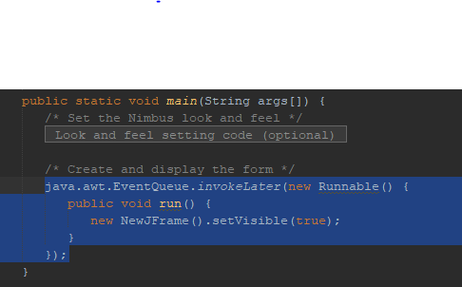

Paste this code to the main method of your main class/application class(class with the main method) of your program(a non gui class).

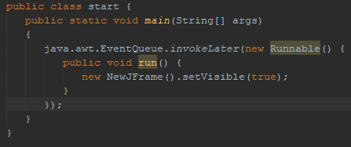

Clean and build. Use the .jar file in dist folder of project.

**---Navigation, text editing etc.**

-arrows, end, home: move around.

-ctrl + left/right arrows: move one word at a time.

-shift + arrows: select one character to left or right or select all characters from here to same column but up or down row.

-ctrl + shift + left/right arrows: select one word at a time

-ctrl + up/down arrow: Go up or down, pointer stays in position, file moves up/down.

-Ctrl + Shift + up/down arrow: Create a copy of current line above/below. You can even highlight multiple lines and then use this to create copies of those multiple lines above or below.

-Shift + alt + up and down arrows to move this line of text up or down.

-Ctrl + alt + up/down arrow: creates a copy of current line above or below.

-Select multiple lines + Ctrl + alt + up/down arrow: creates a copy of selected lines above or below.

-Ctrl + delete to delete word by word

-Shift + delete to delete the entire line

-You can select a word by double clicking on it or you can select a row by triple clicking on it or a word on it(you can select an empty row like this too).

**---Shortcuts:**

Ctrl + F = Find

Ctrl + H: Find and Replace

Alt + Enter: See the error of current line.

Ctrl + X: Cut the current line

Ctrl + C: Copy the current line

Ctrl + Enter: Put the current line below and put a blank line to the current line.

Alt + shift + F or Right click and select format to format your code.

- Ctrl+ Tab: Switch between tabs.Don’t hold ctrl to go between last 2 files. Hold ctrl to to choose any file in any method you want(you can choose to see source or history etc.)

- Ctrl + Shift + T: Open the last closed tab.

-Ctrl + W: Close current tab.

- Shift + Tab Decrease Indent

- Ctrl + 4: Switch to output window. (Especially useful to input after running.)

**---Notes:**

-For incompatible projects, you can take the code and files and put them in a new project.

-You can move a file (for example .java) to a package in a project in netbeans.

-Double click on code tabs to minimize results tab to view more code. Works for Eclipse(Removes result and navigation tabs) too.

**-Restoring deleted files:**Right click the folder you deleted files from in netbeans. Click on history and click on revert deleted.

**-Keeping unwanted codes away from your way:** Keep the auxilary codes(patterns etc) in a seperate package group(in default package) so they dont interfere when you want to run(selecting main method manually), compile the code you are working on.

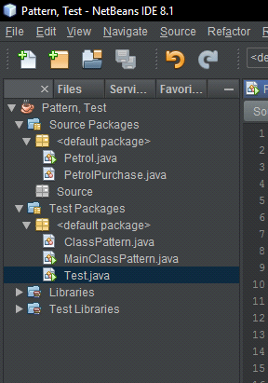

**-How to access web pages:** Your root directory is Web Pages. So you don’t have to type Web Pages in URL. Servlets are carried to Web Pages root directory at deployment. Html and JSPs stay in their folders. If they are in a sub folder in Web Pages then you need to type it in URL. If public.html is under Web Pages\Public\login.jsp then we access it via

“http://localhost:8080/WebApplication1/Public/login.jsp”.

**---Auto Completion:**

-Write a block header, go down one line, write left brace and press enter. It will put the next two lines automatically and put your cursor in middle of block indented.

public static int randomNumber()

{// Press enter here

-You type a method’s name, you type a left paranthesis, right paranthesis will be typed for you, when you are done typing arguments, press “;”. It will automatically move you to right side right paranthesis end type a “;”.

-Or you could auto complete methods name using ctrl+space,

If it has arguments, enter arguments one by one then press enter until you are done(it will show up pink), and then press enter one more time to move to end of the line.

If it doesn’t have any arguments, you can just press “;”.

-When you want to use a member of a class or and object, start typing name of the class /object. When it pops up, press “.” To automatically type class/object name and put a “.” At the end of it.

You can use the notes above to quickly type methods with or without arguments.

-Also when just write “s” and press ctrl + space to auto complete the long print statement. But make sure you don’t use System.err.println instead.Choose system.out from the list.

**-Ctrl + space**: Auto complete. Select the option you want with up and down arrows and then you can either use enter or “;”. Using enter wont put a “;” at the end of the method. Using “;” will put a “;” at the end of method.

-ctrl space also içerik açıklama sayfası açar bir şey ile ilgili bilgi almak istersen. Show source code, Select something and press ctrl-shift-B to see source code. Or you can hold ctrl and click on things.

-Especially when creating subclasses, you can auto create constructors using ctrl+space. It has the superclass parameters and specialized subclass parameters in parameter list and it uses superclass parameters in a super(…) call while assigning the specialized parameters to this.variableName.

**-Generating:** Position your cursor in a class and alt + insert. Very useful for set, get and toString methods.

**---Database:**

-right click thae table and select grab table to export it.

-right click to tables tab(above view and procedures) and select recreate table to import a table.

-To create a table using DDL SQL code or to execute any other SQL code right click “Tables”and click “Execute Command”

**-Last line:**<https://stackoverflow.com/questions/2287967/why-is-it-recommended-to-have-empty-line-in-the-end-of-file>