**Background and Objectives:**

Bushfires and floods are the top 2 natural disasters of Australia. Geographically, bushfires occur mainly in south-eastern Australia, whereas floods occur mainly on the eastern coastline. According to the historical disaster data, houses destroyed were higher by disasters from bushfires compared to floods. In the years between 1967 and 2013, bushfires cost approximately A$4.7 billion, including deaths and injuries but excluding most indirect losses ([link](https://www.ga.gov.au/scientific-topics/community-safety/bushfire)). Royal Commission into National Natural Disaster Arrangements had an inquiry that Australia is not well-prepared for natural disasters. For several months spanning late 2019 and early 2020, bushfires devastated communities across Australia. One of the most brutal fire seasons in recent memory saw thousands of acres of property burnt, homes destroyed, and lives lost. ([link](https://www.healthdirect.gov.au/natural-disasters#:~:text=%20The%20Australian%20Red%20Cross%20has%20an%20emergency,important%20documents%20in%20a%20safe%20place...%20More%20)). Post-traumatic stress disorder (PTSD) is the most commonly seen after natural disasters. Approximately 30-40% among direct victims, 10-20% among rescue workers, and 5-10% among the general population experienced PTSD after a natural disaster ([link](https://r.search.yahoo.com/_ylt=Awr4xLD69nxgKR8A5DgL5gt.;_ylu=Y29sbwNncTEEcG9zAzEEdnRpZANDMTYzNV8xBHNlYwNzcg--/RV=2/RE=1618831227/RO=10/RU=https%3a%2f%2fpubmed.ncbi.nlm.nih.gov%2f15958429%2f/RK=2/RS=Fpn3B7uGu8OBCDbkhb98XLd8tv0-)).

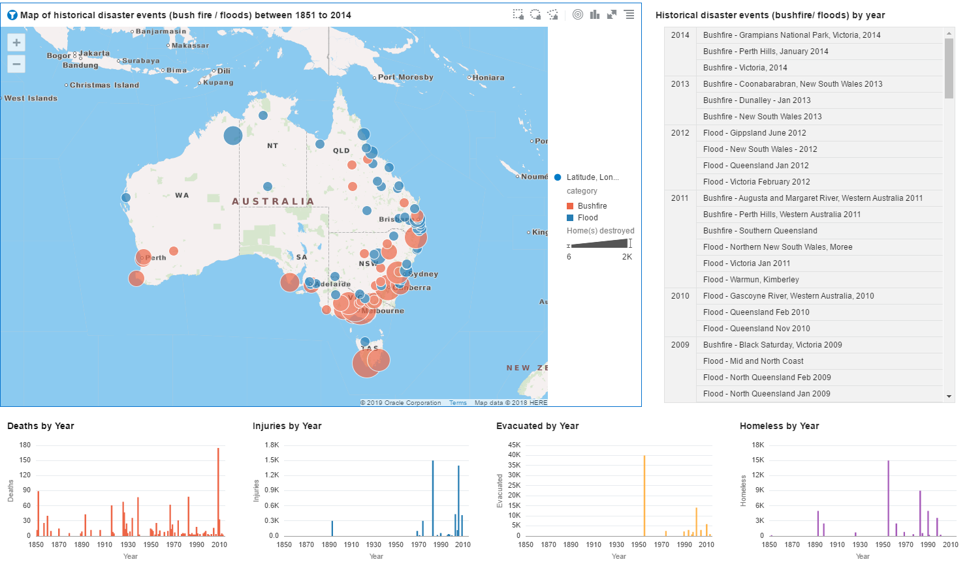

Data: <https://data.gov.au/data/dataset/disaster-events-with-category-impact-and-location>

Minderoo foundation ([link](https://www.minderoo.org/)), a modern philanthropic organisation, aims to build resilience to fires and floods by harnessing the collective power of the communities, industry, and government. We support Noble Minderoo Mission and come up with ideas that will help build resilient communities through self-awareness and acts of kindness. The organisation is reaching out to the leaders of the communities to build a resilient community (top-down approach). We aim to build awareness and contribution at the individual level to build community resilience (bottom-up). We are providing an app where each and everyone can register and prepare themselves for disaster and actively give them recommendations of acts of kindness which they can do at their pace to build Resilient Communities. The power of individuals is immeasurable. For example, a nine-year-old girl started actions to ban the use of plastic straws in her community, and now it has influenced major franchise like Starbucks to use a paper straw instead ([link](https://www.1millionwomen.com.au/blog/10-year-old-girl-ending-plastic-straw-pollution-heres-how/)). Both top-down and bottom-up approach will need to be used for effective implementation to build community resilience.