VINAYAKA VEDIKA
Village Vinayaka Chavithi Committee Portal

Requirements Document
Version 2.0
20 August 2026

Table of contents
(Right-click below and choose “Update Field” in Word to populate this list.)

1. Executive summary
Vinayaka Vedika is a mobile-first web portal that gives our village’s Vinayaka Chavithi committee one shared place for everything the celebration needs: who’s on the committee, what’s been donated and spent, what’s happening each day, and the memories collected along the way.
A working version already exists today. It covers donations and expenses with full transparency, a day-by-day activity schedule with calendar reminders, a photo and video gallery, and two new additions for this year: a year-over-year purchases register (so nothing gets bought twice) and live Day 3 bidding, with winning bids flowing straight into Donations.
This document is the full picture — what’s built, what’s next, and the open questions worth deciding as a team. Section 3 shows what it actually looks like; Section 13 onward is a technical appendix for whoever manages the backend side.

2. Project overview
Every year, the committee coordinates donations, expenses, activities, volunteers, and memories largely through WhatsApp messages, notebooks, and word of mouth. Details get lost between years, contributors don’t always get visible recognition, and each new committee starts from scratch.
Vinayaka Vedika brings all of this into one shared, mobile-friendly place — so any villager can see what’s happening and what’s been contributed, and any committee member can manage it without needing technical skill.

Why “Vinayaka Vedika”
“Vedika” means platform or stage — the same word used for the raised stage or dais at a festival. Vinayaka Vedika is, quite literally, the digital vedika for the celebration: the one place everything about it stands. It also echoes the festival’s own name, so it reads naturally to anyone in the village.

Where things stand
A working prototype already exists — built as a lightweight web app with no separate server behind it, which is a good fit for piloting with one committee this season. Section 14 (Storage & Data Architecture) and Section 15 (Authorization & Access Control) lay out what that means for the long run.

3. Visual reference
A look at the portal as it stands today — real screens, filled with sample data for illustration.
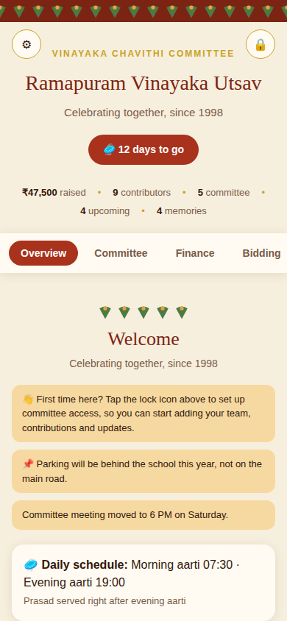
Overview — countdown, live totals, notices, and a place to ask questions.
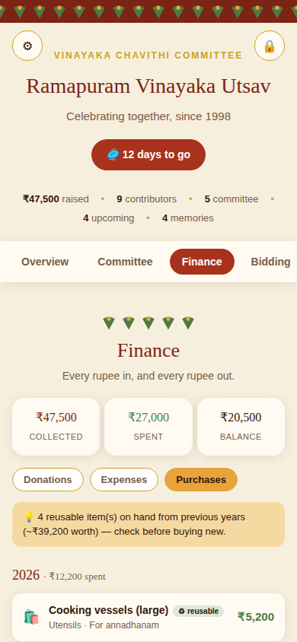
Finance › Purchases — what was bought this year and last, and what can be reused.
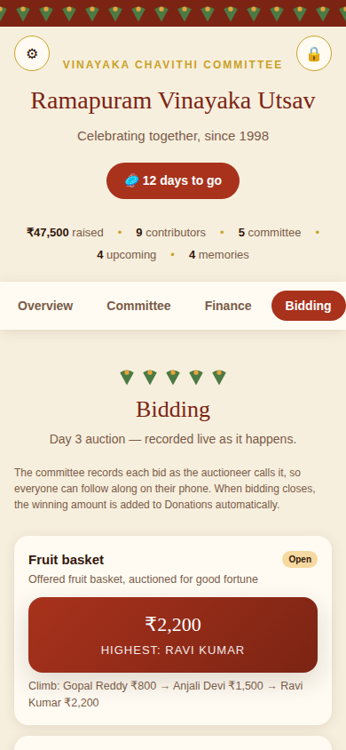
Bidding — Day 3 auction, tracked live, with the winning bid added to Donations automatically.
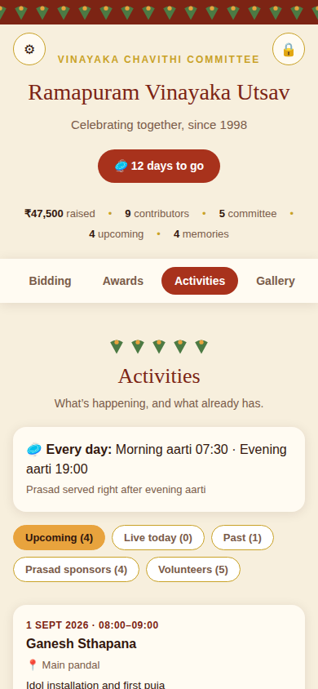
Activities — each event can be added straight to a personal calendar, reminder included.
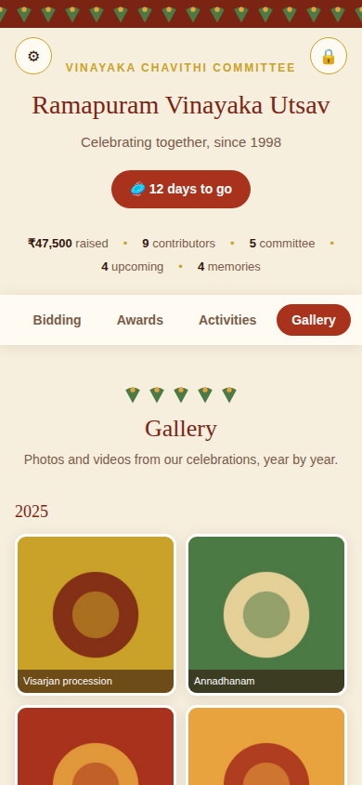
Gallery — photos and videos, grouped year by year.

4. Getting started
How anyone opens the portal, and how the committee gets access to manage it.
Role | Description | Access
Villager / Visitor | Anyone who opens the portal link. Can view every section, vote in the Best Pandal poll, and ask the guidance assistant a question. | View + vote only, no login
Committee Member (Admin) | Unlocked with a shared passcode set by the committee. | Add, edit, and delete entries in every module
# | Feature | Description | Priority | Status
FR-1.1 | Festival countdown | Show a countdown to the festival date, set once in Settings. | Must | Built
FR-1.2 | Live stats strip | Show totals raised, contributor count, committee size, upcoming activities, and gallery items. | Must | Built
FR-1.3 | Celebration details | Set village name, tagline, and festival date. | Must | Built
FR-1.4 | Committee passcode | Set or change the shared passcode that unlocks admin actions. | Must | Built
FR-1.5 | Passcode recovery | If the passcode is forgotten, clear it from the login screen so a fresh one can be set. No one is ever permanently locked out. | Should | Built
FR-1.6 | Data backup | Download a full JSON backup of all portal data on demand. | Should | Built
FR-1.7 | Emergency contacts | Set doctor, police, and coordinator numbers; shown on Overview once filled in with real numbers. | Should | Built

5. Community & committee
Who’s running things, and how the committee keeps everyone informed.
# | Feature | Description | Priority | Status
FR-2.1 | Committee directory | List members with photo, name, role, and phone. | Must | Built
FR-2.2 | Manage members | Add, edit, and remove members (admin only). | Must | Built
FR-2.3 | Manage notices | Add, pin, and remove short notices (admin only). | Should | Built
FR-2.4 | Display on Overview | Show pinned notices first, most recent next. | Should | Built
FR-2.5 | Volunteer duty roster | Record volunteer name, duty, date/shift, and contact. | Should | Built

6. Money
Every rupee in, every rupee out, what was bought, and this year’s Day 3 auction — all in one place, with a live Collected / Spent / Balance summary at the top of the tab.

Donations
# | Feature | Description | Priority | Status
FR-3.1 | Donation log | Record donor name, amount, date, and an optional note. | Must | Built
FR-3.2 | Running total | Show total raised and number of contributors. | Must | Built
FR-3.3 | Search & sort | Search by name; sort by date or amount. | Should | Built
FR-3.4 | Top contributors | Highlight the top three contributions. | Could | Built
FR-3.5 | Contribution tiers | Badge each donation as Platinum / Gold / Silver / Contributor by amount. | Could | Built
FR-3.6 | UPI scan-to-pay | Generate a QR code from a UPI ID set in Settings. | Could | Built
FR-3.7 | Printable receipt | Print a simple receipt per donation (admin only). | Could | Built

Expenses
# | Feature | Description | Priority | Status
FR-4.1 | Expense log | Record category, amount, date, paid-to, and an optional note. | Should | Built
FR-4.2 | Balance summary | Show collected, spent, and balance in hand together. | Should | Built

Purchases & assets — new
A year-over-year register of what’s been bought, so the committee can see what’s already on hand before spending again.
# | Feature | Description | Priority | Status
FR-5.1 | Purchase log | Record item, category, cost, year, and whether it’s reusable, plus a condition note. | Should | Built
FR-5.2 | Year grouping | Group purchases by year, newest first, each with a year total spent. | Should | Built
FR-5.3 | Reusable inventory flag | Highlight items marked reusable, with their combined value, so nothing gets bought twice. | Should | Built

Bidding — new
Day 3 includes a live auction. The committee records each bid as it’s called out, so anyone can follow along on their phone — and when bidding closes, the winning amount is added to Donations automatically.
# | Feature | Description | Priority | Status
FR-6.1 | Bid items | Add items for auction with a starting bid and description (admin only). | Should | Built
FR-6.2 | Record a bid | Log each new highest bid and bidder as the auction happens (admin only). | Should | Built
FR-6.3 | Bid history | Show the climb of previous bids for each item. | Could | Built
FR-6.4 | Close bidding | Lock in the winner and automatically create a matching donation entry. | Should | Built
Design note: bids are recorded by the committee rather than submitted directly by bidders. That matches how the auction actually runs — an auctioneer calling numbers aloud — and avoids the awkwardness of an unverified online bid that no one intends to honour.

7. Celebration schedule
What’s happening, when, and how villagers get reminded.

Activities & daily schedule
# | Feature | Description | Priority | Status
FR-7.1 | Activity schedule | List activities split into Upcoming, Live today, and Past, classified automatically by date. | Must | Built
FR-7.2 | Manage activities | Add and remove activities with title, date, time, location, and description. | Must | Built
FR-7.3 | Daily schedule | Set recurring morning/evening aarti timings and a note, shown on Overview and Activities. | Should | Built

Calendar & reminders
# | Feature | Description | Priority | Status
FR-8.1 | Start & end time on activities | Every activity can carry both a start and end time (e.g., Puja 8:00–9:00), not just a single time. | Must | Built
FR-8.2 | Add to Google Calendar | A link on each timed activity opens Google Calendar pre-filled with the title, time, and location. | Should | Built
FR-8.3 | Download calendar file (.ics) | Each timed activity can be downloaded as a standard calendar file, for Apple Calendar, Outlook, and others. | Should | Built
FR-8.4 | Built-in reminder | Every downloaded calendar file carries a 30-minute-before reminder, handled by the villager’s own phone once it’s added. | Should | Built
FR-8.5 | Automatic reminder to every visitor | Notify everyone who has opened the portal ahead of an event, without them adding anything themselves. | Could | Needs backend
FR-8.1 to FR-8.4 need nothing beyond what’s already built: a villager taps “Add to Google Calendar” or downloads the .ics file, the event — with its reminder — lands in their own calendar, and their phone handles the notification from there.
FR-8.5 needs a hosted web app with its own domain, a notification service, and a server that fires reminders on schedule — the same backend investment described in Section 14. A more immediate alternative: use the “Copy shareable update” feature on Overview to post timings into the committee’s WhatsApp group.

Prasad / bhandara sponsors
# | Feature | Description | Priority | Status
FR-9.1 | Sponsor sign-up | Record sponsor name, date, item, and an optional note. | Should | Built

8. Recognition

Awards
# | Feature | Description | Priority | Status
FR-10.1 | Awards list | List recognitions by year, with recipient and category. | Should | Built
FR-10.2 | Manage awards | Add and remove awards (admin only). | Should | Built

Best pandal voting
# | Feature | Description | Priority | Status
FR-11.1 | Nominees | Add nominees with name, note, and optional photo (admin only). | Could | Built
FR-11.2 | Public voting | Anyone can cast one vote per visit; no login required. | Could | Built
FR-11.3 | Live tally | Show a live vote count and proportion bar per nominee. | Could | Built

9. Memories
# | Feature | Description | Priority | Status
FR-12.1 | Photo uploads | Upload photos; compress automatically for storage. | Must | Built
FR-12.2 | Video / album links | Add a link for video or albums; auto-embed recognised YouTube links. | Should | Built
FR-12.3 | Year grouping | Group gallery items by year automatically. | Should | Built
FR-12.4 | Lightbox viewer | Open any photo or video in a focused viewer. | Must | Built
FR-12.5 | Storage warning | Warn once in-app photo storage is close to its limit. | Should | Built

10. Getting help — new
Answering a visitor’s question about the festival — either using this portal’s own live data, or general knowledge about Vinayaka Chavithi traditions.
# | Feature | Description | Priority | Status
FR-13.1 | Ask a question | A visitor types a question and gets a short answer, grounded in this portal’s own schedule and totals where relevant. | Could | Built
This works by having the portal call Anthropic’s Claude API directly from the visitor’s browser, passing in the portal’s current settings and schedule as context. No separate backend or subscription is needed — it rides on the same platform this portal itself is built on. It’s meant for lightweight guidance (timings, general tradition questions), not a substitute for asking the committee directly about anything important.

11. Localization — planned
An English / Telugu / Hindi language toggle has been agreed but intentionally deferred, since it touches every label in the app and deserves a focused pass to get right rather than being rushed in alongside other features.
# | Feature | Description | Priority | Status
FR-14.1 | Language toggle | Switch all interface labels between English, Telugu, and Hindi. | Should | Planned

12. Suggested enhancements (not yet scoped)
Ideas worth discussing for a future version. None of these are committed yet — listed here so the team can weigh them together.
Suggestion | Description
Lost & found board | A simple board for lost/found items during event days.
Visarjan (immersion) day logistics | Tank/pond location, timing, and transport arrangements for immersion day.
Cultural program sign-up | Slot-based sign-up for singers, dancers, and skits during evening programs.
Guest book / wishes wall | A short message or blessing visitors can leave.
Committee handover notes | A place for this year’s committee to leave lessons for next year’s.
Local sponsor strip | A small thank-you row for local shops/businesses that contribute.
Entrance QR code | A printable QR code linking straight to the portal, for the pandal entrance.
Vendor/supplier directory | Tent house, flowers, priest, electrician contacts with past years’ rates.
Multi-year trends dashboard | Compare funds raised and spent across years.
Post-event feedback form | A short 3-question QR-based survey after the festival.
Granular admin roles | Separate passcodes for, say, a treasurer (Finance only) versus general committee.
Installable app (PWA) | Let villagers add the portal to their phone’s home screen like an app.
Rain / contingency plan note | A static note field for the wet-weather backup plan.
VIP / guest visit log | A simple log of dignitary visits, if relevant.
Accessibility notes | Priority access information for elderly or differently-abled visitors.

Technical appendix
The sections below are for whoever manages the technical side of the portal — committee members don’t need to read further to understand what it does.

13. Non-functional requirements
- Mobile-first: the primary audience will open this on a phone, often on an ordinary Android browser.
- No login required to view; a lightweight shared passcode unlocks editing today — see Section 15 for what real authorization would involve.
- Storage sits on a lightweight, built-in layer rather than a traditional server — see Section 14 for what that can and can’t do long-term.
- Backups: a manual full-data export (JSON) is available; regular backups are recommended given the portal holds donation and expense records.
- Language: English at launch; Telugu and Hindi planned (Section 11).
- Low-bandwidth tolerance: village connectivity can be inconsistent, so the page should stay light and avoid unnecessary heavy assets.
- The AI guidance feature (Section 10) calls Anthropic’s API directly from each visitor’s browser — there is no stored credential or server-side component to manage.

14. Storage & data architecture
The prototype stores everything using a lightweight, built-in storage layer tied to the Claude artifact itself — there is no separate server or database behind it today.
What that means in practice:
- Text and structured records — donations, expenses, purchases, committee members, activities, bidding, notices, and so on — work reliably, with no meaningful limit for a village committee’s scale.
- Photos are stored as compressed images inside that same storage. A reasonable number work well; there’s a soft ceiling around 5 MB in total, after which the portal recommends external links instead.
- Videos are never stored directly — always by link (YouTube, Google Photos, or Drive), which matches how most committees already share video anyway.
- There’s no traditional file system or database to back up separately — the one-click JSON export (FR-1.6) is the closest thing to a backup today.
Good fit for: piloting with one committee this season, at no hosting cost, with nothing to maintain.
Real limits for: guaranteed durability across many years, large media archives, several villages sharing one system, or any situation requiring formal data-custody guarantees.
If Vinayaka Vedika continues beyond this season, the natural next step is a small hosted backend — a real database (for example PostgreSQL, or a managed option like Supabase or Firebase) and file storage for larger media (for example Cloudinary or S3) — or simply continuing to lean on YouTube and Google Photos links, which cost nothing and villagers already know how to use.

15. Authorization & access control
Today, one shared passcode unlocks every admin action for whoever holds it. It works as a deterrent against casual visitors editing things by accident, but it is not real access control — anyone with the passcode can do anything, and there’s no record of who made which change. If the passcode is forgotten, anyone can clear it from the login screen and set a new one (FR-1.5) — a deliberate trade-off: no one gets permanently locked out, at the cost of the reset itself not being gate-kept. That trade-off is consistent with treating this as a deterrent rather than real security.
A proper system would add:
- Individual accounts, most practically phone number plus OTP, since that’s already how most villagers verify identity elsewhere.
- Roles — for example, a Treasurer limited to the Finance module, a General Committee member with full access, and a read-only Viewer role.
- An audit trail — a simple log of who changed what, and when.
This needs the same backend investment described in Section 14; it isn’t something the current lightweight prototype can add on its own. It’s listed here as a decision point for whenever the committee is ready to move past this season’s pilot — see also “Granular admin roles” in Section 12.

16. Data model
A brief look at what the portal stores, for anyone building or extending it.
Entity | Key Fields
Settings | Village name, tagline, festival date, UPI ID, aarti timings, emergency contacts, committee passcode
Committee Member | Name, role, phone, photo
Donation | Donor name, amount, date, note
Expense | Category, amount, date, paid to, note
Purchase | Item, category, cost, year, reusable flag, condition note
Bid Item | Item name, description, starting bid, current bid, current bidder, status, bid history
Award | Title, recipient, year, note
Nominee (voting) | Name, note, photo, vote count
Activity | Title, date, start/end time, location, description
Prasad Sponsor | Sponsor name, date, item, note
Volunteer | Name, duty, date/shift, contact
Notice | Message, date, pinned flag
Gallery Item | Type (photo/video), source, caption, date

17. Open questions & assumptions
- This year’s exact festival date needs local confirmation — it shifts yearly on the lunar calendar.
- Contribution tier thresholds are assumed at ₹10,000 (Platinum), ₹5,000 (Gold), and ₹1,000 (Silver) — confirm these match community expectations.
- Who holds and rotates the committee passcode each year is not yet decided.
- Whether the portal’s data should carry over year to year, or reset each season, needs a decision.
- Whether the default 30-minute calendar reminder (Section 7) suits the community, or should be adjusted.
- Whether WhatsApp broadcast remains the primary reminder channel, or automatic push notifications are worth the backend investment later (Section 7).
- Whether bid items (Section 6) need photos or just descriptions for the auction.
- Whether purchase records (Section 6) from years before this portal existed are worth back-filling, or only tracked going forward.
- Whether the AI guidance feature (Section 10) should be visible to every visitor by default, or something the committee turns on deliberately.
- When, if at all, to invest in a real backend for long-term storage and proper authorization (Sections 14–15) depends on how many committees/villages adopt it.

