**Lesson 4 Demo 1**

**Creating User Stories**



Stepsto be followed:

1. Navigate to the Jira Software tool
2. Create user stories

**Step 1: Navigate to the Jira Software tool**

* 1. We have already created a project called eStore.

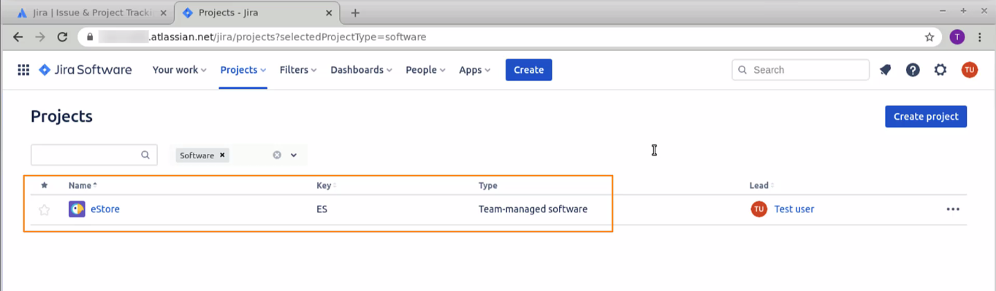

* 1. When you open the project, you will be directed to the board.

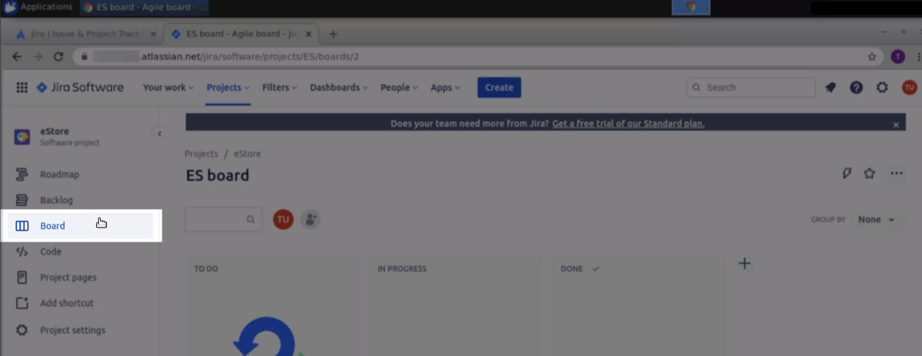

**Step 2: Create user stories**

* 1. We will be dividing the e-commerce application into two parts. One we will have the admin dashboard with all project details and an end-user application, which the users will use to browse the projects. So, click on the **Create** button.

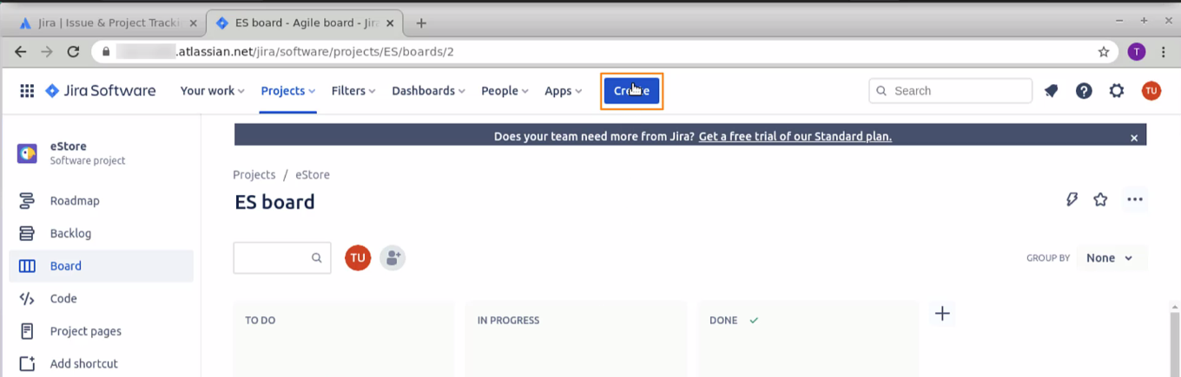

* 1. Select the issue type as Epic

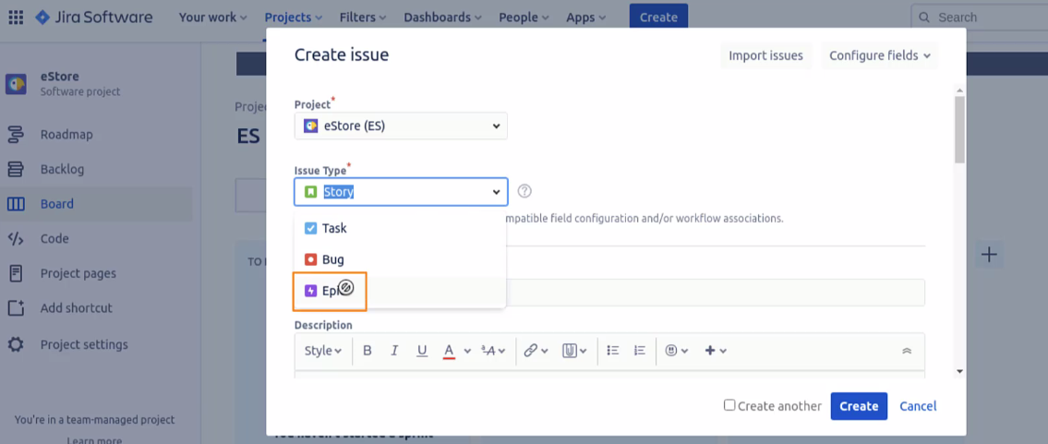

* 1. Add the summary for the admin dashboard and add some description for it

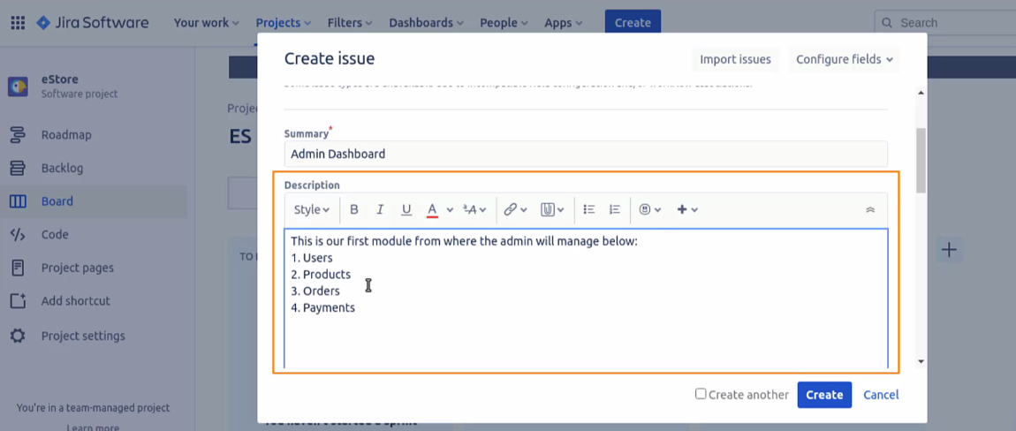

* 1. Once the description and the details are added, click on the **create** button

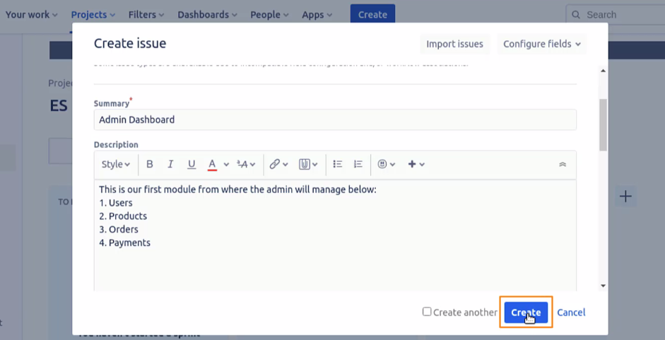

* 1. The Epics created are not inside the board, but are moved inside the roadmap. So, go to the roadmap, and you would be able to see the Epic listed there.

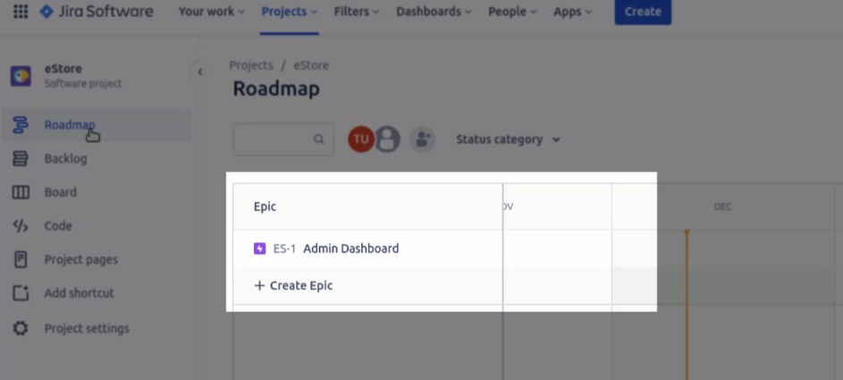

* 1. You can also create the epics directly from here by clicking on the create Epic button. Click on it and create another Epic for an end-user web app.

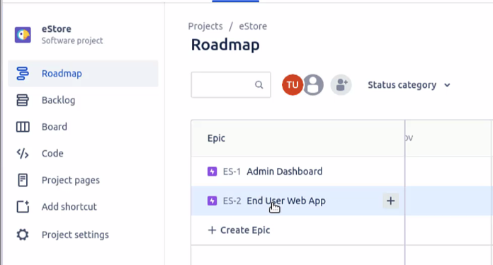

* 1. Go to the right-hand side and add all the descriptions for it. It has an auto-save feature. Whatever you write gets auto-saved.

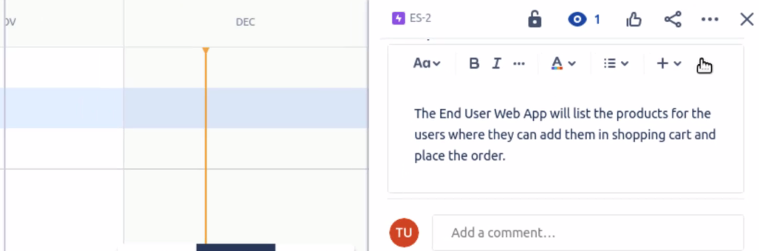

* 1. Now, let us create the user stories. Go to the epic and click on the **+ icon.**

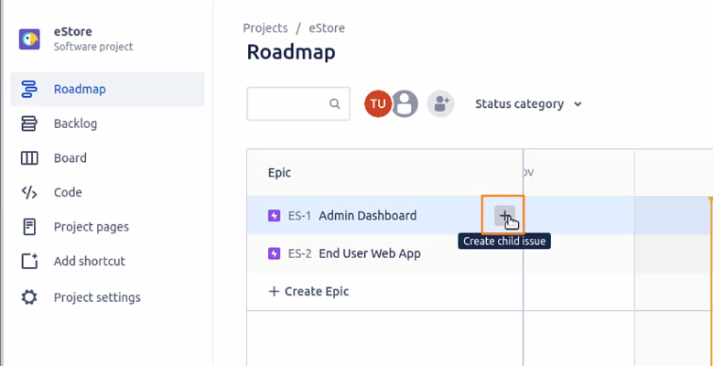

* 1. Change the issue type to the story and add a summary and description to it

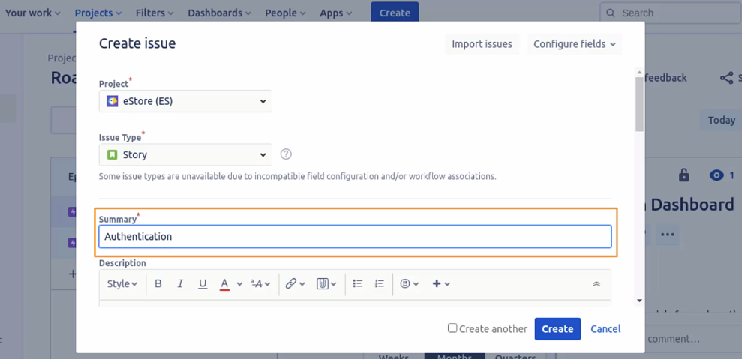

* 1. Add description. You can select the text and click on bold to bold the text. You will be adding descriptions about the modules in your authentication module, which include, the description, acceptance criteria, validations, and more.

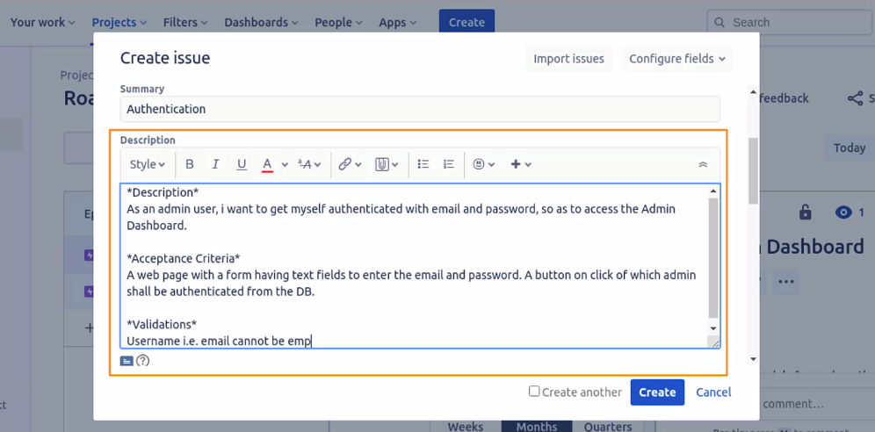

* 1. You can also add details about the non-functional requirements. Please note, all these factors depend on the application you are going to build.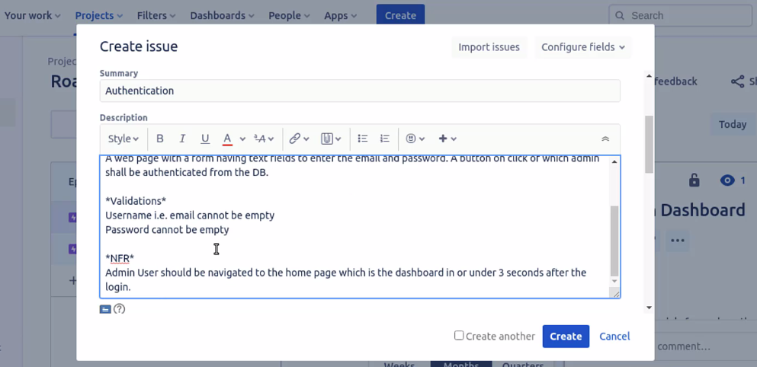
  2. Scroll down, link the story to the issues created, and click on the **create** button

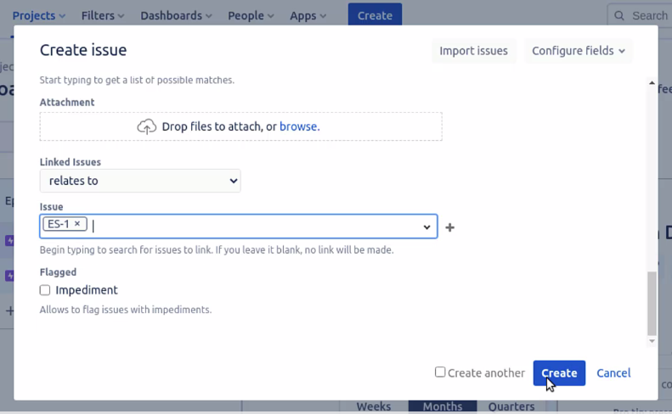

* 1. A prompt will appear for the user story being created.

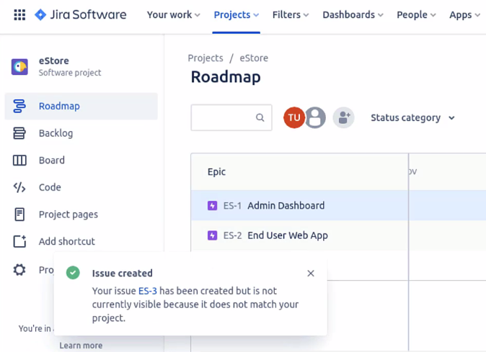

* 1. Now, go to the backlog, and you can see that the Authentication is a story. Click on it, and you can move it to **In progress.**

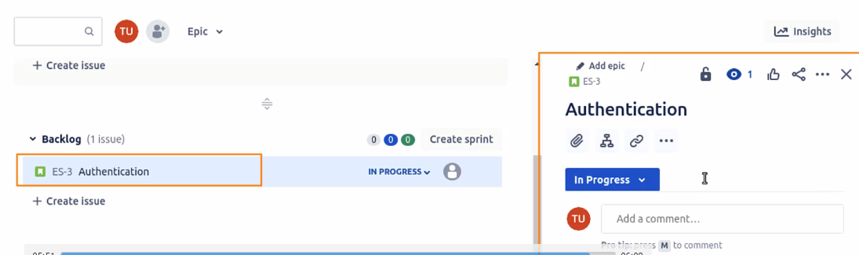

This is how you create and work with user stories.