**Lesson 4 Demo 2**

**Jira Walkthrough**



There are multiple software development tools in an incremental approach. One such tool is Jira software. Agile is one of the software development approaches with the help of which you can develop the software in an incremental approach. You can regularly deliver a high-priority software solution to the customer by satisfying all the requirements effectively. It is one of the more robust, agile management tools. It comes up with all the requirements to support software development through Agile.

Steps to be followed:

1. Jira walkthrough

**Step 1: Jira walkthrough**

1.1 Login to the Jira software or signup using a GitHub or Google account. Once you log in, you will be logged into the Atlassian account, and you can see various tools available.

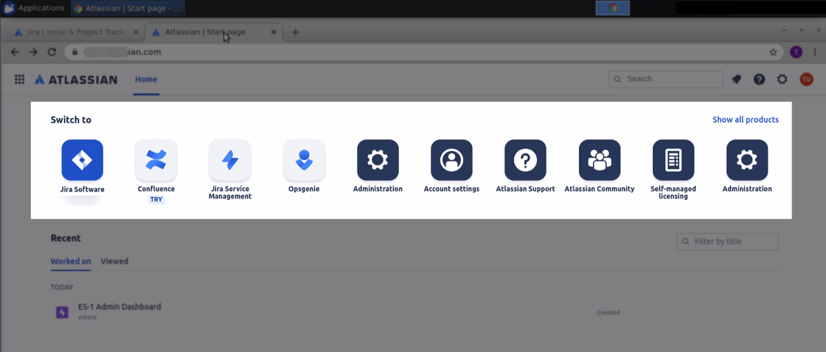

* 1. Click on the Jira software

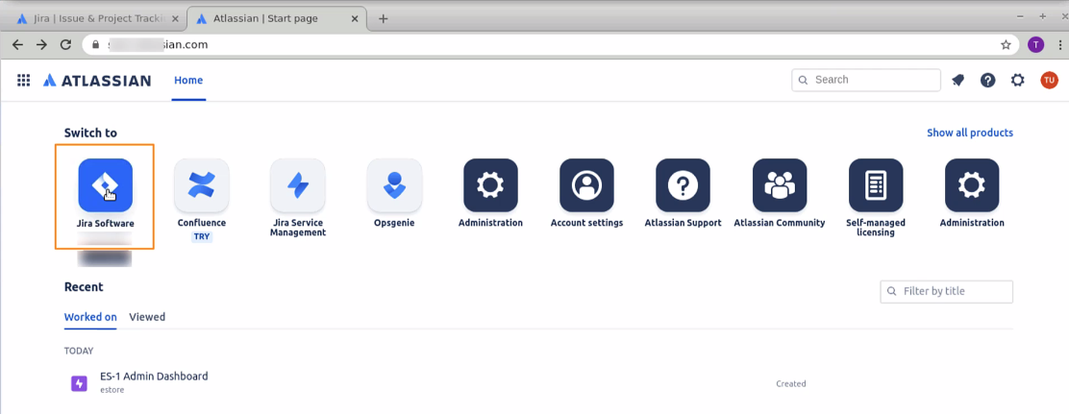

* 1. We can create a project by clicking on the **Create project** button.

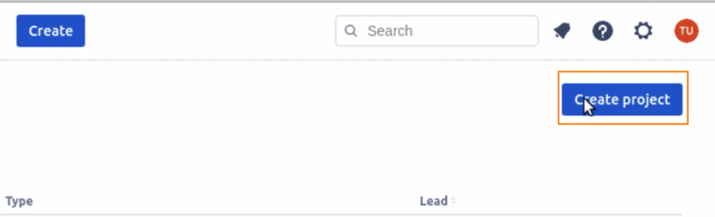

* 1. You can also work with some applications and link them to Jira. Go to the apps section, and you can see the apps.

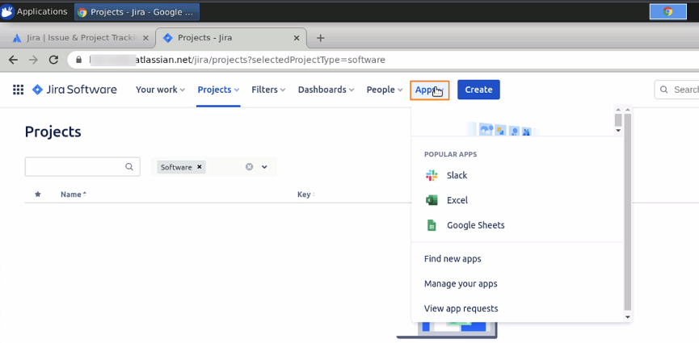

* 1. In the people section, you can invite your teammates or create a team.

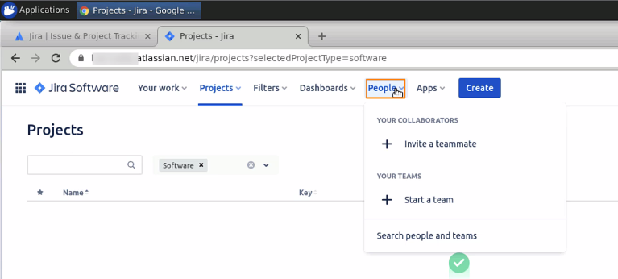

* 1. The dashboard gives you a powerful visualization of whatever you do in your project.

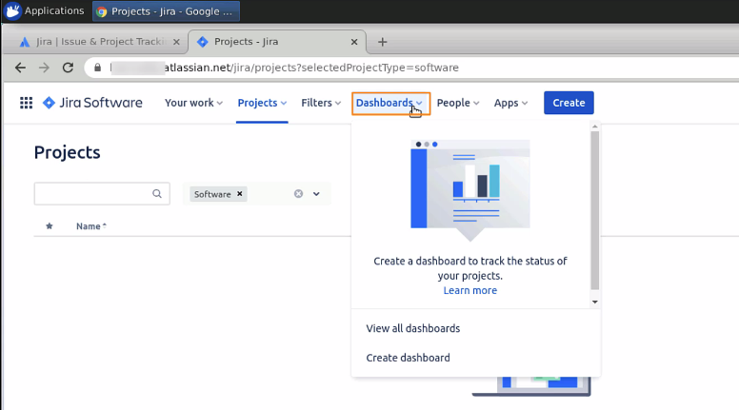

* 1. The projects window is basically where you can manage your projects.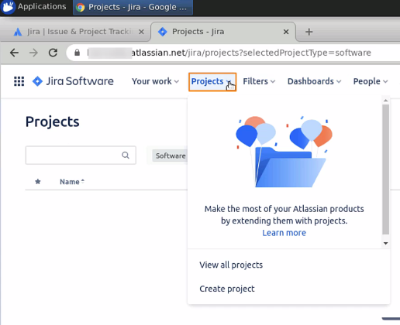
  2. In filters, you can apply the filters so that you get some issues out of your projects in some basic way.

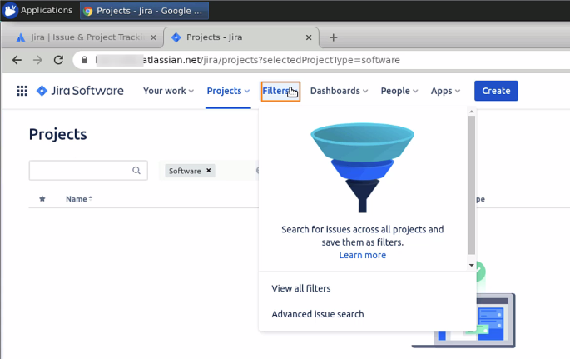

* 1. Now, create a project by clicking on the **Create project** button

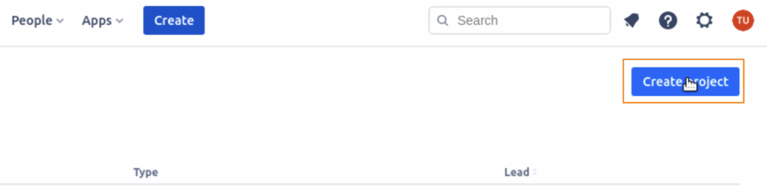

* 1. You will be able to see three different templates in the software, as shown below:

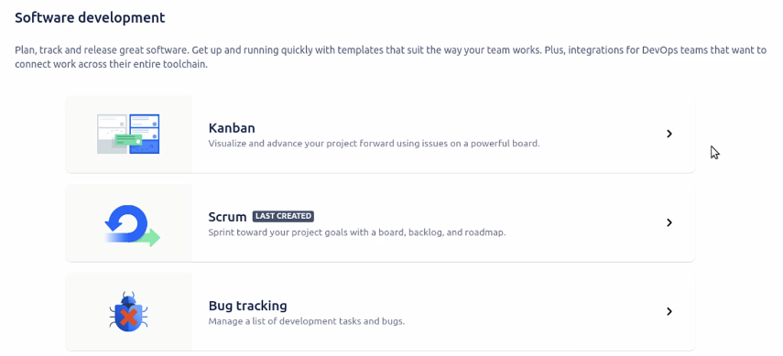

* 1. Click on **Scrum**, as we will be using Scrum to define sprints and user points

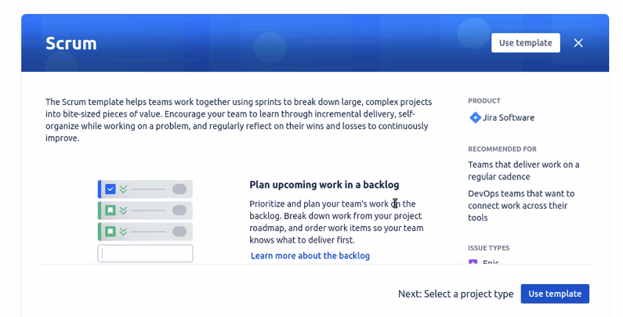

* 1. Scroll down, and you will be able to see different issue types

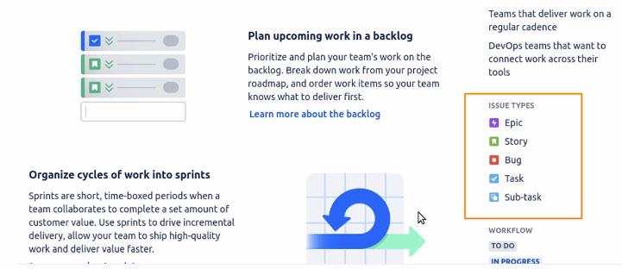

* 1. In the workflow, you can see the status of the tasks. Click on the use template button

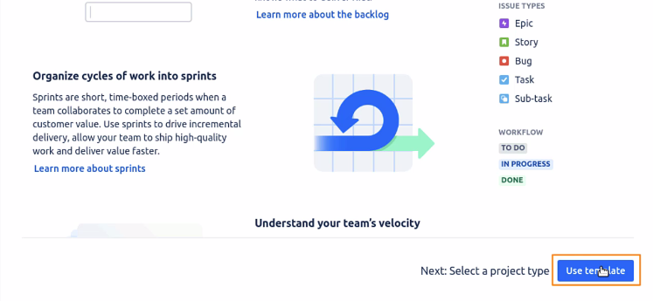

* 1. Choose the project type

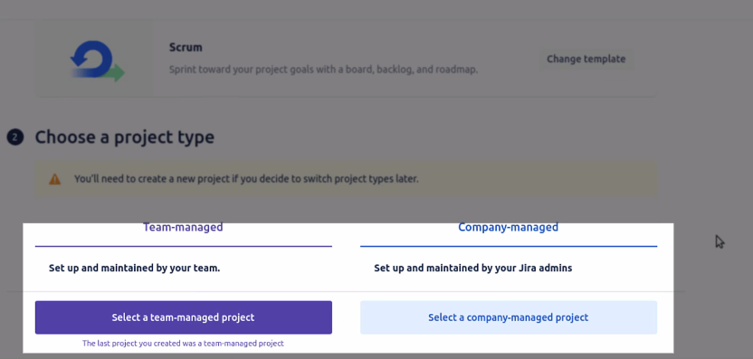

* 1. Click on **Select a team-managed project**

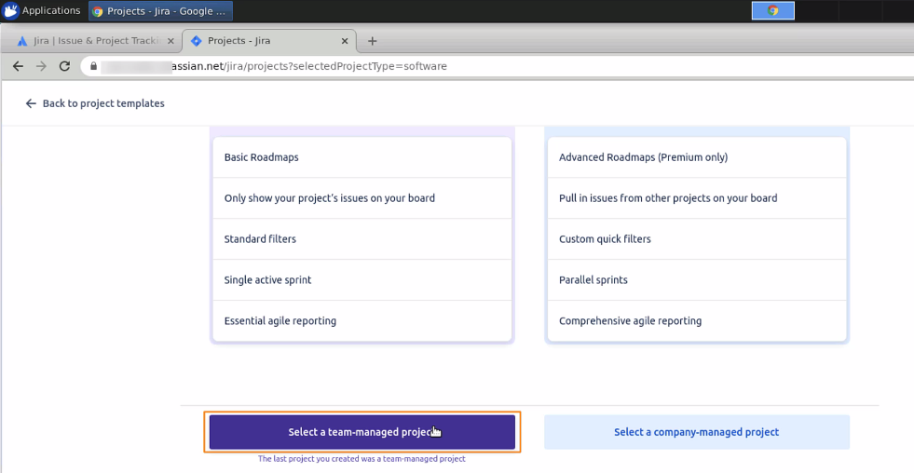

* 1. Give a name to the project, say, eStore, for an e-commerce web application. The key will be taken automatically. This key is an identifier of which key belongs to which project.

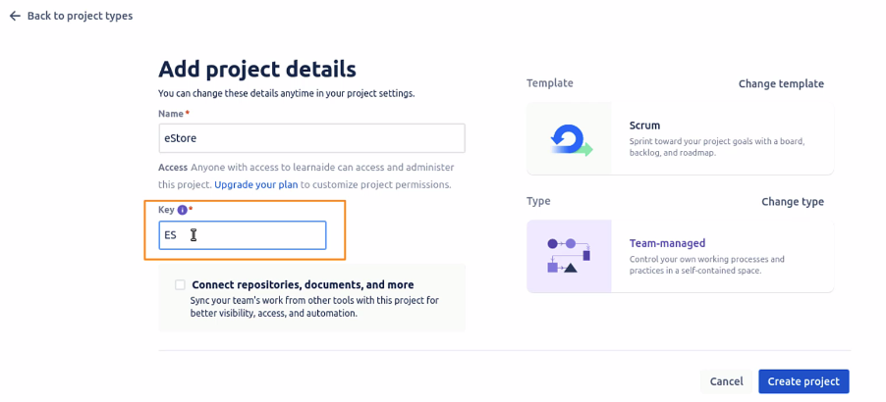

* 1. Once done, click on the **create project** button. The project will be created.
  2. By default, we will land on the board section. You can see the *TO DO*, *In Progress*, and the *DONE* section. You can also click on the + button to create a customized board.

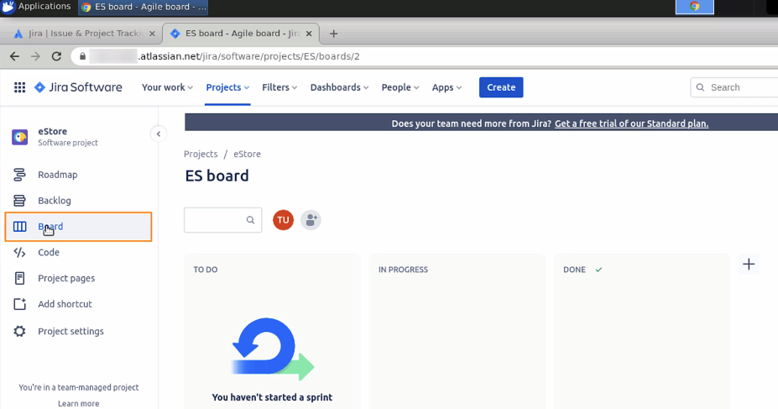

* 1. Now, go to the roadmaps. This specifies the epics for your projects.

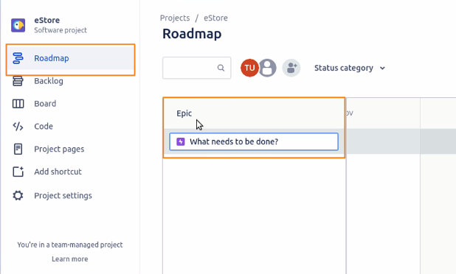

* 1. The backlog section has all the issues listed, and you can plan your sprint here.

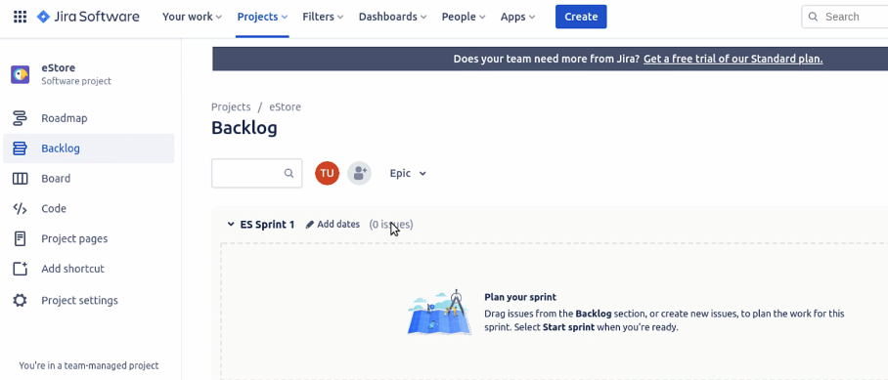

* 1. In the code section, the team can work on the code for the project. It allows integration with GitHub, BitBucket, and other tools.

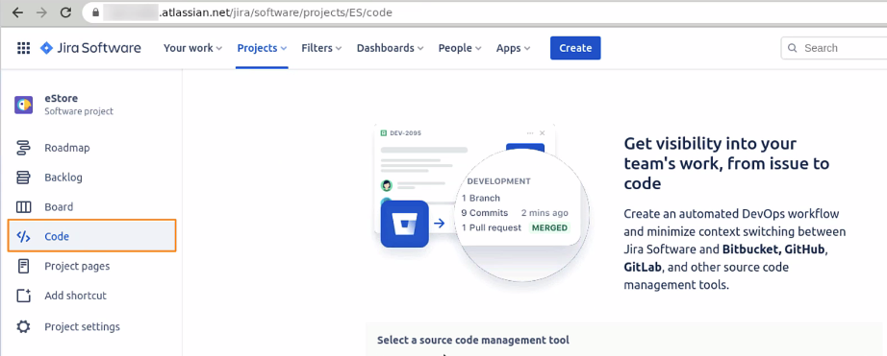

* 1. The project page section helps in creating documentations about the project.

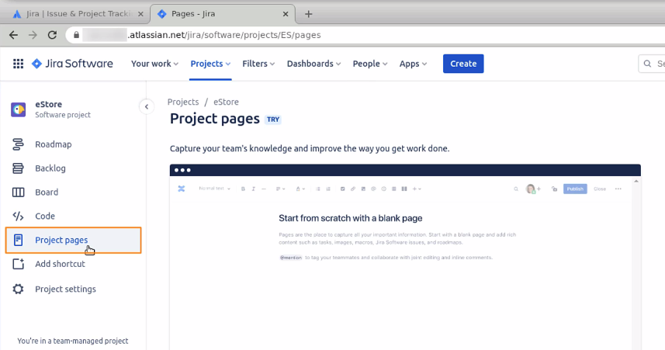

* 1. In the retrospective section, you can manage the retrospective approach.

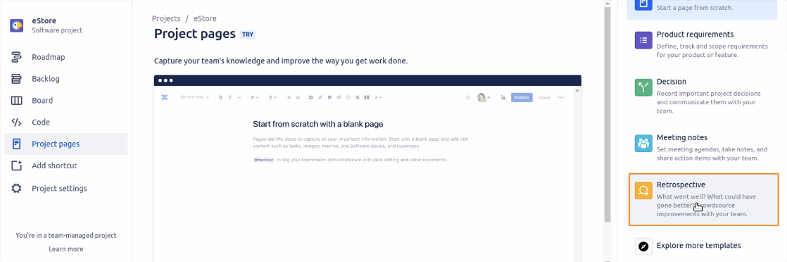

* 1. Click on **Add Shortcut** button to add shortcuts to frequently used repositories

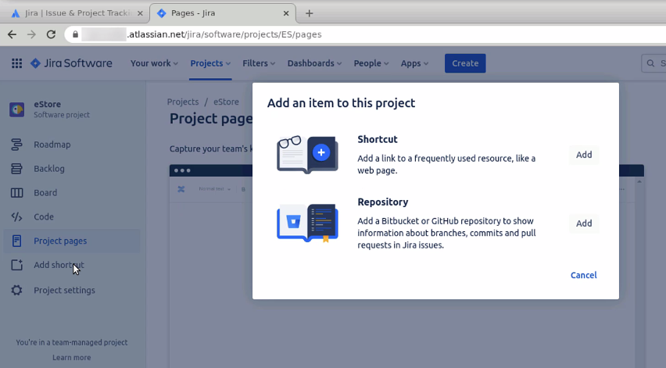

* 1. In the project settings, there are options to change a few structures of the project.

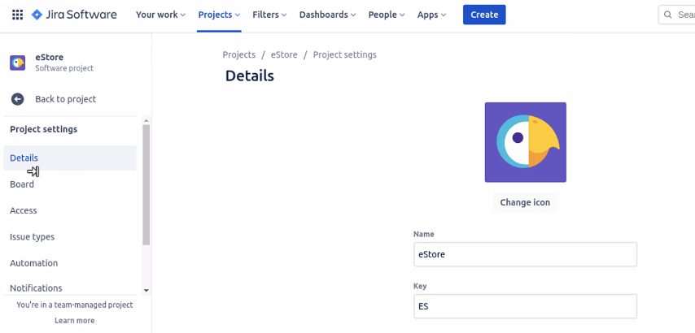

* 1. Now, go back and click on the **create** button

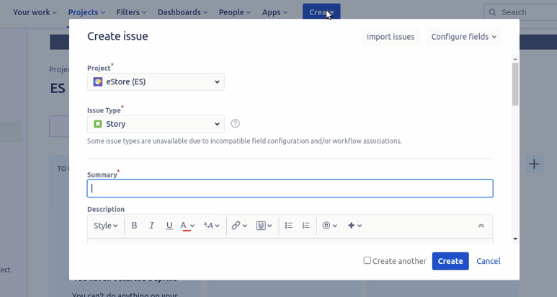

* 1. You can create issues, which can be a story, Task, Bug, or Epic

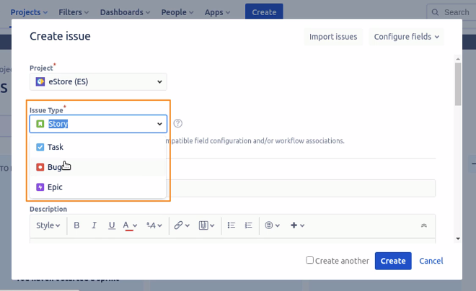

* 1. You can also add a summary, a description, an assignee, labels, and so on.

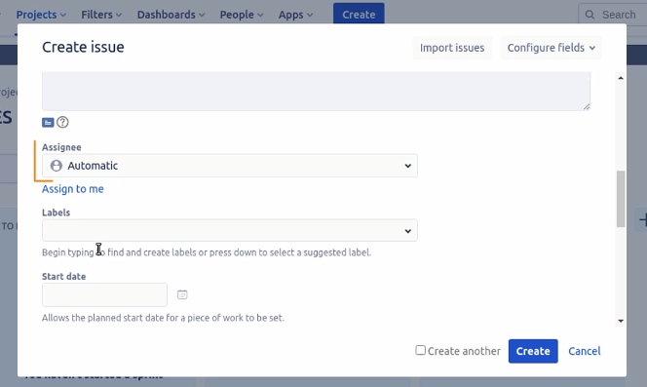

Please note, the same fields will appear, irrespective of the issue type selected. Different issues can be created inside the Jira project, which helps in managing the project. This is all about the walkthrough of Jira.