**Lesson 1 Demo 1**

**Using Angular CLI Commands**

**Steps to perform:**

1. Open the terminal window, and execute the **ng version** command

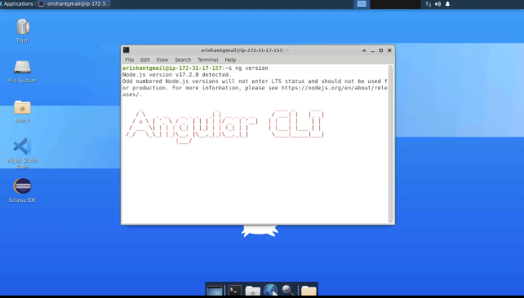

1. Type **ng v** for version check

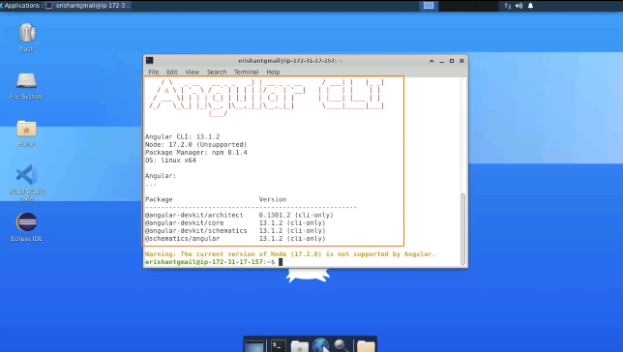

1. The **ng help** command shows the available commands with their description

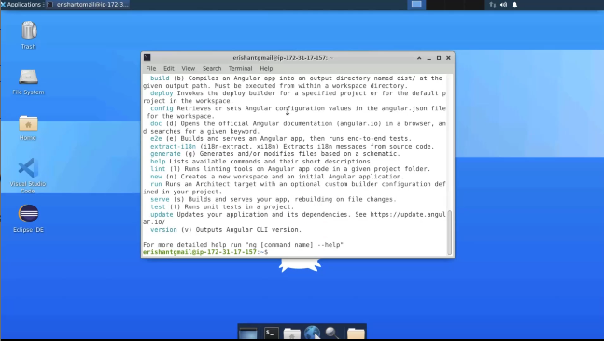

1. Write **ng - - help**

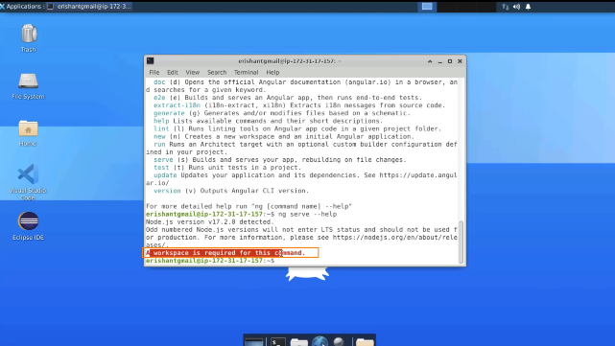

1. Open **estore** project with terminal

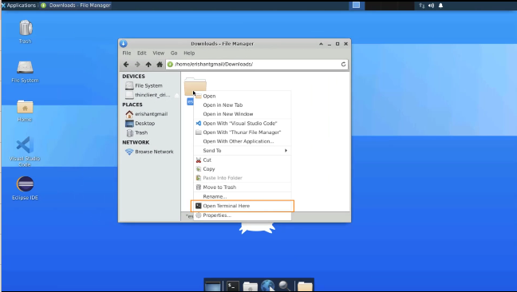

1. Open the directory with Visual Studio Code

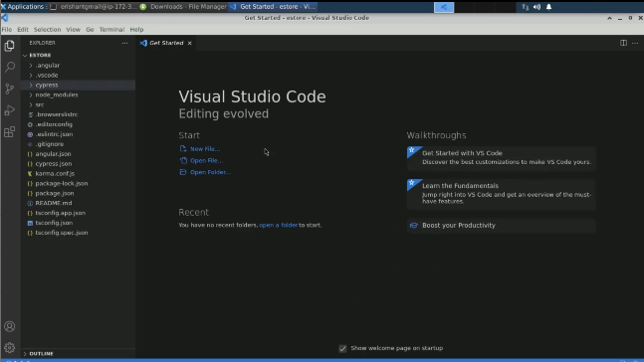

1. Execute the command **ng help**

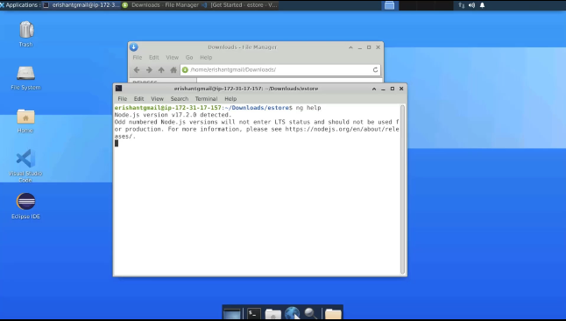

1. Type **ng - - help**

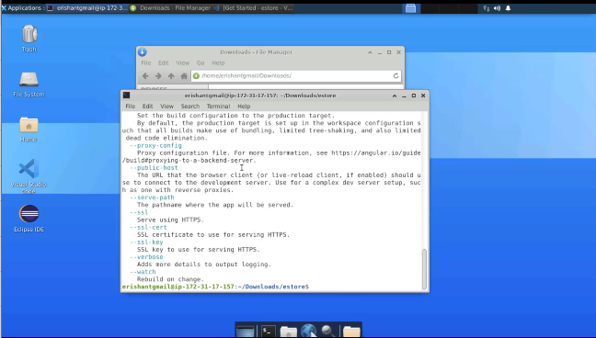

1. Pass **ng serve** command

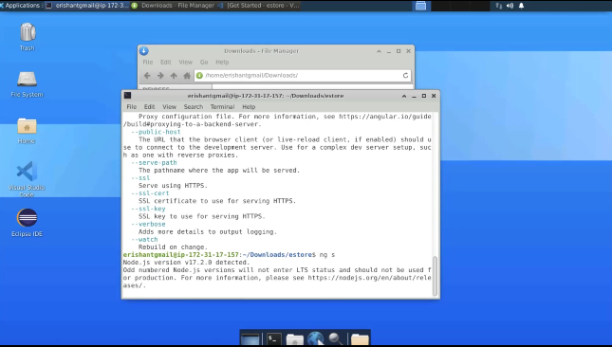

1. Open the local host using a browser

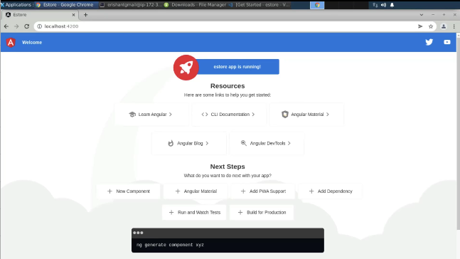

1. Navigate to the source and then the application

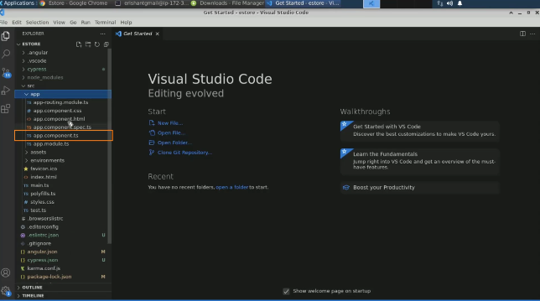

1. Write **estore – shopping made easy** as the title and save it

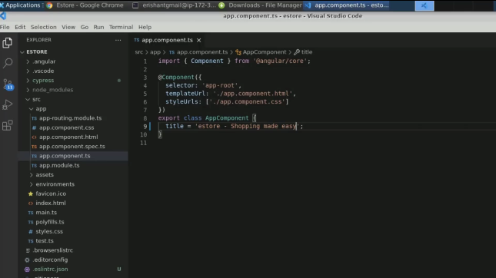

1. Navigate back to the browser

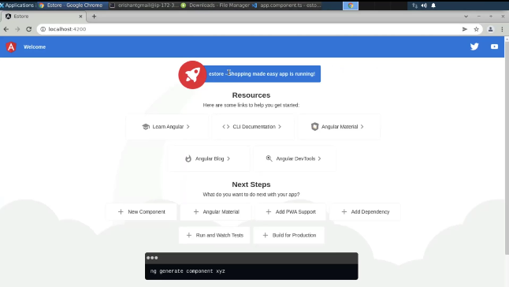

1. Type **ng serve – o** and press enter

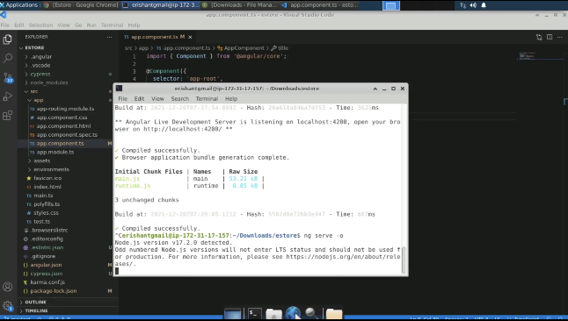

1. Type **ng build** to compile the Angular application

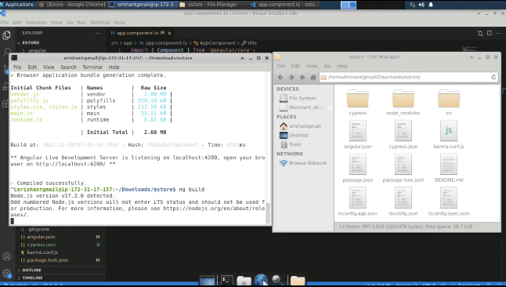

1. The new directory is added to the folder

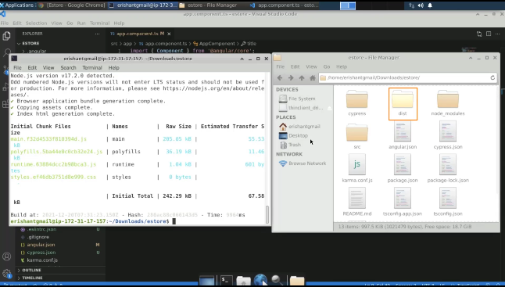

1. Run **ng test** command

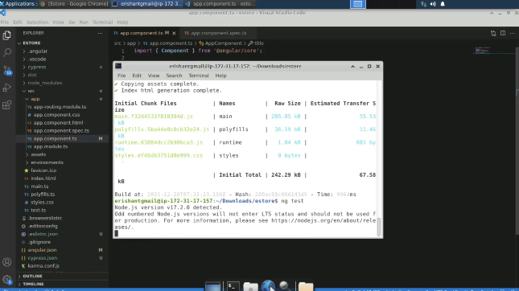

1. One of the test cases is failed

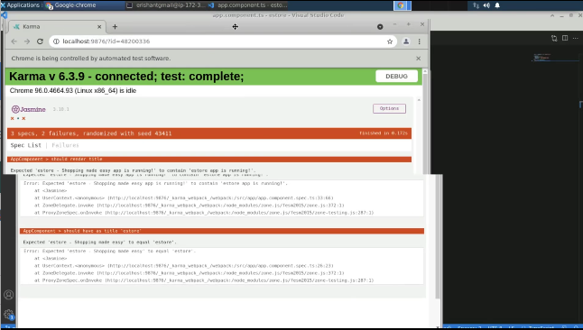

1. Change the title to **estore** only in the components

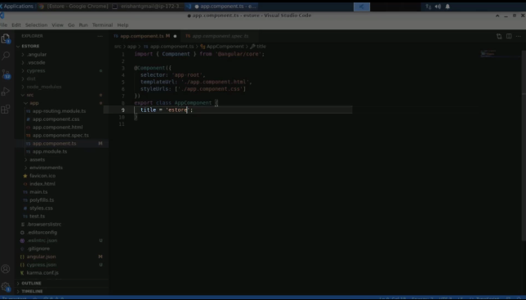

1. Execute the **ng test** command again

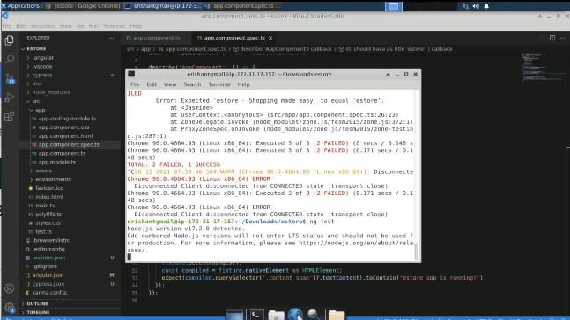

1. All the test cases are passed

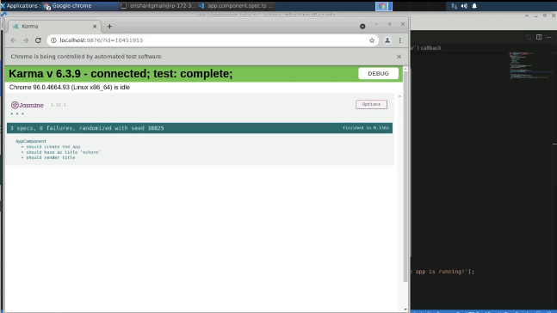

1. Run **ng e2e** command

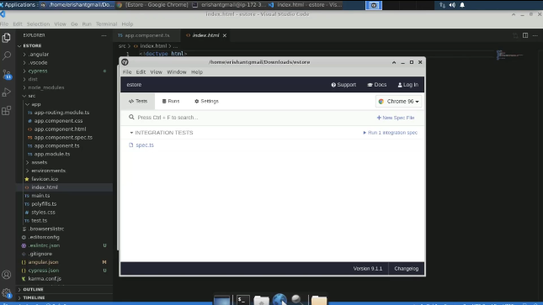

1. e2e command helps to run end-to-end run cases

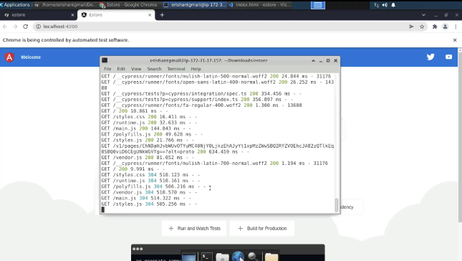

1. Run the **ng g component profile** command and press enter

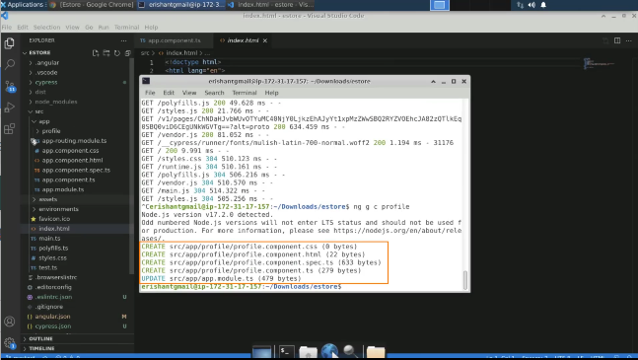

1. Now, the profile folder is created

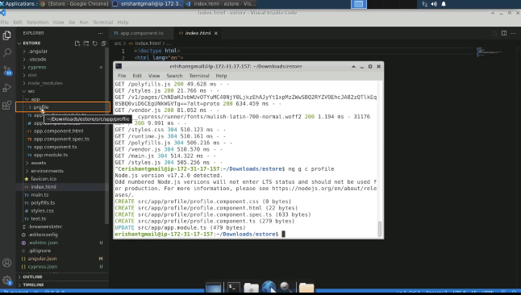

1. Write **ng generate service DataProvider**

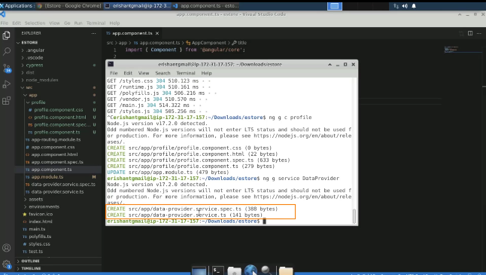

1. To check the quality of the project, write **ng lint**

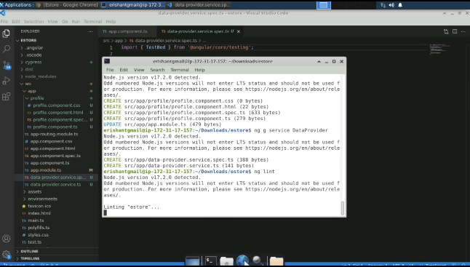

1. Remove the semicolon from the ts file and save it

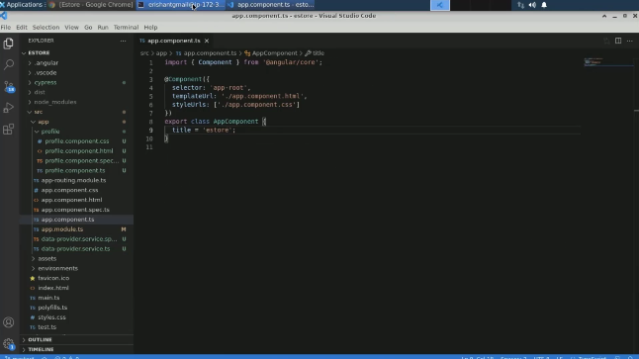

1. Write **ng serve - o** command

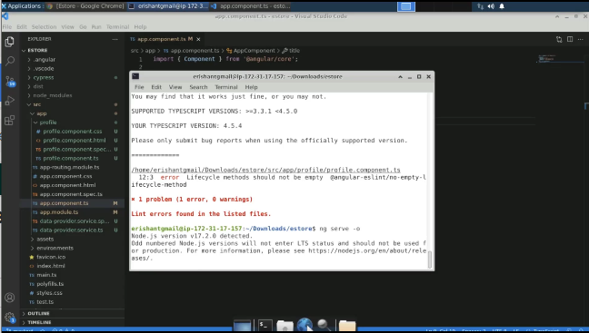

1. Go to the **profile.component.ts** file and create one constant

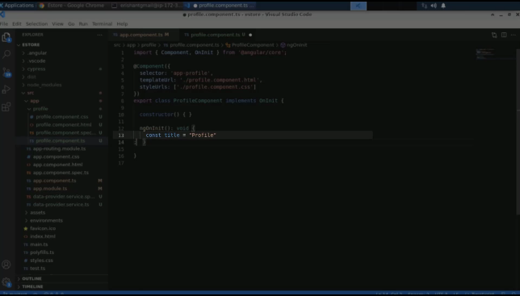

1. Re-run the **ng lit**

