**Lesson 2 Demo 2**

**Using ngFor and ngIf**



**Steps to perform:**

1. Create a new folder in the source directory named **modal**

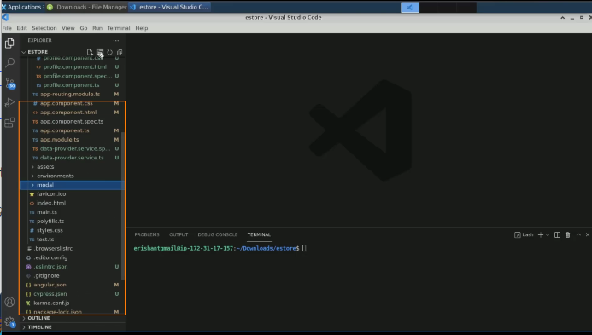

1. Write a new typescript file in **modal** named **product.ts**

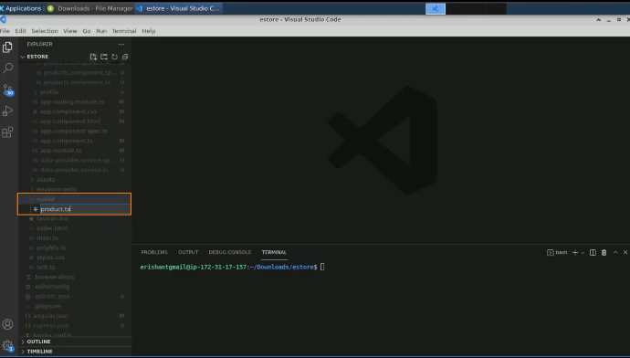

1. Export the class product

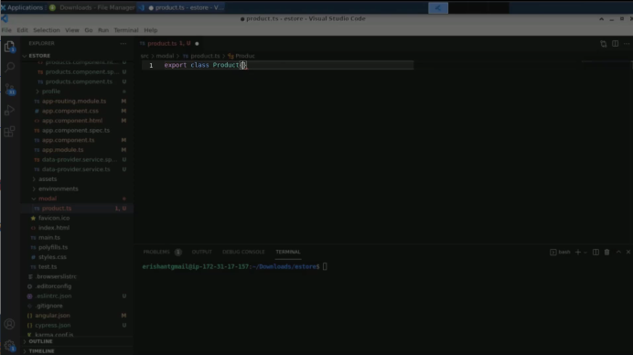

1. Add a product id, name, price and ratings

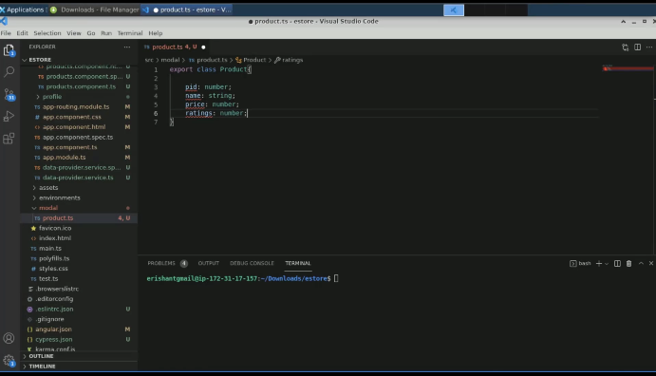

1. Add a constructor to initialize the values

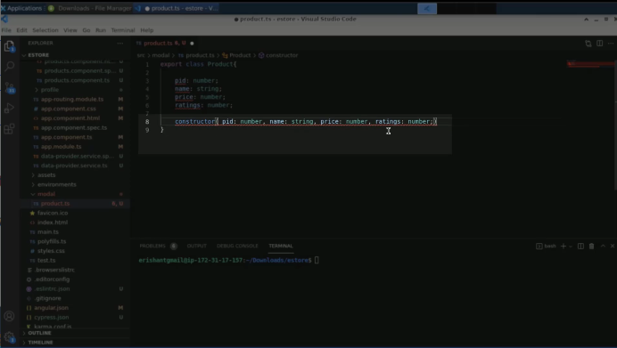

1. Initialize all the attributes through the constructor

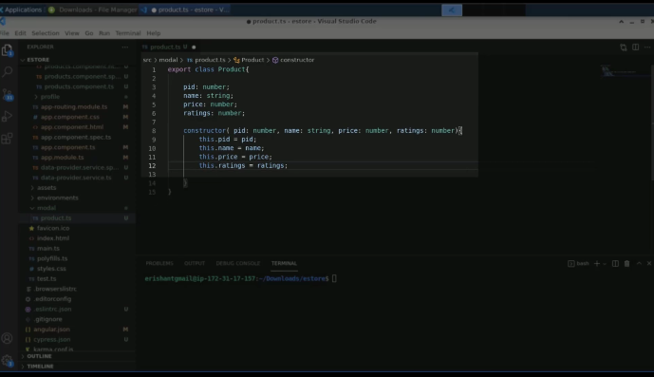

1. Optionally, write show products function

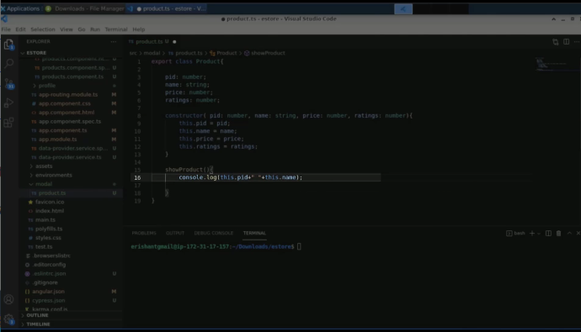

1. Navigate to the **products.component.ts**

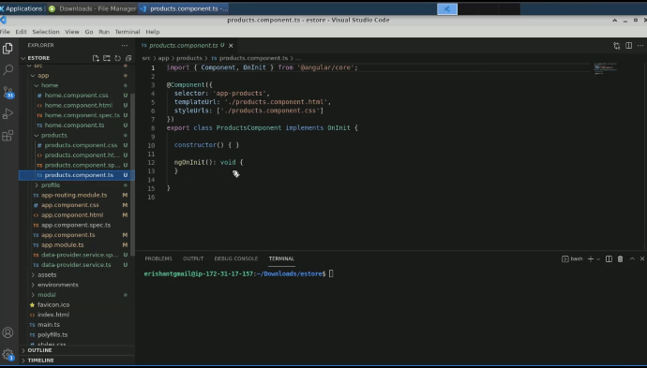

1. Create an array of products

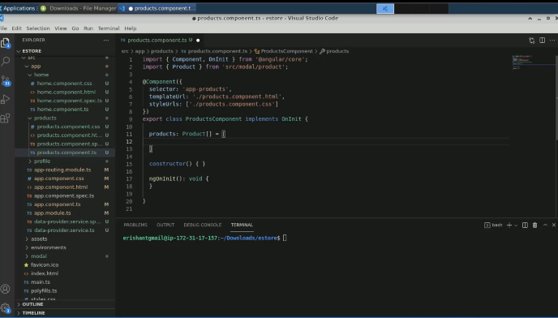

1. Pass the following command

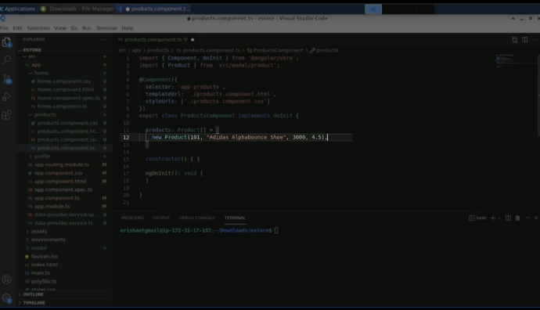

1. Create a few more products objects

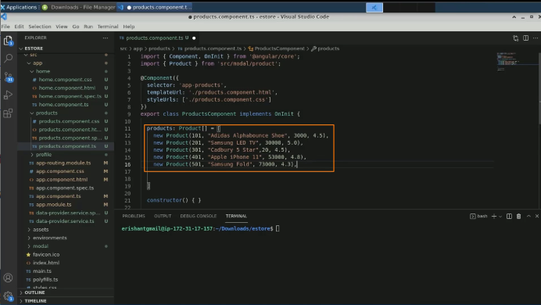

1. Open **products.component.html** file

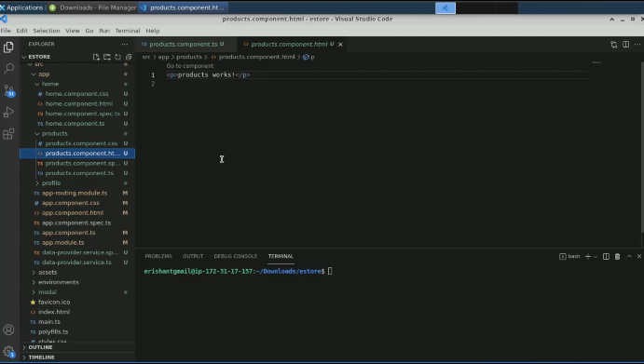

1. Write **All Products** in the paragraph tag

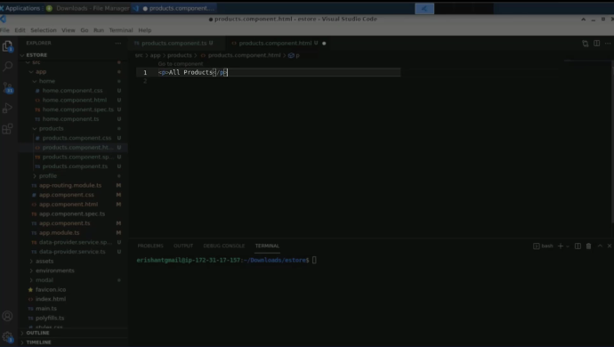

1. Write a list of products using the h3 tag within the paragraph tag

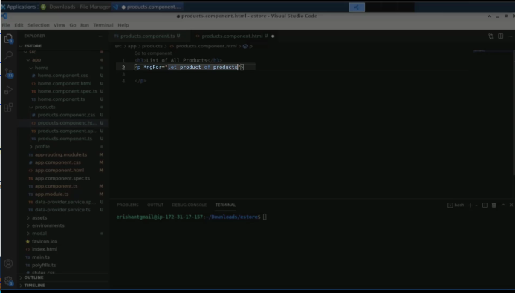

1. Do the variable printing as follows

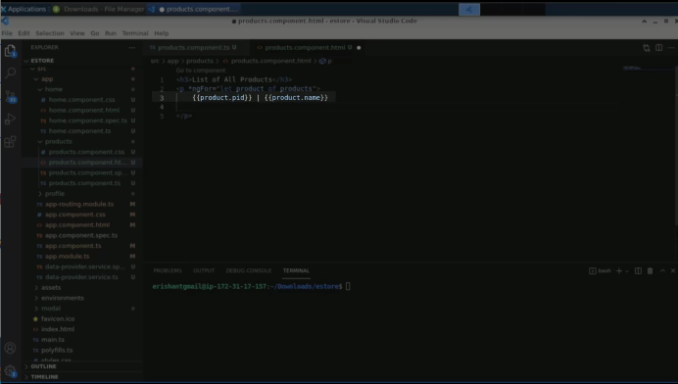

1. Execute the program in the terminal to check the output

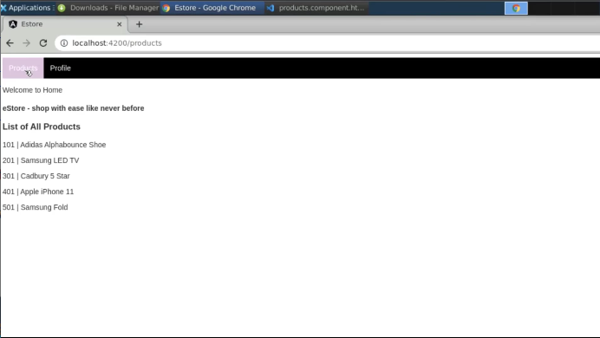

1. Add some more variable details to print

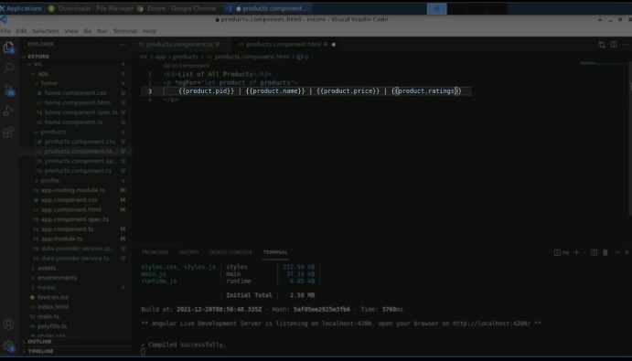

1. Re-run the program

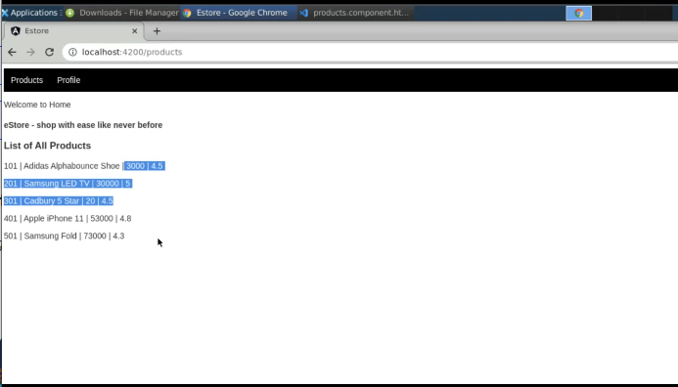

1. Add a div tag in which the list of products will be displayed

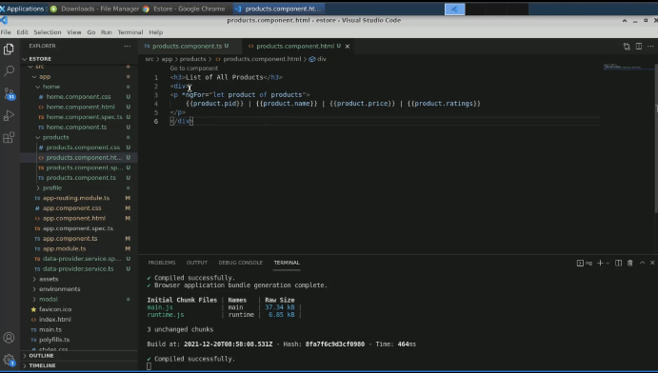

1. Create a variable with a value as **true** in the **product.component.ts** file

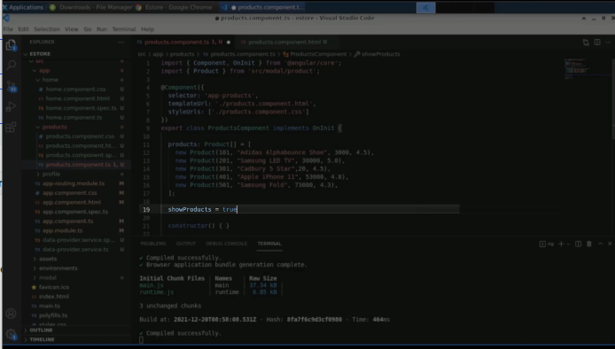

1. View the output

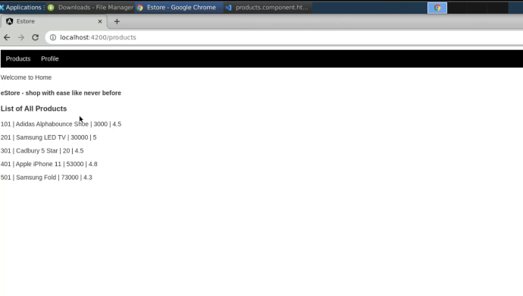

1. Change the variable value to **false**

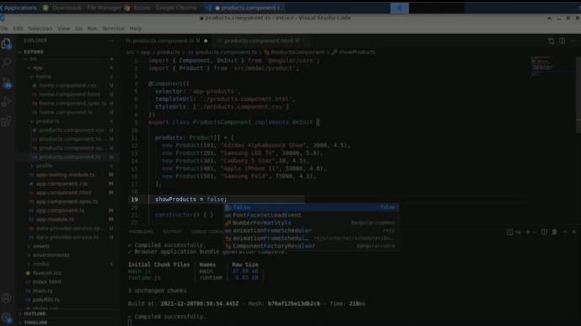

1. Save and execute the program

