**Lesson 2 Demo 3**

**Creating Reactive Form with Form Control**



**Steps to perform:**

1. Run the application in the Angular framework

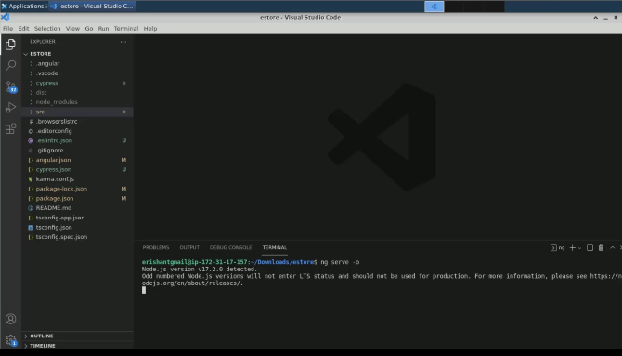

1. Output on the browser will look like this:

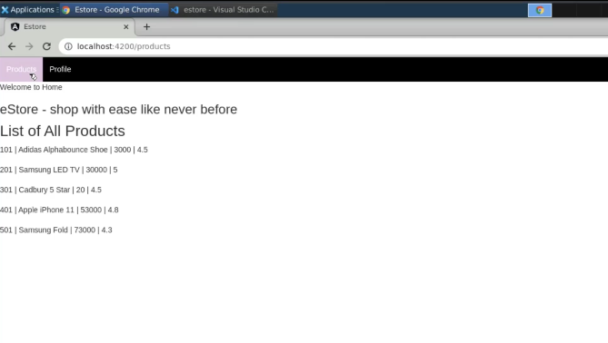

1. Open the typescript file from the product component and create one form group object here:

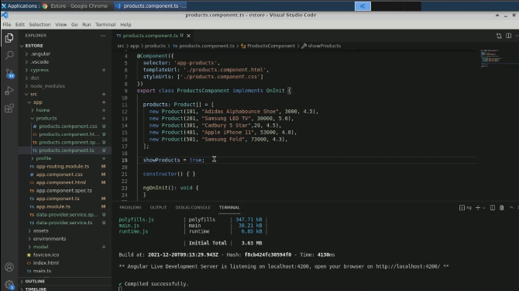

1. Create a product form

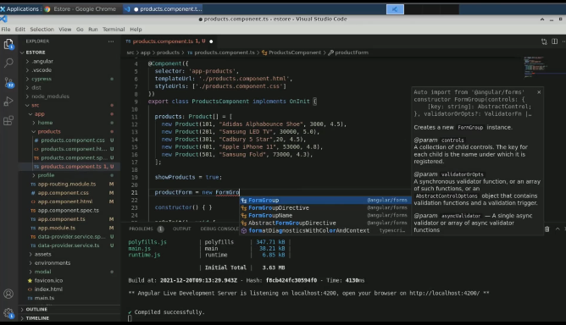

1. Pass an object in product form as form control, namely; product id, name, price and ratings

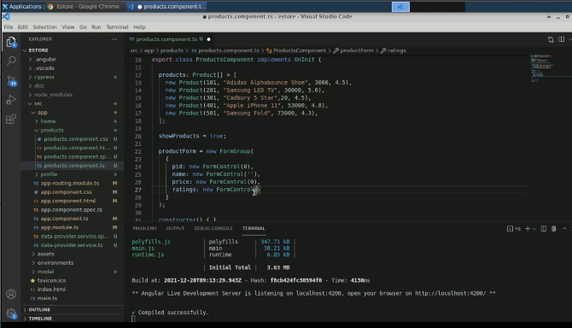

1. Create an array named **categories**

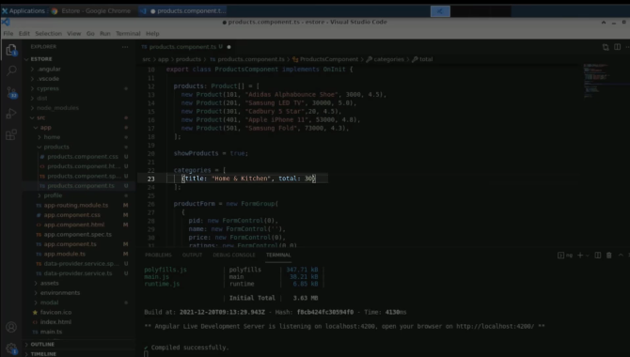

1. Create a few more categories

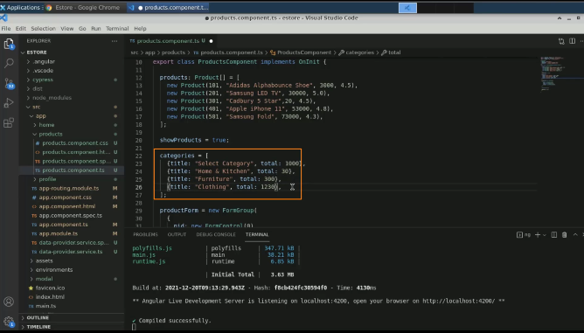

1. Insert the following statement of category

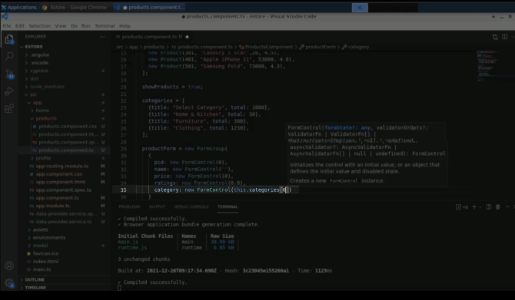

1. Open **products.component.html** and create an h3 tag to ad products

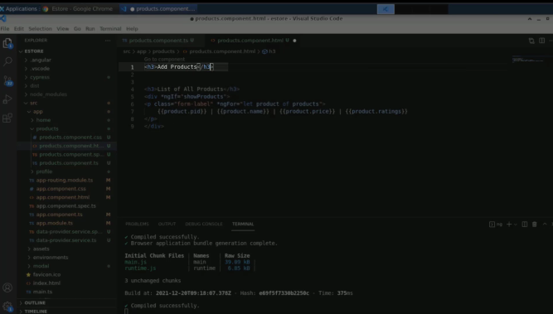

1. Create a form inside a div tag

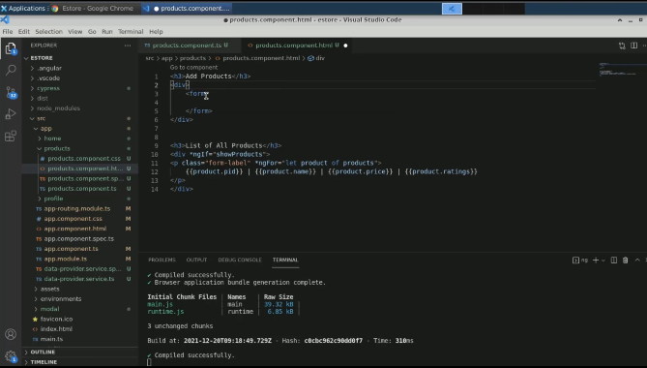

1. Add a form group as a product form

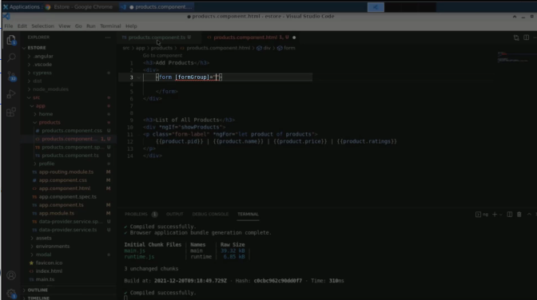

1. Create input fields for it

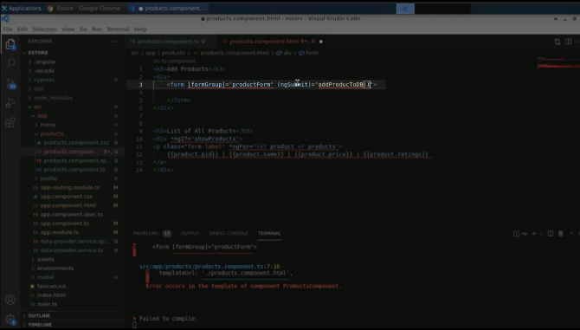

1. Add a placeholder for a demonstration

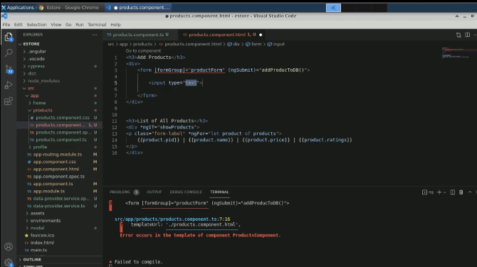

1. Add the name as **product id**

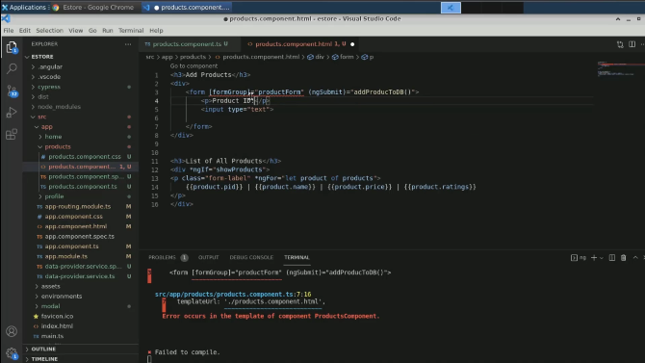

1. Break the statement and add more placeholders for each variable

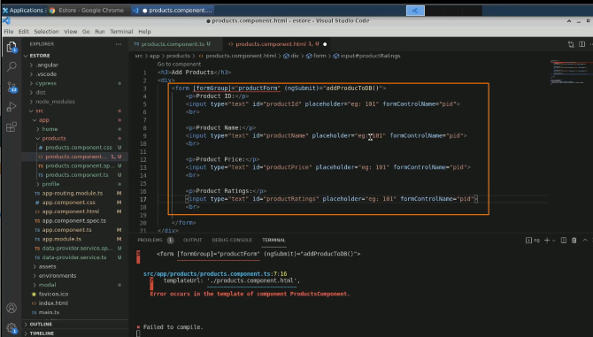

1. Alter the form control names

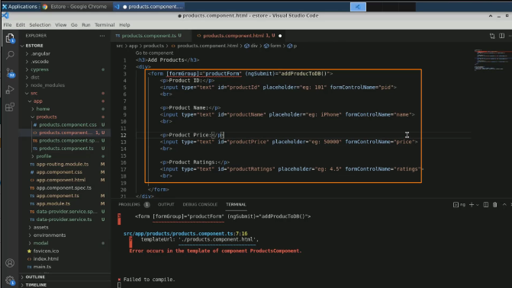

1. Create a drop-down

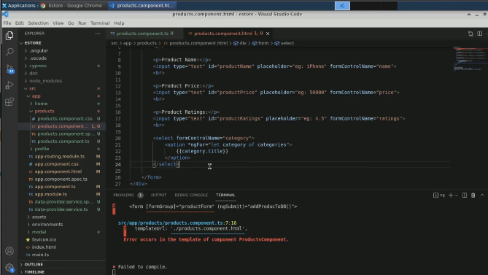

1. Create a submit button

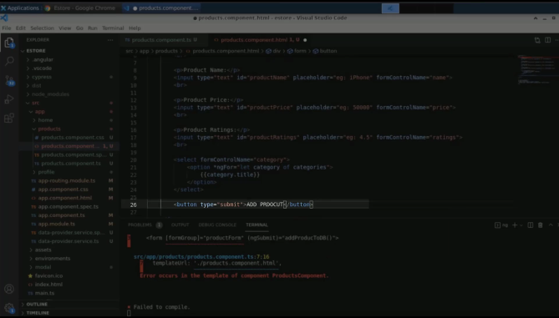

1. There is an error shown in the terminal

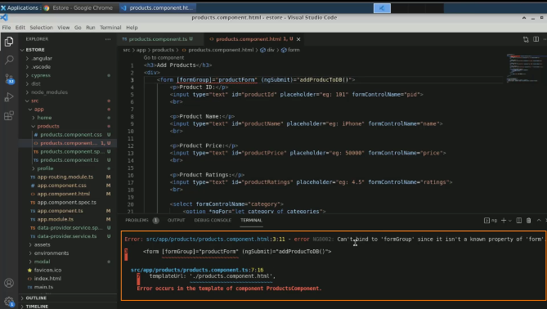

1. In the **app.module.ts** file, import the module and save the file

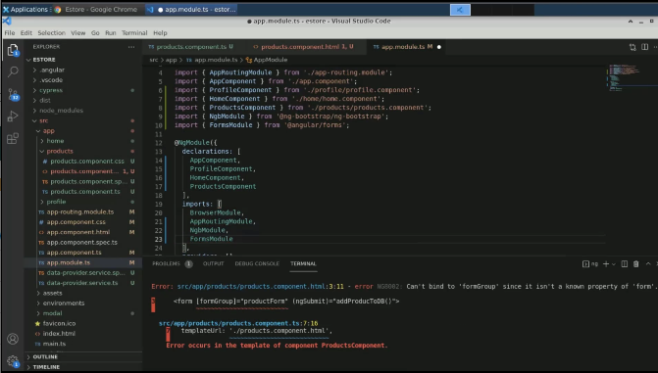

1. Add a reactive form module in the **app.module.ts** file

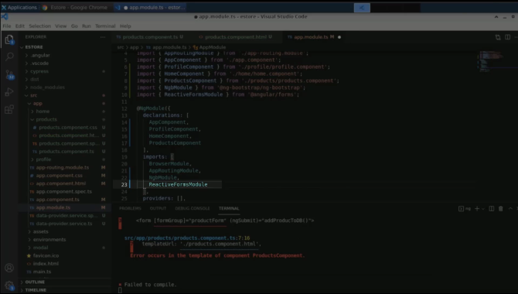

1. Revisit the page on the browser

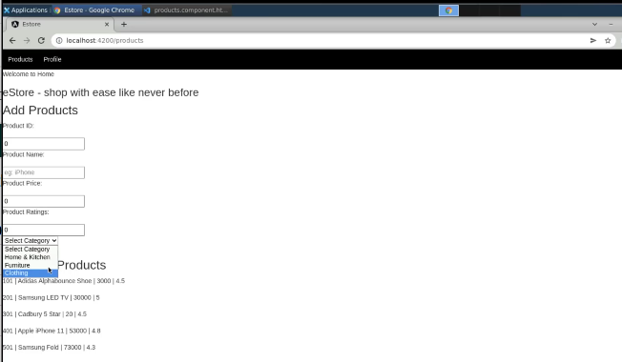

1. Add a paragraph tag inside the h3 tag in the HTML file

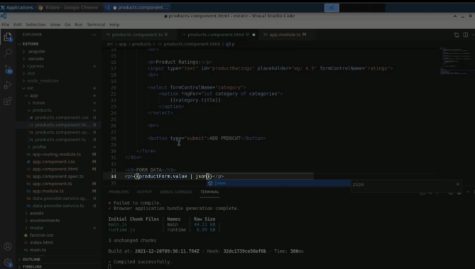

1. Refresh the page

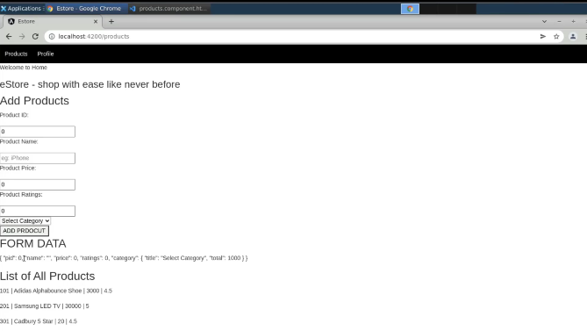

1. Fill up the fields to pass the input

